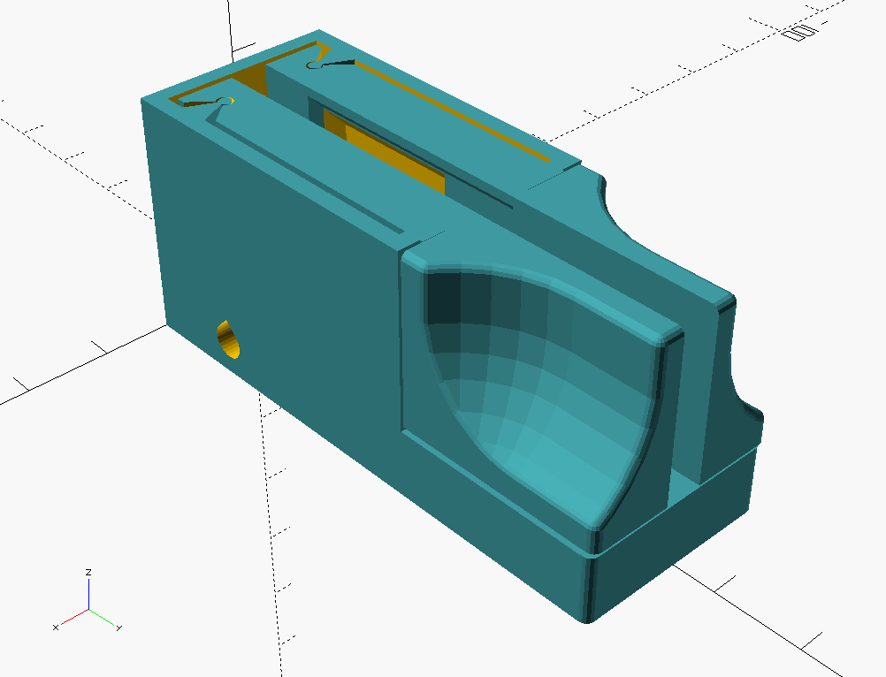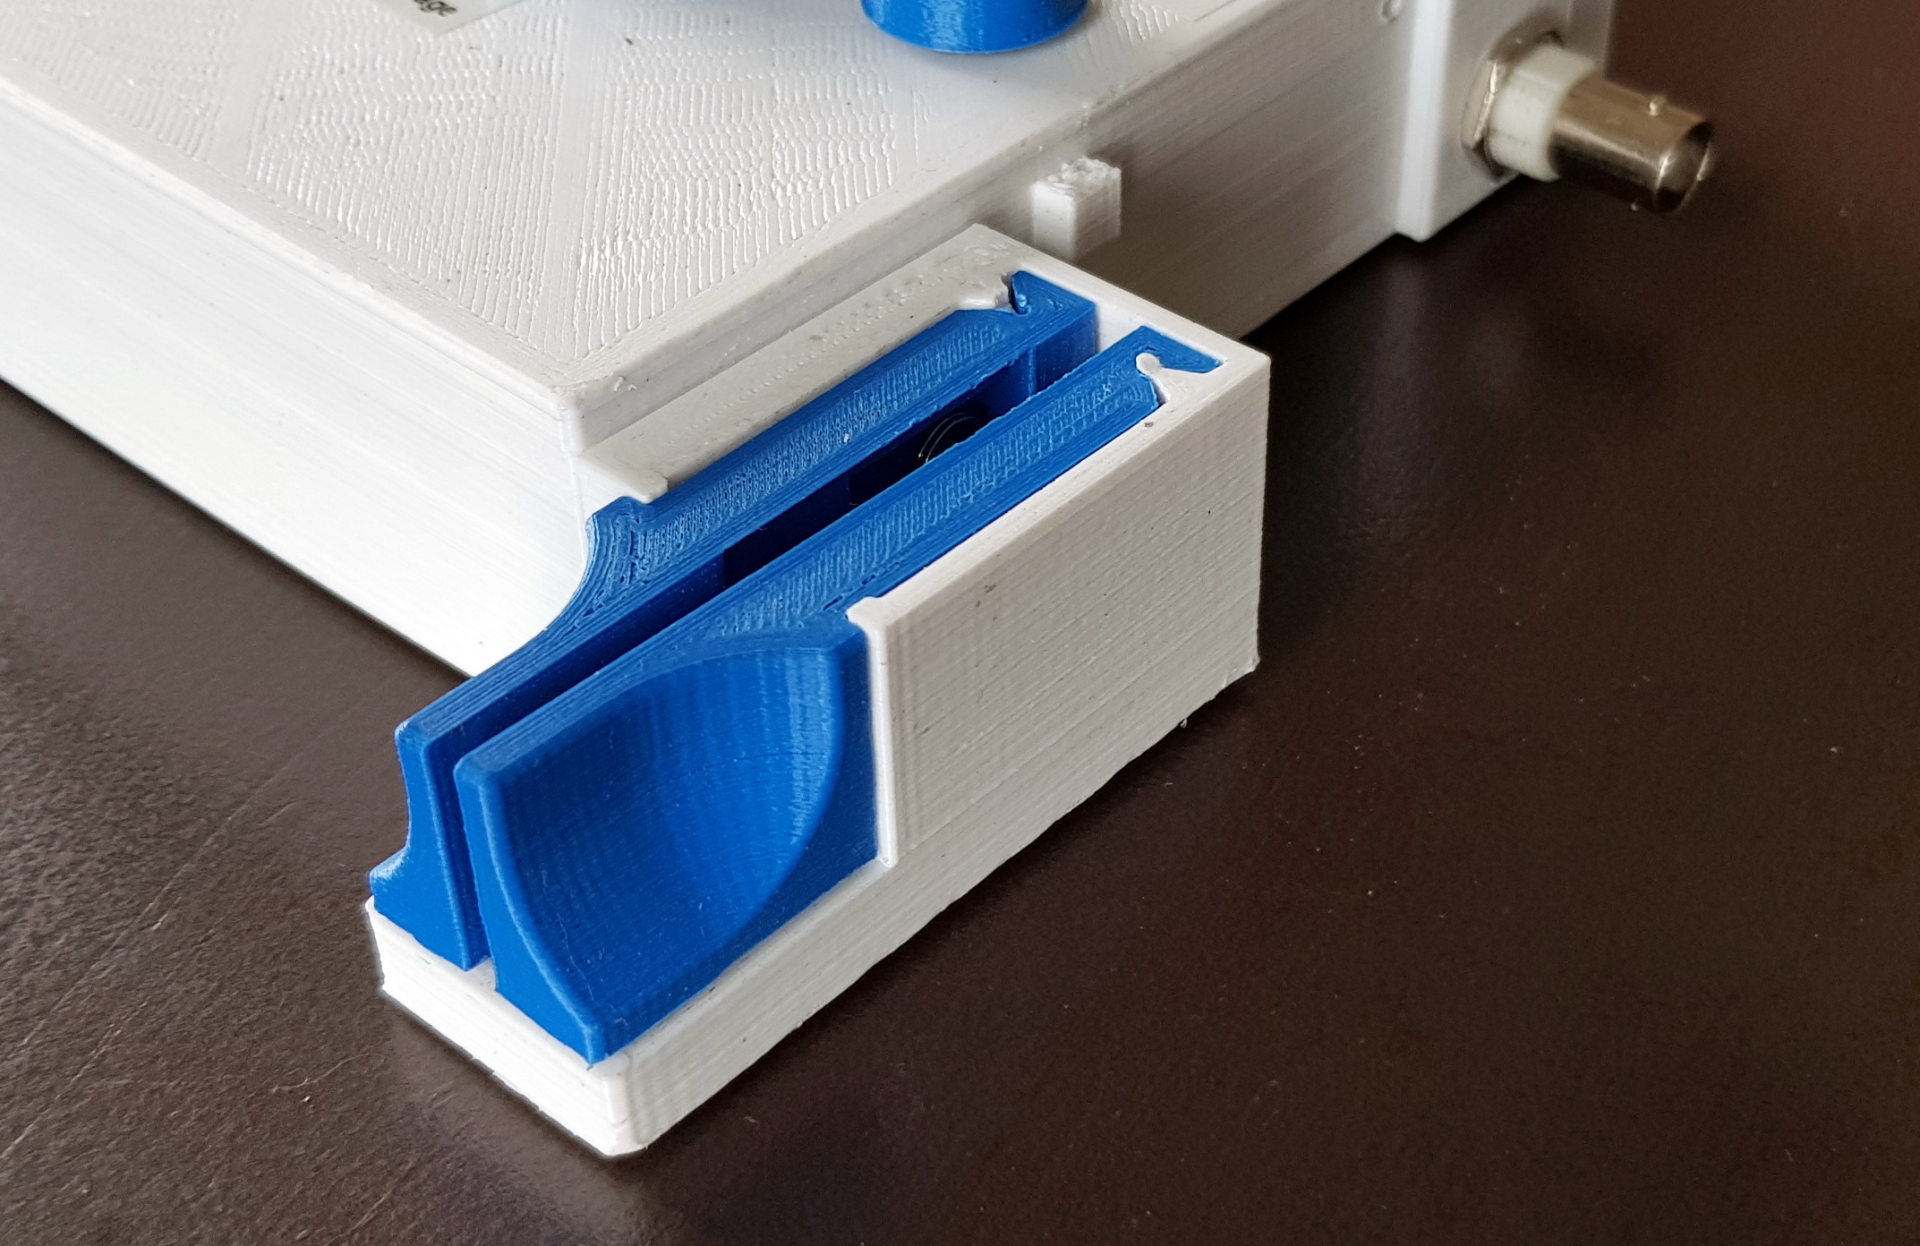

Morse Paddles LA4ZCA, v2

## Description

This design is for 3D-printed iambic paddles for sending Morse code. The design is simple, but provides precise movement with adjustable force and travel. Design features include a printed rocker hinge, force adjustment by a sliding spring, travel adjustment using a modified screw, ergonomic grip and general simplicity and precision. The design is compact and well suited for portable use.

The version 2 of the paddles is a bit sleeker, and also more robust against pushing the arms out or place, thanks to a base that extends under the full length of the arms. The space inside is a bit more tight, and the central screw has to be shorter. Otherwise the design is essentially the same as the first version. These instructions are not updated with new images of everything, and both designs work just fine. Version 2 is used in the [Compact QCX enclosure](https://github.com/tskauli/QCX_enclosure_LA4ZCA).

Spring force is adjusted by moving the spring closer or further away from the hinge. The center screw forms the common contact and is flattened to a blade shape at the contact points. By rotating the center screw, accessible from the bottom, the length of travel is adjusted by changing the angle of the blade. The paddles need attachment to a steady surface for good ergonomy. Holes for attachment screws are provided. Alternatively, an adhesive can be used: "Blu-tack" putty works well, and is removable.

## Materials:

* 3 printed parts
* 2 screws M3x5mm, cylinder head, with washers for adjustment if needed
* 1 screw M4x18-20mm, cylinder head, with washer and nut
* Compression spring, 6-8 mm in diameter
* Compression spring, 4-5 mm in diameter
* Cable with plug as required, up to 3.5 mm diameter

Note: Nickel plated brass screws have been found to give the most reliable contact operation. Dimensions of screws, springs and cable can be changed in the code.

## Assembly

First, prepare the 3D-printed parts by removing support material in the arm spring well and in the ends of the cable holes. Also remove any protuding edges and bumps by gently filing the surfaces.

Place the large spring so that it is held between the paddles approximately in the middle of the spring well. Also place the small spring in the holes at the hinge. Temporarily slide the two paddles in place. Check the spring force on the paddles and adjust as desired by either moving the spring along the well or by bending the spring to change its length. Make sure that the small spring keeps the arms in place at the hinges during use.

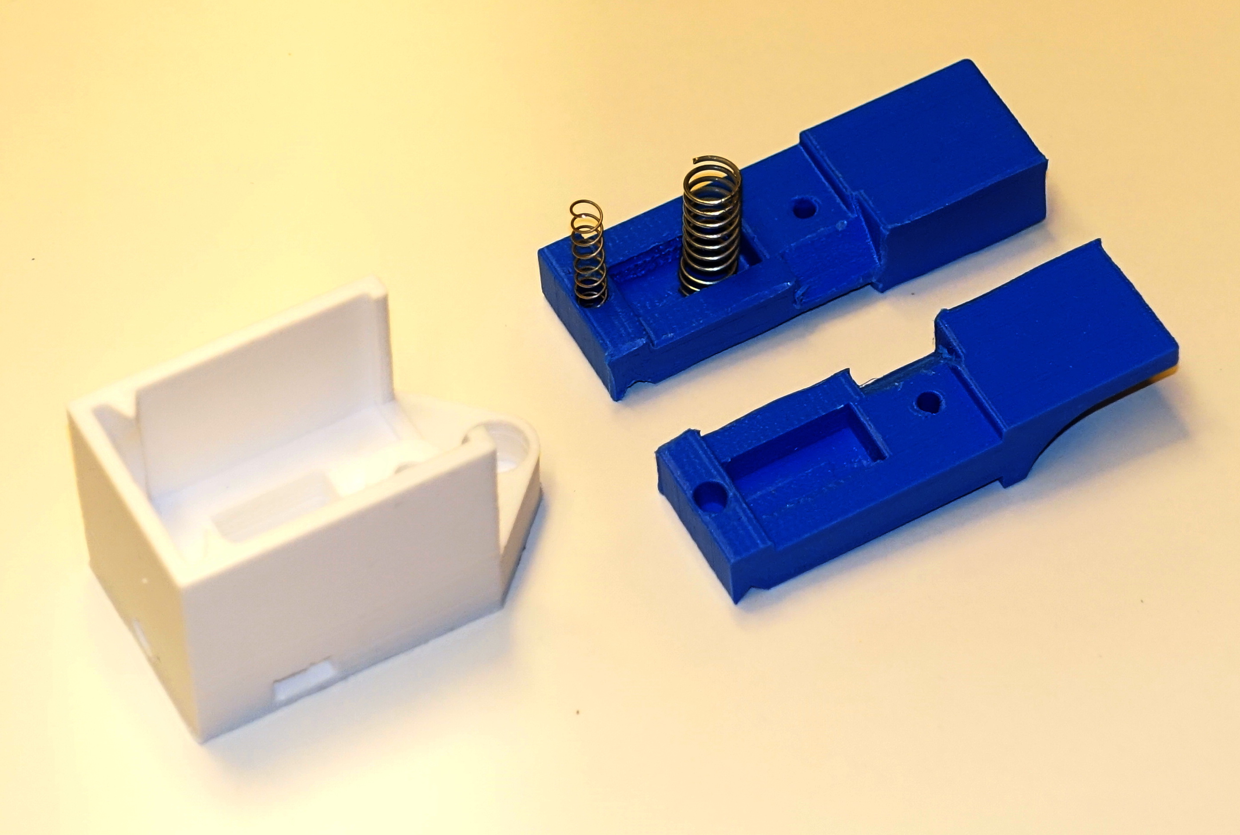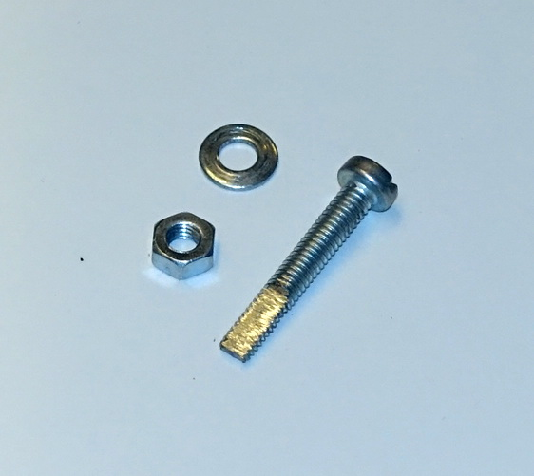

Remove 6-8 cm of the outer isolation (if present) of the cable and 1 cm of the inner isolation of each wire. Insert the cable from the back through the diagonal hole, and temporarily pull it out from the side "window". Insert the cable back into the other hole and press the cable bend into the window so that the outer isolation ends in the interior wiring well. This forms a strain relief.

Prepare a 25 mm M4 screw with cylindrical head by grinding the outer 10 mm to flatten two opposing sides. Preferably align the flattened screw end with the slot in the screw head.

Enter two M3 screws with cylindrical heads into the paddle arms. The screws should be able to self-thread into the holes, but depending on the printer it may be necessary to adjust the hole diameter. Clamp the dot and dash wire ends under these screw heads.

Enter the M4 screw from the bottom and clamp the ground wire underneath the washer. Tighten the screw firmly, while allowing a small amount of adjustment of the screw angle to set the travel distance.

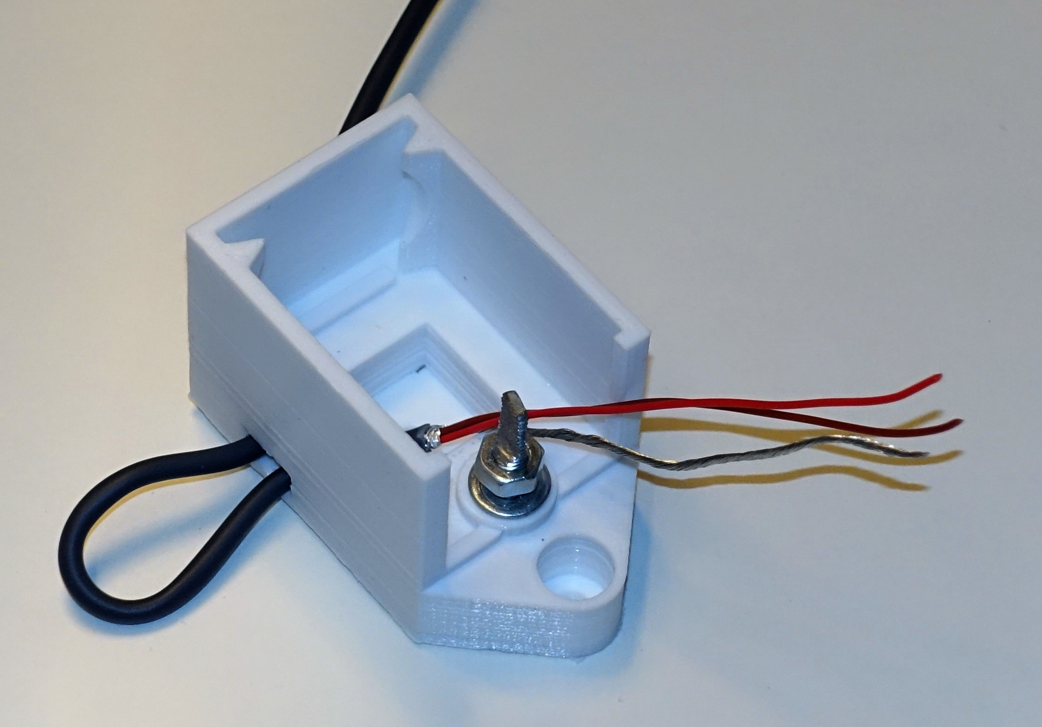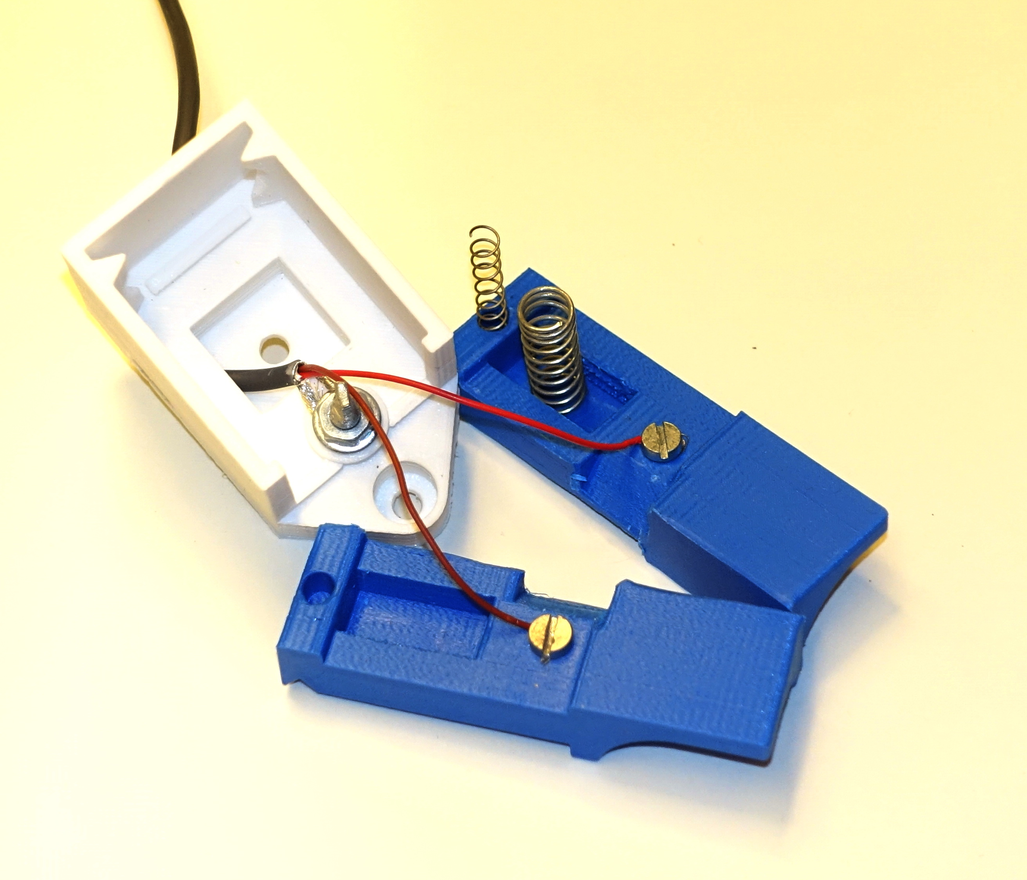

Place the springs between the paddles and slide the arms in place. Adjust travel by rotating the M4 screw. If the travel is asymmetric, it may be necessary to correct the difference by placing a washer under the head of one of the M3 screws in the paddle arms.

73 de Torbjorn, LA4ZCA (tskauli@gmail.com)