

თბილისის თავისუფალი უნივერსიტეტი

კომპიუტერული მეცნიერებების, მათემატიკისა და ინჟინერიის
სკოლა (MACS[E])

ელექტრო და კომპიუტერული ინჟინერიის პროგრამა

ბეჟანიშვილი ნიკოლოზ
ცხვედაძე ქეთევანი

ელექტრო და კომპიუტერული ინჟინერიის ლაბორატორია - პროექტის ანგარიში ანალოგური მოდულარული სინთეზატორი

თბილისი
2026

Annotation
This project was done as part of the “Electro and Computer Engineering Lab” course. The objective of this project was to get acquainted with basic electrical engineering concepts, analog circuits, common components (resistors, capacitors, transistors, op-amps, etc.), project workflow, and software for SPICE simulations, schematic and PCB layout, as well as gaining practical experience with hardware by designing and building an analog modular synthesizer. At the end of the project, all of the aforementioned goals were achieved: we successfully designed a synthesizer, obtained competence in necessary software and deepened our knowledge of analog electronics. We designed, simulated in SPICE and built (soldered) on a perfboard the following modules: Sequencer, VCO (Voltage-Controlled Oscillator, VCA (Voltage-Controlled Amplifier), Mixer. We’ve also designed a ready-for-printing PCB design of a Sequencer and a VCO.
ანოტაცია
ეს პროექტი შესრულდა კურსის „ელექტრო და კომპიუტერული ინჟინერიის ლაბორატორია“ ფარგლებში. პროექტის მიზანი იყო ელექტრო ინჟინერიის საბაზისო კონცეპტების, ანალოგური წრედების, ხშირად გამოყენებადი კომპონენტების (რეზისტორები, ტრანზისტორები, ოპ-ამპები და სხვ.) და პროექტის სამუშაო პროცესის გაცნობა; SPICE სიმულაციისა, სქემატური და PCB დიზაინებისთვის ხშირად გამოყენებადი პროგრამების შესწავლა და ელექტრულ აპარატურასთან მუშაობის პრაქტიკული გამოცდილების მიღება ანალოგური მოდულარული სინთეზატორის შექმნისა გაკეთების გზით. პროექტის დასასრულ, ყველა აღნიშნული მიზანი იქნა მიღწეული: ჩვენ წარმატებით შევქმენით სინთეზატორი, შევიძინეთ აუცილებელ პროგრამულ უზრუნველყოფასთან მუშაობის უნარები და გავიღრმავეთ ცოდნა ანალოგური ელექტრონიკის სფეროში. ჩვენ დავაპროექტეთ, მოვახდინეთ SPICE სიმულირება და სამონტაჟო დაფაზე (perfboard) ავაწყვეთ (შედუღებით) შემდეგი მოდულები: VCO (Voltage-Controlled Oscillator, VCA (Voltage-Controlled Amplifier), Mixer. ასევე შევქმენით დაბეჭდისთვის მზა PCB დიზაინი შემდეგი მოდულებისთვის: Sequencer, VCO.

Table Of Contents
Annotation ii
Table Of Contents iii
Table of Figures iii
Introduction 1
Technical Review 2
Sequencer 2
VCO (Voltage-Controlled Oscillator) 4
VCA (Voltage-Controlled Amplifier) 8
Mixer 10
Conclusion 12
Individual contributions 13
GitHub repository 13
References 14
Attachments & Project Visuals 15

Table of Figures
Figure 1: Sequencer. Schematic Design. 15
Figure 2: The sequencer generating a stepping signal (with values of the potentiometers set as on Figure 1). 15
Figure 3: VCO. Schematic Design. 16
Figure 4: The linear input (black) of a VCO being transformed to exponential (blue) by the linear-to-exponential converter. 17
Figure 5: The triangle output of the VCO with linear input (same as in Figure 4). 17
Figure 6: The square output of the VCO with linear input (same as in Figure 4). 17
Figure 7: VCA. Schematic Design. 18
Figure 8: The attenuation of the input signal (blue) to the output signal (red) by the VCA via setting CV to 2V DC. 18
Figure 10: A possible combination of input signals for the mixer. 19
Figure 9: Mixer. Schematic Design. 19
Figure 11: The three output signals - inverted (blue), normal (red), clipped (pink) - of the Mixer for the input signals from Figure 10. 19

Introduction
This project was done as part of the “Electro and Computer Engineering Lab” course as the first one of the three assignments we were given. The modules we chose to build are: Sequencer; VCO (Voltage-Controlled Oscillator); VCA (Voltage-Controlled Amplifier); Mixer. Below is a short description of each module. A more detailed description, as well as a list of initial requirements and achieved results can be found under the “Technical Review” section.
Sequencer. A Sequencer is a module that can produce repeating stepping sequence of voltage pulses, which can later be used in other modules to produce various effects and eventually play a repeating sequence of notes.
VCO. A Voltage-Controlled Oscillator (VCO) is a module that can generate a periodic (oscillating) output signal of high frequency, which can be controlled by the input voltage. We have built a 1V/Octave Triangle & Square wave VCO, meaning that a 1V increase in the input voltage doubles the frequency of the output voltage, and the two possible outputs of the module are a Triangular waveform and a Square waveform.
VCA. A Voltage-Controlled Amplifier (VCA) is a module that can amplify (increase or decrease the amplitude of) the input signal based on a Control Voltage (CV). The higher the CV, the bigger the amplitude of the output signal.
Mixer. A mixer is a module that can join multiple signals into one, creating a single waveform with unique properties depending on the inputs. It has three outputs: Inverted, normal and clipped. Each output has different acoustic properties.
Along with physically building and soldering the modules on a perfboard, we simulated their behavior in a SPICE program (LTspice) and designed a ready-for-printing PCB layout. These files can be found on out github repository linked at the end of this report.

Technical Review

Sequencer
- The goal.
The purpose of a sequencer is to generate a repeating stepping sequence of voltage pulses. More specifically, the requirements are:
- CV Generation: The Sequencer can produce a stepping CV signal.
- Integrated Clock: The Sequencer has a stable internal timing source.
- Variable step control: The Sequencer can be set to generate 3-5 steps (the user must be able to choose the desired output count).
- Simulation: A simulation of the module is present.
- PCB Design: A schematic diagram and a PCB layout of the module are present.

- The methods.
To achieve these goals, we used a 555-Timer (SE555) in astable configuration connected to a. decade counter (CD4017BE). In astable configuration, the Timer generates a clock signal. It is connected to two external resistors (R₁ and R₂) and an external capacitor (C) as shown in Figure 1. The frequency of the resulting clock signal is determined by the values of R₁, R₂ and C as follows:
$$f=\frac{1.44}{{(R}_{1}+2*R_{2})*C}$$
By using a potentiometer instead of R₂, the frequency can be regulated manually. Although this also changes the duty cycle, it does not matter for our application, which is to use it as an input clock signal for a decade counter. A decade counter can count from 0 to 9, making steps when the clock input pulses. By connecting the first 5 outputs (0-4) to potentiometers through diodes (to protect the IC from backward voltage), and then combining them into a single output, the desired 5-step signal can be achieved. The potentiometers can be used to adjust the amplitude of each step.
In order to have a variable step control, we used a 3-position rotary switch connecting the reset pin of the decade counter to the common pin of the switch and the outputs 3-5 to the three selector positions. This way, the switch regulates after how many steps does the counter reset, regulating the number of steps.
- The result.
All aforementioned requirements were met: the module successfully produces a stepping CV stepping signal, has a stable internal clock signal and variable step control. In addition to the requirements, 5 LEDs were added in parallel with each output pin of the counter, as well as one with the clock output, allowing for easier visual representation of the module’s functionality. The simulation operates as expected; the schematic diagram of the module matches the actual build on a Perfboard, and a PCB layout is present.

VCO (Voltage-Controlled Oscillator)
- The goal.
The purpose of a VCO is to generate different waveforms of various frequencies determined by the Control Voltage (CV). More specifically, the requirements are:
- Wave generation: The VCO can generate at least two stable waveforms observable on an oscilloscope.
- CV Pitch Control: The input CV changes the frequency in a predictable manner (meaning that for each 1V change in the input signal, the output signal is changed by one octave).
- Tonal stability: The Oscillator does not “drift”, maintaining a stable tonal range for several minutes.
- Simulation: A simulation of the module is present.
- PCB Design: A schematic diagram and a PCB layout of the module are present.

- The method.
There are different types of VCOs. The one we chose to design is a 1V/Octave triangle core oscillator. A dual power supply is required for the operation of this module. We decided to use one ranging from -9V to +9V for the simulation, though the module operates well at other values within the component’s tolerance. For simplicity, we will refer to the positive terminal of the supply as V+, The negative terminal as V- and the common terminal as Ground (or GND). This module can arbitrarily be divided into three parts: Input adjust, Linear-to-exponential converter and oscillator.
The purpose of the “input adjust” part is to adjust the input signal of the module. VCOs typically have more than one inputs (usually three: KEY, TUNE, and LFO) which would be added together, scaled down and flipped via an op-amp configured as an inverting summing amplifier. In this configuration, the op-amp is powered by the dual supply, its non-inverting input is connected to GND, its inverting input joins all the input signals of the module through 100k resistors and the output is connected to the inverting input via a resistor. Ideally, this resistor would have a fixed value that would allow for a perfect 1V/Octave relation in the entire circuit, but in reality, the resistor values are not precise enough, temperature of the environment and other factors cause minor changes in the behavior of the circuit, so the value of that resistor would sometimes need to be adjusted to achieve ideal operation. For this reason, we decided to add a 1k trimming potentiometer in series with a 1k resistor to allow for manual adjustment of the resistance. For the simulation, we found that the value of 0.471k works best.
In the linear-to-exponential converter part of the module, two npn BJT transistors (Q1 & Q2) form a differential pair, whose emitters are joint. The output of the “input adjust” part is then connected to Q1’s base. There is an exponential relationship between the base-emitter current ($I_{BE})$ and voltage ($V_{BE})$:
$$I_{BE}≈I_{S}*e^{\frac{V_{BE}}{V_{T}}}$$
Where $I_{S}$ is the saturation current of the transistor and is a small, device-dependent value, and $V_{T}$ is thermal voltage. This is how the 1V/Octave relation is achieved. By nature, the human hearing is logarithmic, meaning that on each octave, the frequency of the sound waves doubles. The aforementioned exponential relationship is used to achieve the same result, effectively doubling frequency after each 1V change in the base current.
The collectors of Q1 is connected to an op-amp’s inverting input, which is also connected to V+ through 1M resistor. This op-amp is power by the dual supply, its non-inverting input is connected to ground and its output is connected to the inverting input through 1nF capacitor and to the junction of Q1 and Q2’s emitters through a 1k resistor. This configuration forms a constant-current reference loop, forcing Q1 to hold a constant current. Thus, changing the voltage on its base forces the relative base-emitter voltage of Q2 to change.
The last step is to turn the exponential current flowing through Q2 into a usable voltage signal. This is done using a transimpedance amplifier configuration of an op-amp. In this configuration, it acts as a current-to-voltage converter. It is powered by dual supply, its non-inverting input is connected to ground, the inverting input is connected to the collector of Q2, and output is connected to the non-inverting input through a series connection of a 20k resistor and 10k potentiometer. Adjusting the value of the potentiometer allows for adjustment of the starting pitch of the oscillator.
Next, the exponential voltage from the converter is used as input voltage for the oscillator core. This configuration of an oscillator generates triangle and square waveforms, whose frequency is determined by the input voltage. The oscillator first generates a triangle waveform, which is later used to generate a square waveform. For triangle waveform generation, an integrator configuration of an op-amp is used. In this configuration, it is powered by a single power supply (though using dual power supply would achieve the same result) its output is connected to the inverting input through a 4.7nF ceramic capacitor. Its non-inverting input is connected to a voltage divider dividing the input voltage by two, and the inverting input is connected to the input voltage through a 100k resistor. The resistance of this resistor determines the time it takes for the capacitor to charge. The charging and discharging of the capacitor create triangular waveform oscillating around V+/2, whose frequency is determined by the time it took to charge, which, in turn, is determined by the input voltage.
This triangular waveform is going into a Schmitt trigger. A Schmitt trigger is made using an op-amp by connecting its output to the non-inverting input and the non-inverting input is connected to a reference voltage to compare against. In this configuration, it is powered by a single power supply (V+ and GND). The triangle waveform goes into the inverting input of the op-amp. which compares it against the reference voltage. When the voltage on the inverting input is greater than the reference voltage, the output is a logical one or the voltage on the positive terminal of the supply, when it is less, the output is a logical 0, or the voltage on the negative terminal of the power supply. The reference voltage is V+/2, achieved by using a voltage divider. Because the wave is oscillating around V+/2, it will be greater than it half of the time and less than it the other half, resulting the output to oscillate between V+ and 0.
- The result.
All aforementioned requirements were met: the module successfully generates two stable waveforms (Triangle and Square), a 1V change in the CV corresponds to 1 Octave change, having a trimming potentiometer allowing for manual correction of the pitch, and the module maintains a stable tonal range for several minutes. The simulation operates as expected; the schematic diagram of the module matches the actual build on a Perfboard, and a PCB layout is present.

VCA (Voltage-Controlled Amplifier)
- The goal.
The purpose of a VCA is to amplify the input signal. The amplitude of the output signal is determined by a control voltage (CV). More specifically, the requirements are:
- Control Voltage Input: Takes voltage signals that dynamically control the amplitude.
- Output: Outputs amplified or attenuated signals ready for a mixer or final output.
- Level Control: The output amplitude can be controlled manually without the need to change CV.

- The method.
The type of VCA we chose to design is often regarded to as “Long-Tailed Pair Differential Amplifier”. The core of the design is to use the gain of a bipolar transistor to control the amplitude of the input signal. The core part of the design is two npn transistors with joint emitters (Q7 & Q8). It is essential for them to be as close to each other as possible in the real build to ensure that they operate at the same temperature and to prevent thermal runaway. A dual power supply is required for the operation of this module. We decided to use one ranging from -9V to +9V for the simulation, though the module operates well at other values within the component’s tolerance. For simplicity, we will refer to the positive terminal of the supply as V+, The negative terminal as V- and the common terminal as Ground (or GND). Two op-amps are used in this design (one TL072 IC), which are both powered via the dual supply. The collectors of Q7 and Q8 are connected to V+ through 47k resistors each. As values of the resistors in the real world are not always precise, we empathize that it is essential that the difference between the real values of these resistors is lower than 0.1%.
The input signal of the module first goes through 1μF capacitor to remove the DC offset, then scaled down via 200k/1k voltage divider and fed into Q7’s base. The base of Q8 is connected to GND via 1k resistor. The gain of a bipolar transistor is directly proportional to the amount of constant DC current flowing through its emitter. This is the mechanism we can use to control the output volume.
The Control Voltage (CV) first goes through a 100k potentiometer to allow for manual adjustment, and is then connected to the inverting input of an op-amp configured as an inverting amplifier/buffer, by connecting its non-inverting input to ground and its output to its inverting input through a 100k resistor. The output is connected to the joint emitters of Q7 and Q8 through a 47k resistor. With this configuration, the op-amp is pulling current from the emitters of the transistors, thus increasing the gain at their collectors. The difference between the collectors of Q7 and Q8 is caused by the difference at their bases, which is due to the input signal. The greater the CV, the greater the difference. The voltage on both collectors also has a DC offset. By using another op-amp in subtractor configuration, we can subtract the voltages of the collectors from each other effectively canceling the DC offset. The resulting signal is an amplified version of the input.
- The result.
All of the requirements are met. The CV can successfully dynamically control the amplitude of the output signal and the output signal is an amplified version of the input signal with DC offset removed, making it ready for a mixer or final output. The amplification can also be manually controlled independently of CV via a 100k potentiometer. We built this module on a perfboard with audio jack ports for the input, output and CV and a KF301 3-pin copper connector for dual power supply. In addition to the requirements, we made a simulation of the circuit that behaves as expected, as well as a schematic design and PCB layout.

Mixer
- The goal.
The purpose of a Mixer module is to combine multiple input signals into one output, allowing for creation of unique waveforms. A Mixer has multiple outputs, each combining the input signals in different ways. More specifically, the requirements are:
- Input control: Each input signal’s contribution to the output can be regulated manually
- Output signal type diversity: The Mixer has multiple outputs to choose from: normal, clipped or inverted, each creating different sound effects.
- Linearity: The normal output maintains the relative proportion between the amplitudes of the input signal.

- The method.
A dual power supply is required for the operation of this module. We decided to use one ranging from -9V to +9V. For simplicity, we will refer to the positive terminal of the supply as V+, The negative terminal as V- and the common terminal as Ground (or GND). The three desired outputs of the module can be achieved using three op-amps in different configurations. We used a TL074 IC powered by a dual power supply for this purpose.
The mixer can theoretically have any number of input signals. For our design, we decided to have at most three simultaneous inputs. Each input is connected to the inverting input of an operational amplifier in an inverting summing configuration through a 100k potentiometer, allowing for manual adjustment of each input signal’s contribution in the final output. In inverting summing configuration, the non-inverting input of the op-amp is connected to GND and its output is connected to the inverting input through a 100k resistor. The output is the inverted mathematical sum of all incoming signals. This output is connected to an audio jack as this is one of the three desired outputs of the module – the inverted output.
In order to have a normal output, we used another op-amp in a Unity-Gain inverting configuration. The voltage gain is determined by the negative of the ratio of the feedback resistor to the input resistor. Having them both at 100k, the gain is -1, meaning that the output the op-amp is an inverse of the input. By using the output of the previous op-amp as the input on the inverting input of this one, we get a normal mixed signal of the original inputs of the mixer module. This output is connected to an audio jack as this is another one of the three desired outputs of the module – the normal output.
The third output of the module is the clipped output. This output is often used to create aggressive distortion. To achieve this effect, we use another op-amp configured as a Schmitt Trigger. In this configuration, its output is connected to its non-inverting input through a voltage divider in a way that when the signal on its inverting input is greater than approx. 1.9V, the output becomes 9V and when it is lower than -1.9V, the output is -9V. Before the normal output from the previous input signal enters the inverting input of this Schmitt trigger, it goes through a 100k resistor to scale down the signal and a variable diode clipper. A variable diode clipper is two diodes in anti-parallel configuration connecting the input signal to GND through a 20k potentiometer. By adjusting the value of this potentiometer, the output value, the clipping can be adjusted, subsequently changing the output of the op-amp. This output is connected to an audio jack as this is the third one of the three desired outputs of the module – the clipped output.
- The result.
All of the requirements are met. The Module successfully mixed up to three inputs into one, allowing for manual adjustment of each input signal’s contribution to the final output, has three different output options: inverted, normal and clipped and successfully maintains the relative proportion between the amplitudes of the input signal. We built this module on a perfboard with audio jack ports for the inputs and outputs and a KF301 3-pin copper connector for dual power supply. In addition to the requirements, we added a potentiometer allowing for manual adjustment of the clipping and made a simulation of the circuit that behaves as expected, as well as a schematic design and PCB layout.

Conclusion
All of the requirements set for each individual module were met. We built and soldered all of the modules onto a perfboard, using TL072 and TL074 for op-amps, SE555 for the timer and CD4017BE for the decade counter in the sequencer, KF301 2-pin and 3-pin copper connectors for single and dual power supply accordingly and IC sockets, allowing for easy replacement of the IC chips without the need for de-soldering. made the schematic design and simulated each module in SPICE before building a prototype on a Perfboard, then, after making sure it functions as expected, designed a PCB layout ready for printing thus proving our acquaintance with common engineering software for simulations and PCB/Schematic design and the regular workflow of hardware design.

Individual contributions
Nikoloz Bezhanishvili:
- Research
- Circuit Design
- Circuit Simulation
- Physical Assembly
- Project Report Writing
Ketevani Tskhvedadze:
- Research
- Circuit Design
- Circuit Simulation
- Schematic Design
- PCB Layout
- Physical Assembly

GitHub repository
We’ve been documenting all steps of this project’s development on our GitHub. All SPICE simulation files, schematic layouts, PCB designs and other relevant files can be found there.
GitHub repository for this project: https://github.com/tskhvedadzee/ECE-Modular-Analog-Synthesizer

Contributors’ profiles:
Nikoloz Bezhanishvili – https://github.com/nbezh
Ketevani Tskhvedadze - https://github.com/tskhvedadzee

References
Datasheets
[1] Texas Instruments, "TL07xx JFET-Input Operational Amplifiers," Datasheet. [Online]. Available: https://www.ti.com/lit/ds/symlink/tl074a.pdf?HQS=TI-null-null-alldatasheets-df-pf-SEP-wwe&ts=1775959136755.
[2] Texas Instruments, "CD4017B, CD4022B CMOS Counter/Dividers," Datasheet. [Online]. Available: https://www.ti.com/lit/ds/symlink/cd4017b.pdf?ts=1775941781218&ref_url=https%253A%252F%252Fwww.ti.com%252Fproduct%252FCD4017B%253FkeyMatch%253Dcd4017%2526tisearch%253Duniversal_search.
[3] Texas Instruments, "NE555 Precision Timers," Datasheet. [Online]. Available: https://www.ti.com/lit/ds/symlink/ne555.pdf?HQS=TI-null-null-alldatasheets-df-pf-SEP-wwe&ts=1775935249714&ref_url=https%253A%252F%252Fwww.alldatasheet.com%252F.
[4] "TL074 Datasheet," Alldatasheet. [Online]. Available: https://www.alldatasheet.com/datasheet-pdf/pdf/28778/TI/TL074.html.
Articles and Web Pages
[5] R. Mitchell, "DIY Synth Series Part 1 — The Exponential VCO," All About Circuits, Aug. 8, 2016. [Online]. Available: https://www.allaboutcircuits.com/projects/diy-synth-series-vco.
[6] E. Winer, "Building a Guitar-Controlled Synthesizer: VCA & VCF," audioXpress, Aug. 2022. [Online]. Available: https://audioxpress.com/article/you-can-diy-building-a-guitar-controlled-synthesizer-vca-vcf.
Video Content
[7] M. Klein, "Moritz Klein," YouTube channel. [Online]. Available: https://www.youtube.com/@MoritzKlein0.
[8] The Geek Pub, "555 Timer (astable mode)," YouTube, Nov. 10, 2021. [Video]. Available: https://www.youtube.com/watch?v=FodORXu-Jjk.
[9] Electro University, "How to Make LED Chaser Circuit With 555 Timer and CD4017," YouTube, Mar. 16, 2025. [Video]. Available: https://www.youtube.com/watch?v=Gfp2vgVGE4M&t=4s.

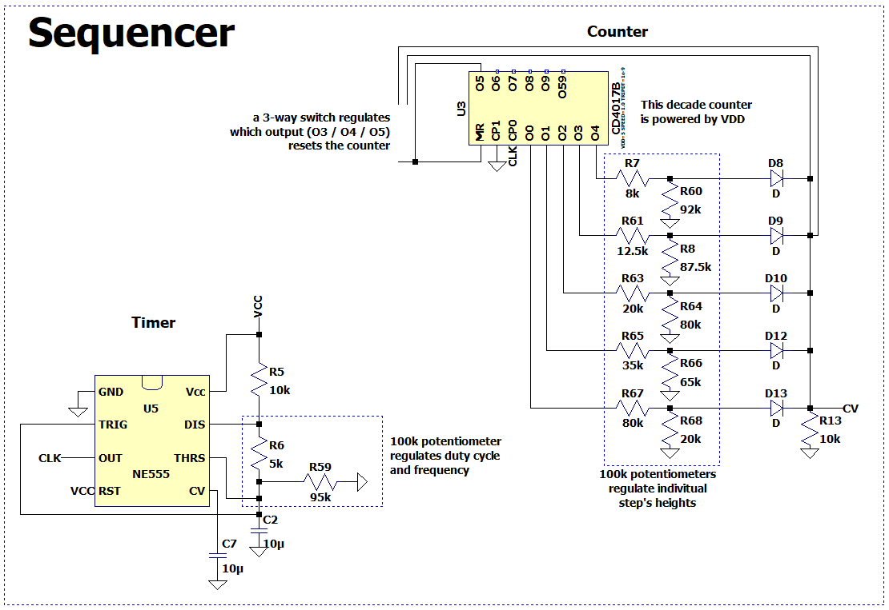
Attachments & Project Visuals
Figure 1: Sequencer. Schematic Design.
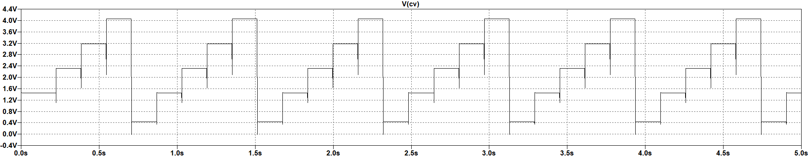
Figure 2: The sequencer generating a stepping signal (with values of the potentiometers set as on Figure 1).

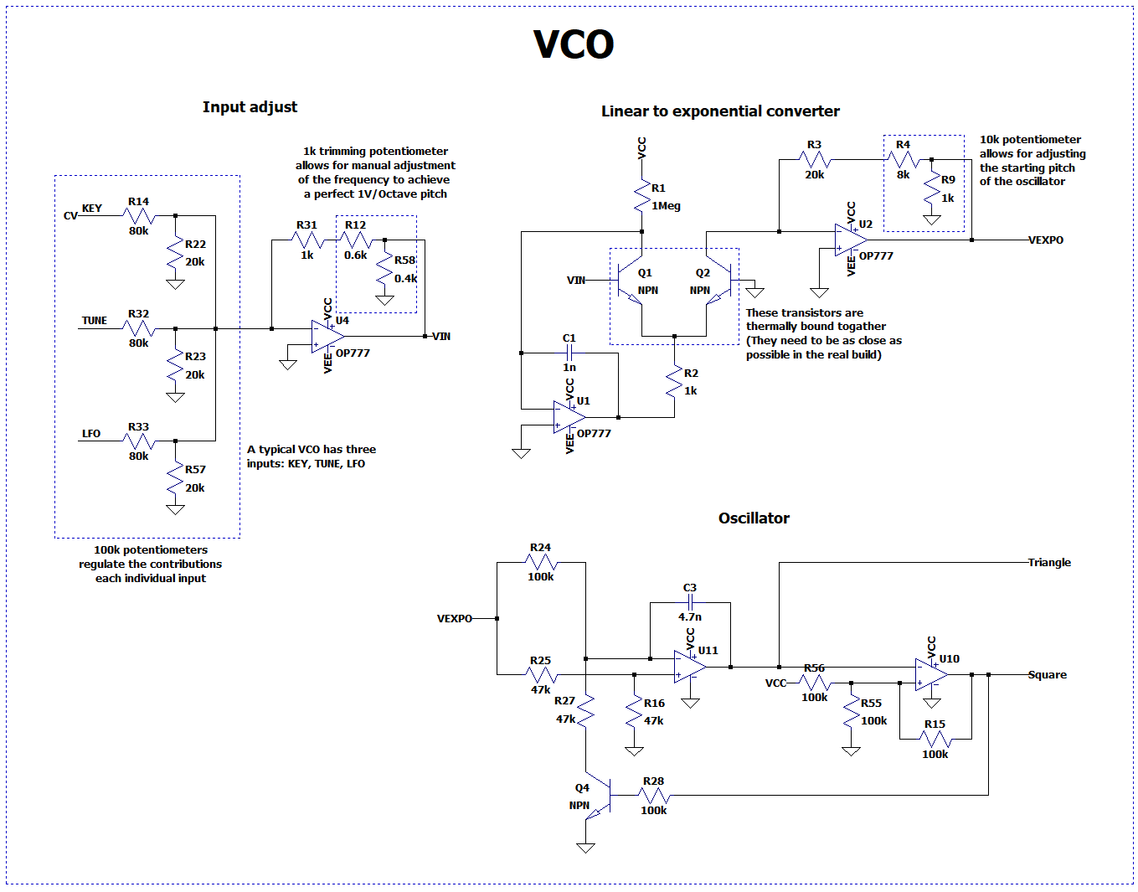
Figure 3: VCO. Schematic Design.

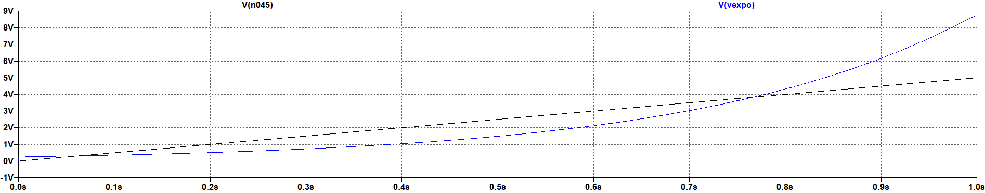

Figure 4: The linear input (black) of a VCO being transformed to exponential (blue) by the linear-to-exponential converter.

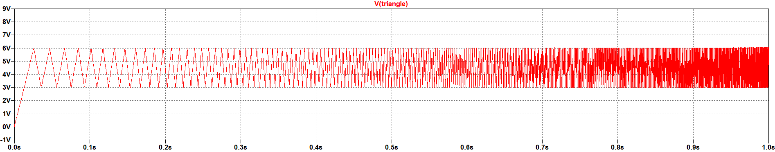

Figure 5: The triangle output of the VCO with linear input (same as in Figure 4).

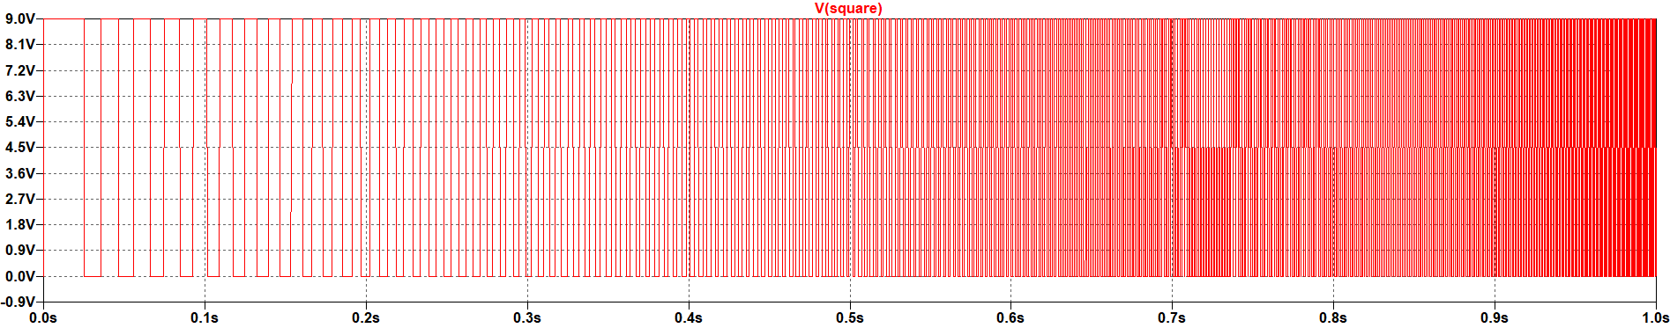

Figure 6: The square output of the VCO with linear input (same as in Figure 4).

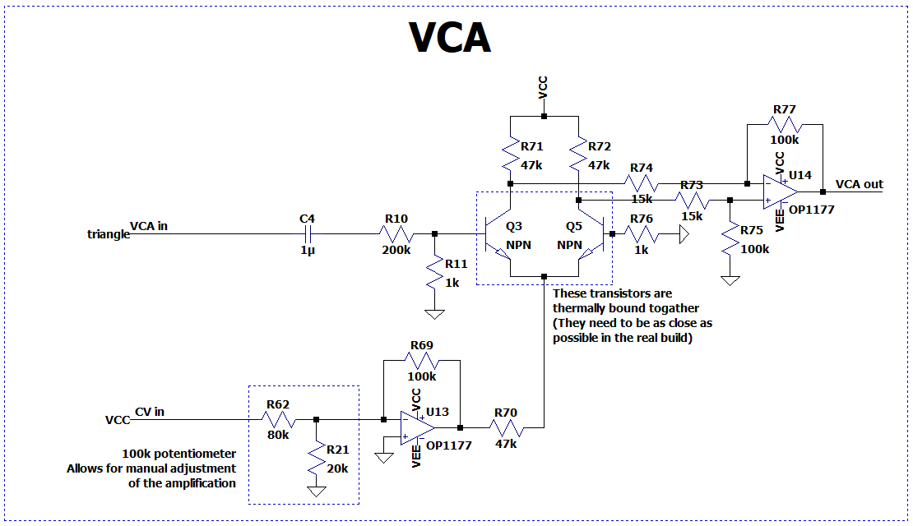

Figure 7: VCA. Schematic Design.
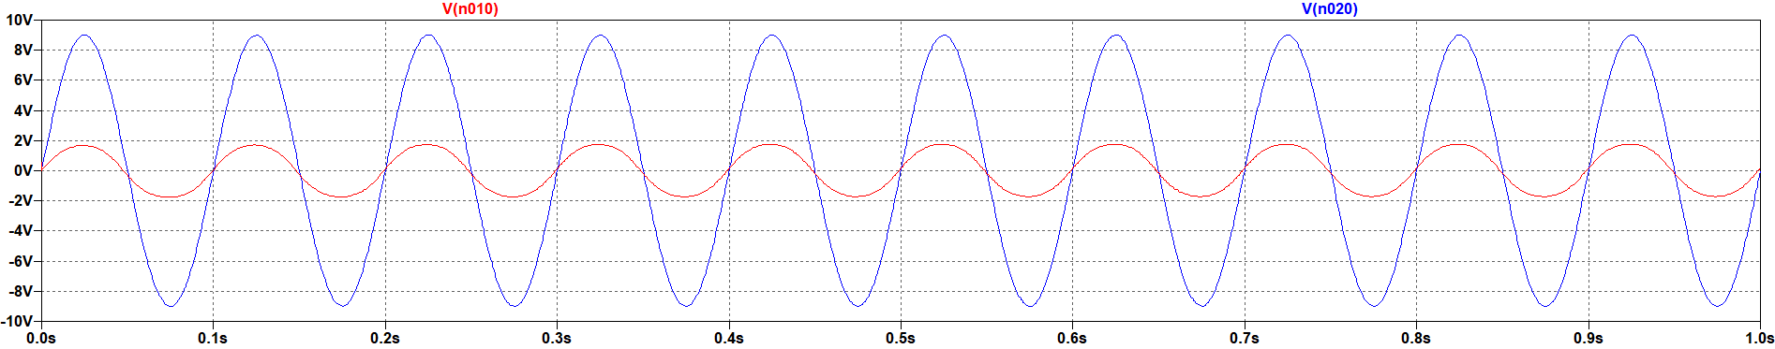

Figure 8: The attenuation of the input signal (blue) to the output signal (red) by the VCA via setting CV to 2V DC.

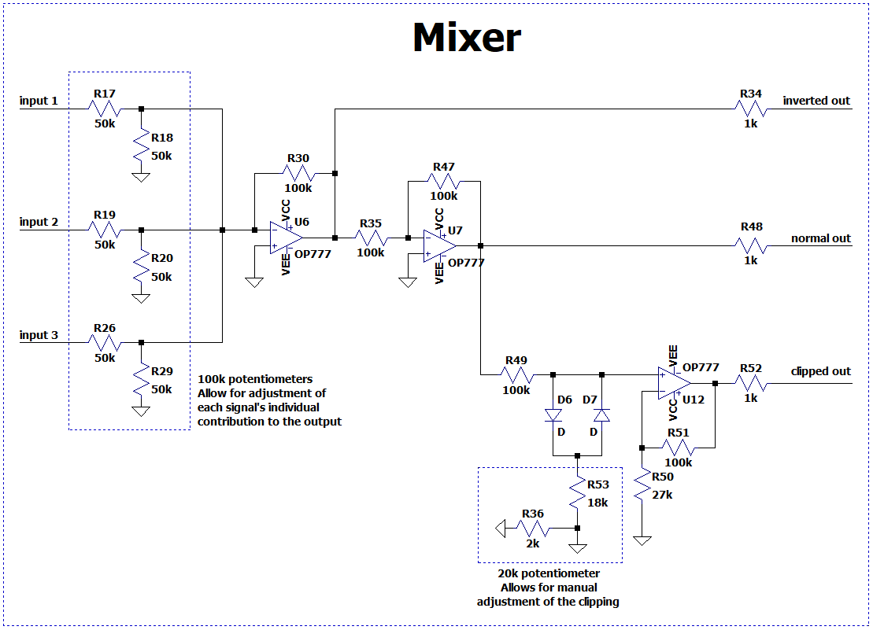
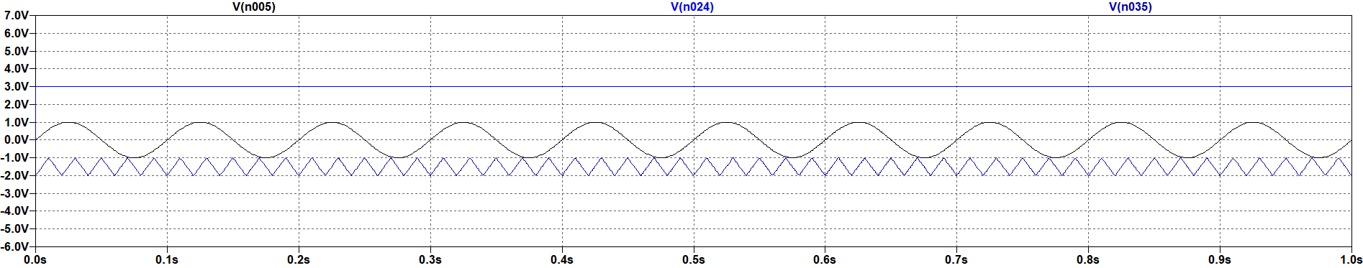
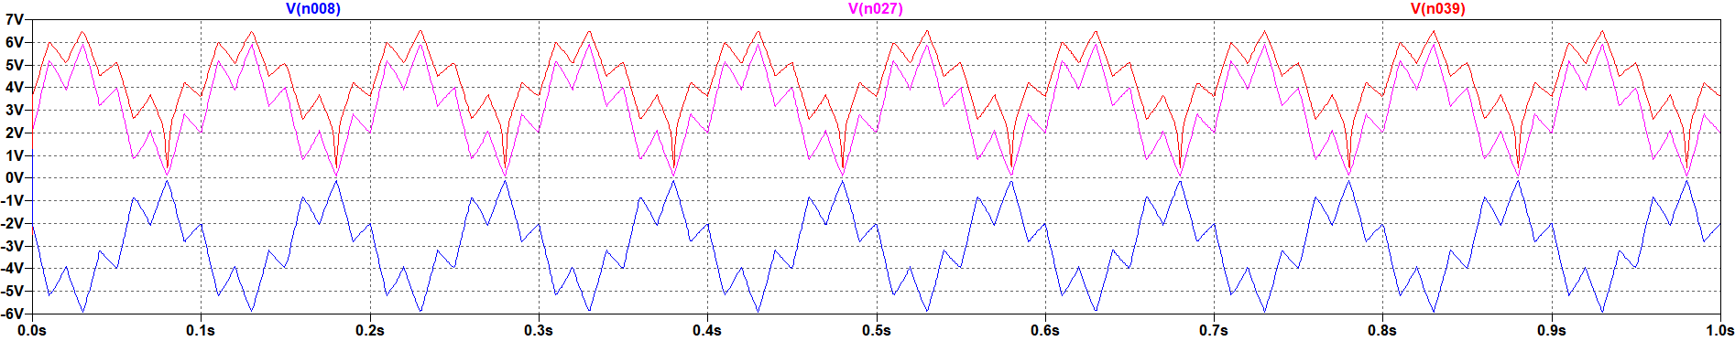
Figure 10: A possible combination of input signals for the mixer.
Figure 9: Mixer. Schematic Design.
Figure 11: The three output signals - inverted (blue), normal (red), clipped (pink) - of the Mixer for the input signals from Figure 10.

Texas Instruments, "NA555, NE555, SA555, SE555 Precision Timers," Datasheet SLFS022K, Mar. 2026. [Online]. Available: https://www.ti.com/lit/ds/slfs022k/slfs022k.pdf

