Table of Contents

Getting Started 1

Main Screen 3

User Tab 6

Participant Tab 7

Goals Tab 8

My Account 9

Note writing 10

Note Review Tab..........................................................................................................................................11

Time Review ..13

Print Tab……………………………………………………………………………………………………………………………………………………15

Getting Started

Logging in: Once the user has launched the Application, the user will be greeted with the login screen. This page has two text fields and two buttons. To login simply enter your username and password. Once both the username and password are entered just press the Login button. The password is case sensitive so be sure to check that caps lock is off. If the user makes a mistake or wish to restart, the user can press the Clear button in order to clear both fields.

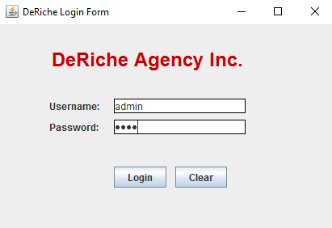

Possible Errors: In the case where the user inputs incorrect username or password, they will receive the following notification.

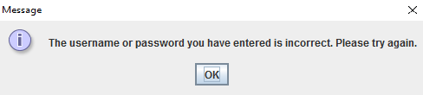

As mentioned before the password is **case sensitive**. The password must be an exact match to the one the Administrator created for the user. Usernames must also be **unique**. Meaning there cannot be two different users with the same username.

Main Screen

Upon successful Login the main screen will grace the user's eyes.

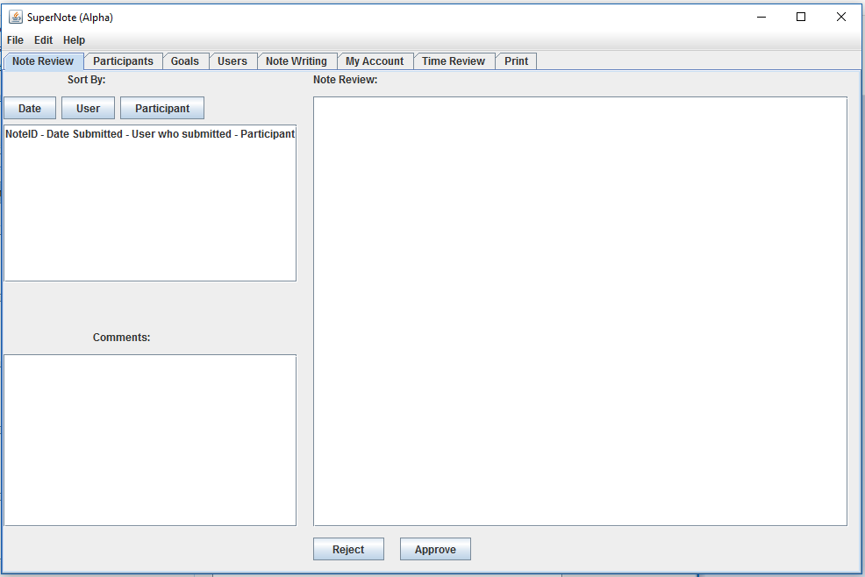

The Main screen or Admin Form has **eight** tabs. The number of tabs shown to a user depends on their user level:

**Admin** has access to everything

**Reviewer** has access to note writing, note review, time review, and my account.

**DCP** has access to note writing and my account

**Auditor** has access to note review, my account, and time review.

**Terminated** is for users that have been denied access by the Administrator.

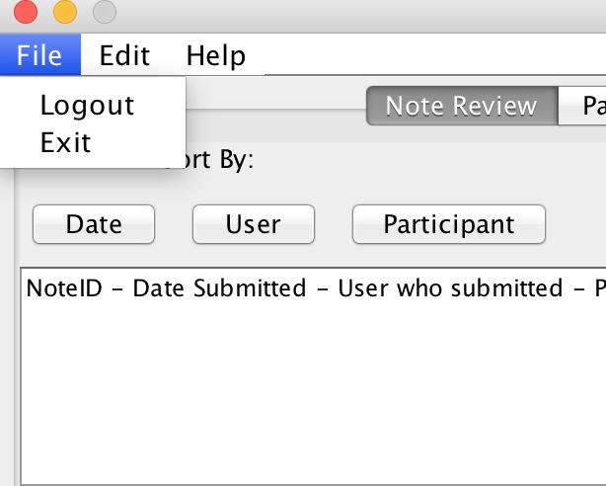

The File tab houses the ability to logout and exit the program. Logging out will take the user back to the Login screen. Exit will close the program and any unsaved data will be lost.

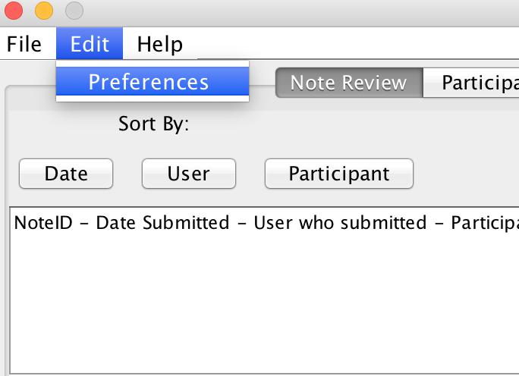

The Preferences tab is not yet functional.

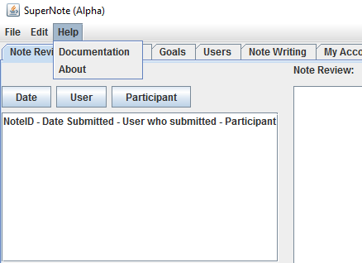

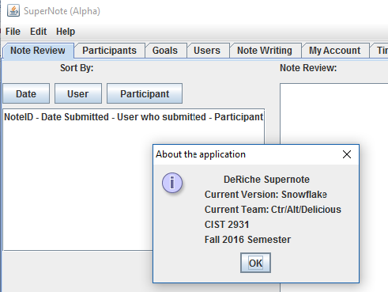

Clicking on documentation under **HELP** menu will fire up the user's guide and clicking on **ABOUT** will show the current version of the software.

User Tab:

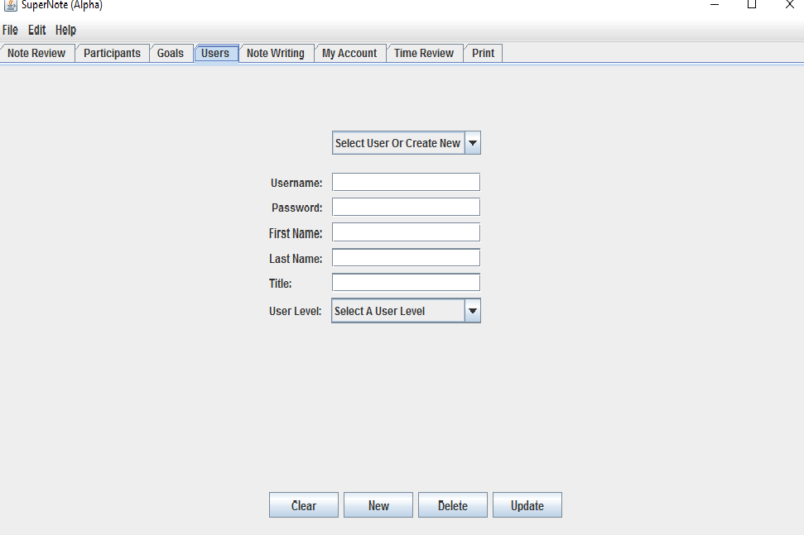

The user page has three main functions. The Administrator can add a user to the system, delete a user from the system under certain circumstances (more on that later), and updating a user’s information. Let’s go over these functions one at a time.

**Title**: The Administrator can assign specific title to each user.

**Clear**: The clear button clears data of all the fields so that new data can be entered.

**New:** Inserting a new user is just a few steps. Leave the Select User dropdown box alone for now. First fill inthe text fields with the information. Usernames must be unique since this is how the user will be identified while logging in. If the user attempts to add a duplicate user the program will prevent the user from doing so and tell the user to choose a unique name. Both the password and name fields will accept any input. The User Level drop down has all the privilege levels available to a user.

**Update:** To update a user simply select the user from the Select User dropdown at the top of the tab. Allthe fields on the page should populate with the selected user’s information. From here the user can change anything the user wish to update. When the user is satisfied with the input information, the user needs to click update and confirm.

**Delete:** The program records the user who writes each note. This is to help keep the writer of each noteaccountable for the quality of the note. Because of this the delete function only works on users who have not submitted a note or saved a draft. This is to preserve the integrity of each note stored in the system. If a user who has written notes needs to be removed for some reason, update their user level using the update function and select “Terminated”. The delete button is more for accidental insertions.

Participant Tab:

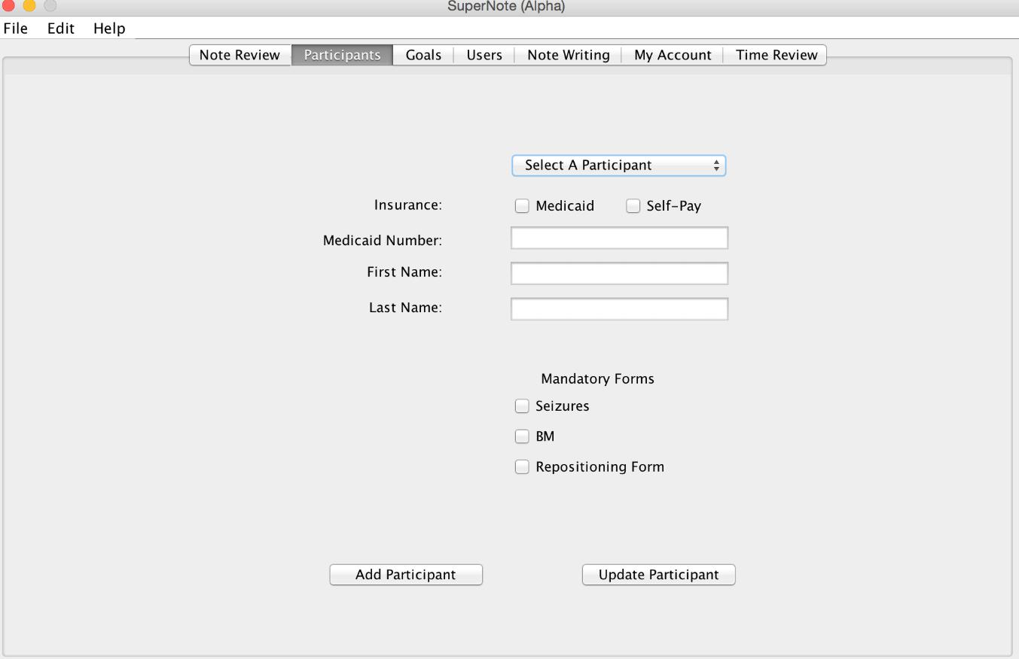

The Participant page allows the user to add and update a participant.

**Insert:** To add a participant, the user has to ignore the “Select A Participant dropdown” field. Select insurance forthe participant. If the user selected Self-Pay then the user can skip adding the Medicaid number. Once the user has filled out all the required fields for the participant the user can click add participant to insert them into the system.

**Update:** To update a participant, use the Select A Participant from the dropdown box at the top of thepage. Once selected the other fields should fill with the participant’s information. Change the participant’s information as desired before clicking the update participant.

Note: Mandatory forms have not been implemented yet and do not do anything.

Goals Tab:

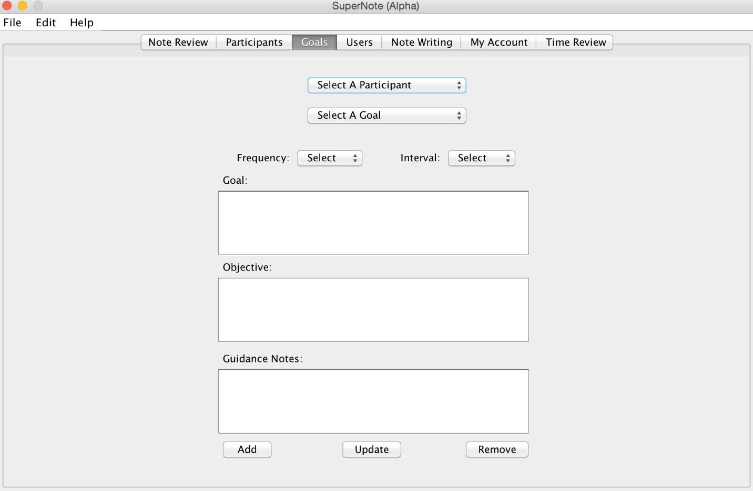

The Goal page allows the user to add and update goals for a specific Participant. The Remove button removes current goals for participant.

**Insert goal:** To insert a goal first, select a participant from the “Select A Participant” dropdown. If thatparticipant already has some goals in the system then the “Select A Goal dropdown” will have those in the list. Check the goals in that list if the user cannot remember if the user already added a certain goal. Once you’re sure the user needs to add a new goal select the first item in the “Select A Goal” list. This prevents user from creating new goal. Select a frequency, interval, and fill out the remaining fields before clicking “Add”.

**Frequency –** is the number of times a goal is completed within the time interval

**Interval** –Is the measure of time over which the goal must be done at a certain frequency

**Update goal:** To update a goal, select the participant from the participant dropdown. Next select a goalfrom the goal dropdown. If nothing shows up in the dropdown it means that the selected participant does not have any goals entered. When a goal is selected then all of the components will populate with the goal’s information. Change any information as desired before clicking update.

**Remove goal:** Lets the user to remove goal.

My Account:

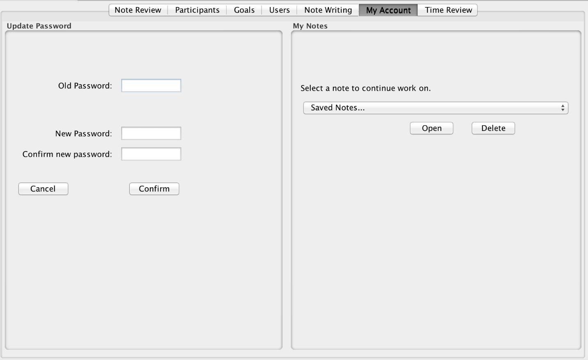

The account page allows the user to change password as well as select a draft to continue to work on.

**Update Password:** Changing password requires the user to enter the user's current password, enter newpassword and confirm new password. Remember, the password is case sensitive!

**Saved Notes:** This feature allows the user to select drafts that have been saved previously. The saved draft and rejected notes populate also lets the user select the desired. To continue working on the draft simply select it and click the “Open” button. Clicking the open button, the saved draft will open in note writing where the user can edit or add more notes and do the final submission. To find out why the note has been rejected, the user will have to click on the SUBMIT NOTE button and message box will pop up showing the reviewer's comment. Deleting a draft works the same way as opening one. Select a draft and click Delete. The user will be prompt with a message box to make sure they really want to delete the draft.

Note writing:

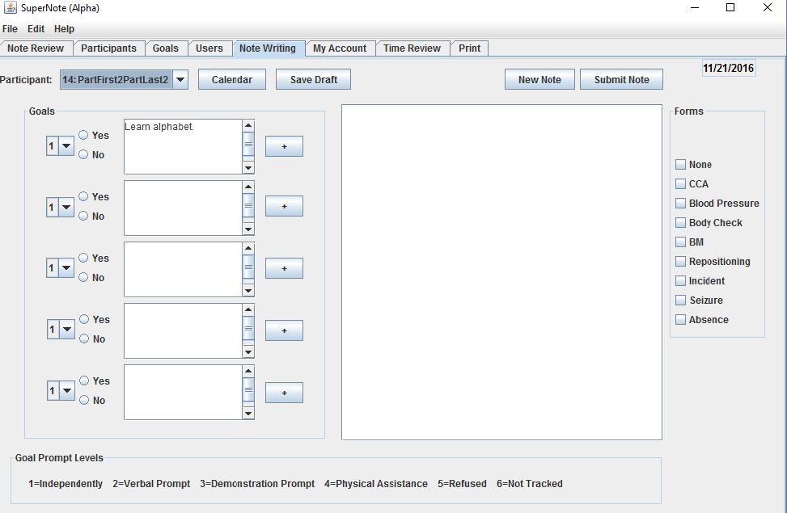

The Note Writing page allows the user to submit notes and save drafts that the user can continue working on later. To start, select a participant in the participant dropdown. Once selected, that participant’s goals will automatically populate into the small text fields on the page. If a participant has one goal then only the first text field will be filled. If the participant has two then only the first two will fill and so on. If the note writer needs to insert the text of the goal into the main note they can click on the arrow buttons to add the goals to the text area. The Note is of course written in the largest text field on the page.

**Submit Note:** Once the user is satisfied with the note, the user then clicks Submit Note button. This will open the commentpage. If required, user can enter comments for reviewer then click the submit button. At the same time, the user will have to click on the SUBMIT NOTE button to find out why a note has been rejected by the reviewer. This will make a message box pop up showing the reviewer's comment regarding the reason the note was rejected.

**Save Draft:** If for some reason the user needs to exit the program while writing a note leaving the note incomplete, the user can save the notewithout submitting it by clicking the Save Draft button. Simply confirm the action and the note will be saved. To later access the saved draft go to the My Account tab and select it from the My Notes section of the page. See My Account section in this guide for more.

**New Note:** If the user is done writing/editing note for one participant, he/she can start working on another participant simply clicking the NEW NOTE button. Then the user will have to select a participant and proceed to the note writing.

**Forms:** The user can select multiple forms for a participant. At the moment, the forms open outside of the program where the user can type the participant's name and work on the form and save the form file either on the computer or flash drive.

Note: The goal prompt levels and radio buttons on the left side of the page are not yet functional. The calendar is more of a concept of design for the following teams to complete. And the only form that is not functional is the Bowel Movement Form (BM). We currently do not have this one.

Note Review Tab:

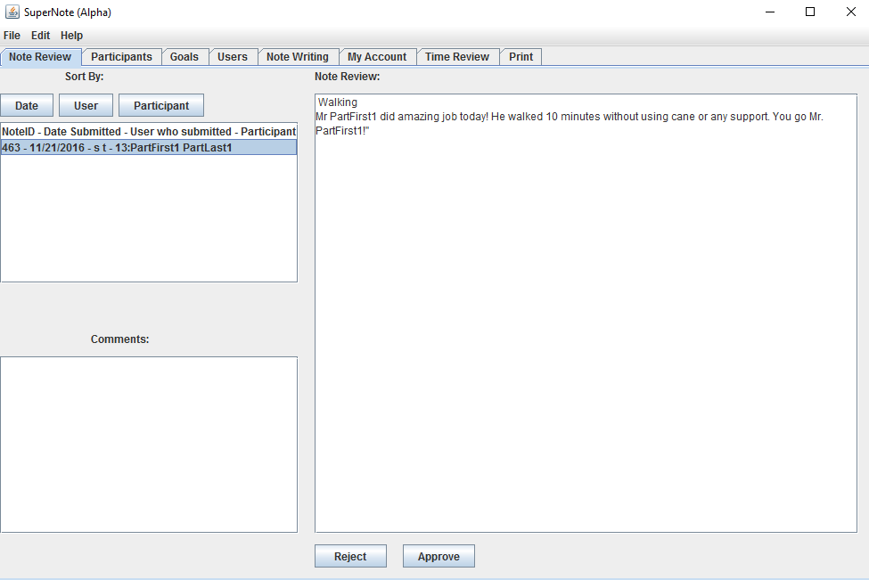

Once the note is completed, it accumulates in the note review in order for the reviewer to approve or reject the note that has been submitted. To view notes simply select it in the top left list area. Selecting an item in the list will pull the text from that note and place it in the large text area to the right. The note that pulls up in the text area is not editable (the reviewer cannot edit it).

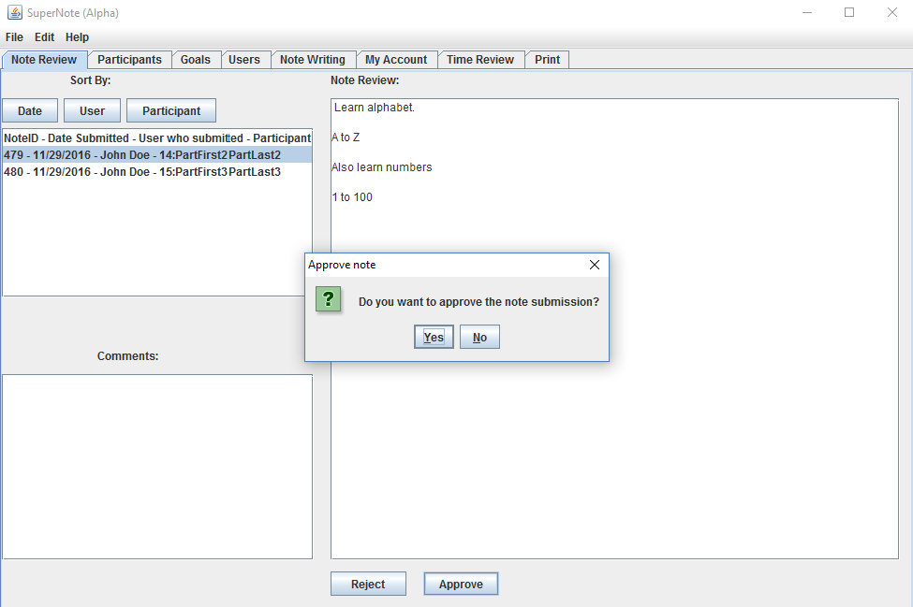

**Approve:** If the reviewer is happy with the note, he/she can click APPROVE button to approve the note. A dialog box pops up to re verify if the user really wants to approve the note.

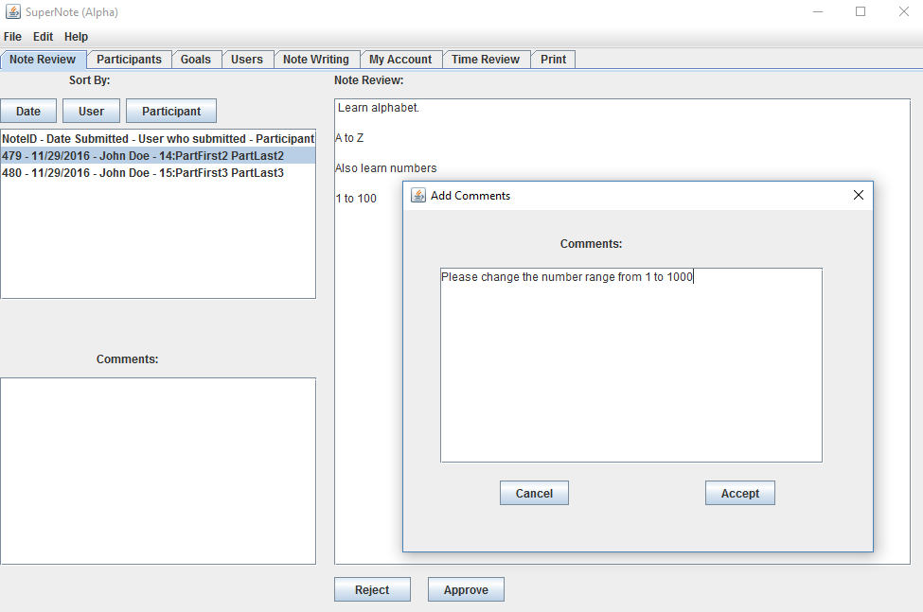

**Reject**: If the reviewer finds mistakes in the submitted note, he/she can reject the note by clicking Reject button. Clicking the button makes a comment box to pop up where the reviewer can add comment for the DCP describing the reasons why the note was rejected, etc.

Note: The sort by function does not work yet. The Comments List is not yet implemented.

Time Review:

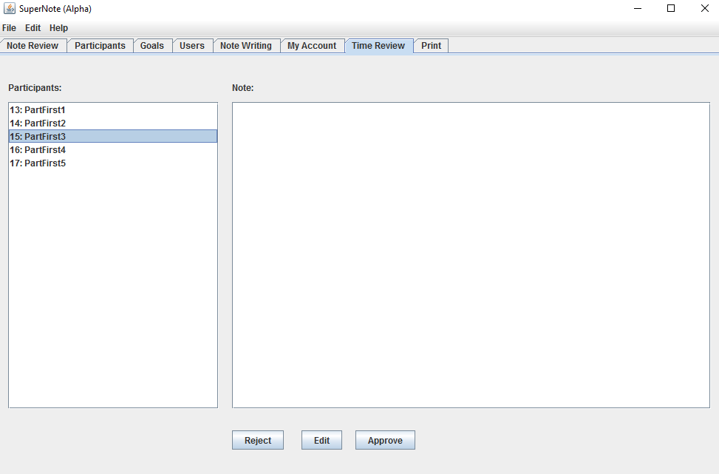

Time Review has not been implemented as of yet. No function should work on this page. It will work in much the same was as Note Review when finished.

Print:

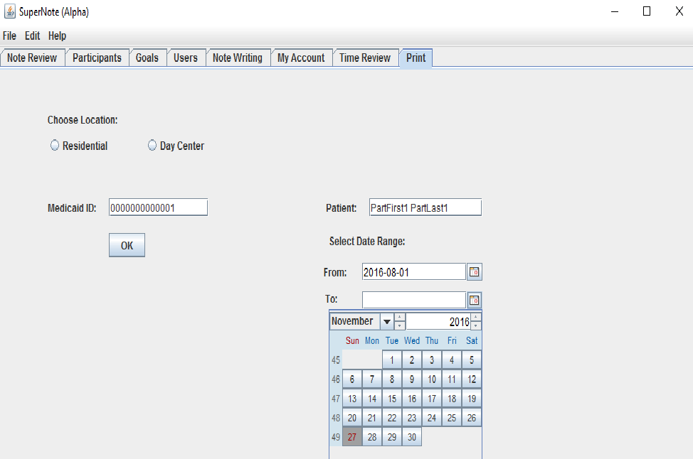

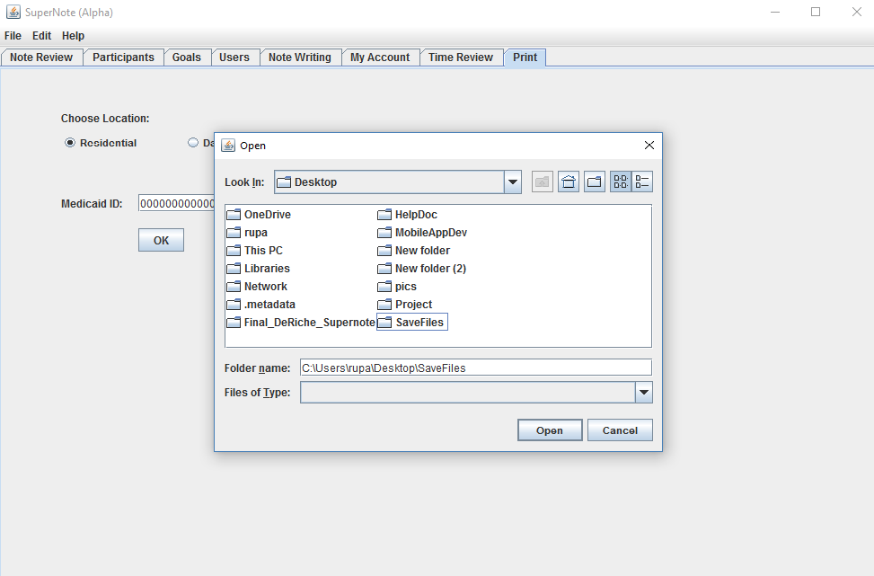

The print tab allows user to print or save notes from and to specific date range for participants. User will have to select the location whether it is "Residential" or "Day Center" then type a valid Medicaid ID. When clicked ok button, the name shows up in the text field to verify the right participant. The user then can select the date range. If the user accidentally clicks OK button without typing Medicaid ID, a message box pops up asking the user to type a valid Medicaid ID. At the moment, both the PRINT button is saved to **default** and SAVE button saves desired notes to desired location as laptop, flash drive, DVD, etc. The saved note can be accessed later for printing.