Sound Card Neo GS.
Revision C
NedoPC group. 2010
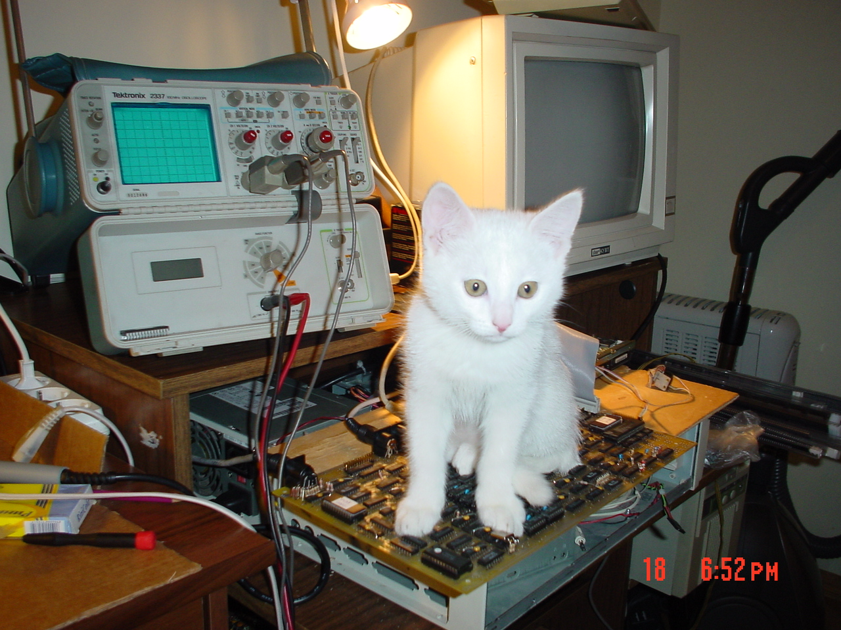
Table of Contents
Description. 2
Install 2
Use 3
Check the NeoGS 3
Tune 3
Software 3
Documentation 3
Service 4
Project status 4
About 4

(version 3. Feb. 2012)
www.nedopc.com

Description.
Sound card designed for playing MOD and MP3 music files. Sound card not use computer resources via playing.
Sound card designed for using in spectrum compatible computer with ZXBUS slot.
Sound card compatible with General Sound and support programs for General Sound.
Features:
- 4Mb RAM and 512Kb ROM;
- SD card reader;
- Additional turbo-mode for processor (20МГц);
- MP3-decode chip MA8201A-U(compatible with vs1011);
- 8-sound channels by hardware;
- Easy firmware upgrade.

Install
pin 1
Sound card designed for installing to ZXBUS board. First pin placed on left side of board (on top side with parts of board, see picture). Sound cards board has key (near first pin, see picture) for easy installing to slot.
Warning! Power off before install or remove sound card to/from main-board.
Warning! Not use extremely force via installing board. It may to destroy connector of sound card or slot of main-board.
Warning! Please install sound card to slot on right direction. If install NeoGS on incorrect direction then NeoGS or main-board may be malfunction.
Warning! Installed sound card must not contacted with other cards or case sides. If NeoGS contacted to other card then please isolate NeoGS.
Warning! Please sure then contacts of NeoGS not shifted to main-boards slot contacts.
Warning! Power off before connect speakers or amplifier to sound card.

Use

Check the NeoGS
You can to check the NeoGS via Basic program:
10 OUT 187,244
20 PAUSE 100
30 PRINT IN 179
Must displayed value 126.

Tune
NeoGS board has jumper J1 (placed on top side of board, in right-down, down to processor). Jumper regulate NeoGS reaction to “reset” signal from main-board:
- J1 short — NeoGS reset if signal come from main-board;
- J1 open — NeoGS not react if signal come from main-board.

Software
NeoGS started to compatible with General Sound mode. Can to use any software for General Sound in this mode.
Software, whose work in other modes of NeoGS (for example MP3 player), set NeoGS to non-compatible with General Sound state. Recommended to reset NeoGS after using this software via NeoGS-reset button (placed on top side of board, in right-up, see picture) or via software reset.
New firmware available from site www.nedopc.com .

Documentation
Hardware sources and programming manual available from site www.nedopc.com .

Service
Sound card NeoGS shipped ready to use.
All sound cards tested on ZX-Evolution computer.
Supplier decline all responsibility in any cases.

Project status
Project is open source.
Please coordinate NeoGS production questions with authors.

About
Authors: Vadim Akimov (LVD), Roman Chunin (CHRV), Vyacheslav Savenkov (Savelij), Aleks Ghabin (KOE), Vasily Klimov (JTN).
Site: http://www.nedopc.com
NeoGS page: http://www.nedopc.com/gs/ngs.php
Catalog: http://www.nedopc.com/catalog.php

Thanks to:
Evgeny Muchkin — for information about General Sound and for coordinating author rules.

