ZX Evolution

Update Flash-ROM

from «Test&Service» configuration.

(version 21.03.2013)
www.nedopc.com
Requirement:
- SD-card, formatted FAT12, FAT16 or FAT32.
- PS/2 keyboard
- Configuration «Test&Service» file (file ZXEVO_FW.BIN)
- Flash-ROM image (file ZXEVO.ROM)
- Base configuration file (file ZXEVO_FW.BIN)
Note: any configuration files (Base configuration or «Test&Service») has same names.

All needed files located here: http://www.nedopc.com/zxevo/zxevo_eng.php

1. «Test&Service» configuration and ROM-image copy to root directory of SD-card .
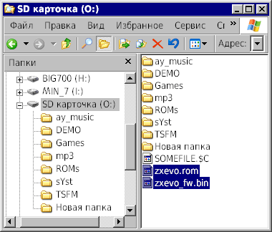
2. Set SD-card to ZX Evolution.
3. Activate bootloader: While SoftReset pins [J6] (on ZXEvolution board) shorted, short and open HardReset pins [J9]. Or while SoftReset pins [J6] shorted, switch on power to ZXEvolution.
Configuration load approximately 10 seconds. Beeper not sound on success.
Test&Service work in TV mode by default. Press ScrollLock for switching to VGA mode.
4. Set last item «Update Flash-ROM» in main menu.
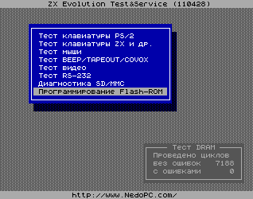

5. Set to «Select image» in menu panel.
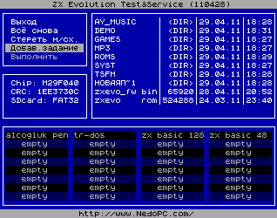

6. Select file ZXEVO.ROM in file panel.
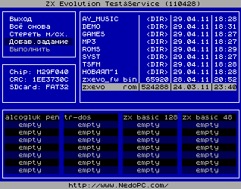

7. Press <Enter> two times.
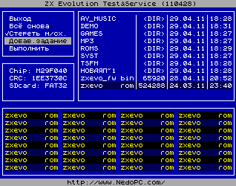

8. Select «Start» in menu panel and press <Y> on keyboard for confirmation.
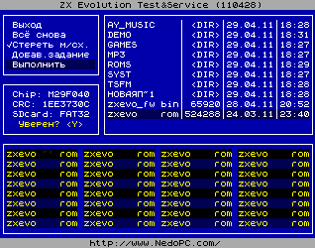

9. First stage – Erase content of Flash-ROM chip...
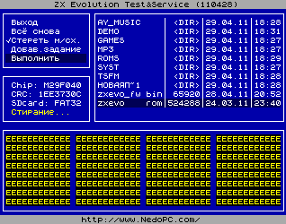

...Second stage – write data from selected image...
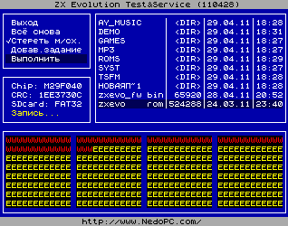

...End stage – verify data...
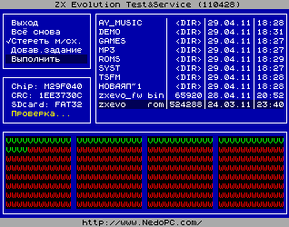

...if all OK then green message viewed.
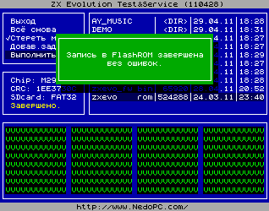

10. Press <Enter>. Calculate and inform about pages of Flash-ROM.
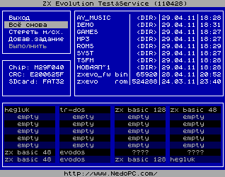
Some pages mark by «????». Cause TEST&SERVICE not identify this pages (cause this pages content some new parts of ROM).
Restore Base configuration.
11. Remove SD-card from ZXEvo, and delete TEST&SERVICE configuration file (zxevo_fw.bin). Copy Base configuration file (zxevo_fw.bin) to root directory of SD-card.
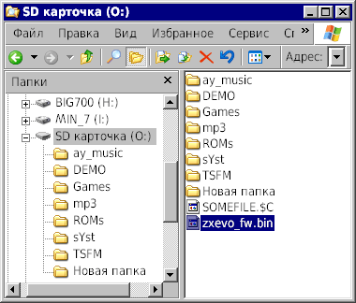
12. Set SD-card to ZX Evolution.
13. Activate bootloader: While SoftReset pins [J6] shorted, short and open HardReset pins [J9]. Or while SoftReset pins [J6] shorted, switch on power to ZXEvolution.
Configuration load approximately 10 seconds. Beeper not sound on success.
14. You get new configuration and ROM on your ZX Evolution. Congratulation!

