ZX Evolution.
(version 11/13/2010)
www.nedopc.com
Firmware update
manual

Table of contents
1 Description 2
2 Update from SD memory card 2
3 Update via null-modem cable from other computer 3
4 Example: Update configuration via null-modem cable from HyperTerminal program 4

Description
Boot loader can update peripheral microcontrollers (ATMEGA128) flash memory.
Peripheral microcontrollers flash memory content FPGA configuration and program for controller (base configuration of ZX Evolution).
User can update base configuration (firmware) manually.
Official configuration locate in NedoPC site (www.nedopc.com). But user can to use alternate configuration from other developers.
Boot loader can update configuration (firmware) with two different way:
- from SD memory card;
- via null-modem cable from other computer.

Update from SD memory card
- File with configuration (ZXEVO_FW.BIN) write to root directory of SD memory card. Memory card must be formatted FAT12, FAT16 or FAT32. Insert SD memory card to SD holder on ZX Evolution.
- Hold pressed soft reset button (hold shorted soft reset contacts on board) and switch on power to ZX Evolution or press on few time hard reset button (short on few time hard reset contacts).
Configuration will update in some seconds.
Updating process is not indicated on display. Errors is signaled by PWR LED (VD6) and beeper. Number of beeps according to next errors:
- 1 – SD memory card not detected;
- 2 – error on reading sector on SD memory card;
- 3 – supported file system not found on SD memory card;
- 4 – file with configuration not found on SD memory card;
- 5 – file with configuration is bad.

Update via null-modem cable from other computer
- RS232 connector of ZX Evolution connect via null-modem cable to other computer. Run terminal program on other computer (speed 115200, without parity checking, 8 bit, 2 stop-bit, without CTS).
- Hold pressed soft reset button (hold shorted soft reset contacts on board) and switch on power to ZX Evolution or press on few time hard reset button (short on few time hard reset contacts).
- After receiving message «Try update from RS-232...» send file with configuration (ZXEVO_FW.BIN) via X-Modem-CRC protocol.
Can used simple null-modem cable (only three wires):
X1, X2 – D-Sub9F | 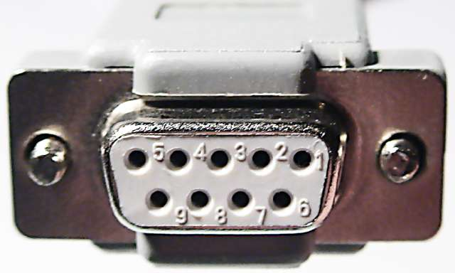

Example: Update configuration via null-modem cable from HyperTerminal program
RS232 connector of ZX Evolution connect via null-modem cable to PC computer.
- Start HyperTerminal program on PC.
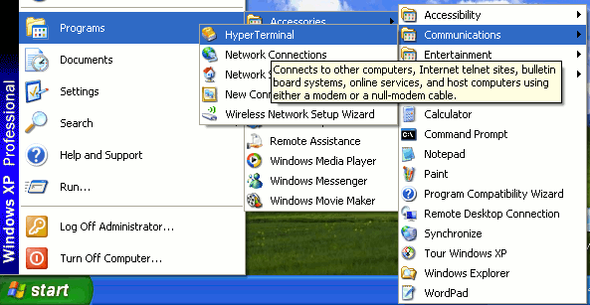
If HyperTerminal started first time than it view next dialogs.
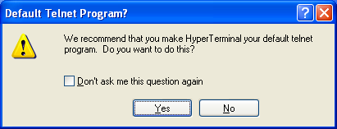
Set checkbox and press “Yes”.
Set area code (if area code not set and terminal start than dialog views again).
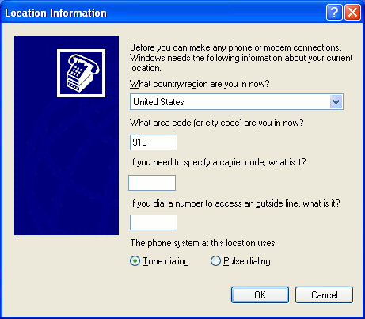
- Set the name for connection. Connection settings will saved by this name.
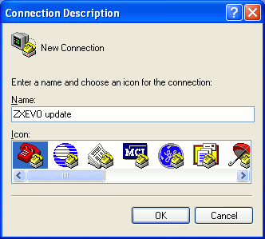
- Select port.
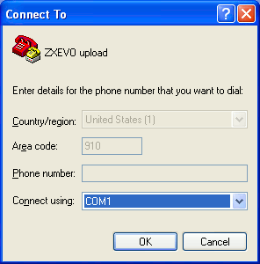
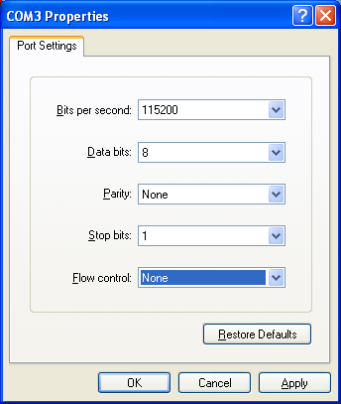
- Set port settings as in picture.
- Hold pressed soft reset button (hold shorted soft reset contacts on board) and switch on power to ZX Evolution or press on few time hard reset button (short on few time hard reset contacts).
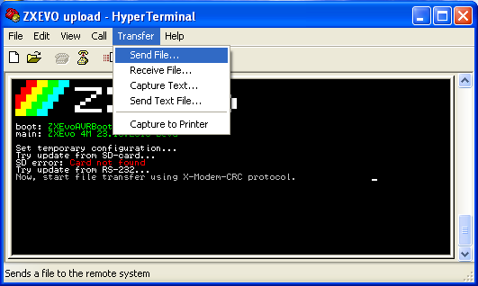
- Select file with configuration (ZXEVO_FW.BIN), set protocol «X-Modem» and press button “Send”.
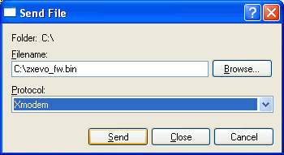
Warning: If not send file during one minute than ZX Evolution exit from update mode and start current configuration.

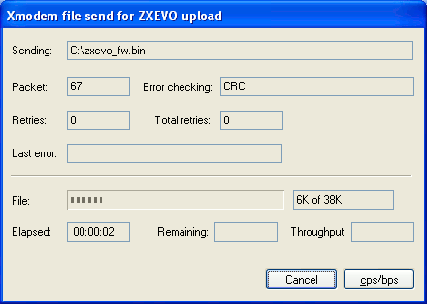
Transfer take some seconds.

If configuration updated successfully than string with it name and version is shown. Computer start up with new configuration.
