System Description
Audio Analyzer

Created: 01/20/21 by Tom Lever
Updated: 01/20/21 by Tom Lever

Existing Resources

In 2010, Chris Cannam et al. published “Sonic Visualiser: An Open Source Application for Viewing, Analysing, and Annotating Music Audio Files”. Figure 1 shows a screenshot of a waveform layer and a peak-frequency spectrogram layer in Sonic Visualiser for a recording of “Hey Ho, to the Greenwood”. The peak-frequency spectrogram includes a piano keyboard on the left, a default set of frequency bins (which each extend for more than one piano key), a central time marker, and data traces indicating peak Fourier powers (in dB) for each frequency bin over time. An end-user of Sonic Visualiser may move their cursor over traces in the peak-frequency layer to reveal a textbox listing time, peak frequency, bin frequency, peak pitch, bin pitch, Fourier power, and Fourier Phase. The end-user may add annotations to the waveform at specific times by pressing their semicolon button during playback, and manually enter chords or other text.

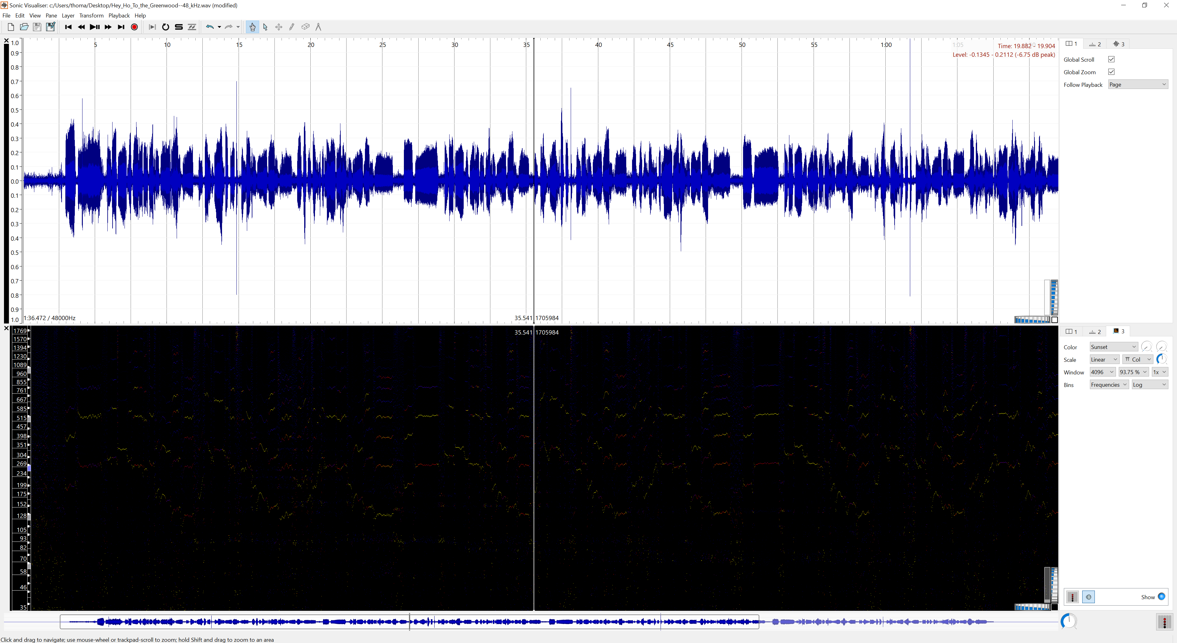

Figure 1: Screenshot of Waveform and Peak-Frequency Spectrogram Layers in Sonic Visualiser

Intentions for Audio Analyzer

Our intentions are:
- To develop an Audio Analyzer that will cache results of analysis of an audio file and during playback of that audio file will output a rest or the most powerful twelve-tone-equal-temperament pitch at the present time, as well as its total duration.

Questions:
- Where is the balance between optimizing for frequency resolution by including more data in each time-series window, and optimizing for fine resolution in time?
- Do we zero-pad time-series windows to increase the number of bins in the frequency domain and the precision of the power spectrum, or to match bins to piano keys?
- What happens if, at one point in time, power A is just a little greater than power B, and at the very next point in time, power B is just a little greater than power A?

- To extend the Audio Analyzer to outputting a rest or up to three relatively powerful twelve-tone-equal-temperament pitches at each point in time, and their durations.

Questions:
- What happens if the most powerful pitch is significantly more powerful than the second and third most powerful pitches?
- Does what happen change based on whether the pitches are from the same instrument, whether the pitches comes from two different instruments with different capacities for volume, or whether one instrument is closer to the recording device than the other?
- What if the second and third most powerful pitches are (inter)harmonics that are strongly linked to the most powerful pitch?

- To extend the Audio Analyzer to finding a rest or all twelve-tone-equal-temperament pitches at each point in time, and their durations.

- To extend the Audio Analyzer to finding a rest or all pitches at each point in time (including, for example, melismatic pitches).

- To extend the Audio Analyzer to identifying the instruments (including voices) associated with each pitch.

References

- Cannam, Chris et al. (June 10, 2010). “Sonic Visualizer: An Open Source Application for Viewing, Analysing, and Annotating Music Audio Files”. Proceedings of the ACM Multimedia 2010 International Conference. Association for Computing Machinery. https://www.sonicvisualiser.org/sv2010.pdf.

