**Pages of JHA Keeper**

Created: 01/07/21 by Tom Lever

Updated: 01/07/21 by Tom Lever

**Welcome Page**



**Login Page**

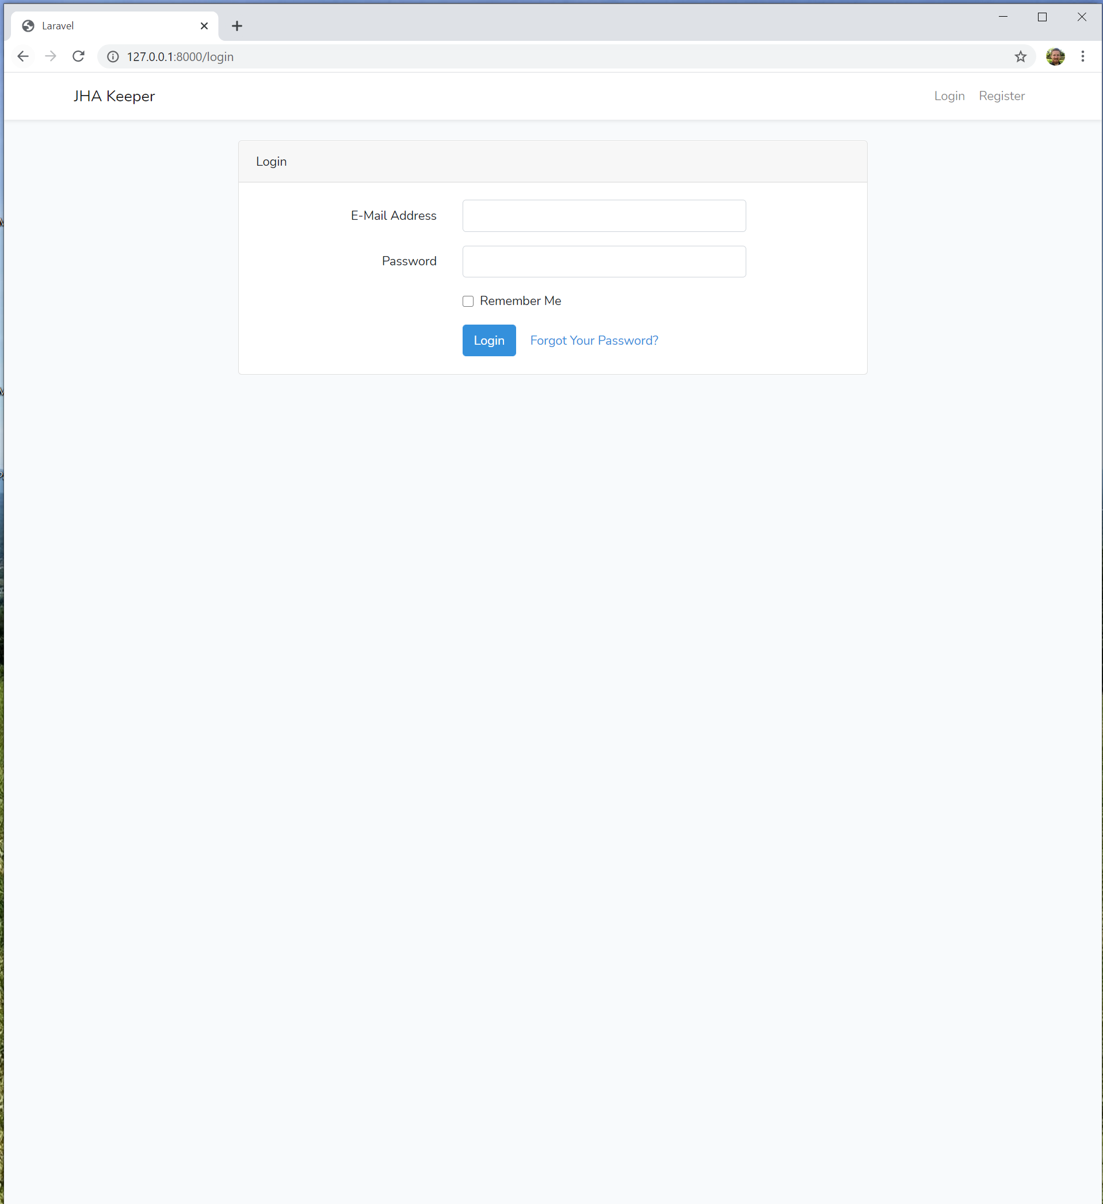

**Listing of JHA’s by Activity**

Goal 1: Fix values in jha_id column to match the first id in database table jhas corresponding to the relevant activity.

Note: Activity names A1 and A2 are hyperlinks to “/jha/{activity_name}”. Each page corresponding to each activity name contains an activity-specific JHA table with activity name, job steps, hazards, and controls. See below for a screenshot of the JHA table for activity A1.

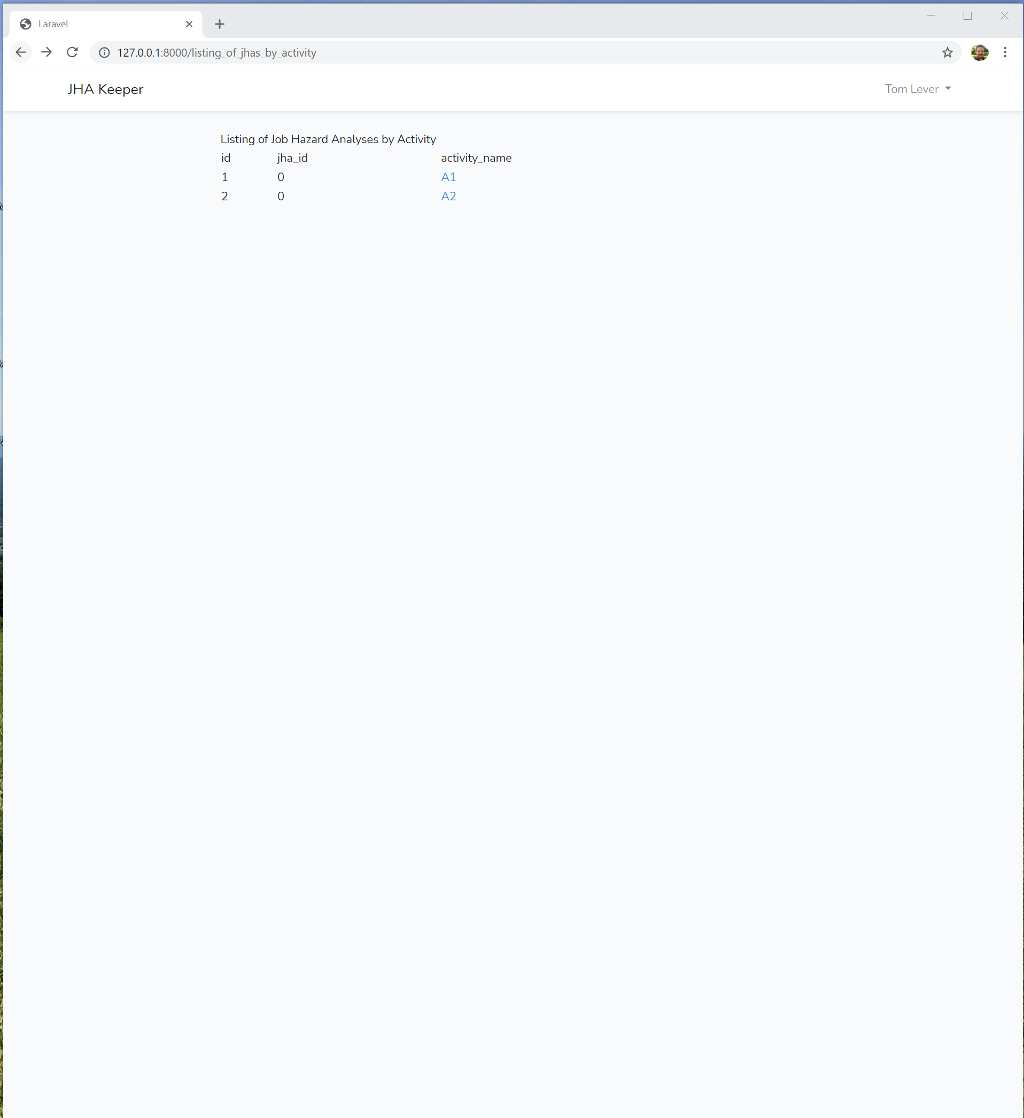

**Activity-Specific JHA Table: Activity A1**

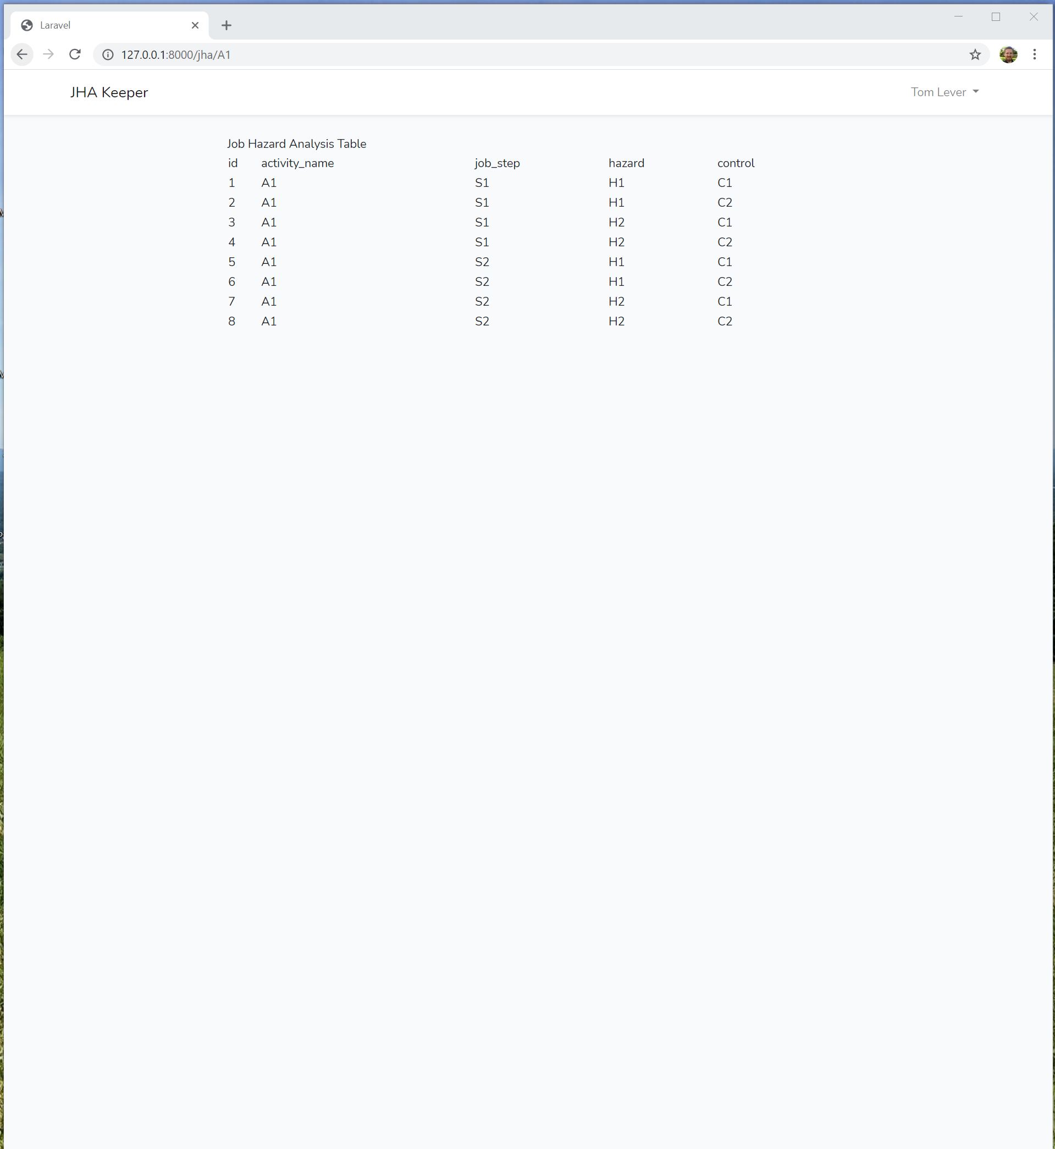

**JHA Form,**

**Multi-Activity JHA Table outputted by PHP, and**

**JSON Array outputted by JavaScript representing Multi-Activity JHA Table**

Goal 1: Eliminate multi-activity JHA table outputted by PHP. Have JavaScript output all rows in multi-activity JHA table where the activity_name of that row is the same as the text in the form textbox with name activity_name.

