**Design Of Additional Building**

Created on 08/07/2024 by Tom Lever

Updated on 09/09/2024 by Tom Lever

The below figure illustrates the area of an additional building and describes offsets from the house and required and actual setbacks.

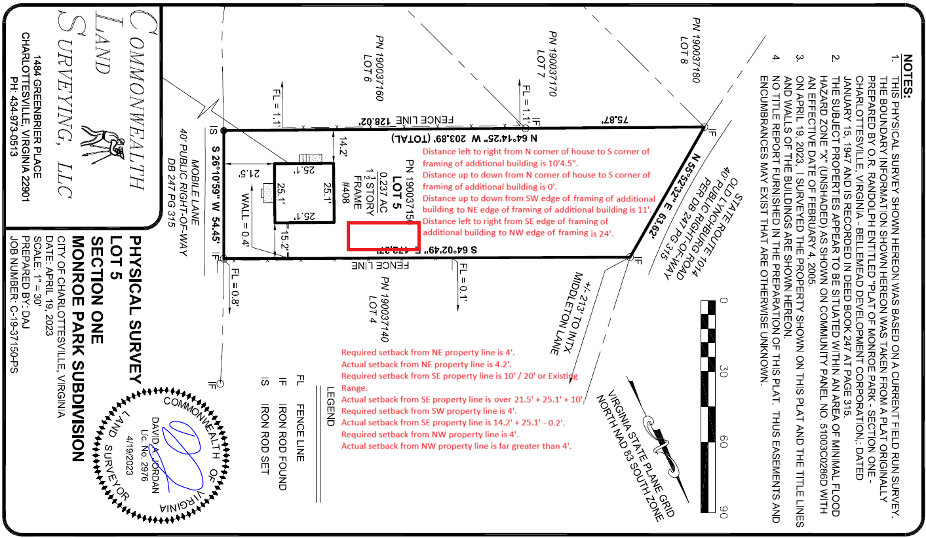

Per “City of Charlottesville Minimum Mandatory Inspections”, all organic soil, vegetation, and roots will be removed from holes for piers. Finished grade will allow for tops of piers to be 6 inches above finished grade and top of subfloor to be even with top of house’s slab. On top of piers there will be ice and water shield or polymer tape with a thickness of 1/16”, saddle brackets with a thickness of 1/8”, pressure treated beams with a thickness of 5.5”, ice and water shield or polymer tape protecting saddle brackets and subfloor from pressure treated beams with a thickness of 1/8”, and subfloor with a thickness of 23/32”, for a total thickness of 6-17/32”.

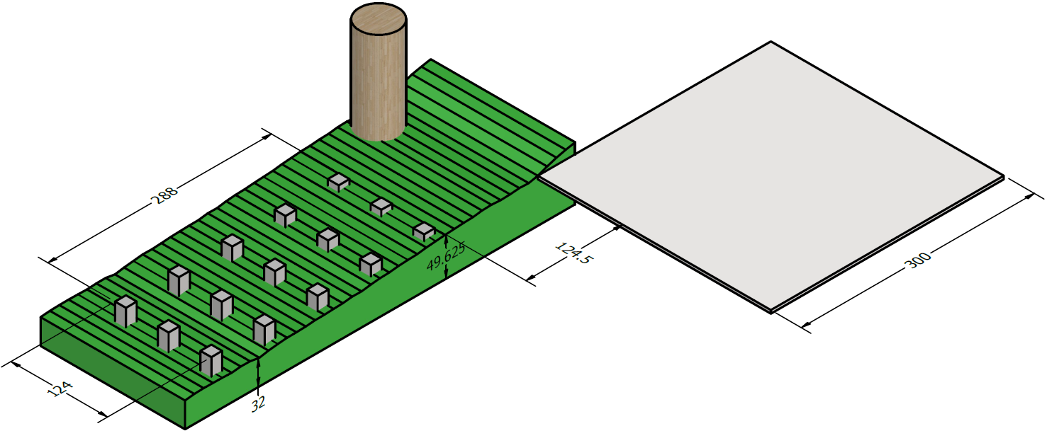

Per Commonwealth Land Surveying on 04/19/2023, The shortest distance between the N edge of the house and the property line is 15.2’ = 15’2-3.2/8”.

Per Chuck Miller representing the City of Charlottesville on 08/01/2024, the minimum setback from the NE property line is 4’.

The maximum depth of the additional building is 11.2’ = 11’2-3.2/8”.

The shortest distance between the N edge of the house and where the backyard really starts to descend is about 38’.

The minimum distance between flammable materials on two buildings is 5’.

A maple tree may be approximated as a cylinder with a diameter of 50”.

The central axis of the maple tree is about 44” from the N edge of the house going SE to NW.

A good distance between the N edge of the house and the surface of a pier considering the maple tree is 10’, plus 4.5” considering a potential future addition to the house.

The maximum length of an additional building is 27’7.5”.

Per Mr. Miller on 08/01/2024, the maximum area of an additional building in Charlottesville that does not require a permit is 256 square feet.

Per Mr. Miller on 08/01/2024, an additional building may have an area that is any proportion of the area of the house.

An additional building that has an area of 256 square feet and a depth of 11’ has a length of 23’3”.

I intend for the additional building to have a depth of 11’ and a length of 24’.

A permit is required.

Per “Table R401.4.1: Presumptive Load-Bearing Values Of Foundation Materials” (<https://codes.iccsafe.org/s/VRC2018P1/chapter-4-foundations/VRC2018P1-Ch04-SecR401.4>), clay has a load-bearing pressure of 1,500 pounds per square foot.

Per “Section R502.3.2: Other floor joists” (<https://codes.iccsafe.org/content/IRC2021P2/chapter-5-floors>), “Table R502.3.1(2) shall be used to determine the maximum allowable span of floor joists that support… areas of the building… other than sleeping areas and attics, provided that the design live load does not exceed 40 pounds per square foot (1.92 kPa) and the design dead load does not exceed 20 pounds per square foot (0.96 kPa).” This implies that the design live load is 40 pounds per square foot and the design dead load is 20 pounds per square foot.

Mr. Miller suggested on 09/06/2024 that I could use a design dead load of 10 pounds per square foot.

I will use a design dead load of 10 pounds per square foot.

Per “City of Charlottesville Climatic and Geographic Design Criteria” (<https://www.charlottesville.gov/DocumentCenter/View/391/City-of-Charlottesville-Climatic-and-Geographic-Design-Criteria-PDF>), ground snow load is 30 pounds per square foot. Frost depth is 18 inches.

For a shed 11’ wide and 24’ long, total load is (11 ft)(24 ft)(10 PSF + 40 PSF + 30 PSF) = 21,120 lb. The required soil area to support the total load is (21,120 lb) / (1,500 PSF) = 14.08 square feet.

The area of a square cross section of a pier width a length of a side of 14 inches is 1.167 square feet.

For a shed 11’ feet wide and 24’ feet long, the number of piers required is ceiling(14.08 square feet / 1.167 square feet) = 13.

We will pour 15 square piers in a 3 x 5 grid.

Per “R404.1.6, Height above finished grade”, “Concrete and masonry foundation walls shall extend above the finished grade adjacent to the foundation at all points not less than 4 inches (102 mm) where masonry veneer is used and not less than 6 inches (152 mm) elsewhere.

Per Mr. Miller on 09/06/2024, if lumber that is pressure treated is used as a floor system, the minimum height between finished grade and the floor system is 6”. If lumber that is not pressure treated is used as a floor system, the minimum height between finished grade and the floor system is 18”.

The tops of the piers will be at least 6” above finished grade.

Per “City of Charlottesville Minimum Mandatory Inspections”, the “minimum footing depth [below finished grade] is 18” deep”. This depth is regardless of height above finished grade. This depth is equal to frost depth.

I believe that Mr. Miller on 09/01/2024 suggested the minimum footing depth below finished grade is 24”.

I will use 18”.

The bottoms of the piers will be at least 18” below finished grade, plus an additional 14” to allow for future excavation.

Piers should have a length of at least 6” + 18” + 14” = 38”. 6” corresponds to minimum height above finished grade. 18” corresponds to minimum depth below finished grade and frost depth. 14” corresponds to the maximum height the house slab and underlying soil that can be excavated.

The piers will be within a 24’ x 10’4” area that is offset from the NW foundation wall of the house by 124.5” and from the NE foundation wall of the house by 8”. The shortest distance between the front of the front pier and the front of the second to front pier is (124” - 14”) / (3 - 1) = 55”. The shortest distance between the right of the right pier and the right of the second to right pier is (288” - 14”) / (5 - 1) = 68.5”.

Mr. Miller on 09/06/2024 encouraged me to determine the side length or diameter of a pier following “Typical Deck Details” at <https://www.charlottesville.gov/DocumentCenter/View/9152/Typical-Deck-Details-PDF> . I created the below grid.

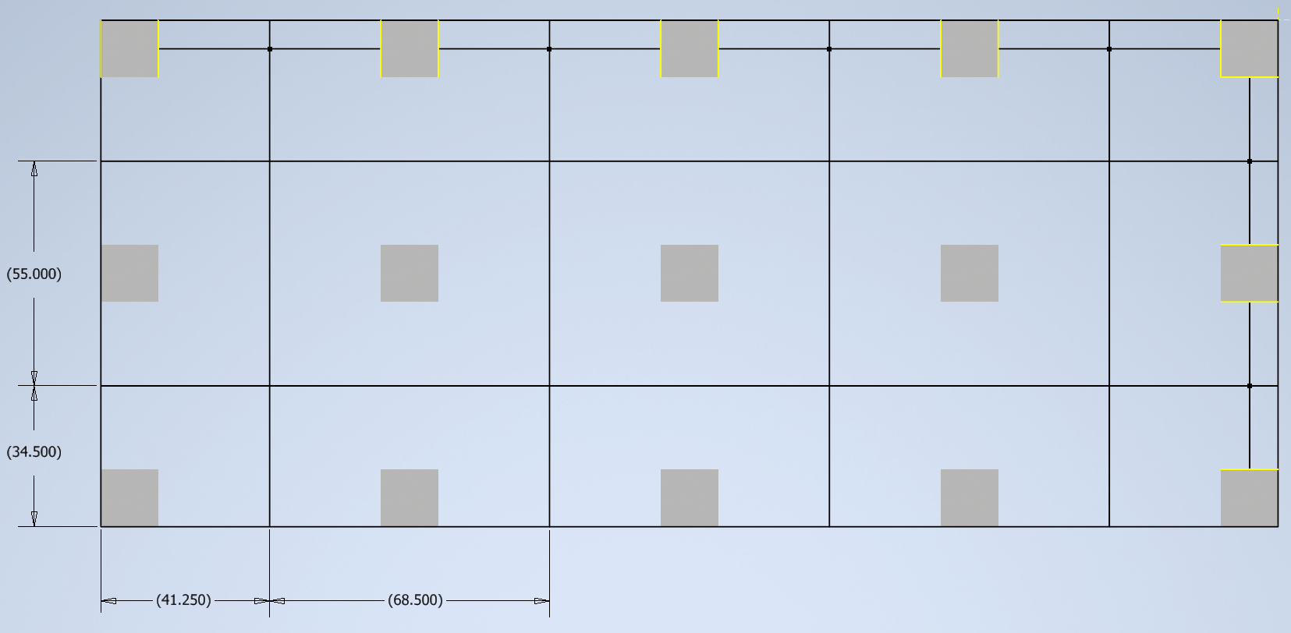

Maximum tributary area is 26.163 square feet.

Per “Typical Deck Details”, for a design live load or ground snow load of 40 PSF, a load-bearing pressure of 1,500 PSF, the above maximum tributary area, the side of a square footing must be 14 inches and the thickness / depth of a footing must be at least 8 inches.

I plan on using square footings with a side length of 14 inches and a depth far greater than 8 inches.

Forms of concrete will be rectangular tubes with an inside side length of 14 inches.

I plan on having holes dug. Holes will be square. Forms will fit inside holes. Holes will have a depth of 18” + 14” = 32”.

The shortest rebar cage will reinforce a pier of height 38”.

The cage will look as follows.

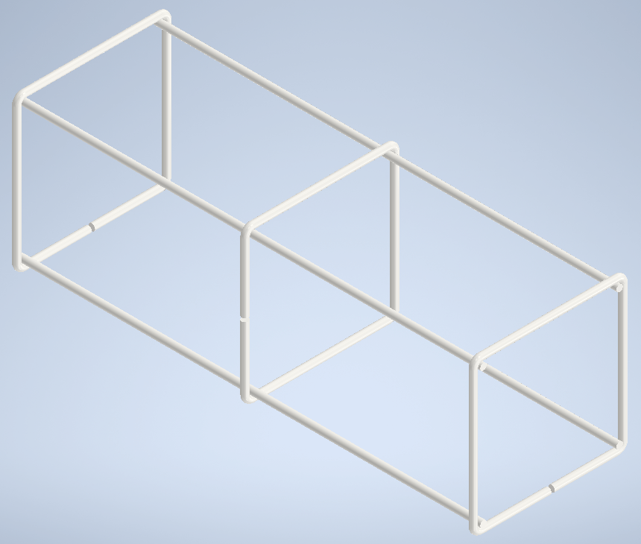

The height of the cage will be 34”.

The cage will be elevated 2” from the bottom of its hole by a plastic chair like <https://www.lowes.com/pd/PROWORX-4-33-in-x-2-83-in-100-Pack-Polypropylene-Rebar-Chair/5000895143> .

The length of a side of a square ring of rebar will be 11”.

The cage will be separated from the form by wheel spacers with a radius of 1.5 inches like <https://www.amazon.com/LTM-CONCRETE-Wheel-Spacers-Clip/dp/B097F8SPZ1?th=1> .

The building will be served electrically.

Per “City of Charlottesville Minimum Mandatory Inspections”, “New houses and detached garages shall have [Ufer] installed for electrical services if there is rebar in the footings.”

Following member MRKN’s reply from 06/29/2018 on forum “Pier grounding detail” of Mike Holt’s Forum at <https://forums.mikeholt.com/threads/pier-grounding-detail.143597/> ,

“If the structure is electrically served, then it is required to be grounded. If there is 20 linear feet or more of interconnected rebar, an astute inspector will require it to be connected to the proposed ground rod under [NFPA 70: National Electrical Code: 2023: Section] 250.50… However something the code does not cover is longer term galvanic corrosion. I would recommend you to simply coil 20’ of [bare copper wire of gage] #4 elevated off the lowest rebar with PVC spacers and be done with it.”

I plan on coiling 20’ of bare copper wire of gage 4 around the bottom of the cage.

I plan to install a saddle bracket like the following at every pier.

<https://www.lowes.com/pd/Nuvo-Iron-9-5-in-x-3-75-in-Black-Powder-Coated-Satin-Painted-Galvanized-Steel-Post-Connector/5013302125>

Most pressure treated lumber sold by Lowe’s is Southern Yellow Pine with grade 2.

Per “Table R502.3.1(2): FLOOR JOIST SPANS FOR COMMON LUMBER SPECIES” (<https://codes.iccsafe.org/content/IRC2021P2/chapter-5-floors>), a board of Southern pine with grade 2 that is not pressure treated, that is nominally 2” x 6”, and that is spaced 24” on center may span 7’7”, which is more than the maximum distance between centers of adjacent piers.

Per “Table R507.5(1): MAXIMUM DECK BEAM SPAN”, [https://codes.iccsafe.org/content/IRC2021P2/chapter-5-floors](https://codes.iccsafe.org/content/IRC2021P2/chapter-5-floorsG), a beam of Southern pine with grade 2 that is not pressure treated, that is nominally 2” x 6”, and that anchors joists with an effect span length of 8’ may span 5’11”, which is more than the maximum distance between centers of adjacent piers.

I plan to use 3 runs of beams. Each run will consist of 2 beams. Each beam will be of Southern pine with grade 2 that is pressure treated and that is 4” x 6”.

The front beam will be flush with the front of the piers.

The middle beam will be center on the middle piers.

The back beam will be flush with the back of the piers.

I plan to use joists of Southern pine with grade 2 that are pressure treated, that are nominally 2” x 6”, and that are spaced 16” on center.

According to “Pressure Treated Lumber Effect on Sheet Steel”, “Isolating steel from the wood with water resistant barrier materials is an extremely effective way to minimize corrosion issues with the ACQ-D treated wood. Such materials would include ice and water shield, polymer tapes, masking, and lining materials.”

I plan to use one of the following products to separate saddle brackets and joist hangers from faces of piers and faces of beams and joists within 1 inch of the saddle brackets or joist hangers.

<https://www.lowes.com/pd/APOC-Self-Bond-36-in-x-50-ft-150-sq-ft-Polypropylene-Roof-Underlayment/1002828868>

<https://www.amazon.com/POLYGUARD-Poly-Wall-Decking-Adhering/dp/B0B34YWC8R/ref=asc_df_B0B34YWC8R/?tag=hyprod-20&linkCode=df0&hvadid=692875362841&hvpos=&hvnetw=g&hvrand=3720539238291012404&hvpone=&hvptwo=&hvqmt=&hvdev=c&hvdvcmdl=&hvlocint=&hvlocphy=1027070&hvtargid=pla-2281435182418&mcid=9fb6411bfdf33e5b83512cdc13e19eff&hvocijid=3720539238291012404-B0B34YWC8R-&hvexpln=73&th=1>

<https://www.amazon.com/Cylinnda-Waterproof-Self-Adhesive-Anticorrosion-Beams-Black/dp/B0C58YXB5J/ref=asc_df_B0C58YXB5J/?tag=hyprod-20&linkCode=df0&hvadid=692875362841&hvpos=&hvnetw=g&hvrand=3720539238291012404&hvpone=&hvptwo=&hvqmt=&hvdev=c&hvdvcmdl=&hvlocint=&hvlocphy=1027070&hvtargid=pla-2281435184298&mcid=2669b7c7fc3033c7bf5cb9e2e549424e&hvocijid=3720539238291012404-B0C58YXB5J-&hvexpln=73&th=1>

<https://www.amazon.com/3M-Outdoor-Masking-Poly-Tape/dp/B004VB06WG?source=ps-sl-shoppingads-lpcontext&ref_=fplfs&psc=1&smid=ATVPDKIKX0DER>

<https://www.amazon.com/ELK-Polyethylene-Moisture-Crawlspace-Encapsulations/dp/B0CSBZDT5D?source=ps-sl-shoppingads-lpcontext&ref_=fplfs&smid=A3D53DZ7TUJUM1&th=1>

<https://www.amazon.com/Stuck-Tape-Multi-Purpose-Polyethylene-Protection/dp/B085HVCYRH?source=ps-sl-shoppingads-lpcontext&ref_=fplfs&smid=A2OHL6HUCAZROK&th=1>

Siding will extend beyond the NE edges of piers by up to 0.2’. The roof of the additional building will be about 8.5” above finished grade and will extend beyond siding by up to 2’.