**Layout Of Additional Building**

Created on 08/07/2024 by Tom Lever

Updated on 09/08/2024 by Tom Lever

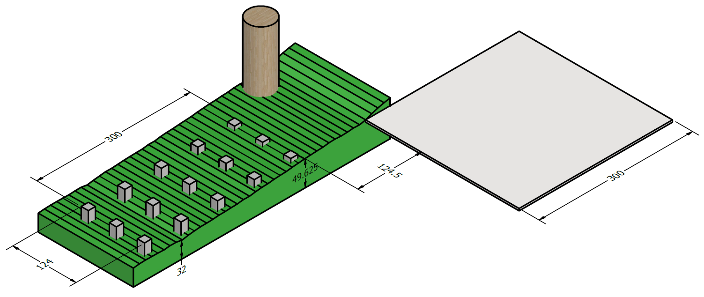

A foundation of an additional building will consist of 15 square piers each with a side length of 14 inches. The piers will be within a 300” x 124” area that is offset from the NW foundation wall of the house by 124.5” and from the NE foundation wall of the house by 8”. The bottoms of the piers will be at least 18” below finished grade, plus an additional 14” to allow for future excavation. The tops of the piers will be at least 6” above finished grade. All organic soil, vegetation, and roots will be removed from the holes for the piers.

Per Commonwealth Land Surveying on 04/19/2023, The shortest distance between the N edge of the house and the property line is 15.2’ = 15’2-3.2/8”.

Per Chuck Miller representing the City of Charlottesville on 08/01/2024, the minimum setback from the NE property line is 4’.

The maximum depth of the additional building is 11.2’ = 11’2-3.2/8”.

The shortest distance between the N edge of the house and where the backyard really starts to descend is about 38’.

The minimum distance between flammable materials on two buildings is 5’.

A maple tree may be approximated as a cylinder with a diameter of 50”.

The central axis of the maple tree is about 44” from the N edge of the house going SE to NW.

A good distance between the N edge of the house and the surface of a pier considering the maple tree is 10’, plus 4.5” considering a potential future addition to the house.

The maximum length of an additional building is 27’7.5”.

Per Mr. Miller on 08/01/2024, the maximum area of an additional building in Charlottesville that does not require a permit is 256 square feet.

Per Mr. Miller on 08/01/2024, an additional building may have an area that is any proportion of the area of the house.

An additional building that has an area of 256 square feet and a depth of 11’ has a length of 23’3”.

I intend for the additional building to have a depth of 11’ and a length of 25’ to mimic the living room of the house.

A permit is required.

Per “Table R401.4.1: Presumptive Load-Bearing Values Of Foundation Materials” (<https://codes.iccsafe.org/s/VRC2018P1/chapter-4-foundations/VRC2018P1-Ch04-SecR401.4>), clay has a load-bearing pressure of 1,500 pounds per square foot.

Per “Section R502.3.2: Other floor joists” (<https://codes.iccsafe.org/content/IRC2021P2/chapter-5-floors>), “Table R502.3.1(2) shall be used to determine the maximum allowable span of floor joists that support… areas of the building… other than sleeping areas and attics, provided that the design live load does not exceed 40 pounds per square foot (1.92 kPa) and the design dead load does not exceed 20 pounds per square foot (0.96 kPa).” This implies that the design live load is 40 pounds per square foot and the design dead load is 20 pounds per square foot.

Mr. Miller suggested on 09/06/2024 that I could use a design dead load of 10 pounds per square foot.

I will use a design dead load of 10 pounds per square foot.

Per “City of Charlottesville Climatic and Geographic Design Criteria” (<https://www.charlottesville.gov/DocumentCenter/View/391/City-of-Charlottesville-Climatic-and-Geographic-Design-Criteria-PDF>), ground snow load is 30 pounds per square foot. Frost depth is 18 inches.

For a shed 11’ wide and 25’ long, total load is (11 ft)(25 ft)(10 PSF + 40 PSF + 30 PSF) = 22,000 lb. The required soil area to support the total load is (22,000 lb) / (1,500 PSF) = 14.667 square feet.

The area of a square cross section of a pier width a length of a side of 14 inches is 1.167 square feet.

For a shed 11’ feet wide and 25’ feet long, the number of piers required is ceiling(14.667 square feet / 1.167 square feet) = 13.

We may pour 15 piers in a 3 x 5 grid.

The front of the front pier should be offset from the NE side of the house by 8” in case an addition for the house with a footer is ever built.

The shortest distance between the front of the front pier and the back of the back pier is 10’4”.

The shortest distance between the front of the front pier and the front of the second to front pier is (124” - 14”) / (3 - 1) = 55”.

The shortest distance between the right of the right pier and the left of the left pier is 25”.

The shortest distance between the right of the right pier and the right of the second to right pier is (300” - 12”) / (5 - 1) = 71.5”.

Per “R404.1.6, Height above finished grade”, “Concrete and masonry foundation walls shall extend above the finished grade adjacent to the foundation at all points not less than 4 inches (102 mm) where masonry veneer is used and not less than 6 inches (152 mm) elsewhere.

Per Mr. Miller on 09/06/2024, if lumber that is pressure treated is used as a floor system, the minimum height between finished grade and the floor system is 6”. If lumber that is not pressure treated is used as a floor system, the minimum height between finished grade and the floor system is 18”.

Per “City of Charlottesville Minimum Mandatory Inspections”, the “minimum footing depth [below finished grade] is 18” deep”. This depth is regardless of height above finished grade. This depth is equal to frost depth.

I believe that Mr. Miller on 09/01/2024 suggested the minimum footing depth below finished grade is 24”.

I will use 18”.

Piers should have a length of at least 6” + 18” + 14” = 38”. 6” corresponds to minimum height above finished grade. 18” corresponds to minimum depth below finished grade and frost depth. 14” corresponds to the maximum height the house slab and underlying soil that can be excavated.

Mr. Miller on 09/06/2024 encouraged me to determine the area of a cross section of a pier following “Typical Deck Details” at <https://www.charlottesville.gov/DocumentCenter/View/9152/Typical-Deck-Details-PDF> . I created the below grid.

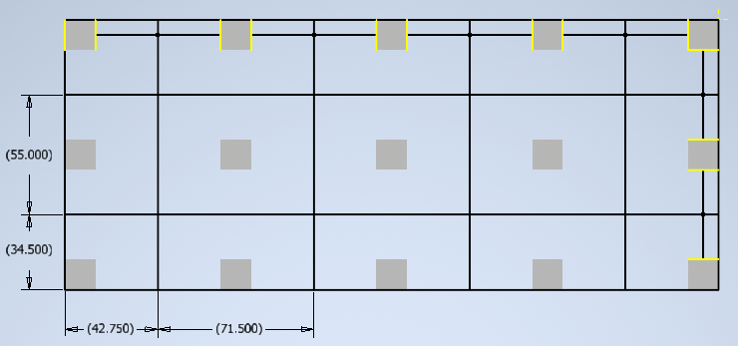

Maximum tributary area is 27.309 square feet.

Per “Typical Deck Details”, for a design live load or ground snow load of 40 PSF, a load-bearing pressure of 1,500 PSF, and maximum tributary area of 27.309 square feet, the side of a square footing must be 14 inches and the thickness / depth of a footing must be at least 8 inches.

I plan on using square footings with a side length of 14 inches and a depth far greater than 8 inches.

Forms of concrete will be rectangular tubes with an inside side length of 14 inches.

I plan on having holes dug. Holes will be square. Forms will fit inside holes. Holes will have a depth of 18” + 14” = 32”.

The shortest rebar cage will reinforce a pier of height 38”.

The cage will look as follows.

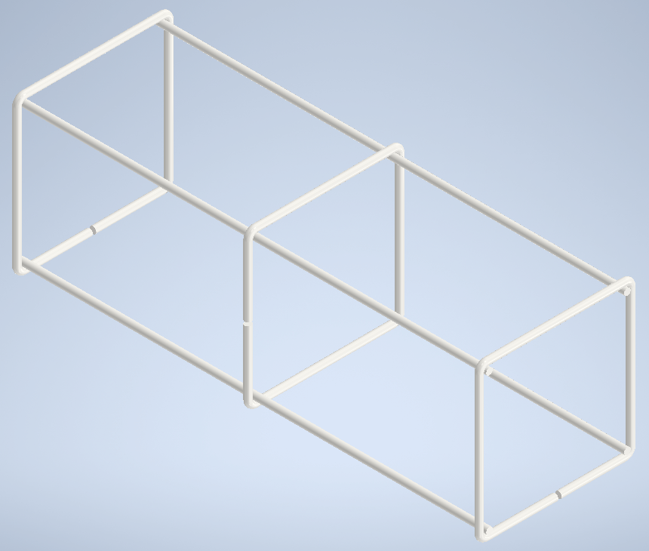

The height of the cage will be 34”.

The cage will be elevated 2” from the bottom of its hole by a plastic chair like <https://www.lowes.com/pd/PROWORX-4-33-in-x-2-83-in-100-Pack-Polypropylene-Rebar-Chair/5000895143> .

The length of a side of a square ring of rebar will be 11”.

The cage will be separated from the form by wheel spacers with a radius of 1.5 inches like <https://www.amazon.com/LTM-CONCRETE-Wheel-Spacers-Clip/dp/B097F8SPZ1?th=1> .

The building will be served electrically.

Per “City of Charlottesville Minimum Mandatory Inspections”, “New houses and detached garages shall have [Ufer] installed for electrical services if there is rebar in the footings.”

Following member MRKN’s reply from 06/29/2018 on forum “Pier grounding detail” of Mike Holt’s Forum at <https://forums.mikeholt.com/threads/pier-grounding-detail.143597/> ,

“If the structure is electrically served, then it is required to be grounded. If there is 20 linear feet or more of interconnected rebar, an astute inspector will require it to be connected to the proposed ground rod under [NFPA 70: National Electrical Code: 2023: Section] 250.50… However something the code does not cover is longer term galvanic corrosion. I would recommend you to simply coil 20’ of [bare copper wire of gage] #4 elevated off the lowest rebar with PVC spacers and be done with it.”

I plan on coiling 20’ of bare copper wire of gage 4 around the bottom of the cage.

Most pressure treated lumber sold by Lowe’s is Southern Yellow Pine with grade 2.

Per “Table R502.3.1(2): FLOOR JOIST SPANS FOR COMMON LUMBER SPECIES” (<https://codes.iccsafe.org/content/IRC2021P2/chapter-5-floors>), a board of Southern pine with grade #2 that is not pressure treated, that is nominally 2” x 6”, and that is spaced 24” on center may span 7’7”.

Per “Table R507.5(1): MAXIMUM DECK BEAM SPAN”, [https://codes.iccsafe.org/content/IRC2021P2/chapter-5-floors](https://codes.iccsafe.org/content/IRC2021P2/chapter-5-floorsG), a beam of Southern pine with grade 2 that is not pressure treated, that is nominally 2” x 6”, and that anchors joists with an effect span length of 8’ may span 5’11”, which is more than the maximum unsupported distance left to right between piers.

I plan to use 3 beams of Southern pine with grade 2 that are pressure treated and that are 4” x 6”.

The front beam will be flush with the front of the piers.

The middle beam will be center on the middle piers.

The back beam will be flush with the back of the piers.

I plan to use joists of Southern pine with grade 2 that are pressure treated, that are nominally 2” x 6”, and that are spaced 24” on center.

The thickness of rebar is 0.5”.

To attach anchor bolts for the front and back piers to a cage, I plan on putting one piece of rebar under the front or back side of the top ring of the cage. The distance between the central axis of the ring and the central axis of the piece will be 1”. The distance between the front of the front pier and the anchor bolt will be 1.5 inches.

To attach anchor bolts for the middle piers to a cage, I plan on putting two crosses of rebar under the top ring of the cage. The distance between the central axis of the ring and the central axis of the bottom cross will be 1”. The anchor bolt will be roughly centered in the cage.

Concrete will be poured 2” above a rebar cage.

I plan on separating the concrete piers and the beams with sill seal with a thickness of 0.25” adhered using Liquid Nails Panel & Foam Adhesive. See <https://www.lowes.com/pd/Dow-Sill-Seal-R-1-50-sq-ft-Unfaced-Polystyrene-Roll-Insulation-7-5-in-W-x-50-ft-L/1000172805> and <https://www.lowes.com/pd/LIQUID-NAILS-Construction-Adhesive/3362264> .

A beam that is nominally 4” x 6” has a height of 5.5”.

I plan on purchasing anchor bolts like <https://www.lowes.com/pd/Hillman-1-2-in-x-12-in-Anchor-Bolt/3472361> .