**Main and Test Output for Module 3 Programming Assignments**

Created: 06/05/21 by Tom Lever

Updated: 06/05/21 by Tom Lever

**Problem 3A: Recursion in Arrays**

*Main Output for argument string “I 8”*

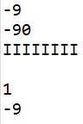

*Main Output for argument string “Java 3”*

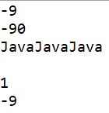

*Main Output for argument string “I -10”*

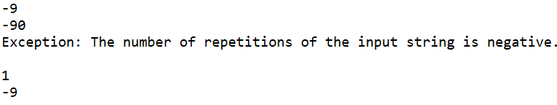

*Test Output for main*

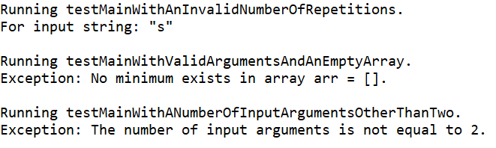

*Test Output for smallest with One Argument*

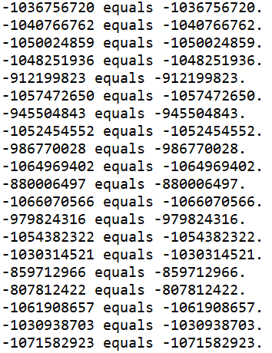

*Test Output for smallest with Two Arguments*

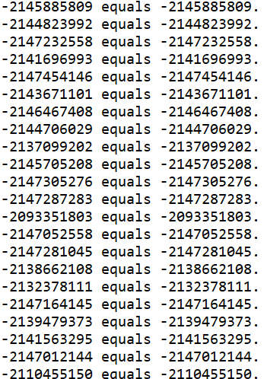

**Problem 4A: Area Fill**

Main Output for argument string “resources/area2.txt 1 2”

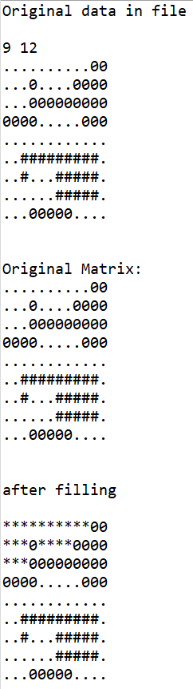

Main Output for argument string “resources/area2.txt 1 3”

