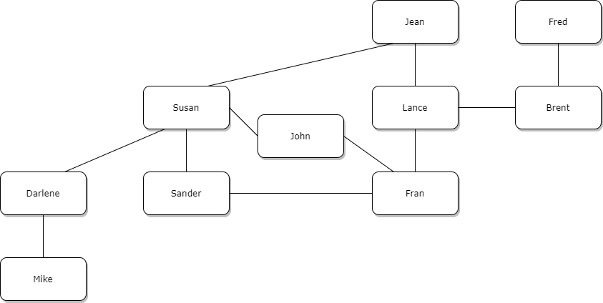

It seems like Mike could work for Darlene, and Darlene would be the supervisor of, senior to, Mike. Same with Fred and Brent, Darlene and Susan, and Brent and Lance. It seems like John could be a President, Susan and Fran Vice Presidents, Sander an Assistant VP, Darlene a Project Manager, Lance a Senior Project Managers with Jean as a COO.