**MEMORANDUM**

|  |  |
| --- | --- |
| Date: | Wednesday, December 6, 2023 |
| To: | United States Digital Corps |
| From: | Tom Lever |
| CC: |  |
| Subject: | Project-Based Assessment |

To whom it may concern,

In this memorandum I describe the design, implementation, and testing of a function that searches for a word in the scanned content of a number of books.

Below is a **System Description** for

Function That Searches For A Word In An Array Of Excerpts Of Books.

*Context*

Electronic books are valuable in part because they are searchable. Kindle For PC is a software application that allows users to read electronic books and search electronic books for words.

*Opportunity That Function Will Address*

Our function may be used by a new system that allows users to read electronic books and search electronic books for words.

*What Function Will Do*

Our function will receive from a searcher a word and an array of excerpts of books. Our function will provide an array of search results.

*Iterations Of Development*

At the end of a first iteration, our function will be as described in *What Function Will Do* and *Design Of Interface* below.

Below is a **System Diagram**.

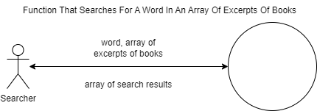

Below is a summary of a **Use-Case Description** for

Searcher Requests Search Results.

Searcher Requests Search Results is a use case related to our function. In this use case, a searcher provides a word and an array of excerpts of books and receives an array of search results. See below interface between a searcher and our function.

Below is a **Design Of Interface** between Searcher And

First Iteration Of Function That Searches For A Word In An Array Of Excerpts Of Books.

Our function will receive a word. A word contains one or more letters and contains either an optional / soft hyphen or a required hyphen after each syllable. A word may contain one or more non-adjacent apostrophes.

Our function will receive an array of excerpts of books. An excerpt of books contains a title, an International Standard Book Number (ISBN), and an array of lines. A line contains the number of the page of the line in a book, the number of the line on the page with the line, and the text of the line.

Our function will provide an array of search results. A search result contains an ISBN, a number of a page with the line indicated by a number of a line, and the number of a line with text containing the provided word or the beginning of the word. A word may be split by a hyphen across two lines.

Below illustrating the implementation of **Flow Chart For findSearchTermInBooks**.

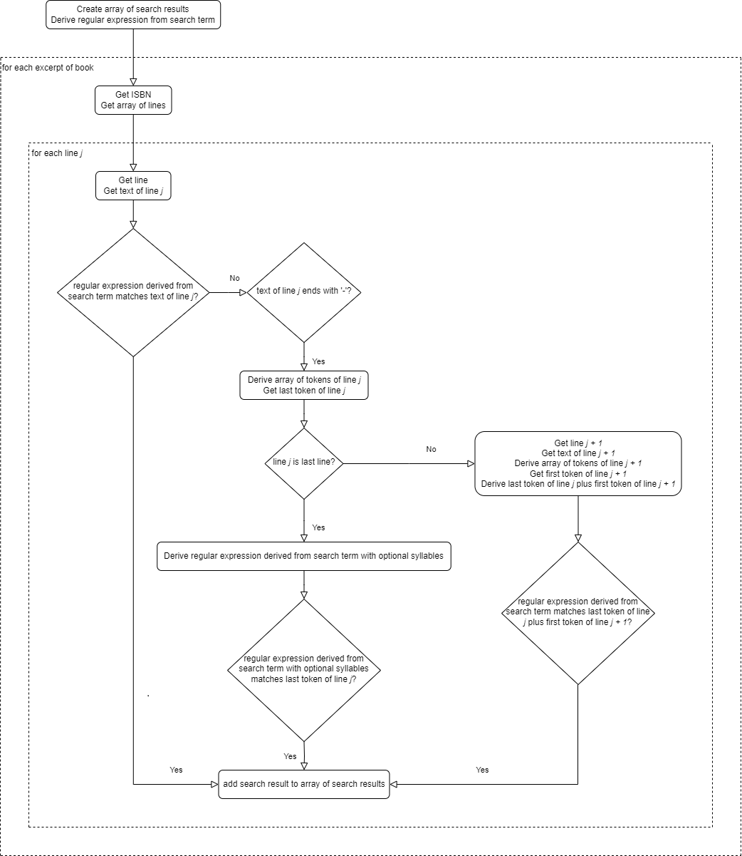

Best regards,

Tom Lever