

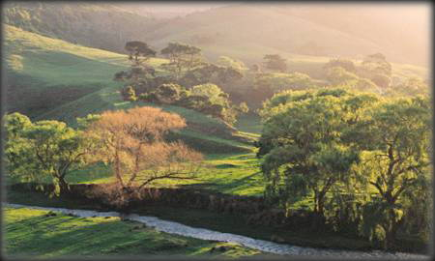
It is estimated that at least $50 million is spent each year on preventing or remedying streambank erosion in Australia. Added to this is the cost of treatment to counter reduced water quality. Given these costs, it is not surprising that there is a rapidly-growing interest in techniques to help stabilise streams and their banks. Maintaining healthy riparian vegetation is one technique that can provide relatively cheap and long-term stability as well as numerous other benefits. However, in some situations vegetation will have to be combined with other forms of protection to adequately protect the banks.

Streambank erosion - what it is and why it occurs
There are two main types of bank erosion:
Scour | where sediment is removed from streambanks bit by bit, particle by particle; and
Collapse | where the bank fails and collapses or topples forward suddenly.

Streambanks erode for many reasons. A stream may erode its bed because a dam built upstream has altered its flow, or because the stream has been deliberately straightened downstream to increase its capacity to handle floods. The subsequent increase in bank height will then lead to collapse. Clearing for agriculture increases rates of surface flow, and this, combined with overclearing of vegetation from streambanks, leaves banks especially vulnerable to erosion. The removal of streamside vegetation and its continued suppression through grazing, or other rural or urban management, is often an important trigger for bank erosion. Although collapse is the most obvious and dramatic form of bank erosion, scour is arguably more destructive. If collapsed material is not removed by scour, the bank will probably remain stable. It is scour which primes the bank for the next collapse. Vegetation reduces scour by reducing water velocity (especially close to the bank) and will also ride down with a collapsed bank and protect its toe from scour.

How riparian vegetation affects streambanks

Root systems
The roots of vegetation reinforce the soil in the same way that steel rods reinforce concrete. Fine roots are more important in this process than are thick roots. Root reinforcement by riparian vegetation is usually the most important safeguard against bank collapse.

Feature of vegetation | Impact on amount of bank collapse | Impact on amount of scour
Root systems | Large reduction | Large reduction
Surcharge | Reduced or increased | -
Water use | Small reduction | -
Buttressing | Reduction | -
Reduced velocity of flow | - | Large reduction

Surcharge

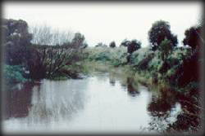
Surcharge is the weight imposed on a bank by vegetation. Large trees can weigh several tonnes but, surprisingly, this weight does not necessarily increase the risk of a bank collapsing. Whether it does so depends upon the weight of the vegetation, the height and slope of the bank, and the character of the bank material. In general, surcharge is an issue only when banks are vertical, or nearly so. For sloping banks, vegetation will normally improve bank stability.

Water use
Riparian vegetation uses much of the water present in streambanks and also improves the drainage of the bank soils. As most banks collapse when they are saturated with water, riparian vegetation, by using that water and by improving drainage, can help stabilise the bank and reduce the risk of sudden collapse. This effect is usually small.

Buttressing
Riparian vegetation which is present on the face of a stream bank helps support (or buttress) the soil above it so that it does not collapse. When banks do collapse, the soil forms a sloping section at the base. Revegetating this section will help buttress the upper section of the bank.

Reduced velocity
The velocity of water flow in a channel can be decreased by vegetation growing either on the bank or in the water, and by debris or sediment in the stream. The impact on erosion is complex.

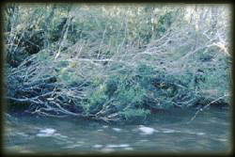
If the vegetation is growing on the bank face it can reduce scour and, thereby, undercutting and collapse. The extent to which velocity is reduced is very dependent on the type of vegetation - for example, grass is more effective than widely spaced trees. In some cases, vegetation is highly invasive and actually grows into the river channel. Vegetation growing within the channel will reduce scour by decreasing the average flow velocity.

However, if the vegetation becomes too dense - for example, in the case of reed beds - it can direct flow into the banks and increase scour.
When dense vegetation invades and chokes channel floors it can lead to deflection and erosion, but it can also encourage deposition and bed stability. This can be an advantage in the many Australian streams that have filled with sand since European settlement. However, lower flow velocity in channels invaded by vegetation, especially willows, comes at the cost of greater flow depths and lower channel capacity. The result is an increase in the frequency of nuisance flooding.

Using vegetation to stabilise streambanks

Tackling the three main results of erosion
Landholders and managers normally face three general types of stream erosion.

Incised streams
in which the bed is deepening and the banks fail because they are oversteep.
There is little point in stabilising streambanks until the streambed has been made stable. Vegetation on the gully floor, while being notoriously difficult to establish, is useful in stabilising the bed, although some initial grade control structures (such as rock-chutes) may be needed. It is important that dense vegetation does not then fill the centre of the gully and divert flow into the banks.
In some cases the best management is simply to fence the stream off from grazing, stabilise the bed with rock chutes, and allow the bed and banks to be colonised by grass.

Channel widening
which may or may not be related to incision.
If both banks of a stream are eroding, it may be that:
- the stream cannot carry the increased flows which have resulted from clearing of the catchment;
- the channel has deepened;
- unusual rainfall has caused a large flood or series of floods; or
- the banks have been overcleared.
In large channels, the key is to establish vegetation as far down the face of the bank as possible, as well as on the bank top. Special attention needs to be given to stabilising the toe of eroding banks, and this may require rocks or other structures to help maintain the toe region while vigorous vegetation becomes established above it.

Erosion of the outer bank

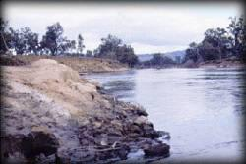
Usually a steep bank on the outside of a meander bend. This is the most common erosion problem faced on larger streams. The outside bank of a meander is often steep or even vertical, making it difficult to establish vegetation on the bankface. In general, the higher the bank, the less useful vegetation on the top of the bank is in reducing collapse. In channels under three meters high, establishing vegetation on the top of the banks will have some value if the bank suffers rotational failure or topples. In this case, vegetated blocks topple to the toe of the bank. If the vegetation is sufficiently vigorous, and there is sufficient moisture, this may stabilise the toe.

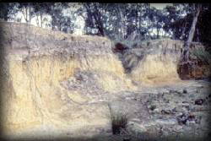
Position of vegetation
In revegetating to reduce bank erosion, correct siting is most important. Poorly-sited plant growth can increase local flow velocity and increase erosion. The best solution is to establish vegetation on the bankface. If a bank is not too steep, then surcharge effects will actually increase stability. The decreased flow velocity around the vegetated face will reduce scour and protect the bank toe - the most critical erosion point

Selection of appropriate plant species

A range of vegetation
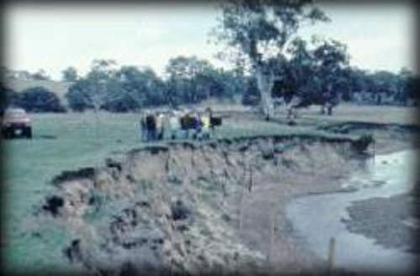Under natural conditions, healthy riparian vegetation contains a range of species. Native grasses and reeds, and shrubs with flexible branches often occupy the lowest part of the bank, where they are subject to occasional inundation. Their ability to bind soil and resist floodflows are highly-prized characteristics. Further up the bank, shrubs and small trees may predominate, with either an understorey of grassy species or, if there is adequate shade and moisture, a strong mat of fibrous roots present on the outside of the bank. At the top of the bank there may be large trees with a shrub understorey, or a combination of trees and grass. This type of generalised pattern, and the particular needs of individual species for water, light, initial frost protection and so on, must be considered when planning a revegetation project.

In general, vegetation planted along banks or within the mainstream channel (in order to reduce velocity) needs to be securely-rooted, preferably with a spreading, fibrous root mass that will thoroughly penetrate bank soil, and with a flexible upper portion that can bend and move in peak flows.

Native grasses and reeds
Native grasses and reeds are particularly useful in providing protection from erosion. There have been cases where establishing trees along previously cleared banks has increased erosion because of the shading-out of undergrowth species. The fine roots of grasses and small shrubs are effective in providing additional strength to streambank soils, and at the same time the species avoid possible surcharge effects.

Trees
Large trees can be detrimental to the stability of very steep banks where surcharge and the combined effects of windloadings on individual trees or a single row of trees may contribute to bank collapse. The fine roots of native trees can provide additional soil strength for at least three meters depth, depending upon the shape and type of roots.

Woody debris
In the past, many landholders and river management groups have assumed that any large, woody debris within streams had a substantial impact on reducing flood conveyance or on directing flow onto banks and causing increased erosion. In fact, research conducted in Victoria suggests that snags dragged back against the banks at an angle of 40¡ have little effect on diverting water flow onto the banks. Another general rule of thumb is that large logs or living vegetation within a stream channel will have a measurable influence on flow rates only if they occupy more than ten per cent of the cross-sectional area of the channel.

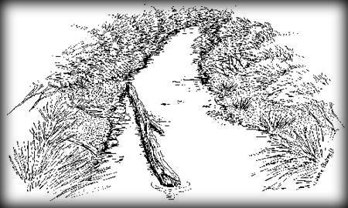

Size of stream
The effectiveness of revegetation depends in part on the size of the stream. Along small tributaries, whether in the upper part of the catchment or in the lowlands, where the channel depth is small relative to the height of vegetation, riparian plants can significantly improve bank stability. If vegetation is planted or allowed to recolonise the bank, the roots are able to penetrate to, or below, the bed of the channel, limiting bank collapse and increasing the banks resistance to scour. Where the banks are undercut, the vegetated bank soil will collapse downwards, enabling the vegetation to slow, or protect the banks, from further erosion.
Further downstream, or as the channel gets wider, vegetation begins to play a different role. Very large channels and slumping failures generally occur below the root zone of trees, often at a depth of three meters or more. Measurements suggest that in large channels, a dense stand of trees at the top of the bank can reduce the erosion rate of a meander bend by up to a half.

Some golden rules in revegetating for bank stability

Understand why erosion has occurred
This may require a simple survey of the river reach or professional advice. Once the cause has been determined, you can then design and carry out revegetation works with confidence - matching the type and position of vegetation to the nature of the problem and combining it, if necessary, with structural work.

Work with others
It is important to remember that the effects of overclearing or loss of vegetation, and of revegetation, may have impacts downstream. There is much to be gained by joint planning and revegetation action by groups of landholders to deal with a whole section or reach of a river rather than individual action by one or two landholders.

Simply re-establishing original species will not necessarily work
The nature of many streams has changed substantially since European settlement. Revegetation will rarely, completely reverse this process and return the stream to its original condition. The type of vegetation needed must be determined once you are clear about why the area became degraded in the first place and what you intend to do with the land.

Establish vegetation as far down the base of the bank as possible
This may require special work to stabilise the toe of the bank or to batter it to an angle where healthy riparian vegetation can become well-established and provide stability. Vegetation on the floodplain and on banks has little impact on in-channel flow where the width of the channel is more than thirty times the depth.

Use a range of vegetation species
Copy nature. Natural, stable streambanks support a range of grasses and reeds, shrubs and trees. By replicating this variety, newly-planted vegetation can be self-perpetuating and require little maintenance. Introduced or non-local species may be required for especially difficult situations, or to stabilise active erosion sites while native species get a chance to become established.

Choose suitable species
Dense undergrowth can provide more resistance to bank erosion than can tree trunks, particularly down towards the channel and at the toe of the bank. Species with a dense, fibrous root system and with flexible leaves or stems able to move with the flow are to be preferred. Higher up the bank, which should preferably be sloping, larger shrubs and trees can help to dry out the bank soil while their fine roots add substantially to soil strength.

Be careful with in-stream vegetation
If there is evidence that lack of channel capacity during floodflow is a cause of bank erosion, vegetation should not be planted within the channel or allowed to stabilise sediment bars. Although the impact of riparian vegetation decreases with channel size, willows and reeds choking a 15m-wide channel of about 4m depth will roughly halve channel capacity to convey major flows.

Carefully consider woody debris
Vegetation and large, woody debris would need to occupy at least 10 per cent of the cross-section of the channel before having much effect on flow velocity and flooding. Snags dragged back against the banks at an angle of 40¡ have little effect in diverting water flow onto the banks. Only in very choked channels has the removal of large, woody debris led to measurable increases in the amount of flow a channel can carry.
*The importance of root systems, surcharge, water use and buttressing in preventing collapse of streambanks largely depends on the height and angle of the bank, and the cohesion (soil strength) of the bank material. In general, root systems, by strengthening the bank, are the most important way in which vegetation acts to minimise the risk of bank collapse.
These fact sheets have been produced as part of Land & Water Australia's National Riparian Lands Management and Rehabilitation Program with support from the National Landcare Program. The fact sheets have been compiled by:

Michael Askey-Doran | Tasmanian Parks and Wildlife Service
Stuart Bunn | Centre for Catchment and In-stream Research
Peter Hairsine | CSIRO Division of Soils & the CRC for Catchment Hydrology
Phil Price | LWRRDC
Ian Prosser | CSIRO Division of Water Resources & the CRC for Catchment Hydrology
Ian Rutherfurd | CRC for Catchment Hydrology, Monash University

Front cover: Dairying pastures, VIC (Peter Walton Photography)
Edited by Wendy Tubman
Artwork by Jane Burrell
Graphic design by e.g. design
LWRRDC GPO Box 2182, Canberra ACT 2601
October 1996
ISBN 0 642 20637 6


Home | About | Activities | Publications | River Ramblers
Working Together
Whats New | Search | Feedback
Last updated: 10:20, Tue 12 Feb, 2002
The information contained on this page is
subject to the disclaimer on the River Landscapes Homepage.
© Copyright River Landscapes 2000

