|  |
| --- |
| Software design |
| Music system |
| Version 2.0 |
| Prepared by class SE1634, Group 6  Tống Sỹ Nhật  Nguyễn Minh Tân  Cấn Phương Nam  Đỗ Đức Việt  October 15, 2022 |

1. Document description 2

2. SRS overview 2

2.1. List of system users 2

2.2. List of use case 2

2.3. Use case diagram 2

2.3.1. Preliminary use case diagram 2

2.3.2. Use case detail diagrams 2

2.3.2.1. Use case detail diagram for “Search song” 2

2.3.2.2. Use case detail diagram for “Listen song” 2

2.3.2.3. Use case detail diagram for “Add song to favorite list” 2

2.3.2.4. Use case detail diagram for “Delete song in favorite list” 2

2.3.2.5. Use case detail diagram for “Add new song to online” 2

2.3.2.6. Use case detail diagram for “Delete song they added” 2

2.3.2.7. Use case detail diagram for “Delete user account” 2

2.3.2.8. Use case detail diagram for “Login” 2

2.3.2.9. Use case detail diagram for “Register” 2

2.4. Activity diagram of use case scenarios 2

2.4.1. Activity diagram for use case “Search song” 2

2.4.2. Activity diagram for use case “Listen song” 2

2.4.3. Activity diagram for use case “Add song to favorite list” 2

2.4.4. Activity diagram for use case “Delete song in favorite list” 2

2.4.5. Activity diagram for use case “Add new song to online” 2

2.4.6. Activity diagram for use case “Delete song they added” 2

2.4.7. Activity diagram for use case “Delete user account” 2

2.4.8. Activity diagram for use case “Log in” or ”Log out” 2

2.4.9. Activity diagram for use case “Register” 2

3. Data model 2

3.1. Entity Relationship Diagram 2

3.2. Table details/Chi tiết các bảng 2

3.2.1.Table name: Users 2

3.2.1.Table name: Lists 3

3.2.1.Table name: Songs 4

3.2.1.Table name: List_Song 5

4. Class diagram 6

4.1. List of classes in the Layers 6

4.2. Modeling the Class Behaviors - sequence diagrams 6

4.2.1. Sequence diagram for use case ” Search song ” 6

4.2.2. Sequence diagram for use case ” Listen song ” 6

4.2.3. Sequence diagram for use case ” Add song to favorite list ” 6

4.2.4. Sequence diagram for use case ” Delete song in favorite list ” 6

4.2.5. Sequence diagram for use case ” Add new song to online ” 6

4.2.6. Sequence diagram for use case ” Delete song they added ” 6

4.2.7. Sequence diagram for use case ” Delete user account ” 6

4.2.8. Sequence diagram for use case ” Login ” 6

4.2.8. Sequence diagram for use case ” Register” 6

5. User Interface Model Design 6

5.1. User interface model design 6

5.1.2. UI when user see their songs they added 6

5.2. Interface Flow Diagrams 6

# 1. Document description

# 2. SRS overview

## 2.1. List of system users

1. Admin: The person is working in Music room

2. User: The person use features of Music system.

## 2.2. List of use case

- Search song

- Listen song

- Add song to favorite list

- Delete song in favorite list

- Add new song to online

- Delete/Hide song they added

- Delete user account

- Login

- Register

## 2.3. Use case diagram

### 2.3.1. Preliminary use case diagram

### 2.3.2. Use case detail diagrams

#### 2.3.2.1. Use case detail diagram for “Search song”

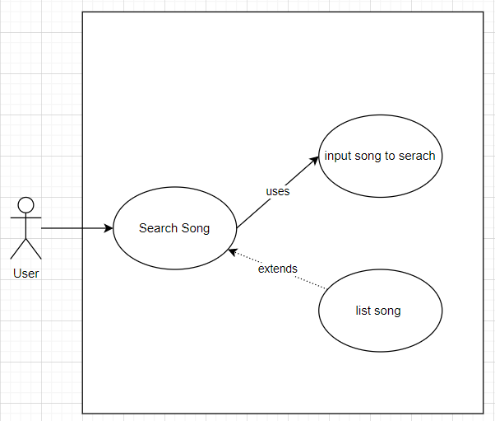

#### 2.3.2.2. Use case detail diagram for “Listen song”

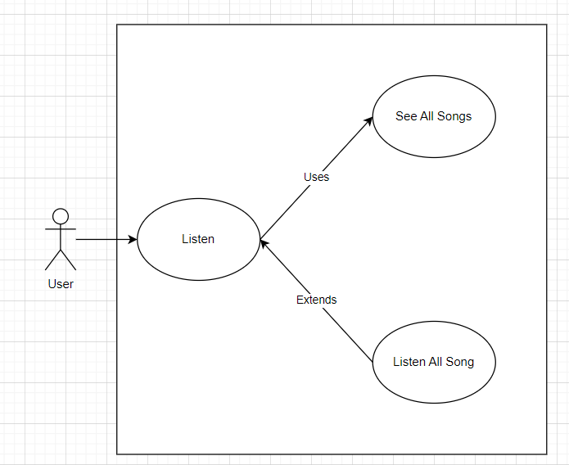

#### 2.3.2.3. Use case detail diagram for “Add song to favorite list”

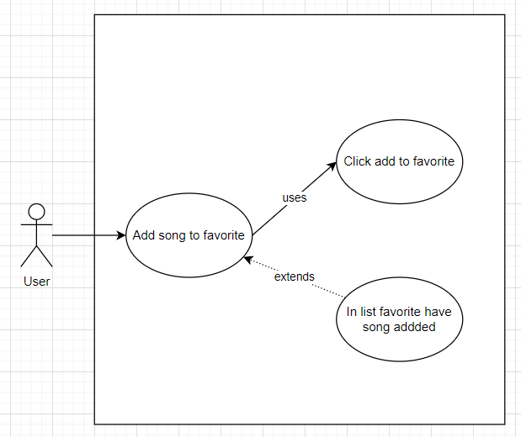

#### 2.3.2.4. Use case detail diagram for “Delete song in favorite list”

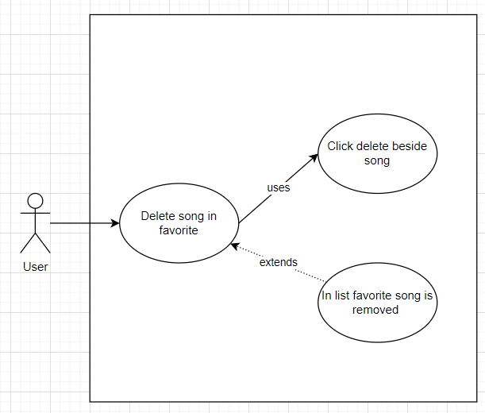

#### 2.3.2.5. Use case detail diagram for “Add new song to online”

#### 2.3.2.6. Use case detail diagram for “Delete/Hide song they added”

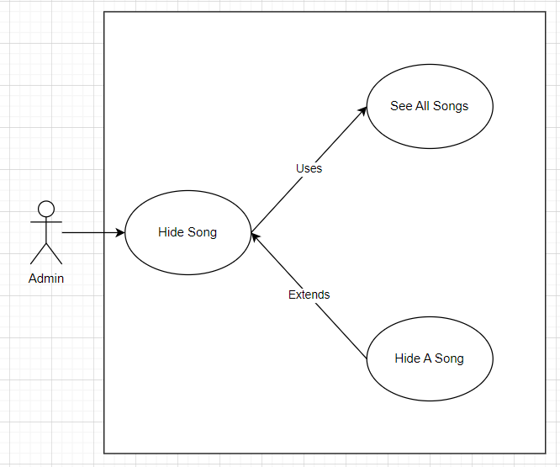

#### 2.3.2.7. Use case detail diagram for “Ban user account”

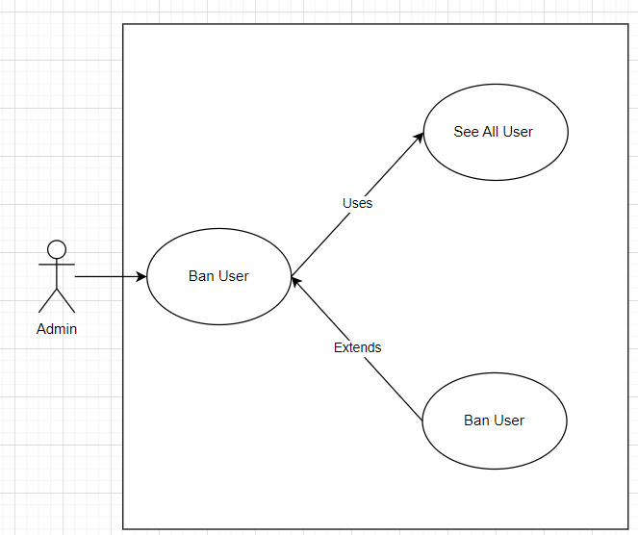

#### 2.3.2.8. Use case detail diagram for “Login”

#### 2.3.2.9. Use case detail diagram for “Register”

## 2.4. Activity diagram of use case scenarios

### 2.4.1. Activity diagram for use case “Search song”

### 2.4.2. Activity diagram for use case “Listen song”

### 2.4.3. Activity diagram for use case “Add song to favorite list”

### 2.4.4. Activity diagram for use case “Delete song in favorite list”

### 2.4.5. Activity diagram for use case “Add new song to online”

### 2.4.6. Activity diagram for use case “Delete song they added”

### 2.4.7. Activity diagram for use case “Delete user account”

### 2.4.8. Activity diagram for use case “Log in” or ”Log out”

### 2.4.9. Activity diagram for use case “Register”

# 3. Data model

## 3.1. Entity Relationship Diagram

## 3.2. Table details/Chi tiết các bảng

Note: Attribute with underline is Primary key

### 3.2.1. Table name: Users

|  |  |  |  |
| --- | --- | --- | --- |
| **Field name** | **Type** | **Size** | **Note** |
| User name | nvarchar | 50 | Use for login |
| Password | nvarchar | 50 | Use for login |
| Role | int |  | Authorization |

### 3.2.1. Table name: Lists

|  |  |  |  |
| --- | --- | --- | --- |
| **Field name** | **Type** | **Size** | **Note** |
| ListNumber | int |  | Auto generate |
| Author | nvarchar | 50 | Username create list |
| Title | nvarchar | 200 | Title of list |

### 3.2.1. Table name: Songs

|  |  |  |  |
| --- | --- | --- | --- |
| **Field name** | **Type** | **Size** | **Note** |
| SongNumber | int |  | Auto generate by system |
| Author | nvarchar | 50 | Foreign key refer to table Users |
| AudioPath | nvarchar | 50 | Name of audio file. Unique |
| Lyric | nvarchar | 1000 | Lyric |
| Name | nvarchar | 100 | Name of song |
| imgPath | nchar | 50 | Name of file image Unique |
| IsHide | Bit(boolean) |  | Hide or show song |

### 3.2.1. Table name: List_Song

|  |  |  |  |
| --- | --- | --- | --- |
| **Field name** | **Type** | **Size** | **Note** |
| ListNumber | int |  | FK table Lists (ListNumber) |
| SongNumber | int |  | FK table Songs (SongNumber) |
| dateAdded | datetime |  | Time author add song to List |

# 4. Class diagram

## 4.1. List of classes in the Layers

## 4.2. Modeling the Class Behaviors - sequence diagrams

### 4.2.1. Sequence diagram for use case ” Search song ”

### 4.2.2. Sequence diagram for use case ” Listen song ”

### 4.2.3. Sequence diagram for use case ” Add song to favorite list ”

### 4.2.4. Sequence diagram for use case ” Delete song in favorite list ”

### 4.2.5. Sequence diagram for use case ” Add new song to online ”

### 4.2.6. Sequence diagram for use case ” Delete song they added ”

### 4.2.7. Sequence diagram for use case ” Delete user account ”

### 4.2.8. Sequence diagram for use case ” Login ”

### 4.2.8. Sequence diagram for use case ” Register”

# 5. User Interface Model Design

## 5.1. User interface model design

### 5.1.2. UI login

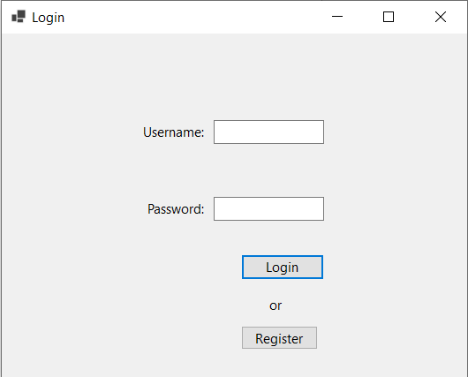

### 5.1.2. UI Main

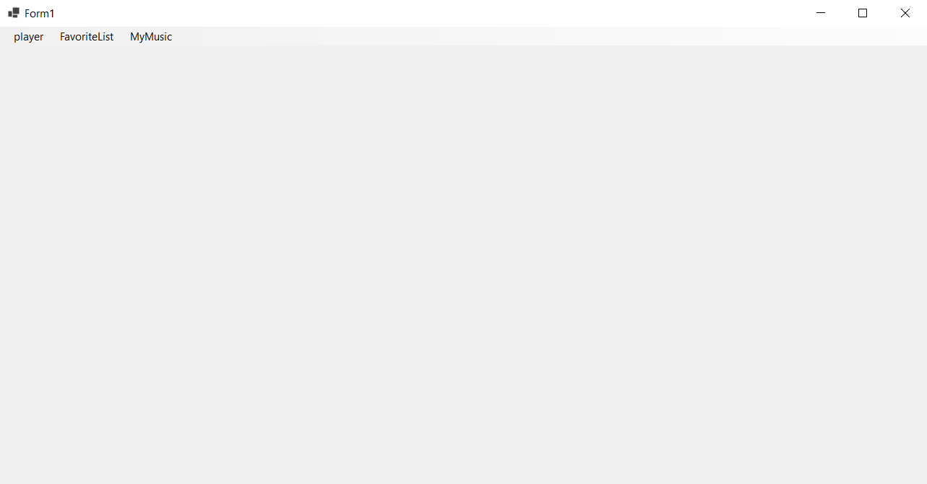

## 5.1.3 UI player

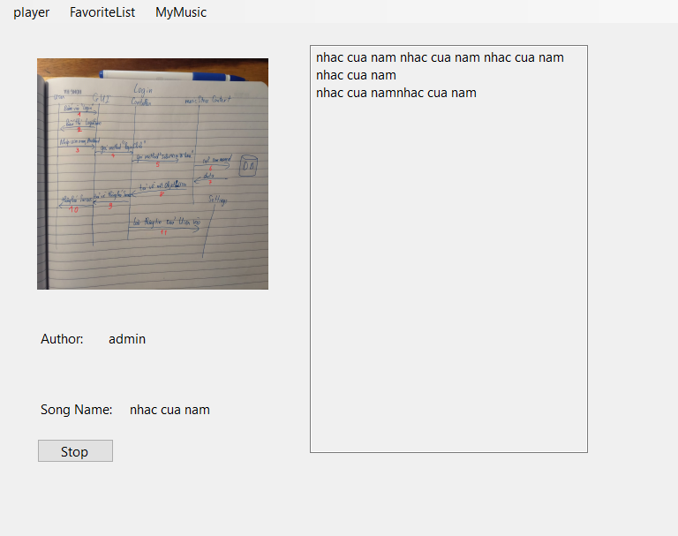

## 5.1.4 UI FavoriteList

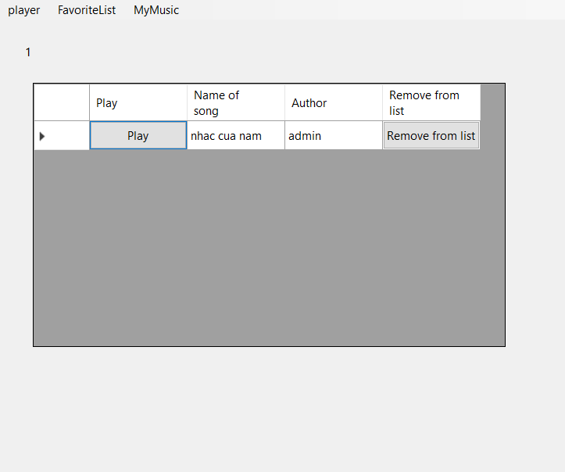

## 5.1.4 UI MyMusic

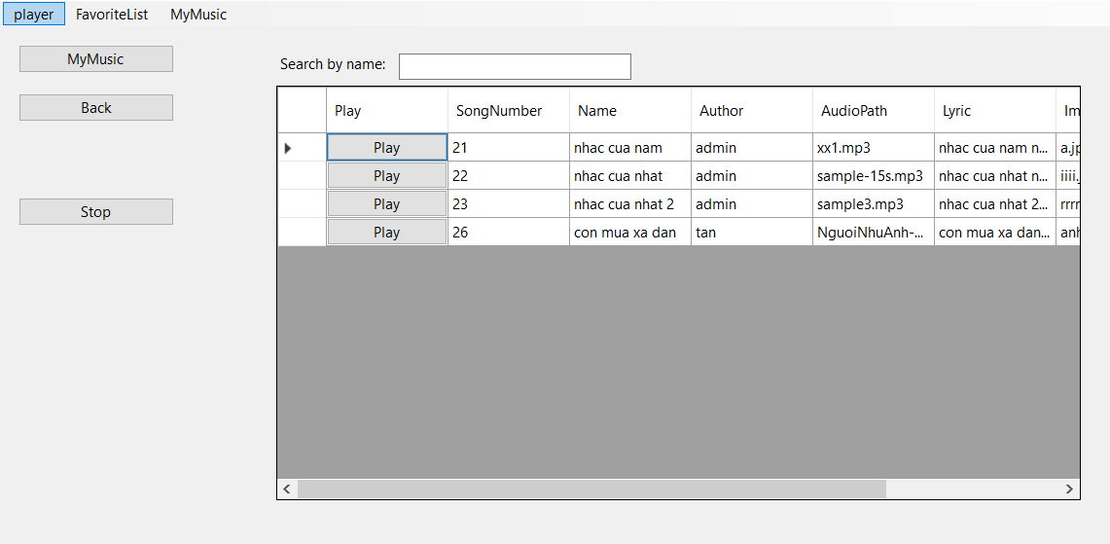

## 5.1.5 UI AdminManageSong

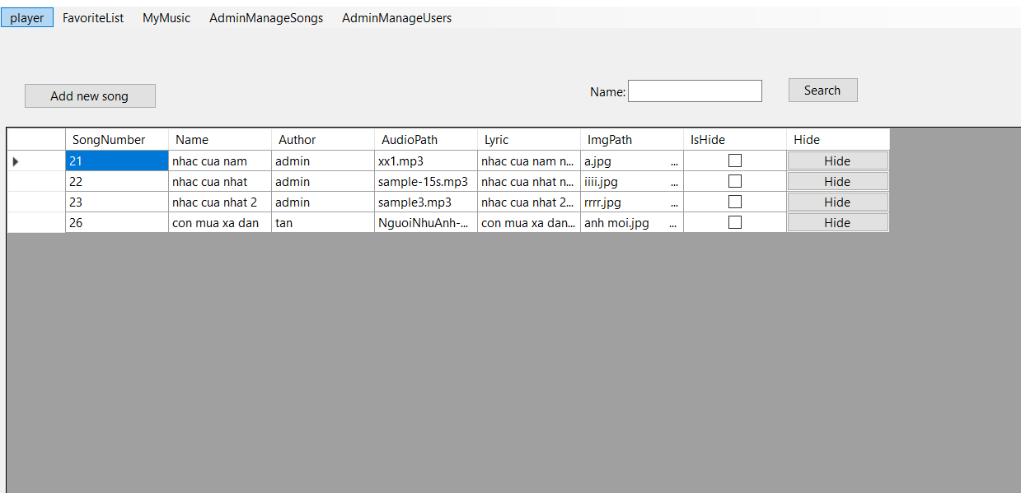

## 5.1.6 UI AdminManageUser

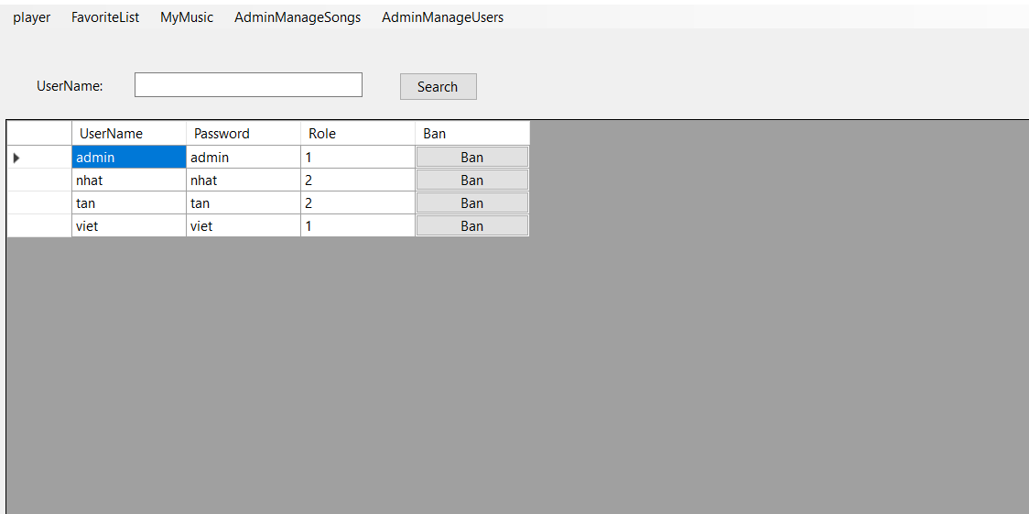

## 5.1.7 UI RegisterNewUser

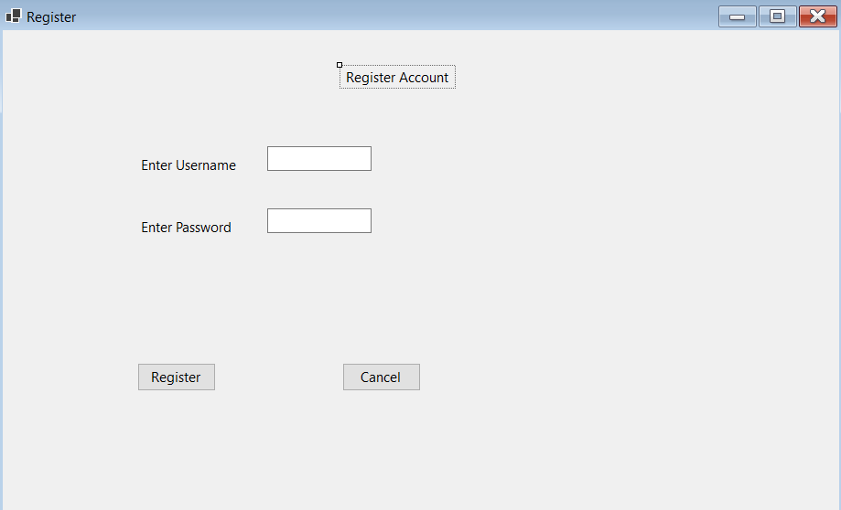

## 5.2 UI Flow