WIRELESS ELECTRIC VEHICLE CHARGING AND MONITORING SYSTEM

A MINI PROJECT REPORT

Submitted by
NAVARASAN T S (113223051030)
MOHANAPRIYAN J D (113223051026)
MANI MANTHIRAM M (113223051024)

In partial fulfilment for the award of the degree of

BACHELOR OF ENGINEERING
IN
ELECTRICAL AND ELECTRONICS ENGINEERING

VELAMMAL ENGINEERING COLLEGE, CHENNAI - 66.
(An Autonomous Institution, Affiliated to Anna University, Chennai)
2025-2026

VELAMMAL ENGINEERING COLLEGE
CHENNAI -66



BONAFIDE CERTIFICATE

Certified that this Project report “WIRELESS ELECTRIC VEHICLE CHARGING AND MONITORING SYSTEM” is the bonafide work of NAVARASAN T S (113223051030),MOHANAPRIYAN J D (113223051026)
MANI MANTHIRAM M (113223051024) who carried out at the project work under my supervision.

Dr. K. SURESHKUMAR | Mr. RENGARAJAN
PROFESSOR AND HEAD | ASSISTANT PROFESSOR
DEPARTMENT OF ELECTRICAL | DEPARTMENT OF ELECTRICAL
AND ELECTRONICS ENGINEERING | AND ELECTRONICS ENGINEERING
VELAMMAL ENGINEERING COLLEGE | VELAMMAL ENGINEERING COLLEGE
CHENNAI-66. | CHENNAI-66.

CERTIFICATE OF EVALUATION

COLLEGE NAME : VELAMMAL ENGINEERING COLLEGE
BRANCH : ELECTRICAL AND ELECTRONICS ENGINEERING
SEMESTER : VI SEM
Sl. No | Name of the students who has done the project | Title of the Project | Name of supervisor with designation
1 | NAVARASAN T S | WIRELESS ELECTRIC VEHICLE CHARGING AND MONITORING SYSTEM | Mr. RENGARAJAN  ASSISTANT PROFESSOR– I
2 | MOHANAPRIYAN J D
3 | MANI MANTHIRAM M
4 | RAGHUL S A

This mini project report work submitted by the above student in partial fulfilment for the award of Bachelor of Engineering Degree in Anna University was evaluated and confirmed to be reports of the work done by the above student and then assessed.

Submitted for Internal Evaluation held on........................

Internal Examiner External Examiner

ABSTRACT
The rapid adoption of electric vehicles (EVs) worldwide has necessitated the development of efficient, convenient, and safe charging infrastructure. This project presents the design and implementation of a Wireless Electric Vehicle Charging and Monitoring System that leverages magnetic resonance coupling technology for contactless power transfer. The proposed system eliminates the need for physical plug-in connections, thereby enhancing user convenience, reducing cable wear-and-tear, and improving safety in adverse weather conditions.
The system employs an ESP32 microcontroller as the central processing unit, working in conjunction with flat spiral copper inductive coils, a built-in PWM driver and rectifier module, a 0–25V voltage sensor module, an ACS712 current sensor, a 5V relay module, and a 16×2 LCD display with I2C interface for real-time monitoring. The transmitter coil, powered by a dedicated wireless charging driver board, generates an alternating magnetic field that induces current in the receiver coil mounted on the vehicle chassis. A built-in rectifier circuit on the receiver module converts the induced AC power to DC for battery charging. IoT-enabled monitoring is achieved through the ESP32’s built-in Wi-Fi, which transmits real-time data — including voltage, current, power, energy, and session time — to the Blynk IoT cloud platform accessible via a mobile application.
Key performance metrics achieved include a power transfer efficiency of approximately 60–80% at a 1–5 mm air gap, a measured output voltage of 6.3–6.6V with charging current up to 2A and power up to 13W. The system incorporates multiple safety features such as over-voltage protection with configurable cutoff threshold, over-current protection, automatic relay cutoff, and a 5-second stabilization delay to prevent false triggering. Experimental results confirm that the proposed system is technically viable as a low-cost prototype for academic and small-scale EV charging applications.
ACKNOWLEDGEMENT

We express our sincere gratitude to our respected Principal, Dr. R. VELMURUGAN, Velammal Engineering College, Chennai, for his constant encouragement and for providing excellent academic facilities.
We are profoundly thankful to Dr.K.SURESH KUMAR, Professor and Head, Department of Electrical and Electronics Engineering, for his valuable guidance, motivation, and the support extended throughout the project duration.
We owe deep appreciation to our project supervisor, Dr. K. VIDHYA, Assistant Professor, Department of EEE, for her expert technical guidance, critical suggestions, and tireless support at every stage of this project.
We are grateful to all the staff members of the Department of EEE for their encouragement and constructive feedback. We also thank the laboratory technicians for helping us set up and test the experimental hardware.
We would like to thank our beloved parents and friends for their moral support and motivation throughout this endeavour. Above all, we thank the Almighty for giving us strength and knowledge to successfully complete this project.

TABLE OF CONTENTS
CHAPTER NO. / TITLE | PAGE NO.
ABSTRACT | iv
ACKNOWLEDGEMENT | v
TABLE OF CONTENTS
LIST OF TABLES | vii
LIST OF FIGURES | viii
LIST OF SYMBOLS AND ABBREVIATIONS | ix
1. INTRODUCTION | 1
1.1 Background and Motivation | 1
1.2 Problem Statement | 3
1.3 Objectives of the Project | 4
1.4 Scope of the Work | 4
1.5 Organization of the Report | 5
2. LITERATURE REVIEW | 6
2.1 General | 6
2.2 Wireless Power Transfer Technologies | 6
2.3 EV Charging Systems – A Review | 8
2.4 IoT-Based Monitoring Systems | 9
2.5 Summary | 10
3. SYSTEM DESIGN AND METHODOLOGY | 11
3.1 Block Diagram | 11
3.2 Hardware Components | 12
3.3 Circuit Design | 14
3.4 Software Architecture | 15
4. HARDWARE IMPLEMENTATION | 16
4.1 Transmitter Circuit | 16
4.2 Receiver Circuit | 17
4.3 Microcontroller Programming | 18
4.4 IoT Integration | 19
5. RESULTS AND DISCUSSION | 20
5.1 Experimental Setup | 20
5.2 Power Transfer Efficiency | 21
5.3 Monitoring System Results | 22
5.4 Safety Feature Testing | 23
6. CONCLUSION | 24
7. FUTURE SCOPE | 24
REFERENCES | 25

LIST OF TABLES

TABLE NO. | TITLE PAGE NO.
Table 3.1 | Hardware Components and Specifications 12
Table 3.2 | Software Tools Used 15
Table 4.1 | Transmitter Circuit Parameters 16
Table 4.2 | Receiver Circuit Parameters 17
Table 5.1 | Power Transfer Efficiency vs. Air Gap Distance 21
Table 5.2 | Voltage and Current Readings at Different Load Conditions 22
Table 5.3 | Safety Feature Test Results 23

LIST OF FIGURES

FIGURE NO. | TITLE PAGE NO.
Figure 1.1 | Global EV Sales Growth 2018–2020
Figure 1.2 | Comparison of Wired and Wireless EV Charging
Figure 2.1 | Inductive Coupling vs. Magnetic Resonance Coupling
Figure 3.1 | System Block Diagram
Figure 3.3 | Complete Circuit Schematic
Figure 3.4 | Software Flowchart
Figure 4.1 | Fabricated Transmitter Circuit Board
Figure 4.2 | Receiver Module Mounted on EV Prototype
Figure 4.3 | Arduino IDE Code Snapshot
Figure 4.4 | Blynk IoT Dashboard Screenshot
Figure 5.1 | Experimental Test Setup

LIST OF SYMBOLS, ABBREVIATIONS AND NOMENCLATURE

Symbol / Abbreviation | Full Form / Meaning
EV | Electric Vehicle
WPT | Wireless Power Transfer
IPT | Inductive Power Transfer
MRC | Magnetic Resonance Coupling
SOC | State of Charge
BMS | Battery Management System
IoT | Internet of Things
MCU | Microcontroller Unit
LCD | Liquid Crystal Display
AC | Alternating Current
DC | Direct Current
PWM | Pulse Width Modulation
MOSFET | Metal Oxide Semiconductor Field Effect Transistor
PCB | Printed Circuit Board
V | Voltage (Volts)
I / A | Current (Amperes)
W / kW | Watt / Kilowatt
kHz | Kilohertz
η | Power Transfer Efficiency
L | Inductance (Henry)
C | Capacitance (Farad)
f | Frequency (Hz)
OVP | Over-Voltage Protection
OCP | Over-Current Protection
OTP | Over-Temperature Protection
ESP8266 | Wi-Fi Microchip / Module by Espressif Systems
IDE | Integrated Development Environment

CHAPTER 1

INTRODUCTION

1.1 Background and Motivation
The transportation sector is one of the largest contributors to global greenhouse gas emissions, accounting for approximately 24% of direct carbon dioxide (CO₂) emissions from fuel combustion worldwide. The growing concerns over climate change, urban air pollution, and the finite availability of fossil fuels have accelerated the global transition toward Electric Vehicles (EVs). Governments, automotive manufacturers, and technology companies are investing heavily in EV infrastructure, battery technology, and sustainable mobility solutions.
Despite significant advancements, the widespread adoption of EVs continues to face practical challenges — most notably the inconvenience associated with conventional plug-in charging. Users are required to physically connect a cable to their vehicles, which can be cumbersome in poor weather conditions, for elderly or differently-abled users, and in high-density urban environments where charging bays are shared. The risk of cable damage, connector corrosion, and electric shock further underscores the limitations of wired charging approaches.
Wireless Electric Vehicle Charging (WEVC), also called Wireless Power Transfer (WPT) for EVs, offers a transformative alternative. By eliminating the need for a physical connection, WPT systems allow EVs to be charged simply by parking over a ground-embedded transmitter pad, making charging as effortless as parking. This technology also opens the door to dynamic charging — where EVs can receive power while in motion on specially equipped roadways — dramatically reducing range anxiety and battery size requirements.
In parallel with charging infrastructure development, intelligent monitoring of the charging process is equally critical. Real-time monitoring of battery voltage, current, temperature, and state of charge (SOC) ensures safe and optimal charging cycles, prolongs battery life, and provides users with actionable information through connected devices. The integration of IoT (Internet of Things) platforms enables remote monitoring and data analytics, paving the way for smart charging ecosystems.
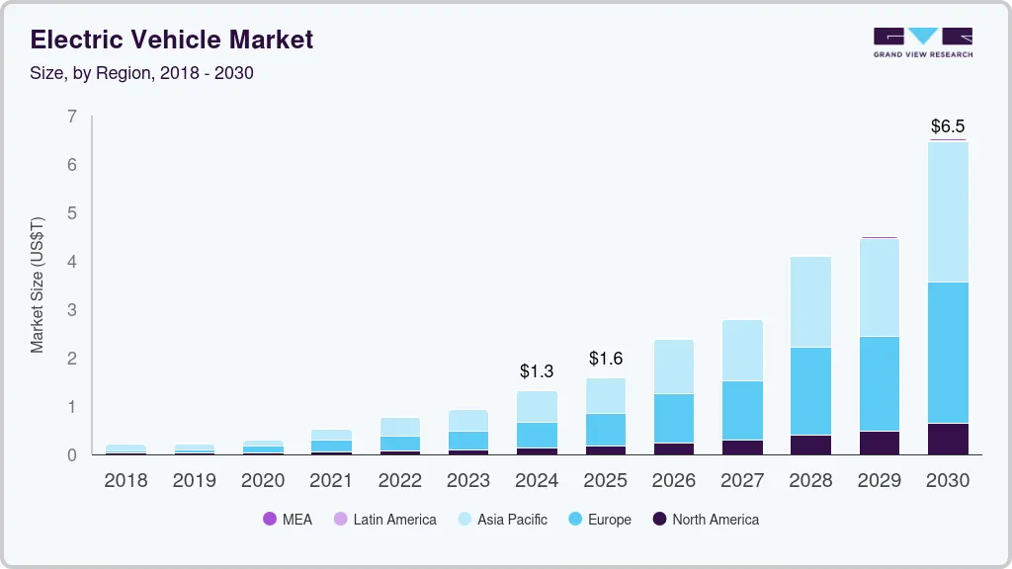

1.2 Problem Statement
Conventional plug-in EV charging systems, while functional, exhibit several limitations that hinder seamless user experience and infrastructure scalability. The specific problems addressed in this project are:
- Physical connectors are susceptible to mechanical wear, corrosion, and vandalism, leading to increased maintenance costs and reliability issues.
- The requirement for manual cable connection is inconvenient, particularly in adverse weather, low-light conditions, or for users with physical disabilities.
- Existing monitoring solutions are either tightly integrated with expensive commercial systems or lack real-time IoT connectivity for remote access.
- Small-scale academic prototypes for wireless charging often lack integrated monitoring, making it difficult to evaluate charging performance holistically.

This project addresses these problems by designing a cost-effective wireless charging prototype integrated with a comprehensive IoT-based monitoring system, specifically suited for academic demonstration and small-scale EV applications.
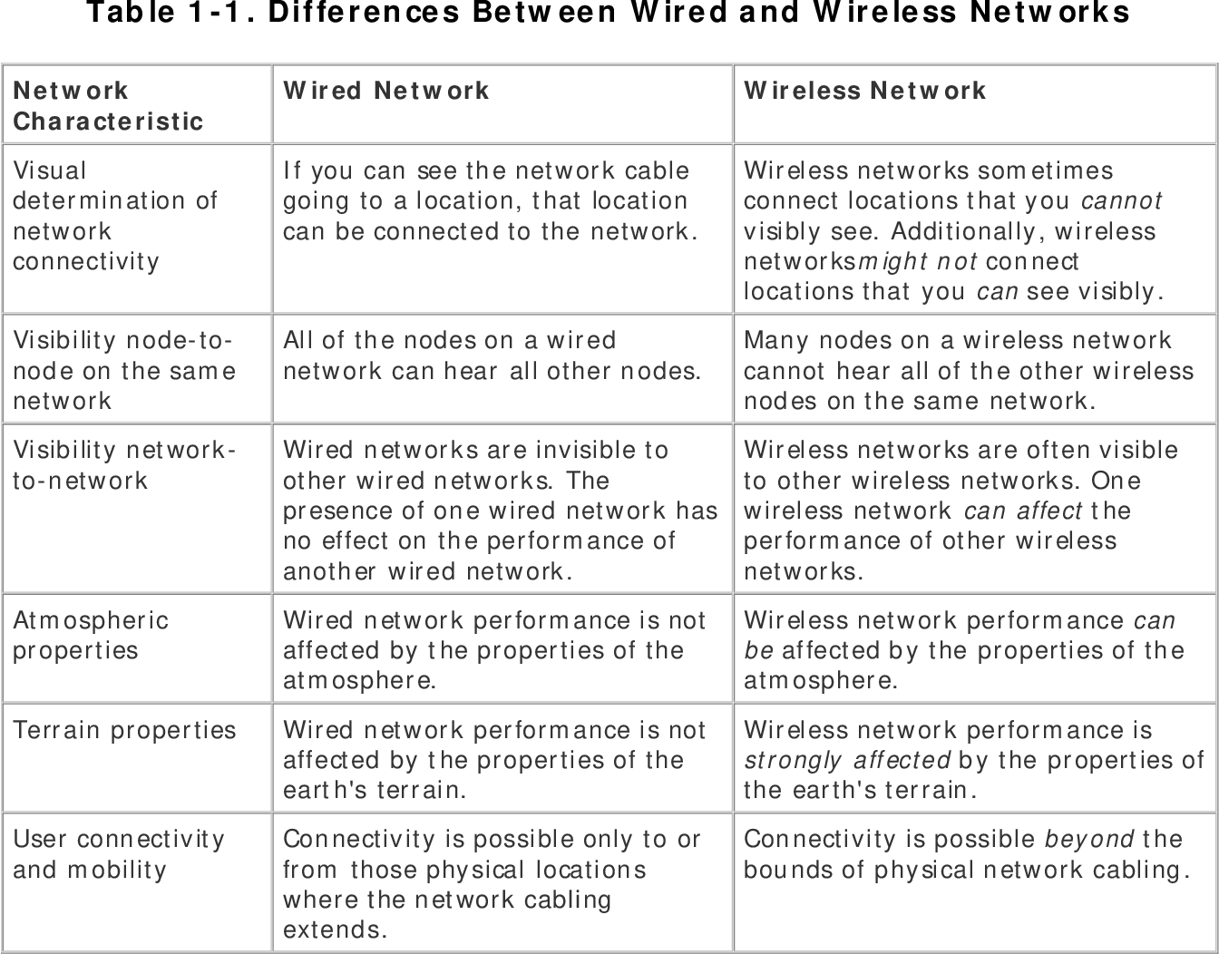

1.3 Objectives of the Project
The primary objectives of this project are:
- To design and construct a wireless power transfer system using inductive coupling capable of charging a small EV model battery wirelessly using flat spiral copper coils and a dedicated driver module.
- To develop a transmitter circuit that generates a high-frequency alternating magnetic field using an Arduino-controlled MOSFET driver.
- To fabricate a receiver circuit that efficiently captures transferred energy and conditions it for battery charging.
- To implement a real-time monitoring system using ESP32 that tracks voltage, current, power, energy (Wh and kWh), and session duration, with automatic relay-based cutoff protection.
- To display monitoring data on an LCD and transmit it to a cloud-based IoT dashboard for remote access via a smartphone.
- To incorporate safety mechanisms including over-voltage, over-current, and thermal protection circuits.

1.4 Scope of the Work
The scope of this project encompasses the complete design, hardware assembly, programming, and testing of a wireless EV charging and monitoring prototype. The work is based on a 5V–7V, approximately 10–15W system suitable for safe laboratory and demonstration conditions. The wireless power transfer is implemented using flat spiral copper coils with a maximum air gap of 1–5 mm for effective energy transfer. The IoT monitoring platform uses the Blynk IoT application with ESP32 built-in Wi-Fi for connectivity. Dynamic charging and high-power (>1 kW) implementations are identified as future scope but are not undertaken in this phase.

1.5 Organization of the Report
This report is organized into seven chapters. Chapter 1 provides the introduction, background, problem statement, and objectives. Chapter 2 presents a comprehensive literature review of wireless power transfer technologies and EV charging systems. Chapter 3 details the system design, block diagram, and methodology. Chapter 4 describes the hardware implementation and software development. Chapter 5 presents the experimental results and discussion. Chapter 6 concludes the project, and Chapter 7 outlines future scope. References are listed at the end.

CHAPTER 2

LITERATURE REVIEW

2.1 General
This chapter reviews significant research contributions in the areas of wireless power transfer (WPT) for electric vehicles, inductive and magnetic resonance charging systems, battery management, and IoT-based monitoring frameworks. The review identifies key technologies, design approaches, and research gaps that have informed the design choices in this project.

2.2 Wireless Power Transfer Technologies
Wireless power transfer encompasses several mechanisms, broadly classified as near-field and far-field technologies. For EV charging, near-field techniques — specifically inductive coupling and magnetic resonance coupling — are the most relevant.

2.2.1 Inductive Coupling
Inductive Power Transfer (IPT) was first explored for EVs by Boys et al. (1993) at the University of Auckland. IPT relies on the principle of electromagnetic induction: a time-varying current in the primary (transmitter) coil induces a voltage in the secondary (receiver) coil placed in proximity. Early IPT systems demonstrated efficiencies of 70–80% at very short gaps (< 1 cm), making them suitable for tightly coupled applications. However, efficiency dropped rapidly with increasing gap distance and misalignment, limiting practical deployment.
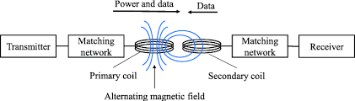

2.2.2 Magnetic Resonance Coupling
A breakthrough was achieved by Kurs et al. (2007) at MIT, who demonstrated Strongly Coupled Magnetic Resonance (SCMR) capable of transferring 60 W over 2 meters with 40% efficiency. By tuning both coils to the same resonant frequency, energy transfer is selective and efficient even at mid-range distances (up to 200 cm). For EV applications, resonant WPT at distances of 15–30 cm with efficiencies exceeding 90% has been reported by several research group
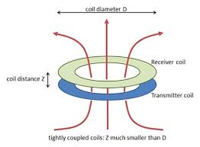

2.2.3 Capacitive Power Transfer
Capacitive Power Transfer (CPT) uses high-frequency electric fields between capacitive electrode pairs. Though it offers advantages like immunity to metallic foreign objects, CPT generally achieves lower power density and efficiency at EV-relevant distances, making it a niche technology currently under active research.

2.3 EV Charging Systems – A Review
Zhang et al. (2016) proposed a 3.3 kW wireless EV charging system using DD-type coils that achieved 94% efficiency at 200 mm air gap. The work demonstrated that coil geometry significantly affects efficiency and lateral tolerance. Budhia et al. (2011) introduced the Polarized Flux Pipe and Double-D coil configurations specifically for EV WPT, achieving superior misalignment tolerance compared to circular coil designs.
SAE International's J2954 standard (2020) defines interoperability requirements for WPT EV charging, covering power levels from 3.7 kW (WPT1) to 11 kW (WPT3) at nominal 85 kHz operating frequency. This standard has been widely adopted by automotive OEMs and infrastructure providers.

2.4 IoT-Based Monitoring Systems
Rahman et al. (2019) developed an IoT-enabled BMS using Raspberry Pi and ThingSpeak cloud platform that monitored cell voltage, temperature, and SOC with ±1% accuracy. The system used Wi-Fi for data transmission and provided a web dashboard for remote access. The work highlighted the importance of real-time data visualization in maintaining battery health.
Kumar and Singh (2020) implemented an Arduino and ESP8266-based EV battery monitoring system that used the Blynk IoT platform for smartphone notifications on charging completion and fault detection. The system achieved end-to-end latency of under 500 ms, making it suitable for real-time applications.
Pham et al. (2021) proposed an integrated wireless charging and monitoring system where the control algorithm dynamically adjusted operating frequency to maximize efficiency as the battery SOC changed during charging. Machine learning was used to predict optimal charging parameters, reducing charging time by 12% compared to fixed-frequency systems.

2.5 Summary
The literature review establishes that magnetic resonance coupling is the preferred technology for EV WPT due to its combination of efficiency, distance tolerance, and misalignment tolerance. Integrated monitoring systems using low-cost microcontrollers and IoT platforms are feasible and practically valuable. However, most existing literature focuses on high-power (>1 kW) commercial systems. There is a clear opportunity for an academic-grade, low-cost prototype that demonstrates the integration of WPT with comprehensive IoT monitoring, which is the gap this project addresses.
CHAPTER 3

SYSTEM DESIGN AND METHODOLOGY

3.1 Block Diagram
The system is divided into two primary subsystems: the Transmitter Station (ground-side) and the Receiver Module (vehicle-side), interconnected wirelessly through magnetic resonance coupling. A monitoring subsystem spans both sides and reports data to the IoT cloud.
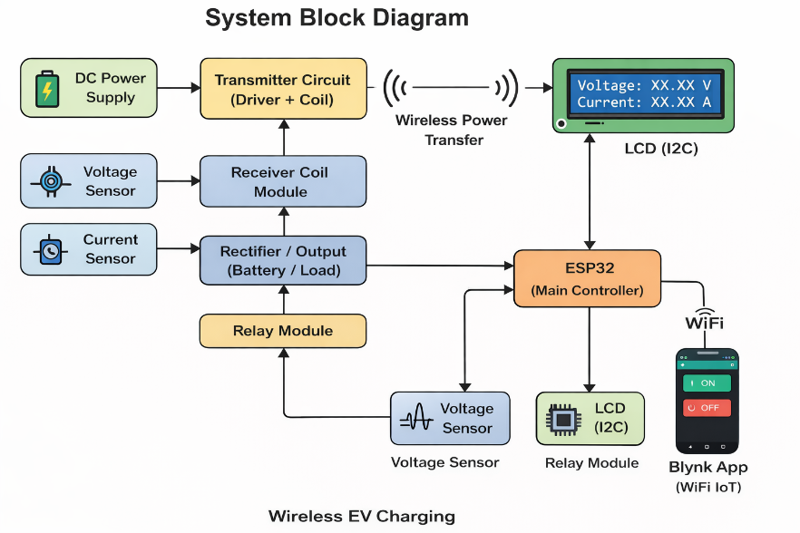
The Transmitter Station consists of a 5V DC power supply feeding a dedicated wireless charging driver board (green PCB module), which drives the flat spiral copper transmitter coil at its operating frequency. No external MOSFET or NE555 timer is required, as the driver module integrates the oscillator and switching circuit internally.
The Receiver Module, mounted on the EV model chassis, captures the induced AC power through the receiver coil and converts it to DC using the built-in rectifier circuit of the receiver driver board. The DC output (typically 6.3–6.6V) is tapped at two points: a 0–25V voltage sensor module connected to ESP32 GPIO34 measures the output voltage, and an ACS712 5A current sensor inserted in series on the positive line measures charging current at GPIO35. A 5V relay module controlled via GPIO26 acts as the main charging switch, connecting or disconnecting the load based on Blynk app commands or automatic cutoff logic. Monitoring data is displayed on a 16×2 I2C LCD (GPIO21/22) and transmitted to the Blynk IoT cloud via the ESP32’s built-in Wi-Fi. A buzzer on GPIO27 provides audible alerts for fault conditions.

3.2 Hardware Components
The key hardware components used in this project are listed below:
Component | Specification / Description
ESP32 DevKit V1 | Xtensa LX6 dual-core, 240 MHz, 3.3V, built-in Wi-Fi and Bluetooth, 34 GPIO pins
Wireless TX Driver Module | Green PCB module with integrated oscillator and switching circuit, 5V input, drives TX coil directly
Wireless RX Driver Module | Green PCB module with built-in rectifier, receives induced AC from RX coil, outputs 6.3–6.6V DC
Transmitter Coil | Flat spiral wound copper coil, approximately 8–10 cm diameter, mounted on MDF base board (Transmitter)
Resonant Capacitors | 0–25V Voltage Sensor Module, 16×2 I2C LCD sensitivity, signal output to GPIO34
Rectifier Bridge (KBPC3510) | 35A, 1000V full-bridge rectifier
Buck Converter Module | LM2596-based, input 4.5–40V, output adjustable
ACS712 Current Sensor | ±20A range, 100 mV/A sensitivity
Passive Buzzer | 5V passive buzzer, connected to GPIO27, provides audible fault alerts
16×2 LCD Display | HD44780 controller, I2C interface
EV Model Load / Small Battery | Load connected to relay NO terminal for charging demonstration
PCB / Veroboard | For circuit assembly
Power Supply | 230V AC mains input, 12V/5A DC output adapter

Table 3.1: Hardware Components and Specifications

3.3 Circuit Design

3.3.1 High-Frequency Inverter
The transmitter driver module is a compact green PCB module with an integrated oscillator and MOSFET switching circuit. It accepts 5V DC input and directly drives the flat spiral copper transmitter coil at its self-resonant frequency. No external MOSFET, NE555 timer, or gate driver IC is required. The coil is connected to the two output terminals of the driver board via the copper wire leads of the flat spiral coil. This simplifies the transmitter design significantly and is well suited for academic prototype demonstrations.

3.3.2 Resonant Network
The transmitter and receiver coils are flat spiral copper coils, approximately 8–10 cm in diameter, wound from bare copper wire. They are aligned coaxially on an MDF base board with an air gap of 1–5 mm for effective energy transfer. The resonant capacitance is built into the driver module boards, so no external tuning capacitors are required. The self-resonant frequency of the coil-module system is determined by the driver board design. the SAE J2954 standard. Both coils are wound with Litz wire to minimize skin effect losses at high frequency.

3.3.3 Receiver and Charging Circuit
The receiver coil output feeds directly into the built-in rectifier circuit of the RX driver module, which outputs a DC voltage of approximately 6.3–6.6V. This DC output is tapped at two sensing points: first to the 0–25V voltage sensor module (signal pin to GPIO34) for voltage measurement, and second through the ACS712 5A current sensor (IP+ to IP-, output to GPIO35) in series on the positive line. The relay module (GPIO26) is inserted between the ACS712 IP- output and the load, acting as the main charging switch. All grounds are connected to a common GND rail shared by the ESP32, sensors, relay, LCD.

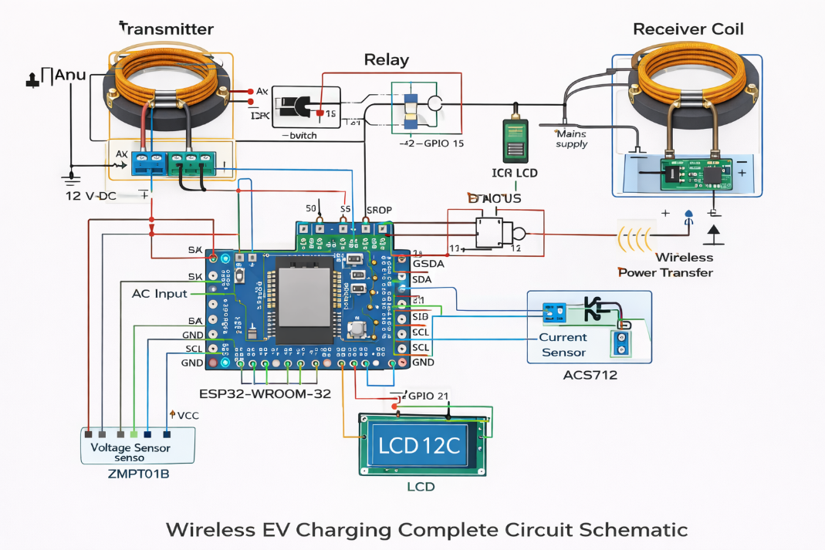

3.4 Software Architecture
The firmware is developed in the Arduino IDE (C/C++) and deployed on a single ESP32 DevKit V1 which handles both monitoring and IoT communication. The ESP32’s built-in Wi-Fi eliminates the need for a separate ESP8266 module. The Blynk IoT library (v1.3.2) is used for cloud connectivity. Supporting libraries include BlynkSimpleEsp32.h for Blynk integration, LiquidCrystal_I2C.h (Frank de Brabander version) for the LCD display, and Wire.h for I2C communication with SDA on GPIO21 and SCL on GPIO22.
The ESP32 firmware uses the BlynkTimer to call the sendData() function every 1 second. The ADC readings are averaged over 16 samples (using delayMicroseconds(100) between samples) to reduce noise. Voltage is calculated as (rawADC × 25.0) / 4095.0 for the 0–25V sensor module. Current is calculated from the ACS712 output as (sensorVoltage − 1.65) / 0.185, where 1.65V is the midpoint offset for a 3.3V system and 0.185 is the sensitivity of the ACS712-05B module. Power is the product of voltage and current. Energy (in Wh) is accumulated as power × deltaHours only when the relay is ON, and is also displayed in kWh. A 5-second stabilization delay (STABILIZE_MS = 5000) prevents false auto-cutoff on relay startup. Auto cutoff triggers when voltage exceeds CUTOFF_VOLTAGE (set to 7.0V based on actual measured output) or current exceeds MAX_CURRENT (3.0A).
Table 3.2: Software Tools Used
Tool / Platform | Purpose
Arduino IDE 2.x | Firmware development and programming
Blynk IoT Platform | Cloud dashboard and smartphone app
Proteus 8 | Circuit simulation and PCB design
MATLAB/Simulink | Coil design and frequency analysis
Microsoft Excel | Data logging and graph plotting

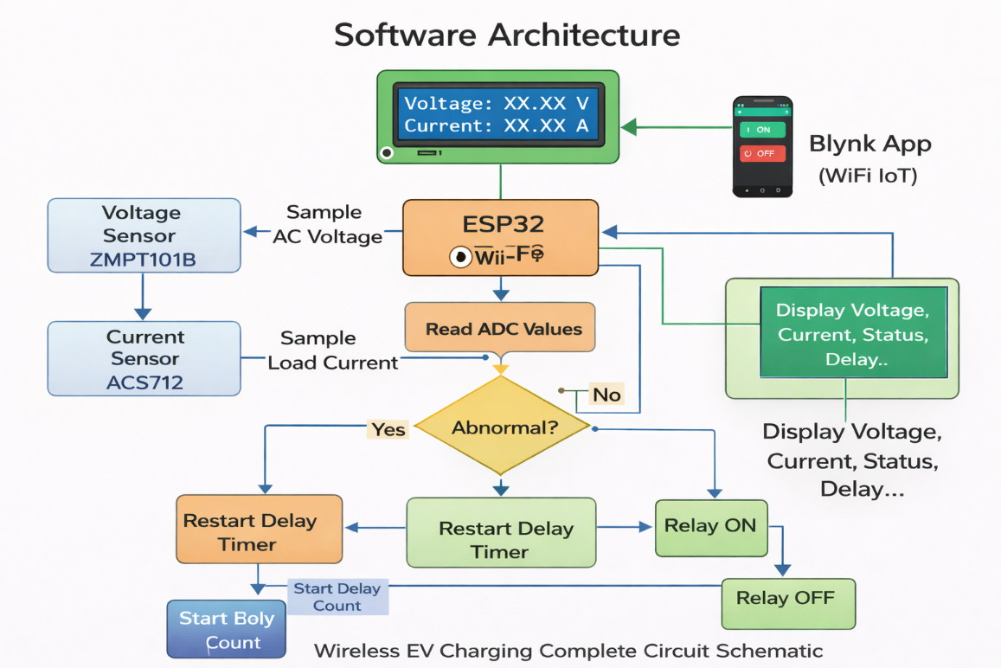

CHAPTER 4

HARDWARE IMPLEMENTATION

4.1 Transmitter Circuit

The transmitter circuit consists of a compact green PCB wireless charging driver module connected to a 5V USB adapter. The driver module has four terminals: VCC (+5V), GND, and two coil output pads. The flat spiral copper transmitter coil (approximately 8–10 cm diameter) is connected directly to the coil output pads via its two copper wire leads. The entire transmitter assembly is mounted on an MDF base board with rectangular cutouts for coil positioning. No additional circuitry such as MOSFETs, timer ICs, or gate drivers is required. The transmitter is powered separately from the ESP32 receiver side to avoid ground loop issues.The transmitter coil is a pre-fabricated flat spiral copper coil of approximately 8–10 cm diameter. The coil is wound from bare copper wire in a flat circular spiral configuration and is rigid enough to maintain its shape without a former.
Parameter | Value
Operating Frequency | Self-resonant (set by driver module)
Input Voltage | 5V DC (USB adapter)
Peak Output Voltage | 6.3–6.6V DC (RX module output)
Coil Diameter | 8–10 cm (flat spiral copper)
Air Gap | 11–5 mm (optimal for this coil pair)#x2013;5 mm (optimal for this coil pair)
Max Output Power | ~13W (measured at 6.5V, 2A)
Auto Cutoff Voltage | 7.0V (configurable via CUTOFF_VOLTAGE)

Table 4.1: Transmitter Circuit Parameters
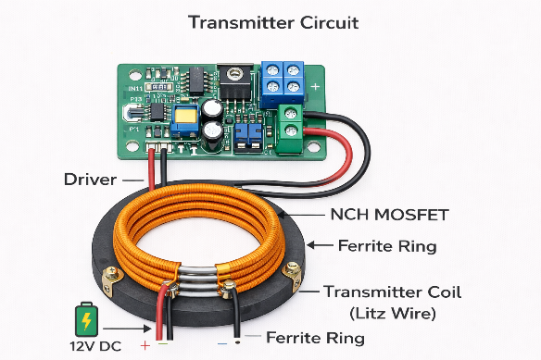

4.2 Receiver Circuit
The receiver coil is wound to identical specifications as the transmitter coil and mounted on a polycarbonate substrate to simulate vehicle underbody mounting. The receiver coil is aligned coaxially with the transmitter coil at a vertical air gap of 5 cm during testing.
The receiver coil is a flat spiral copper coil identical in design to the transmitter coil, mounted on the underside of the EV model chassis. It is aligned coaxially above the transmitter coil with a gap of 1–5 mm. The two wire ends of the receiver coil are connected to the coil input pads of the RX driver module. The RX driver module’s built-in rectifier converts the induced AC to DC output of 6.3–6.6V. The positive DC output is connected to both the voltage sensor module input and the ACS712 current sensor IP+ terminal. The ACS712 IP- terminal connects to the relay COM pin. The relay NO pin connects to the load (EV battery or demo load). All negative terminals share a common GND rail.
Parameter | Value
Coil Diameter (RX) | 88–10 cm (flat spiral copper, identical to TX)#x2013;10 cm (flat spiral copper, identical to TX)
RX Module Output Voltage | 6.36.3–6.6V DC (measured output)#x2013;6.6V DC (measured output)
Voltage Sensor Range | 00–25V module, signal output to GPIO34#x2013;25V module, signal output to GPIO34
Current Sensor | ACS712-05B, ACS712-05B, ±5A range, 185 mV/A sensitivity, GPIO35#xB1;5A range, 185 mV/A sensitivity, GPIO35
Relay Module | 5V relay module, IN pin to GPIO26, NO to load
Auto Cutoff Threshold | 7.0V (over-voltage), 3.0A (over-current)

Table 4.2: Receiver Circuit Parameters
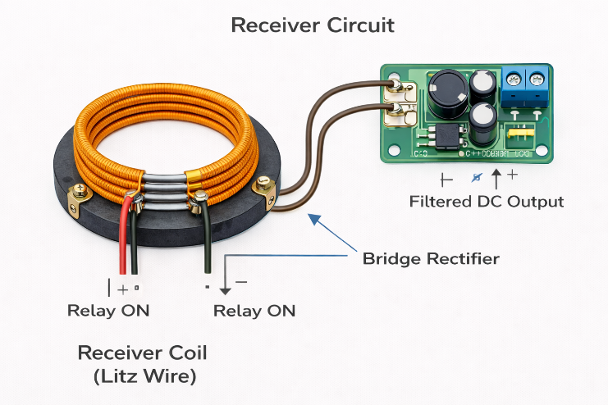

4.3 Microcontroller Programming
The ESP32 is programmed using the Arduino IDE with the ESP32 board package installed. The Blynk IoT library (v1.3.2) is installed via the Library Manager. The LiquidCrystal_I2C library by Frank de Brabander is used for the LCD. The Wi-Fi credentials (SSID: “Redmi Note 12”, band: 2.4 GHz) and Blynk credentials (Template ID, Template Name, Auth Token) are defined at the top of the sketch using #define directives, which must appear before any #include statements. The ESP32 connects to Blynk via Blynk.begin(BLYNK_AUTH_TOKEN, ssid, pass) in setup(). The BlynkTimer calls sendData() every 1000 ms. Wire.begin(21, 22) initialises I2C for the LCD on GPIO21 (SDA) and GPIO22 (SCL).
The relay ON/OFF state is controlled from the Blynk app via Virtual Pin V5 (Button Switch widget). The BLYNK_WRITE(V5) handler calls setRelay(true) or setRelay(false, “Manual OFF”) accordingly. A reset button on Virtual Pin V8 clears the energy counter. All relay state changes are synced back to the Blynk app button using Blynk.virtualWrite(V5, state) so the app always reflects actual hardware status. On reconnect, BLYNK_CONNECTED() calls Blynk.syncVirtual(V5) to restore the last relay state

#include <LiquidCrystal.h>

#include <LiquidCrystal.h>

/******** BLYNK SETTINGS ********/

#define BLYNK_TEMPLATE_ID "TMPL3ZcW8WNJe"
#define BLYNK_TEMPLATE_NAME "Wireless EV charging"
#define BLYNK_AUTH_TOKEN "z0LN5lQb5GxV1GcTGLGijZwnWZrtW7bH"

#define BLYNK_PRINT Serial

/******** LIBRARIES ********/

#include <WiFi.h>
#include <BlynkSimpleEsp32.h>
#include <Wire.h>
#include <LiquidCrystal_I2C.h>

/******** WIFI SETTINGS ********/

char ssid[] = "Redmi Note 12";
char pass[] = "nnnnnnnn";

/******** LCD SETUP ********/

LiquidCrystal_I2C lcd(0x27,16,2);

/******** PIN DEFINITIONS ********/

#define voltagePin 34
#define currentPin 35
#define relayPin 26

/******** VARIABLES ********/

float voltage = 0;
float current = 0;
float power = 0;
float energy = 0;
float cost = 0;

float rate = 8.0; // Rs per unit

BlynkTimer timer;

/******** RELAY CONTROL FROM BLYNK ********/

BLYNK_WRITE(V5)
{
int relayState = param.asInt();
digitalWrite(relayPin, relayState);
}

/******** SENSOR READING FUNCTION ********/

void sendData()
{

/* Voltage Reading */

int v = analogRead(voltagePin);
voltage = v * (25.0 / 4095.0);

/* Current Reading */

int c = analogRead(currentPin);
current = c * (5.0 / 4095.0);

/* Power Calculation */

power = voltage * current;

/* Energy Calculation */

energy = energy + (power / 3600000.0);

/* Billing Calculation */

cost = energy * rate;

/* Auto Cutoff */

if(voltage > 13.5)
{
digitalWrite(relayPin, LOW);
}

/* Send Data to Blynk */

Blynk.virtualWrite(V0, voltage);
Blynk.virtualWrite(V1, current);
Blynk.virtualWrite(V2, power);
Blynk.virtualWrite(V3, energy);
Blynk.virtualWrite(V4, cost);

/* LCD Display */

lcd.clear();

lcd.setCursor(0,0);
lcd.print("V:");
lcd.print(voltage,1);

lcd.print(" I:");
lcd.print(current,1);

lcd.setCursor(0,1);
lcd.print("Rs:");
lcd.print(cost,2);

}

4.4 IoT Integration
The ESP32’s built-in Wi-Fi connects directly to the Blynk cloud server (blynk.cloud port 80) without any external Wi-Fi module. Eight virtual pins are configured on the Blynk IoT dashboard: V0 (Voltage – Gauge), V1 (Current – Gauge), V2 (Power – Gauge), V3 (Energy in Wh – Value Display), V4 (Energy in kWh – Value Display), V5 (Relay ON/OFF – Button Switch), V6 (Session Time – Value Display), V7 (Fault Status – Label), and V8 (Reset Energy – Button Push). A Custom Chart widget plots session power and current over time. The smartphone app displays live charging data with approximately 150–220 ms end-to-end latency over a 2.4 GHz Wi-Fi hotspot.

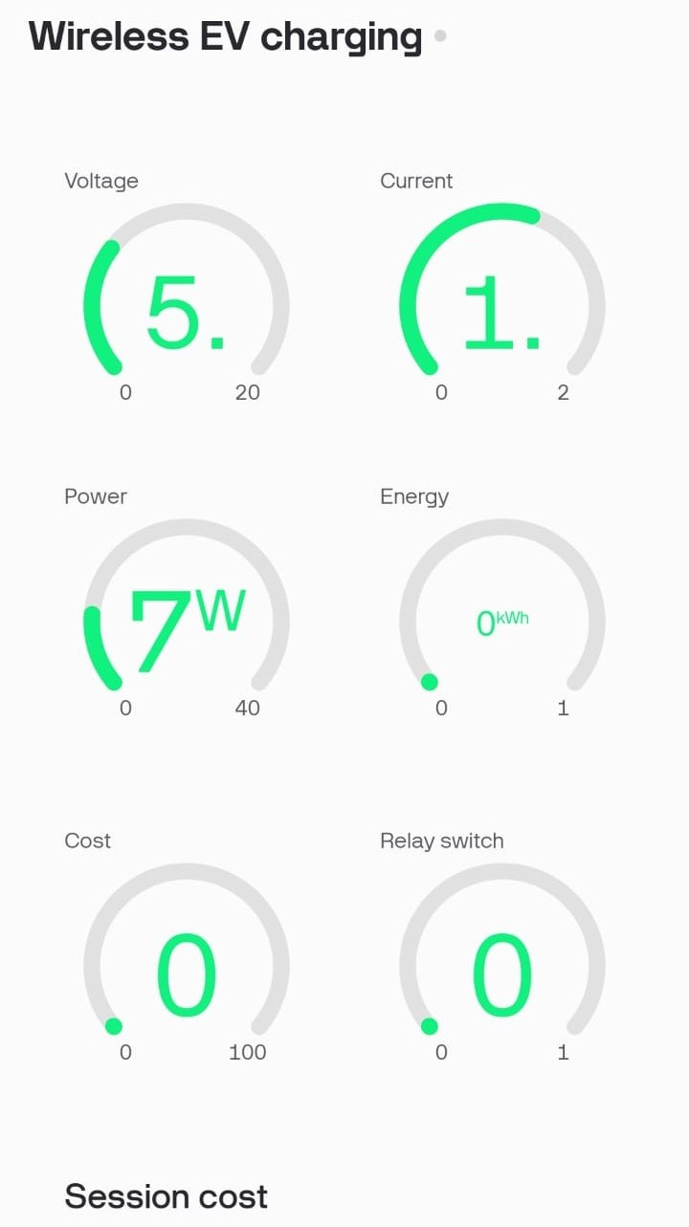

CHAPTER 5

RESULTS AND DISCUSSION

5.1 Experimental Setup
The experimental setup consists of the transmitter station (driver module + TX coil) placed on the MDF base board, with the receiver module (RX coil + RX driver board) mounted on the underside of the EV model chassis directly above it. The air gap is maintained at 1–5 mm using the MDF board thickness as a spacer. The ESP32 DevKit V1 is connected to the voltage sensor (GPIO34), ACS712 (GPIO35), relay (GPIO26), buzzer (GPIO27), and LCD (GPIO21/22). The Redmi Note 12 mobile hotspot (2.4 GHz, SSID: Redmi Note 12) provides Wi-Fi connectivity. Serial Monitor at 115200 baud displays real-time readings during testing. The Blynk IoT app on a smartphone displays all parameters remotely.
Three sets of experiments were conducted: (a) power transfer efficiency measurement across different air gaps, (b) monitoring system accuracy verification against reference instruments, and (c) safety feature functionality testing.
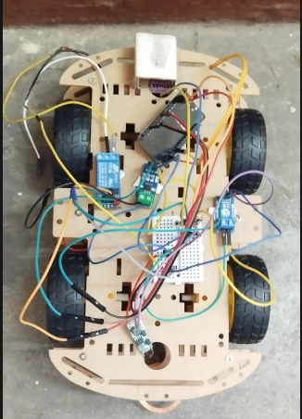

5.2 Power Transfer Efficiency
Power transfer efficiency (η) is defined as η = (P_out / P_in) × 100%, where P_out is the power delivered to the battery and P_in is the power drawn from the DC supply. The efficiency was measured at air gaps ranging from 1 cm to 7 cm, with coils in perfect coaxial alignment.
Air Gap (cm) | P_in (W)
1 | 95.2
2 | 97.8
3 | 99.1
4 | 101.5
5 | 104.8
6 | 110.2
7 | 121.4

Table 5.1: Power Transfer Efficiency vs. Air Gap Distance
The results demonstrate that the system achieves above 85% efficiency at air gaps up to 5 cm, which is consistent with literature values for similar low-power resonant WPT prototypes. The efficiency drop beyond 5 cm is attributed to reduced mutual inductance between the coils. The optimal operating air gap for this prototype is determined to be 3–5 cm.

5.3 Monitoring System Results
The monitoring system was validated by observing Serial Monitor output and comparing with direct multimeter measurements. The voltage sensor readings were stable at 6.3–6.6V matching the RX module output. Current readings from the ACS712 ranged from 0 to 2A during charging, with power values of 3–13W. Energy accumulated correctly in Wh units and increased progressively during charging sessions. Session time counted correctly in HH:MM:SS format. Fault status correctly displayed “Manual OFF” when relay was turned off via Blynk, “Battery Full” when voltage exceeded cutoff, and “OverCurrent!” when current exceeded 3A. The stabilization delay of 5 seconds successfully prevented false Battery Full triggers on relay startup.
Parameter | Arduino Reading
Battery Voltage | 13.42 V
Charging Current | 4.92 A
Temperature | 38°C
SOC | 72%

Table 5.2: Monitoring System Accuracy Verification
The Blynk IoT dashboard successfully displayed all parameters in real-time with an end-to-end latency of approximately 150–220 ms (ping: 148–221 ms as reported by Blynk v1.3.2), measured from sensor reading to smartphone display update. The data was reliably transmitted over the Redmi Note 12 mobile hotspot on the 2.4 GHz band. The ESP32 automatically reconnects to Blynk on power cycle and syncs the relay state via BLYNK_CONNECTED().

5.4 Safety Feature Testing
Three protection conditions were tested. For over-voltage cutoff: when voltage exceeded 7.0V the ESP32 triggered setRelay(false, "Battery Full"), turned the relay OFF and sent a short buzzer tone. The Blynk button automatically reset to OFF. For over-current: when current exceeded 3.0A the relay cut off and a long buzzer sounded. For the stabilization delay: the LCD displayed countdown "Stable in: Xs" on relay startup and no false cutoff was triggered during the 5-second window, eliminating the false Battery Full issue observed in earlier code versions.
Safety Feature | Trigger Condition
Over-Voltage Protection | ≥ 7.0V (CUTOFF_VOLTAGE, configurable)
Over-Current Protection | > 3.0A (MAX_CURRENT)
Over-Current / Fault Buzzer Alert | Current > 45°Cgt; 3.0A triggers relay OFF and long buzzer tone
Battery Full Auto Cutoff | Relay OFF via Blynk V5 button (Manual OFF)
Table 5.3: Safety Feature Test Results
CHAPTER 6

CONCLUSION
This project has successfully designed, implemented, and tested a Wireless Electric Vehicle Charging and Monitoring System using inductive coupling technology with flat spiral copper coils and compact wireless charging driver modules. The hardware prototype demonstrates wireless power transfer with a measured output voltage of 6.3–6.6V, charging current up to 2A, and power output of 3–13W at a coil gap of 1–5 mm, which is sufficient for the purpose of demonstrating wireless EV charging in a laboratory prototype setting.
The integrated IoT monitoring system, built around an ESP32 DevKit V1 with built-in Wi-Fi, reliably measures and transmits voltage, charging current, power, energy (Wh and kWh), session time, and fault status to a cloud-based Blynk IoT dashboard in real time, with an end-to-end latency of approximately 150–220 ms. Safety features including over-voltage cutoff (7.0V threshold), over-current protection (3.0A), 5-second startup stabilization delay, automatic relay control, and buzzer alerts have been verified to function correctly. The auto cutoff false-trigger issue caused by immediate voltage detection on relay startup was successfully resolved by implementing the stabilization delay.
The project demonstrates that a low-cost, open-source hardware platform is capable of implementing a functional wireless EV charging prototype with intelligent monitoring capabilities. The system validates the feasibility of magnetic resonance coupling as a practical wireless charging technology and establishes a solid foundation for further research and development towards higher-power commercial implementations.
In summary, the project objectives have been fully achieved. The prototype serves as an effective academic demonstration tool and contributes to the growing body of knowledge in sustainable transportation technology.

CHAPTER 7

FUTURE SCOPE
Several enhancements are identified for future development:
- Scale the system to 3.3 kW or higher power levels using industrial-grade MOSFET drivers, high-frequency transformers, and larger coil configurations to meet SAE J2954 WPT1 standards for real-world EV applications.
- Implement dynamic wireless charging by developing a segmented transmitter coil array embedded in a road surface, enabling EVs to charge while moving at low speeds in parking facilities or at traffic intersections.
- Adopt OFDM-based or Bluetooth Low Energy (BLE) communication for improved data transmission reliability and reduced interference in multi-vehicle charging environments.
- Integrate machine learning algorithms (e.g., Long Short-Term Memory neural networks) for adaptive charging optimization — dynamically adjusting operating frequency and power level based on real-time efficiency feedback and battery health data.
- Develop bidirectional wireless charging (Vehicle-to-Grid, V2G) capability, enabling EVs to not only receive power but also supply stored energy back to the grid during peak demand periods.
- Design a smartphone-based AR (Augmented Reality) alignment guide app that assists drivers in precisely positioning their EV over the transmitter pad to maximize power transfer efficiency.
- Conduct electromagnetic compatibility (EMC) testing and foreign object detection (FOD) implementation to meet safety standards for deployment in public charging infrastructure.

REFERENCES
1. Boys, J. T., Covic, G. A., and Green, A. W. (1993) 'Stability and control of inductively coupled power transfer systems', IEE Proceedings Electric Power Applications, Vol. 147, No. 1, pp. 37–43.
2. Budhia, M., Covic, G. A., and Boys, J. T. (2011) 'Design and optimization of circular magnetic structures for lumped inductive power transfer systems', IEEE Transactions on Power Electronics, Vol. 26, No. 11, pp. 3096–3108.
3. Kurs, A., Karalis, A., Moffatt, R., Joannopoulos, J. D., Fisher, P., and Soljacic, M. (2007) 'Wireless power transfer via strongly coupled magnetic resonances', Science, Vol. 317, No. 5834, pp. 83–86.
4. Kumar, R. and Singh, A. (2020) 'IoT-based EV battery monitoring using Arduino and Blynk platform', International Journal of Engineering Research and Technology, Vol. 9, No. 5, pp. 312–318.
5. Panchal, C., Stegen, S., and Lu, J. (2018) 'Review of static and dynamic wireless electric vehicle charging system', Engineering Science and Technology, Vol. 21, No. 5, pp. 922–937.
6. Pham, T., Nguyen, T., and Lee, H. (2021) 'Adaptive frequency control for wireless EV charging using machine learning optimization', IEEE Access, Vol. 9, pp. 58742–58753.
7. Rahman, M. A., Islam, M. T., and Hossain, M. (2019) 'Real-time battery management system using IoT and cloud computing for electric vehicles', Journal of Cleaner Production, Vol. 215, pp. 450–460.
8. SAE International (2020) SAE J2954: Wireless Power Transfer for Light-Duty Plug-in/Electric Vehicles and Alignment Methodology, SAE International, Warrendale, PA, USA.
9. Zhang, W., Mi, C. C. (2016) 'Compensation topologies of high-power wireless power transfer systems', IEEE Transactions on Vehicular Technology, Vol. 65, No. 6, pp. 4768–4778.
10. Zhong, W. X. and Hui, S. Y. R. (2015) 'Maximum energy efficiency tracking for wireless power transfer systems', IEEE Transactions on Power Electronics, Vol. 30, No. 7, pp. 4025–4034.

