**Project Documentation**

We have created a registration form that validates the data on both frontend and backend and later that data will be added to the mysql database. For this project we have used html, css, bootstrap, jquery for the frontend and php for the backend, MySQL as the database.

**Instructions to run the project:**

1. Download the project and place it in the htdocs folder in Xampp.
2. Now open the Xampp control panel and start the apache server and mysql server.

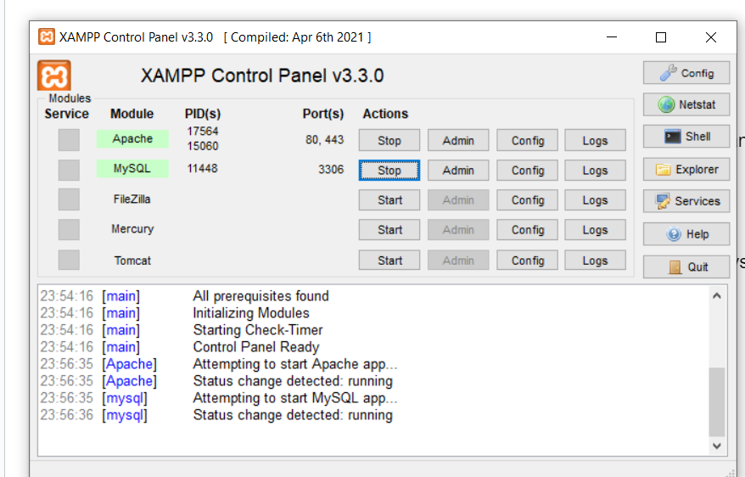

1. Now we can access the registration form by accessing the url <http://localhost/project/form.html>

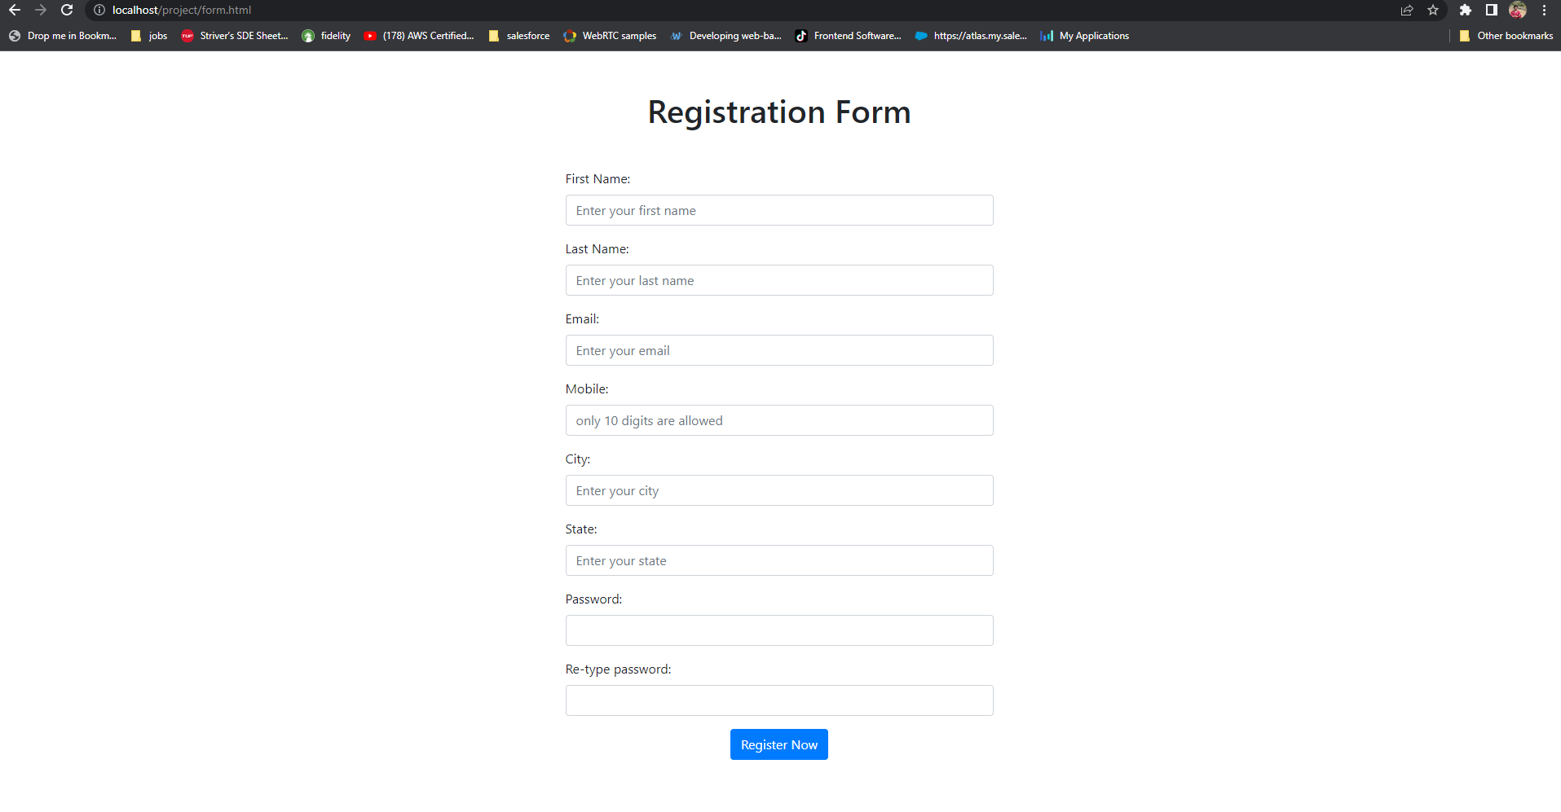

**Code Screenshots:**

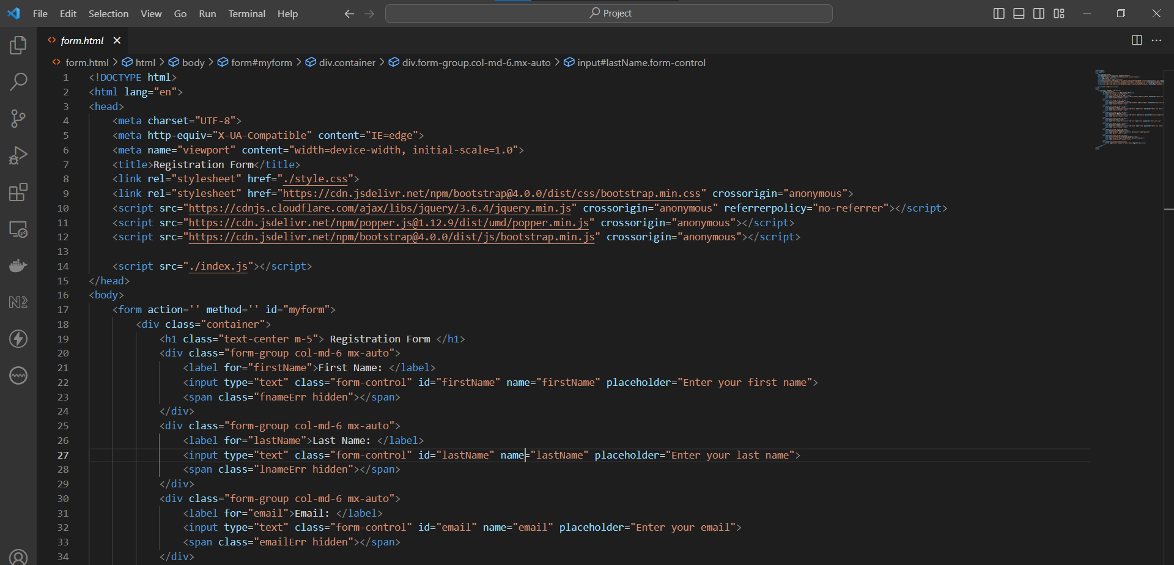

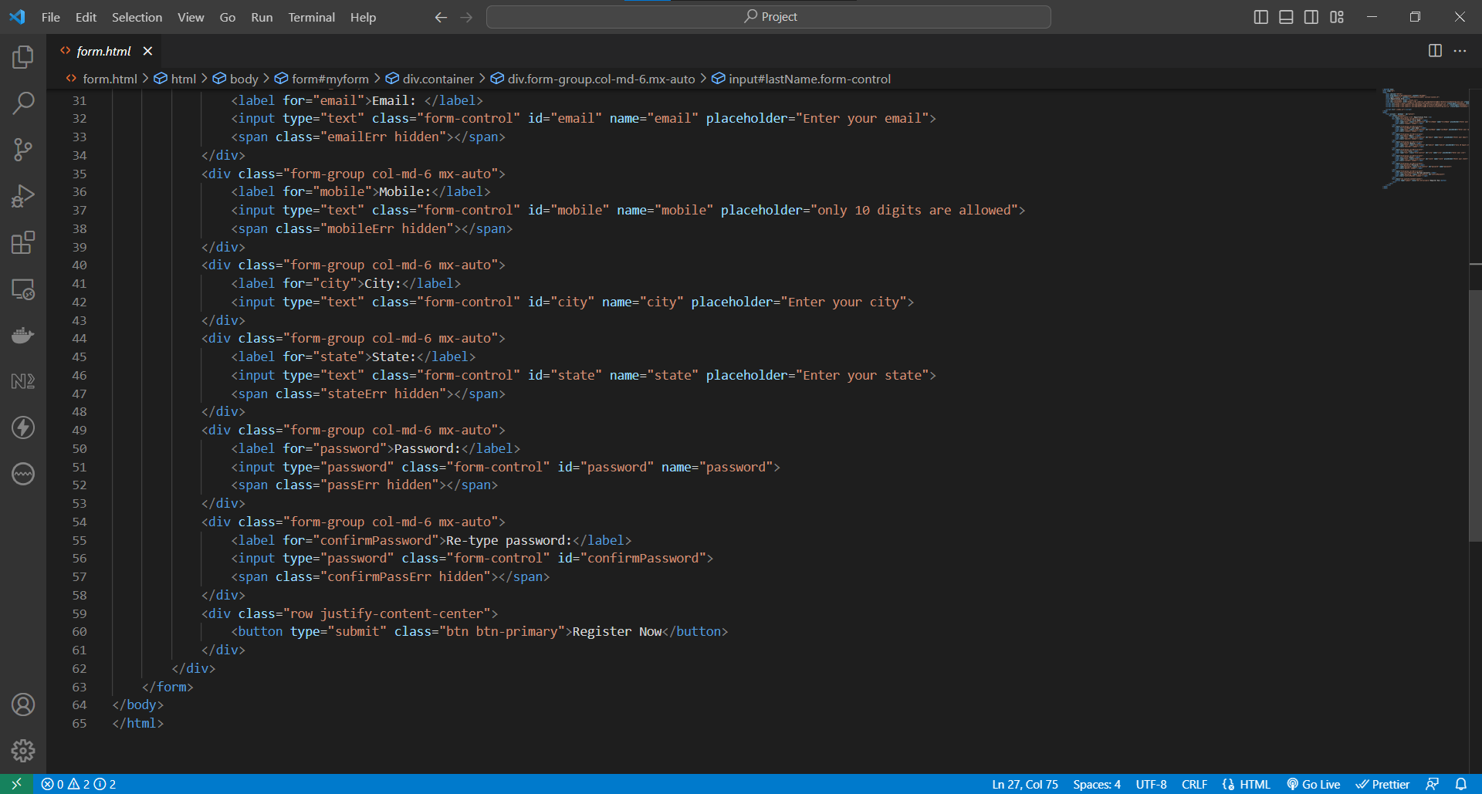

The above two images show the code for the form.html is the frontend file which shows the registration form.

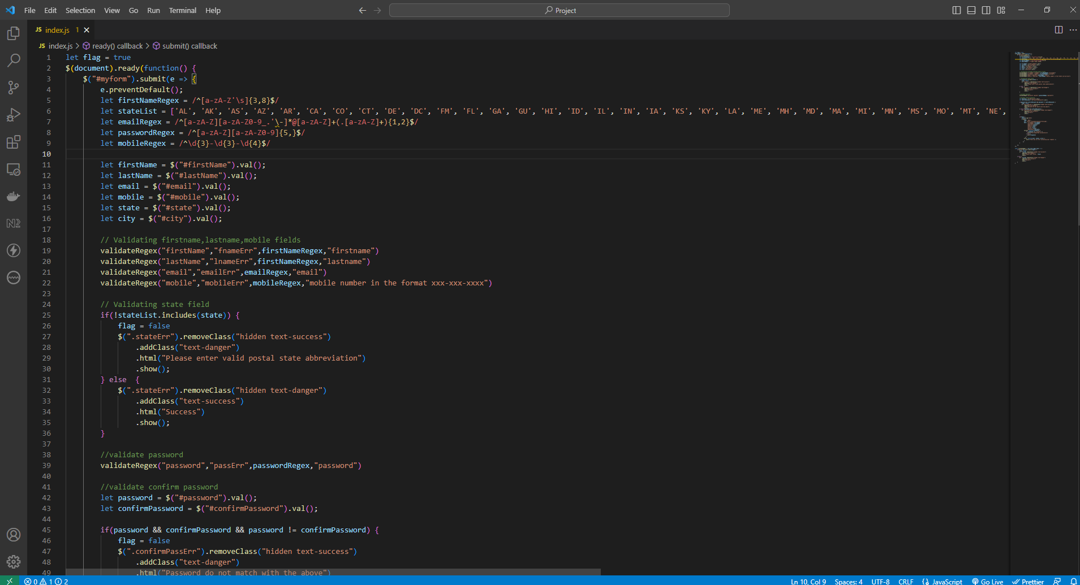

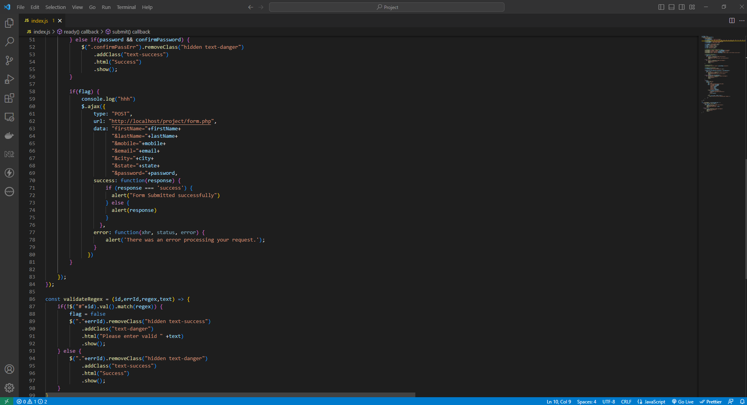

The above 2 images show the javascript code which has been used for the frontend validation of the registration data. We have used Regex to validate the data.

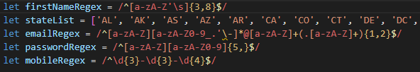

The below 2 images shows the form.php (backend) code:

This part of the code is used to connect to the mysql database:

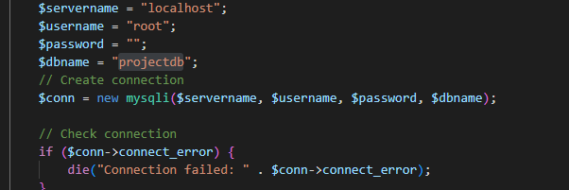

The below part of the code creates the database and table if not exists and inserts the data into the table

**Code Explanation:**

Once a user enters the registration data and clicks on the Register Now, the data will be validated on the frontend using the regex added to the respective field. If there is any validation error there will be a error message on below the field like below:

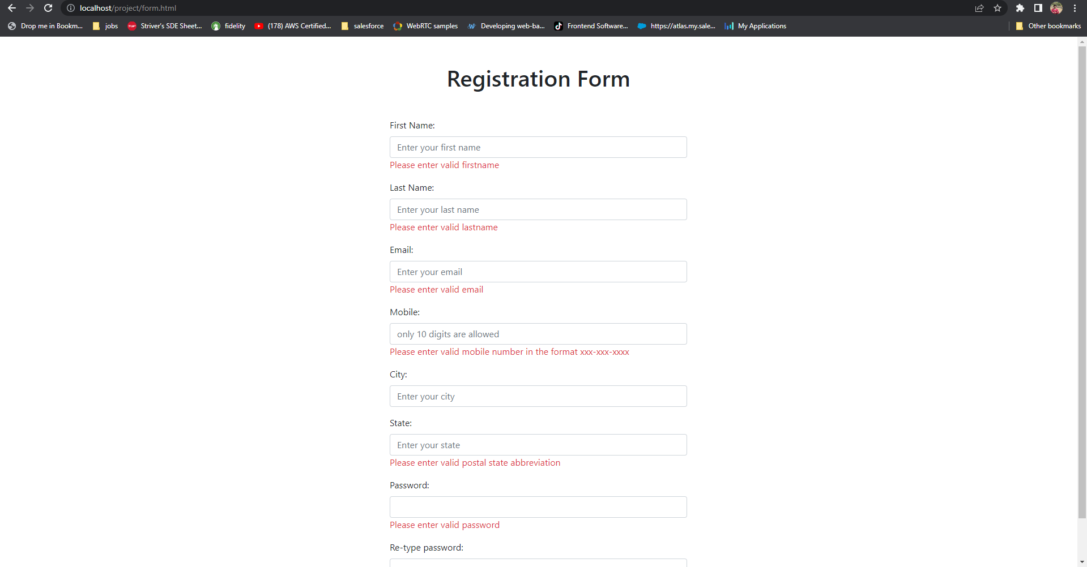

If all the fields are validated and there is no error then the data will be sent to the backend using an Ajax call. Below is the ajax call to the backend sending the data:

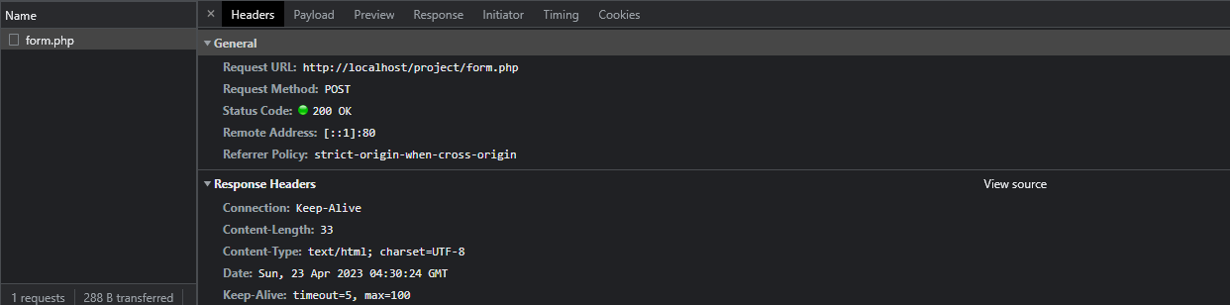

Once the data is received by the backend(form.php) the registration data is again validated with the same Regex used in the frontend and once validation is done then the data will be added to the MySQL database. After successfully adding the data the form.php will return a message to the frontend saying the registration is completed and that message is shown in as alert message in the frontend just like below:

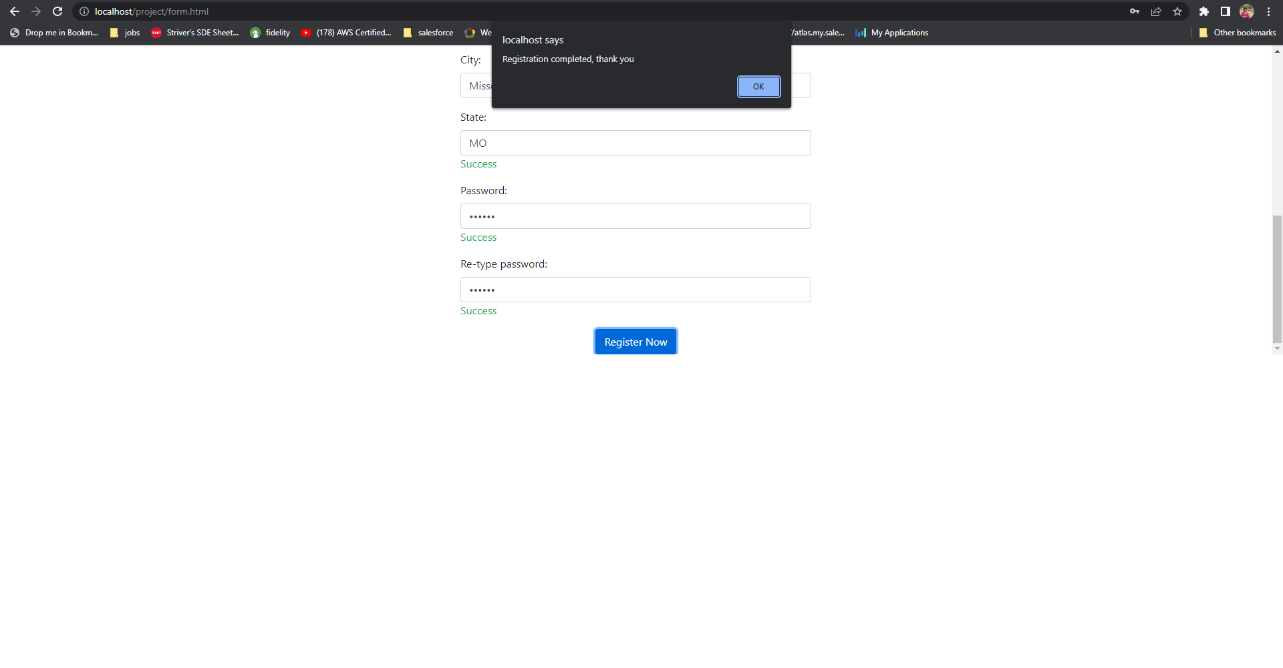

**Project Contributions:**

Every team member’s contribution proved to enhance the final outcome of the project. Sneha and Vineetha took the responsibility of building the frontend of the project, where we worked on the structure, styling (HTML & CSS), Bootstrap and jQuery codes. On the other hand, Nihal, Charan and Shiva continued working on the backend environment where they worked on PHP scripting and generating MySQL database queries. As soon as the foundation was put in place, we worked together to develop the regular expressions and form validations to make sure that the data input was accurately captured and then executed the ajax call to send the data to backend where it would be validated again and stored in the database. At each stage, we tested the programs to ensure the program generated accurate alert messages and that the data was accurately collected and stored in the database.