CS445 Project 1 (Total 100 points)

**I. Purpose**: The purpose of this class project is to provide the student with hands-on experience with the specification and design of user interface (UI) software.

**II. Background:** In [computer science](https://en.wikipedia.org/wiki/Computer_science), a **stack** or **LIFO** (**last in, first out**) is an [abstract data type](https://en.wikipedia.org/wiki/Abstract_data_type) that serves as a [collection](https://en.wikipedia.org/wiki/Collection_(computing)) of element. **The operations on a stack collection would be listed as the below:**

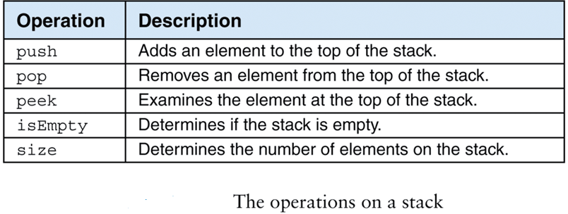

1. <https://www.cs.usfca.edu/~galles/visualization/StackArray.html>

The above link is current online Stack visualization learning model. I would like you to design more friendly ***User Interface for learning Stack, which can reflect on  the Human-Computer Interaction Concepts.***

2. Your project 1 would be designing a friendly Stack Learning Model in GUI, which could help others understand the Stack Data Structure. You need to use Bootstrap and jQuery as well as CSS to create your project1.

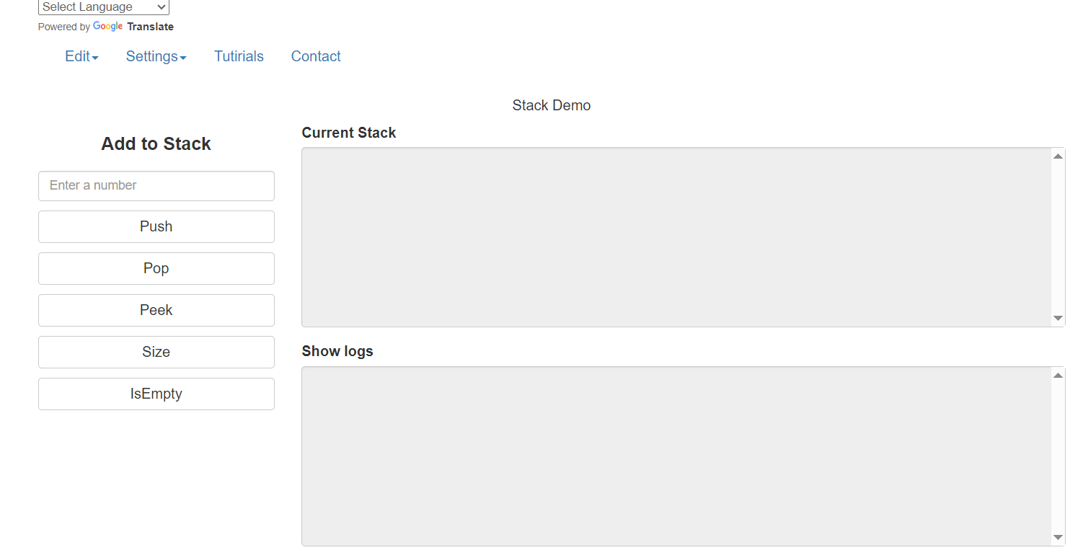

**III. Interface Requirements**:

1. Your Project’ framework is to develop a responsive and mobile first project on the web.

**2. Functional Buttons:** Your Project1 should demonstrate the data structure like Stack Collection’s functionalities by using at least 5 buttons (Push, Pop, Peek, Size, and isEmpty).

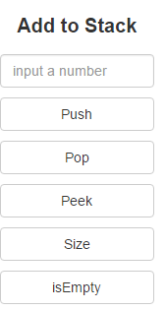

**3. Navigation Bar:** Your project1 GUI design must include at least four navigation items (Edit, Setting, Tutorial, Contact), which including at least 2 sub-menus [ Edit(Clear Stack, Clear Log, etc. ), Setting (change Font-Face, Font-Size, and Font-Style) ].

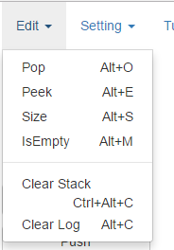

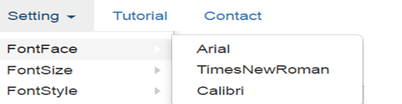

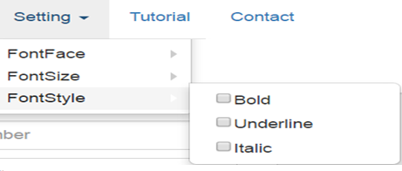

4. **Language drop-down menu (users can select any language):**

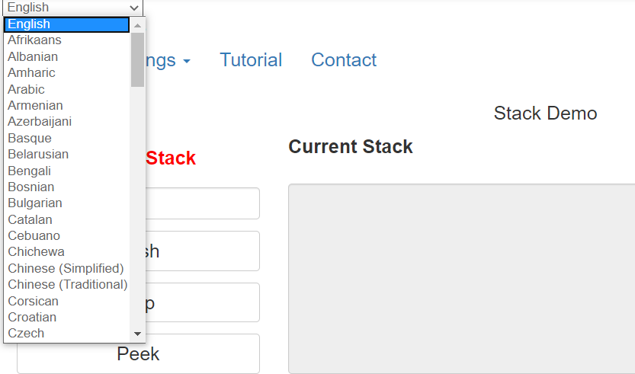

**5. Information Display:** Your project1 needs to include at least two TextArea (showStack and showLog), one input element (inputNumber), one header element (<h1></h1>) and one label.

**6. Different user level:** Your project1 needs to consider the users’ skill level, including Tootips, entry level tutorial and high-level shortcut keys. Tutorial must use step-by-step introducing modes.



**7. Accessibility:** Your project1 needs to consider the user accessibility, you should consider screen reader settings, color combinations, videos and captions.

**8. Diversity:** Your project should have **Language drop-down menu in order to** reflect on multi-cultures, also your contact page should have video and texts to reflect on multi-media information, which means you post a video explaining the Stack in Computer Science on YouTube.

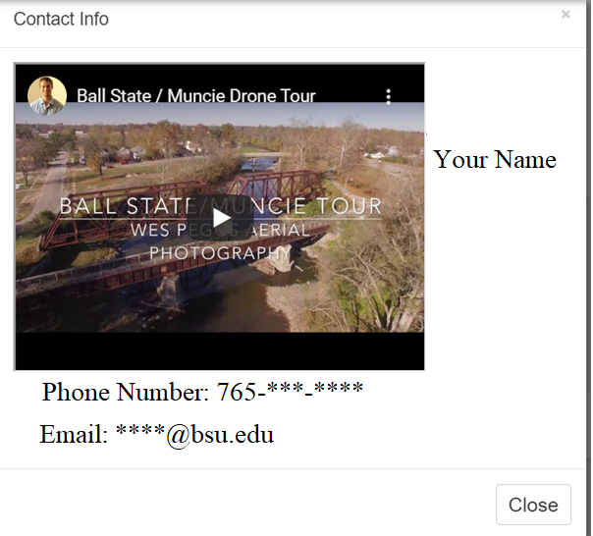

**9. Add Input Validation Control:**

A. Add a customized validation control for the input box. Hint: if a user leaves input box blank (curse is not focus on the input box), there should be a message like “This field is required!” with red color and font size as 22.

B. Add anything that you can think about to prevent a user to make errors.

**10. Make Project 1 menu bar as “**mobile-first”.

|  |  |
| --- | --- |
|  |  |

**IV. Demo**

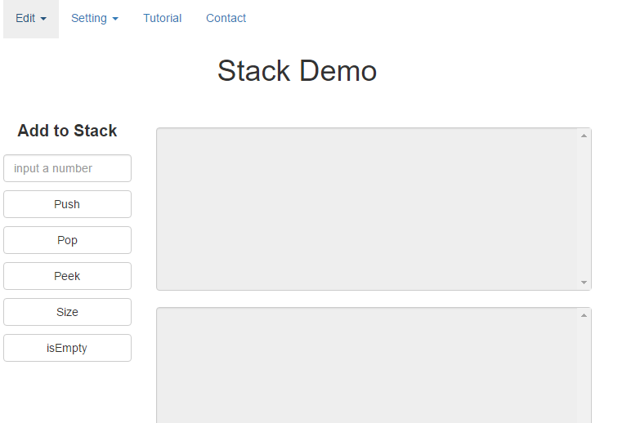

A. Edit menu



B. Setting menu



C. Tutorial affects

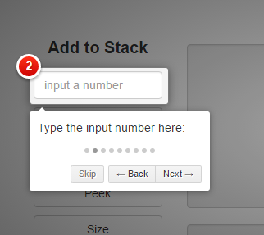

D. Contact Page



V. Grading Requirements:

1. Nice layout and font settings- 5 points

2. Well organized menu - 5 points

3. Shortcut for menu items and buttons - 5 points

4. Tooltips for main objects - 5 points

5. Style properties by using Bootstrap - 5 points

6. Error handling such as error message - 5 points

7. Use tutorial to explain your project - 5 points

8. Author info should contain your name, your phone number, your picture (optional) and your email - 5 points

VI. Based on HCI Usability Evaluation that addressed by Mr. Nielsen from Week 1 PowerPoint, you need to evaluate your project1 for the below criteria:

1. Visibility of System Status - 5 points (feedback, keep track)

2. Match between System and the Real World- 5 points (tipToolText and error message)

3. User Control and Freedom - 5 points (reverse action)

4. Consistency and Standards - 5 points (same font, color style, variable name)

5. Error Prevention - 5 points (detect error and display warning message)

6. Recognition Rather than Recall - 5 points (user log)

7. Flexibility and Efficiency of Use - 5 points (Accelerators)

8. Aesthetic and Minimalist Design - 5 points (show dialog and information only when need)

9. Help Users Recognize, Diagnose, and Recover from Errors- 5 points (support the trouble shooting, solve the problem instead of only warning)

10. Help and Documentation - 5 points (inform, manual)

11. Project 1 coding must work: 30 Points.

VII: How to turn in your CS445 Project1 to canvas:

How to turn in your CS445Project1 zip folder to Canvas for grading

First, make your Project1 folder as a zipped folder, then access to Project1 through Canvas/Week6, click Week6/CS445Project1 icon from Canvas, click “Submit Assignment” button on your top of right, Choose File button, select Project1 zipped folder from your Desktop, then upload it onto Canvas, finally click “Submit Assignment” button.

VIII. Do your own work:

If your project 1 was found out that you used the previous CS445 students’ materials or copied from other students’ source code, your project 1 would be graded as zero.

Thanks!

Dr. Zhang