Task 1. Create folders and files that follow below structure:

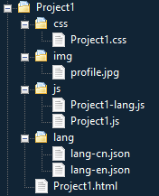

Task 2: Use Notepad++ to create a file called Project1.html and save it into Project1 folder. Attention: copy the below content into Project1.html file:

<!DOCTYPE html>

<html lang="en">

<head>

<meta charset="utf-8">

<meta http-equiv="X-UA-Compatible" content="IE=edge">

<meta name="viewport" content="width=device-width, initial-scale=1">

<title>CS445 Project1- Your Name</title>

<link rel="stylesheet" href="https://maxcdn.bootstrapcdn.com/bootstrap/3.3.7/css/bootstrap.min.css" />

<script src="https://ajax.googleapis.com/ajax/libs/jquery/1.12.4/jquery.min.js"></script>

<script src="https://maxcdn.bootstrapcdn.com/bootstrap/3.3.7/js/bootstrap.min.js"></script>

</head>

<body>

</body>

</html>

Task 3. Use HTML create the below layout:

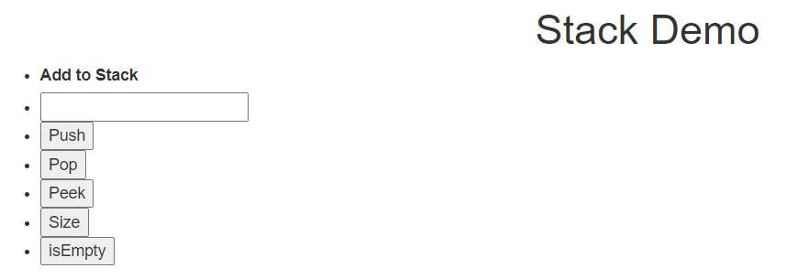

Task 4. Add Bootstrap classes to make the below layout:

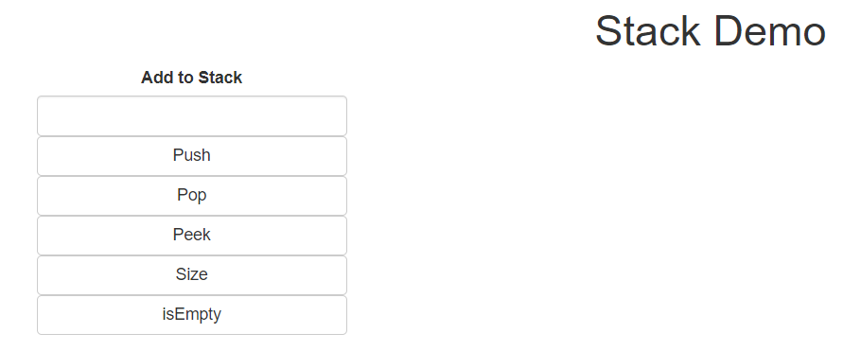

Task 5:

2. Create simple layout of project 1 page like below:

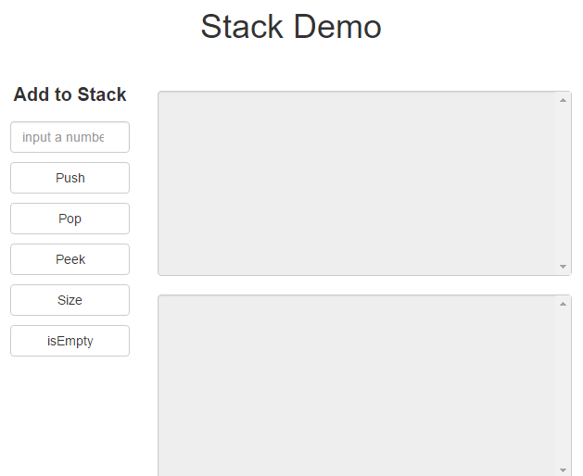

Hint: All contents are in a container division, inside container is row, inside row is column. Left part (1 label, 1 input textbox, 5 buttons) occupied 3 columns and right part (2 textareas) occupied 9 columns. Left part could follow the format like:

<ul class="nav text-center actionBar">

<li></li>

<li></li>

...

</ul>