CS261 Machine Organization

(Prof. Theys)

Lab Week 6

Name: UIN:

Name: UIN:

Please answer the following questions about two arrays “myArray” and “cube” declared in the provided C code. (100 Points)

myArray - 1d array of type short

- What is the starting address of myArray ( address of element myArray[0] )? (5 points)

- What is the address of myArray[1]? (5 points)

- What is the address of myArray[9]? (5 points)

- What values (in hex) can the least significant nibble of the ​address​for myArray​[i]​be? (10 points)
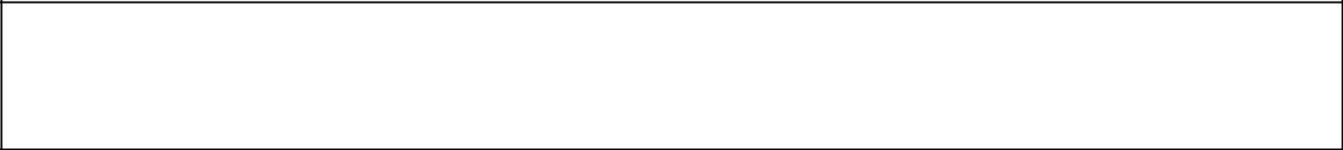


5) What is the equation to find the address of element myArray[i]? (10 points)

cube - 3d array of type short

- What is the starting address of cube (address of element cube[0][0][0])? (5 points)

- What is the starting address of the second ​row​of cube (address of element cube[0]​[1]​[0])? (5 points)

- How many bytes are there in a row of cube? (10 points)

- What is the starting address of the second ​plane​of cube (address of element cube​[1]​[0][0]); (5 points)
- How many bytes are in a plane of cube? (10 points)

- What is the equation required to determine the address of cube[i][j][k]? Your answer should use i,j,k in the equation and information from questions 6-10. (20 points)

- If the 3d array cube, is changed to be a struct of size 32 bytes instead of short, how would your equation in 11 change? (10 points)
