IVTR үнэлгээний үр дүн
  - IV = parent_educ_mean / Parents_year_mean; Threshold = 17-18

Үр дүн
Хүснэгт 1. First-stage үр дүн
N | IV | Estimate | SE | First-stage F | p-value
3188 | parent_educ_mean | 0.362 | 0.015 | 558.45 | <0.001

Хүснэгт 2. Threshold estimate ба sample split
Threshold variable | Gamma hat | N | Low regime N | High regime N | Low 2SLS beta | High 2SLS beta
student_teacher_ratio_avg_17_18 | 19.531 | 3188 | 1051 | 2137 | 0.078 | 0.109

Хүснэгт 3. OLS болон 2SLS baseline
Model | N | Term | Estimate | SE | p-value
OLS baseline | 3188 | educ_years | 0.047 | 0.003 | <0.001
2SLS parent_educ_mean IV | 3188 | fit_educ_years | 0.103 | 0.012 | <0.001

Хүснэгт 4. IVTR GMM final results
Term | Estimate | SE | t-stat | p-value | High - Low
educ_low | 0.078 | 0.019 | 4.10 | <0.001 | 0.031
educ_high | 0.109 | 0.010 | 11.50 | <0.001 | 0.031

Хүснэгт 5. Bootstrap inference
B success | Gamma observed | Gamma 2.5% | Gamma 97.5% | Beta low | Beta high | High - Low | Diff 2.5% | Diff 97.5% | Bootstrap p
399 | 19.531 | 17.937 | 25.535 | 0.078 | 0.109 | 0.031 | 0.006 | 0.058 | 0.038

Хүснэгт 6. Горим хоорондын ялгааны Wald test
Wald statistic | df1 | df2 | p-value
2.922 | 1 | 21 | 0.102

Графикууд
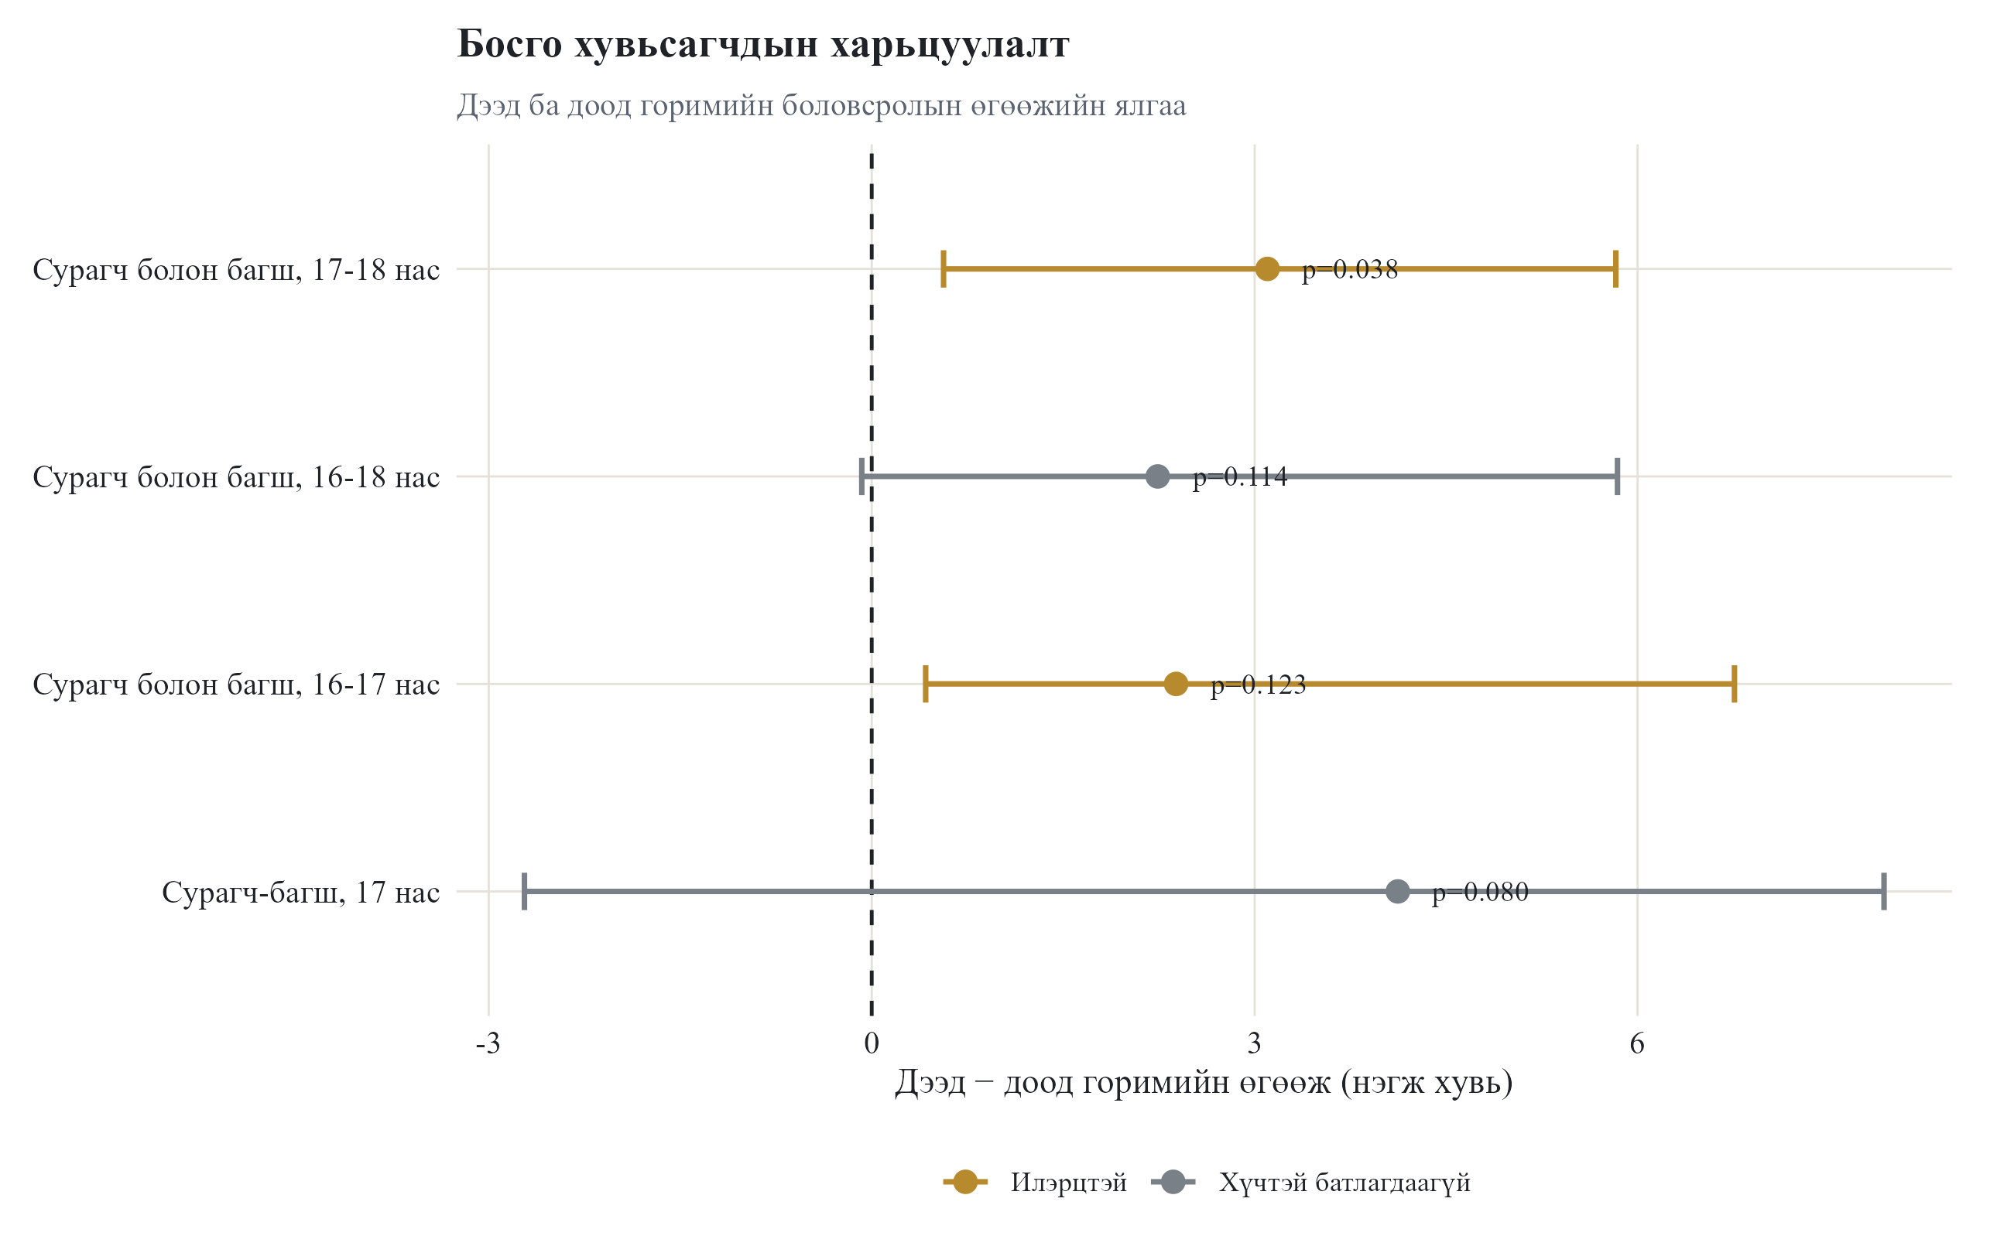
Зураг 1. IVTR threshold comparison
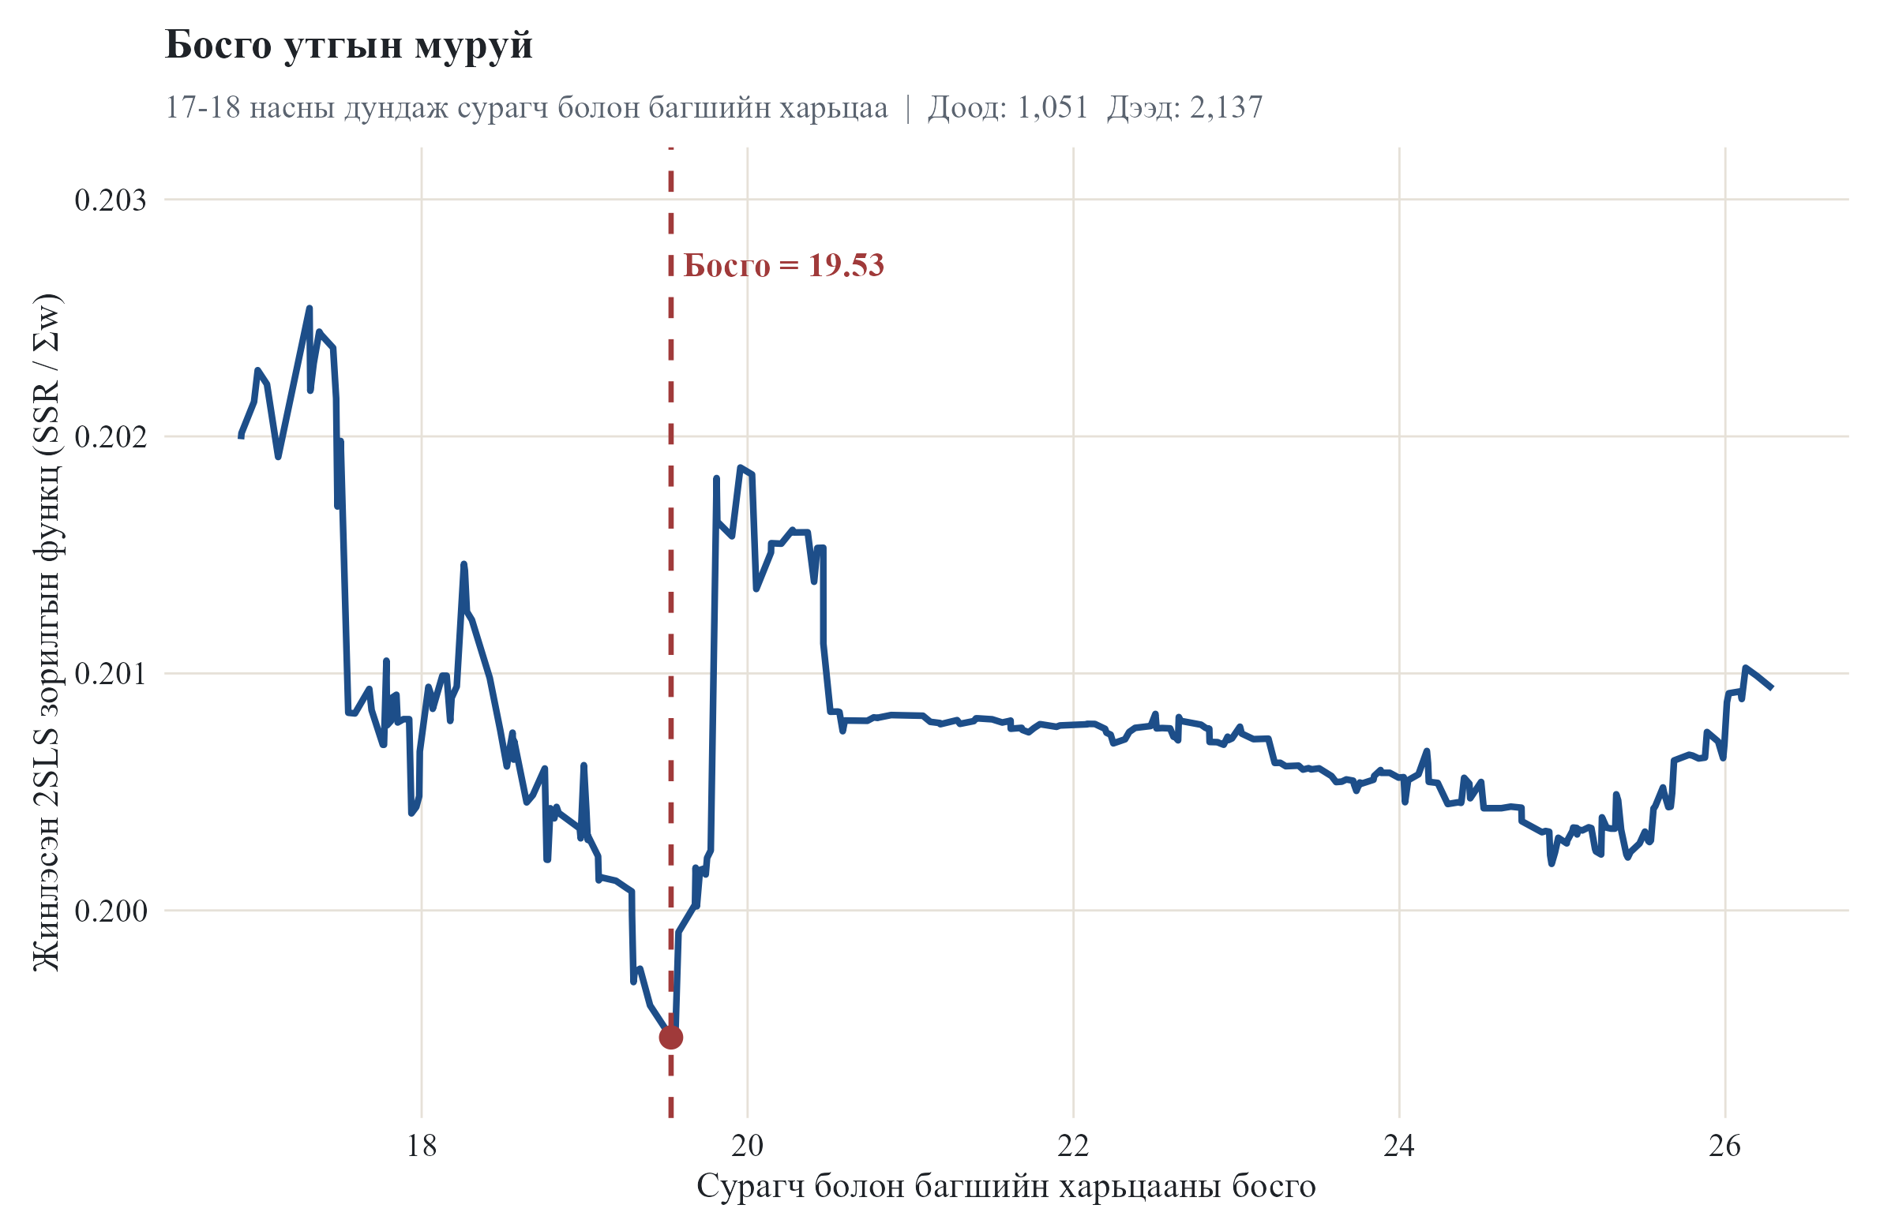
Зураг 2. 17-18 threshold grid objective
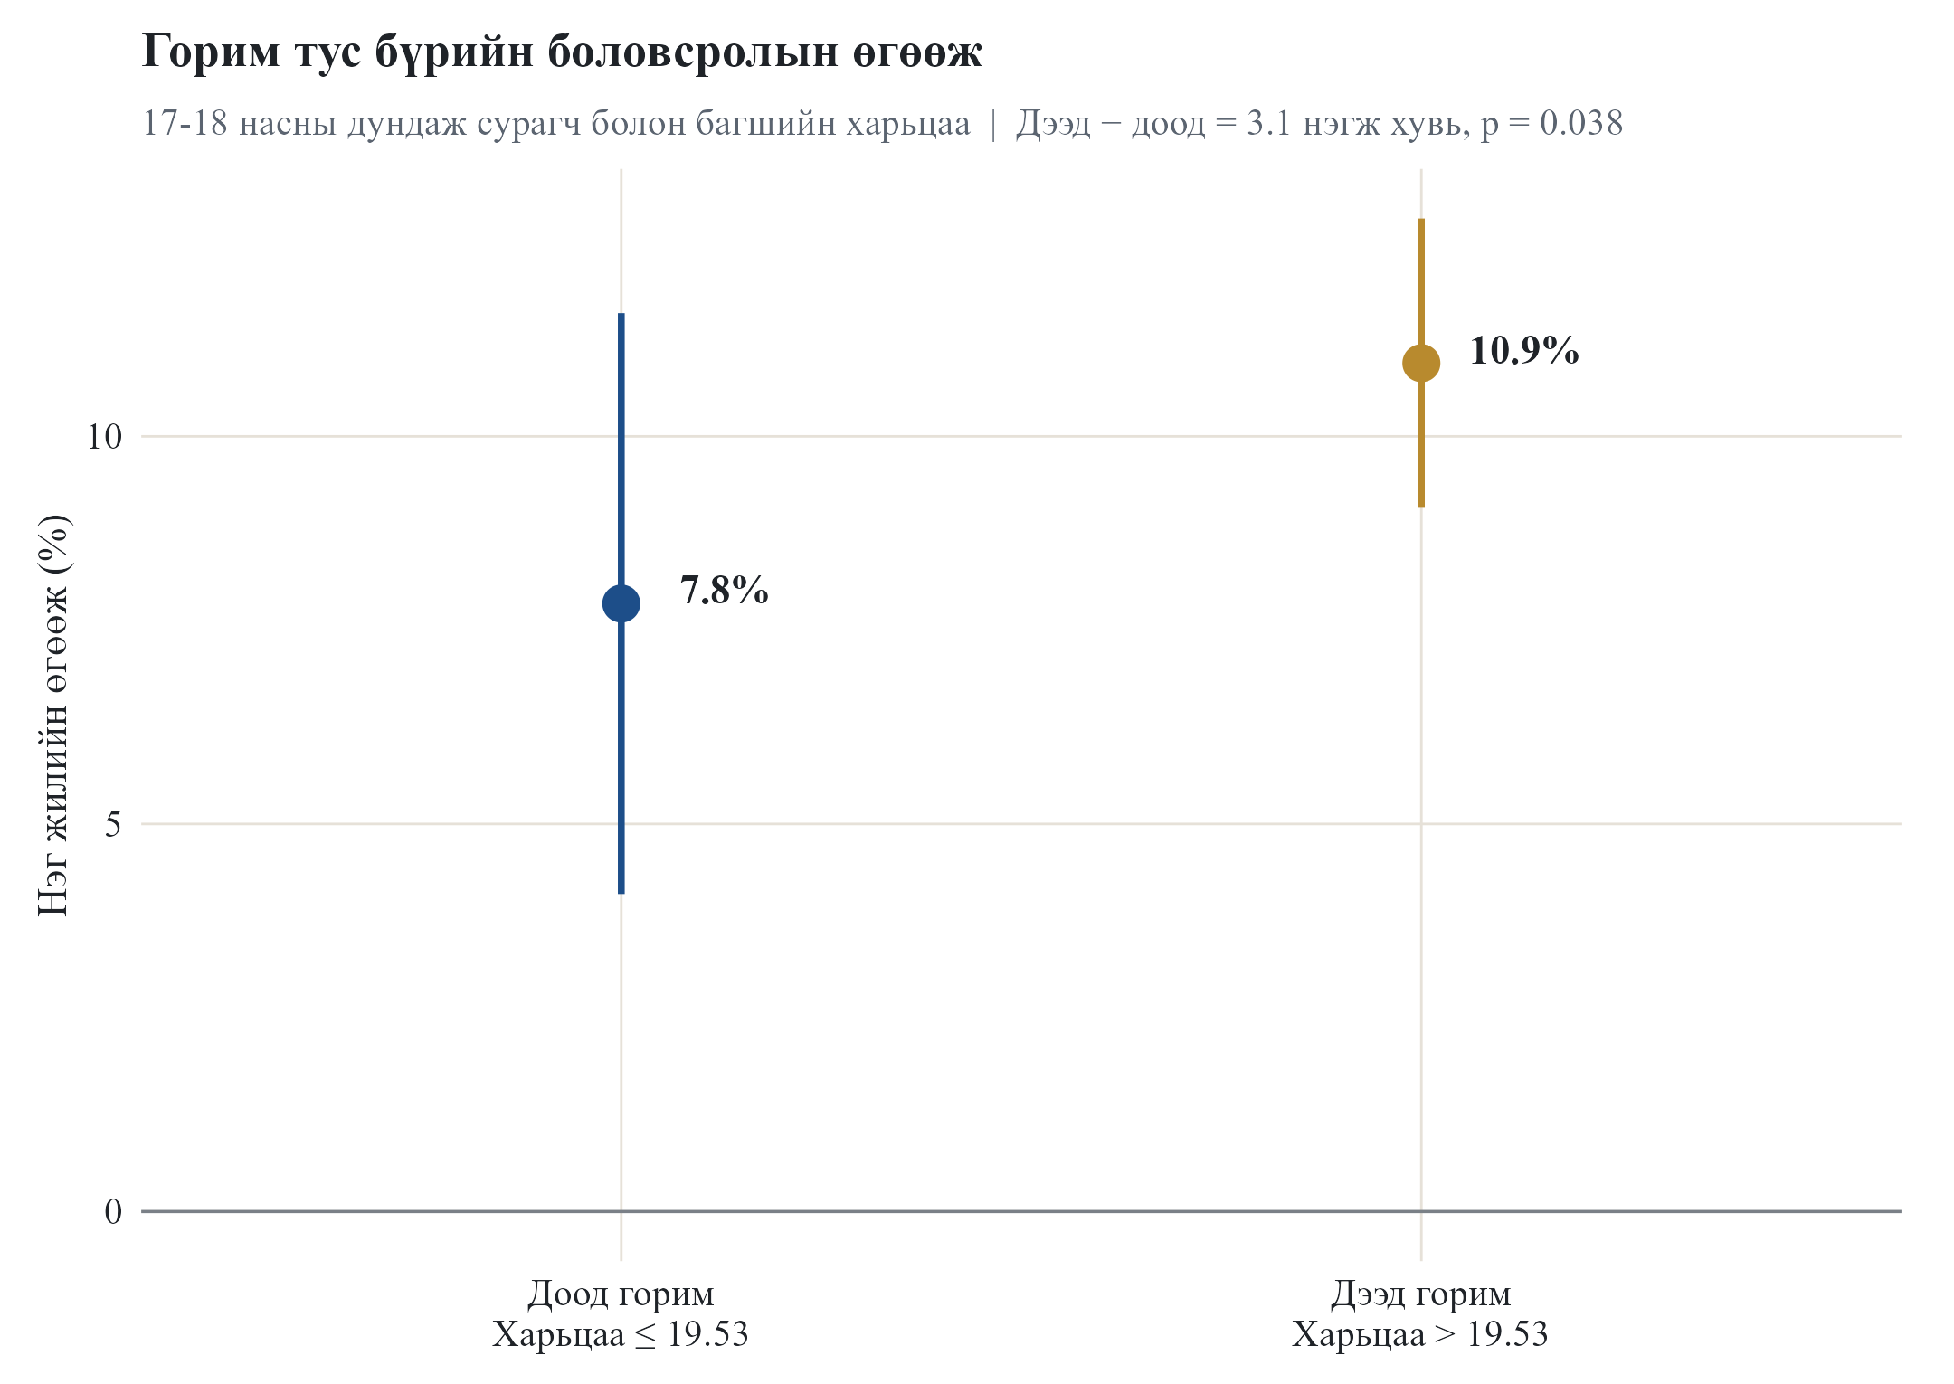
Зураг 3. 17-18 горим тус бүрийн боловсролын өгөөж
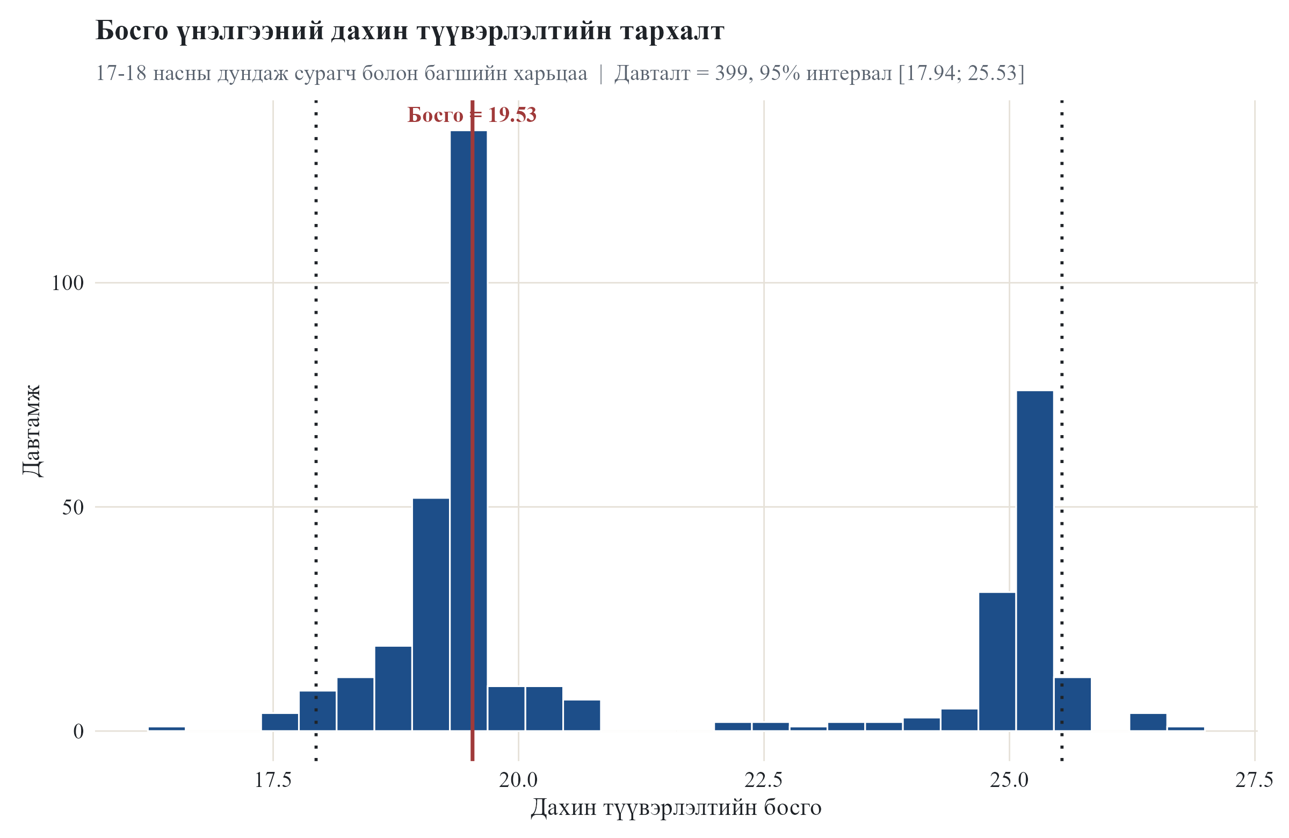
Зураг 4. 17-18 bootstrap gamma тархалт
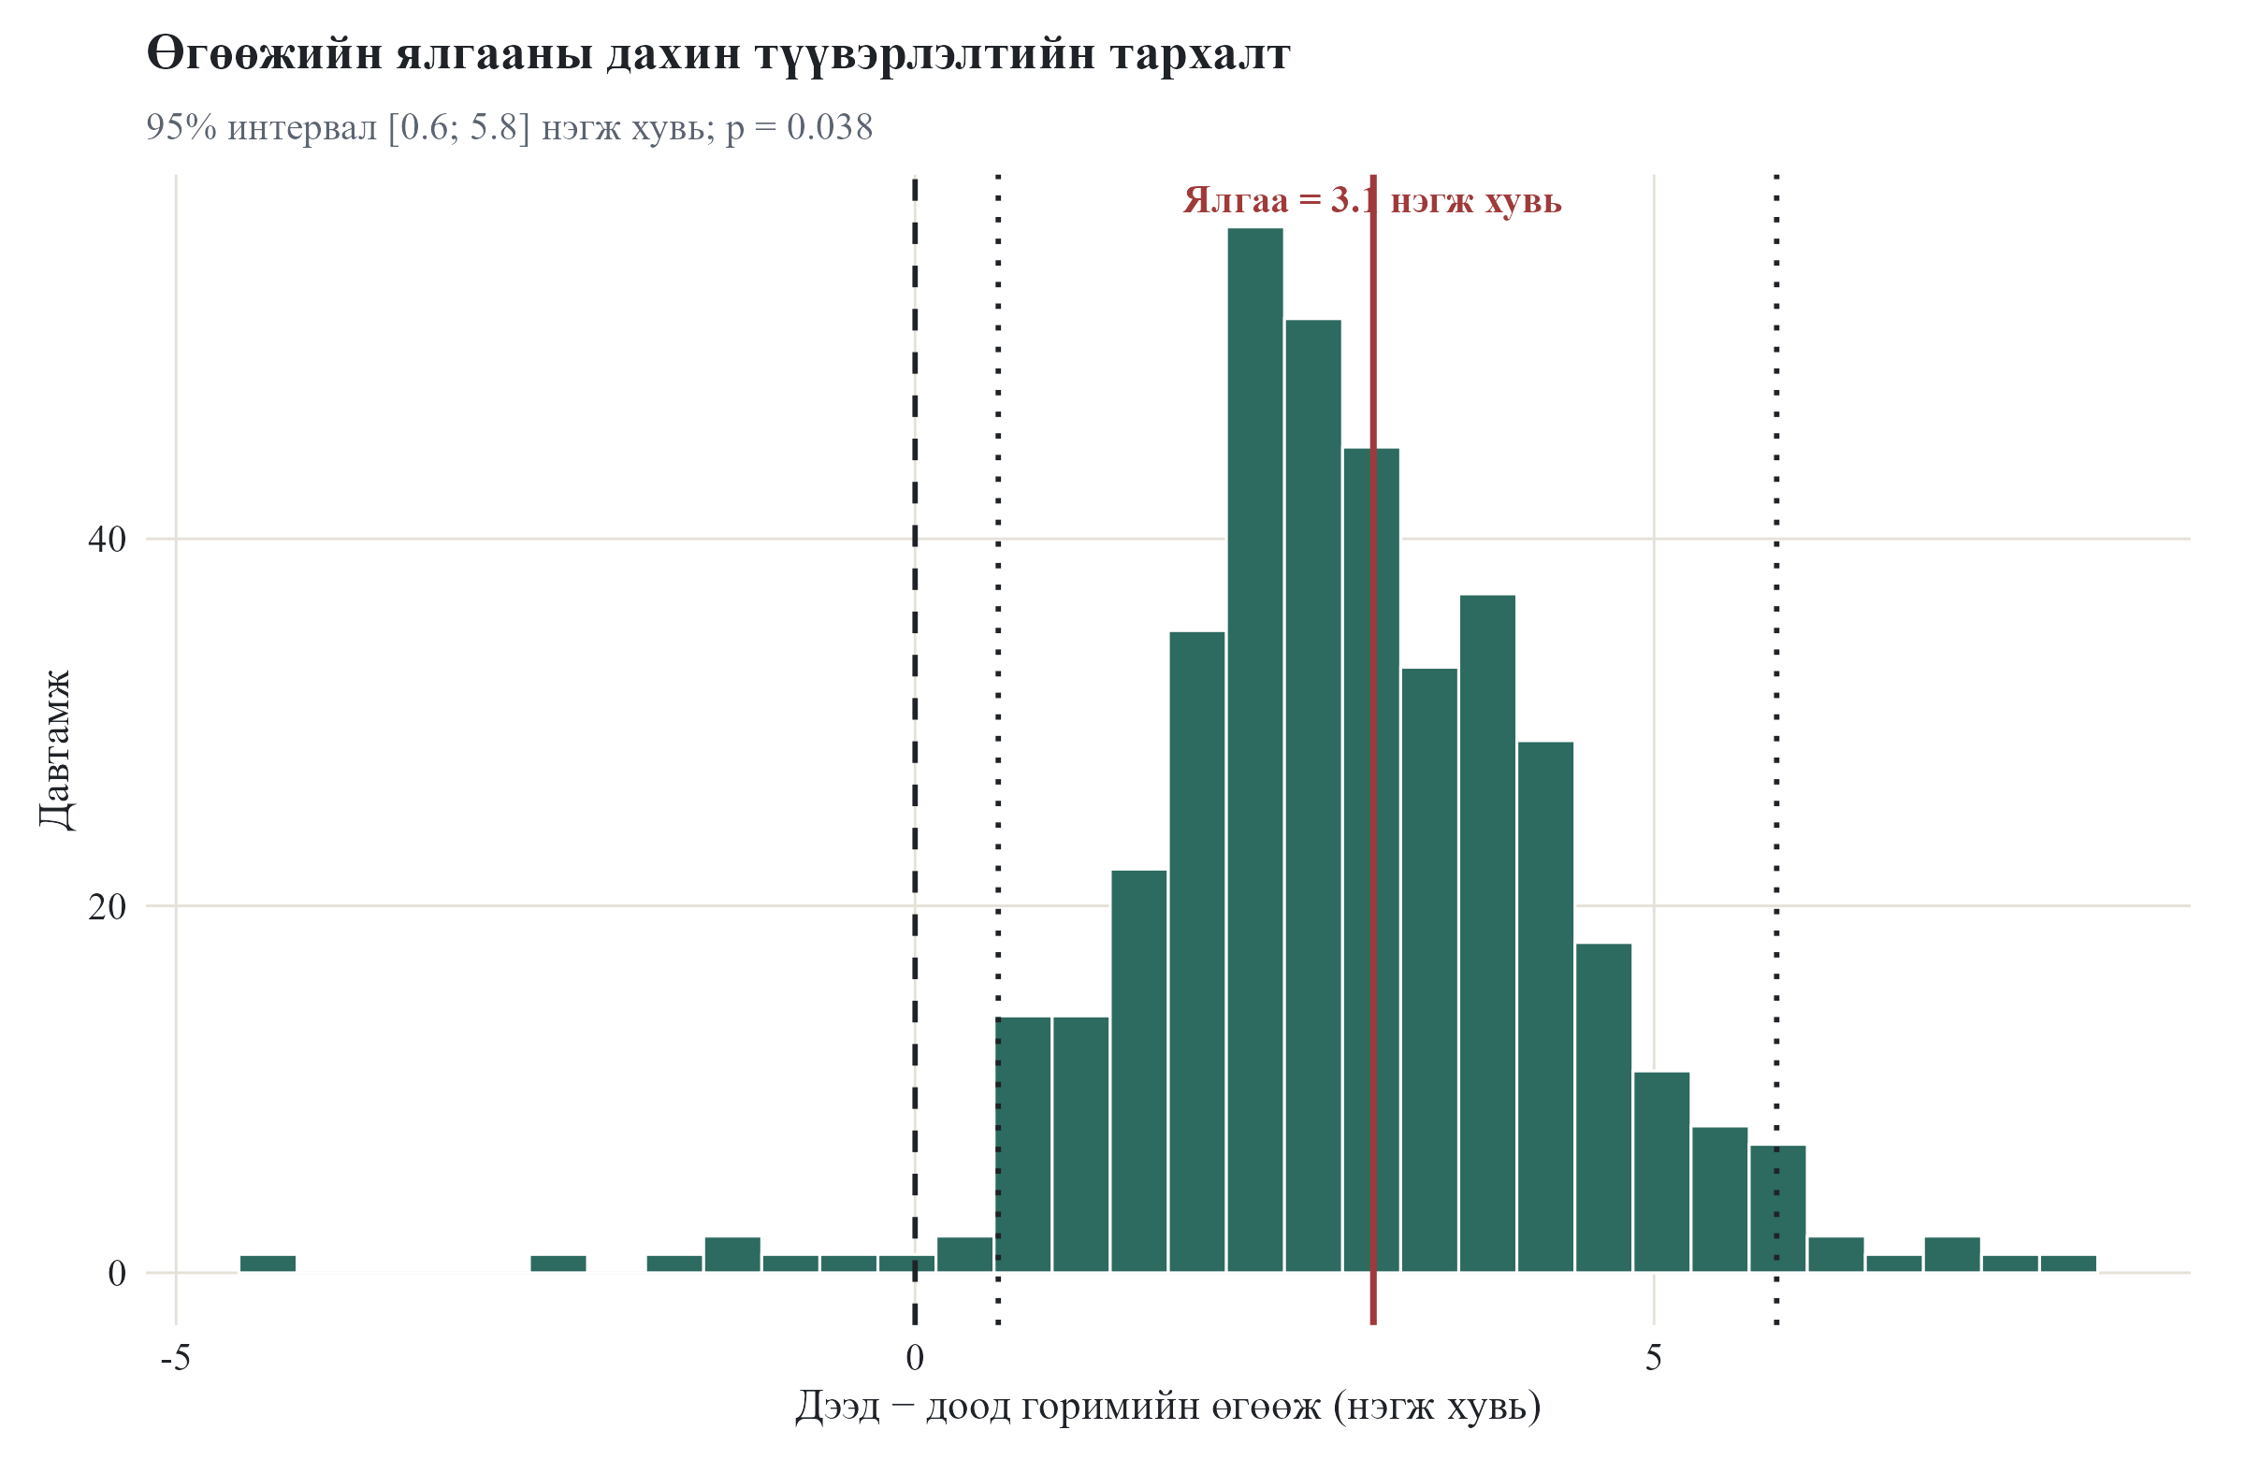
Зураг 5. 17-18 bootstrap beta-difference тархалт
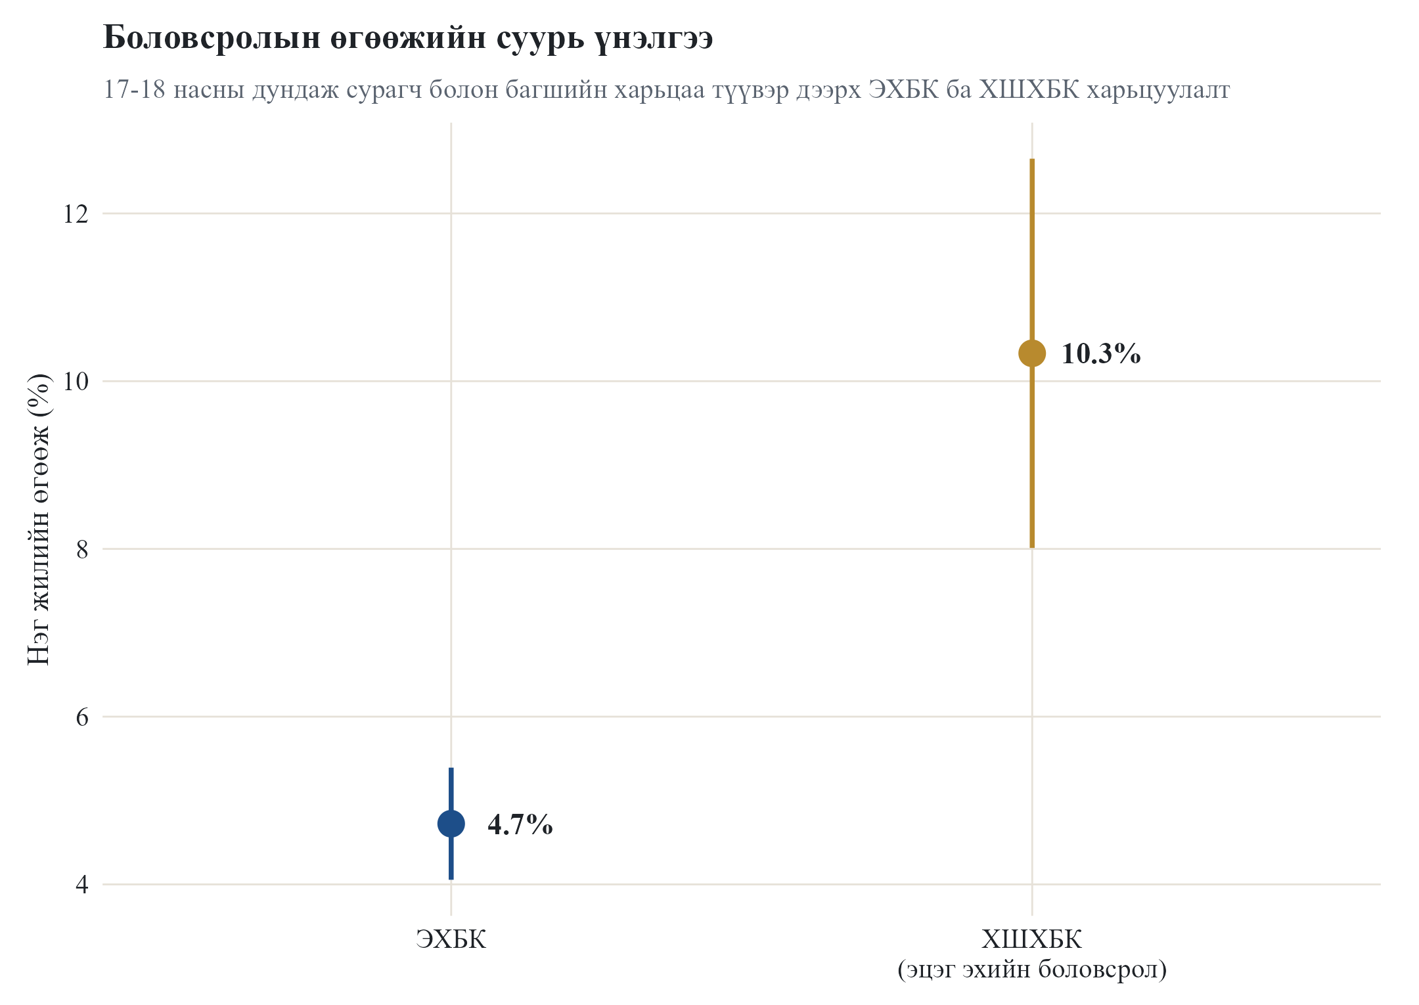
Зураг 6. 17-18 sample дээрх OLS ба 2SLS baseline

