Procedure to construct one MDSplus server on Lab PC:
- Install Java SE Development Kit 8 and Run Time Environment
- Install the stable version of MDSplus application for all user:
  - Check environment variables – MDPLUS_DIR, MDS_PATH, main_path
(Note no new entity will be defined in “path” variable; necessary dynamic libraries will be installed in folder “C:\Windows\System32”)
  - Note that newer version of MDSPlus no longer create a bin directory on the C drive. Instead they put the executable directly into the system32 folder.
  - Access the demonstration tree “main” via jTraverser, TCL and jScope (Ensure that the user you are using has full control permission of the folder containing “main” tree)

- Build one new tree (“PHASMA” herein)
  - Create a new a folder for “PHASMA” on the D: drive or wherever you want with full control permission, NTFS format. The actual folder name is “MDSPLUS_PHASMA” and this will be the place that raw data is stored as well as all the compressed shot binary files. Also stored in here are the tree structure files. A good practice is to make a backup of the tree structure files in case you have to restore the tree structure.
  - Create a new environment variable “PHASMA _PATH” with value of the location of the folder you just created; at the same time it’s better to add another environment variable “PHASMA_HOST” with value of “157.182.26.58:57800” for accessing data with MatLab, C, LabView, LabWindow or Python.
  - Open TCL, “edit PHASMA /new” to generate three model files. These files will be stored in the location set by the path variable.
  - Open jTraverser, edit tree structure. If you accidentally kill the tree structure, you can restore the structure by taking an existing shot with the correct tree structure and using that for a new model file. This is done with the commands in TCL of
    - TCL> Set tree phasmas2025 /shot=existing shot number
    - TCL> create pulse -1 (this will overwrite the model structure with the tree structure of the existing shot).

- Setup one port for MDSIP (57800 herein)
  - New inbound rule for port 57800 in firewall
  - Go to “C:\Windows\System32”; new file “mdsip.hosts” with accessing restriction as contents
  - Run command “mdsip –p 57800 –m –h mdsip.hosts” to start listening
(It’s strange that default application “Install server at port 8000” doesn’t work)

(To hide the icon of running mdsip in taskbar, we can construct mdsip.vps :
Dim WShell
Set WShell = CreateObject("WScript.Shell")
WShell.Run "mdsip.exe -p 57800 -m -h mdsip.hosts", 0 Set WShell = Nothing)

(Create and move the shortcut of “mdsip.vps” to startup folder)

(The process “mdsip.exe” can be monitored by Task Manager)
  - Open jScope, new server list: argument (Set this server as default via modifying “jScope.properties” in “$UserFolder/jScope”:
jScope.data_server_9.name = PHASMA_TEST
jScope.data_server_9.user = ps00003
jScope.data_server_9.argument = 157.182.26.58:57800
jScope.data_server_9.class = MdsDataProvider )
  - Access data from MatLab: add “$MDSPLUS_DIR/matlab” folder to search path; test mdsconnect(“157.182.26.58:57800”) which should return 1.
(The technical problem is that the external IP is presently limited to IP of similar gateway inside WVU campus, because we have to request opening one port with ITS if we want to access it beyond campus.)

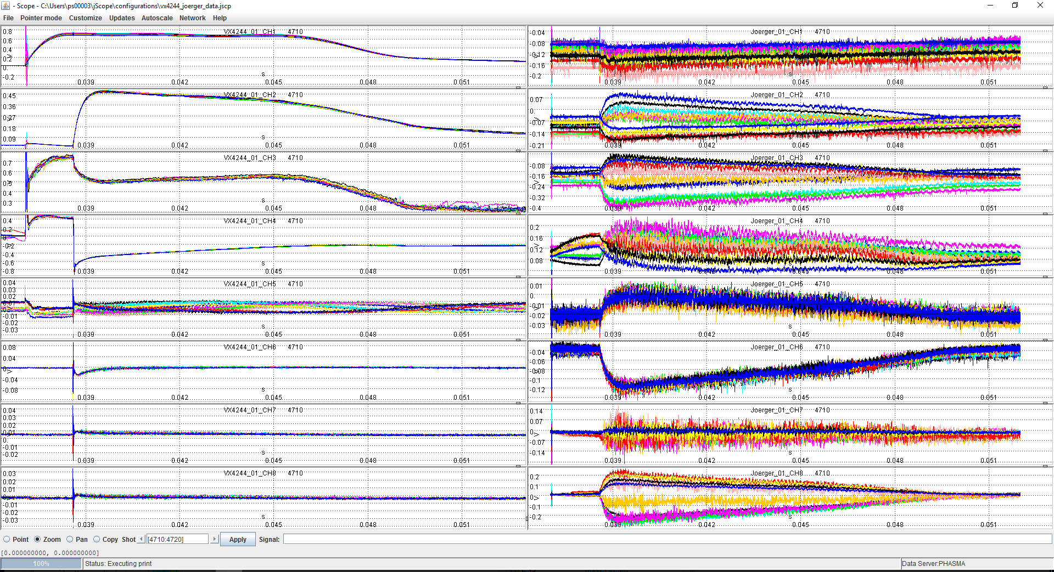
Show case of Bt scanning including 11 shots. Left panel is gun’s currents and voltage and right is magnetic signals.
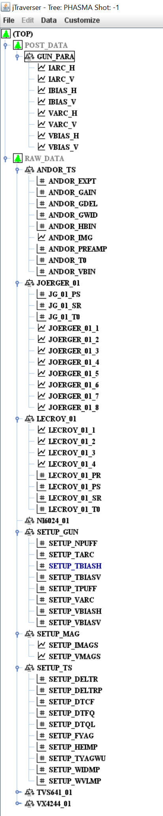
Tree structure: 2 mains sections in original PHASMA tree
- Raw data: cataloged by data acquisition channels:
- VX4244_01 card
  - \VX4244_01_1, \VX4244_01_2, … , \VX4244_01_16;
  - \VX4244_01_PR (PreSamples); \VX4244_01_PS (PostSamples); \VX4244_01_SR (Sample Rate); \VX4244_01_T0 (Trigger Time)
- Joerger VTR10012 card
  - \JOERGER_01_1, \JOERGER_01_2, …. , \JOERGER_01_8;
  - \JR_01_SR (Sample Rate); \JR_01_PS (PostSamples); \JR_01_T0 (Trigger Time);
- Lecroy Waverunner
  - \LECROY_01_1, \LECROY_01_2, … , \LECROY_01_4;
  - \ LECROY _01_SR (Sample Rate); \ LECROY _01_PS (PostSamples); \ LECROY _01_T0 (Trigger Time); \ LECROY _01_PR (PreSamples);

- NI 6024 card
  - \NI6024_01_1, \NI6024_01_2, … , \NI6024_01_8;
  - \ NI6024 _01_SR (Sample Rate); \ NI6024 _01_PS (PostSamples); \ NI6024 _01_T0 (Trigger Time); \ NI6024 _01_PR (PreSamples);

- Andore iCCD
  - \ANODR_IMG
  - \ANDOR_HBIN; \ANDOR_VBIN; \ANDOR_GAIN (Gain of itensifier); \ANDOR_PREAMP (Pre Amplifier); \ANDOR_GDEL (Gate Delay); \ANDOR_GWID (Gate Width); \ANDOR_EXPT (Exposure Time);

- Thomson scattering Setup
  - \SETUP_TYAGWU (YAG Warmup Time); \SETUP_FYAG (YAG Pulse Frequency); \SETUP_DTCF (YAG Charge to Fire Delay); \SETUP_DTFQ (YAG Fire to Q-Switch Delay) \SETUP_DTQL (YAG Q-Switch to Lasing Delay); \SETUP_DELTR (Instrumental Delay of Trigger for YAG); \SETUP_DELTRP (Instrumental Delay per Pulse of Trigger for YAG);
  - \SETUP_WIDMP (McPherson Slit Width); \SETUP_HEIMP (McPherson Slit Height); \SETUP_WVLMP (McPherson Center Wavelength);

- Magnets Setup
  - \SETUP_IMAGS (Coil currents from HELIX to PHASMA, 22); \SETUP_VMAGS (Coil voltages from HELIX to PHASMA, 22)

- Gun Setup
  - \SETUP_TPUFF (Puff Duration); \SETUP_NPUFF (Puff Times); \SETUP_TARC (Arc Time); \SETUP_TBIASH (Bias Time for Gun-H); \SETUP_TBIASV (Bias Time for Gun-V); \SETUP_VARC (Arc Charging Votage); \SETUP_VBIASH (Bias Charging Votage for Gun-H); \SETUP_VBIASV (Bias Charging Votage for Gun-V);

- Post processed data: to store processed data with physical values and units.

