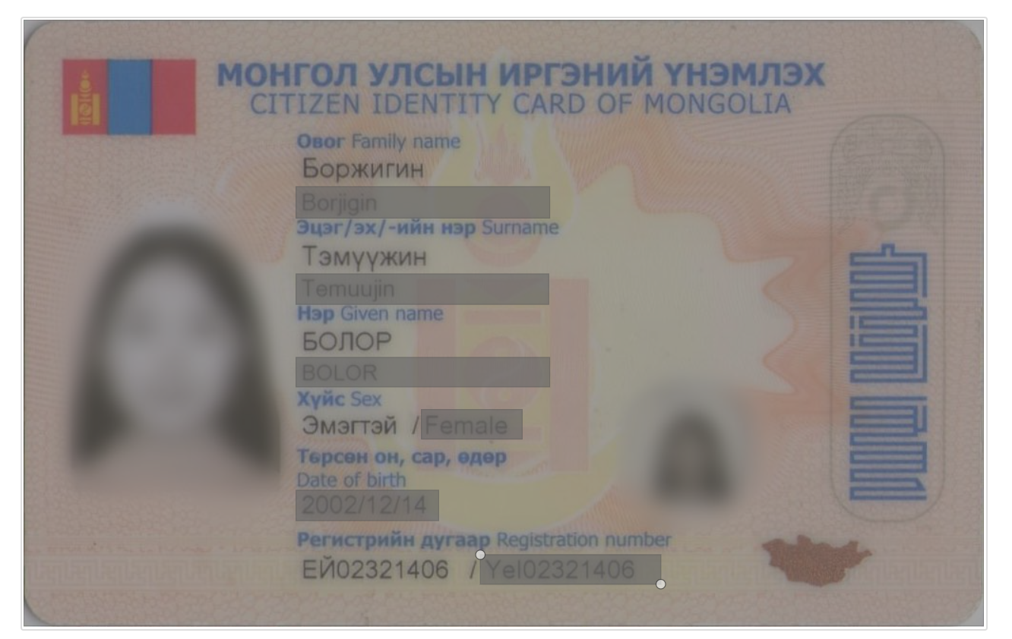

{

"image_width": 1011,

"image_height": 639,

"FamilyName": {"x": 287, "y": 177, "width": 265, "height": 32},

"SurName": {"x": 287, "y": 268, "width": 265, "height": 32},

"GivenName": {"x": 287, "y": 356, "width": 265, "height": 32},

"Sex": {"x": 419, "y": 411, "width": 106, "height": 32},

"DateOfBirth": {"x": 287, "y": 496, "width": 150, "height": 32},

"RegistrationNumber": {"x": 481, "y": 564, "width": 190, "height": 32}

}