**The Report**

In this project we demonstrate data analysis, data manipulation, data visualization, algorithm design and implementation.

We work with the “Players.xlsx” file containing the data of Golden Boot 2017 of 25 soccer players. Each player has the following information: Age, Goals, Factor. “Points” is computed as “Points = Goals x Factor”. For example, Lionel Messi has 74 points.

The Players Analysis Program:

-  Computes the Points value for each soccer player.

-  Ranks the soccer players in terms of points.

-  Computes the Points value for each soccer player.

-  Ranks the soccer players in terms of points.

-  Creates a bar chart as follows: showing the points and ages information of top 10 soccer players  (in terms of points) following the ranking computed above.

-  Creates a bar chart as follows: showing the goals and ages information of top 10 soccer players  (in terms of goas) following the ranking computed above.

-  Creates a pie chart as follows by age;

- Calculates statistical data: min, max, average.

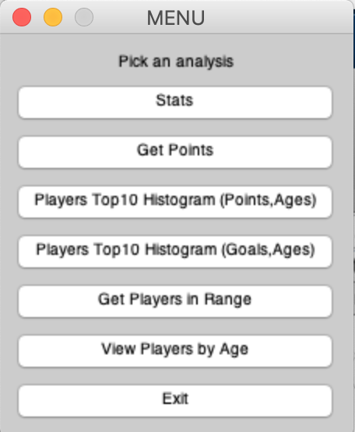

* To compute the Points in Matlab, we use **element-wise** multiplication: Points = Goals.*Factors;
* To rank the players in terms of points, we use the **sort** function [*val*,*idx*] = **sort**(Points,'descend');
* where *val* contains the points after sorting whereas *idx* contains the corresponding indices.
* Out project has 2 m-files: main.m, PlayersAnalysis.m
* main.m - the start file (script). We need to run this file.
* In this file we create the menu and call the function for analysis (function PlayersAnalysis() from file PlayersAnalysis.m)
* The file PlayersAnalysis.m consists the functions:
* - PlayersAnalysis()
* - NumPlayers();
* - AverageGoals();
* - GetPoints();
* - AverageAge();
* - PlayersTop10Histogram(txt,data);%Points
* - GetPlayersInRange(txt,data);
* - PlayersTop10Histogram1(txt,data); %Goals
* - MinAge(data);
* - MaxAge(data);
* - GetPie(data);

We create 3 plots:

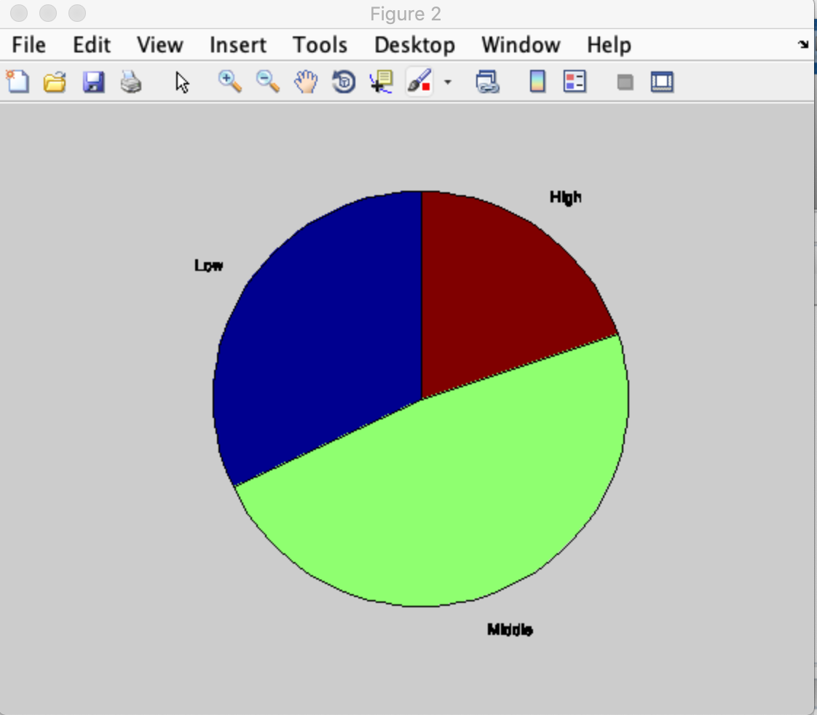

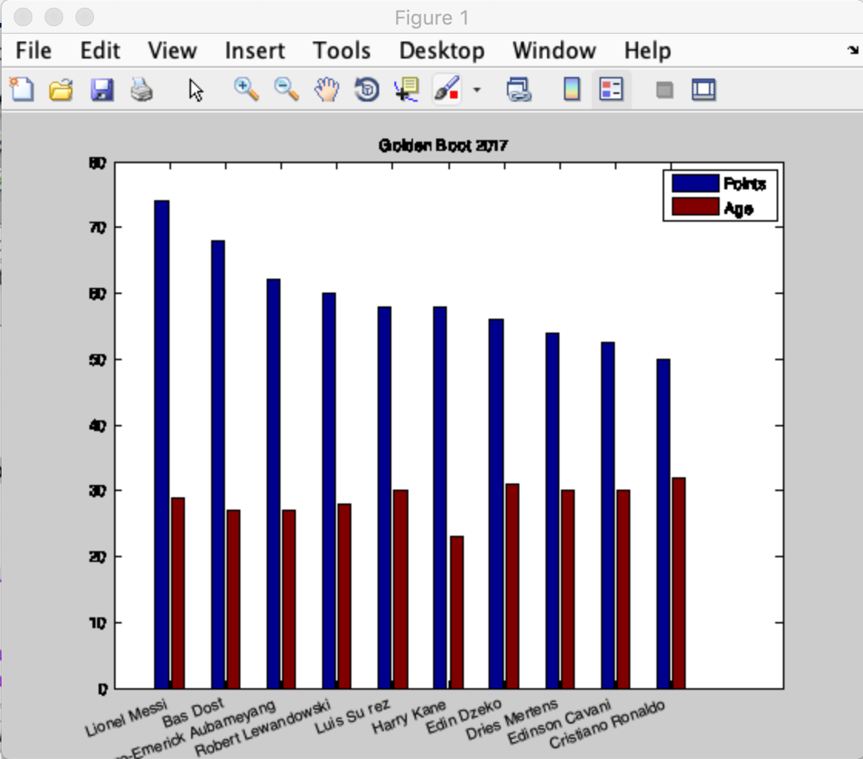

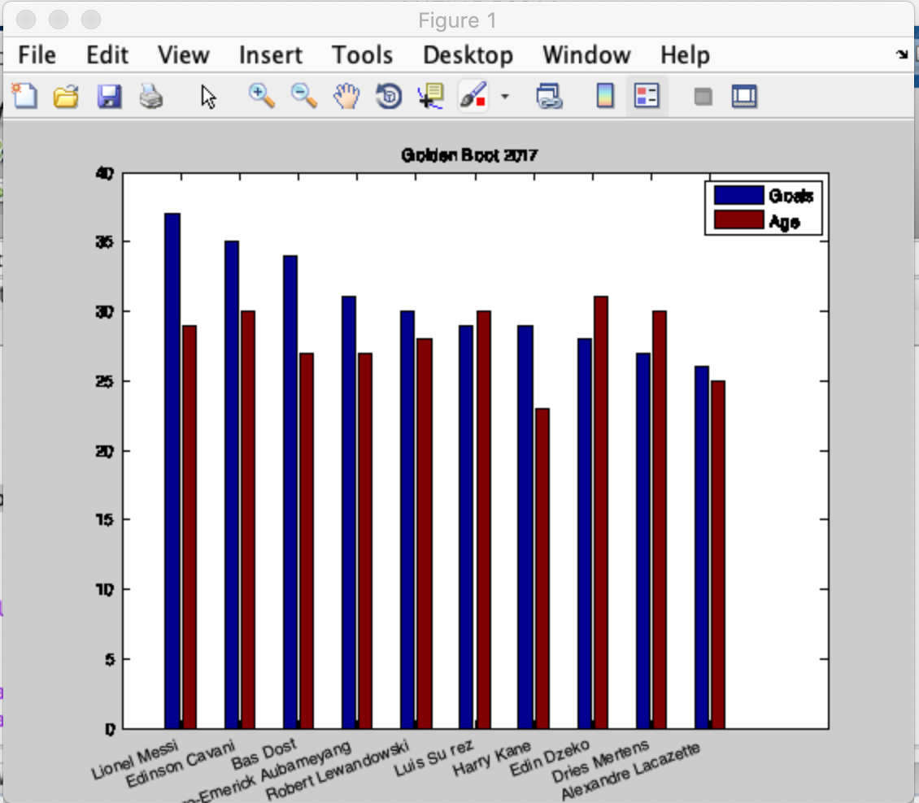

This is the part of the result from command window:

** Players Analysis Program **

Total # of players: 25

Average of goals: 25.640000

Average player age: 26.880000

Min of age: 21

Max of age: 32

Player Point

Lionel Messi 74.000000

Bas Dost 68.000000

…

Alexis Sánchez 48.000000

Mauro Icardi 48.000000

Ciro Immobile 44.000000

Timo Werner 42.000000

Sergio Agüero 40.000000

Diego Costa 40.000000

…

Dele Alli 36.000000

Minimum number of goals: 40

Maximum number of goals: 60

Names =

Player not found...

Minimum number of goals: 32

Maximum number of goals: 58

Lionel Messi

Bas Dost

Edinson Cavani