Peanut for Concrete5 Installation

## Install Concrete5 and Knockout View Package

1. Create your database then download and install or upgrade Concrete5 version 8.2.1  
   <https://documentation.concrete5.org/developers/installation/installation>
2. Make a database backup. It is unlikely to be needed but good to have if any installation problems occur.
3. From the distribution zip file, extract directories below 'web.root' to your Concrete 5 root directory
4. ***Important: You must perform this step before installing the package.***  
   Replace **application/bootstrap/app.php** with the **peanut-app.php** file in the same directory. Keep a copy of the original app.php file in case you wish to uninstall the ‘Knockout View’ package.  
     
   If you have made any custom changes to app.php, you’ll need to merge the file contents together. Otherwise, simply delete or rename the **app.php** file and then rename **peanut-app.php** to **app.php**.
5. Install the ‘Knockout View’ package.
6. Install and activate the ‘Peanut’ theme or another theme that supports Bootstrap modals.

## Run the Peanut Smoke Test

1. Create a new page.
2. In edit mode, drag and drop a “Knockout View” block on to the page.  
   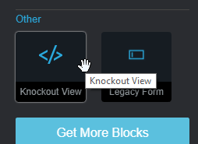
3. Enter the View Model name: peanut-smoke-test and check “Add Wrapper Markup. In this case it is not necessary to add anything in the content field.  
   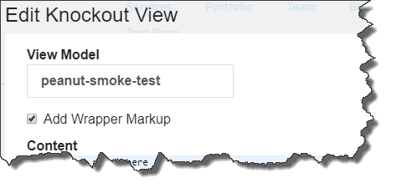
4. Save changes and display page.

## Custom Themes

Our sample theme “Peanut” is based on “Cloneamental”, a clone of the default C5 theme.

Themes that use peanut and want to use the Bootstrap modal feature must ensure that Bootstrap modals are included. Use the on_start function in packages/peanut/controller.php, as in this example

**public function** on_start()  
{  
 *// add bootstrap modals, not included in C5* $al = AssetList::*getInstance*();  
 $al->register(  
 **'javascript'**, **'bootstrap/modals'**,  
 **'js/bootstrap/modals.js'**,  
 **array**(**'minify'** => **false**, **'position'** => \Concrete\Core\Asset\Asset::***ASSET_POSITION_FOOTER***),  
 $this  
 );  
}

In the case of the Cloneamental theme, the Bootstrap javascript for modals was not included, so we just downloaded it and placed in the packages/peanut/js/bootstrap folder.