08

Fall



**V1.1**

**Product Requirements Specification (HERMES)**

April 14, 2014

#### Auditory Implant Initiative

**Dr. Jed Grisel**

**Gene Fojtik, Solution Architect**

*Atomic Axis: Designing, Developing, and Transforming Experiences for Mobile, Web, and Big Data.*

**Table of Contents**

1. Product Overview 4

1.1. Executive Summary 4

1.2. Mission/Success Criteria 4

1.3. Value Proposition 4

1.4. User of System 5

2. Glossary of Terms 6

3. Product Capabilities 7

4. Process 8

4.1. Holistic Patient Care Flow 8

4.2. Phases of Care (State Model) 9

5. Product Requirements / User Stories 12

5.1. [Security & Authorization Management] Ensure HIPAA/HITECH Compliance 12

5.1.1. Requirements 12

5.2. [Security & Authorization Management] Enable Group Access control Levels 12

5.2.1. Requirements 13

5.3. [CARE TEAM MANAGMENT] AUSBAT view and manage care team invitations 13

5.3.1. Requirements 14

5.4. [CARE TEAM MANAGEMENT] AUSBAT accept and sign a BAA 15

5.4.1. Requirements 15

5.5. [CARE TEAM MANAGEMENT] AUSBAT to find a provider near the patient (geo-location) 15

5.5.1. Requirements 16

5.6. [CARE TEAM MANAGEMENT] AUSBAT receive the signed BAA 16

5.6.1. Requirements 16

5.7. [CARE TEAM MANAGEMENT] AUSBAT invite a provider to join the care team 17

5.7.1. Requirements 17

5.8. [COMMUNICATION MANAGEMENT] AUSBAT to manage messages, notifications and alerts 17

5.8.1. Requirements 18

5.9. [PHASES OF CARE (workflow)] AUSBAT view the phases of care 18

5.9.1. Requirements 19

5.10. [PHASES OF CARE (workflow)] AUSBAT manage the phases of care 19

5.10.1. Requirements 20

5.11. [PHASES OF CARE (workflow] AUSBAT create a new patient record 20

5.11.1. Requirements 20

5.12. [REPORTING & ANALYTICS] Ensure HIPAA/HITECH Compliance 21

5.12.1. Requirements 21

5.13. [REPORTING & ANALYTICS] AUSBAT view individual, facility, and holistic stats 21

5.13.1. Requirements 22

5.14. [REPORTING & ANALYTICS] Ensure HIPAA/HITECH compliance 22

5.14.1. Requirements 22

5.15. [SECURITY & AUTHORIZATION MANAGEMENT] Ensure HIPAA/HITECH compliance 23

5.15.1. Requirements 23

5.16. [SECURITY & AUTHORIZATION MANAGEMENT] Enable user group access control levels 24

5.16.1. Requirements 24

6. Product Roadmap 24

7. Attachments 24

7.1. Requirements Spreadsheet 24

# Product Overview

## Executive Summary

The Auditory Implant Initiative is embarking on a mission to de-centralize patient care by enabling providers to collaborate and extend the reach of Cochlear implants to a larger demographic, while also capturing valuable patient data to further optimize the overall patient care process.

A key enabler of this mission is a product that allows providers to network, collaborate, and analyze integrated patient data.

## Mission/Success Criteria

**Mission:**

Dedicated to improving cochlear care in the community, focusing on research collaboration and research.

**Success Criteria:**

* Financially stable as an organization
* The majority of community surgeons, (Members) putting data into the tool
* Move the Dot of CI reach (10%)
* Increase community based CI implant care
  + Safely and ethicality of performing CI in community setting
* Robust data analytics

## Value Proposition

This product provides the following value proposition to each of the stakeholders identified: Patients and Providers.

**Value to patient:**

* Every aspect of the visit can be performed at the local community, not having to travel

**Value to provider:**

* Holistic data management tracking, Reporting/Analytics
  + Current EMR (data in -> data-out)
* For a practice
  + Data for practice
  + Practice Management; best practices
* Allow providers to participate in research
  + Benchmarking
* Networking/Collaboration: Cochlear implant, communicate based
  + Collaboration, value
* Standardization, as part of the network, standard process
  + Raising the minim quality of care
* Virtual Center of Excellence: Scoring/Rating for Providers.
* Clinical Reminders: Notifications to care team
  + ‘Orchestration of Care’
* Cochlear Implant Coordinator
  + Dashboard for reports; optimizing workload
* Centralized Cochlear Care Team Management:
  + Care Team Management
    - Follow-up care, invited doctor (Virtual Practice)

## User of System

The following users of the system have been identified:

| **User** | **Actions** |
| --- | --- |
| Facility Coordinator / CI Coordinator | Create the patient record Enter data regarding patient record Send/View Messages View/Print Reports Invite care team members |
| MA / Nurse | User data entry Send/View Messages |
| Physicians | User data entry Send/View Messages Invite providers View/Print Reports Invite care team members (*not default) |
| Patient (*Not included in the 1st version) | View patient summary Send/View Messages |

# Glossary of Terms

|  |  |
| --- | --- |
| **Term** | **Definition** |
| ePHI | Electronic Personal Health Information |
| AUSBAT | A User Should Be Able To |
| HIPAA | Health Insurance Portability and Accountability Act |
| BAA | Business Associates Agreement |
| MA | Medical Assistant |
| CI | Cochlear Implant |
| KBA | Knowledge Based Assessment |
| HITECH | Health Information Technology for Economic and Clinical Health Act |

# Product Capabilities

The following table provides a general overview of the overall system capabilities (functionality).

| Capability Name | Feature Description |
| --- | --- |
| Care Team Management | This capability provides the patient centric provider network, including:   * Care team invitations * System invitations * Acceptance/Rejecting Invitations * Adding/Removing from Care Team |
| Communications Management | This capability provides all the functionality around:   * Patient to provider / Provider to Patient messaging (*Later phase) * Provider to Provider messaging * System to provider notifications * System to provider alerts * System to Patient notifications (*Later Phase) * System to Patient alerts (*Later Phase) |
| Security & Authorization Management | This capability providers all the functionality around user authorization, system access levels and HIPAA/HITECH requirements |
| Phases of Care Management (Workflow) | This capability provides the logic flow of patient care, corresponding to electronic data collection milestones |
| Reporting & Analytics | The capability provides the necessary canned reports and ability to perform ad-hoc analysis and reporting |

The following table provides a basic overview of the capabilities, and the overall base requirements for each capability (Complexity)

|  |  |
| --- | --- |
| Capability | Base Requirements |
| Care Team Management | 20 |
| Communication Management | 8 |
| Phase of Care Management (Workflow) | 10 |
| Reporting & Analytics | 6 |
| Security & Authorization Management | 5 |

# Process

## Holistic Patient Care Flow

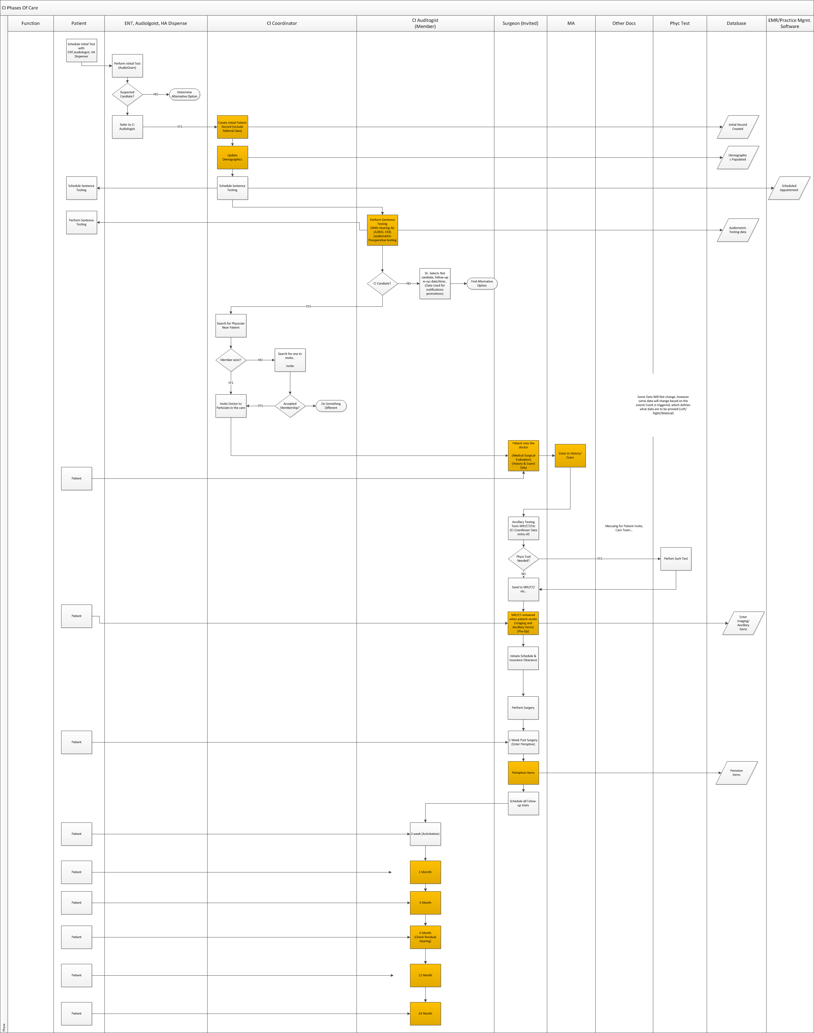

*Orange indicates the phases of care milestones where we will track data.

## Phases of Care (State Model)

The following table and state model describe the phases of care. The phases of care are the logic steps in patient care, where each step identifies the milestone and data that will be collected during that milestone.

|  |  |
| --- | --- |
| **Care Phase** | **Who is Collecting the Data** |
| Demographics | CI Coordinator |
| Candidacy Testing | Audiologist |
| Initial Surgical Consultation | Medical Assistant performs Data Entry |
| Preoperative Visit | MA / Surgeon |
| One week Postoperative Check | MA / Surgeon |
| Activation (3 week) | Audiologist |
| 1 Month | Audiologist |
| 3 Month | Audiologist |
| 6 Month | Audiologist |
| 12 Month | Audiologist |
| 24 Month | Audiologist |

State Model Flow (Linear)

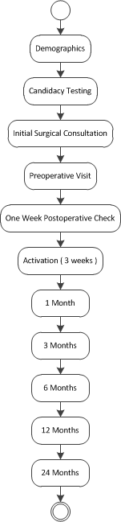

# Product Requirements / User Stories

## [Security & Authorization Management] Ensure HIPAA/HITECH Compliance

|  |  |
| --- | --- |
| User Story | Ensure HIPAA/HITECH complete |
| Description | The system should meet the necessary HIPAA and HITECH regulations for storing and transmitting ePHI data |
| Persona(s) | System |
| Pre-Conditions |  |
| Post-Conditions | * HIPAA and HITECH Compliant |

### Requirements

|  |  |  |
| --- | --- | --- |
| # | Title | Liability |
| SA_1 | The system shall provide a HIPAA compliant platform for ePHI information | MUST |
| SA_2 | The system shall provide a minimal NIST security level 2 [SSL/TLS, oAUTH2.0, AES256 bit encryption?] | MUST |
| SA_3 | The system shall provide the ability to verify the identify of an invited user through a KBA (Knowledge based assessment) | MUST |

## [Security & Authorization Management] Enable Group Access control Levels

|  |  |
| --- | --- |
| User Story | Enable User Group access control levels |
| Description | The system should be able to manage users by groups, where access control is provide to the group and users are added to the group |
| Persona(s) | System |
| Pre-Conditions | * Users exist, system has the ability to provide specific rights to course and fine-grain services |
| Post-Conditions | * Groups are created, system rights are provided to specific functionality and assigned to groups, users are added to groups |

### Requirements

|  |  |  |
| --- | --- | --- |
| # | Title | Liability |
| SA_4 | The system shall provide the ability to set system access by groups (Access Control Levels) | MUST |
| SA_5 | The system shall provide the ability to add users to groups | MUST |

## [CARE TEAM MANAGMENT] AUSBAT view and manage care team invitations

|  |  |
| --- | --- |
| User Story | AUSBAT view and manage care team invitations |
| Description | This user story describes the user interaction and requirements for managing care team invitations |
| Persona(s) | Physician, CI Coordinator |
| Pre-Conditions | * User logged |
| Post-Conditions | * Provider has been invited * Invitation accepted or rejected * Provider added to patient care team |

### Requirements

|  |  |  |
| --- | --- | --- |
| # | Title | Liability |
| CT_1 | The user shall be able to visually view and manage received invitations | MUST |
| CT_2 | The user shall be able to reject an invitation | MUST |
| CT_3 | The user shall be able to accept an invitation | MUST |
| CT_4 | The user shall receive notification of sent invitation status (Accepted/Rejected) | MUST |
| CT_5 | The user shall be able to send an invitation to an invitee from a known directory | MUST |
| CT_6 | The user shall be able to send an invitation to an invitee by ad-hoc (email) | MUST |
| CT_7 | The owner of the patient record (Initiated invitations to care team) shall be able to remove other providers | MUST |
| CT_10 | The system shall resend the invitation if the recipient has not responded (Accepted/Rejected) within a system configurable amount of time (x days) | MUST |
| CT_11 | The system shall send a notification to the invitation generator upon resending the notification when the configurable time has expired for invitee response | MUST |
| CT_12 | The user should be able to select an alternative provider to invite to the care team upon notification of care team invitation rejection | MUST |
| CT_13 | The user should receive notifications when their invitation has either been rejected or accepted | MUST |
| CT_14 | The user added to the care team of the patient shall be able to add other providers | MUST |
| CT_15 | The user associated to a patient shall receive a notification anytime a provider is added or removed | MUST |
| CT_16 | The use should be able to perform a KBA upon receipt of invitation to join the system | MUST |

## [CARE TEAM MANAGEMENT] AUSBAT accept and sign a BAA

|  |  |
| --- | --- |
| User Story | AUSBAT accept and sign a BAA |
| Description | This user story describes the interaction to accept and sign the BAA |
| Persona(s) | All users |
| Pre-Conditions | * User logged in * User passed KBA |
| Post-Conditions | * User accepts BAA |

### Requirements

|  |  |  |
| --- | --- | --- |
| # | Title | Liability |
| CT_9 | The user shall be prompted to electronically sign a BAA (Business Associates Agreement) | MUST |

## [CARE TEAM MANAGEMENT] AUSBAT to find a provider near the patient (geo-location)

|  |  |
| --- | --- |
| User Story | AUSBAT to find a provider near the patient (geo-location) |
| Description | This user story describes the functionality required to find a provider located geographically close to the user |
| Persona(s) | Physicians, CI Coordinator |
| Pre-Conditions | * The user is entered into the system, and they have an address * The system has a good directory of providers |
| Post-Conditions | * Provider found |

### Requirements

|  |  |  |
| --- | --- | --- |
| # | Title | Liability |
| CT_17 | The user shall be able to search for a provider near the patient address | MUST |

## [CARE TEAM MANAGEMENT] AUSBAT receive the signed BAA

|  |  |
| --- | --- |
| User Story | AUSBAT receive the signed BAA |
| Description | This user story describes the necessary functionality for the user to receive the signed BAA and the system to store the BAA |
| Persona(s) | All Users |
| Pre-Conditions | * The user has been invited to the system * The user has passed the KBA * The user has signed the BAA |
| Post-Conditions | * The user received the signed BAA |

### Requirements

|  |  |  |
| --- | --- | --- |
| # | Title | Liability |
| CT_9.1 | The system shall send the signed BAA to the user and store the record for record retention purposes | MUST |

## [CARE TEAM MANAGEMENT] AUSBAT invite a provider to join the care team

|  |  |
| --- | --- |
| User Story | AUSBAT invite a provider to join the care team |
| Description | This user story describes the necessary functionality for the user invite a provider to join the care team |
| Persona(s) | Facility Coordinator / CI Coordinator ; Physician |
| Pre-Conditions | * The user has the necessary privileges to invite the provider |
| Post-Conditions | * The invitee has received the invitation to join the system * The invitee has received the invitation to join the care team |

### Requirements

|  |  |  |
| --- | --- | --- |
| # | Title | Liability |
| CT_8 | The user shall be able to invite the provider to the care team for the patient | MUST |
| CT_8a | The user shall be able to invite the provider to the system to participate in the care team (provider not part of the system) | MUST |
| CT_8a.1 | The invitee when accepting the invitation to join the system after passing the KBA will immediately be placed in the care team of the original request | MUST |

## [COMMUNICATION MANAGEMENT] AUSBAT to manage messages, notifications and alerts

|  |  |
| --- | --- |
| User Story | AUSBAT to manage messages, notifications, and alerts |
| Description | This user story describes the interaction regarding all messaging, notifications and alerts |
| Persona(s) | All |
| Pre-Conditions | * The user is logged in |
| Post-Conditions | * The user manages messages |

### Requirements

|  |  |  |
| --- | --- | --- |
| # | Title | Liability |
| CM_1 | The user shall be able to view messages in their inbox | MUST |
| CM_2 | The user shall be able to view message they sent in their sent box | MUST |
| CM_3 | The user shall be able to receive notifications | MUST |
| CM_4 | The uses shall be able to have a visual indicatory of the number of messages, notifications and alerts | MUST |
| CM_5 | The user shall be able to send a message to an existing provider | MUST |
| CM_6 | The user shall receive notifications on defined items such as [invitations, acceptance/reject of sent invitations] | MUST |
| CM_7 | The user shall receive alerts on defined items as [phases of care transitions, phases of care schedule missing] | MUST |
| CM_8 | The system shall associate the messaging/notification/alerts with the patient record where applicable | MUST |

## [PHASES OF CARE (workflow)] AUSBAT view the phases of care

|  |  |
| --- | --- |
| User Story | AUSBAT to view the phases of care |
| Description | This user story describe the functionality required to view the phases of care and stats for each phase |
| Persona(s) | All |
| Pre-Conditions | * The user is logged in * The user has access to view patient or facility records |
| Post-Conditions | * The user views the data |

### Requirements

|  |  |  |
| --- | --- | --- |
| # | Title | Liability |
| PC_1 | The authorized user shall be able to view the status of the phases of care for an individual patient | MUST |
| PC_2 | The authorized user shall be able to view the status of the phases of care for a facility | MUST |
| PC_3 | The system shall implement the phases of care | MUST |
| PC_4 | The system shall store the current state of phases of care | MUST |

## [PHASES OF CARE (workflow)] AUSBAT manage the phases of care

|  |  |
| --- | --- |
| User Story | AUSBAT manage the phases of care |
| Description | This user story describe the functionality required to manage the phases of care, including the workflow, data collection, and care team member viewing regarding the patient record |
| Persona(s) | All |
| Pre-Conditions | * The user is logged in * The user has access to view patient or facility records |
| Post-Conditions | * The user views the data |

### Requirements

|  |  |  |
| --- | --- | --- |
| # | Title | Liability |
| PC_5 | The user shall be able to record patient data for the specific phase of care | MUST |
| PC_6 | The user shall be able to advance/retract the phases of care (move through the process) | MUST |
| PC_7 | The user shall be able to easily record, in sequence, the data required for the specific phase of care | MUST |
| PC_8 | The system shall provider a care team view for the patient (all providers related to the patient) | MUST |

## [PHASES OF CARE (workflow] AUSBAT create a new patient record

|  |  |
| --- | --- |
| User Story | AUSBAT create a new patient record |
| Description | This user story describes the functionality required to create a new patient record |
| Persona(s) | CI Coordinator |
| Pre-Conditions | * User Logged in |
| Post-Conditions | * Patient record created and associated to provider |

### Requirements

|  |  |  |
| --- | --- | --- |
| # | Title | Liability |
| PC_2 | The authorized user shall be able to create a new patient record | MUST |
| PC_2.1 | The system shall associate the new patient record with the creator, ensuring ownership is assigned to the creator | MUST |

## [REPORTING & ANALYTICS] Ensure HIPAA/HITECH Compliance

|  |  |
| --- | --- |
| User Story | Ensure HIPAA/HITECH compliance |
| Description | This user story describes the needs to ensure compliance in regards to data retention |
| Persona(s) | System |
| Pre-Conditions |  |
| Post-Conditions |  |

### Requirements

|  |  |  |
| --- | --- | --- |
| # | Title | Liability |
| RA_3 | The system shall retain records in accordance to HIPPA (>6 years) | MUST |
| RA_3 | The system shall keep all ePHI data encrypted at rest | MUST |
| RA_3 | The system shall ensure that only users provided explicit permission can view ePHI data (Providers invited to the patient record) | MUST |

## [REPORTING & ANALYTICS] AUSBAT view individual, facility, and holistic stats

|  |  |
| --- | --- |
| User Story | AUSBAT view individual, facility, and holistic stats |
| Description | This user story describes the functionality required to create canned reports as well as ensure the ability to perform ad-hoc reporting |
| Persona(s) | All |
| Pre-Conditions | * User is logged in * User has necessary privileges |
| Post-Conditions | * Data report viewed |

### Requirements

|  |  |  |
| --- | --- | --- |
| # | Title | Liability |
| RA_1 | The user shall be able to view individual patient phases of care stats | MUST |
| RA_2 | The user shall be able to view a facilities patient phases of care 'aggregated' stats | MUST |
| RA_3 | The system shall provide the ability for offline ad-hoc analysis of information | MUST |

## [REPORTING & ANALYTICS] Ensure HIPAA/HITECH compliance

|  |  |
| --- | --- |
| User Story | Ensure HIPPA/HITECH compliance |
| Description | This user story describes the functionality required to ensure that the data is HIPPA/HITECH compliant |
| Persona(s) | All |
| Pre-Conditions |  |
| Post-Conditions | * System meets HIPAA/HITECH compliance |

### Requirements

|  |  |  |
| --- | --- | --- |
| # | Title | Liability |
| RA_4 | The system shall retain records in accordance to HIPPA (>6 years) | MUST |
| RA_5 | The system shall keep all ePHI data encrypted at rest | MUST |
| RA_6 | The system shall ensure that only users provided explicit permission can view ePHI data (Providers invited to the patient record) | MUST |

## [SECURITY & AUTHORIZATION MANAGEMENT] Ensure HIPAA/HITECH compliance

|  |  |
| --- | --- |
| User Story | Ensure HIPAA/HITECH compliance |
| Description | This user story describes the functionality required to meet HIPAA/HITECH security requirements |
| Persona(s) | System |
| Pre-Conditions |  |
| Post-Conditions |  |

### Requirements

|  |  |  |
| --- | --- | --- |
| # | Title | Liability |
| SA_1 | The system shall provide a HIPAA compliant platform for ePHI information | MUST |
| SA_2 | The system shall provide a minimal NIST security level 2 [SSL/TLS, oAUTH2.0, AES256 bit encryption?] | MUST |
| SA_3 | The system shall provide the ability to verify the identify of an invited user through a KBA (Knowledge based assessment) | MUST |

## [SECURITY & AUTHORIZATION MANAGEMENT] Enable user group access control levels

|  |  |
| --- | --- |
| User Story | Enable user group access control levels |
| Description | This user story describes the requirements for the system to support user groups, and access control levels by groups |
| Persona(s) | System |
| Pre-Conditions |  |
| Post-Conditions |  |

### Requirements

|  |  |  |
| --- | --- | --- |
| # | Title | Liability |
| SA_4 | The system shall provide the ability to set system access by groups (Access Control Levels) | MUST |
| SA_5 | The system shall provide the ability to add users to groups | MUST |

# Product Roadmap

All user stories within this document are to be considered part of the initial product, with the exception of the patient user. The Patient user and user stories shall be implemented at a later date.

# Attachments

## Requirements Spreadsheet

