samlogo_blue_pc.tif

**Shelly Cashman** Word 2013

Chapter 1: SAM Project 1a

Band Seeking Bassist

completing a flyer with a picture

Project Goal

M Project Name

Project Goal

# PROJECT DESCRIPTION

For your marketing and special event major, you are helping to coordinate a concert fundraiser for a local homeless shelter. The band that is headlining the event needs a substitute bass player and has asked for your help finishing their flyer. You will add a picture and formatting to create an eye-catching flyer.

# GETTING STARTED

* Download the following file from the SAM website:
  + **SC\_Word2013\_C1\_P1a\_*FirstLastName*\_1.docx**
* Open the file you just downloaded and save it with the name:
  + **SC\_Word2013\_C1\_P1a\_*FirstLastName*\_2.docx**
  + *Hint:* If you do not see the **.docx** file extension in the Save file dialog box, do not type it. Word will add the file extension for you automatically.
* To complete this Project, you will also need to download and save the following support files from the SAM website:
  + **support\_SC\_W13\_C1\_P1a\_guitar.jpg**
* With the file **SC\_Word2013\_C1\_P1a\_*FirstLastName*\_2.docx** still open, ensure that your first and last name is displayed in the footer. If the footer does not display your name, delete the file and download a new copy from the SAM website.

# PROJECT STEPS

1. Change the theme colors of the document to **Violet II** (18th option in the Theme Colors palette).
2. Resize the picture of the guitar at the beginning of the document so that it is **1.7”** tall.
3. Apply the **Rotated, White** picture style to the picture, and then apply the **Blue, 11 pt. glow, Accent color 3** Glow picture effect.
4. Change the Paragraph Spacing Before the headline paragraph “Band needs bassist: homeless shelter fundraiser”to **12** **pt**.
5. Change the case of the headline paragraph to **Capitalize Each Word,** change the font size to **20 pt.**,and then **center** the paragraph.
6. **Bold** the words “Campus Creatures” in the paragraph that begins “Join Campus Creatures….”
7. In the same paragraph, delete the sentence “We have a Fender you can use.”
8. In the next paragraph, find the phrase “looking for a bassist and maybe a drummer.” Type the phrase **We are** so that the sentence reads “We are looking for a bassist and maybe a drummer.”
9. Create a bulleted list beginning with the paragraph “Bluegrass” and ending with the paragraph “Funk.” (*Hint:* Your bulleted list should contain four items.)
10. Select the bulleted list and change the font to **Comic Sans MS** and the font color to **Blue, Accent 5, Darker 50%** (9th column, 6th row in the Theme Colors palette).
11. **Italicize** the text “Prepare for classic riffs and odd time signatures”.
12. Apply the outline text effect **Plum, Accent 1, Darker 25%** (5th column, 5th row in the Theme colors palette) to the paragraph “Call 555.006.0987”.
13. Apply paragraph shading **Lavender, Background 2** (3rd column, 1st row in the Theme Colors palette) to the paragraph “Call 555.006.0987”.
14. In the blank line after the paragraph “Call 555.006.0987”, insert the picture file **support\_SC\_W13\_C1\_P1a\_guitar.jpg** available for download from the SAM website. Resize the picture so that it is **1”** tall.
15. Add a page border of your choosing to the document. (*Hint:* To match the Final Figure below, select the 2nd option from the border Style list). Change the width of the border to **1 ½ pt**. and change the border color to **Dark Purple, Text 2** (4th column, 1st row in the Theme Colors palette).

Your document should look like the Final Figure on the following page. Save your changes, close the document, and exit Word. Follow the directions on the SAM website to submit your completed project.

# Final Figure

# 

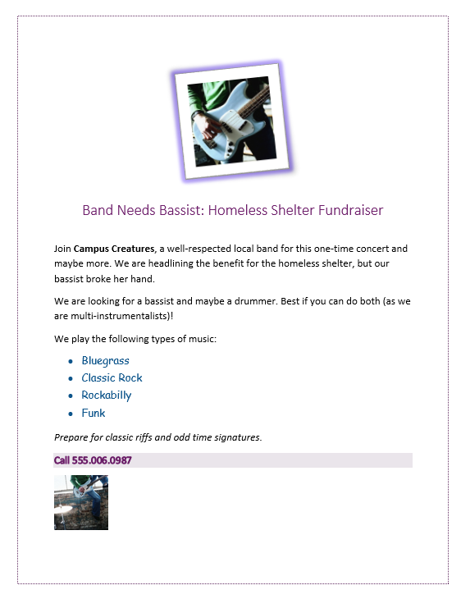

Microsoft product screenshots used with permission from Microsoft Corporation.

Both images courtesy of Holly Harris/Getty Images. Copyright © 2014 Cengage Learning. All Rights Reserved.