Tania Soutonglang

**CS 581 Spring 2024 Written Assignment #01**

Due: **Saturday, February 10, 2024, 11:59 PM CST**

Points: **30**

**Instructions:**

1. Use this document template to report your answers. Name the complete document as follows:

LastName_FirstName_CS581_Written01.doc

**(only MS Word or PDF files accepted!)**

1. Submit the final document to Blackboard Assignments section before the due date. No late submissions will be accepted.

**Objectives:**

1. (10 points) Demonstrate your understanding of MiniMax search algorithm,
2. (10 points) Demonstrate your understanding of A* search algorithm,
3. (10 points) Demonstrate your understanding of a basic Genetic Algorithm.

**Problem 1 [5 pts]:**

Apply MiniMax algorithm on the following game tree. What is the maximum utility that MAX can achieve, assuming MIN plays optimally?

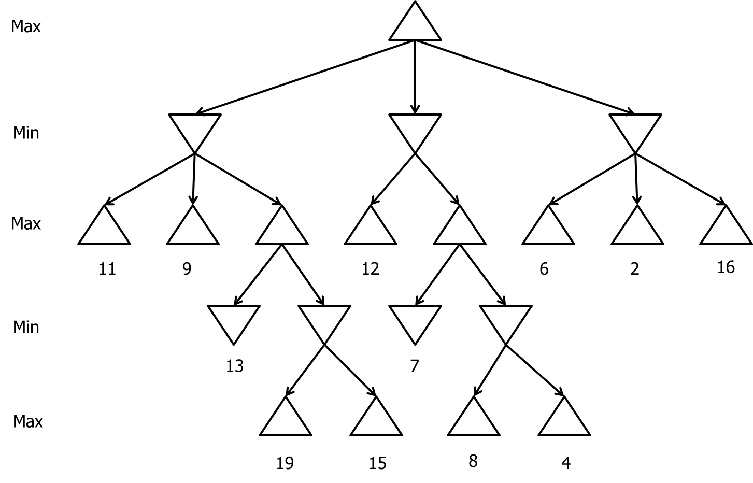  
Maximum utility: 9



**Problem 2 [5 pts]:**

This is the same game as in Problem 1. Hand trace the alpha-beta search. Show the updated bounds on the nodes. Clearly mark which branches are pruned, if any.

**Problem 3 [10 pts]:**

Consider the following problem **state space** (undirected and weighted) graph (fig. 1) representing a map with cities (vertices) and roads (maps).

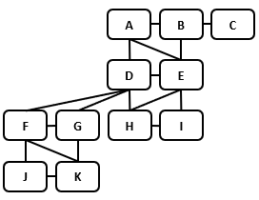

*Figure 1: Problem state space (“cities and roads”).*

The table (Table 1) below provides adjacency matrices for the state space graph above (Driving distances) and a corresponding (but not shown) straight-line distances graph.

Data in matrices represents action host and heurisitic function value, respectively.

|  |
| --- |
| 1. Driving distances |
| |  |  |  |  |  |  |  |  |  |  |  |  | | --- | --- | --- | --- | --- | --- | --- | --- | --- | --- | --- | --- | |  | **H** | **K** | **E** | **J** | **C** | **B** | **G** | **D** | **F** | **I** | **A** | | **H** | 0 | 0 | 102 | 0 | 0 | 0 | 0 | 114 | 0 | 87 | 0 | | **K** | 0 | 0 | 0 | 64 | 0 | 0 | 112 | 0 | 129 | 0 | 0 | | **E** | 102 | 0 | 0 | 0 | 0 | 68 | 0 | 170 | 0 | 50 | 180 | | **J** | 0 | 64 | 0 | 0 | 0 | 0 | 0 | 0 | 112 | 0 | 0 | | **C** | 0 | 0 | 0 | 0 | 0 | 164 | 0 | 0 | 0 | 0 | 0 | | **B** | 0 | 0 | 68 | 0 | 164 | 0 | 0 | 0 | 0 | 0 | 116 | | **G** | 0 | 112 | 0 | 0 | 0 | 0 | 0 | 205 | 127 | 0 | 0 | | **D** | 114 | 0 | 170 | 0 | 0 | 0 | 205 | 0 | 293 | 0 | 158 | | **F** | 0 | 129 | 0 | 112 | 0 | 0 | 127 | 293 | 0 | 0 | 0 | | **I** | 87 | 0 | 50 | 0 | 0 | 0 | 0 | 0 | 0 | 0 | 0 | | **A** | 0 | 0 | 180 | 0 | 0 | 116 | 0 | 158 | 0 | 0 | 0 | |
| 1. Straight-line distances |
| |  |  |  |  |  |  |  |  |  |  |  |  | | --- | --- | --- | --- | --- | --- | --- | --- | --- | --- | --- | --- | |  | **H** | **K** | **E** | **J** | **C** | **B** | **G** | **D** | **F** | **I** | **A** | | **H** | 0 | 234 | 93 | 278 | 229 | 116 | 151 | 82 | 242 | 66 | 172 | | **K** | 234 | 0 | 322 | 53 | 463 | 348 | 84 | 258 | 105 | 284 | 384 | | **E** | 93 | 322 | 0 | 368 | 149 | 63 | 242 | 139 | 335 | 41 | 152 | | **J** | 278 | 53 | 368 | 0 | 505 | 390 | 126 | 291 | 91 | 332 | 417 | | **C** | 229 | 463 | 149 | 505 | 0 | 116 | 380 | 230 | 458 | 191 | 138 | | **B** | 116 | 348 | 63 | 390 | 116 | 0 | 265 | 119 | 342 | 96 | 89 | | **G** | 151 | 84 | 242 | 126 | 380 | 265 | 0 | 176 | 113 | 206 | 301 | | **D** | 82 | 258 | 139 | 291 | 230 | 119 | 176 | 0 | 231 | 133 | 126 | | **F** | 242 | 105 | 335 | 91 | 458 | 342 | 113 | 231 | 0 | 305 | 353 | | **I** | 66 | 284 | 41 | 332 | 191 | 96 | 206 | 133 | 305 | 0 | 178 | | **A** | 172 | 384 | 152 | 417 | 138 | 89 | 301 | 126 | 353 | 178 | 0 | |

*Table 1: Adjacency matrices for the problem.*

**Your task:** Apply the **A* Search** algorithm to the problem with following initial/goal states:

**initial state (IS): F goal state (GS): I**

Show how the tree search develops:

* assume that **root node (corresponding to F) was already dequeued from the frontier** (see updated Reached structure below) and is ready to be expanded,
* **show the search tree after first TWO (2) expansions,**
* **show changes in the frontier and reached/visited structures** **BEFORE AND AFTER EVERY NODE EXPANSION**

|  |  |  |  |  |  |  |  |  |  |  |  |  |
| --- | --- | --- | --- | --- | --- | --- | --- | --- | --- | --- | --- | --- |
| **Frontier structure [front ← rear]** | | | | | | | | | | | | |
| Parent |  |  |  |  |  |  |  |  |  |  |  |  |
| State |  |  |  |  |  |  |  |  |  |  |  |  |
| f() |  |  |  |  |  |  |  |  |  |  |  |  |

|  |  |  |  |  |  |  |  |  |  |  |  |  |
| --- | --- | --- | --- | --- | --- | --- | --- | --- | --- | --- | --- | --- |
| **Reached / visited** | | | | | | | | | | | | |
| Parent | - |  |  |  |  |  |  |  |  |  |  |  |
| State | F |  |  |  |  |  |  |  |  |  |  |  |
| distance from  IS | 0 |  |  |  |  |  |  |  |  |  |  |  |

Show your work below (make sure it is legible)

|  |
| --- |
| **Search Tree diagrams + structures** |
|  |

**Problem 4 [10 pts]:**

You are solving an optimization problem using a basic Genetic Algorithm. Algorithm parameters are:

* Individual representation:
  + binary with 16th bits,
  + first 8 bits correspond to a base2 (binary) encoding of base10 variable (“gene”) X value,
  + second 8 bits correspond to a base2 (binary) encoding of base10 variable (“gene”) Y value,
* Population size N = 6,
* Fitness function:
* Selection mechanism:
  + order individuals according to their fitness in **descending order** (in case of ties: the individual that was first in unordered population goes first here as well)
  + offspring is created by pairing two subsequent parents with “wraparound”:
* parent1 + parent2 -> child1,
* parent2 + parent3 -> child2,
* ….,
* parentN-1 + parentN -> childN,
* parentN + parent1 -> childN
* Probability of crossover Pc = 1,
* Crossover mechanism: 2-point crossover with crossover points after the 4th and 12th bit (counting from the left),
* Probability of mutation Pm = 0.

Your initial population is shown below:

|  |  |  |  |  |  |  |  |  |  |  |  |  |  |  |  |  |
| --- | --- | --- | --- | --- | --- | --- | --- | --- | --- | --- | --- | --- | --- | --- | --- | --- |
| **Generation 1** | | | | | | | | | | | | | | | | |
| Individual 1 | 1 | 1 | 1 | 1 | 1 | 1 | 1 | 1 | 0 | 0 | 0 | 0 | 0 | 0 | 0 | 0 |
| Individual 2 | 0 | 0 | 0 | 0 | 0 | 0 | 0 | 0 | 1 | 1 | 1 | 1 | 1 | 1 | 1 | 1 |
| Individual 3 | 1 | 1 | 1 | 1 | 0 | 0 | 0 | 0 | 0 | 0 | 0 | 0 | 1 | 1 | 1 | 1 |
| Individual 4 | 0 | 0 | 0 | 0 | 1 | 1 | 1 | 1 | 1 | 1 | 1 | 1 | 0 | 0 | 0 | 0 |
| Individual 5 | 0 | 1 | 0 | 1 | 0 | 1 | 0 | 1 | 0 | 1 | 0 | 1 | 0 | 1 | 0 | 1 |
| Individual 6 | 1 | 0 | 1 | 0 | 1 | 0 | 1 | 0 | 1 | 0 | 1 | 0 | 1 | 0 | 1 | 0 |

|  |  |  |  |  |
| --- | --- | --- | --- | --- |
| **Generation 1 Evaluation** | | | | |
| **Individual** | **X** | **Y** | **Fitness** | **Fitness ratio [%]** |
| Individual 1 |  |  |  |  |
| Individual 2 |  |  |  |  |
| Individual 3 |  |  |  |  |
| Individual 4 |  |  |  |  |
| Individual 5 |  |  |  |  |
| Individual 6 |  |  |  |  |

Now, apply the Genetic Algorithm specified above. Stop after Generation 4 is created and evaluated:

* populate and show Generation and Generation Evaluation tables every time a new generation is created,
* generate Fitness = f(Generation) plot. It is enough to plot best individual of the generation’s fitness.