Tania Soutonglang

**CS 581 Spring 2024 Written Assignment #03**

Due: **Sunday, March 31, 2024, 11:59 PM CST**

Points: **80**

**Instructions:**

1. Use this document template to report your answers. Name the complete document as follows:

LastName_FirstName_CS581_Written03.doc or pdf

**(only MS Word or PDF files accepted!)**

1. Submit the final document to Blackboard Assignments section before the due date. No late submissions will be accepted.

**Objectives:**

1. (10 points) Demonstrate your understanding of Particle Swarm Optimization.
2. (15 points) Demonstrate your understanding of basic probability rules.
3. (15 points) Demonstrate your understanding of Bayes Networks.
4. (25 points) Demonstrate your understanding of Decision Networks.
5. (15 points) Demonstrate your understanding of Hidden Markov Models.

**Problem 1 [10 pts]:**

Consider the Particle Swarm Optimization problem with the following parameters:

N – number of particles: 5, w – inertia weight: 0.3, c1 – cognitive constant: 1, c2 – social constant: 1

At some time t particles are defined with (assume that this is a maximizing problem):

|  |  |  |  |  |  |  |
| --- | --- | --- | --- | --- | --- | --- |
| Particle | Particle’s best Xibest | Current Velocity Vit | Current Position Xit | Particle’s best Fitness (so far) | a | b |
| 1 | [0.2,0.1,0.2] | [0.2,0.1,0.1] | [0.5,0.5,0.1] | 1.0 | 0.10 | 0.23 |
| 2 | [0.9,1.1,0.2] | [0.1,0.1,0.0] | [0.2,0.2,0.1] | 0.9 | 0.55 | 0.45 |
| 3 | [0.6,1.1,0.6] | [0.0,1.5,0.6] | [0.0,0.0,0.0] | 0.8 | 0.12 | 0.78 |
| 4 | [1.2,4.1,1.2] | [0.2,1.1,0.4] | [0.5,0.5,0.1] | 1.2 | 0.89 | 0.54 |
| 5 | [1.0,1.0,1.0] | [0.0,0.7,1.0] | [0.3,0.5,0.1] | 0.7 | 0.56 | 0.67 |

What are particle positions at time t+1 assuming that a and b are random numbers for cognitive and social influence respectively?

|  |
| --- |
| **Your answer [show all your work]:** |
| |  |  |  |  |  |  |  |  |  |  |  |  |  | | --- | --- | --- | --- | --- | --- | --- | --- | --- | --- | --- | --- | --- | | **Particle** | **w * Vit** | | | **c1*a*(Xibest - Xit)** | | | **c2*b*(Xgbest - Xit)** | | | **Vi(t+1) = w * Vit + c1*a*(Xibest - Xit) + c2*b*(Xgbest - Xit)** | | | | 1 | 0.06 | 0.03 | 0.03 | -0.03 | -0.04 | 0.01 | -0.046 | 0 | 0 | -0.016 | -0.01 | 0.04 | | 2 | 0.03 | 0.03 | 0 | 0.385 | 0.495 | 0.055 | 0.045 | 0.135 | 0 | 0.46 | 0.66 | 0.055 | | 3 | 0 | 0.45 | 0.18 | 0.072 | 0.132 | 0.072 | 0.234 | 0.39 | 0.078 | 0.306 | 0.972 | 0.33 | | 4 | 0.06 | 0.33 | 0.12 | 0.623 | 3.204 | 0.979 | -0.108 | 0 | 0 | 0.575 | 3.534 | 1.099 | | 5 | 0 | 0.21 | 0.3 | 0.392 | 0.28 | 0.504 | 0 | 0 | 0 | 0.392 | 0.49 | 0.804 |  |  |  |  |  | | --- | --- | --- | --- | | **Particle** | **Xi(t+1) = Xit + Vi(t+1)** | | | | 1 | 0.484 | 0.49 | 0.14 | | 2 | 0.66 | 0.86 | 0.155 | | 3 | 0.306 | 0.972 | 0.33 | | 4 | 1.075 | 4.034 | 1.199 | | 5 | 0.692 | 0.99 | 0.904 | |

**Problem 2 [15 pts]:**

Consider the following full joint probability distribution for three Boolean variables X, Y, and Z **[show all your work, formulas, etc.]**:

|  |  |  |  |
| --- | --- | --- | --- |
| X | Y | Z | P(X, Y, Z) |
| T | T | T | 0.03 |
| T | T | F | 0.12 |
| T | F | T | 0.17 |
| T | F | F | 0.18 |
| F | T | T | 0.03 |
| F | T | F | 0.12 |
| F | F | T | 0.24 |
| F | F | F | 0.11 |

Calculate probabilities (**round to 3 decimal places**):

1. **[1 pt]** P(X = F) = $0.03+0.12+0.24+0.11=0.500$

b) **[1 pt]** P(X = T) = $0.03+0.12+0.17+0.18=0.500$

1. **[1 pt]** P(X = T, Z = T) = $0.03+0.17=0.200$

d) **[1 pt]** P(X = T | Y = T) = $\frac{0.03+0.12}{0.03+0.12+0.03+0.12}=0.500$

e) **[1 pt]** P(Z = F | Y = T) = $\frac{0.12+0.12}{0.03+0.12+0.03+0.12}=0.800$

Answer [**YES/NO**] the following questions:

f) **[2.5 pts]** Are X and Y independent of each other? **Justify your answer.**

|  |
| --- |
| **Your answer:** |
| $$P\left(X,Y\right)=0.15$$ $$P\left(X\right)×P\left(Y\right)=0.5×0.3=0.15$$ $0.15=0.15$ X and Y are **independent** of each other |

g) **[2.5 pts]** Are Y and Z independent of each other? **Justify your answer.**

|  |
| --- |
| **Your answer:** |
| $$P(Z,Y)=0.06$$ $$P\left(Y\right)×P\left(Z\right)=0.3×0.47=0.141$$ $0.06≠0.141$ Y and Z are **not independent** of each other |

h) **[2.5 pts]** Are Y and Z conditionally independent given X? **Justify your answer.**

|  |
| --- |
| **Your answer:** |
| Y and Z are not conditionally independent given X. |

i) **[2.5 pts]** Are X and Z conditionally independent given Y? **Justify your answer.**

|  |
| --- |
| **Your answer:** |
| X and Z are not conditionally independent given Y. |

**Problem 3 [15 pts]:**

Given the following Bayes Network:

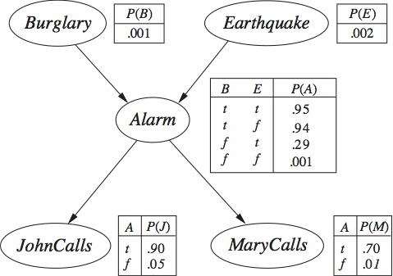

Use the **General Inference Procedure** to calculate the probability (**show all your work**):

P(Alarm = False | Earthquake = True, MaryCalls = False)

|  |
| --- |
| **Your solution:** |
|  |

**Problem 4 [25 pts]:**

Consider the following decision network (**note three decisions for D: x, y, z**):

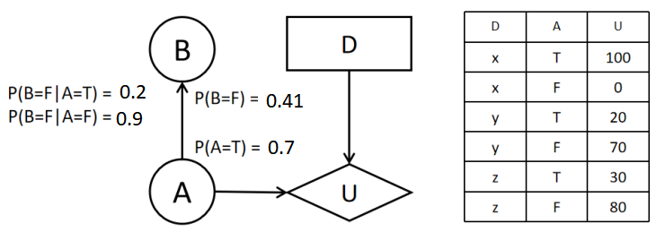

|  |
| --- |
| 1. **Complete conditional probability tables for each chance node. [1 pt]:** |
| Node A   |  |  | | --- | --- | | T | 0.7 | | F | 0.3 |   Node B   |  |  | | --- | --- | | T | 0.59 | | F | 0.41 |   Conditional Probability Table   |  |  |  | | --- | --- | --- | | A | B | P(B|A) | | T | T | 0.8 | | T | F | 0.2 | | F | T | 0.1 | | F | F | 0.9 | |

|  |
| --- |
| 1. **Which decision (x, y, or z) is best given evidence B = T? Justify your answer. [12 pts]:** |
|  |
| 1. **What is the value of information for B? Justify your answer. [12 pts]:** |
|  |

**Problem 5 [15 pts]**

Consider the following Hidden Markov Model (no start/end state – that’s fine):

|  |  |  |  |  |  |
| --- | --- | --- | --- | --- | --- |
| Transition Probability Matrix | | | | | |
| State | S1 | S2 | S3 | S4 | S5 |
| S1 | 0.02 | 0.70 | 0.11 | 0.08 | 0.09 |
| S2 | 0.01 | 0.20 | 0.30 | 0.45 | 0.04 |
| S3 | 0.10 | 0.14 | 0.16 | 0.29 | 0.31 |
| S4 | 0.80 | 0.03 | 0.04 | 0.01 | 0.12 |
| S5 | 0.21 | 0.22 | 0.23 | 0.19 | 0.15 |

|  |  |  |  |  |  |
| --- | --- | --- | --- | --- | --- |
| Emission Probability Matrix [**selected observations only**] | | | | | |
| State | o1 | o5 | o8 | o11 | o15 |
| S1 | 0.10 | 0.04 | 0.05 | 0.11 | 0.21 |
| S2 | 0.20 | 0.00 | 0.14 | 0.02 | 0.50 |
| S3 | 0.21 | 0.03 | 0.07 | 0.16 | 0.22 |
| S4 | 0.83 | 0.08 | 0.06 | 0.00 | 0.00 |
| S5 | 0.31 | 0.32 | 0.19 | 0.13 | 0.00 |

Given the sequence of observations (in that order): o8, o11, o5, what is the most likely sequence of states that generated it (**show all your work: formulas and calculations**):

1. S1, S4, S5
$$P\left(S_{1},S_{4},S_{5} \right|o_{8},o_{11}, o_{5})=P\left(S_{1} | o_{8}\right)×P\left(S_{4} | o_{11}\right)×P(S_{5}|o_{5})$$

$$=0.10×0.00×0.32=0.00$$

2. S2, S4, S5
$$P\left(S_{2},S_{4},S_{5} \right|o_{8},o_{11}, o_{5})=P\left(S_{2} | o_{8}\right)×P\left(S_{4} | o_{11}\right)×P(S_{5}|o_{5})$$

$$=0.14×0.00×0.32=0.00$$

3. S1, S2, S3

$$P\left(S_{1},S_{2},S_{3} \right|o_{8},o_{11}, o_{5})=P\left(S_{1} | o_{8}\right)×P\left(S_{2} | o_{11}\right)×P(S_{3}|o_{5})$$

$$=0.05×0.02×0.03=0.00003$$

S1, S2, S3 is most likely.