N-tier FireBanApp Web API

Application Architecture
- Class Library
- DTO
- Web API

http://www.rfs.nsw.gov.au/feeds/fdrToban.xml is parsed and data is given out in the form generic list object by the class library. It is assumed that the xml file is updated once in a day.

Web API application is divided into repository, services and controller. The repository class gets data from the dll and services class wraps over the reposity.
Controller is dependent on Services. It is provided to the controller through Unity Container.
Controller Action method is Cached to improve performance. Normally the Web API has no cache. But the Get function is cached and Control Cache in the header is having a max age. This cache is stored in both server and client.

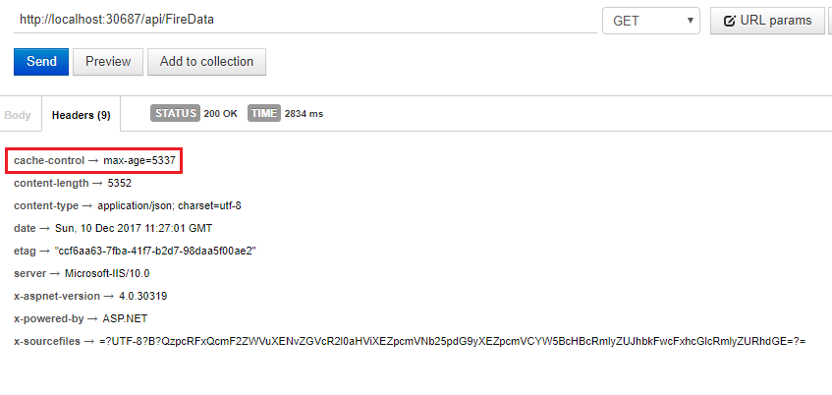
Figure 1 Web API Action Method

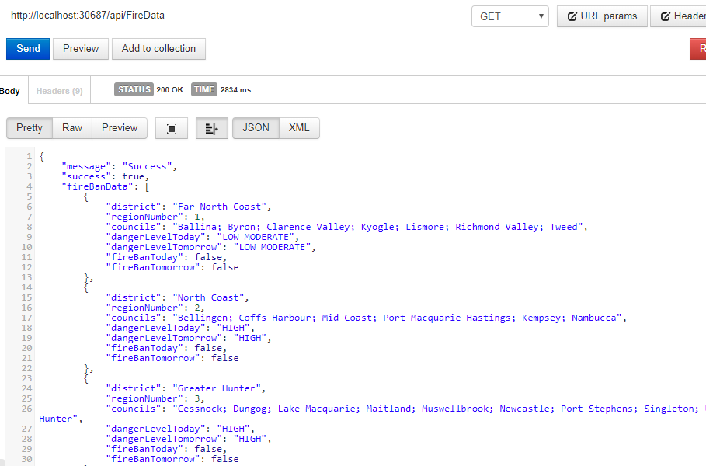
Figure 2 Web API Response

Unit Testing
Project is unit tested using NUnit and NSubstitute
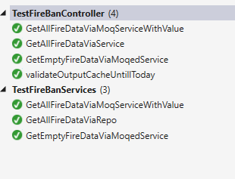
Figure 3 Unit Testing Result

