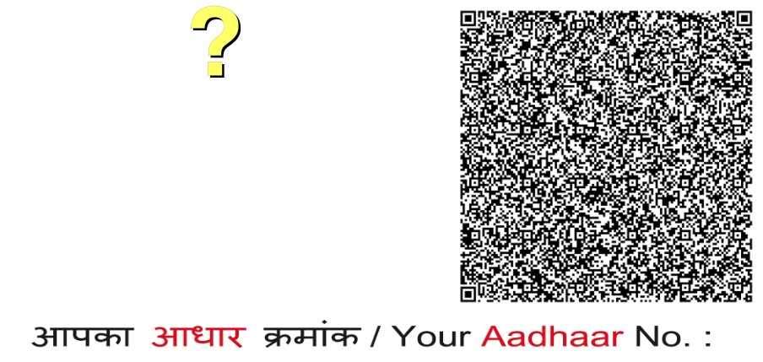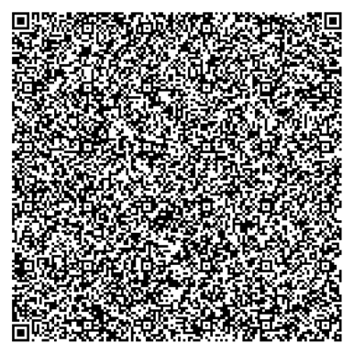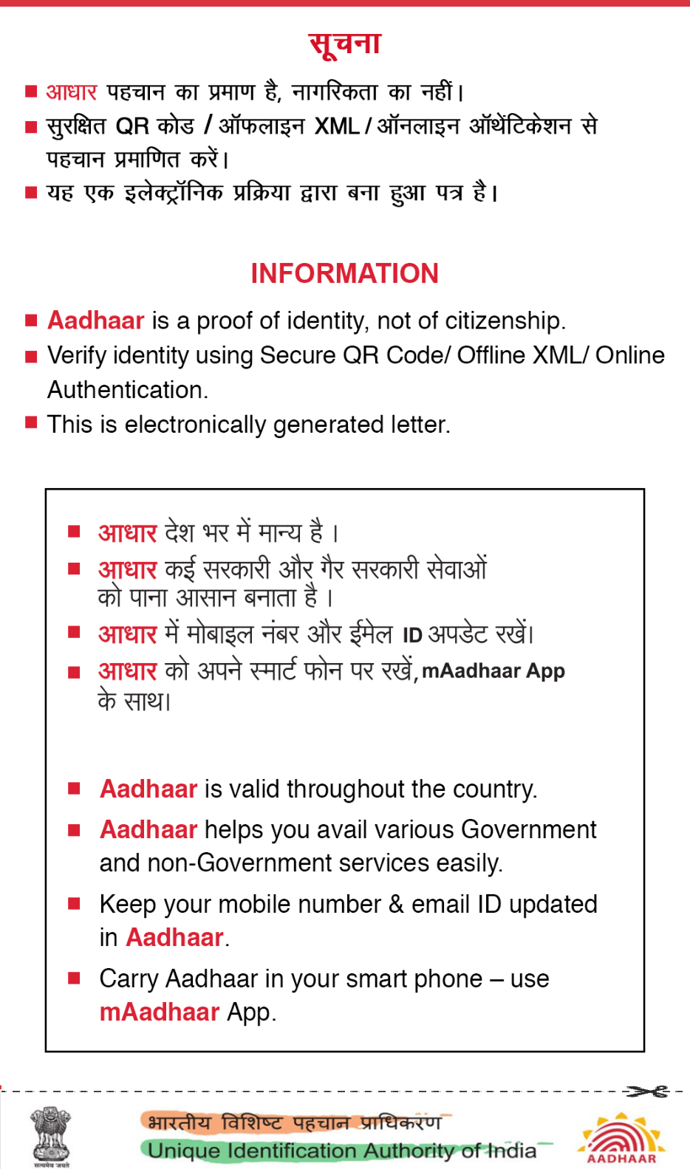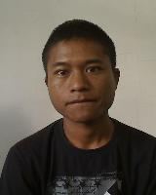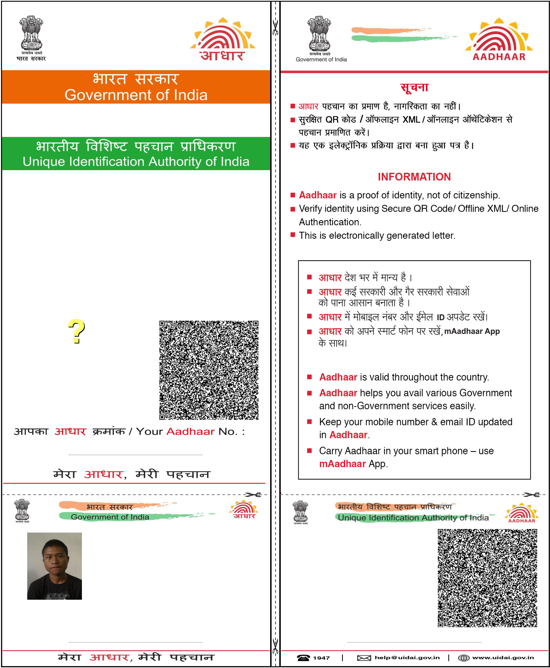

|  |  |
| --- | --- |
| � %&$�'$(�)�* THIPKJklQ�VmJ�nQlHoHQR��  �  +�� �B�C$C�  +�� | � F�F�!"# �$F�"   +�� .23�-2567�89:;<:<8<<-./01 |