Technical Evaluation Report: Harness Implementation for UI Automation
(CSB Bank/united bank/bankrupt)

Document Information
Field | Details
Document Title | Technical Evaluation Report on Harness Implementation for Testing
Department | Devops
Document Owner | Rahulganesh TS
Primary Author | Rahulganesh TS
Organization | Infinite computer solution
Location | Pune
Status | Analysis
Start/EndDate | 5-12-2025 | 19-12-2025
Confidentiality | Internal / Confidential

Version History
Version | Date | Author | Description of Change
0.1.0 | 19-12-2025 | Rahulganeshts | Initial draft
0.2.0 | - | - | Review comments incorporated
0.3.0 | - | - | Approved release

Events In Sequence Of Execution:
Content 1:Program for csb bank,which passed in java editor,done in VDI environment:
Content 2 : screenshot of the result
Content 3: Result Report
Content 4 : Xpath Entries used in this program and over all builds, only for username, password and submit button
Content 5: Real unedited worksheet for iteration 1,2,3 ….16
Content 6: Result of harness with all the screenshot details of all build and pipeline iterations
Content 7: Errors on all xpath type against harness errors
Content 8: Expected behaviour in any domain,if no restrictions
Content 9:same program ,modified into 3 times more for harness compatibility without change of logical Locators
Content 10: previous url failure on any xpath type
Conclusion :

Technical Evaluation Report: Harness Implementation for UI Automation
(CSB Bank/united bank/bankrupt)

Content 1:Program for csb bank,which passed in java editor,done in VDI environment:
import org.openqa.selenium.*;
import org.openqa.selenium.chrome.ChromeDriver;
import org.openqa.selenium.chrome.ChromeOptions;
import org.openqa.selenium.support.ui.ExpectedConditions;
import org.openqa.selenium.support.ui.WebDriverWait;
import java.io.File;
import java.io.FileWriter;
import java.io.IOException;
import java.nio.file.Files;
import java.nio.file.Path;
import java.text.SimpleDateFormat;
import java.time.Duration;
import java.util.Date;
public class csbbank {
public static void main(String[] args) {
// Set ChromeDriver path (adjust if needed)
System.setProperty("webdriver.chrome.driver",
"C:\\Users\\FA62XEA\\Downloads\\chromedriver-win64\\chromedriver-win64\\chromedriver.exe");
// Prepare report folders
File reportDir = new File("report");
File screenshotDir = new File(reportDir, "screenshots");
reportDir.mkdirs();
screenshotDir.mkdirs();
String timestamp = new SimpleDateFormat("yyyyMMdd_HHmmss").format(new Date());
File reportFile = new File(reportDir, "LoginReport_" + timestamp + ".html");
// Chrome options
ChromeOptions options = new ChromeOptions();
options.addArguments("--remote-allow-origins=*");
options.addArguments("--disable-notifications");
WebDriver driver = new ChromeDriver(options);
WebDriverWait wait = new WebDriverWait(driver, Duration.ofSeconds(12));
long start = System.currentTimeMillis();
String status = "PASS";
String message = "";
String pageTitle = "";
String currentUrl = "";
String screenshotPath = "";
String dashboardHeaderText = "";
try {
driver.manage().window().maximize();
driver.get("https://csbbankonline-p2.onlinebank.com/SignIn.aspx");
// Username
wait.until(ExpectedConditions.visibilityOfElementLocated(
By.xpath("//input[contains(@class,'form-control') and contains(@class,'component-group')]")
)).sendKeys("Retailuser1");
// Password
wait.until(ExpectedConditions.visibilityOfElementLocated(
By.cssSelector("input.signin-password")
)).sendKeys("Google@44566");
// Sign In button
wait.until(ExpectedConditions.elementToBeClickable(
By.xpath("//*[contains(@class,'btn') and contains(@class,'btn-primary')]")
)).click();
// Wait for the correct page title (use title, not URL)
wait.until(ExpectedConditions.titleContains("Account Summary - COMMUNITY STATE BANK"));
currentUrl = driver.getCurrentUrl();
pageTitle = driver.getTitle();
System.out.println("Dashboard Title: " + pageTitle);
// Optional: try grabbing a visible header on the page (replace with real selector if available)
try {
// Example generic header probe. Please replace with a real selector from CSB dashboard.
WebElement header = wait.until(ExpectedConditions.visibilityOfElementLocated(
By.xpath("//h1|//h2|//h3|//h4|//h5|//h6")
));
dashboardHeaderText = header.getText();
System.out.println("Dashboard Header Text: " + dashboardHeaderText);
} catch (Exception ignored) {
// If no reliable header, title verification is sufficient
}
// Simple validation based on title
if (!"Account Summary - COMMUNITY STATE BANK".equals(pageTitle)) {
status = "FAIL";
message = "Unexpected title: " + pageTitle;
} else {
message = "Login and Account Summary - COMMUNITY STATE BANK verified.";
}
// Optional: add a pragmatic URL check, if there is a stable pattern (adjust if you know it)
// if (!currentUrl.contains("onlinebank.com")) {
// status = "FAIL";
// message = "Expected to be on CSB OnlineBank domain. Current URL: " + currentUrl;
// }
} catch (Exception e) {
status = "FAIL";
message = "Exception: " + e.getClass().getSimpleName() + " - " + safe(e.getMessage());
// Screenshot on failure
try {
screenshotPath = new File(screenshotDir, "failure_" + timestamp + ".png").getAbsolutePath();
TakesScreenshot ts = (TakesScreenshot) driver;
File src = ts.getScreenshotAs(OutputType.FILE);
Files.copy(src.toPath(), Path.of(screenshotPath));
} catch (Exception ignored) { /* may fail if driver already quit */ }
} finally {
try {
driver.quit();
} catch (Exception ignored) {
}
long end = System.currentTimeMillis();
long durationMs = end - start;
// Write HTML report
writeHtmlReport(reportFile, status, message, pageTitle, dashboardHeaderText,
currentUrl, screenshotPath, start, end, durationMs);
System.out.println("HTML report: " + reportFile.getAbsolutePath());
if (!screenshotPath.isEmpty()) {
System.out.println("Failure screenshot: " + screenshotPath);
}
}
}
private static void writeHtmlReport(File reportFile,
String status,
String message,
String title,
String headerText,
String url,
String screenshotPath,
long start,
long end,
long durationMs) {
String startStr = new SimpleDateFormat("yyyy-MM-dd HH:mm:ss").format(new Date(start));
String endStr = new SimpleDateFormat("yyyy-MM-dd HH:mm:ss").format(new Date(end));
String statusClass = "PASS".equalsIgnoreCase(status) ? "status-pass" : "status-fail";
StringBuilder sb = new StringBuilder();
// NOTE: We are writing real HTML (no &lt;/&gt; escaping of structural tags).
sb.append("<!DOCTYPE html>\n<html lang=\"en\">\n<head>\n<meta charset=\"UTF-8\">\n")
.append("<title>Account Summary - COMMUNITY STATE BANK Login Report</title>\n<style>\n")
.append("body{font-family:Arial,sans-serif;margin:20px;} .card{border:1px solid #ddd;border-radius:8px;padding:16px;max-width:900px;}")
.append(".status-pass{color:#0b7a0b;font-weight:bold;} .status-fail{color:#b00020;font-weight:bold;} .row{margin:8px 0;} ")
.append("code{background:#f7f7f7;padding:2px 6px;border-radius:4px;} a{color:#0069c0;text-decoration:none;}\n")
.append("hr{border:none;border-top:1px solid #eee;margin:14px 0;}\n")
.append("</style>\n</head>\n<body>\n<h2>Account Summary - COMMUNITY STATE BANK Login Report</h2>\n<div class=\"card\">\n")
.append("<div class=\"row\"><strong>Status:</strong> <span class=\"").append(statusClass).append("\">")
.append(escapeHtml(status)).append("</span></div>\n")
.append("<div class=\"row\"><strong>Message:</strong> ").append(escapeHtml(message)).append("</div>\n")
.append("<div class=\"row\"><strong>Start:</strong> ").append(startStr).append("</div>\n")
.append("<div class=\"row\"><strong>End:</strong> ").append(endStr).append("</div>\n")
.append("<div class=\"row\"><strong>Duration:</strong> ").append(durationMs).append(" ms</div>\n<hr/>\n")
.append("<div class=\"row\"><strong>Page Title:</strong> <code>").append(escapeHtml(title)).append("</code></div>\n")
.append("<div class=\"row\"><strong>Dashboard Header:</strong> <code>").append(escapeHtml(headerText)).append("</code></div>\n")
.append("<div class=\"row\"><strong>URL:</strong> <a href=\"").append(escapeHtml(url)).append("\" target=\"_blank\">")
.append(escapeHtml(url)).append("</a></div>\n");
if (screenshotPath != null && !screenshotPath.isEmpty()) {
String rel = relPathForReport(reportFile, screenshotPath);
sb.append("<div class=\"row\"><strong>Screenshot:</strong><br/>\n")
.append("<img src=\"").append(escapeHtml(rel)).append("\" alt=\"Screenshot\" style=\"max-width:100%;border:1px solid #ccc;\"/>\n")
.append("</div>\n");
}
sb.append("</div>\n</body>\n</html>");
try (FileWriter fw = new FileWriter(reportFile)) {
fw.write(sb.toString());
} catch (IOException e) {
System.err.println("Failed to write HTML report: " + e.getMessage());
}
}
private static String relPathForReport(File reportFile, String screenshotAbs) {
try {
Path reportDir = reportFile.getParentFile().toPath().toAbsolutePath();
Path screenshot = Path.of(screenshotAbs).toAbsolutePath();
return reportDir.relativize(screenshot).toString().replace("\\", "/");
} catch (Exception e) {
return screenshotAbs;
}
}
private static String safe(String s) {
return (s == null) ? "" : s;
}
// Escape only dynamic content (do NOT escape structural HTML tags)
private static String escapeHtml(String s) {
if (s == null) return "";
return s.replace("&", "&amp;")
.replace("<", "&lt;")
.replace(">", "&gt;");
}
}

Content 2 : screenshot of the result
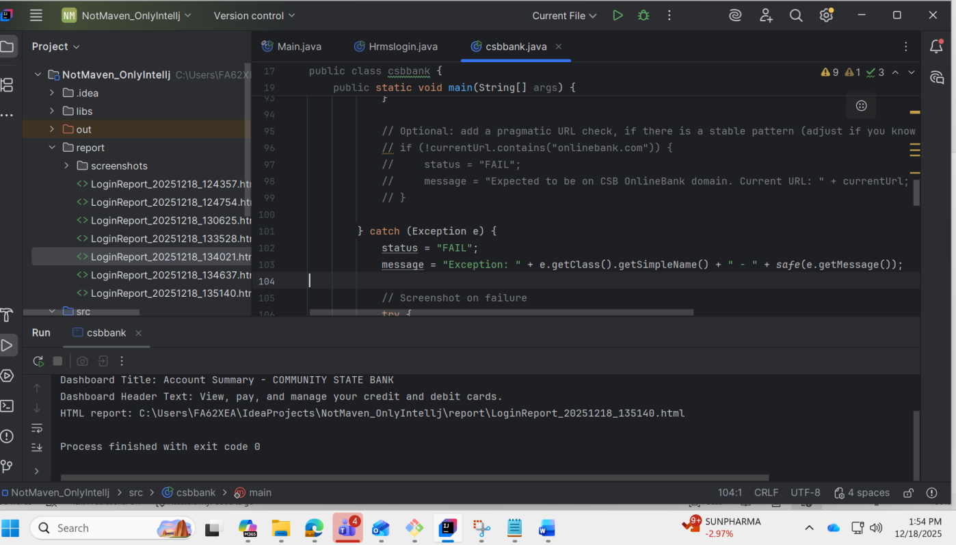
Content 3: Result Report
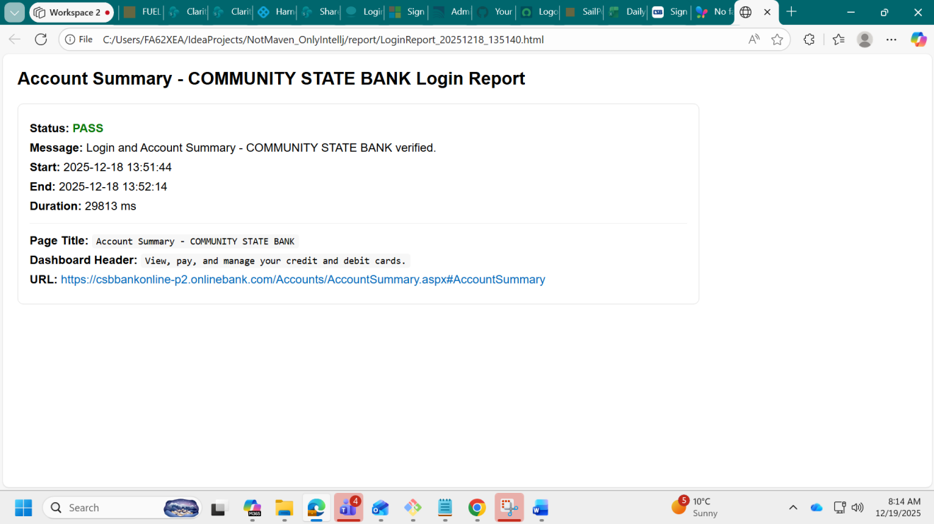
Content 4 : Xpath Entries used in this program and over all builds, only for username, password and submit button
Note : I had already proved that with By.id ,By.name,By.css selector failed with harness though it got passed running java program in Intellj.
For url: Sign In - COMMUNITY STATE BANK
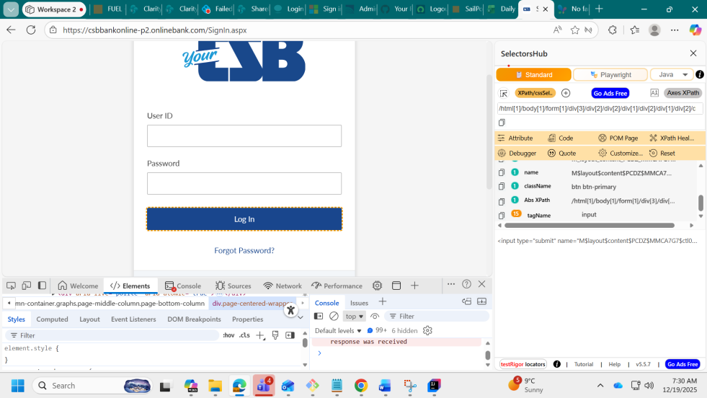
User name :
Relative xpath for css selector : #M_layout_content_PCDZ_MMCA7G7_ctl00_webInputForm_txtLoginName
Relative xpath for Id : //input[@id='M_layout_content_PCDZ_MMCA7G7_ctl00_webInputForm_txtLoginName']
Index xpath for id : (//input[@id='M_layout_content_PCDZ_MMCA7G7_ctl00_webInputForm_txtLoginName'])[1]
Relative xpath for name : M$layout$content$PCDZ$MMCA7G7$ctl00$webInputForm$txtLoginName
Class name : form-control component-group
Password:
Relative xpath for css selector : #M_layout_content_PCDZ_MMCA7G7_ctl00_webInputForm_txtPassword
Relative xpath for id: //input[@id='M_layout_content_PCDZ_MMCA7G7_ctl00_webInputForm_txtPassword']
Relative xpath for name://M$layout$content$PCDZ$MMCA7G7$ctl00$webInputForm$txtPassword
Class name : signin-password
Submit button:
Relative xpath for css selector : #M_layout_content_PCDZ_MMCA7G7_ctl00_webInputForm_cmdContinue
Relative xpath for id: //input[@id='M_layout_content_PCDZ_MMCA7G7_ctl00_webInputForm_cmdContinue']
Relative xpath for name://:M$layout$content$PCDZ$MMCA7G7$ctl00$webInputForm$cmdContinue
Class name : btn btn-primary
Index xpath for id :(//input[@id='M_layout_content_PCDZ_MMCA7G7_ctl00_webInputForm_cmdContinue'])[1]

Now this is the proof for left out xpath scenario ,class and contains to prove that class and contains (in generic way) also will fail in harness.
FYI : Starts with and ends with will be out of scope.
Xpath entries :
// Username
wait.until(ExpectedConditions.visibilityOfElementLocated(
By.xpath("//input[contains(@class,'form-control') and contains(@class,'component-group')]")
)).sendKeys("Retailuser1");
// Password
wait.until(ExpectedConditions.visibilityOfElementLocated(
By.cssSelector("input.signin-password")
)).sendKeys("Google@44566");
// Sign In button
wait.until(ExpectedConditions.elementToBeClickable(
By.xpath("//*[contains(@class,'btn') and contains(@class,'btn-primary')]")
)).click();
// Wait for the correct page title (use title, not URL)
wait.until(ExpectedConditions.titleContains("Account Summary - COMMUNITY STATE BANK"));
Content 5: Real unedited worksheet for iteration 1,2,3 ….16
iteration 1
FA62XEA@CPC-rahul-F7OF5 MINGW64 ~/IdeaProjects/IDEAPROJECTS_BACKUP (main)
$ cd ..
FA62XEA@CPC-rahul-F7OF5 MINGW64 ~/IdeaProjects
$ ls
IDEAPROJECTS_BACKUP/ NotMaven_OnlyIntellj/
FA62XEA@CPC-rahul-F7OF5 MINGW64 ~/IdeaProjects
$ cd ~/documents
FA62XEA@CPC-rahul-F7OF5 MINGW64 ~/documents
$ ls
Auto8/ Hrms/ POC/ auto2/ auto4/ auto6/ vscodeproj/
Drivers/ My_config/ 'XD_Automation BDD 12-03-2025_mahesh'/ auto3/ auto5/ auto7/
FA62XEA@CPC-rahul-F7OF5 MINGW64 ~/documents
$ cd Auto8
FA62XEA@CPC-rahul-F7OF5 MINGW64 ~/documents/Auto8
$ ls
NotMaven_OnlyIntellj.iml src/

FA62XEA@CPC-rahul-F7OF5 MINGW64 ~/documents/Auto8
$ cd ..
FA62XEA@CPC-rahul-F7OF5 MINGW64 ~/documents
$ ls
Auto8/ Hrms/ POC/ auto2/ auto4/ auto6/ vscodeproj/
Drivers/ My_config/ 'XD_Automation BDD 12-03-2025_mahesh'/ auto3/ auto5/ auto7/
FA62XEA@CPC-rahul-F7OF5 MINGW64 ~/documents
$ cp -r ~/auto7/pom.xml Auto8
cp: cannot stat '/c/Users/FA62XEA/auto7/pom.xml': No such file or directory
FA62XEA@CPC-rahul-F7OF5 MINGW64 ~/documents
$ cp -r ~/documents/auto7/pom.xml Auto8
FA62XEA@CPC-rahul-F7OF5 MINGW64 ~/documents
$ cd Auto8
FA62XEA@CPC-rahul-F7OF5 MINGW64 ~/documents/Auto8
$ ls
NotMaven_OnlyIntellj.iml pom.xml src/
FA62XEA@CPC-rahul-F7OF5 MINGW64 ~/documents/Auto8
$ cd src
FA62XEA@CPC-rahul-F7OF5 MINGW64 ~/documents/Auto8/src
$ ls
Main/ Test/
FA62XEA@CPC-rahul-F7OF5 MINGW64 ~/documents/Auto8/src
$ cd Test
FA62XEA@CPC-rahul-F7OF5 MINGW64 ~/documents/Auto8/src/Test
$ ls
Java/
FA62XEA@CPC-rahul-F7OF5 MINGW64 ~/documents/Auto8/src/Test
$ cd Java
FA62XEA@CPC-rahul-F7OF5 MINGW64 ~/documents/Auto8/src/Test/Java
$ ls
Hrmslogin.java Main.java csbbank.java
FA62XEA@CPC-rahul-F7OF5 MINGW64 ~/documents/Auto8/src/Test/Java
$ cd ..
FA62XEA@CPC-rahul-F7OF5 MINGW64 ~/documents/Auto8/src/Test
$ cd ..
FA62XEA@CPC-rahul-F7OF5 MINGW64 ~/documents/Auto8/src
$ cd ..
FA62XEA@CPC-rahul-F7OF5 MINGW64 ~/documents/Auto8
$ git init
Initialized empty Git repository in C:/Users/FA62XEA/Documents/Auto8/.git/
FA62XEA@CPC-rahul-F7OF5 MINGW64 ~/documents/Auto8 (master)
$ git add .
warning: in the working copy of '.gitignore', LF will be replaced by CRLF the next time Git touches it
warning: in the working copy of 'src/Main/java/libs/selenium-java-4.38.0 (1)/CHANGELOG', LF will be replaced by CRLF the next time Git touches it
warning: in the working copy of 'src/Main/java/libs/selenium-java-4.38.0 (1)/LICENSE', LF will be replaced by CRLF the next time Git touches it
warning: in the working copy of 'src/Main/java/libs/selenium-java-4.38.0 (1)/NOTICE', LF will be replaced by CRLF the next time Git touches it
warning: in the working copy of 'src/Main/java/report/LoginReport_20251218_124357.html', LF will be replaced by CRLF the next time Git touches it
warning: in the working copy of 'src/Main/java/report/LoginReport_20251218_124754.html', LF will be replaced by CRLF the next time Git touches it
warning: in the working copy of 'src/Main/java/report/LoginReport_20251218_130625.html', LF will be replaced by CRLF the next time Git touches it
warning: in the working copy of 'src/Main/java/report/LoginReport_20251218_133528.html', LF will be replaced by CRLF the next time Git touches it
warning: in the working copy of 'src/Main/java/report/LoginReport_20251218_134021.html', LF will be replaced by CRLF the next time Git touches it
warning: in the working copy of 'src/Main/java/report/LoginReport_20251218_134637.html', LF will be replaced by CRLF the next time Git touches it
warning: in the working copy of 'src/Main/java/report/LoginReport_20251218_135140.html', LF will be replaced by CRLF the next time Git touches it
warning: in the working copy of 'src/Test/Java/Main.java', LF will be replaced by CRLF the next time Git touches it

FA62XEA@CPC-rahul-F7OF5 MINGW64 ~/documents/Auto8 (master)
$ git branch -m master main
FA62XEA@CPC-rahul-F7OF5 MINGW64 ~/documents/Auto8 (main)
$ git commit -m "first commit"
[main (root-commit) 2aaa35d] first commit
100 files changed, 5089 insertions(+)
create mode 100644 .gitignore
create mode 100644 NotMaven_OnlyIntellj.iml
create mode 100644 pom.xml
create mode 100644 src/Main/java/libs/4.21.0/selenium-java-4.21.0.pom.lastUpdated
create mode 100644 src/Main/java/libs/4.23.0/selenium-java-4.23.0.pom.lastUpdated
create mode 100644 src/Main/java/libs/4.26.0/selenium-java-4.26.0.pom.lastUpdated
create mode 100644 src/Main/java/libs/4.33.0/selenium-java-4.33.0.pom.lastUpdated
create mode 100644 src/Main/java/libs/selenium-java-4.38.0 (1)/CHANGELOG
create mode 100644 src/Main/java/libs/selenium-java-4.38.0 (1)/LICENSE
create mode 100644 src/Main/java/libs/selenium-java-4.38.0 (1)/NOTICE
create mode 100644 src/Main/java/libs/selenium-java-4.38.0 (1)/auto-service-annotations-1.1.1-sources.jar
create mode 100644 src/Main/java/libs/selenium-java-4.38.0 (1)/auto-service-annotations-1.1.1.jar
create mode 100644 src/Main/java/libs/selenium-java-4.38.0 (1)/byte-buddy-1.17.8-sources.jar
create mode 100644 src/Main/java/libs/selenium-java-4.38.0 (1)/byte-buddy-1.17.8.jar
create mode 100644 src/Main/java/libs/selenium-java-4.38.0 (1)/commons-exec-1.5.0-sources.jar
create mode 100644 src/Main/java/libs/selenium-java-4.38.0 (1)/commons-exec-1.5.0.jar
create mode 100644 src/Main/java/libs/selenium-java-4.38.0 (1)/error_prone_annotations-2.41.0-sources.jar
create mode 100644 src/Main/java/libs/selenium-java-4.38.0 (1)/error_prone_annotations-2.41.0.jar
create mode 100644 src/Main/java/libs/selenium-java-4.38.0 (1)/failureaccess-1.0.3-sources.jar
create mode 100644 src/Main/java/libs/selenium-java-4.38.0 (1)/failureaccess-1.0.3.jar
create mode 100644 src/Main/java/libs/selenium-java-4.38.0 (1)/guava-33.5.0-jre-sources.jar
create mode 100644 src/Main/java/libs/selenium-java-4.38.0 (1)/guava-33.5.0-jre.jar
create mode 100644 src/Main/java/libs/selenium-java-4.38.0 (1)/j2objc-annotations-3.1-sources.jar
create mode 100644 src/Main/java/libs/selenium-java-4.38.0 (1)/j2objc-annotations-3.1.jar
create mode 100644 src/Main/java/libs/selenium-java-4.38.0 (1)/jspecify-1.0.0-sources.jar
create mode 100644 src/Main/java/libs/selenium-java-4.38.0 (1)/jspecify-1.0.0.jar
create mode 100644 src/Main/java/libs/selenium-java-4.38.0 (1)/listenablefuture-9999.0-empty-to-avoid-conflict-with-guava.jar
create mode 100644 src/Main/java/libs/selenium-java-4.38.0 (1)/opentelemetry-api-1.55.0-sources.jar
create mode 100644 src/Main/java/libs/selenium-java-4.38.0 (1)/opentelemetry-api-1.55.0.jar
create mode 100644 src/Main/java/libs/selenium-java-4.38.0 (1)/opentelemetry-common-1.55.0-sources.jar
create mode 100644 src/Main/java/libs/selenium-java-4.38.0 (1)/opentelemetry-common-1.55.0.jar
create mode 100644 src/Main/java/libs/selenium-java-4.38.0 (1)/opentelemetry-context-1.55.0-sources.jar
create mode 100644 src/Main/java/libs/selenium-java-4.38.0 (1)/opentelemetry-context-1.55.0.jar
create mode 100644 src/Main/java/libs/selenium-java-4.38.0 (1)/opentelemetry-exporter-logging-1.55.0-sources.jar
create mode 100644 src/Main/java/libs/selenium-java-4.38.0 (1)/opentelemetry-exporter-logging-1.55.0.jar
create mode 100644 src/Main/java/libs/selenium-java-4.38.0 (1)/opentelemetry-sdk-1.55.0-sources.jar
create mode 100644 src/Main/java/libs/selenium-java-4.38.0 (1)/opentelemetry-sdk-1.55.0.jar
create mode 100644 src/Main/java/libs/selenium-java-4.38.0 (1)/opentelemetry-sdk-common-1.55.0-sources.jar
create mode 100644 src/Main/java/libs/selenium-java-4.38.0 (1)/opentelemetry-sdk-common-1.55.0.jar
create mode 100644 src/Main/java/libs/selenium-java-4.38.0 (1)/opentelemetry-sdk-extension-autoconfigure-1.55.0-sources.jar
create mode 100644 src/Main/java/libs/selenium-java-4.38.0 (1)/opentelemetry-sdk-extension-autoconfigure-1.55.0.jar
create mode 100644 src/Main/java/libs/selenium-java-4.38.0 (1)/opentelemetry-sdk-extension-autoconfigure-spi-1.55.0-sources.jar
create mode 100644 src/Main/java/libs/selenium-java-4.38.0 (1)/opentelemetry-sdk-extension-autoconfigure-spi-1.55.0.jar
create mode 100644 src/Main/java/libs/selenium-java-4.38.0 (1)/opentelemetry-sdk-logs-1.55.0-sources.jar
create mode 100644 src/Main/java/libs/selenium-java-4.38.0 (1)/opentelemetry-sdk-logs-1.55.0.jar
create mode 100644 src/Main/java/libs/selenium-java-4.38.0 (1)/opentelemetry-sdk-metrics-1.55.0-sources.jar
create mode 100644 src/Main/java/libs/selenium-java-4.38.0 (1)/opentelemetry-sdk-metrics-1.55.0.jar
create mode 100644 src/Main/java/libs/selenium-java-4.38.0 (1)/opentelemetry-sdk-trace-1.55.0-sources.jar
create mode 100644 src/Main/java/libs/selenium-java-4.38.0 (1)/opentelemetry-sdk-trace-1.55.0.jar
create mode 100644 src/Main/java/libs/selenium-java-4.38.0 (1)/selenium-api-4.38.0-sources.jar
create mode 100644 src/Main/java/libs/selenium-java-4.38.0 (1)/selenium-api-4.38.0.jar
create mode 100644 src/Main/java/libs/selenium-java-4.38.0 (1)/selenium-chrome-driver-4.38.0-sources.jar
create mode 100644 src/Main/java/libs/selenium-java-4.38.0 (1)/selenium-chrome-driver-4.38.0.jar
create mode 100644 src/Main/java/libs/selenium-java-4.38.0 (1)/selenium-chromium-driver-4.38.0-sources.jar
create mode 100644 src/Main/java/libs/selenium-java-4.38.0 (1)/selenium-chromium-driver-4.38.0.jar
create mode 100644 src/Main/java/libs/selenium-java-4.38.0 (1)/selenium-devtools-v140-4.38.0-sources.jar
create mode 100644 src/Main/java/libs/selenium-java-4.38.0 (1)/selenium-devtools-v140-4.38.0.jar
create mode 100644 src/Main/java/libs/selenium-java-4.38.0 (1)/selenium-devtools-v141-4.38.0-sources.jar
create mode 100644 src/Main/java/libs/selenium-java-4.38.0 (1)/selenium-devtools-v141-4.38.0.jar
create mode 100644 src/Main/java/libs/selenium-java-4.38.0 (1)/selenium-devtools-v142-4.38.0-sources.jar
create mode 100644 src/Main/java/libs/selenium-java-4.38.0 (1)/selenium-devtools-v142-4.38.0.jar
create mode 100644 src/Main/java/libs/selenium-java-4.38.0 (1)/selenium-edge-driver-4.38.0-sources.jar
create mode 100644 src/Main/java/libs/selenium-java-4.38.0 (1)/selenium-edge-driver-4.38.0.jar
create mode 100644 src/Main/java/libs/selenium-java-4.38.0 (1)/selenium-firefox-driver-4.38.0-sources.jar
create mode 100644 src/Main/java/libs/selenium-java-4.38.0 (1)/selenium-firefox-driver-4.38.0.jar
create mode 100644 src/Main/java/libs/selenium-java-4.38.0 (1)/selenium-http-4.38.0-sources.jar
create mode 100644 src/Main/java/libs/selenium-java-4.38.0 (1)/selenium-http-4.38.0.jar
create mode 100644 src/Main/java/libs/selenium-java-4.38.0 (1)/selenium-ie-driver-4.38.0-sources.jar
create mode 100644 src/Main/java/libs/selenium-java-4.38.0 (1)/selenium-ie-driver-4.38.0.jar
create mode 100644 src/Main/java/libs/selenium-java-4.38.0 (1)/selenium-java-4.38.0-sources.jar
create mode 100644 src/Main/java/libs/selenium-java-4.38.0 (1)/selenium-java-4.38.0.jar
create mode 100644 src/Main/java/libs/selenium-java-4.38.0 (1)/selenium-json-4.38.0-sources.jar
create mode 100644 src/Main/java/libs/selenium-java-4.38.0 (1)/selenium-json-4.38.0.jar
create mode 100644 src/Main/java/libs/selenium-java-4.38.0 (1)/selenium-manager-4.38.0-sources.jar
create mode 100644 src/Main/java/libs/selenium-java-4.38.0 (1)/selenium-manager-4.38.0.jar
create mode 100644 src/Main/java/libs/selenium-java-4.38.0 (1)/selenium-os-4.38.0-sources.jar
create mode 100644 src/Main/java/libs/selenium-java-4.38.0 (1)/selenium-os-4.38.0.jar
create mode 100644 src/Main/java/libs/selenium-java-4.38.0 (1)/selenium-remote-driver-4.38.0-sources.jar
create mode 100644 src/Main/java/libs/selenium-java-4.38.0 (1)/selenium-remote-driver-4.38.0.jar
create mode 100644 src/Main/java/libs/selenium-java-4.38.0 (1)/selenium-safari-driver-4.38.0-sources.jar
create mode 100644 src/Main/java/libs/selenium-java-4.38.0 (1)/selenium-safari-driver-4.38.0.jar
create mode 100644 src/Main/java/libs/selenium-java-4.38.0 (1)/selenium-support-4.38.0-sources.jar
create mode 100644 src/Main/java/libs/selenium-java-4.38.0 (1)/selenium-support-4.38.0.jar
create mode 100644 src/Main/java/out/production/NotMaven_OnlyIntellj/Hrmslogin.class
create mode 100644 src/Main/java/out/production/NotMaven_OnlyIntellj/Main.class
create mode 100644 src/Main/java/out/production/NotMaven_OnlyIntellj/csbbank.class
create mode 100644 src/Main/java/report/LoginReport_20251218_124357.html
create mode 100644 src/Main/java/report/LoginReport_20251218_124754.html
create mode 100644 src/Main/java/report/LoginReport_20251218_130625.html
create mode 100644 src/Main/java/report/LoginReport_20251218_133528.html
create mode 100644 src/Main/java/report/LoginReport_20251218_134021.html
create mode 100644 src/Main/java/report/LoginReport_20251218_134637.html
create mode 100644 src/Main/java/report/LoginReport_20251218_135140.html
create mode 100644 src/Main/java/report/screenshots/failure_20251218_130625.png
create mode 100644 src/Main/java/report/screenshots/failure_20251218_133528.png
create mode 100644 src/Main/java/report/screenshots/failure_20251218_134021.png
create mode 100644 src/Main/java/report/screenshots/failure_20251218_134637.png
create mode 100644 src/Test/Java/Hrmslogin.java
create mode 100644 src/Test/Java/Main.java
create mode 100644 src/Test/Java/csbbank.java
FA62XEA@CPC-rahul-F7OF5 MINGW64 ~/documents/Auto8 (main)
$ gh auth status
github.com
✓ Logged in to github.com account tsrahulganesh (keyring)
- Active account: true
- Git operations protocol: https
- Token: gho_************************************
- Token scopes: 'gist', 'read:org', 'repo'
FA62XEA@CPC-rahul-F7OF5 MINGW64 ~/documents/Auto8 (main)
$ gh repo create auto-demo-round10 --public --description "Myautologin"
✓ Created repository tsrahulganesh/auto-demo-round10 on github.com
https://github.com/tsrahulganesh/auto-demo-round10
FA62XEA@CPC-rahul-F7OF5 MINGW64 ~/documents/Auto8 (main)
$ git remote -v
FA62XEA@CPC-rahul-F7OF5 MINGW64 ~/documents/Auto8 (main)
$ git remote add origin https://github.com/tsrahulganesh/auto-demo-round10.git
FA62XEA@CPC-rahul-F7OF5 MINGW64 ~/documents/Auto8 (main)
$ git remote set-url origin https://github.com/tsrahulganesh/auto-demo-round10.git
FA62XEA@CPC-rahul-F7OF5 MINGW64 ~/documents/Auto8 (main)
$ git remote -v
origin https://github.com/tsrahulganesh/auto-demo-round10.git (fetch)
origin https://github.com/tsrahulganesh/auto-demo-round10.git (push)
FA62XEA@CPC-rahul-F7OF5 MINGW64 ~/documents/Auto8 (main)
$ git push -u origin main
Enumerating objects: 118, done.
Counting objects: 100% (118/118), done.
Delta compression using up to 4 threads
Compressing objects: 100% (114/114), done.
Writing objects: 100% (118/118), 31.67 MiB | 3.16 MiB/s, done.
Total 118 (delta 13), reused 0 (delta 0), pack-reused 0 (from 0)
remote: Resolving deltas: 100% (13/13), done.
To https://github.com/tsrahulganesh/auto-demo-round10.git
* [new branch] main -> main
branch 'main' set up to track 'origin/main'.
FA62XEA@CPC-rahul-F7OF5 MINGW64 ~/documents/Auto8 (main)
Iteration 2
FA62XEA@CPC-rahul-F7OF5 MINGW64 ~/documents/Auto8 (main)
$ git init
Reinitialized existing Git repository in C:/Users/FA62XEA/Documents/Auto8/.git/
FA62XEA@CPC-rahul-F7OF5 MINGW64 ~/documents/Auto8 (main)
$ git add .
warning: in the working copy of 'Main.java', LF will be replaced by CRLF the next time Git touches it
warning: in the working copy of 'libs/selenium-java-4.38.0 (1)/CHANGELOG', LF will be replaced by CRLF the next time Git touches it
warning: in the working copy of 'libs/selenium-java-4.38.0 (1)/LICENSE', LF will be replaced by CRLF the next time Git touches it
warning: in the working copy of 'libs/selenium-java-4.38.0 (1)/NOTICE', LF will be replaced by CRLF the next time Git touches it
warning: in the working copy of 'report/LoginReport_20251218_124357.html', LF will be replaced by CRLF the next time Git touches it
warning: in the working copy of 'report/LoginReport_20251218_124754.html', LF will be replaced by CRLF the next time Git touches it
warning: in the working copy of 'report/LoginReport_20251218_130625.html', LF will be replaced by CRLF the next time Git touches it
warning: in the working copy of 'report/LoginReport_20251218_133528.html', LF will be replaced by CRLF the next time Git touches it
warning: in the working copy of 'report/LoginReport_20251218_134021.html', LF will be replaced by CRLF the next time Git touches it
warning: in the working copy of 'report/LoginReport_20251218_134637.html', LF will be replaced by CRLF the next time Git touches it
warning: in the working copy of 'report/LoginReport_20251218_135140.html', LF will be replaced by CRLF the next time Git touches it
FA62XEA@CPC-rahul-F7OF5 MINGW64 ~/documents/Auto8 (main)
$ git commit -m "2nd commit_12.18.25"
[main eb33a95] 2nd commit_12.18.25
97 files changed, 393 insertions(+)
create mode 100644 Hrmslogin.java
create mode 100644 Main.java
create mode 100644 csbbank.java
rename {src/Main/java/libs => libs}/4.21.0/selenium-java-4.21.0.pom.lastUpdated (100%)
rename {src/Main/java/libs => libs}/4.23.0/selenium-java-4.23.0.pom.lastUpdated (100%)
rename {src/Main/java/libs => libs}/4.26.0/selenium-java-4.26.0.pom.lastUpdated (100%)
rename {src/Main/java/libs => libs}/4.33.0/selenium-java-4.33.0.pom.lastUpdated (100%)
rename {src/Main/java/libs => libs}/selenium-java-4.38.0 (1)/CHANGELOG (100%)
rename {src/Main/java/libs => libs}/selenium-java-4.38.0 (1)/LICENSE (100%)
rename {src/Main/java/libs => libs}/selenium-java-4.38.0 (1)/NOTICE (100%)
rename {src/Main/java/libs => libs}/selenium-java-4.38.0 (1)/auto-service-annotations-1.1.1-sources.jar (100%)
rename {src/Main/java/libs => libs}/selenium-java-4.38.0 (1)/auto-service-annotations-1.1.1.jar (100%)
rename {src/Main/java/libs => libs}/selenium-java-4.38.0 (1)/byte-buddy-1.17.8-sources.jar (100%)
rename {src/Main/java/libs => libs}/selenium-java-4.38.0 (1)/byte-buddy-1.17.8.jar (100%)
rename {src/Main/java/libs => libs}/selenium-java-4.38.0 (1)/commons-exec-1.5.0-sources.jar (100%)
rename {src/Main/java/libs => libs}/selenium-java-4.38.0 (1)/commons-exec-1.5.0.jar (100%)
rename {src/Main/java/libs => libs}/selenium-java-4.38.0 (1)/error_prone_annotations-2.41.0-sources.jar (100%)
rename {src/Main/java/libs => libs}/selenium-java-4.38.0 (1)/error_prone_annotations-2.41.0.jar (100%)
rename {src/Main/java/libs => libs}/selenium-java-4.38.0 (1)/failureaccess-1.0.3-sources.jar (100%)
rename {src/Main/java/libs => libs}/selenium-java-4.38.0 (1)/failureaccess-1.0.3.jar (100%)
rename {src/Main/java/libs => libs}/selenium-java-4.38.0 (1)/guava-33.5.0-jre-sources.jar (100%)
rename {src/Main/java/libs => libs}/selenium-java-4.38.0 (1)/guava-33.5.0-jre.jar (100%)
rename {src/Main/java/libs => libs}/selenium-java-4.38.0 (1)/j2objc-annotations-3.1-sources.jar (100%)
rename {src/Main/java/libs => libs}/selenium-java-4.38.0 (1)/j2objc-annotations-3.1.jar (100%)
rename {src/Main/java/libs => libs}/selenium-java-4.38.0 (1)/jspecify-1.0.0-sources.jar (100%)
rename {src/Main/java/libs => libs}/selenium-java-4.38.0 (1)/jspecify-1.0.0.jar (100%)
rename {src/Main/java/libs => libs}/selenium-java-4.38.0 (1)/listenablefuture-9999.0-empty-to-avoid-conflict-with-guava.jar (100%)
rename {src/Main/java/libs => libs}/selenium-java-4.38.0 (1)/opentelemetry-api-1.55.0-sources.jar (100%)
rename {src/Main/java/libs => libs}/selenium-java-4.38.0 (1)/opentelemetry-api-1.55.0.jar (100%)
rename {src/Main/java/libs => libs}/selenium-java-4.38.0 (1)/opentelemetry-common-1.55.0-sources.jar (100%)
rename {src/Main/java/libs => libs}/selenium-java-4.38.0 (1)/opentelemetry-common-1.55.0.jar (100%)
rename {src/Main/java/libs => libs}/selenium-java-4.38.0 (1)/opentelemetry-context-1.55.0-sources.jar (100%)
rename {src/Main/java/libs => libs}/selenium-java-4.38.0 (1)/opentelemetry-context-1.55.0.jar (100%)
rename {src/Main/java/libs => libs}/selenium-java-4.38.0 (1)/opentelemetry-exporter-logging-1.55.0-sources.jar (100%)
rename {src/Main/java/libs => libs}/selenium-java-4.38.0 (1)/opentelemetry-exporter-logging-1.55.0.jar (100%)
rename {src/Main/java/libs => libs}/selenium-java-4.38.0 (1)/opentelemetry-sdk-1.55.0-sources.jar (100%)
rename {src/Main/java/libs => libs}/selenium-java-4.38.0 (1)/opentelemetry-sdk-1.55.0.jar (100%)
rename {src/Main/java/libs => libs}/selenium-java-4.38.0 (1)/opentelemetry-sdk-common-1.55.0-sources.jar (100%)
rename {src/Main/java/libs => libs}/selenium-java-4.38.0 (1)/opentelemetry-sdk-common-1.55.0.jar (100%)
rename {src/Main/java/libs => libs}/selenium-java-4.38.0 (1)/opentelemetry-sdk-extension-autoconfigure-1.55.0-sources.jar (100%)
rename {src/Main/java/libs => libs}/selenium-java-4.38.0 (1)/opentelemetry-sdk-extension-autoconfigure-1.55.0.jar (100%)
rename {src/Main/java/libs => libs}/selenium-java-4.38.0 (1)/opentelemetry-sdk-extension-autoconfigure-spi-1.55.0-sources.jar (100%)
rename {src/Main/java/libs => libs}/selenium-java-4.38.0 (1)/opentelemetry-sdk-extension-autoconfigure-spi-1.55.0.jar (100%)
rename {src/Main/java/libs => libs}/selenium-java-4.38.0 (1)/opentelemetry-sdk-logs-1.55.0-sources.jar (100%)
rename {src/Main/java/libs => libs}/selenium-java-4.38.0 (1)/opentelemetry-sdk-logs-1.55.0.jar (100%)
rename {src/Main/java/libs => libs}/selenium-java-4.38.0 (1)/opentelemetry-sdk-metrics-1.55.0-sources.jar (100%)
rename {src/Main/java/libs => libs}/selenium-java-4.38.0 (1)/opentelemetry-sdk-metrics-1.55.0.jar (100%)
rename {src/Main/java/libs => libs}/selenium-java-4.38.0 (1)/opentelemetry-sdk-trace-1.55.0-sources.jar (100%)
rename {src/Main/java/libs => libs}/selenium-java-4.38.0 (1)/opentelemetry-sdk-trace-1.55.0.jar (100%)
rename {src/Main/java/libs => libs}/selenium-java-4.38.0 (1)/selenium-api-4.38.0-sources.jar (100%)
rename {src/Main/java/libs => libs}/selenium-java-4.38.0 (1)/selenium-api-4.38.0.jar (100%)
rename {src/Main/java/libs => libs}/selenium-java-4.38.0 (1)/selenium-chrome-driver-4.38.0-sources.jar (100%)
rename {src/Main/java/libs => libs}/selenium-java-4.38.0 (1)/selenium-chrome-driver-4.38.0.jar (100%)
rename {src/Main/java/libs => libs}/selenium-java-4.38.0 (1)/selenium-chromium-driver-4.38.0-sources.jar (100%)
rename {src/Main/java/libs => libs}/selenium-java-4.38.0 (1)/selenium-chromium-driver-4.38.0.jar (100%)
rename {src/Main/java/libs => libs}/selenium-java-4.38.0 (1)/selenium-devtools-v140-4.38.0-sources.jar (100%)
rename {src/Main/java/libs => libs}/selenium-java-4.38.0 (1)/selenium-devtools-v140-4.38.0.jar (100%)
rename {src/Main/java/libs => libs}/selenium-java-4.38.0 (1)/selenium-devtools-v141-4.38.0-sources.jar (100%)
rename {src/Main/java/libs => libs}/selenium-java-4.38.0 (1)/selenium-devtools-v141-4.38.0.jar (100%)
rename {src/Main/java/libs => libs}/selenium-java-4.38.0 (1)/selenium-devtools-v142-4.38.0-sources.jar (100%)
rename {src/Main/java/libs => libs}/selenium-java-4.38.0 (1)/selenium-devtools-v142-4.38.0.jar (100%)
rename {src/Main/java/libs => libs}/selenium-java-4.38.0 (1)/selenium-edge-driver-4.38.0-sources.jar (100%)
rename {src/Main/java/libs => libs}/selenium-java-4.38.0 (1)/selenium-edge-driver-4.38.0.jar (100%)
rename {src/Main/java/libs => libs}/selenium-java-4.38.0 (1)/selenium-firefox-driver-4.38.0-sources.jar (100%)
rename {src/Main/java/libs => libs}/selenium-java-4.38.0 (1)/selenium-firefox-driver-4.38.0.jar (100%)
rename {src/Main/java/libs => libs}/selenium-java-4.38.0 (1)/selenium-http-4.38.0-sources.jar (100%)
rename {src/Main/java/libs => libs}/selenium-java-4.38.0 (1)/selenium-http-4.38.0.jar (100%)
rename {src/Main/java/libs => libs}/selenium-java-4.38.0 (1)/selenium-ie-driver-4.38.0-sources.jar (100%)
rename {src/Main/java/libs => libs}/selenium-java-4.38.0 (1)/selenium-ie-driver-4.38.0.jar (100%)
rename {src/Main/java/libs => libs}/selenium-java-4.38.0 (1)/selenium-java-4.38.0-sources.jar (100%)
rename {src/Main/java/libs => libs}/selenium-java-4.38.0 (1)/selenium-java-4.38.0.jar (100%)
rename {src/Main/java/libs => libs}/selenium-java-4.38.0 (1)/selenium-json-4.38.0-sources.jar (100%)
rename {src/Main/java/libs => libs}/selenium-java-4.38.0 (1)/selenium-json-4.38.0.jar (100%)
rename {src/Main/java/libs => libs}/selenium-java-4.38.0 (1)/selenium-manager-4.38.0-sources.jar (100%)
rename {src/Main/java/libs => libs}/selenium-java-4.38.0 (1)/selenium-manager-4.38.0.jar (100%)
rename {src/Main/java/libs => libs}/selenium-java-4.38.0 (1)/selenium-os-4.38.0-sources.jar (100%)
rename {src/Main/java/libs => libs}/selenium-java-4.38.0 (1)/selenium-os-4.38.0.jar (100%)
rename {src/Main/java/libs => libs}/selenium-java-4.38.0 (1)/selenium-remote-driver-4.38.0-sources.jar (100%)
rename {src/Main/java/libs => libs}/selenium-java-4.38.0 (1)/selenium-remote-driver-4.38.0.jar (100%)
rename {src/Main/java/libs => libs}/selenium-java-4.38.0 (1)/selenium-safari-driver-4.38.0-sources.jar (100%)
rename {src/Main/java/libs => libs}/selenium-java-4.38.0 (1)/selenium-safari-driver-4.38.0.jar (100%)
rename {src/Main/java/libs => libs}/selenium-java-4.38.0 (1)/selenium-support-4.38.0-sources.jar (100%)
rename {src/Main/java/libs => libs}/selenium-java-4.38.0 (1)/selenium-support-4.38.0.jar (100%)
rename {src/Main/java/report => report}/LoginReport_20251218_124357.html (100%)
rename {src/Main/java/report => report}/LoginReport_20251218_124754.html (100%)
rename {src/Main/java/report => report}/LoginReport_20251218_130625.html (100%)
rename {src/Main/java/report => report}/LoginReport_20251218_133528.html (100%)
rename {src/Main/java/report => report}/LoginReport_20251218_134021.html (100%)
rename {src/Main/java/report => report}/LoginReport_20251218_134637.html (100%)
rename {src/Main/java/report => report}/LoginReport_20251218_135140.html (100%)
rename {src/Main/java/report => report}/screenshots/failure_20251218_130625.png (100%)
rename {src/Main/java/report => report}/screenshots/failure_20251218_133528.png (100%)
rename {src/Main/java/report => report}/screenshots/failure_20251218_134021.png (100%)
rename {src/Main/java/report => report}/screenshots/failure_20251218_134637.png (100%)
delete mode 100644 src/Main/java/out/production/NotMaven_OnlyIntellj/Hrmslogin.class
delete mode 100644 src/Main/java/out/production/NotMaven_OnlyIntellj/Main.class
delete mode 100644 src/Main/java/out/production/NotMaven_OnlyIntellj/csbbank.class
FA62XEA@CPC-rahul-F7OF5 MINGW64 ~/documents/Auto8 (main)
$ git remote -v
origin https://github.com/tsrahulganesh/auto-demo-round10.git (fetch)
origin https://github.com/tsrahulganesh/auto-demo-round10.git (push)
FA62XEA@CPC-rahul-F7OF5 MINGW64 ~/documents/Auto8 (main)
$ git pull --rebase origin main
remote: Enumerating objects: 19, done.
remote: Counting objects: 100% (19/19), done.
remote: Compressing objects: 100% (6/6), done.
remote: Total 18 (delta 3), reused 0 (delta 0), pack-reused 0 (from 0)
Unpacking objects: 100% (18/18), 1.41 KiB | 6.00 KiB/s, done.
From https://github.com/tsrahulganesh/auto-demo-round10
* branch main -> FETCH_HEAD
2aaa35d..d5ba4f3 main -> origin/main
Successfully rebased and updated refs/heads/main.
FA62XEA@CPC-rahul-F7OF5 MINGW64 ~/documents/Auto8 (main)
$ git push -u origin main
Enumerating objects: 107, done.
Counting objects: 100% (107/107), done.
Delta compression using up to 4 threads
Compressing objects: 100% (104/104), done.
Writing objects: 100% (105/105), 31.66 MiB | 3.96 MiB/s, done.
Total 105 (delta 12), reused 0 (delta 0), pack-reused 0 (from 0)
remote: Resolving deltas: 100% (12/12), done.
To https://github.com/tsrahulganesh/auto-demo-round10.git
d5ba4f3..b967ced main -> main
branch 'main' set up to track 'origin/main'.

Iteration3
$ git init
Reinitialized existing Git repository in C:/Users/FA62XEA/Documents/Auto8/.git/
FA62XEA@CPC-rahul-F7OF5 MINGW64 ~/documents/Auto8 (main)
$ git add .
FA62XEA@CPC-rahul-F7OF5 MINGW64 ~/documents/Auto8 (main)
$ git commit -m "3rdcommit on 12.18.25"
[main 4e13875] 3rdcommit on 12.18.25
3 files changed, 2 insertions(+), 15 deletions(-)
delete mode 100644 src/Test/Java/Main.java
rename src/{Test/Java/Hrmslogin.java => test/java/HrmsloginTest.java} (99%)
rename src/{Test/Java/csbbank.java => test/java/csbbankTest.java} (99%)
FA62XEA@CPC-rahul-F7OF5 MINGW64 ~/documents/Auto8 (main)
$ git pull --rebase origin main
From https://github.com/tsrahulganesh/auto-demo-round10
* branch main -> FETCH_HEAD
Current branch main is up to date.
FA62XEA@CPC-rahul-F7OF5 MINGW64 ~/documents/Auto8 (main)
$ git push -u origin main
Enumerating objects: 9, done.
Counting objects: 100% (9/9), done.
Delta compression using up to 4 threads
Compressing objects: 100% (5/5), done.
Writing objects: 100% (7/7), 3.90 KiB | 798.00 KiB/s, done.
Total 7 (delta 2), reused 0 (delta 0), pack-reused 0 (from 0)
remote: Resolving deltas: 100% (2/2), completed with 1 local object.
To https://github.com/tsrahulganesh/auto-demo-round10.git
b967ced..4e13875 main -> main
branch 'main' set up to track 'origin/main'.
FA62XEA@CPC-rahul-F7OF5 MINGW64 ~/documents/Auto8 (main)
No test ran, without Harness changes
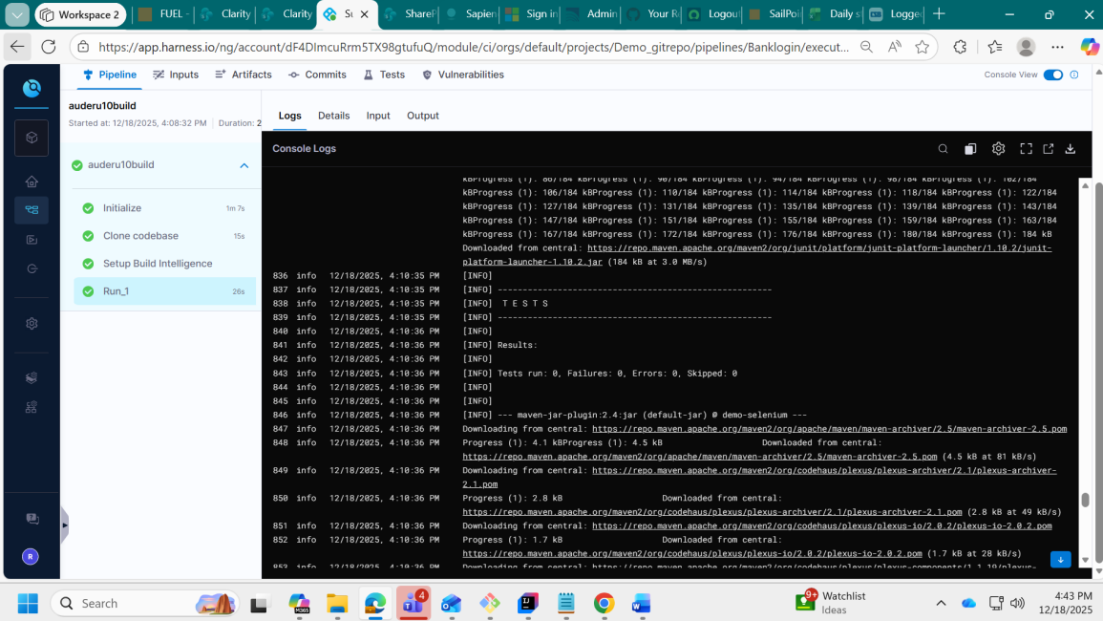
passing many alteration jumped into 16 (skipped for many changes undergone until blocked)
Iteration 16, build id 15 for this Banklogin pipeline
FA62XEA@CPC-rahul-F7OF5 MINGW64 ~/documents/Auto8 (main)
$ git init
Reinitialized existing Git repository in C:/Users/FA62XEA/Documents/Auto8/.git/
FA62XEA@CPC-rahul-F7OF5 MINGW64 ~/documents/Auto8 (main)
$ git add .
FA62XEA@CPC-rahul-F7OF5 MINGW64 ~/documents/Auto8 (main)
$ git commit -m "commited on 12.19.25"
[main 9cd87b1] commited on 12.19.25
1 file changed, 3 deletions(-)
FA62XEA@CPC-rahul-F7OF5 MINGW64 ~/documents/Auto8 (main)
$ git pull --rebase origin main
From https://github.com/tsrahulganesh/auto-demo-round10
* branch main -> FETCH_HEAD
Current branch main is up to date.
FA62XEA@CPC-rahul-F7OF5 MINGW64 ~/documents/Auto8 (main)
$ git push -u origin main
Enumerating objects: 17, done.
Counting objects: 100% (17/17), done.
Delta compression using up to 4 threads
Compressing objects: 100% (3/3), done.
Writing objects: 100% (9/9), 542 bytes | 90.00 KiB/s, done.

Total 9 (delta 2), reused 0 (delta 0), pack-reused 0 (from 0)
remote: Resolving deltas: 100% (2/2), completed with 2 local objects.
To https://github.com/tsrahulganesh/auto-demo-round10.git
6c1fad1..9cd87b1 main -> main
branch 'main' set up to track 'origin/main'.
Content 6: Result of harness with all the screenshot details of all build and pipeline iterations

With harness changes after 16 iteration on this just one login case, Thus proved ,it failed for left out generic xpath variations like contains and class
Please find the error screenshot of 16th build failed on point for the generic locators.
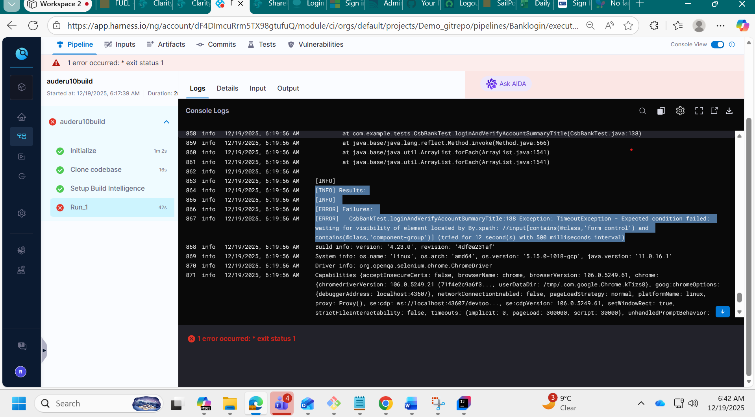
Build ran only this pipeline
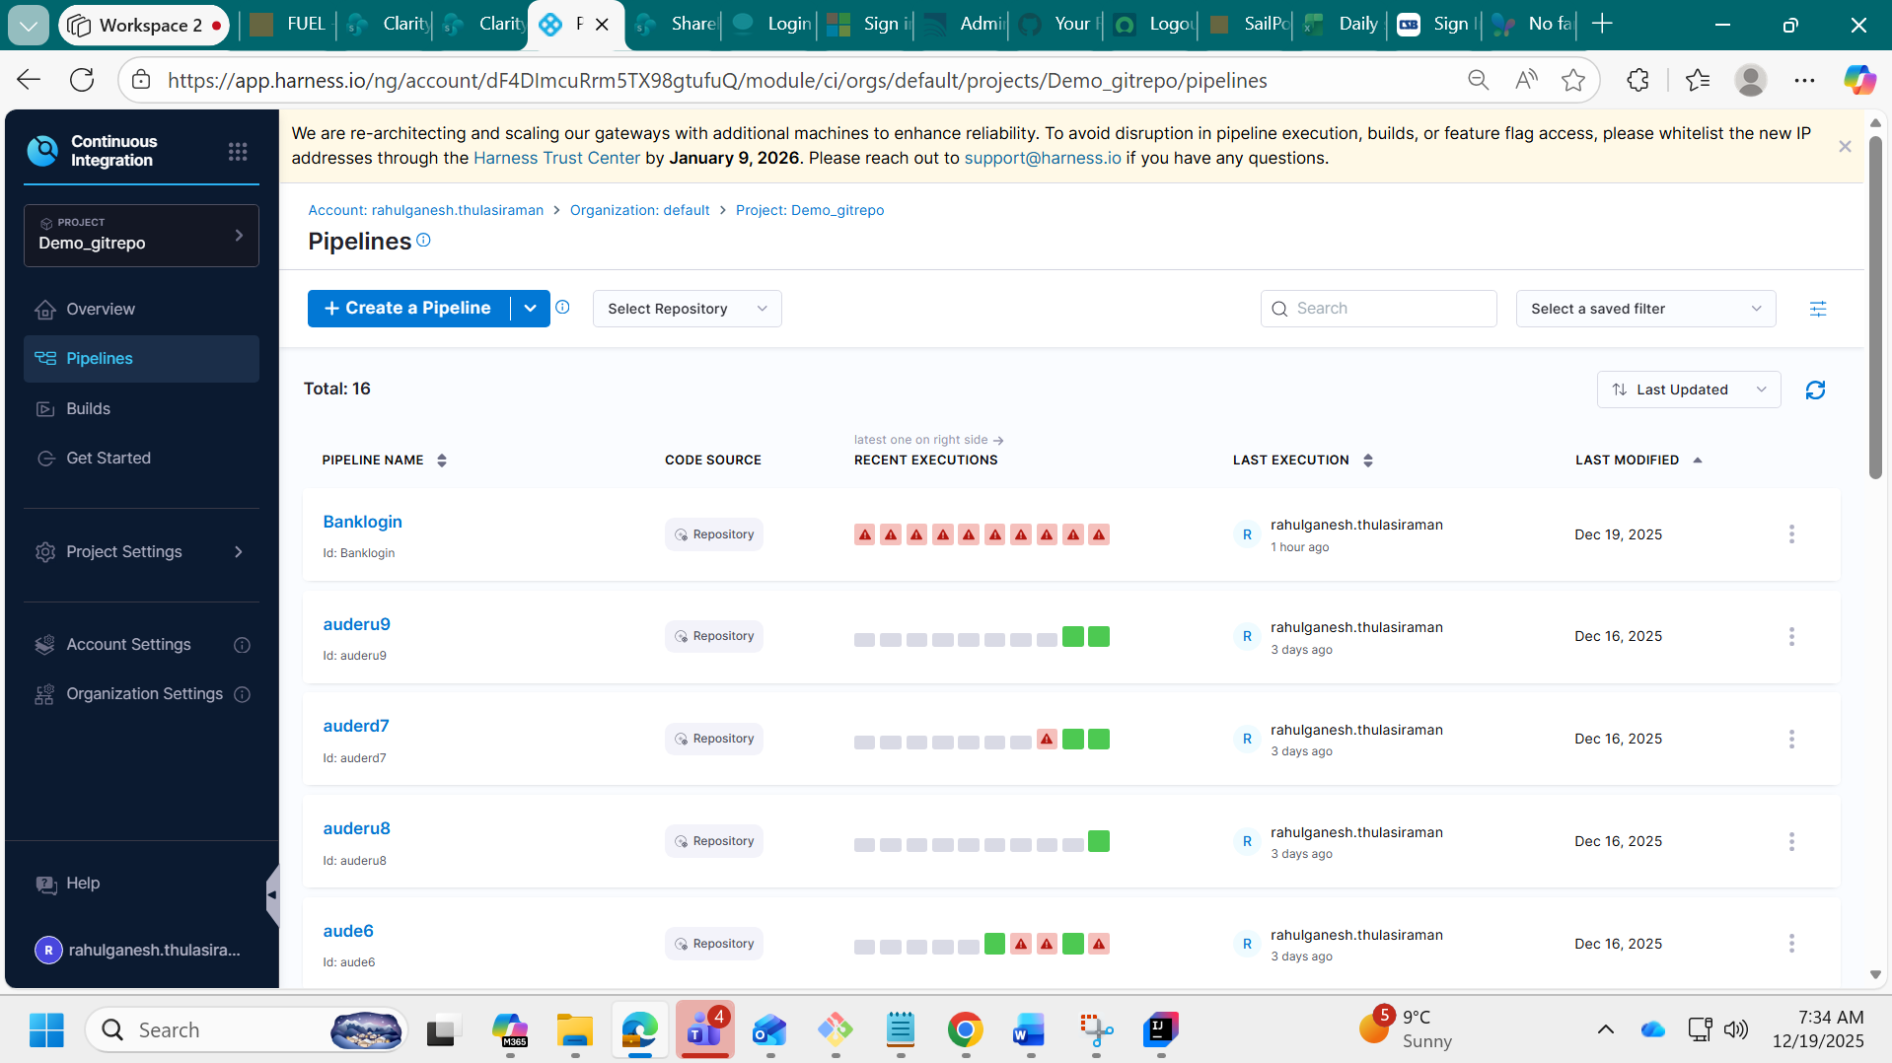
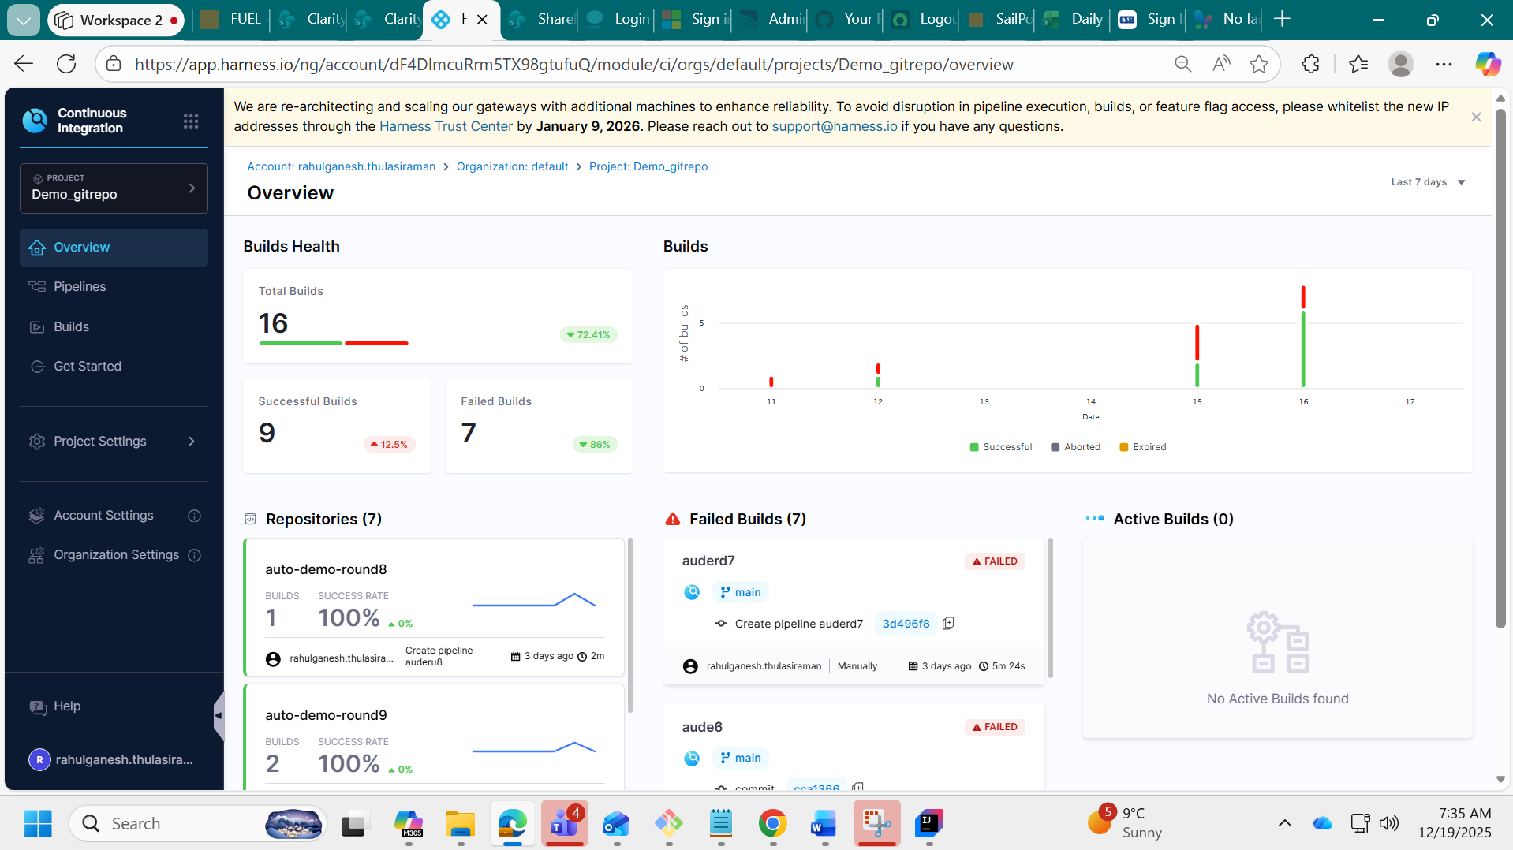
Over all Builds 155
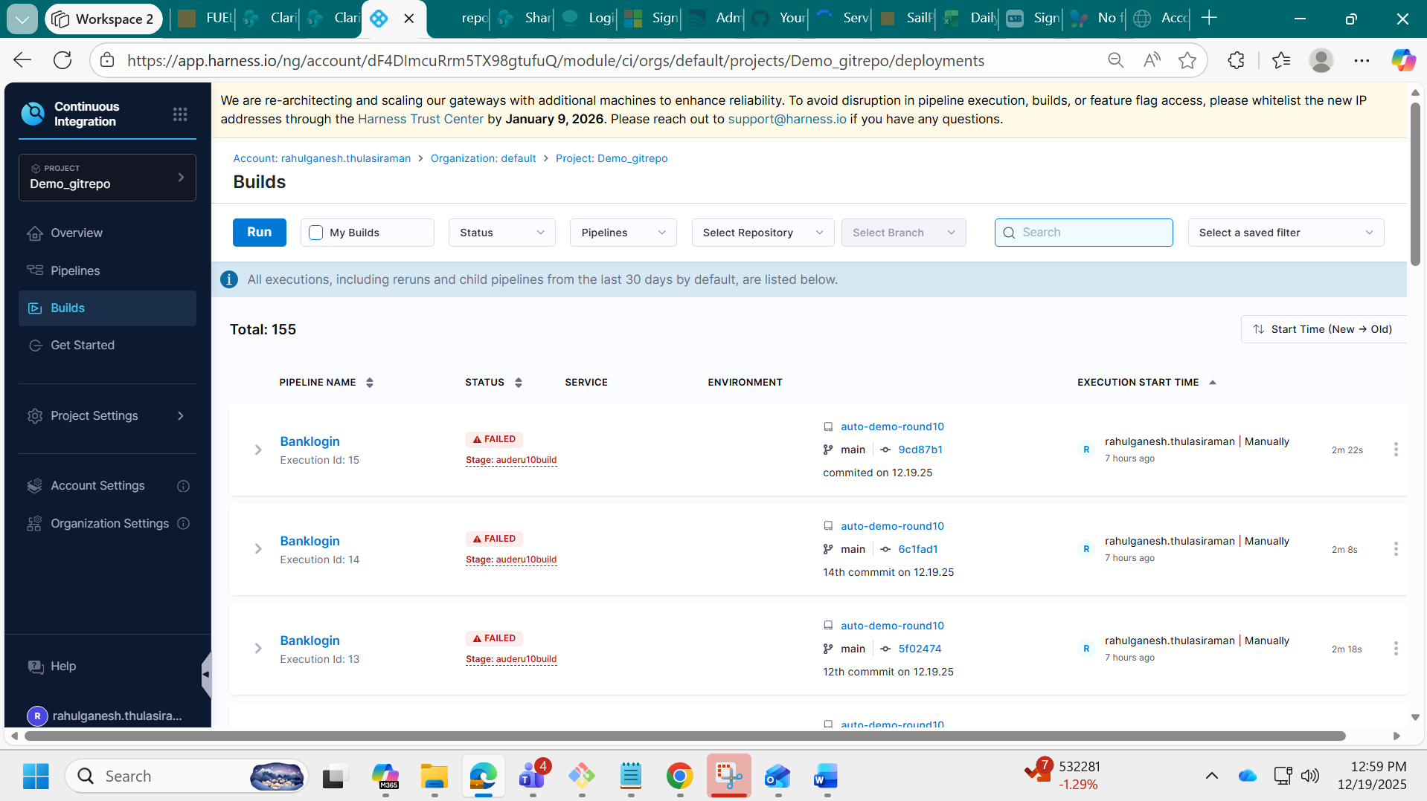
Content 7: Errors on all xpath type against harness errors
Errors : Forxpath generic contains and class -xpath
864 info 19/12/2025, 6:19:56 AM
[INFO] Results:
865 info 19/12/2025, 6:19:56 AM
[INFO]
866 info 19/12/2025, 6:19:56 AM
[ERROR] Failures:
867 info 19/12/2025, 6:19:56 AM
[ERROR] CsbBankTest.loginAndVerifyAccountSummaryTitle:138 Exception: TimeoutException - Expected condition failed: waiting for visibility of element located by By.xpath: //input[contains(@class,'form-control') and contains(@class,'component-group')] (tried for 12 second(s) with 500 milliseconds interval)
868 info 19/12/2025, 6:19:56 AM
Build info: version: '4.23.0', revision: '4df0a231af'
Errors : For the type ID and name in xpath
962 info 15/12/2025, 5:43:42 PM
Session ID: 738825c28dc1668b131305889c6456de
963 info 15/12/2025, 5:43:42 PM
[ERROR] Login_invalidTest.invalidLogin_wrongUsername:97->performLogin:49 » Timeout Expected condition failed: waiting for visibility of element located by By.xpath: //input[@id='M$layout$content$PCDZ$MW2NO7V$ctl00$webInputForm$txtLoginName'] (tried for 15 second(s) with 500 milliseconds interval)
Errors : For type name in xpath
845 info 16/12/2025, 4:27:01 PM
org.openqa.selenium.TimeoutException: Expected condition failed: waiting for visibility of element located by By.xpath: //input[@id='M_layout_content_PCDZ_MW2NO7V_ctl00_webInputForm_txtLoginName'] (tried for 15 second(s) with 500 milliseconds interval)
Errors : For type submit button in xpath
860 info 10/12/2025, 2:41:58 PM
[ERROR] LoginTest.simpleLoginTest -- Time elapsed: 4.724 s <<< FAILURE!
861 info 10/12/2025, 2:41:58 PM
org.opentest4j.AssertionFailedError: Expected to be past login, but title still looks like a login page: Sign In - UNITED BANK & TRUST ==> expected: <false> but was: <true>
Errors : For type css selector ,submit button in xpath
917 info 11/12/2025, 1:43:25 PM
Session ID: aa5c0f4043965fac01d3b2cf3e2615e8
918 info 11/12/2025, 1:43:25 PM
[ERROR] Login_invalidTest.invalidLogin_wrongUsername:148->performLogin:99 » Timeout Expected condition failed: waiting for element to be clickable: By.cssSelector: button[type='submit'], input[type='submit'], button.btn.btn-primary, a.btn.btn-primary (tried for 15 second(s) with 500 milliseconds interval)
Errors : when button not clickable
875 info 10/12/2025, 2:31:56 PM
[ERROR] Failures:
876 info 10/12/2025, 2:31:56 PM
[ERROR] LoginTest.simpleLoginTest:59 Expected page title to contain 'SERVICE' but was: Sign In - UNITED BANK & TRUST ==> expected: <true> but was: <false>
Errors : For type css selector button in xpath
878 info 10/12/2025, 2:02:13 PM
[ERROR] Errors:
879 info10/12/2025, 2:02:13 PM
[ERROR] LoginTest.simpleLoginTest:56 » Timeout Expected condition failed: waiting for visibility of element located by By.cssSelector: module-title (tried for 20 second(s) with 500 milliseconds interval)
Failed for multibrowser testing
1069 infov 6/12/2025, 1:35:06 PM
[ERROR] Errors: 1070 info 6/12/2025, 1:35:06 PM
[ERROR] MultibrowTest.openAmazonOnFirefox:58->getFirefoxDriver:33 » NoSuchDriver Unable to obtain: geckodriver, error Command failed with code: 65, executed: [--browser, firefox, --browser-path, /usr/bin/firefox, --language-binding, java, --output, json]

Content 8: Expected behaviour in any domain,if no restrictions
Expectation : never happened for banking domain in 155 build leaving this one !!!!!
845 info 15/12/2025, 5:47:05 PM
Title after login: OrangeHRM
846 info 15/12/2025, 5:47:05 PM
Current URL: https://opensource-demo.orangehrmlive.com/web/index.php/dashboard/index
847 info 15/12/2025, 5:47:05 PM
[INFO] Tests run: 1, Failures: 0, Errors: 0, Skipped: 0, Time elapsed: 4.138 s -- in SimpleLoginTest
“Program just for the login case after Harness modification:
Note: This is without changing the locators.”

Content 9:same program ,modified into 3 times more for harness compatibility without change of logical Locators
package com.example.tests;
import org.junit.jupiter.api.AfterEach;
import org.junit.jupiter.api.BeforeEach;
import org.junit.jupiter.api.Test;
import org.openqa.selenium.*;
import org.openqa.selenium.chrome.ChromeDriver;
import org.openqa.selenium.chrome.ChromeOptions;
import org.openqa.selenium.support.ui.ExpectedConditions;
import org.openqa.selenium.support.ui.WebDriverWait;
import java.io.File;
import java.io.FileWriter;
import java.nio.file.Files;
import java.nio.file.Path;
import java.text.SimpleDateFormat;
import java.time.Duration;
import java.util.Date;
import static org.junit.jupiter.api.Assertions.fail;
public class CsbBankTest {
private WebDriver driver;
@BeforeEach
void setUp() {
ChromeOptions options = new ChromeOptions();
// NOTE (CI/Harness)
// Required for CI /Linux containers
options.addArguments("--headless=new");
options.addArguments("--no-sandbox");
options.addArguments("--disable-dev-shm-usage");
options.addArguments("--disable-gpu");
options.addArguments("--window-size=1920,1080");
options.addArguments("--remote-allow-origins=*");
options.addArguments("--disable-notifications");
driver = new ChromeDriver(options);
driver.manage().window().maximize();
}
@AfterEach
void tearDown() {
try {
if (driver != null) driver.quit();
} catch (Exception ignored) { }
}
@Test
void loginAndVerifyAccountSummaryTitle() {
// Prepare report folders
File reportDir = new File("report");
File screenshotDir = new File(reportDir, "screenshots");
reportDir.mkdirs();
screenshotDir.mkdirs();
String timestamp = new SimpleDateFormat("yyyyMMdd_HHmmss").format(new Date());
File reportFile = new File(reportDir, "LoginReport_" + timestamp + ".html");
long start = System.currentTimeMillis();
String status = "PASS";
String message = "";
String pageTitle = "";
String currentUrl = "";
String screenshotPath = "";
String dashboardHeaderText = "";
try {
driver.get("https://csbbankonline-p2.onlinebank.com/SignIn.aspx");
// Username
new WebDriverWait(driver, Duration.ofSeconds(12))
.until(ExpectedConditions.visibilityOfElementLocated(
By.xpath("//input[contains(@class,'form-control') and contains(@class,'component-group')]")
)).sendKeys("Retailuser1");
// Password
new WebDriverWait(driver, Duration.ofSeconds(12))
.until(ExpectedConditions.visibilityOfElementLocated(
By.cssSelector("input.signin-password")
)).sendKeys("Google@44566");
// Sign In button
new WebDriverWait(driver, Duration.ofSeconds(12))
.until(ExpectedConditions.elementToBeClickable(
By.xpath("//*[contains(@class,'btn') and contains(@class,'btn-primary')]")
)).click();
// Wait for the correct page title (use title, not URL)
new WebDriverWait(driver, Duration.ofSeconds(12))
.until(ExpectedConditions.titleContains("Account Summary - COMMUNITY STATE BANK"));
currentUrl = driver.getCurrentUrl();
pageTitle = driver.getTitle();
System.out.println("Dashboard Title: " + pageTitle);
// Optional: try grabbing a visible header on the page (replace with real selector if available)
try {
WebElement header = new WebDriverWait(driver, Duration.ofSeconds(5))
.until(ExpectedConditions.visibilityOfElementLocated(
By.xpath("//h1|//h2|//h3|//h4|//h5|//h6")
));
dashboardHeaderText = header.getText();
System.out.println("Dashboard Header Text: " + dashboardHeaderText);
} catch (Exception ignored) {
// If no reliable header, title verification is sufficient
}
// Simple validation based on title
if (!"Account Summary - COMMUNITY STATE BANK".equals(pageTitle)) {
status = "FAIL";
message = "Unexpected title: " + pageTitle;
fail(message);
} else {
message = "Login and Account Summary - COMMUNITY STATE BANK verified.";
}
} catch (Exception e) {
status = "FAIL";
message = "Exception: " + e.getClass().getSimpleName() + " - " + safe(e.getMessage());
// Screenshot on failure
try {
screenshotPath = new File(screenshotDir, "failure_" + timestamp + ".png").getAbsolutePath();
TakesScreenshot ts = (TakesScreenshot) driver;
File src = ts.getScreenshotAs(OutputType.FILE);
Files.copy(src.toPath(), Path.of(screenshotPath));
} catch (Exception ignored) { /* may fail if driver already quit */ }
// Mark test failure
fail(message);
} finally {
long end = System.currentTimeMillis();
long durationMs = end - start;
// Write HTML report
writeHtmlReport(reportFile, status, message, pageTitle, dashboardHeaderText,
currentUrl, screenshotPath, start, end, durationMs);
System.out.println("HTML report: " + reportFile.getAbsolutePath());
if (!screenshotPath.isEmpty()) {
System.out.println("Failure screenshot: " + screenshotPath);
}
}
}
private static void writeHtmlReport(File reportFile,
String status,
String message,
String title,
String headerText,
String url,
String screenshotPath,
long start,
long end,
long durationMs) {
String startStr = new SimpleDateFormat("yyyy-MM-dd HH:mm:ss").format(new Date(start));
String endStr = new SimpleDateFormat("yyyy-MM-dd HH:mm:ss").format(new Date(end));
String statusClass = "PASS".equalsIgnoreCase(status) ? "status-pass" : "status-fail";
StringBuilder sb = new StringBuilder();
// Write REAL HTML (do not escape structural tags)
sb.append("<!DOCTYPE html>\n<html lang=\"en\">\n<head>\n<meta charset=\"UTF-8\">\n")
.append("<title>Account Summary - COMMUNITY STATE BANK Login Report</title>\n<style>\n")
.append("body{font-family:Arial,sans-serif;margin:20px;} .card{border:1px solid #ddd;border-radius:8px;padding:16px;max-width:900px;}")
.append(".status-pass{color:#0b7a0b;font-weight:bold;} .status-fail{color:#b00020;font-weight:bold;} .row{margin:8px 0;} ")
.append("code{background:#f7f7f7;padding:2px 6px;border-radius:4px;} a{color:#0069c0;text-decoration:none;} ")
.append("hr{border:none;border-top:1px solid #eee;margin:14px 0;}\n")
.append("</style>\n</head>\n<body>\n<h2>Account Summary - COMMUNITY STATE BANK Login Report</h2>\n<div class=\"card\">\n")
.append("<div class=\"row\"><strong>Status:</strong> <span class=\"").append(statusClass).append("\">")
.append(escapeHtml(status)).append("</span></div>\n")
.append("<div class=\"row\"><strong>Message:</strong> ").append(escapeHtml(message)).append("</div>\n")
.append("<div class=\"row\"><strong>Start:</strong> ").append(startStr).append("</div>\n")
.append("<div class=\"row\"><strong>End:</strong> ").append(endStr).append("</div>\n")
.append("<div class=\"row\"><strong>Duration:</strong> ").append(durationMs).append(" ms</div>\n<hr/>\n")
.append("<div class=\"row\"><strong>Page Title:</strong> <code>").append(escapeHtml(title)).append("</code></div>\n")
.append("<div class=\"row\"><strong>Dashboard Header:</strong> <code>").append(escapeHtml(headerText)).append("</code></div>\n")
.append("<div class=\"row\"><strong>URL:</strong> <a href=\"").append(escapeHtml(url)).append("\" target=\"_blank\">")
.append(escapeHtml(url)).append("</a></div>\n");
if (screenshotPath != null && !screenshotPath.isEmpty()) {
String rel = relPathForReport(reportFile, screenshotPath);
sb.append("<div class=\"row\"><strong>Screenshot:</strong><br/>\n")
.append("<img src=\"").append(escapeHtml(rel)).append("\" alt=\"Screenshot\" style=\"max-width:100%;border:1px solid #ccc;\"/>\n")
.append("</div>\n");
}
sb.append("</div>\n</body>\n</html>");
try (FileWriter fw = new FileWriter(reportFile)) {
fw.write(sb.toString());
} catch (Exception e) {
System.err.println("Failed to write HTML report: " + e.getMessage());
}
}
private static String relPathForReport(File reportFile, String screenshotAbs) {
try {
Path reportDir = reportFile.getParentFile().toPath().toAbsolutePath();
Path screenshot = Path.of(screenshotAbs).toAbsolutePath();
return reportDir.relativize(screenshot).toString().replace("\\", "/");
} catch (Exception e) {
return screenshotAbs;
}
}
private static String safe(String s) {
return (s == null) ? "" : s;
}
// // Escape only dynamic content (fix double-escaping)
private static String escapeHtml(String s) {
if (s == null) return "";

return s.replace("&", "&amp;")
.replace("<", "&lt;")
.replace(">", "&gt;");
}
}
Content 10: previous url failure on any xpath type
“This is the third bank URL I am working on. Previously, everything failed when trying to locate the ‘Continue’ button in Java using contains and class please find the screen shot ,related to last Fridays mail failure case.”
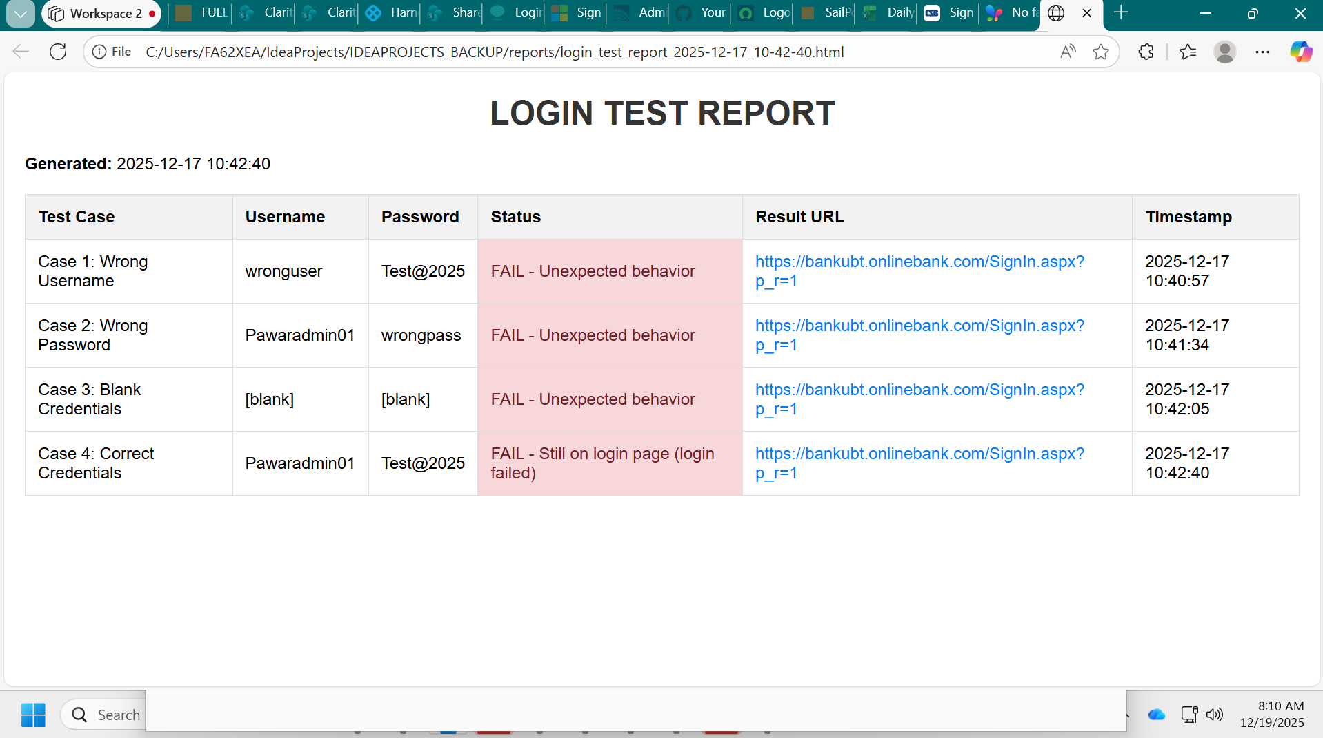

Conclusion :
Conclusion: Why Using Harness for UI Test Automation May Not Be Practical
Continuing from the report that failed last Friday12.12.25, extending to that:
After making numerous changes just for a simple login case, you can imagine the effort required for more complex functionalities. I doubt this approach will serve the intended purpose. Why are we doing this? It feels like a waste of time because we end up reconstructing the entire program just to make it run in Harness—even though it already works successfully in IntelliJ/Eclipse.
Let’s Understand the Purpose of Harness
Harness is primarily designed for continuous integration and deployment of complex applications, enabling multiple engineers to collaborate efficiently across environments. However, I don’t see how this translates effectively for UI testing. If a basic login test is causing significant challenges, what will happen when we move to more complex modules deeper in the application? For context, we’ve had 155 builds so far without a successful login test—except for one case where the HRMS login page worked, which shows that in a general scenario it can succeed. This ratio should be carefully evaluated before proceeding further.
Key Questions
- Are we trying to find issues after completing all functional testing and passing automation tests with reports? If so, what’s the real benefit?
- We have already identified and validated web locators during automation testing, considering the significant effort of the automation team. Why should we spend triple the time redoing locators or restructuring code just to fit Harness?
Major Concerns
- There is no scope for CD (deployment) here. If we are not deploying to any environment, then using Harness seems unnecessary—almost like doing it for self-satisfaction.
- If someone is desperate to implement CI for test pipelines, there are other standard tools like Azure DevOps, Jenkins, and GitHub Actions. These are widely used and well-suited for both application code and test code.
- Moreover, since our application is in the banking domain, there may be restrictions on dynamic DOM elements, which will affect these tools as well. So the challenge is not the CI tool—it’s the nature of the application.
Effort Summary
Over the past 15 consecutive days—including nights and weekends, I have worked on 155 builds. Today marks the 15th day in a row. This effort is not formally accounted for, yet the amount of work invested to identify and prove the root cause of the failure has been significant. Please note that it is still the default organization setup, and no access has been provided yet for any repositories.

Closing Statement
I request that this report be reviewed thoroughly before any decisions are made. The intent is not to assign blame but to highlight the challenges faced and the effort invested so that we can take informed steps moving forward. A collaborative discussion on alternative approaches or additional support would help ensure success for future tasks.

---------------------

