Automation Testscript to Run in Harness CI pipelines for Demo in common environment
No. | Testcases | Status
1 | Opening of url of Google Google chrome browser(Headless) | Pass
2 | Opending of url of Amazon Google chrome browser(Headless) | Pass
3 | Opening of url of flicpkart on Google chrome browser (Headless) | Pass

Test cases:
Overview on Total builds
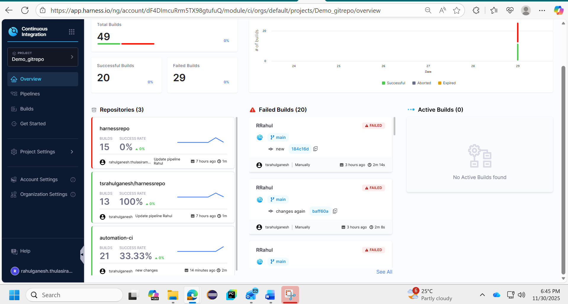

Pipeline overview
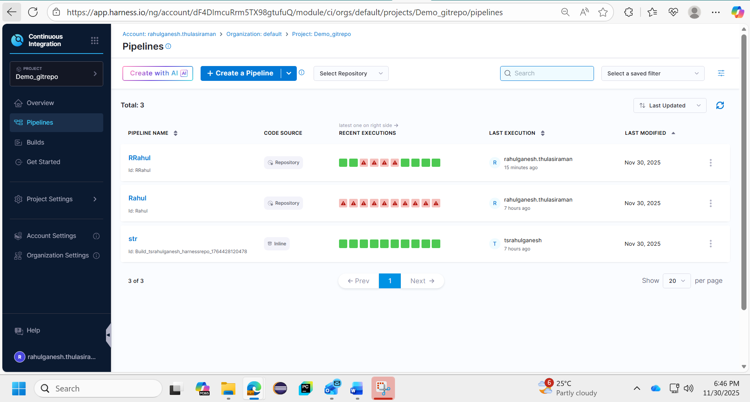
Refined - Result of 3 cases
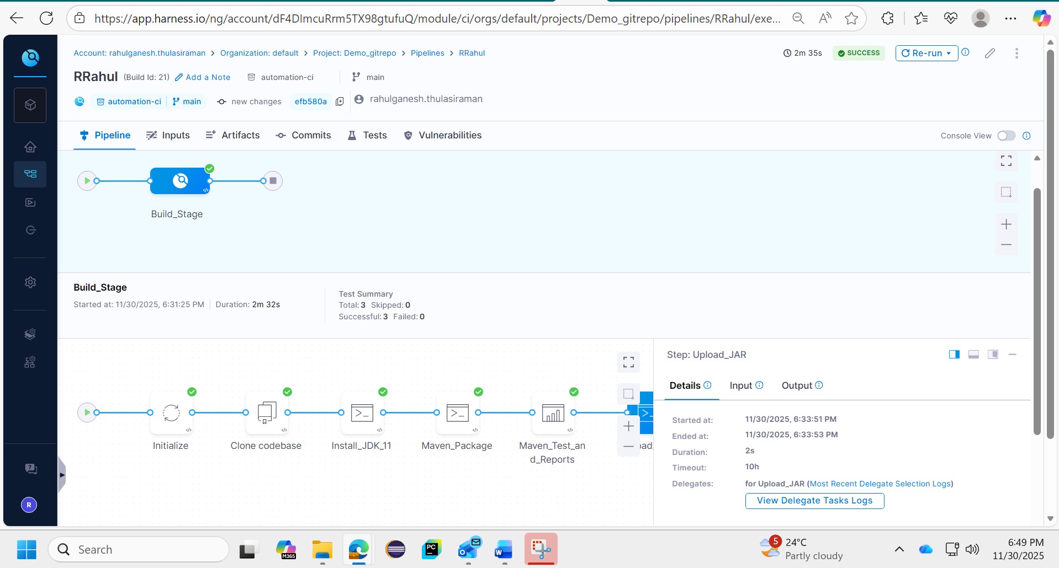

Report on final refined test case
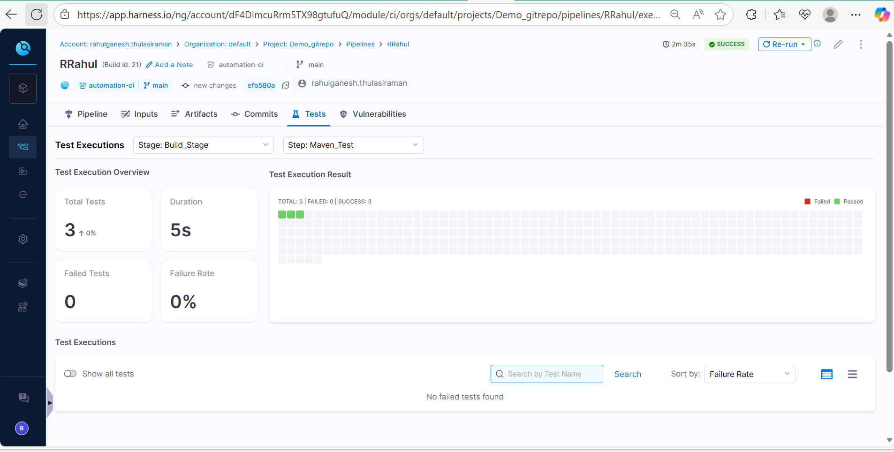
Logs
