Url/FI
Admin Home - UNITED BANK & TRUST
url : Admin Home - UNITED BANK & TRUST
Login cred
Username: Pawaradmin01
Password : Test@2025
Locators :
Xpath name for username : M$layout$content$PCDZ$MW2NO7V$ctl00$webInputForm$txtLoginName
Xpath name for password: M$layout$content$PCDZ$MW2NO7V$ctl00$webInputForm$txtPassword
Xpath class for continue : btn btn-primary
module-title

code for valid secnario
import org.junit.jupiter.api.Test;
import org.openqa.selenium.By;
import org.openqa.selenium.WebDriver;
import org.openqa.selenium.WebElement;
import org.openqa.selenium.chrome.ChromeDriver;
import org.openqa.selenium.chrome.ChromeOptions;

import static org.junit.jupiter.api.Assertions.*;

public class LoginTest {

private WebDriver getDriver() {
ChromeOptions options = new ChromeOptions();
options.addArguments("--headless=new"); // Headless mode for CI
options.addArguments("--no-sandbox");
options.addArguments("--disable-dev-shm-usage");
return new ChromeDriver(options);
}

@Test
void simpleLoginTest() {
WebDriver driver = getDriver();
try {
// 1) Open login page
driver.get("https://bankubt.onlinebank.com/Service/UserManager.aspx"); // ✅ Replace with your actual login
// URL

// 2) Locate username and password fields using XPath
WebElement usernameField = driver.findElement(
By.xpath("//input[@id='M$layout$content$PCDZ$MW2NO7V$ctl00$webInputForm$txtLoginName']"));
WebElement passwordField = driver.findElement(
By.xpath("//input[@id='M$layout$content$PCDZ$MW2NO7V$ctl00$webInputForm$txtPassword']"));

// 3) Locate login button using XPath (handles spaces in text)
WebElement loginButton = driver
.findElement(By.xpath("//button[normalize-space(text())='btn btn-primary']"));

// 4) Enter credentials
usernameField.sendKeys("Pawaradmin01"); // ✅ Replace with valid username
passwordField.sendKeys("Test@2025"); // ✅ Replace with valid password

// 5) Click login
loginButton.click();

// 6) Assert successful login by checking URL or title
assertTrue(driver.getCurrentUrl().contains("Advanced") || driver.getTitle().contains("Dashboard"),
"module-title");

} finally {
driver.quit();
}
}
}

GIT worksheet
FA62XEA@CPC-rahul-F7OF5 MINGW64 ~/documents/auto2 (main)
$ git add .

FA62XEA@CPC-rahul-F7OF5 MINGW64 ~/documents/auto2 (main)
$ git commit -m "commit2"
[main da53aec] commit2
2 files changed, 53 insertions(+), 42 deletions(-)
delete mode 100644 src/test/java/Demo3Test.java
create mode 100644 src/test/java/LoginTestcase1.java

FA62XEA@CPC-rahul-F7OF5 MINGW64 ~/documents/auto2 (main)
$ git remote -v
origin https://github.com/tsrahulganesh/autodemo2.git (fetch)
origin https://github.com/tsrahulganesh/autodemo2.git (push)

FA62XEA@CPC-rahul-F7OF5 MINGW64 ~/documents/auto2 (main)
$ git pull --rebase origin main
From https://github.com/tsrahulganesh/autodemo2
* branch main -> FETCH_HEAD
Current branch main is up to date.

FA62XEA@CPC-rahul-F7OF5 MINGW64 ~/documents/auto2 (main)
$ git push origin main
Enumerating objects: 10, done.
Counting objects: 100% (10/10), done.
Delta compression using up to 4 threads
Compressing objects: 100% (4/4), done.
Writing objects: 100% (6/6), 1.20 KiB | 244.00 KiB/s, done.
Total 6 (delta 2), reused 0 (delta 0), pack-reused 0 (from 0)
remote: Resolving deltas: 100% (2/2), completed with 2 local objects.
To https://github.com/tsrahulganesh/autodemo2.git
1bbe2f2..da53aec main -> main

FA62XEA@CPC-rahul-F7OF5 MINGW64 ~/documents/auto2 (main)
Result Screenshot
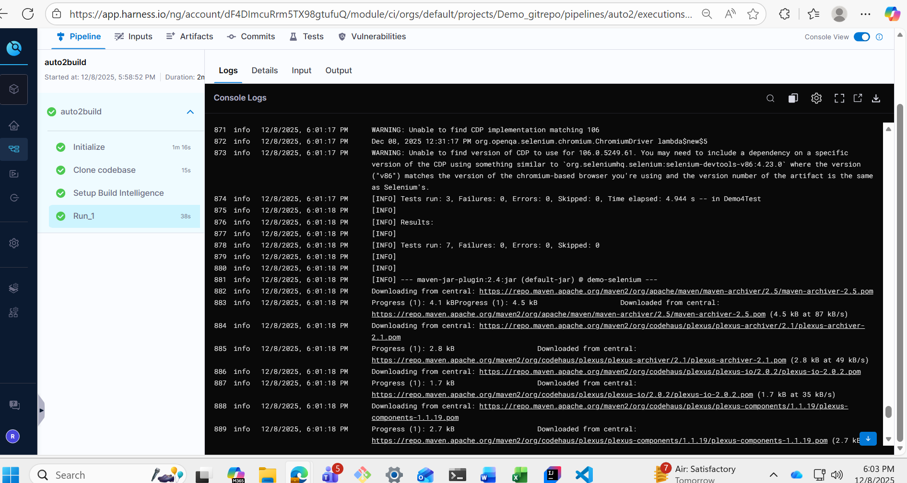
Round 2
FA62XEA@CPC-rahul-F7OF5 MINGW64 ~/documents/auto2
$ gh auth status
github.com
✓ Logged in to github.com account tsrahulganesh (keyring)
- Active account: true
- Git operations protocol: https
- Token: gho_************************************
- Token scopes: 'gist', 'read:org', 'repo'

FA62XEA@CPC-rahul-F7OF5 MINGW64 ~/documents/auto2
$ gh repo list

Showing 30 of 50 repositories in @tsrahulganesh

NAME DESCRIPTION INFO UPDATED
tsrahulganesh/autodemo2 public about 17 hours ago
tsrahulganesh/paprazi_ci public about 3 days ago
tsrahulganesh/auto_ci2 cipipeline public about 5 days ago
tsrahulganesh/auto-demo-round2 My demo round2 public about 5 days ago
tsrahulganesh/harnessrepo public about 6 days ago
tsrahulganesh/automation-ci private about 6 days ago
tsrahulganesh/codeexchange public about 6 days ago
tsrahulganesh/Myconfig_infinite public about 6 days ago
tsrahulganesh/kubestarterr public about 3 months ago
tsrahulganesh/Voting_app_observ public about 3 months ago
tsrahulganesh/Terraform_project public about 3 months ago
tsrahulganesh/Retail_plugandplay_sample_deployement_app- public about 4 months ago
tsrahulganesh/Retail_plugandplay_sample_deployement_app public about 4 months ago
tsrahulganesh/terraform_res_servicemesh public about 6 months ago
tsrahulganesh/Helm-chart-installation public about 6 months ago
tsrahulganesh/TWO-TIER-EC2 public about 6 months ago
tsrahulganesh/TWOTIER2FLASK public about 6 months ago
tsrahulganesh/TWO-TIER-FLASK public about 6 months ago
tsrahulganesh/kubeadm_setup_aws public about 6 months ago
tsrahulganesh/https-github.com-LondheShubham153-two-tier-flask-app public about 6 months ago
tsrahulganesh/AWS_EKS_MICROSERV public about 6 months ago
tsrahulganesh/Argocd_operator public about 6 months ago
tsrahulganesh/Azure-cicd-terraform-full- public about 8 months ago
tsrahulganesh/Ansible_galaxydemo public about 9 months ago
tsrahulganesh/build-pack-todoproj public about 9 months ago
tsrahulganesh/docker-pack-proj public about 9 months ago
tsrahulganesh/kube-project-votie public about 9 months ago
tsrahulganesh/kube--shub public about 9 months ago
tsrahulganesh/Kube-new-repo https://github.com/LondheShubham153/k8s-kind-voting-app.git public about 9 months ago
tsrahulganesh/Kubernetes_piyush public about 9 months ago

FA62XEA@CPC-rahul-F7OF5 MINGW64 ~/documents/auto2
$ git remote add origin https://github.com/tsrahulganesh/auto-demo-round2
fatal: not a git repository (or any of the parent directories): .git

FA62XEA@CPC-rahul-F7OF5 MINGW64 ~/documents/auto2
$ git remote -v
fatal: not a git repository (or any of the parent directories): .git

FA62XEA@CPC-rahul-F7OF5 MINGW64 ~/documents/auto2
$ git status
fatal: not a git repository (or any of the parent directories): .git

FA62XEA@CPC-rahul-F7OF5 MINGW64 ~/documents/auto2
$ git init
Initialized empty Git repository in C:/Users/FA62XEA/Documents/auto2/.git/

FA62XEA@CPC-rahul-F7OF5 MINGW64 ~/documents/auto2 (master)
$ git add .

FA62XEA@CPC-rahul-F7OF5 MINGW64 ~/documents/auto2 (master)
$ git commit -m "commit"
[master (root-commit) fed2225] commit
4 files changed, 260 insertions(+)
create mode 100644 pom.xml
create mode 100644 src/test/java/DemoTest.java
create mode 100644 src/test/java/LoginTest.java
create mode 100644 src/test/java/urltest.java

FA62XEA@CPC-rahul-F7OF5 MINGW64 ~/documents/auto2 (master)
$ git branch -m master main

FA62XEA@CPC-rahul-F7OF5 MINGW64 ~/documents/auto2 (main)
$ git push origin main
fatal: 'origin' does not appear to be a git repository
fatal: Could not read from remote repository.

Please make sure you have the correct access rights
and the repository exists.

FA62XEA@CPC-rahul-F7OF5 MINGW64 ~/documents/auto2 (main)
$ git remote -v

FA62XEA@CPC-rahul-F7OF5 MINGW64 ~/documents/auto2 (main)
$ git remote add origin https://github.com/tsrahulganesh/auto-demo-round2

FA62XEA@CPC-rahul-F7OF5 MINGW64 ~/documents/auto2 (main)
$ git remote set-url origin https://github.com/tsrahulganesh/auto-demo-round2

FA62XEA@CPC-rahul-F7OF5 MINGW64 ~/documents/auto2 (main)
$ git remote-v
git: 'remote-v' is not a git command. See 'git --help'.

The most similar command is
remote-fd

FA62XEA@CPC-rahul-F7OF5 MINGW64 ~/documents/auto2 (main)
$ git remote -v
origin https://github.com/tsrahulganesh/auto-demo-round2 (fetch)
origin https://github.com/tsrahulganesh/auto-demo-round2 (push)

FA62XEA@CPC-rahul-F7OF5 MINGW64 ~/documents/auto2 (main)
$ git pull --rebase origin main
fatal: couldn't find remote ref main

FA62XEA@CPC-rahul-F7OF5 MINGW64 ~/documents/auto2 (main)
$ git push origin main
Enumerating objects: 9, done.
Counting objects: 100% (9/9), done.
Delta compression using up to 4 threads
Compressing objects: 100% (7/7), done.
Writing objects: 100% (9/9), 3.30 KiB | 80.00 KiB/s, done.
Total 9 (delta 1), reused 0 (delta 0), pack-reused 0 (from 0)
remote: Resolving deltas: 100% (1/1), done.
To https://github.com/tsrahulganesh/auto-demo-round2
* [new branch] main -> main

FA62XEA@CPC-rahul-F7OF5 MINGW64 ~/documents/auto2 (main)
$ git status
On branch main
nothing to commit, working tree clean

FA62XEA@CPC-rahul-F7OF5 MINGW64 ~/documents/auto2 (main)
$
Iteration2

FA62XEA@CPC-rahul-F7OF5 MINGW64 ~/documents/auto2 (main)
$ git status
On branch main
nothing to commit, working tree clean

FA62XEA@CPC-rahul-F7OF5 MINGW64 ~/documents/auto2 (main)
$ git init
Reinitialized existing Git repository in C:/Users/FA62XEA/Documents/auto2/.git/

FA62XEA@CPC-rahul-F7OF5 MINGW64 ~/documents/auto2 (main)
$ git add .

FA62XEA@CPC-rahul-F7OF5 MINGW64 ~/documents/auto2 (main)
$ git commit -m "commit"
[main 7ca581f] commit
1 file changed, 23 insertions(+), 9 deletions(-)

FA62XEA@CPC-rahul-F7OF5 MINGW64 ~/documents/auto2 (main)
$ git pull origin main
From https://github.com/tsrahulganesh/auto-demo-round2
* branch main -> FETCH_HEAD
Already up to date.

FA62XEA@CPC-rahul-F7OF5 MINGW64 ~/documents/auto2 (main)
$ git push origin main
Enumerating objects: 11, done.
Counting objects: 100% (11/11), done.
Delta compression using up to 4 threads
Compressing objects: 100% (4/4), done.
Writing objects: 100% (6/6), 1.04 KiB | 177.00 KiB/s, done.
Total 6 (delta 1), reused 0 (delta 0), pack-reused 0 (from 0)
remote: Resolving deltas: 100% (1/1), completed with 1 local object.
To https://github.com/tsrahulganesh/auto-demo-round2
fed2225..7ca581f main -> main

FA62XEA@CPC-rahul-F7OF5 MINGW64 ~/documents/auto2 (main)
-------
FA62XEA@CPC-rahul-F7OF5 MINGW64 ~/documents/auto2 (main)
$ git init
Reinitialized existing Git repository in C:/Users/FA62XEA/Documents/auto2/.git/

FA62XEA@CPC-rahul-F7OF5 MINGW64 ~/documents/auto2 (main)
$ git add .

FA62XEA@CPC-rahul-F7OF5 MINGW64 ~/documents/auto2 (main)
$ git commit -m "commit"
[main bdb6285] commit
1 file changed, 152 insertions(+), 61 deletions(-)

FA62XEA@CPC-rahul-F7OF5 MINGW64 ~/documents/auto2 (main)
$ git pull --rebase origin main
From https://github.com/tsrahulganesh/auto-demo-round2
* branch main -> FETCH_HEAD
Current branch main is up to date.

FA62XEA@CPC-rahul-F7OF5 MINGW64 ~/documents/auto2 (main)
$ git push origin main
Enumerating objects: 11, done.
Counting objects: 100% (11/11), done.
Delta compression using up to 4 threads
Compressing objects: 100% (4/4), done.
Writing objects: 100% (6/6), 3.32 KiB | 226.00 KiB/s, done.
Total 6 (delta 0), reused 0 (delta 0), pack-reused 0 (from 0)
To https://github.com/tsrahulganesh/auto-demo-round2
7ca581f..bdb6285 main -> main

FA62XEA@CPC-rahul-F7OF5 MINGW64 ~/documents/auto2 (main)

