Harness is an application (a SaaS platform) that you use to manage Continuous Delivery (CD), Feature Flags, Cloud Cost Management, and more.
Here’s a quick breakdown:
✅ What kind of app is Harness?
- It’s not just a desktop app—it’s primarily a web-based platform (SaaS).
- You access it via a browser or API.
- It also has CLI tools and integrations for automation.
✅ How do you use it?
- Sign up or log in to Harness.io.
- Create pipelines for deployments.
- Integrate with your CI tools (like Azure DevOps, Jenkins, GitHub Actions).
- Configure connectors for cloud providers (AWS, Azure, GCP), artifact repositories, and secrets managers.
✅ Deployment Targets
- Kubernetes clusters
- VMs
- Serverless environments
- Cloud services
So yes, it’s an application/service for automating CD pipelines, but it’s not installed like a traditional app—it’s mostly cloud-hosted.
✅ Harness vs ArgoCD
Feature | Harness | ArgoCD
Type | SaaS/CD Platform | GitOps CD Tool
Primary Focus | Continuous Delivery with AI-driven verification, cost optimization, governance | GitOps-based Kubernetes deployments
Setup | Cloud-hosted (or on-prem), minimal infra management | Self-hosted in Kubernetes cluster
Deployment Strategies | Canary, Blue-Green, Rolling, Feature Flags | GitOps sync (Declarative deployments)
AI/ML Features | Yes (automated rollback, anomaly detection) | No (manual rollback or sync)
Cost Management | Built-in cloud cost optimization | None
Ease of Use | UI-driven, low-code pipelines | YAML-driven, requires GitOps knowledge
Integrations | Azure DevOps, Jenkins, GitHub Actions, AWS, GCP, etc. | Git repositories (GitHub, GitLab, Bitbucket)
Best For | Enterprises needing governance, security, and AI-driven CD | Teams adopting GitOps for Kubernetes

✅ Key Difference
- Harness = Full-featured CD platform with AI and governance
- ArgoCD = Lightweight GitOps tool for Kubernetes deployments only

Harness design
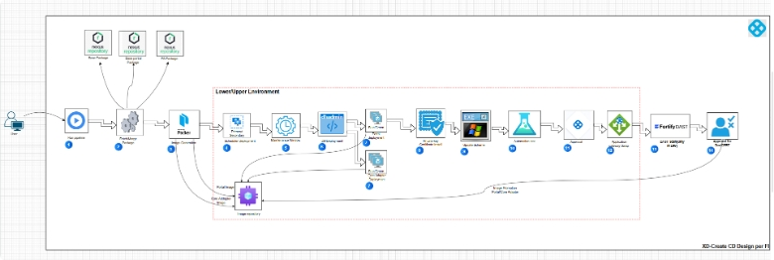

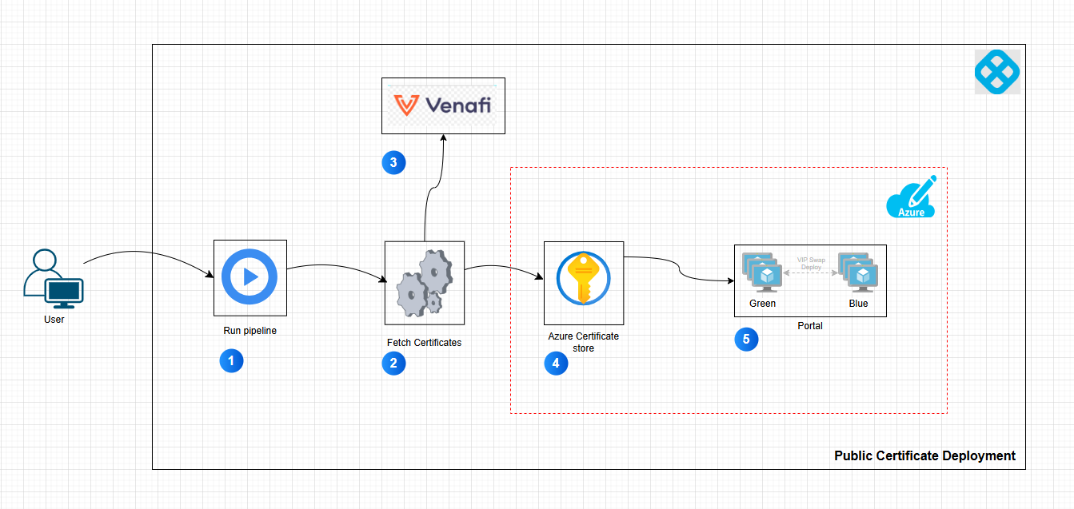

Real deployment
