Microsoft Intune Web Company Portal
https://portal.manage.microsoft.com/apps
from here you install intel j or any app

once you install done, open the intel j and test with test prog.
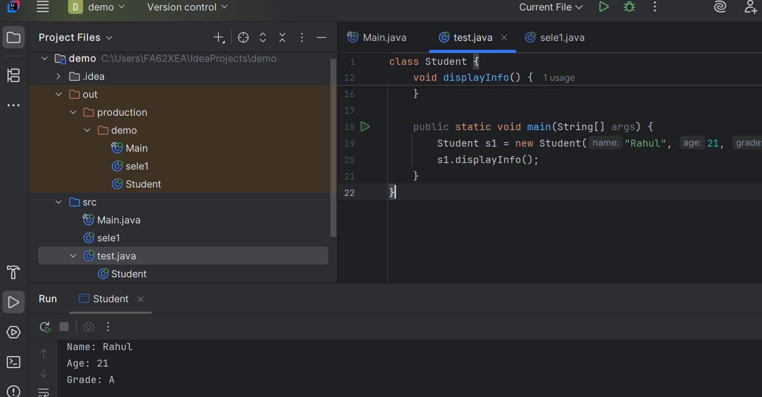
Next , to install selenium .
Go to -- Downloads | Selenium
And click
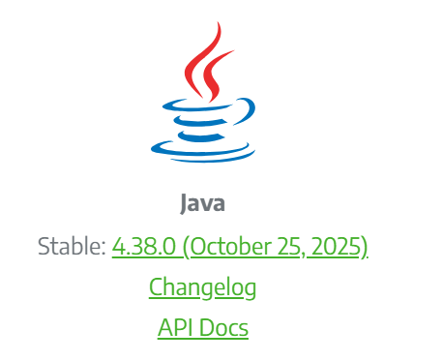
You will get download this
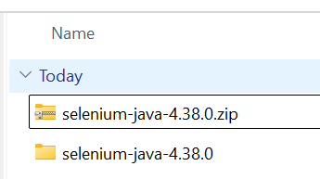
Next
Go to intel j > file>project structure > project setting > module > click + and add configure this path where selenium files present.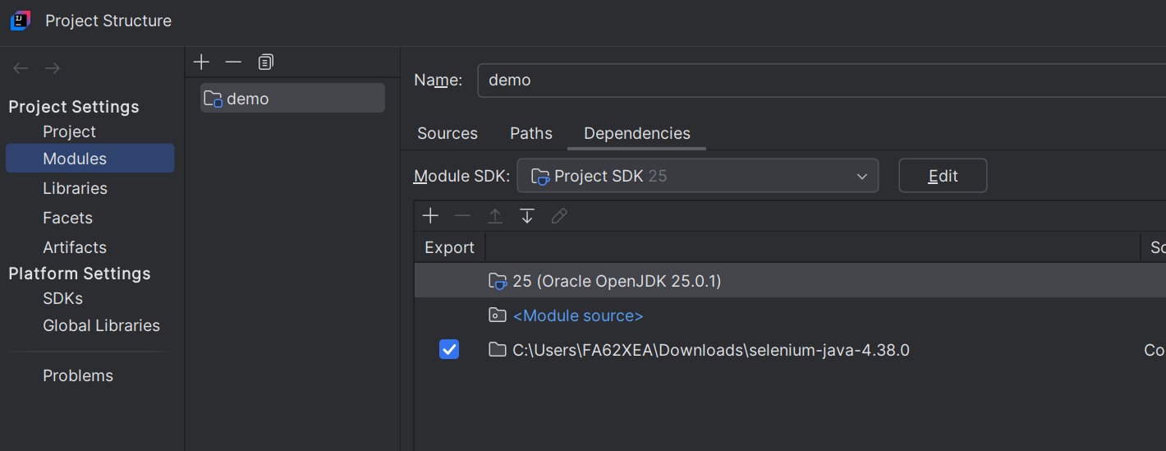
Say apply and ok
Next thing to do is download chrome browser
From here
Download ChromeDriver (free) for Windows, macOS and Linux | Gizmodo
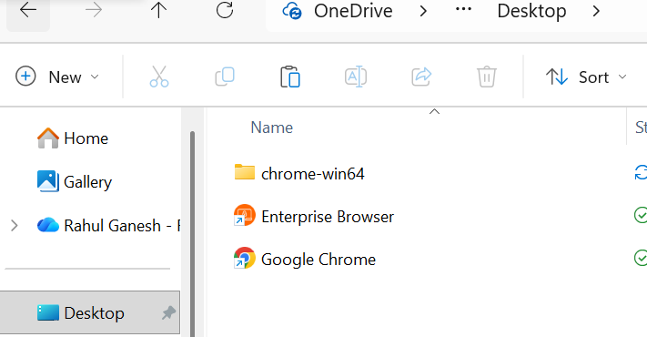
Copy from download item and paste in any folder or desktop
See what is the chrome version of yours
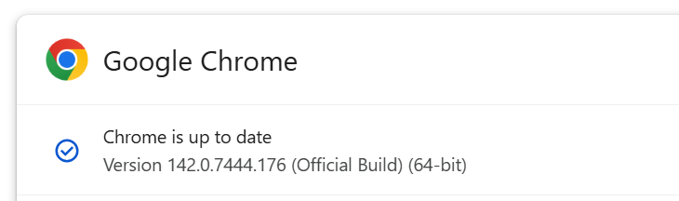
Download the same
https://googlechromelabs.github.io/chrome-for-testing/#stable



Get the downloaded Item and paste it in
chromedriver-win64

"C:\\Users\\FA62XEA\\Documents\\Drivers\\chromedriver-win64\\chromedriver.exe");

Thus your script is working
