Step 1
to get java selenium run and to get it Run icon visible
Take new proj with intell j , and not maven or gradel as in your org ,no permission for maven central repo or gradel, you need to use the intellj option.
Once you choose intellj proj:
Step 1: you will not get run icon, for that you need to set the lib.
So go to Downloads | Selenium and click on java and get download ,java-selenium
Place it in your main idea proj
C:\Users\FA62XEA\IdeaProjects\Demo\libs\selenium-java-4.38.0 (1)
Here is the project structure set up files>project structure>modules>then add the lib path.
Generally the libs will be in here
C:\Users\FA62XEA\.m2\repository\org\seleniumhq\selenium\selenium-java

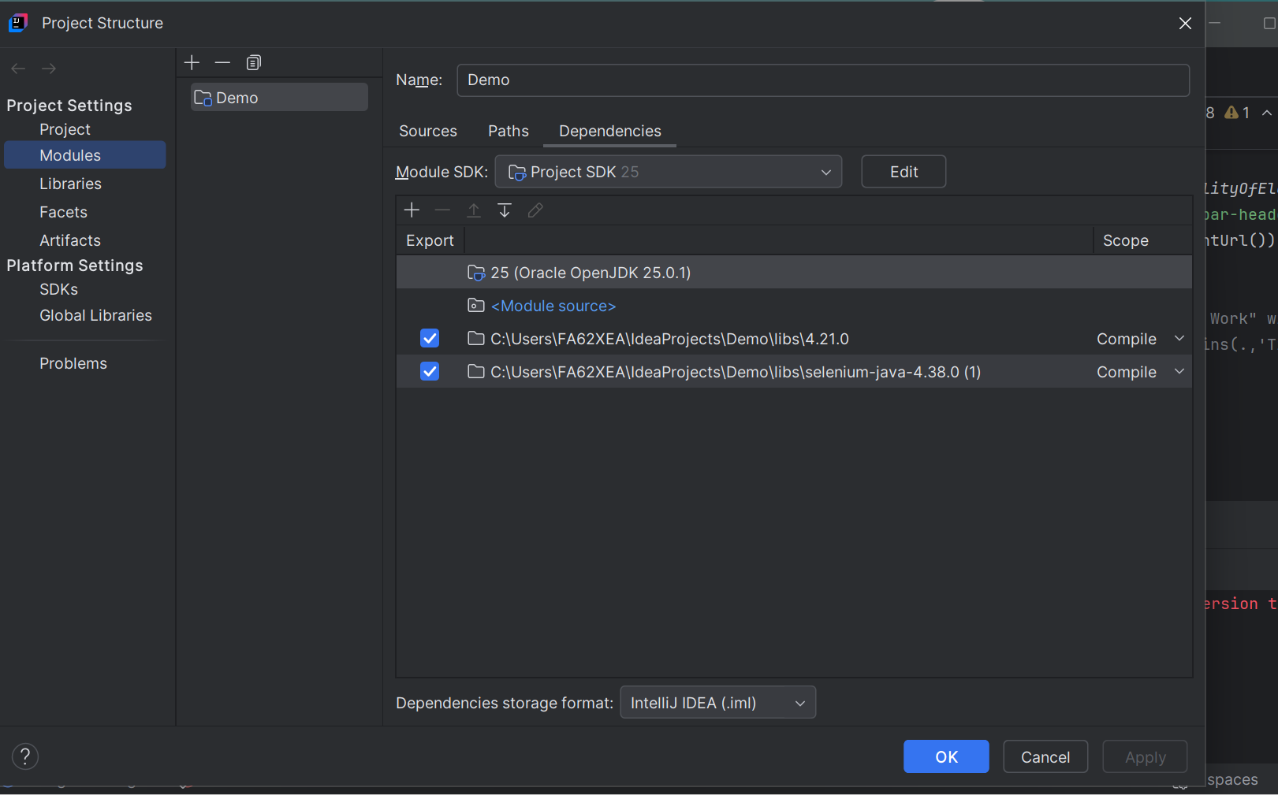
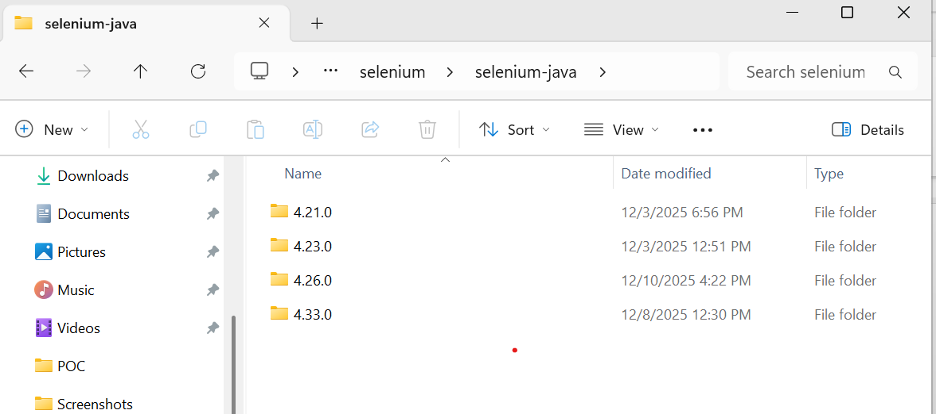
You need to copy this and paste it here
C:\Users\FA62XEA\IdeaProjects\Demo\libs

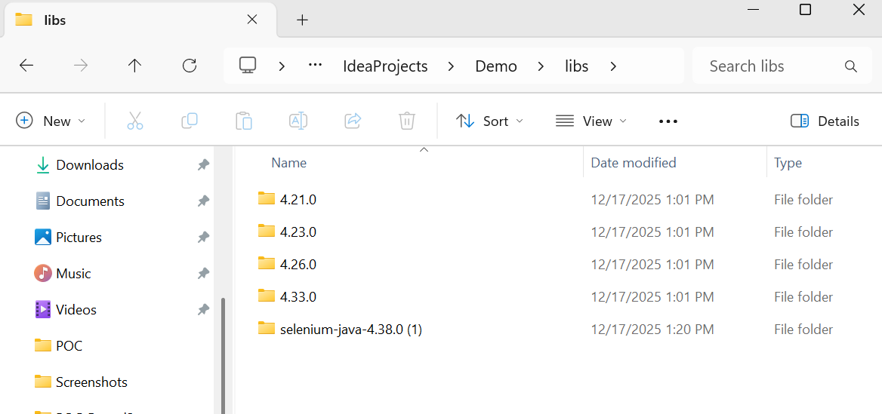
At once you do this you will get run icon.
Step2 : is chrome and chromedriver.exe - version compatibility
See the chrome.exe here : C:\Users\FA62XEA\OneDrive - Fiserv Corp\Desktop\chrome-win64\chrome.exe
C:\Users\FA62XEA\OneDrive - Fiserv Corp\Desktop\chrome-win64
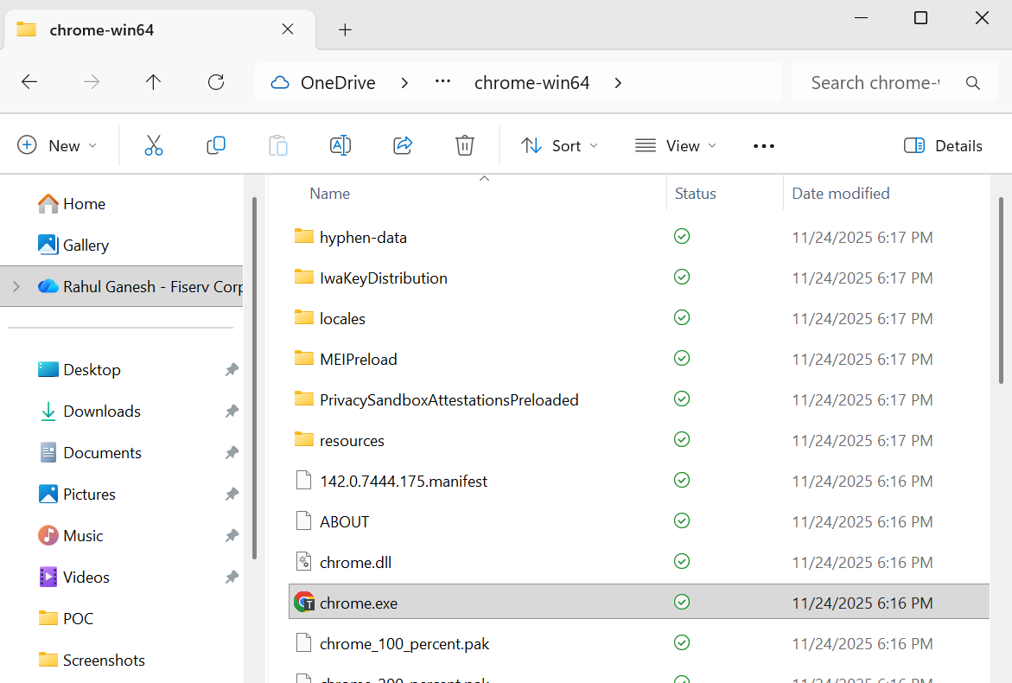
See the chromedriver path after getting download
Downloads | ChromeDriver | Chrome for Developers
C:\Users\FA62XEA\Downloads\chromedriver-win64\chromedriver-win64\chromedriver.exe
C:\Users\FA62XEA\Downloads
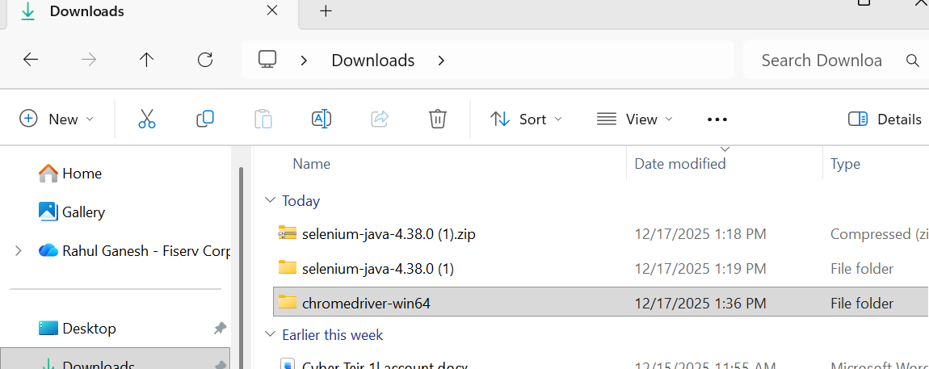
Thus you can run successfully
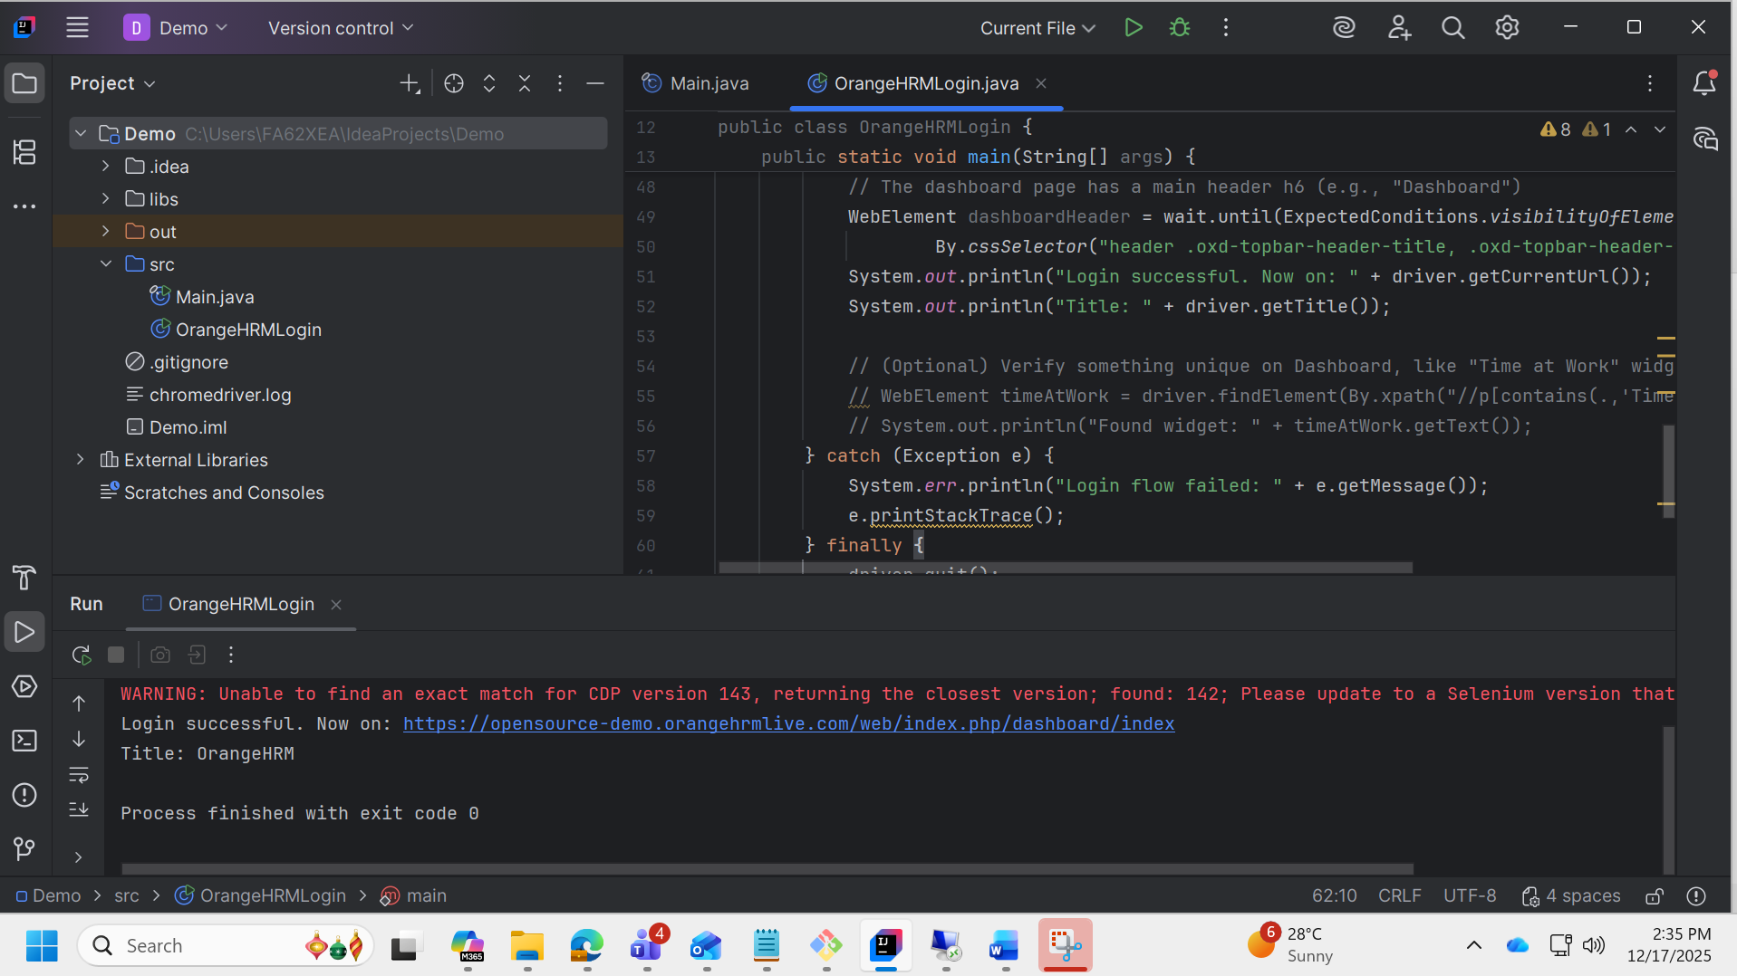

Success login prog:
import org.openqa.selenium.By;
import org.openqa.selenium.WebDriver;
import org.openqa.selenium.chrome.ChromeDriver;
import org.openqa.selenium.chrome.ChromeOptions;
import org.openqa.selenium.support.ui.ExpectedConditions;
import org.openqa.selenium.support.ui.WebDriverWait;
import java.time.Duration;
public class Hrmslogin {
public static void main(String[] args) {
// Set your ChromeDriver path (must end with chromedriver.exe)
System.setProperty("webdriver.chrome.driver",
"C:\\Users\\FA62XEA\\Downloads\\chromedriver-win64\\chromedriver-win64\\chromedriver.exe");
ChromeOptions options = new ChromeOptions();
options.addArguments("--remote-allow-origins=*");
options.addArguments("--disable-notifications");
WebDriver driver = new ChromeDriver(options);
WebDriverWait wait = new WebDriverWait(driver, Duration.ofSeconds(10));
try {
driver.manage().window().maximize();
driver.get("https://opensource-demo.orangehrmlive.com/web/index.php/auth/login");
wait.until(ExpectedConditions.visibilityOfElementLocated(By.name("username"))).sendKeys("Admin");
wait.until(ExpectedConditions.visibilityOfElementLocated(By.name("password"))).sendKeys("admin123");
wait.until(ExpectedConditions.elementToBeClickable(By.cssSelector("button[type='submit']"))).click();
// Wait until dashboard URL appears
wait.until(ExpectedConditions.urlContains("/dashboard"));
// Print the page title after login
String title = driver.getTitle();
System.out.println("Page Title after login: " + title);
// Optional: simple check for expected title
if ("OrangeHRM".equals(title)) {
System.out.println("Dashboard loaded successfully.");
} else {
System.out.println("Unexpected title: " + title);
}
} finally {
driver.quit();
}
}
}
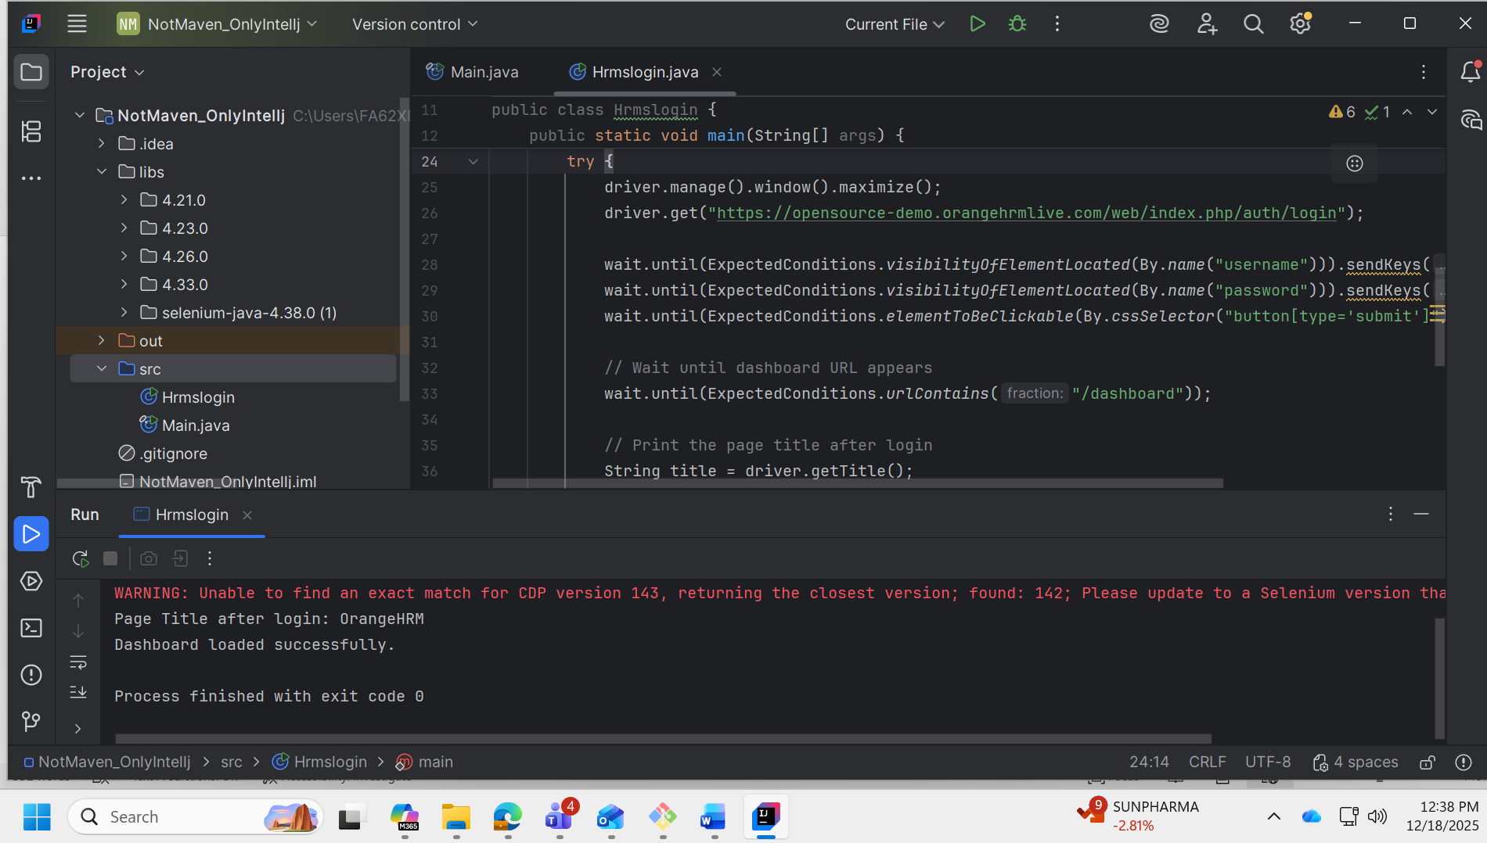
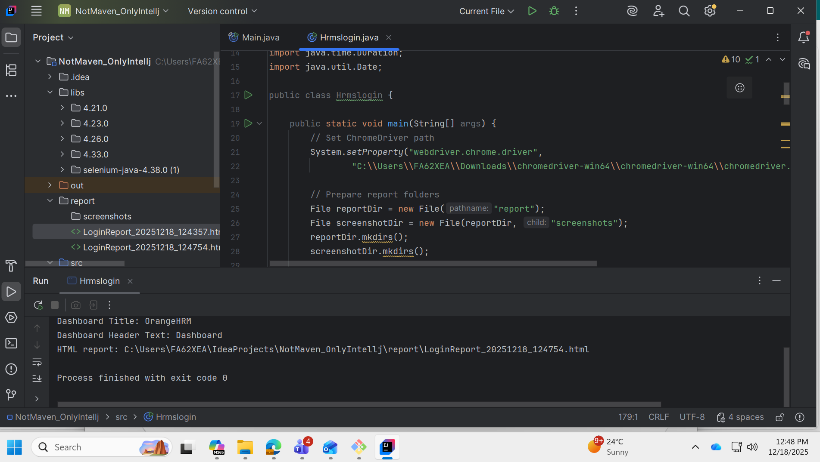
Note :
So you cant use visul code -- as vs code supports does not support intellj manual set up .
It will support only maven and gradel for which pom.xml required and maven central repository should be reachable.
Prog with report:
import org.openqa.selenium.*;
import org.openqa.selenium.chrome.ChromeDriver;
import org.openqa.selenium.chrome.ChromeOptions;
import org.openqa.selenium.support.ui.ExpectedConditions;
import org.openqa.selenium.support.ui.WebDriverWait;
import java.io.File;
import java.io.FileWriter;
import java.io.IOException;
import java.nio.file.Files;
import java.nio.file.Path;
import java.text.SimpleDateFormat;
import java.time.Duration;
import java.util.Date;
public class Hrmslogin {
public static void main(String[] args) {
// Set ChromeDriver path
System.setProperty("webdriver.chrome.driver",
"C:\\Users\\FA62XEA\\Downloads\\chromedriver-win64\\chromedriver-win64\\chromedriver.exe");
// Prepare report folders
File reportDir = new File("report");
File screenshotDir = new File(reportDir, "screenshots");
reportDir.mkdirs();
screenshotDir.mkdirs();
String timestamp = new SimpleDateFormat("yyyyMMdd_HHmmss").format(new Date());
File reportFile = new File(reportDir, "LoginReport_" + timestamp + ".html");
ChromeOptions options = new ChromeOptions();
options.addArguments("--remote-allow-origins=*");
options.addArguments("--disable-notifications");
WebDriver driver = new ChromeDriver(options);
WebDriverWait wait = new WebDriverWait(driver, Duration.ofSeconds(12));
long start = System.currentTimeMillis();
String status = "PASS";
String message = "";
String pageTitle = "";
String currentUrl = "";
String screenshotPath = "";
String dashboardHeaderText = "";
try {
driver.manage().window().maximize();
driver.get("https://opensource-demo.orangehrmlive.com/web/index.php/auth/login");
wait.until(ExpectedConditions.visibilityOfElementLocated(By.name("username"))).sendKeys("Admin");
wait.until(ExpectedConditions.visibilityOfElementLocated(By.name("password"))).sendKeys("admin123");
wait.until(ExpectedConditions.elementToBeClickable(By.cssSelector("button[type='submit']"))).click();
// Wait until Dashboard URL appears
wait.until(ExpectedConditions.urlContains("/dashboard"));
currentUrl = driver.getCurrentUrl();
// Title (tab title)
pageTitle = driver.getTitle(); // Expected: "OrangeHRM"
System.out.println("Dashboard Title: " + pageTitle);
// Optional: in-page "Dashboard" header text
try {
WebElement header = wait.until(ExpectedConditions.visibilityOfElementLocated(
By.cssSelector("header h6.oxd-text--h6, .oxd-topbar-header-breadcrumb h6")));
dashboardHeaderText = header.getText();
System.out.println("Dashboard Header Text: " + dashboardHeaderText);
} catch (Exception ignored) {
// If locator changes, title verification is enough
}
// Simple validation
if (!currentUrl.contains("/dashboard")) {
status = "FAIL";
message = "Dashboard URL not detected.";
} else if (!"OrangeHRM".equals(pageTitle)) {
status = "FAIL";
message = "Unexpected title: " + pageTitle;
} else {
message = "Login and dashboard verified.";
}
} catch (Exception e) {
status = "FAIL";
message = "Exception: " + e.getClass().getSimpleName() + " - " + safe(e.getMessage());
// Screenshot on failure
try {
screenshotPath = new File(screenshotDir, "failure_" + timestamp + ".png").getAbsolutePath();
TakesScreenshot ts = (TakesScreenshot) driver;
File src = ts.getScreenshotAs(OutputType.FILE);
Files.copy(src.toPath(), Path.of(screenshotPath));
} catch (Exception ignored) { /* may fail if driver already quit */ }
} finally {
try { driver.quit(); } catch (Exception ignored) {}
long end = System.currentTimeMillis();
long durationMs = end - start;
// Write HTML report
writeHtmlReport(reportFile, status, message, pageTitle, dashboardHeaderText,
currentUrl, screenshotPath, start, end, durationMs);
System.out.println("HTML report: " + reportFile.getAbsolutePath());
if (!screenshotPath.isEmpty()) {
System.out.println("Failure screenshot: " + screenshotPath);
}
}
}
private static void writeHtmlReport(File reportFile,
String status,
String message,
String title,
String headerText,
String url,
String screenshotPath,
long start,
long end,
long durationMs) {
String startStr = new SimpleDateFormat("yyyy-MM-dd HH:mm:ss").format(new Date(start));
String endStr = new SimpleDateFormat("yyyy-MM-dd HH:mm:ss").format(new Date(end));
String statusClass = "PASS".equalsIgnoreCase(status) ? "status-pass" : "status-fail";
StringBuilder sb = new StringBuilder();
sb.append("<!DOCTYPE html>\n<html lang=\"en\">\n<head>\n<meta charset=\"UTF-8\">\n")
.append("<title>OrangeHRM Login Report</title>\n<style>\n")
.append("body{font-family:Arial,sans-serif;margin:20px;} .card{border:1px solid #ddd;border-radius:8px;padding:16px;max-width:800px;}")
.append(".status-pass{color:#0b7a0b;font-weight:bold;} .status-fail{color:#b00020;font-weight:bold;} .row{margin:8px 0;} ")
.append("code{background:#f7f7f7;padding:2px 6px;border-radius:4px;} a{color:#0069c0;text-decoration:none;}\n")
.append("</style>\n</head>\n<body>\n<h2>OrangeHRM Login Report</h2>\n<div class=\"card\">\n")
.append("<div class=\"row\"><strong>Status:</strong> <span class=\"").append(statusClass).append("\">")
.append(escapeHtml(status)).append("</span></div>\n")
.append("<div class=\"row\"><strong>Message:</strong> ").append(escapeHtml(message)).append("</div>\n")
.append("<div class=\"row\"><strong>Start:</strong> ").append(startStr).append("</div>\n")
.append("<div class=\"row\"><strong>End:</strong> ").append(endStr).append("</div>\n")
.append("<div class=\"row\"><strong>Duration:</strong> ").append(durationMs).append(" ms</div>\n<hr/>\n")
.append("<div class=\"row\"><strong>Page Title:</strong> <code>").append(escapeHtml(title)).append("</code></div>\n")
.append("<div class=\"row\"><strong>Dashboard Header:</strong> <code>").append(escapeHtml(headerText)).append("</code></div>\n")
.append("<div class=\"row\"><strong>URL:</strong> <a href=\"").append(escapeHtml(url)).append("\" target=\"_blank\">")
.append(escapeHtml(url)).append("</a></div>\n");
if (screenshotPath != null && !screenshotPath.isEmpty()) {
String rel = relPathForReport(reportFile, screenshotPath);
sb.append("<div class=\"row\"><strong>Screenshot:</strong><br/>\n")
.append("<img src=\"").append(rel).append("\" alt=\"Screenshot\" style=\"max-width:100%;border:1px solid #ccc;\"/>\n")
.append("</div>\n");
}
sb.append("</div>\n</body>\n</html>");
try (FileWriter fw = new FileWriter(reportFile)) {
fw.write(sb.toString());
} catch (IOException e) {
System.err.println("Failed to write HTML report: " + e.getMessage());
}
}
private static String relPathForReport(File reportFile, String screenshotAbs) {
try {
Path reportDir = reportFile.getParentFile().toPath().toAbsolutePath();
Path screenshot = Path.of(screenshotAbs).toAbsolutePath();
return reportDir.relativize(screenshot).toString().replace("\\", "/");
} catch (Exception e) {
return screenshotAbs;
}
}
private static String safe(String s) {
return (s == null) ? "" : s;
}
private static String escapeHtml(String s) {
if (s == null) return "";
return s.replace("&", "&amp;").replace("<", "&lt;").replace(">", "&gt;");
}
}
