Harness
Harness is the modern devops platform that automates cicd,deployments,security testing,features release,cloud and cost management and chaos engineering - using mL and gitops principles.

in simple words
Harness is an end to end platform to build,test,deploy,verify and manage application automatically.

core modules of harness:
1.ci :
Build pipelines - >fast,container-native,intelligent caching.

2.cd :
Automated deployments with:
. Canary
. Blue green
. Rolling
. 1-click rollback
. AI - verfication

- STO-security testing orchestration

all security scans like
. Sast
. Dast
. Sca
. container/iac scan
. Aggregates vulnerabilities

- Feature flags
- CCM - optimize cloud spend using ML
- Chaos enggineering -- inject failures - test resilience
- Internal developerportal

Advantages:

Ai deployement verification
- click rollback
Gitop -declarative pipeline
pipeline abstraction
plug and play security scans

After login ,https://app.harness.io/
you get
- ci 2. cd 3 .code repo 4.ccm (cloud cost mgt) 5.Feature flags 6.service reliablity mgt
first lets go thru CI - stage 1

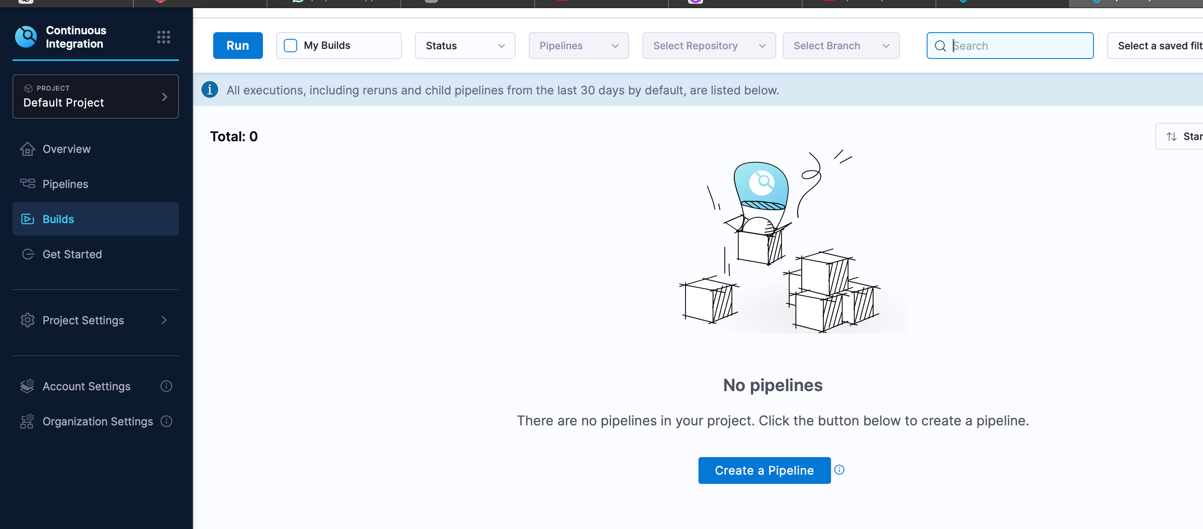
click create new pipeline
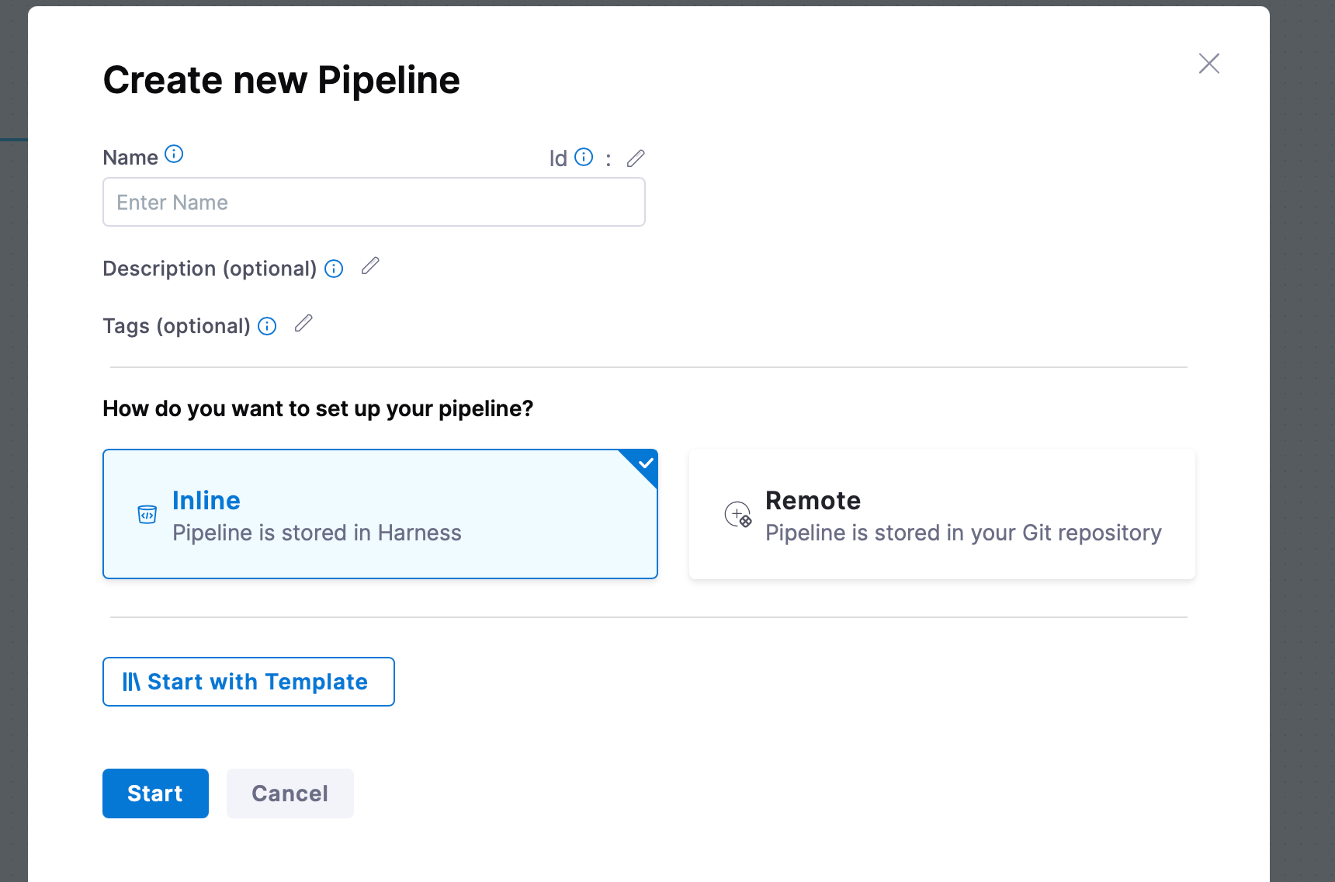
click add stage
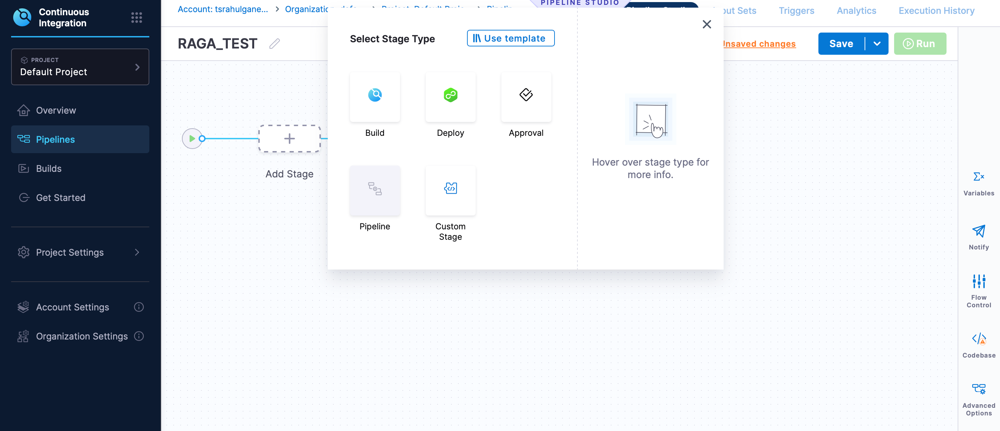
click build - -sec 01
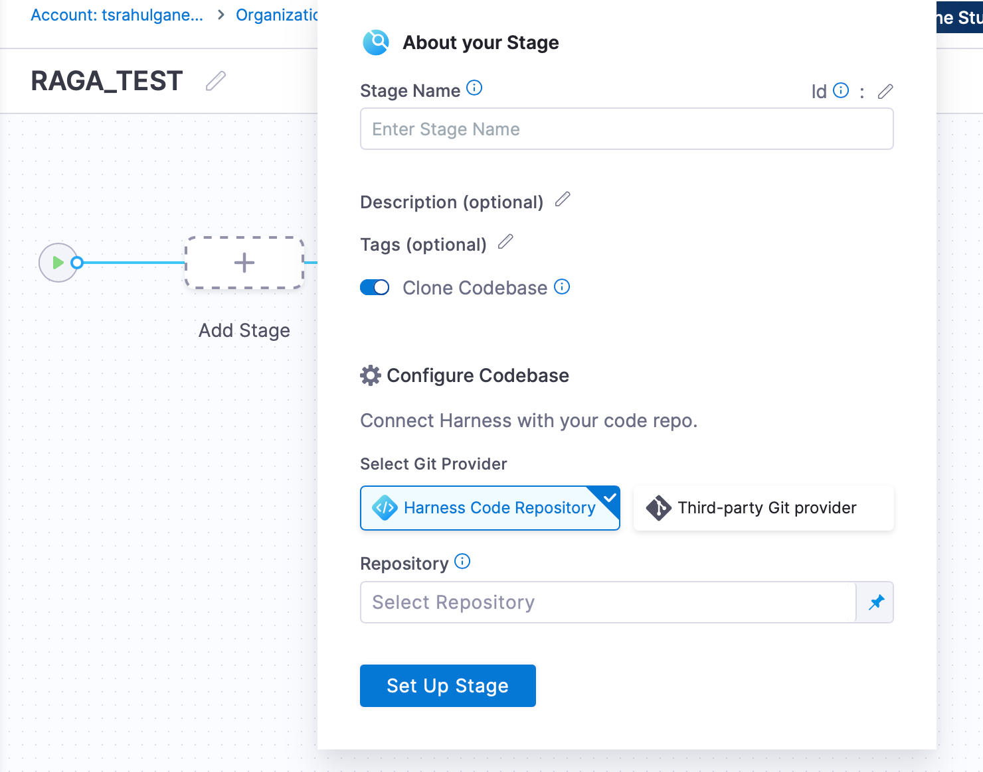
you can find the from where to pick the code.
You can pick the code from harness code repo, third party provider
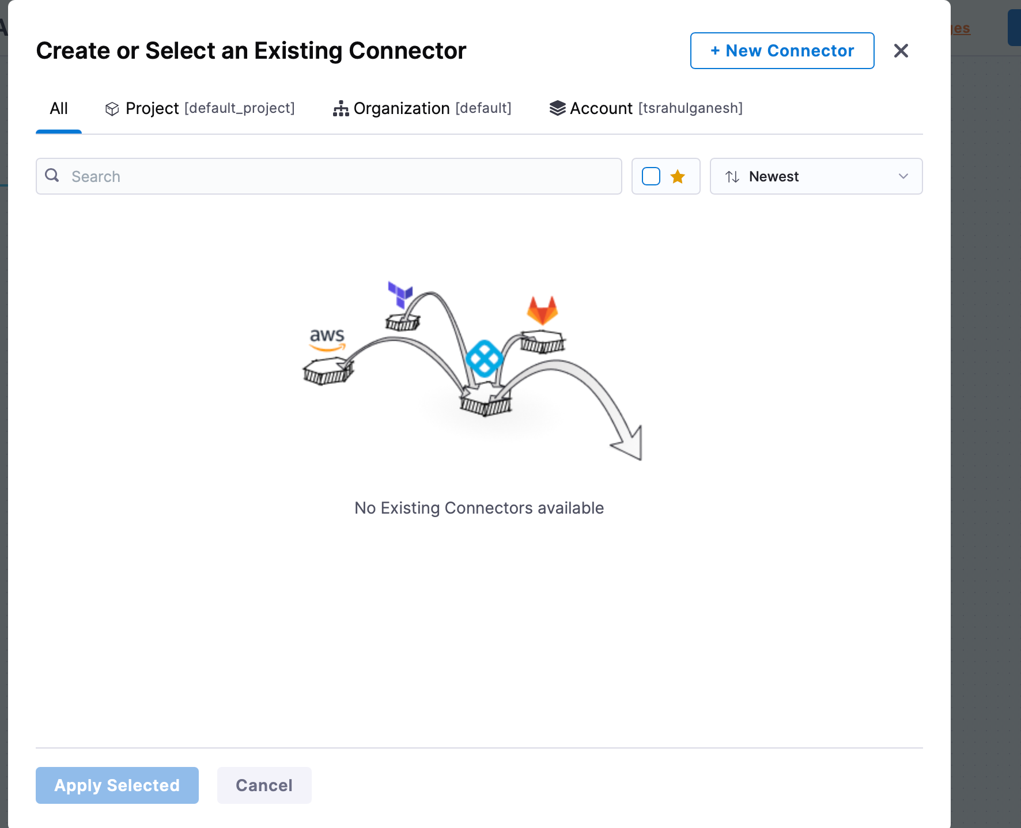
click connector to connect git or git lab or bitbucket
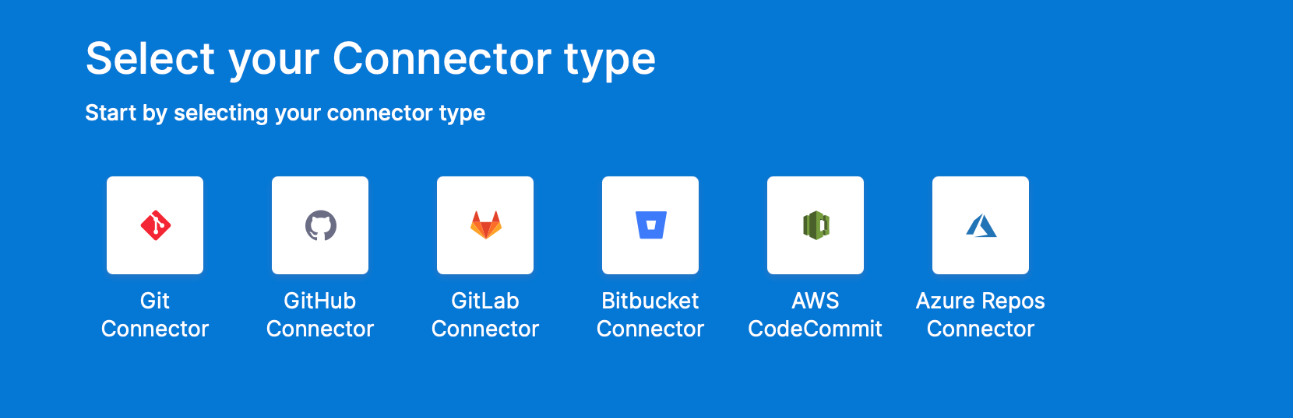
come back and click add stage> deploy
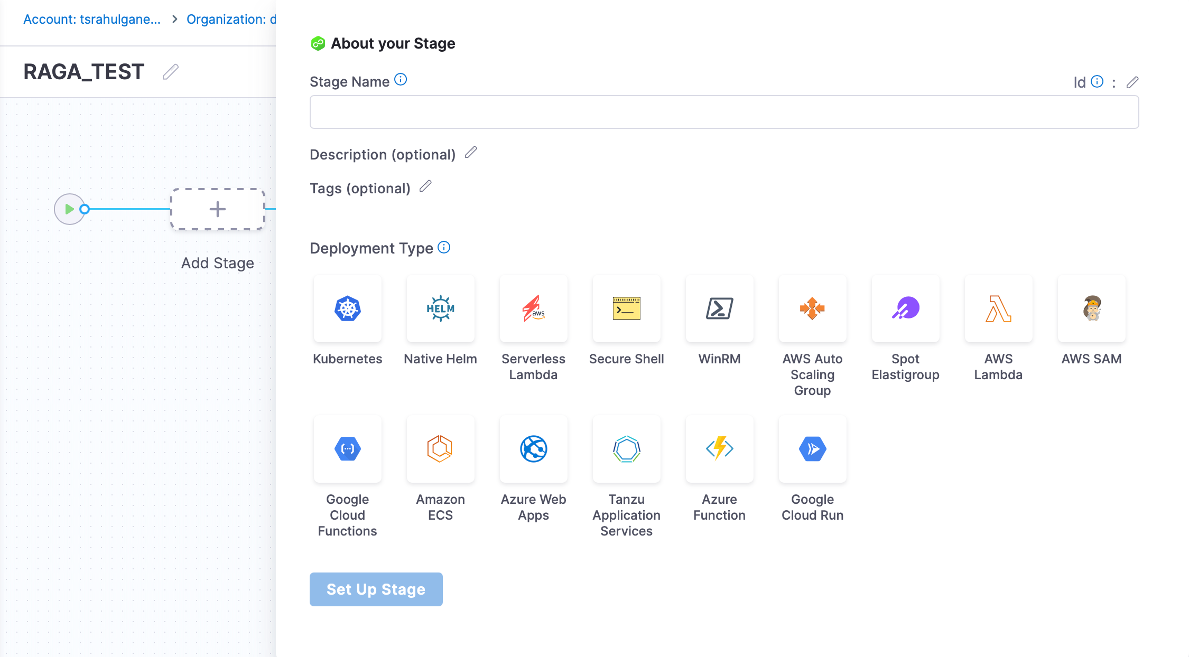
come back for sec 3 -- click add stage > approval
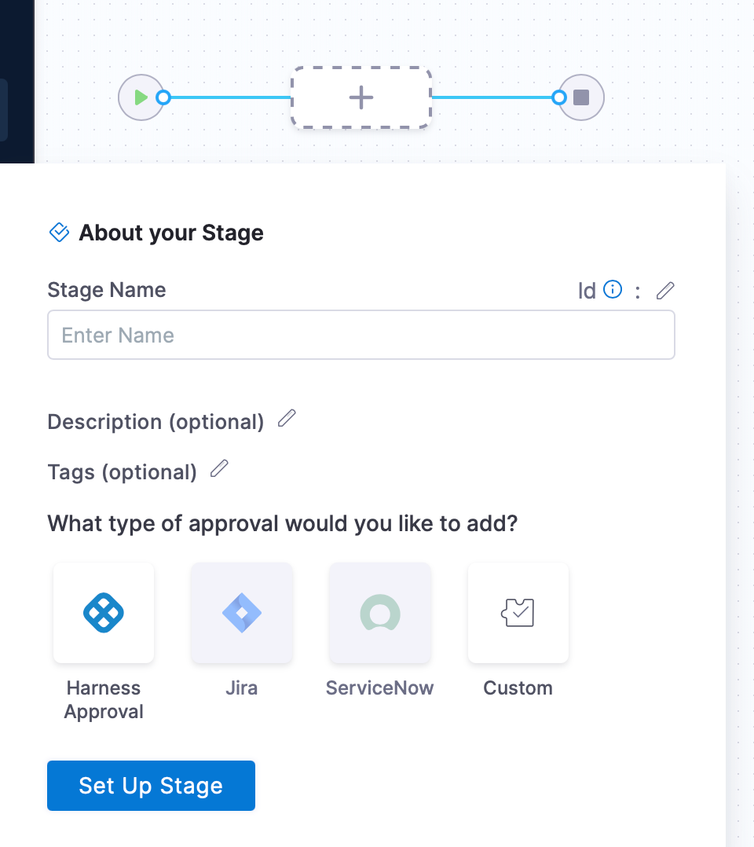

sec 1- build set up
sec2 - deploy set up
sec 3 - approval set up
once set up is done

click “get started”
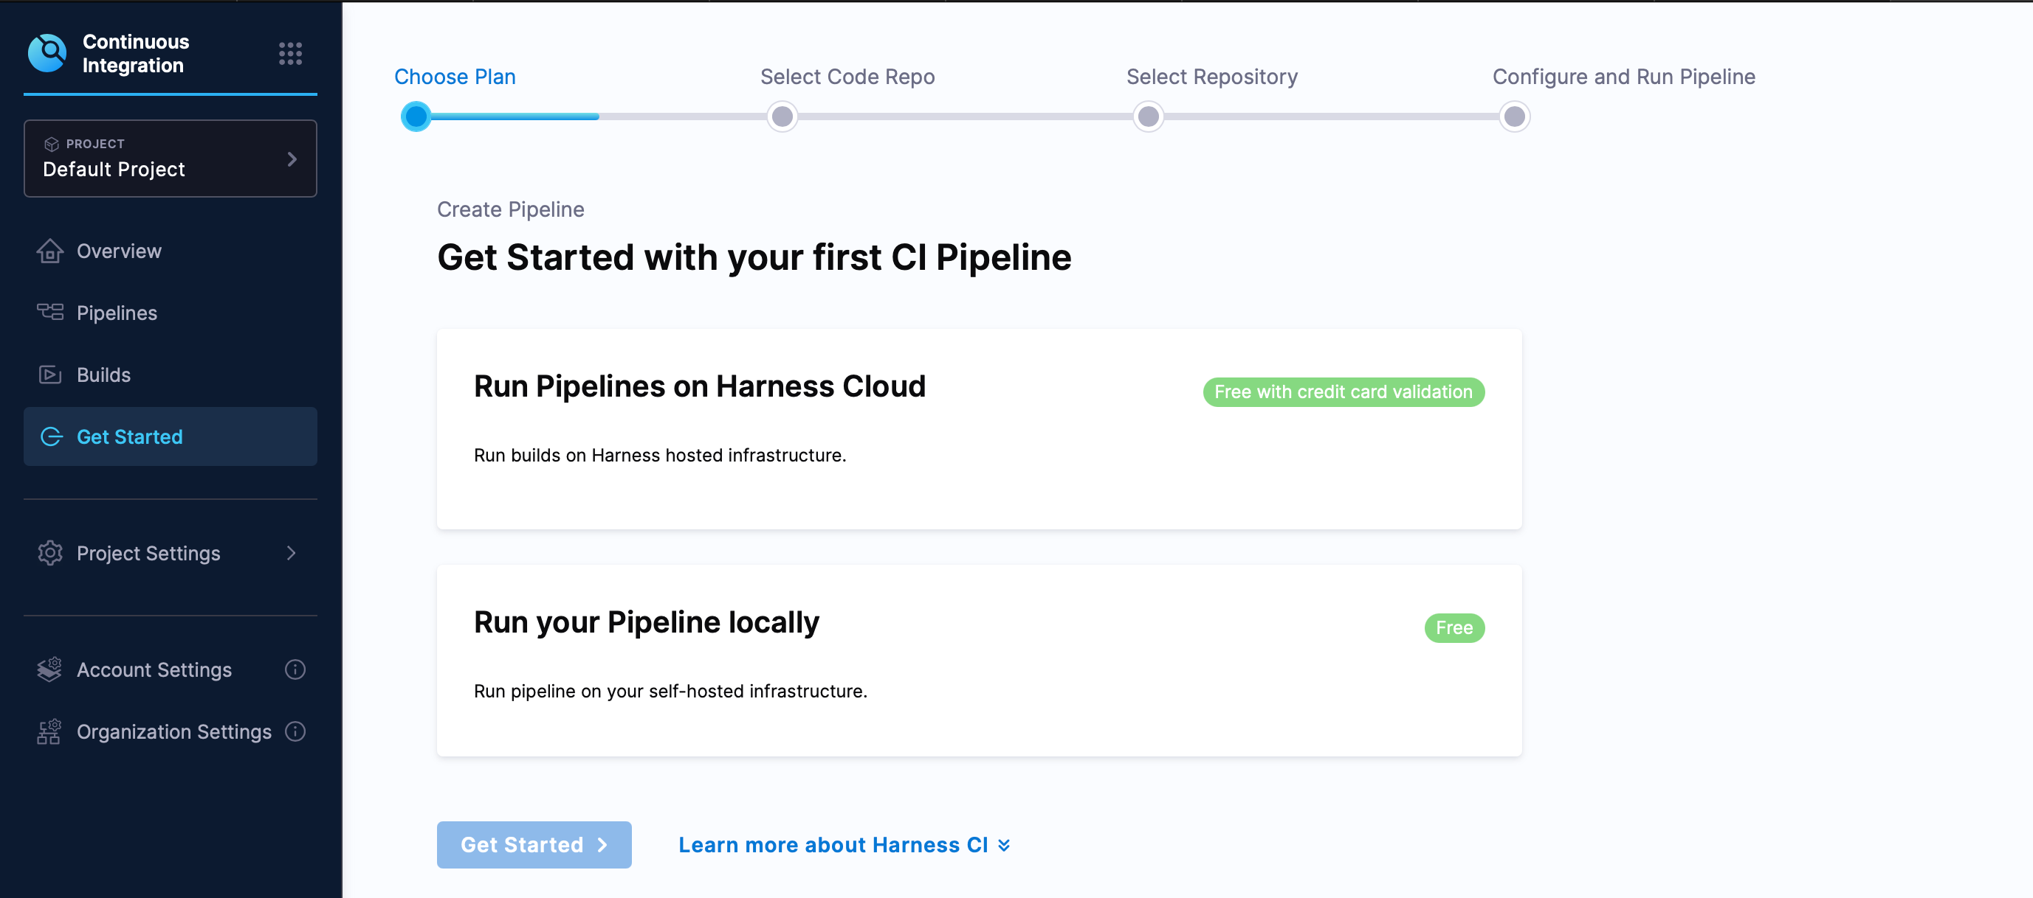
4 steps
1 choose plan
2 select code repo
3 select repository
4 configure and run pipeline
step 5
Run pipeline on harness cloud
step 6
run your pipeline locally

click --Get started

CD - stage 2
a)what service you going to deploy
like
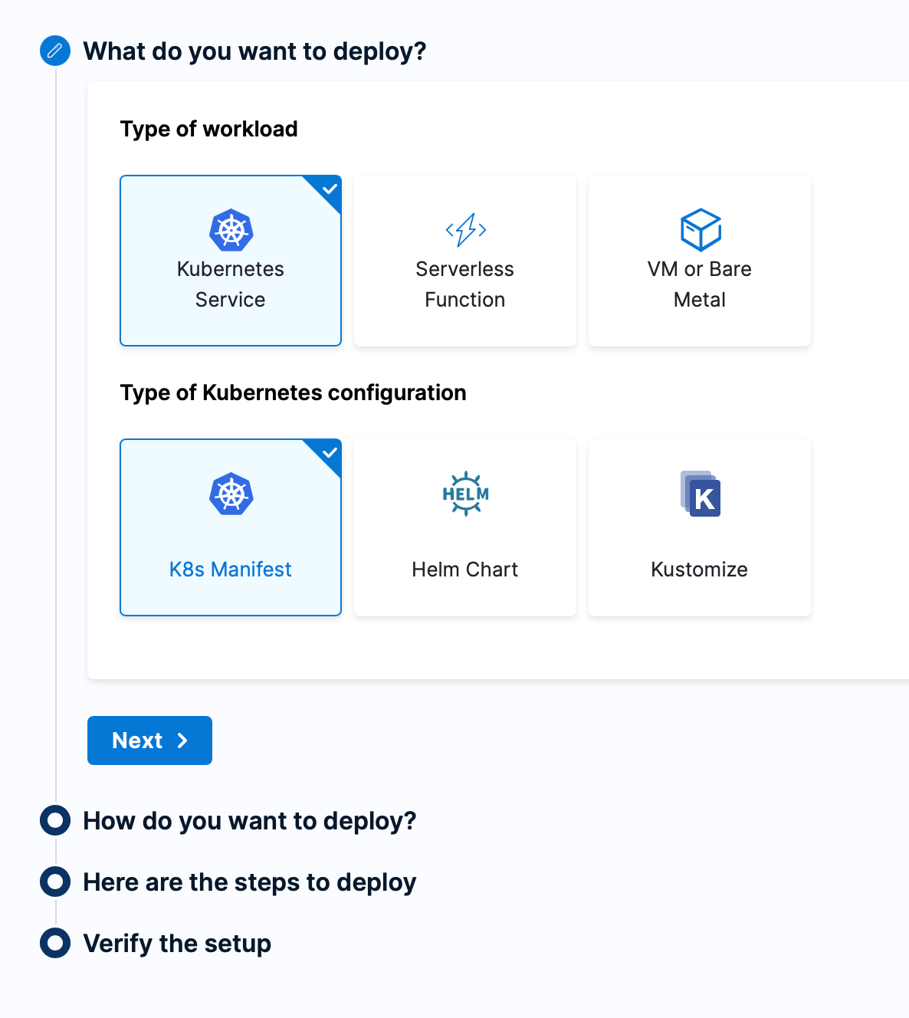
b)how do you want to deploy --> Cd gitops or cicd pipeline
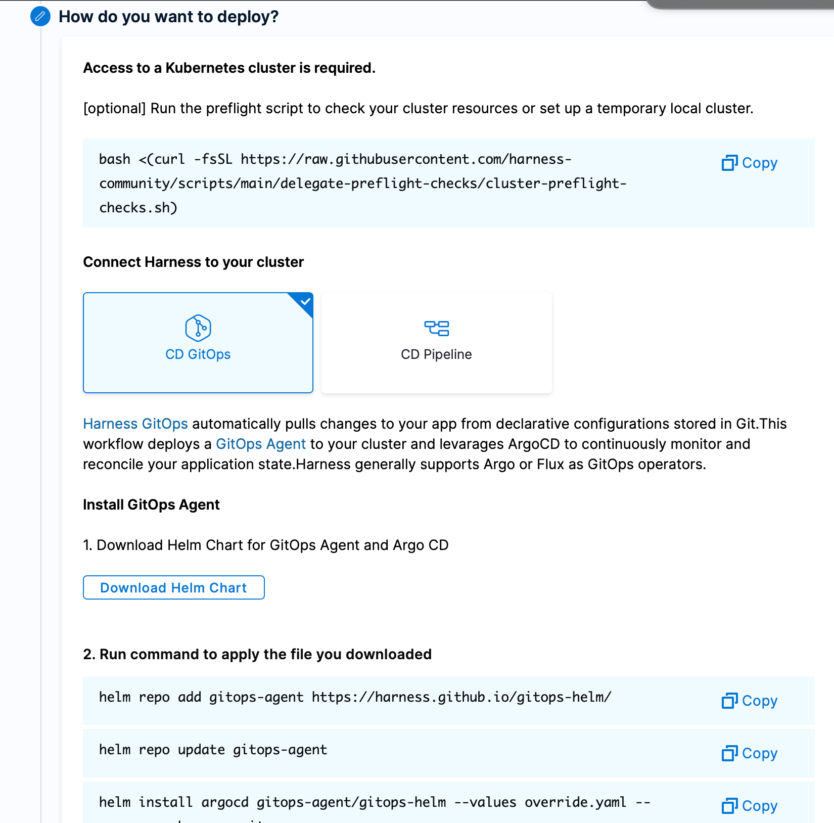
c) here are the steps
d) verify the steps

Rest all you can explore.

Thank s

