# PROJECT : THERMAL POWER PLANT WORKING

**Thermal electricity**

* **Traditional thermal power plants:** also called combustion power plants, they operate with energy produced by a steam boiler fuelled by coal, natural gas, heating oil, as well as by biomass. The steam activates a turbine which, in turn, drives an alternator to produce electricity.

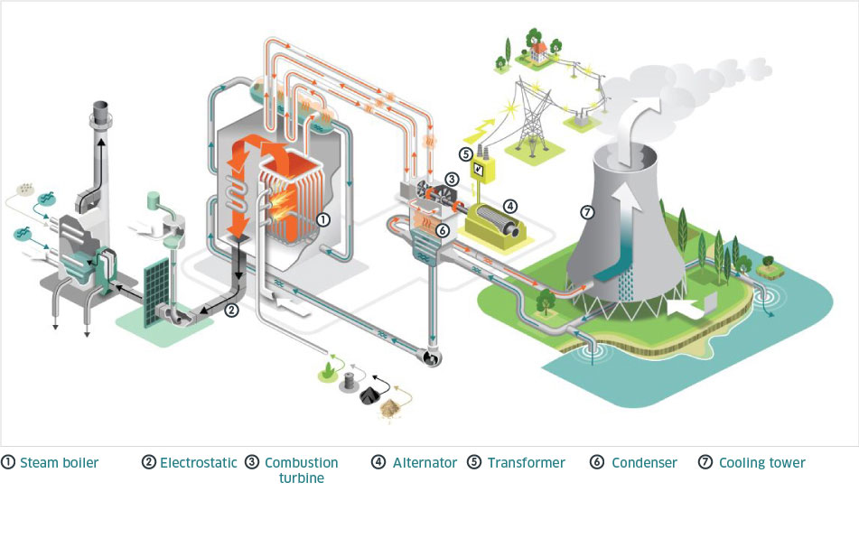

* **Combined cycle gas power plants (or steam-gas turbine plants**: these combine a gas turbine and a traditional thermal plant to generate electricity. Unlike conventional thermal power plants, the residual energy of the gases is used for another cycle. This is one of the reasons for which these kind of plants are more efficient (by 56%), also meaning that they produce lower CO2 emissions than conventional plants.

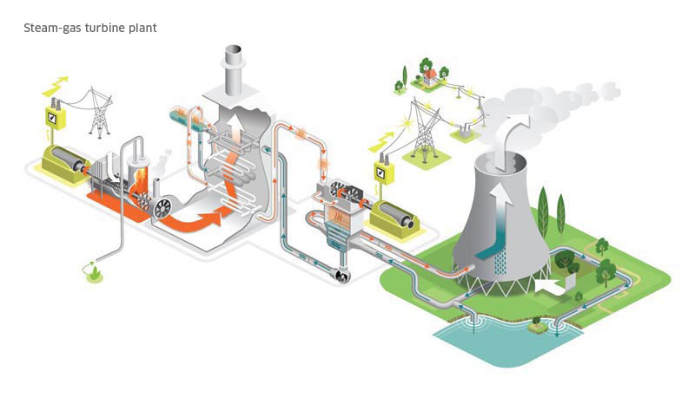

Initially, gas is injected into the combustion turbine. It generates steam, which is then supplied to another turbine. The combustion turbine and steam turbine work in tandem to turn one or more alternators, which produce electricity.

* **Recovery of blast furnace gas:** electricity production can also be obtained by recovering and recycling gases from iron and steel production (blast-furnace gas, coking plant gas, steel plant gas), using a traditional boiler (a comparable technology to traditional thermal power plants) or in a heat recovery boiler in a combined cycle gas plant.

* **Gas turbines and turbojets:** mostly used to supplement the electricity production of other thermal plants, gas turbine and turbojet units can take over very rapidly in the event of a failure of other power plants or of unexpected peaks in consumption.

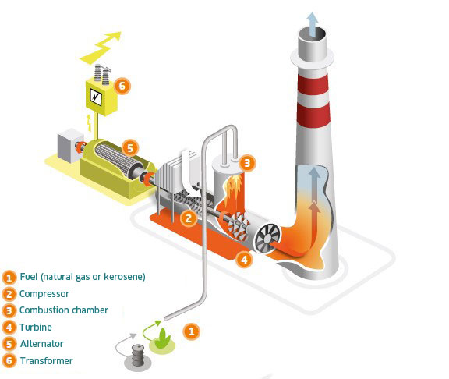

**Gas turbine and turbojets:** The compressor draws in air, compresses it and injects it into the combustion chamber. Natural gas (gas turbine) or kerosene (turbojet) is injected into the chamber to be burned. The hot combustion gases rotate the turbine, which drives an alternator to produce electricity.

* **Cogeneration units:** these produce heat (their principal role) simultaneously with electricity (their secondary role) in a single installation and employing a single fuel. It is a highly energy-efficient solution. By recovering thermal energy normally lost in power generation, these plants are able to produce electricity and heat with efficiency of close to 90%, which is of great interest for industrial sites.

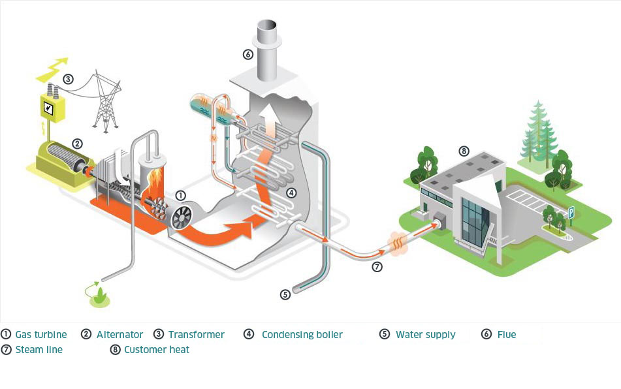

**Co-generation:** A gas-powered generator drives an alternator that produces electricity. Heat recovered from the cooling of the motor and the combustion gases heats a water circuit thanks to heat exchangers.

## **Working Components of Thermal Power Plant**

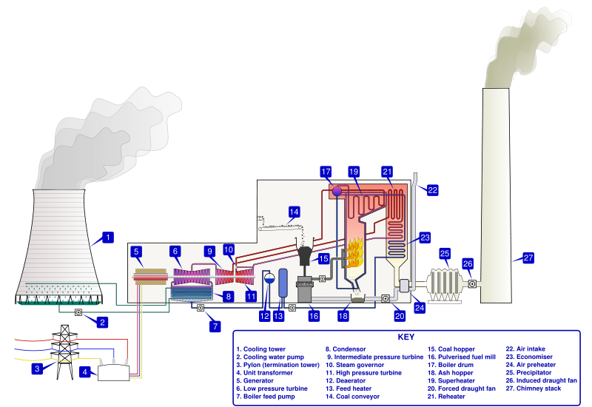

**Thermal Power Plant** consists of a whole set of steps in series for producing electricity. The fuel is transported from mines via trains to the fuel storage facility in a power plant. The fuel transported to the plant is generally bigger in particle size and before it is fed to the boiler furnace it is broken down into smaller pieces using crushers. The fuel is then fed to the boiler generating a large amount of combustion heat.

On the other hand treated water free from impurities and air is fed to the boiler drum where the combustion heat from the fuel is **transferred to water to convert it into high pressure and temperature steam**.

Generally, flue gases from the boiler exhaust are at high temperature and if this heat is not utilized will lead to a large number of losses resulting in reduced boiler efficiencies.

So generally this **waste heat** is recovered by heating either air required for combustion or preheat water before sending it into a boiler.

Flue gases are then allowed to pass through a dust collector or a **bag filter** to arrest dust particles so as to prevent air pollution before sending it to the atmosphere through a **chimney**.

### **Fuel storage and handling plant**

The most essential part of any power plant is to store the fuel safely in an appropriate amount so that the plant can run smoothly in normal days as well as when the supply of fuel from mines is improper. So a fuel storage facility is defined in a plant to store an adequate amount of fuel.

In athermal power plant process, the first step in process of power generation is that the fuel is brought to breaker house with the help of belt conveyor, here light dust is separated with the help of rotary machine through the action of gravity.

It further goes to the crusher where it is crushed to a size of about 50mm.

### **Water Treatment Plant**

In thermal power, plant water is used in large quantity this water is converted into steam and used to rotate the turbine so this water and steam come into direct contact with the boiler, boiler tubes, boiler accessories, and turbine blades.

Normal water is taken from the river, well contains a lot of dirt, suspended particulate matter (SPM), dissolved minerals and dissolved gases such as air etc. If the water fed to the boiler is not treated then it will reduce the life and efficiency of equipment by corroding the surfaces and **scaling of equipment** which may lead to overheating of pressure parts and explosions.

Suspended matter from the water is removed by adding alum into the water tank through gravity separation. Addition of alum coagulates the suspended particles and due to an increase in the density, it settles at the bottom of the tank through gravity.

After gravity separation, water softening is done by ion exchange process. As the hardness comes through the carbonates and bicarbonates of sodium and magnesium, these salts are removed from water anion exchange and cation exchange process.

Water also contains dissolved oxygen and this leads to corrosion and fouling of boiler tubes and surfaces when it comes in their contact. So removing dissolved oxygen from water is done by adding oxygen scavengers and by using a **Deaerator tank**.

Deaerator tank also acts as a feed water tank to store the feed water. On heating feed water in a deaerator tank decreases the solubility of air in water, thereby removing the dissolved air from the water.

“Thermodyne  supplies both Water **Softeners** and Deaerator tanks to improve the quality of your feed water to the boiler as this improves the life and efficiency of your boiler and its equipment.”

### [**Steam Boiler**](https://www.thermodyneboilers.com/what-is-steam-boiler/)

A boiler is a pressure vessel which is used to generate high-pressure steam at a saturated temperature. At this high pressure and temperature generally, bi-drum water tube boilers are used.

Thermodyne Engineering Systems manufactures **water tube boilers** of various sizes and capacities that can run on various fuels. Steam Boiler is main component of thermal plants Water-tube boiler consists of a furnace enclosed by the water tubes membrane. The crushed fuel from the crushers is fed into the boiler furnace over the grate.

The hot air from the **Forced Draft (FD) fan** is mixed with the crushed fuel causing combustion of fuel.

Combustion of fuel generates a lot of radiation heat which is transferred to water in the membrane tubes. Flue gases generated during combustion travel at high velocity across the convection bank of tubes thereby heating water through convection heat transfer. Hot water is sent to a boiler drum at high pressure through the feed-water pump.

The boiler tubes which are in contact with low temperature acts as downcomers to circulate the water while the tubes which are in contact with high temperature acts as risers to carry steam.

This leads to an effective circulation of water thereby preventing the tubes from getting overheated.

The steam leaving the boiler is at saturated temperature and pressure but there are a lot of heat losses during its transportation to the turbines.

So to increase the quality of steam, steam Superheater is installed in a radiate section of a boiler to increase its temperature and dryness fraction without increasing its pressure as well as to accommodate for the transportation temperature losses.

The exhaust gases leaving the boiler are generally at high temperature and this waste heat is extracted by installing an **Economiser** or Water Preheaters to preheat the feed water to the boiler and **Air Preheaters** to pre-heat the air coming from the Forced Draft Fan required for the combustion of fuel.

Installing this equipment help to decrease the flue gas temperature thereby increasing the efficiency.

The flue gases leaving the boiler also contain some ash particles, so to reduce the air pollution, flue gases are allowed to pass through the **Dust Collectors** and **Bag Filters** to remove the ash particulates from the flue gases and are sometimes passed through the **Wet Scrubbers** to decrease the sulphur content from the gases.

The flue gases are drawn through this equipment using an Induced Draft (ID) Fan which is designed for a fixed capacity and head to prevent any backpressure. After the ID fan, flue gases are exhausted off into the atmosphere using a **chimney**.

### **Turbine**

A turbine is a mechanical device which converts the kinetic and pressure energy of steam into useful work. From the superheater steam goes to the turbine where it expands and loses its kinetic and pressure energy and rotates the turbine blade which in turn rotates the turbine shaft connected to its blades. The shaft then rotates the generator which converts this kinetic energy into electrical energy.



## **Company History**

**Maharashtra State Power Generation Co Ltd. (hereinafter referred to as “The Company”) has been incorporated under Indian Companies Act 1956 pursuant to decision of Govt. of Maharashtra to reorganize Erstwhile Maharashtra State Electricity Board (herein after referred to as “MSEB”).**

The said reorganization of the MSEB has been done by Govt. of Maharashtra pursuant to Part XIII read with section 131 of The Electricity Act 2003. MAHAGENCO has been incorporated on 31.5.2005 with The Registrar of Companies, Maharashtra, Mumbai and has obtained Certificate of Commencement of Business on 15.09.2005. MAHAGENCO is engaged in the business of generation and supply of Electricity and has been vested with generation assets, interest in property, rights and liabilities of MSEB as per Gazette Notification dated 4th June 2005 issued by Industry, Energy and Labour Dept of Govt of Maharashtra pursuant to section 131 of Electricity Act 2003.

**Installed Capacity**

**MAHAGENCO** has an installed capacity of **12972** MW. This comprises of Thermal (nearly 75%, i.e. **9540** MW) and a gas based generating station at Uran, having an installed capacity of **672 MW**. The Hydro Electric Projects in the State of Maharashtra were designed, erected and commissioned through the Water Resource Department (WRD) of GoM. After commissioning, the hydro projects were handed over on long term lease to MAHAGENCO for Operation and Maintenance. Presently there are 25 hydel projects, having capacity of **2580 MW.**

**MAHAGENCO** is aware of next green power scenario of power generation from non-conventional energy resources and have clear vision for Green Power for the consumers of Maharashtra. Accordingly to fulfil Renewable Power obligation of distribution companies in Maharashtra, **MAHAGENCO** has commissioned **180MWp** Solar Power Projects till date.

INSTALLED CAPACITY OF MAHAGENCO:(As on 31-12-2022) (Thermal Power Stations Only)

|  |  |  |  |
| --- | --- | --- | --- |
| **SR.NO.** | **POWER STATION** | **UNITS & CAPACITY (MW)** | **INSTALLED CAP. (MW)** |
| 1 | KORADI | 1 x 210 + 3 x 660 | 2190 |
| 2 | NASIK | 3 x 210 | 630 |
| 3 | BHUSAWAL | 1 x 210 + 2 x 500 | 1210 |
| 4 | PARAS | 2 x 250 | 500 |
| 5 | PARLI | 3 x 250 | 750 |
| 6 | KHAPERKHEDA | 4 x 210 + 1 x 500 | 1340 |
| 7 | CHANDRAPUR | 2 x 210 + 5 x 500 | 2920 |
| Total | | | 9540 |