Decision Tree
Business Problem
Datafile=Fraud_check
Should decide
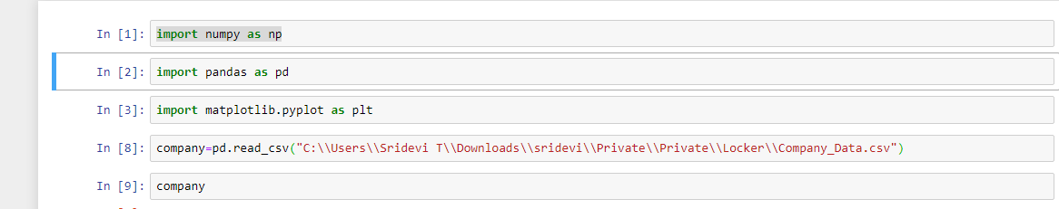
import numpy as np
import pandas as pd
import matplotlib.pyplot as plt
fraud=pd.read_csv("C:\\Users\\Sridevi T\\Downloads\\sridevi\\Private\\Private\\Locker\\Fraud_check.csv")
fraud.sort_values('Urban', inplace=True)
d1=fraud[fraud["Urban"]=="YES"]
d2=fraud[fraud["Urban"]=="NO"]
df1 = pd.DataFrame(d1.iloc[0:25, 0:6])
df2 = pd.DataFrame(d2.iloc[0:25, 0:6])
fraud_train = pd.concat([df1,df2])
fraud_train

x_train=fraud_train.iloc[:, ~fraud_train.columns.isin(['Undergrad', 'Marital.Status', 'Urban'])]

y_train=fraud_train.iloc[:,5]

tf1=pd.DataFrame(d1.iloc[26:, 0:6])
tf2=pd.DataFrame(d2.iloc[26:, 0:6])

fraud_test=pd.concat([tf1, tf2])
fraud_test

x_test=fraud_test.iloc[:, ~fraud_test.columns.isin(['Undergrad', 'Marital.Status', 'Urban'])]
x_test

y_test=fraud_test.iloc[:, 5]
y_test

# Fitting Decision Tree Classification to the Training set
from sklearn.tree import DecisionTreeClassifier
classifier = DecisionTreeClassifier(criterion = 'entropy', random_state = 0)
classifier.fit(x_train, y_train)

DecisionTreeClassifier(class_weight=None, criterion='entropy', max_depth=None,
max_features=None, max_leaf_nodes=None,
min_impurity_decrease=0.0, min_impurity_split=None,
min_samples_leaf=1, min_samples_split=2,
min_weight_fraction_leaf=0.0, presort=False,
random_state=0, splitter='best')

# Predicting the Test set results
y_pred = classifier.predict(x_test)

from sklearn.metrics import confusion_matrix
cm = confusion_matrix(y_test, y_pred)
cm
array([[146, 126],
[148, 128]], dtype=int64)

from sklearn.metrics import accuracy_score
Accuracy_Score = accuracy_score(y_test, y_pred)

Accuracy_Score
0.5

Random Forest

# Fitting Random Forest Classification to the Training set
from sklearn.ensemble import RandomForestClassifier
classifier = RandomForestClassifier(criterion = 'entropy', random_state = 0)
classifier.fit(x_train, y_train))

RandomForestClassifier(bootstrap=True, class_weight=None, criterion='entropy',
max_depth=None, max_features='auto', max_leaf_nodes=None,
min_impurity_decrease=0.0, min_impurity_split=None,
min_samples_leaf=1, min_samples_split=2,
min_weight_fraction_leaf=0.0, n_estimators=10,
n_jobs=None, oob_score=False, random_state=0, verbose=0,
warm_start=False)

# Predicting the Test set results
y_pred = classifier.predict(x_test)

from sklearn.metrics import confusion_matrix
cm = confusion_matrix(y_test, y_pred)
cm
array([[146, 126],
[148, 128]], dtype=int64)

from sklearn.metrics import accuracy_score
Accuracy_Score = accuracy_score(y_test, y_pred)

Accuracy_Score
0.4708029197080292

