**PostgreSQL and SVN Setup Instructions**

1. **Install PostgreSQL** 17.5  **(Windows 64-bit):**

* Copy the PostgreSQL 17.5 Windows 64-bit installer “postgresql-17.5.3-windows-x64.exe “ from the shared network location “\\infor.com\shared\USAL\Departments\Development2\USDAVWTA2 \Postgres\Software”
* Right-click postgresql-17.5.3-windows-x64.exe and select **"Run as administrator"**. Then You’ll see the **PostgreSQL Setup Wizard**.
  + Click **Next**

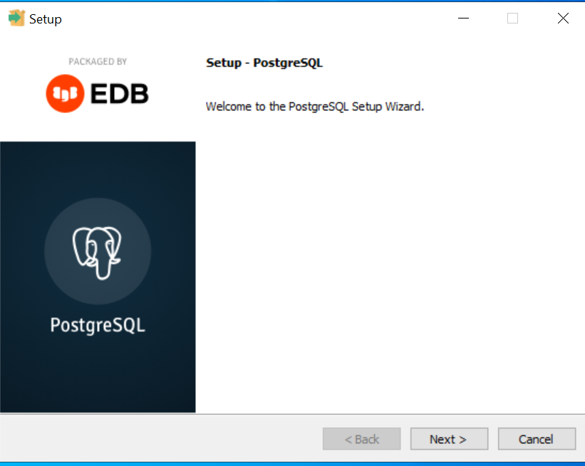

* **Choose Installation Directory**
  + Default: C:\Program Files\PostgreSQL\17
  + Change only if needed.

* + Click **Next**
* **Select Components**

Default selection is recommended:

* PostgreSQL Server
* pgAdmin 4
* Stack Builder
* Command Line Tools

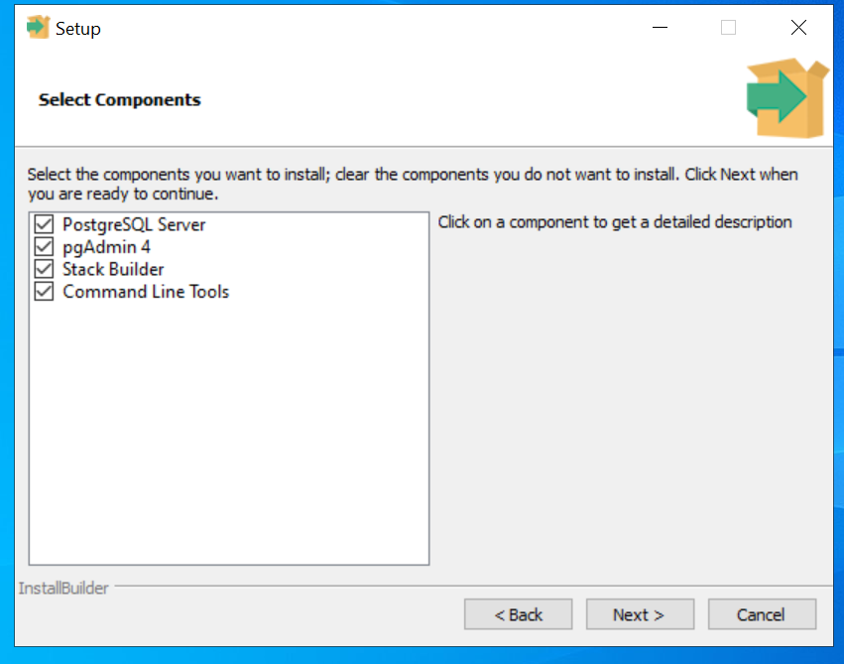

* + Click **Next**
  + Choose Data Directory
  + Default: C:\Program Files\PostgreSQL\17\data

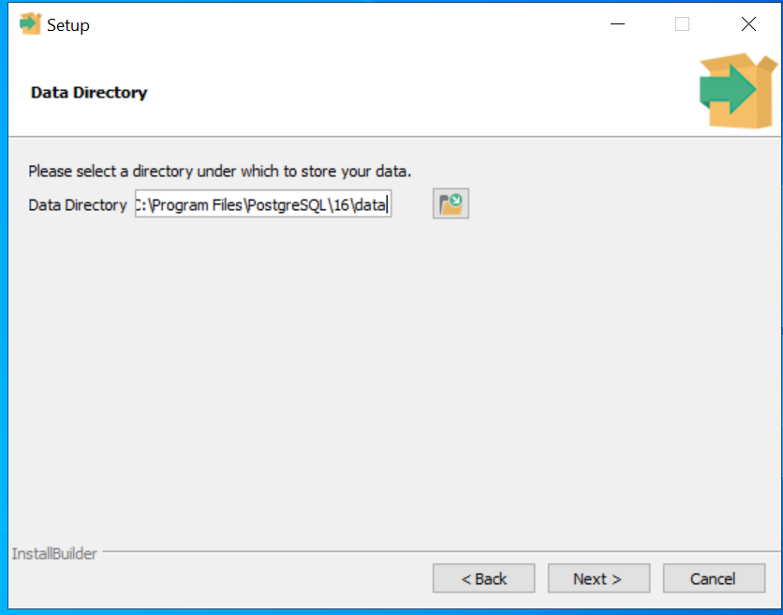

* + Click **Next**
* **Set Password for Postgres User**
  + Enter a strong password for the default PostgreSQL superuser **postgres.**

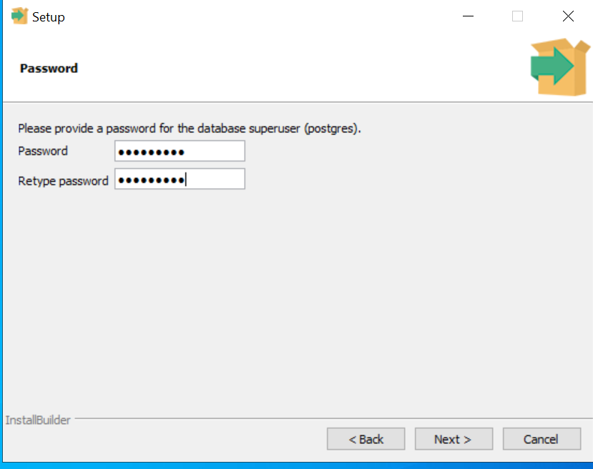

* **Note the password** you set for the postgres user — this will be needed later i.e when executing “postgres_setup.bat”, it will prompts for user and password.
  + Click **Next**
* **Choose Port Number**
  + Default is 5432. Change only if port is in use.

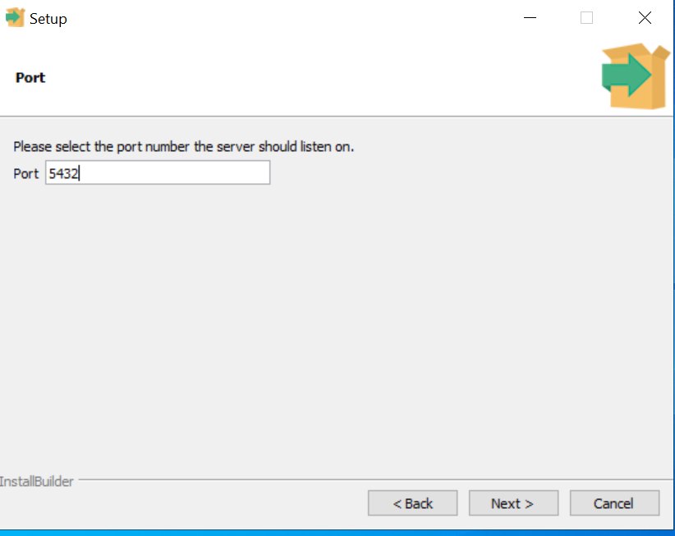

* + Click **Next, Next until you get below screen:**

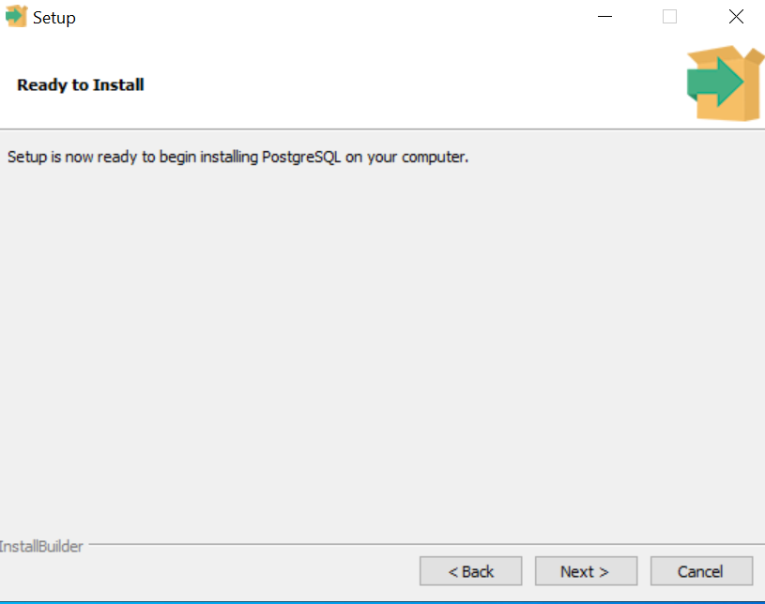

* + Click **Next**
* **Finish Installation**
  + Uncheck **Launch Stack Builder** if you don’t need to install additional tools.
  + Click **Finish**.

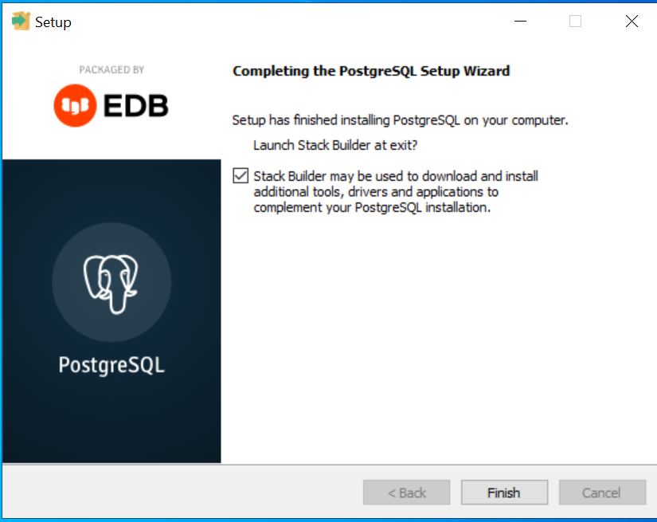

* **Verify Installation**
  + Open **pgAdmin 4**:
    - Press the **Windows key** on your keyboard (or click the **Start** button).
    - Type **pgAdmin** in the search bar.
    - You should see something like **pgAdmin 4** in the results.
    - Click it (or press **Enter**) to launch pgAdmin.

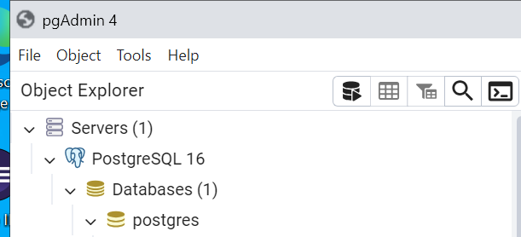

* + or use psql from the terminal
    - Press the **Windows key** on your keyboard (or click the Windows icon).
    - Type **psql**

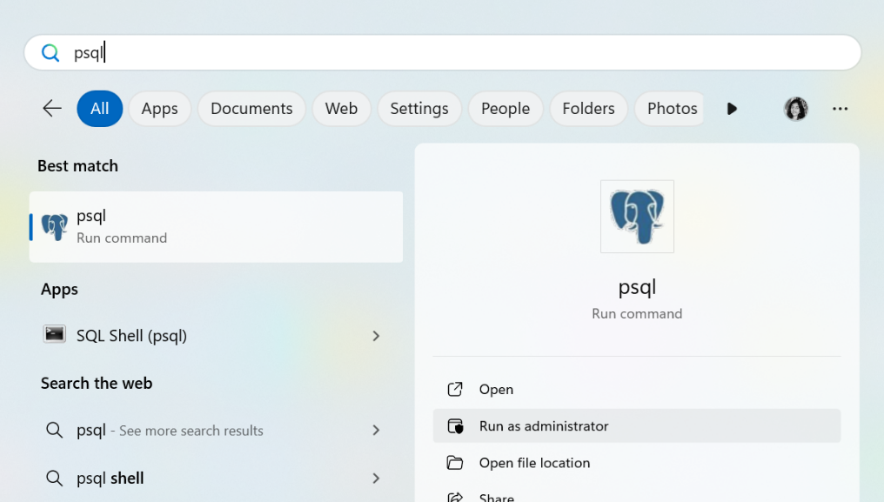

Then the below screen will appear and give the required inputs when prompt:

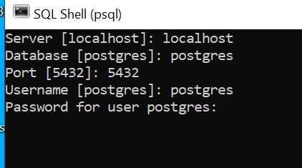

2. **Install TortoiseSVN 1.14.9 with Command-Line Tools:**

* Copy the SVN Windows 64-bit installer “TortoiseSVN-1.14.9.29743-x64-svn-1.14.5.msi “ from the shared network location “\\infor.com\shared\USAL\Departments\Development2\USDAVWTA2\Postgres\Software”
* Right-click TortoiseSVN-1.14.9.29743-x64-svn-1.14.5.msi and select **"Install"**.
* 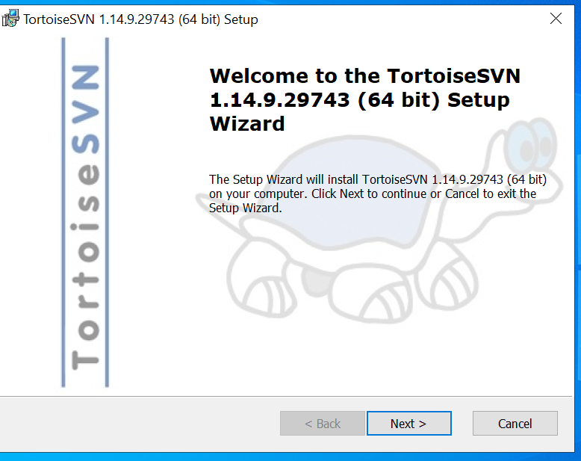
  + Click **Next**

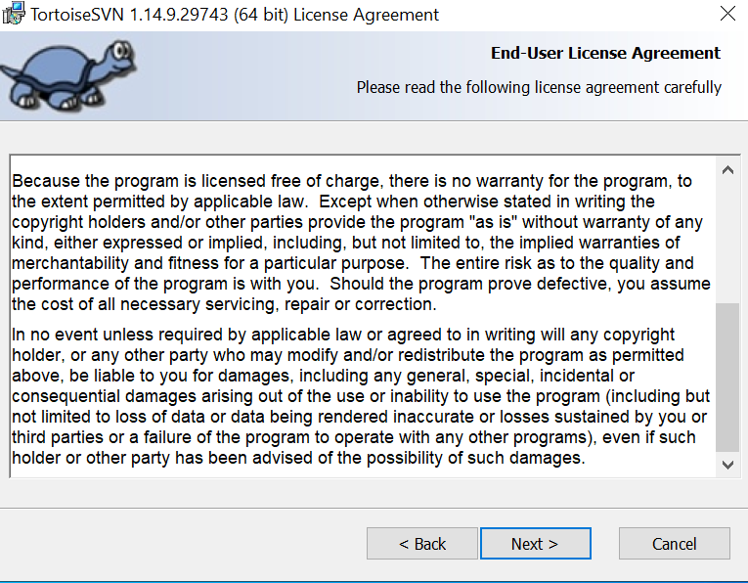

* + Click **Next**
* Expand the features list.
  + **Ensure "Command line client tools" is selected** (this installs svn.exe).

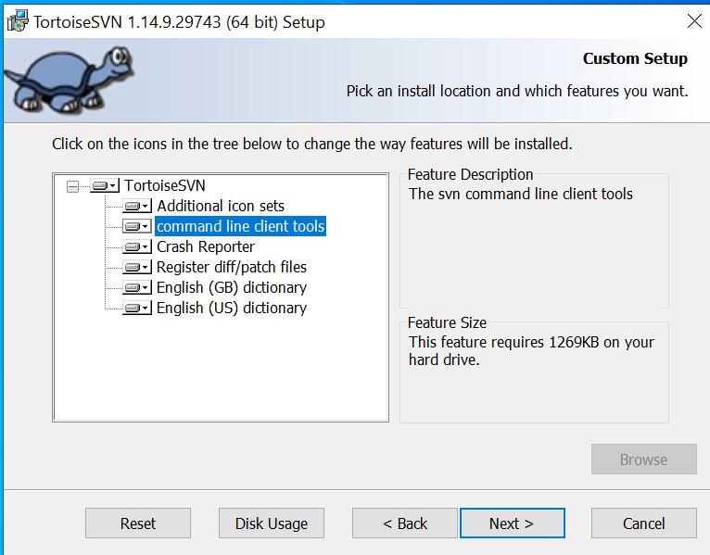

* + Click **Next**
  + Click **Install**
* Complete the installation.

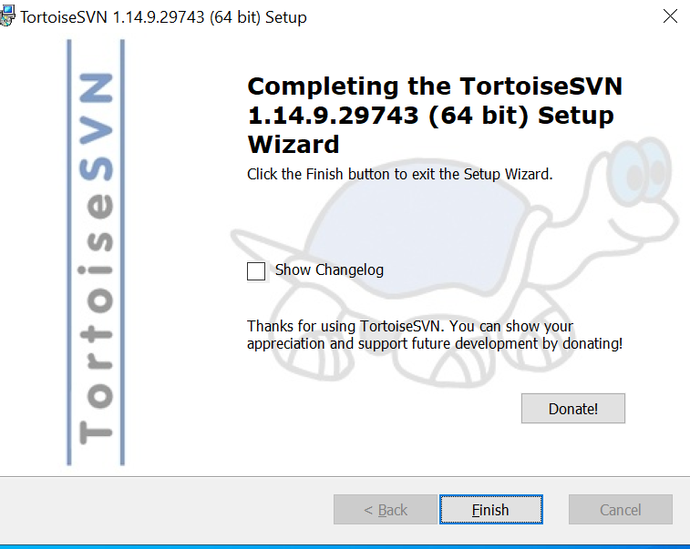

* + Click **Finish**
* **Please make sure the following directories are added to your system's Path environment variable:**
* C:\Program Files\PostgreSQL\16\bin
* C:\Program Files\TortoiseSVN\bin

3. **Run the PostgreSQL Setup Script:**

* Go to [**http://usalvwscebld1.infor.com/svn/sce/installer/branches/CSWMS_2025.07.NK.BDEV_MTSCE-1823/src/sce-db-installer/src/scripts/Postgres_Setup.zip** and download Postgres_Setup.zip](http://usalvwscebld1.infor.com/svn/sce/installer/branches/CSWMS_2025.07.NK.BDEV_MTSCE-1823/src/sce-db-installer/src/scripts/Postgres_Setup.zip%20and%20download%20Postgres_Setup.zip) and unzip the same.
* There you will find postgres_setup.bat and Readme.docx (for handy)
* Right-click postgres_setup.bat and select **"Run as administrator"**.
* When prompted:
  + Provide all inputs such as **installation directory, database name, number of warehouses, etc.**
  + **Do not leave any input blank.**

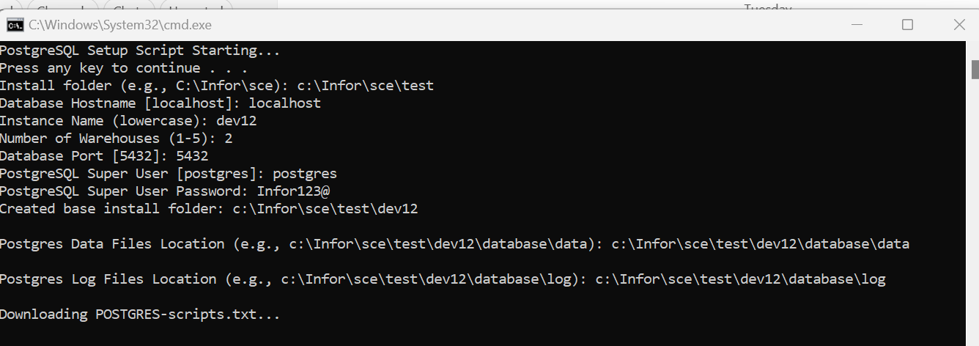

* The script will:
  + Download and execute PostgreSQL scripts from SVN.
  + Create schemas, tables, roles, and insert data.
  + Create a backup and clone (_mst) database.

4. **Checking Database of Postgres:**

* Open pgadmin tool and expand the Databases tab
* A screenshot of a computer

  AI-generated content may be incorrect.