Two-Phase Interleaved Coupled Inductor Buck Converter Module
Team MeGaNism
Team Members: Tanishq Shendokar, Deep Chitroda, Jayesh Jadhav, Imrose Shad
Date: May 4, 2026
Course: ECE 533 Power Electronics Packaging
Instructor: Dr. Douglas Hopkins

Table of Contents
Table of Contents 1
Introduction 3
Problem Statement 4
What Is Given 4
What Is To Be Found 4
What Is Assumed 5
Finalized product parameters 6
Material Characterizations 7
Final Multilayer Stack Definition 7
Copper Thickness Per Layer 8
Estimated Electrical Resistance of Conductive Layers 9
Interconnect Resistance Targets for Conduction Path Optimization (3% RDS(on) Limit) 10
Approximate Conductor Loss and Efficiency Impact 11
Thermal Resistance of the Final Stack 12
Interstitial Shield Capacitance Estimate 14
Material Characterization and Package Design 16
Updated Layer Stack Description 16
Top Copper Plane and Gate-Driver Placement 17
Interstitial Shield Layer 17
MOSFET-Side Copper Plane 18
Thermal Considerations 18
Mechanical Considerations 19
Physical Layout (SolidWorks) 20
Electrical 26
Part Selection 26
Supply Architecture and Isolation 28
Electrical Analysis (LT SPICE) 29
Electrical Schematic 33
Electrical BOM 35
Electrical Characterization 36
Power Loop Inductance 36
Gate Loop Inductance 36
Spice Model with Parasitic Inductances 37
Common Mode Current 43
Parasitic Capacitances 43
Circuit labeled with Parasitics 45
Reduced Order Model 46
Frequency Sweep 48
Thermal Analysis (ANSYS) 50
Simulation Setup 51
Thermal Simulation Results 53
Mechanical Analysis (ANSYS) 54
Simulation Setup 54
Mechanical simulation results 55
Use of AI 57
Conclusions 57
Further Improvements 58
References 58

Introduction
The design of high-density, high-efficiency DC‑DC converters increasingly depends on the tight integration of electrical, thermal, and mechanical considerations within the power module itself. This project focuses on the development of a 72 V to 24 V, 1.1 kW, two-phase interleaved coupled inductor buck converter operating at 200 kHz, following the architectural guidance of TI’s TIDA‑050089 reference design and the coupled inductor analysis presented by Jong Pil Lee et al. Unlike traditional PCB-based converters, this module adopts a vertically stacked structure incorporating an Alpha Novatech heatsink, a TDK coupled inductor, and a central switching layer populated with EPC eGaN FETs, low-profile decoupling capacitors, and high-current terminals. The goal is to explore how physical layout, material selection, and parasitic behavior fundamentally shape converter performance, particularly in fast-switching GaN systems where nanohenry-level inductances and picofarad-level capacitances directly influence voltage overshoot, switching losses, and EMI.
In this expanded phase of the project, the converter is further developed into a fully integrated power module by adding dedicated high-side and low-side gate driver circuits, gate-drive capacitors, interstitial shielding layers to reduce common-mode noise, and a complete mechanical housing. Although the assignment provides the option of a two-sided cooling architecture using dielectric fluid, this design intentionally retains the single-sided cooling approach, relying on the Alpha Novatech heatsink as the primary thermal extraction path. This choice preserves the original vertical stack topology, heatsink on one side, coupled inductor on the other, while avoiding the mechanical complexity of fluid channels and dual-sided sealing, allowing the design effort to focus on electrical performance, parasitic minimization, and EMI control. This works out in our favor because of the EPC QFN package we chose, which features an exposed top cooling thermal pad that dissipates most of the heat through the heat sink without heating the entire board.
To meet the objectives of this project, the work integrates thermomechanical modeling, electrical loss analysis, 3D module layout, and ANSYS Q3D parasitic extraction into a cohesive design workflow. The first stage focuses on material behavior within the Cu/ARC stack, establishing feasible conductor thicknesses, thermal limits, and mechanical stress margins that guide the physical construction of the module under single-sided heatsink cooling. The subsequent stage develops the electrical and physical design of the two-phase interleaved converter, ensuring that current paths, decoupling strategies, gate driver placement, shielding layer routing, and copper geometries satisfy both electrical performance targets and thermal constraints. Finally, parasitic inductances and capacitances extracted from the 3D layout are incorporated into the SPICE simulations to evaluate their influence on switching-node behavior, gate-drive operation, and device stress. Collectively, these analyses provide a unified understanding of how packaging, materials, gate drive architecture, and layout decisions shape the real-world performance of a high-power GaN-based converter module.

Problem Statement

What Is Given
The converter to be designed is a 72 V to 24 V, 1.1 kW, two‑phase interleaved, coupled‑inductor buck converter based on the architectural principles outlined in TI’s TIDA‑050089 reference design. The system employs a coupled inductor to reduce ripple current, improve transient performance, and enable current sharing between phases. Each phase uses EPC eGaN FETs, selected for their low switching loss and high‑frequency capability, enabling efficient operation at the chosen 200 kHz switching frequency.
The power module is constructed on an ARC (Alumina Ribbon Ceramic) substrate, which serves as the primary structural and electrical interconnect platform. Copper layers form the metallization stack, providing low‑resistance current paths and acting as thermal conduits to the external heatsink. The physical layout follows a vertically stacked structure with the Alpha Novatech heatsink on one side, the TDK coupled inductor on the other, and the switching devices and low‑profile decoupling capacitors embedded in the central layer. This project retains the single‑sided heatsink cooling approach, rather than the optional two‑sided dielectric‑fluid configuration.
In addition to the switching stage, the expanded assignment requires the integration of dedicated high‑side and low‑side gate‑driver circuits, gate‑drive capacitors, and voltage‑supply terminals for the gate‑drive network. The ARC substrate stack must also incorporate interstitial shielding layers to route high‑frequency displacement currents back into the center‑tapped decoupling capacitors, reducing common‑mode noise generated by the high‑dv/dt switching node. Finally, the module must be completed with mechanical housing, adhesive sealing, and external high‑current terminals, forming a compact, manufacturable power module architecture consistent with the requirements of the expanded design task.

What Is To Be Found
This project requires determining the key electrical, thermal, and mechanical parameters necessary to design a high-density two-phase interleaved coupled inductor buck converter. First, the material properties of the Cu/nano‑Cu/ARC stack must be evaluated, including equivalent electrical resistivity, thermal conductivity, modulus, CTE, and the resulting stress behavior under operating temperature gradients. These properties are used to determine allowable conductor thicknesses, nano‑copper characteristics, dielectric spacing, and the overall feasibility of the multilayer metallization stack.
Next, the electrical performance of the 72 V to 24 V, 1.1 kW converter must be established through SPICE or PLECS simulation at both light load and full load conditions. This includes switching‑node waveforms, inductor currents, output voltage behavior, and detailed loss breakdowns for the EPC eGaN FETs. From these results, the required layout and interconnect sizing must be determined, specifically ensuring that the freewheeling current path resistance remains within 3% of the FETs’ RDS(on) and that decoupling capacitors, gate drive capacitors, and high‑current terminals are placed to minimize loop inductance and conduction loss.
In the expanded phase of the assignment, the project must also determine the requirements for dedicated high-side and low-side gate driver circuits, including the sizing and placement of gate drive capacitors, bootstrap components, and isolated supply terminals. The design must evaluate how gate driver placement, routing, and parasitic coupling influence switching behavior, turn-on/turn-off dynamics, and overall converter stability.
A second major objective is to incorporate interstitial shielding layers into the ARC substrate stack. These conductive layers must be designed to route high-frequency displacement currents back into the center-tapped decoupling network, thereby reducing common-mode noise generated by the high dv/dt switching node. Determining the optimal dielectric thicknesses, shield layer geometry, and return current paths is essential to achieving effective EMI suppression
The project must also determine the thermal resistance from junction to ambient using ANSYS, including the effect of the selected single‑sided Alpha Novatech heatsink, airflow, and device placement. This analysis yields the expected junction temperature at a 70 °C ambient and provides a 2D or 3D thermal profile of the module. Finally, the parasitic inductances and capacitances of critical switching paths must be extracted using ANSYS Q3D. These parasitics are then re‑inserted into the electrical simulations to quantify their impact on switching‑node overshoot, gate‑driver performance, device stress, and overall converter behavior.
Collectively, these tasks define the electrical, thermal, mechanical, and EMI‑related parameters required to realize a manufacturable, high‑power GaN‑based converter module that integrates switching devices, gate drivers, shielding layers, housing, and terminals into a cohesive vertical‑stack architecture.

What Is Assumed
The design and analysis of this converter rely on several electrical, thermal, and material assumptions necessary to bound the problem and ensure consistent comparison across simulations. The converter operates at a fixed switching frequency of 200 kHz. For thermal modeling, each EPC eGaN device is assumed to have a junction‑to‑case thermal resistance of Rth‑jc = 0.2 °C/W, with the case temperature fixed at 70 °C during full‑load operation. Airflow over the heatsink is assumed to be steady and uniform, with the velocity selected to meet the thermal‑resistance requirements of the chosen Alpha Novatech heatsink. All thermal simulations assume ideal thermal contact between layers except where explicitly modeled.
Material‑level assumptions are also required for the Cu/nano‑Cu/ARC stack. The nano‑copper bonding layer is treated as a porous copper medium, with its electrical, thermal, and mechanical properties scaled linearly with 30% porosity, as specified in the assignment. The ARC substrate is assumed to behave as a homogeneous ceramic with the provided mechanical and thermal properties, and all failures are assumed to occur within bulk materials rather than at interfaces. Electrically, the GaN FETs are assumed to conduct in reverse when gated on, providing synchronous‑rectification behavior with no discrete diode drop. Parasitic elements not explicitly extracted in ANSYS Q3D are assumed to be negligible. These assumptions collectively define the operating environment, material behavior, and boundary conditions used throughout the electrical, thermal, and mechanical analyses.
In the expanded portion of the assignment, additional assumptions are required to support the integration of gate driver circuitry, shielding layers, and mechanical packaging. Each GaN device is assumed to use separate high‑side and low‑side gate‑driver chips, with idealized gate‑drive supply terminals providing stable bias voltages to the gate‑drive capacitors. Bootstrap components and gate‑drive capacitors are assumed to behave ideally unless explicitly modeled, with negligible ESR/ESL except where included in parasitic extraction.
For the EMI‑reduction requirements, the interstitial shielding layer(s) embedded within the ARC substrate are assumed to be perfectly conductive, with uniform thickness and continuous coverage except for intentional routing gaps. The dielectric layers separating the shields from the switching planes are assumed to maintain uniform thickness and permittivity, enabling predictable capacitive coupling paths for common‑mode current return.
Mechanical assumptions are also introduced for the expanded module structure. The design assumes a single‑sided cooling configuration, with the Alpha Novatech heatsink serving as the sole thermal extraction path; no dielectric‑fluid cooling or dual‑sided thermal interfaces are considered. The adhesive or sealing material used to bond the housings to the ARC substrate is assumed to provide perfect mechanical attachment and electrical isolation, with terminals passing through the sealant without introducing additional parasitic paths. The housing is assumed to be rigid, non‑conductive, and thermally insulating unless otherwise specified

Finalized product parameters

Voltage Input | 72 V
Voltage Output | 24 V
Current Output | 46 A
Current Per Phase | 23 A
Total System Power Output | 1.1 kW
Switching Frequency | 200 kHz
Current ripple | <40% peak-to-peak
Voltage ripple | <1% peak-to-peak
Targeted System Efficiency | 95%
Maximum Operating temperature | 150° C
Maximum Package Dimensions | 2.5 x 1.5 x 1.3 in

Material Characterizations

Final Multilayer Stack Definition
Layer Order | Layer | Thickness | Function
1 | 1st Cu plane | 2 oz ≈ 70 µm | Top-side routing for inductor, gate drivers, isolators, and auxiliary components
2 | Alumina dielectric | 70 µm | Electrical isolation between the top copper plane and the shield
3 | Interstitial Cu shield | 70 µm | Common-mode current control and electric-field shielding
4 | Alumina dielectric | 70 µm | Electrical isolation between the shield and the lower copper plane
5 | 2nd Cu plane | 2 oz ≈ 70 µm | MOSFET-side power routing and switching-node current paths
6 | GaN FETs in embedded Alumina | ≈ 700 µm | Mechanical Support and insulation around embedded GaN FETs
7 | TIM / Al-6063 interface | 70 µm | Thermal interface between MOSFET-side copper and heatsink
8 | Heatsink | — | Primary heat extraction path
The first copper plane supports the inductor, gate drivers, isolators, and other low-profile auxiliary components. The interstitial shield is inserted between the two alumina layers to control common-mode noise. The second copper plane is patterned and supports power routing on the MOSFET side. The GaN FETs are embedded in the lower alumina layer, forming a mechanical layer with the FET region and the embedded ceramic region before the TIM and heatsink.
The final design uses the same material characterization philosophy as the midterm problem, but the stack is now expanded to include gate-drive integration and a shield/interstitial layer as required by the final project.

Copper Thickness Per Layer
The two main copper planes use 2 oz of copper. A 2 oz copper layer has an approximate thickness of
tCu = 70 µm
The interstitial shield is also selected as a 70 µm copper layer. This gives the shield the same material-level sheet resistance as the main copper planes, while still allowing it to be treated as a separate electrical node for common-mode current control

Conductive Layer | Material | Thickness | Main Purpose
1st Cu plane | Copper | 70 µm | Top-side routing, gate-driver connections, inductor-side routing
Interstitial shield | Copper | 70 µm | Common-mode current return and electric-field shielding
2nd Cu plane | Copper | 70 µm | MOSFET-side power routing and switching current path

Estimated Electrical Resistance of Conductive Layers
Instead of calculating resistance from individual trace lengths and widths, the electrical resistance of the copper layers is characterized using the sheet resistance method. This method is appropriate for the current package-level design because the module uses broad copper planes rather than simple rectangular traces. The exact current-spreading path depends on final component placement, terminals, and local copper geometry, so the sheet resistance provides a material-level resistance estimate without requiring uncertain trace dimensions
The electrical characterization of the copper metallization layers is performed using the sheet-resistance method as follows:
R_{sq} = ρ_{Cu} / t_{Cu}
where the resistivity and layer thickness parameters are defined as:
ρ_{Cu} = 1.68 × 10⁻⁸ Ω·m, t_{Cu} = 70 × 10⁻⁶ m
Consequently, the resulting sheet resistance for a 2 oz copper layer is determined by:
R_{sq,Cu} = 1.68 × 10⁻⁸ / 70 × 10⁻⁶ = 2.4 × 10⁻⁴ Ω/□ = 0.24 mΩ/□
Based on this characterization, the first copper plane, interstitial shield, and second copper plane are each estimated to exhibit a uniform sheet resistance as follows:
R_{sq} = 0.24 mΩ/□
The alumina layers are dielectric and not part of the lateral electrical conduction path.

Layer | Thickness | Sheet Resistance | Electrical Function
1st Cu plane | 70 µm | 0.24 mΩ/sq | Top-side component and gate-driver routing
Interstitial shield | 70 µm | 0.24 mΩ/sq | Common-mode current return and shielding
2nd Cu plane | 70 µm | 0.24 mΩ/sq | MOSFET-side power plane
Alumina dielectric | 70 µm each/700 µm | Electrically Insulating | Isolation between conductive layers
TIM / Al-6063 layer | 70 µm | Not treated as a signal/power conductor | Thermal interface to heatsink
The resistance of the actual power-current path will be verified later through Q3D or layout-based extraction. In this material characterization section, sheet resistance is used to demonstrate that the selected copper thickness is reasonable for low-resistance plane-level conduction.

Interconnect Resistance Targets for Conduction Path Optimization (3% R_{DS(on)} Limit)
The EPC eGaN FET selected for this module is characterized by a target on‑state resistance specified as follows:
R_{DS(on)} = 5 mΩ
To ensure high efficiency and minimize conduction losses, the parasitic interconnect resistance within the high‑current switching paths must remain negligible relative to the device on‑resistance. The design objective is to limit the effective interconnect resistance to within 3% of R_{DS(on)}:
R_{interconnect,max} = 0.03 R_{DS(on)}
R_{interconnect, max} = 0.03 (5 mΩ)
R_{interconnect,max} = 0.15 mΩ
Consequently, the finalized design target for the effective high‑current MOSFET‑side interconnect resistance is established as:
R_{interconnect,max} = 0.15 mΩ
This parameter serves as the primary optimization target for the MOSFET‑side copper plane layout. As the module uses broad 2-oz copper planes rather than standard traces, the final interconnect resistance will be verified using ANSYS Q3D parasitic extraction to ensure the physical geometry meets the low‑resistance conduction requirements.

Approximate Conductor Loss and Efficiency Impact
The total conductor power dissipation resulting from the established interconnect resistance target is evaluated using the following relation:
P_{Cu} = I² R
Given a total converter output current of 46 A, the two-phase interleaved architecture results in an equivalent phase current determined by:
Iphase = 23 A
Applying the previously defined maximum interconnect resistance target:
R_{interconnect,max} = 0.15 mΩ
The resulting maximum conductor loss per individual phase is calculated as follows:
P_{Cu,phase} = 23²(0.15 × 10⁻³) = 0.079 W
Consequently, the total conductor loss for both phases is determined by:
P_{Cu,total} = 2(0.079) = 0.158 W
The corresponding impact on the overall converter efficiency resulting from this conductor loss is established as:
Δη = (P_{Cu,total} / P_{out}) × 100
Δη = (0.158 / 1100) × 100 = 0.014%
Therefore, if the patterned MOSFET-side copper plane is designed such that its effective resistance remains below the 0.15 mΩ target, the resulting conductor-loss penalty is negligible compared with the 1.1 kW converter output power.
Applying the established 3% R_{DS(on)} design criterion, the maximum permissible effective interconnect resistance for the MOSFET‑side conductive paths is determined to be 0.15 mΩ. Under a phase current of 23 A, the resulting conductor power dissipation is approximately 0.079 W per phase, yielding a total converter loss of 0.158 W. This magnitude corresponds to a negligible efficiency impact of only 0.014% relative to the 1.1 kW rated output power. Consequently, the utilization of 2 oz copper planes is established as a feasible architectural choice for minimizing conduction losses, provided that the finalized patterning of the second copper plane leverages broad current‑spreading geometries in proximity to the GaN FETs and decoupling network.

Thermal Resistance of the Final Stack
The equivalent one-dimensional vertical thermal resistance for the finalized multilayer stack is established using the following fundamental relation:
R_{th} = t / (k.A)
To ensure consistency with the material characterizations performed during the midterm project phase, the aggregate thermal resistance of the stack is evaluated across a standardized cross-sectional area defined as follows:
A = 1 mm × 1 mm = 1 × 10⁻⁶ m²
The assumed thermal conductivities are:
Material | Thermal Conductivity
Copper | 400 W/mK
Alumina | 36 W/mK
Al-6063 / aluminum-like TIM interface | 200 W/mK
The thermal resistance for a single 70 µm copper layer is evaluated as follows:
R_{th,Cu} = 70 × 10⁻⁶ / [400 (1 × 10⁻⁶)] = 0.175 K/W
The finalized stack incorporates three such conductive layers: the first copper plane, the interstitial shield, and the second copper plane.
R_{th,Cu,total} = 3(0.175) = 0.525 K/W
Similarly, the thermal resistance for a single 70 µm alumina dielectric layer is determined by:
R_{th,Alumina} = 70 × 10⁻⁶ / [36 (1 × 10⁻⁶)] = 1.94 K/W
Accounting for the two alumina layers within the stack, the total dielectric thermal resistance is established as:
R_{th,Alumina,total} = 2(1.94) = 3.88 K/W
Furthermore, the thermal resistance for the 700 µm embedded alumina dielectric region is determined as follows:
R_{th,Alumina,700} = 700 × 10⁻⁶ / [36 (1 × 10⁻⁶)] = 19.44 K/W
For the 70 µm Al-6063 / TIM interface layer, the thermal resistance is evaluated as follows:
R_{th,TIM} = 70 × 10⁻⁶ / [200 (1 × 10⁻⁶)] = 0.35 K/W
Consequently, the aggregate 1D vertical thermal resistance of the complete module stack is determined by the summation of the individual layer resistances:
R_{th,total} = 0.525 + 3.88 + 19.44 + 0.35
R_{th,total} = 24.20 K/W

Layer Group | Thermal Resistance Contribution
Three 70 µm Cu layers | 0.525 K/W
Two 70 µm alumina layers | 3.88 K/W
700 µm embedded alumina layer | 19.44 K/W
70 µm Al-6063 / TIM interface | 0.35 K/W
Total stack estimate | 24.20 K/W
The estimated 1D thermal resistance of the full stack over a 1 mm × 1 mm area is approximately 24.20 K/W. The 700 µm embedded alumina layer dominates this value because alumina has much lower thermal conductivity than copper and because the embedded ceramic layer is significantly thicker than the upper alumina dielectric layers. Therefore, for top-side components such as gate drivers, isolators, and auxiliary devices, heat flow through the full stack is relatively limited.
However, the GaN FETs are embedded within the 700 µm alumina layer and are positioned near the TIM and heatsink side. Therefore, the primary MOSFET thermal path is not assumed to pass through the entire 700 µm alumina thickness. Instead, the dominant MOSFET heat path is from the GaN FETs through the TIM / Al-6063 interface and into the heat sink. The embedded alumina mainly provides mechanical support and electrical isolation around the FETs, while the TIM and heatsink provide the main heat extraction path.

Interstitial Shield Capacitance Estimate
The interstitial shield forms a capacitor with both the first and second copper planes. This capacitance is important for common-mode behavior because the high-dv/dt switching node can inject current into the shield through the capacitance.

The parasitic capacitance established between a constituent copper plane and the interstitial shield is evaluated using the following fundamental relation:
C = (ε₀ ε_{r} A) / d
For the alumina dielectric material, the following parameters are assumed:
ε_{r} ≈ 10, d = 70 µm
The resulting capacitance per unit area for the dielectric interface is determined as follows:
C / A = [8.854 × 10⁻¹² (10)] / (70 × 10⁻⁶)
C / A = 1.265 × 10⁻⁶ F/m²
Expressing this value in pF/mm² yields:
C / A = 1.265 pF/mm²
Consequently, the equivalent capacitance for the plane‑to‑shield interface is established by:
C_{plane-shield} = 1.265 A_{overlap} pF
where A_{overlap} represents the standardized cross-sectional area expressed in mm².
Overlap Area | Estimated Capacitance
10 mm² | 12.7 pF
50 mm² | 63.3 pF
100 mm² | 126.5 pF
500 mm² | 632.5 pF
1000 mm² | 1.265 nF

The capacitance from the second copper plane to the heatsink is reduced by the 700 µm embedded alumina layer. If this path is approximated using the embedded alumina thickness:
The equivalent capacitance per unit area for the 700 µm embedded alumina dielectric region is determined using the following relation:
C / A = [8.854 × 10⁻¹² (10)] / (700 × 10⁻⁶)
C / A = 0.1265 pF/mm²
Thus, the direct capacitive coupling from the MOSFET-side copper plane to the heatsink through the embedded alumina is approximately ten times lower than the coupling across a 70 µm alumina layer.
The common‑mode displacement current generated by the high‑dv/dt switching node is estimated using the following fundamental relation:
i_{CM} = C (dv / dt)
This relationship shows that shield placement and dielectric thickness directly affect common-mode current routing.
The 70 µm alumina layers create approximately 1.265 pF/mm² capacitance between the copper planes and the interstitial shield. This capacitance is intentionally used to capture high-frequency displacement current from the switching region. In contrast, the 700 µm embedded alumina layer reduces the direct capacitance from the MOSFET-side copper plane to the heatsink to approximately 0.1265 pF/mm². This helps reduce direct common-mode current flow into the heatsink, while the interstitial shield provides a controlled return path back to the decoupling capacitor network.

Material Characterization and Package Design

Updated Layer Stack Description
The final package uses a multilayer alumina-based power substrate with two 2 oz copper planes, one embedded 70 µm interstitial shield layer, and a lower embedded alumina layer that supports the GaN FETs. The top side of the module contains the inductor, gate drivers, isolators, and other low-profile components. These components are mounted on or connected through the first copper plane.
Below the first copper plane, a 70 µm alumina layer provides electrical isolation from the interstitial shield. The interstitial shield is a continuous 70 µm copper layer used for common-mode noise management. A second 70 µm alumina layer separates the shield from the patterned second copper plane. The second copper plane forms the MOSFET-side power-routing layer and connects to the embedded GaN FETs.
The GaN FETs are embedded into a 700 µm alumina layer, which approximately matches the FET thickness. This embedded ceramic layer provides mechanical support and electrical insulation around the FETs. A continuous 70 µm TIM / Al-6063 layer is placed below the embedded alumina and FET region, followed by the Al-6063 heatsink.
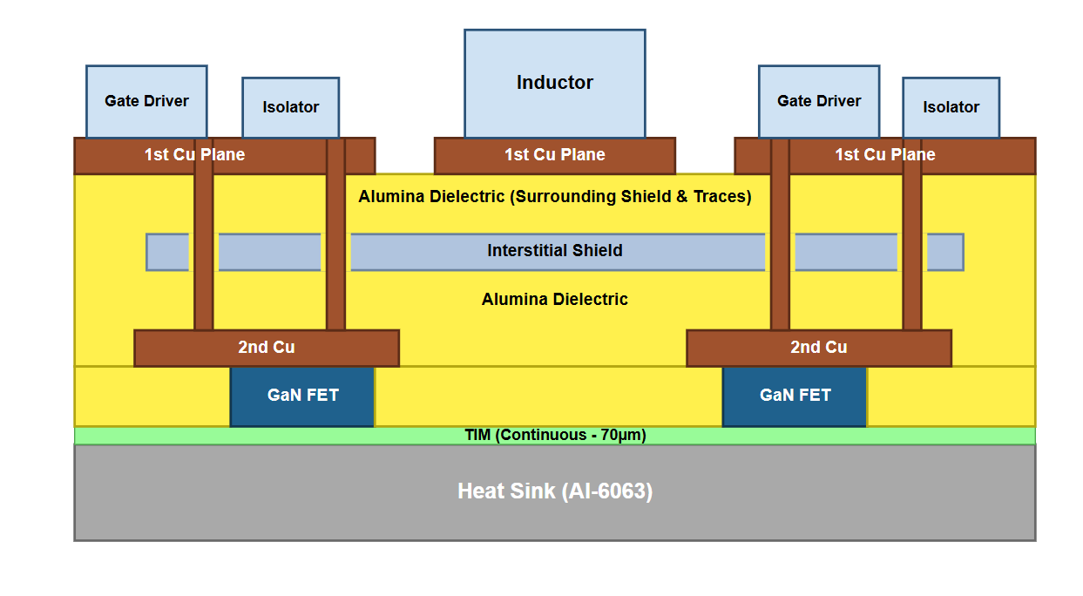
Figure: Cross-sectional layout of the packaging strategy used.
This arrangement separates the module into three functional regions: the top-side auxiliary and gate-drive region, the middle shielded dielectric region, and the lower MOSFET/heatsink thermal region.

Top Copper Plane and Gate-Driver Placement
The gate-driver and isolator circuits are placed on the first copper plane to keep the control-side components physically separated from the high-current MOSFET-side power plane. Vertical copper feedthroughs provide the required electrical connections between the top-side driver circuitry and the lower MOSFET-side copper plane. These feedthroughs must include clearance through the interstitial shield layer so that the shield does not short to gate-drive, power, or control connections.

Interstitial Shield Layer
The architectural integration of an interstitial shield consists of a continuous 70 µm copper layer embedded within a dual 70 µm alumina dielectric stack. The primary objective for the spatial positioning of this interstitial shield between the conductive copper planes is to facilitate the interception of high-frequency displacement currents in proximity to the high-dv/dt switching region, routing these currents back to the center-tapped decoupling capacitor network via a precisely controlled internal return path. This topological configuration is favored over a heatsink-adjacent placement, as the fundamental noise source is localized at the switching-node copper geometry rather than the thermal interface.
During high-speed GaN switching events, the MOSFET-side switching node generates rapid voltage transients, which induce electric-field coupling and common-mode displacement currents across local parasitic capacitances. In the absence of a shielding mechanism, these currents may propagate through the heatsink, mechanical housing, terminals, or external ground paths. By establishing the shield between the first and second patterned copper planes, the design effectively captures a substantial magnitude of these high-frequency currents prior to their propagation into the deeper structural layers of the power module.
The shield is strictly utilized for electromagnetic containment and is not intended to function as a load-current conductor. Consequently, it must maintain electrical isolation from the primary copper planes, vertical copper feedthroughs, gate-drive routing, and the heatsink, excluding the designated shield return terminal. While the shield is defined as a continuous plane, localized clearance apertures are incorporated to accommodate vertical interconnects, thereby precluding accidental electrical shorts between the shield and the power or gate-drive networks.
Furthermore, this shielding strategy avoids interference with the primary thermal extraction path from the embedded GaN FETs to the heatsink. Within the finalized stackup, the GaN devices are embedded in a 700 µm alumina layer, which is interfaced with the heatsink via a 70 µm TIM / Al-6063 layer. Given that the embedded alumina thickness significantly exceeds that of the upper dielectric layers, the direct capacitive coupling from the MOSFET-side copper to the heatsink is inherently attenuated. Thus, a heatsink-side shield placement would yield diminished EMI benefits while introducing unnecessary complexity within the critical thermal conduit.
The parasitic capacitance established between the copper planes and the shield is approximately 1.265 pF/mm² per 70 µm alumina layer. This characterized capacitance is leveraged to guide high-frequency currents into the shield, preventing stochastic coupling into the heatsink or ground. Consequently, while the interstitial shield does not achieve total elimination of common-mode current, it provides a deterministic internal return path that significantly mitigates direct coupling into the heatsink and the surrounding mechanical architecture.
Key Contributions: Prob-2A
A continuous 70 µm copper interstitial shield layer is embedded between two 70 µm alumina dielectric layers within the ARC substrate stack. The shield intercepts high-frequency displacement currents generated by the high-dv/dt switching node before they reach the heatsink or housing. Clearance apertures in the shield accommodate vertical copper feedthroughs without shorting the power or gate-drive planes. The shield return path connects to the center tap of the decoupling capacitor network, providing a controlled common-mode current return consistent with the circuit topology on Lect-25 Slide 6.

MOSFET-Side Copper Plane
The second copper plane is patterned because it must define the MOSFET-side switching node and power-current paths. The GaN FETs are embedded in the 700 µm alumina layer below this plane, allowing the FET region to be mechanically integrated into the lower package structure. This approach supports a compact package while maintaining electrical isolation and providing a direct thermal path toward the TIM and heatsink.

Thermal Considerations
In the corrected final stack, the main MOSFET heat path is from the GaN device through the TIM and into the heatsink. Therefore, the MOSFET cooling path does not rely primarily on conduction through the full top-side ARC stack. This supports the decision to retain the single-sided heatsink design rather than adopting the optional two-sided dielectric-fluid cooling structure.
The top-side components, including the gate drivers, isolators, and gate-drive capacitors, dissipate much less power than the GaN FETs. Their heat spreads through the top copper plane and then through the ARC/shield/ARC stack. The interstitial shield may assist slightly with heat spreading because it is a copper layer, but its main purpose remains common-mode noise control rather than thermal management.
The total conduction losses for the switching devices are determined by the square of the RMS current and the device resistance as follows:
P_{FETs,total} = I² R
Furthermore, the total gate-drive power consumption for the four FETs is calculated using the total gate charge, drive voltage, and switching frequency:
P_{gate,total} = 4Q_{G} V_{drive} f_{s}
The total power dissipation within the converter module is determined by the summation of the conduction losses and the gate‑drive network losses as follows:
P_{total} = P_{FETs,total} + P_{gate,total}
Furthermore, the steady‑state temperature rise resulting from these losses is evaluated using the effective thermal resistance of the module stack:
T = T_{amb} + P_{total} * R_{th}
The 700 µm embedded alumina layer significantly increases the full-stack vertical thermal resistance for heat generated by top-side auxiliary components. However, the GaN FETs are embedded within this alumina layer and are positioned near the TIM/heatsink side. Therefore, the main FET heat path is FET → TIM / Al-6063 → heatsink, while the embedded alumina primarily provides mechanical support and electrical isolation around the FET. This supports the continued use of single-sided heatsink cooling for the power devices.

Mechanical Considerations
The finalized module architecture incorporates a complex series of copper, alumina, shielding, and thermal interface layers. Due to the inherent mismatch in the coefficients of thermal expansion (CTE) among these constituent materials, the assembly is subject to significant mechanical stress during high-power operation and thermal cycling. Structural vulnerability is anticipated primarily at the junctions between the copper metallization and ceramic layers, particularly within the patterned second copper plane, embedded GaN FET regions, and vertical copper feedthroughs. To mitigate the risk of material failure or trace delamination, the layout must prioritize the elimination of sharp copper geometries and ensure sufficient clearance around shield-layer apertures and vertical interconnects.
The 700 µm embedded alumina dielectric region serves as the primary mechanical support and electrical insulation framework for the GaN FETs, establishing a planar interface for the subsequent TIM and heatsink attachment. Protection for the top-side auxiliary components—including the coupled inductor, gate drivers, and decoupling network—is provided by a dedicated module housing. This enclosure must maintain high dielectric strength to prevent unintended electrical coupling between the conductive copper planes, the interstitial common-mode shield, and the external heatsink.
Environmental containment and structural integrity are achieved through adhesive sealing, which bonds the housing to the ARC substrate. The sealant material is required to provide simultaneous mechanical attachment and robust electrical isolation, especially where high-current and control terminals penetrate the enclosure. Careful spatial management is essential to ensure adequate isolation between the DC power rails, isolated gate-drive supplies, and the shield return path, while the interstitial layer must remain electrically decoupled from all vertical copper feedthroughs except at its designated termination point.
This design intentionally preserves the single-sided heatsink configuration, foregoing the added complexity of two-sided dielectric-fluid cooling. This architectural choice is justified by the proximity of the embedded GaN FETs to the lower thermal interface, enabling efficient heat extraction through the continuous 70 µm TIM / Al-6063 layer. Consequently, the dominant MOSFET thermal path is established as follows:
GaN FET → TIM / Al-6063 → Al-6063 heatsink
By leveraging this direct cooling trajectory for the primary heat-generating devices, the module achieves a compact and mechanically reliable vertical-stack architecture without the necessity for fluid channels or pressurized sealing interfaces.

Physical Layout (SolidWorks)

According to all the electrical, thermal and mechanical considerations mentioned, the physical layout of the package is modelled. The layout of the package is designed in Solidworks containing all the copper trace connections, devices with the chosen materials.
The power mosfet connection traces are first defined. A trace of 2oz copper (70um) is used throughout. The mosfets are placed closer to have the trace lengths smaller. The coupled inductor is connected outside the mosfets with appropriate traces for it.
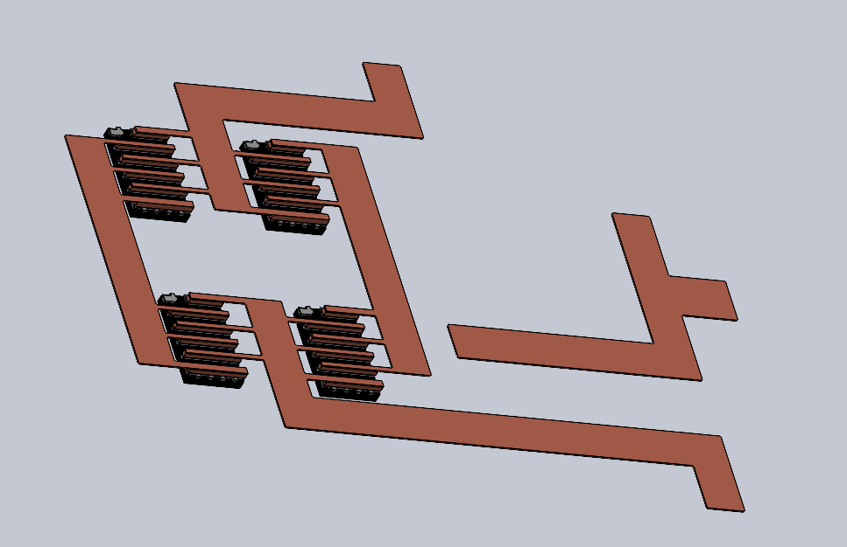
Figure: Copper traces for the high power path
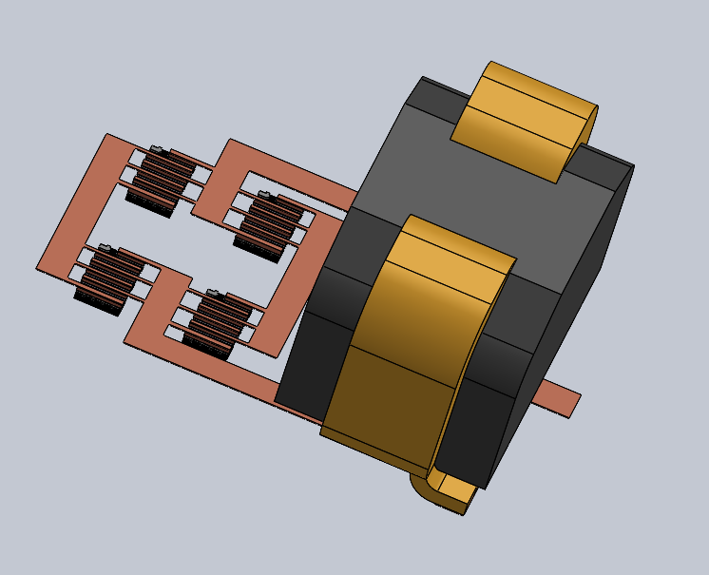
Figure: Connections with the coupled inductor.
Then the gate driver circuit is introduced with the MOSFET’s gate driver terminal connected to the 4 gate driver modules. The traces are modelled in two planes (210um apart) as explained in the cross-section previously.
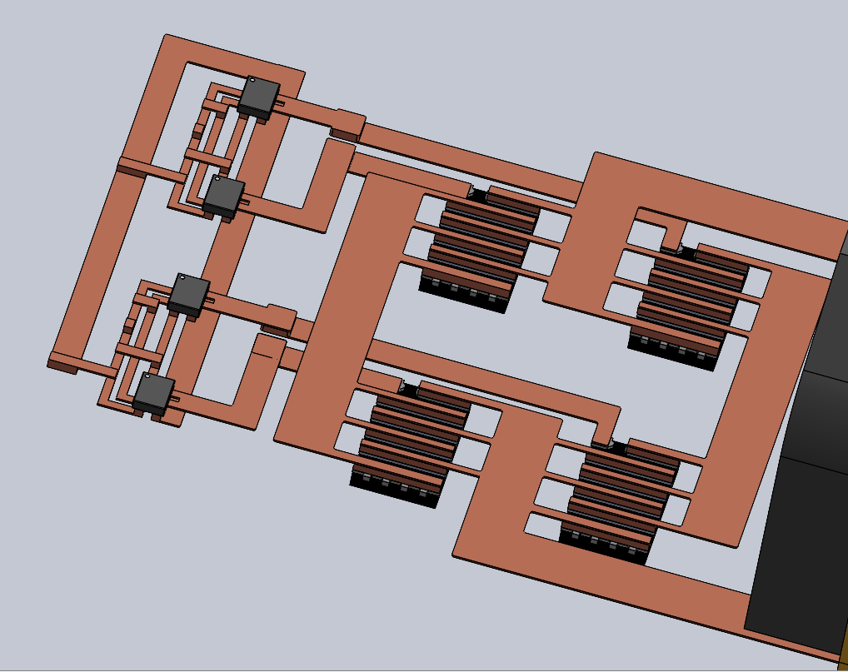
Figure: Traces added for the gate driver using the bottom plane for overlapping geometries.
Then the gate driver isolator and the and the terminal traces are modelled to connect to the gate drivers. Appropriate copper vias are used for connections as required.
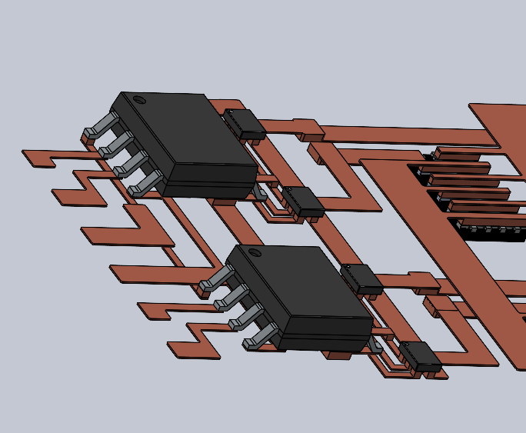
Figure: Gate Isolator and gate terminal connections.
These are assembled in alumina as the filler material and the copper interstitial layer is added. As the GaNs are top-cooled, their topside is kept exposed while they are embedded inside the filler. The interstitial layer is modelled to be 70um thick with gaps for the copper via going from the top plane copper trace to the bottom plane copper trace. The interstitial layer is also equidistant from both the traces at a distance of 70um from both sides.
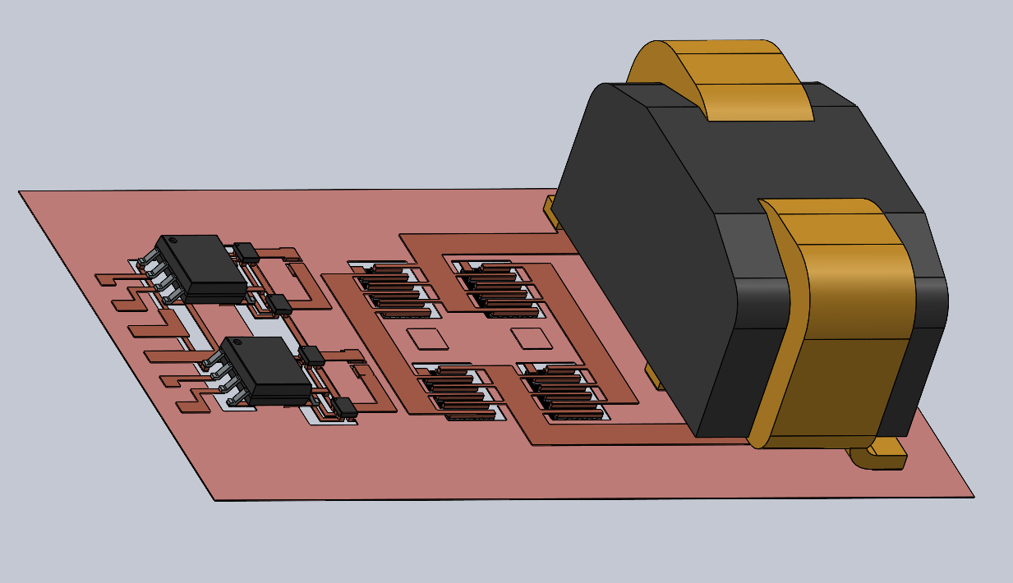
Figure: Interstitial copper layer added in between the top and the bottom copper traces.
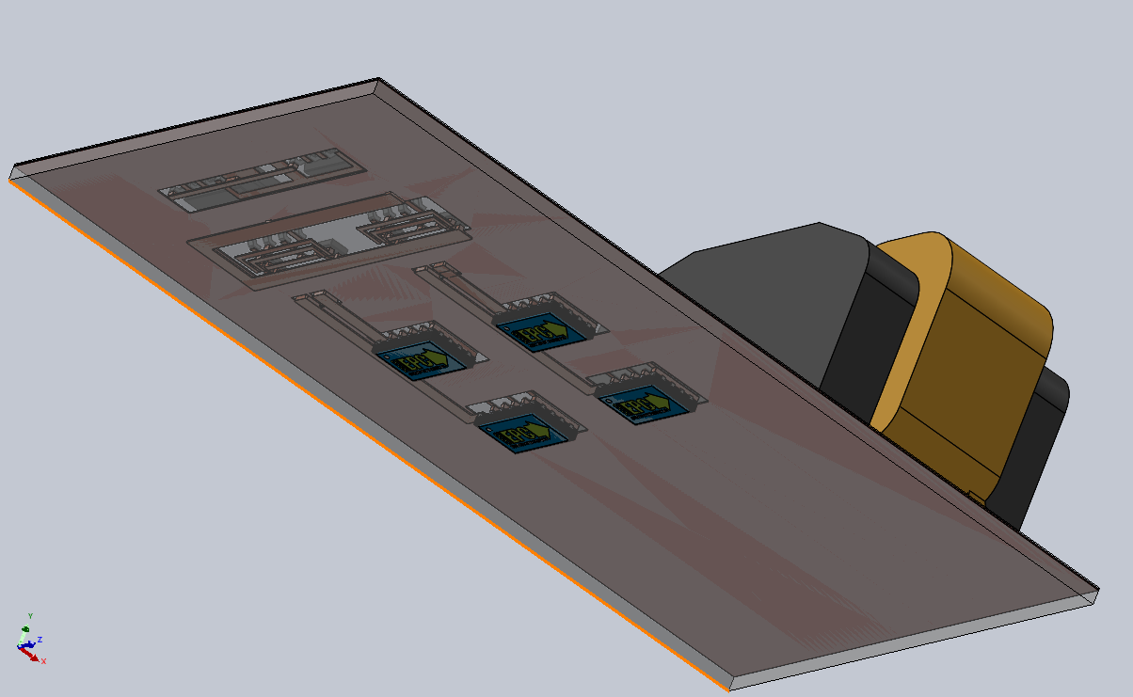
Figure: Alumina filler added to embed the GaN chips inside it with the bottom side surface exposed for cooling.
The TIM is then added on the underside of the package to be in contact with the exposed bottom side surface of the GaNs. Then the heat sink is attached to the TIM surface.
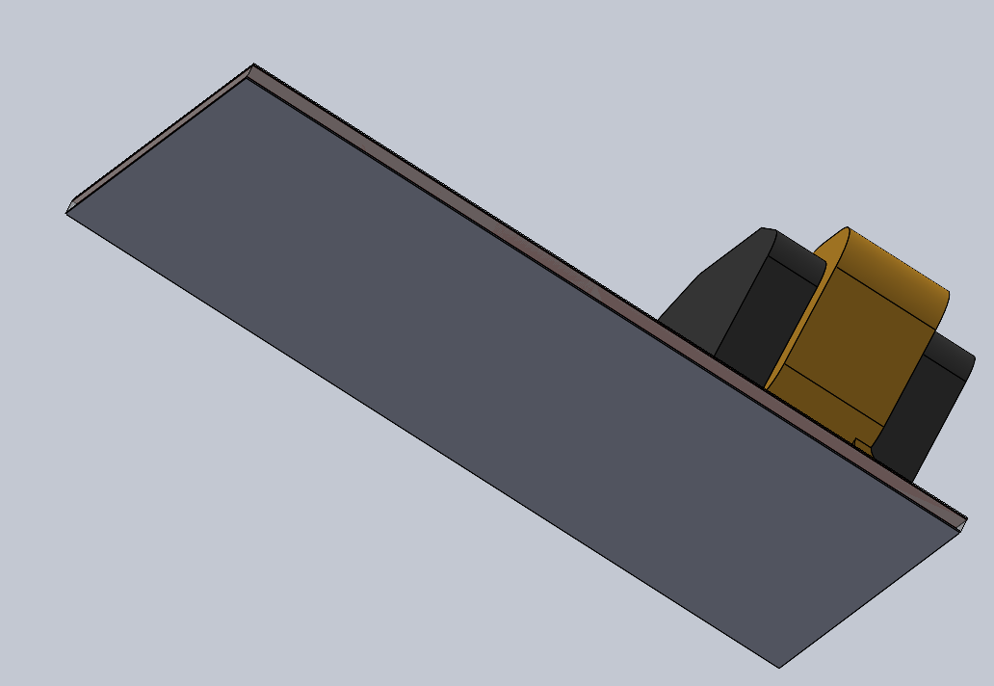
Figure: TIM layer added on the bottom side of the GaN chips.
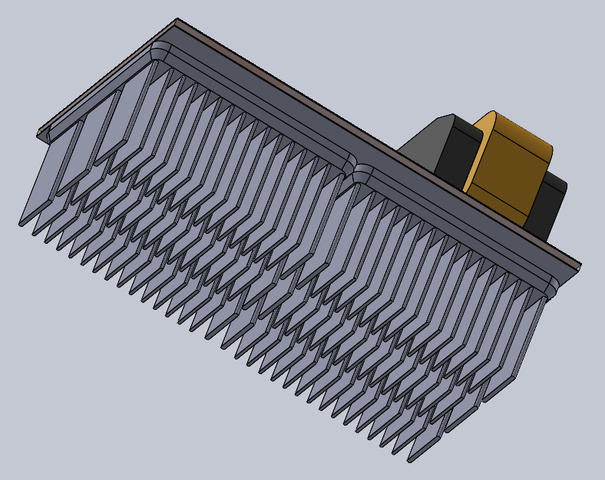
Figure: Heatsink attached to the bottom surface of the TIM.
The terminals for the gatedriver circuit and the converter are added. The terminal for the gate driver is chosen such that the wires can be connected to the package form the side. For the GaN side terminals, vertical terminals are added with wires coming out from the top side of the package.
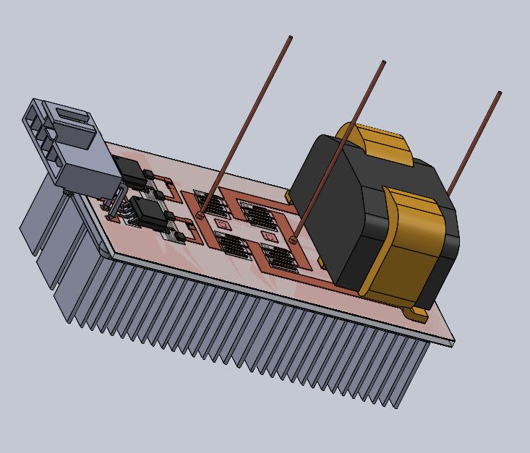
Figure: Gate and power terminals added.
The whole package is then enclosed in a housing for protection from the environment. The heatsink is kept exposed for cooling purposes.
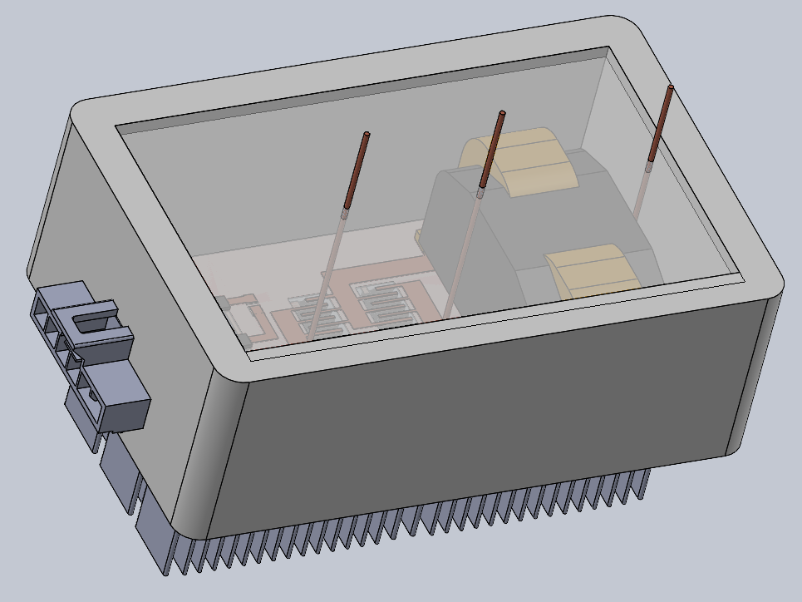
Figure: Full package with an enclosure.

Electrical
Key Contributions: Prob-1A
The gate driver design integrates four individual 1EDN7550 chips (one per EPC2304 GaN FET), selected over the FAN-3122 and LM5114 for its +6 V output swing, 4 A/8 A asymmetric drive capability, and integrated bootstrap architecture. Each driver is placed on the top copper plane of the ARC stack with dedicated gate resistors (2 Ω HS, 6 Ω LS), a 100 nF bootstrap capacitor, and a SS110HL Schottky diode per phase. The module is completed with a full housing, adhesive sealing, and DC power, gate-drive supply, and signal terminals, forming a manufacturable power module consistent with a DigiKey-purchasable integrated design.

Part Selection

EPC GaN MOSFET
Chosen: EPC2304
Target Resistance: <= 5 mOhm
Required Current Rating: >50A
Required Current Pulse rating: >200A

Coupled Inductor
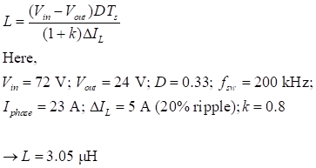

Chosen Inductor: ERUC-3R2K
The chosen inductor value is slightly larger than the calculated value due to the required Current rating and options available from TDK.

Input Capacitor
Ceramic caps: Roughly 40uF target. To reduce the ESR effect, we will use 5x10uF rated at about 150V, accounting for 20% losses.
Model: GRM32EC72A106KE05L x5

Electrolytic caps: Roughly 0.4 mF. Will consider using 4x110 uF electrolytic caps, rated about 150 V, accounting for 50% oversizing
Model: EEU-EE2C101 x4
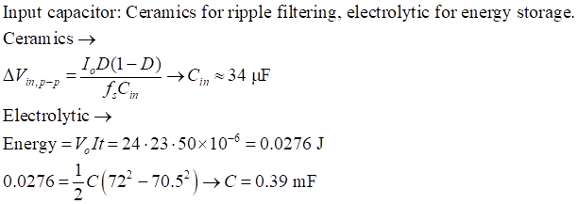

Gate Driver
Each of the four EPC2304 GaN FETs requires a dedicated individual gate driver. Three candidates were evaluated against the selected Infineon 1EDN7550 (TSNP-6): the FAN-3122 bare die provided in the assignment appendix, and the Texas Instruments LM5114. The 1EDN7550UXTSA1 was selected for three decisive reasons. First, its output swings from 0 V to VDD = +6 V, delivering VGS(on) = +6 V to the EPC2304 — 1 V higher than a 5 V rail driver and within the EPC2304 absolute maximum of +7 V — ensuring full channel enhancement and minimum RDS(on) = 3.2 mΩ. Second, its asymmetric 4 A source / 8 A sink output enables faster turn-off than the FAN-3122’s symmetric 3 A rating, which is critical for GaN devices where slow turn-off causes cross-conduction. Third, the TSNP-6 footprint (1.0 × 1.5 mm) is the smallest available package and requires only standard SMT reflow on the ARC copper metallization, whereas the FAN-3122 bare die demands flip-chip bonding or wire-bond infrastructure not useful in this build.
The LM5114 was eliminated because it lacks a bootstrap architecture: floating the high-side gate at VIN = 72 V would require a fully isolated DC-DC supply per phase, conflicting with the assignment’s requirement to omit DC-DC converters. The 1EDN7550’s integrated bootstrap path, charged through an external SS11D Schottky and 4.7 Ω resistor from the +5 Viso rail, eliminates this requirement. One driver is assigned per FET (U1–U4); each uses its HO pin to drive the respective FET gate while the LO pin is left unconnected, satisfying the assignment mandate for individual high-side and low-side chips. The gate resistors are intentionally asymmetric: Rg = 2 Ω on the HS FET for fast switching and Rg = 6 Ω on the LS FET to limit switching-node overshoot driven by commutation loop inductance.

Parameter | 1EDN7550 | FAN-3122 (bare die) | LM5114
Package | TSNP-6 (1.0×1.5 mm) SMT | Bare die (1.72×1.31 mm) flip-chip / wire-bond | SOT-23-5 (1.6×2.9 mm) SMT
VDD supply | 3–18 V (5 V used) | 4.5–18 V | 3–18 V
Output swing | 0 to +6 V (VGS = +6 V, within EPC2304 +7 V abs max) | 0 to +5 V | 0 to +5 V
Peak source / sink | 4 A / 8 A | 3 A / 3 A | 7 A / 7 A
Propagation delay (typ.) | 10 ns | 17 ns | 12 ns
Bootstrap / HS float architecture | Yes — HO pin used for HS gate; LO unused | No — single output only | No — isolated supply required for HS
Individual HS & LS chips (req'd) | Yes — one per FET (×4 total) | Yes — one per FET (×4 total) | Yes — one per FET (×4 total)
Assembly on ARC substrate | Direct SMT reflow on Cu land | Requires flip-chip or wire-bond process | SMT reflow

Bootstrap Capacitor
The bootstrap capacitor must supply sufficient charge to the high-side gate driver during each switching cycle without allowing the bootstrap rail voltage (V_BS) to droop beyond an acceptable threshold. The charge drawn per cycle is dominated by the gate charge required to fully enhance the high-side EPC2304:

Q_{gate} = Q_{G} = 6.84 nC (evaluated from the EPC2304 datasheet at V_{GS} = 5 V)

Allowing a maximum bootstrap voltage drop of ΔV = 0.2 V ensures the gate drive voltage remains well above the EPC2304's minimum enhancement threshold throughout the on-time, preventing incomplete turn-on and the associated conduction loss increase. The minimum required capacitance is:

C_{boot,min} = ΔQ / ΔV = 6.84 nC / 0.2 V = 34.2 nF

In practice, bootstrap capacitors are subject to DC bias derating (ceramic capacitors lose significant capacitance under applied DC voltage), temperature variation, manufacturing tolerance, and the additional charge drawn by the gate driver's internal bias circuitry and leakage. A 2.9× margin above the minimum calculated value is applied, selecting:
C_{boot} = 100 nF
LT Spice Simulation Verification for C_boot functioning.
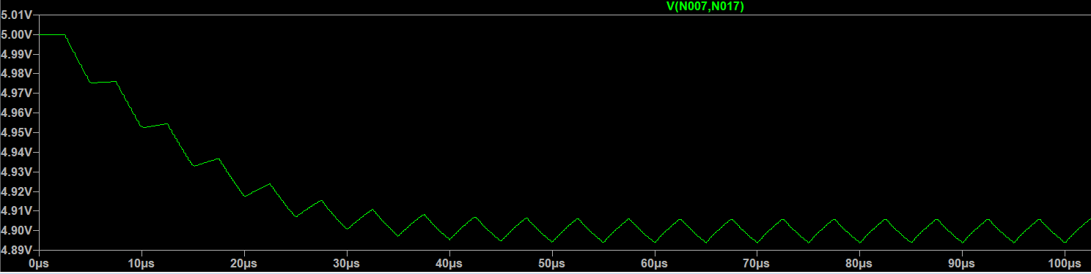
Fig. Voltage across C_boot
The bootstrap capacitor voltage V(VBOOT1, SW1) settles to a steady-state value of approximately 4.90 V after an initial transient of approximately 80 µs. The per-cycle voltage droop is approximately 10 mV, well within the 200 mV design budget established during capacitor sizing and consistent with the modeled gate-charge draw. The bootstrap rail remains well above the 1EDN7550's minimum VBS operating threshold throughout all switching cycles, confirming that C_boot = 100 nF is correctly sized for continuous operation at 200 kHz.

Supply Architecture and Isolation
The gate-drive power supply uses a single NME1S0505SC isolated DC-DC converter (PS1) to generate a +5V_iso rail referenced to power ground on the isolated side of the barrier. This rail supplies the VDD pin of all four 1EDN7550 gate drivers (U1–U4) and the anode side of both SS110HL bootstrap diodes. PWM signals cross the isolation barrier through two SI86S620BC dual-channel digital isolators (AT1, AT2): AT1 carries PWM_HS1 and PWM_LS1 for phase 1, and AT2 carries PWM_HS2 and PWM_LS2 for phase 2. Each isolator output connects directly to the IN pin of the corresponding 1EDN7550. The low-side drivers (U2, U4) are powered directly from +5V_iso referenced to power ground. The high-side drivers (U1, U3) are powered from the bootstrap rail: the SS110HL Schottky charges the 100 nF bootstrap capacitor from +5V_iso during each low-side on-time, and the bootstrap capacitor then floats with the switching node (SW1, SW2) during the high-side on-time, supplying the driver from a voltage equal to +5V_iso above SW. This architecture achieves isolation between the MCU control ground and the power ground through the NME1S0505SC and the SI86S620BC, with no DC path between the two grounds. Gate resistors are intentionally asymmetric: 2 Ω on each high-side driver output for fast turn-on, and 6 Ω on each low-side driver output to limit switching-node overshoot driven by commutation loop inductance.
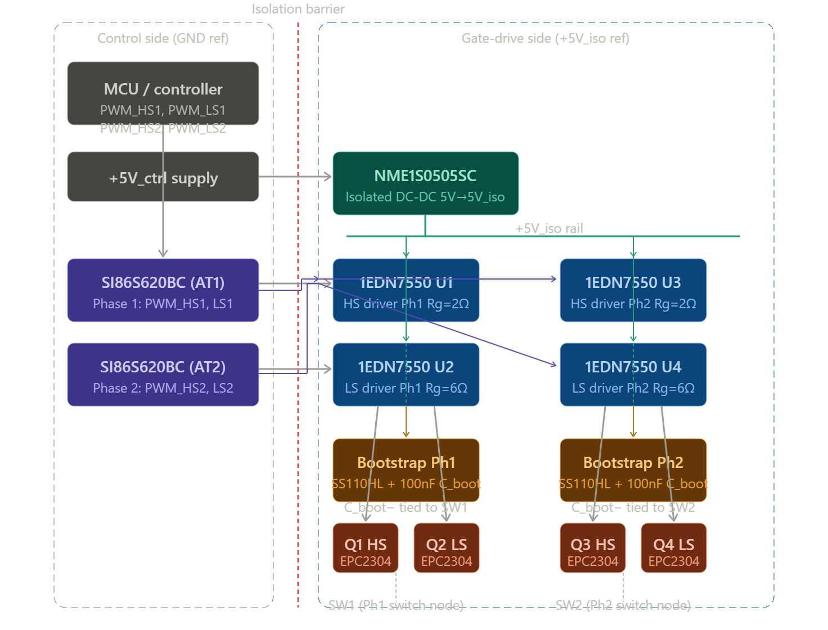

Electrical Analysis (LT SPICE)

Ideal Scenario Schematic (No parasitics)
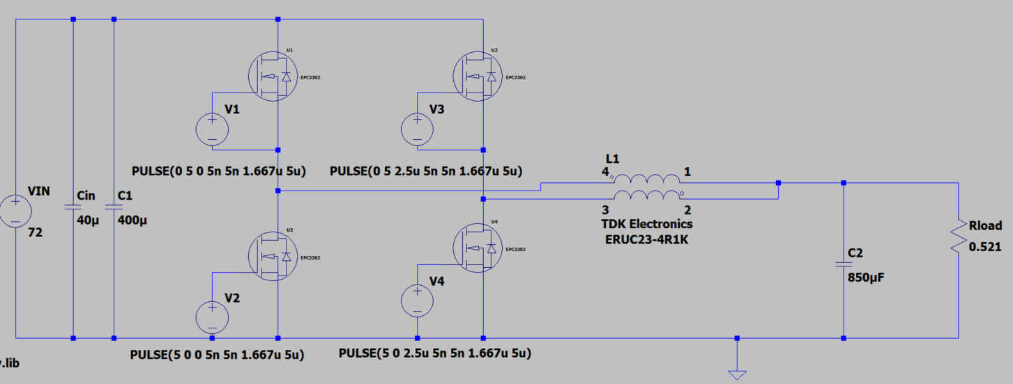
Figure: Ideal Circuit Schematic

Operating Waveforms
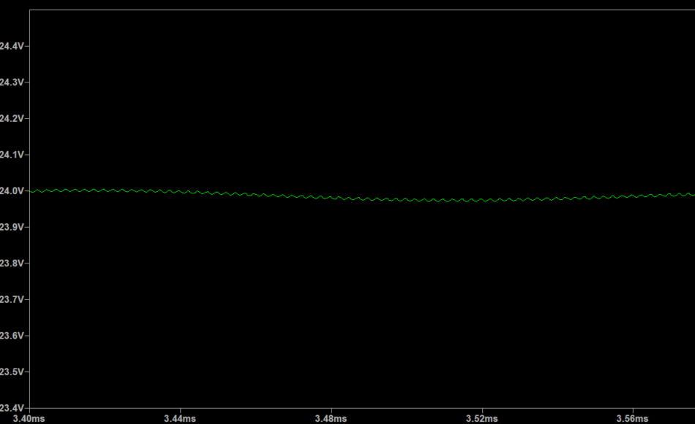
Figure: Output Voltage simulated ~24V
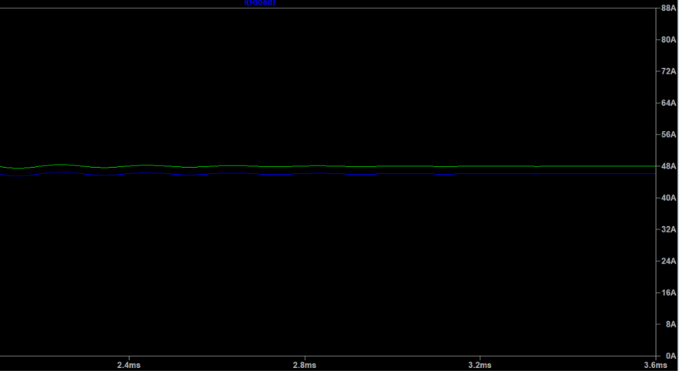
Figure: Output Current Simulated ~46A
MOSFET Switching (V_DS) waveform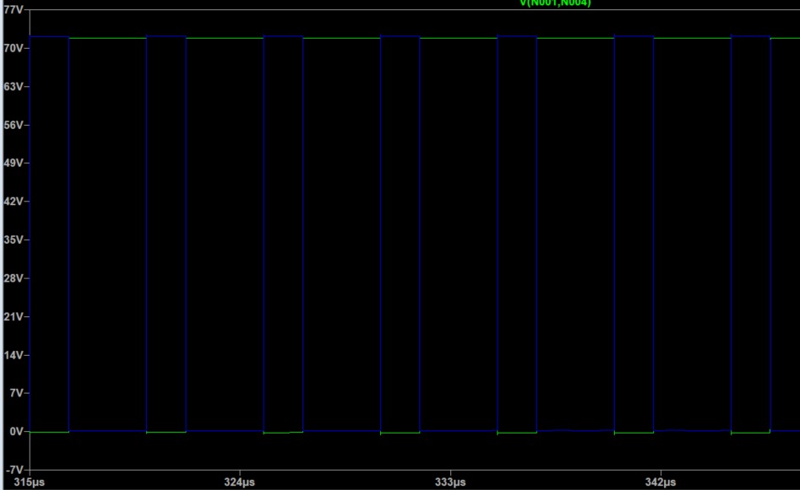
Figure: V_{DS} Switching across Half-bridge MOSFETS

Phase output waveform (Current and Voltage)
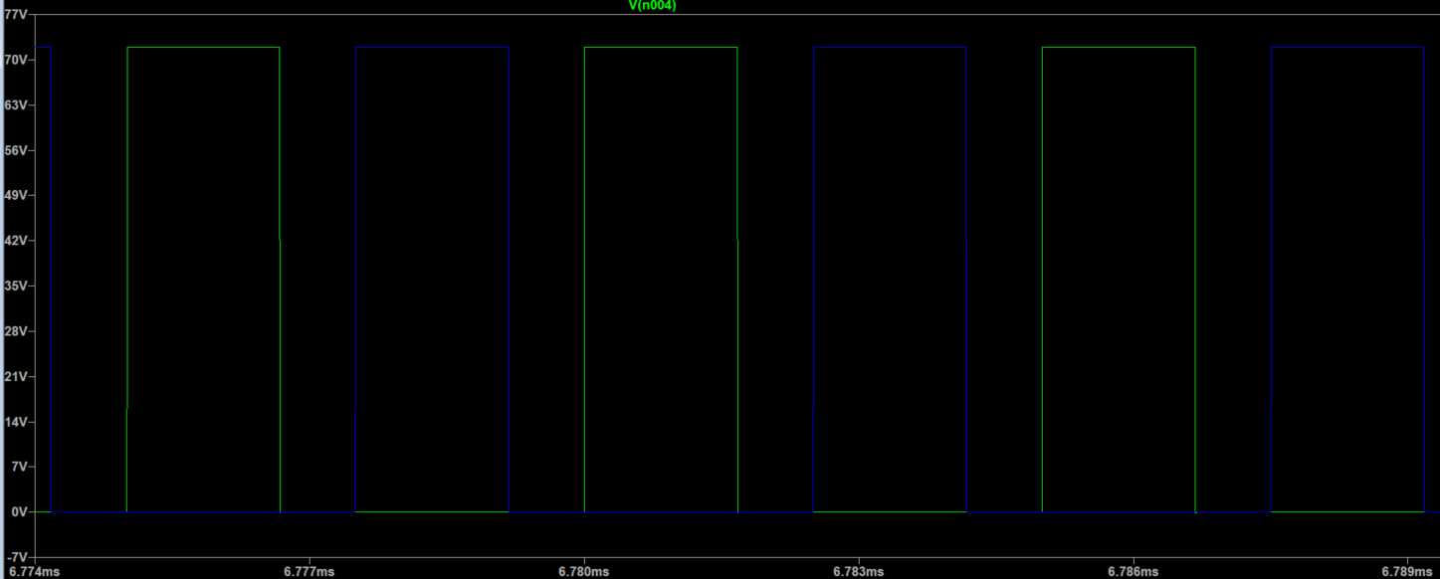
Figure: Voltage Waveform for Half-bridge Outputs
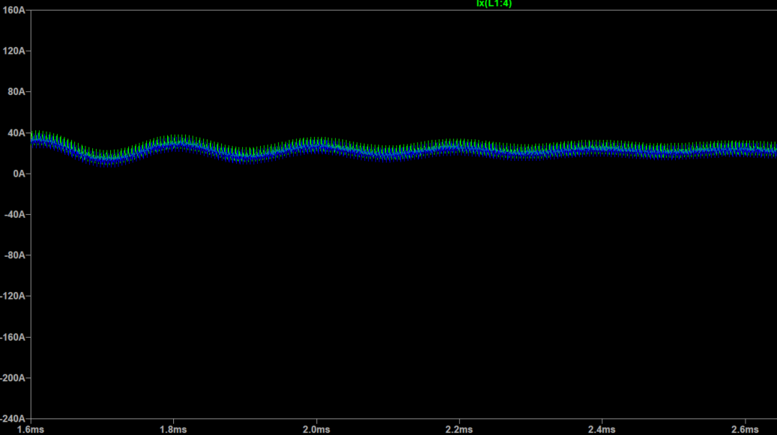
Figure: Current Output on phases ~23A

Electrical Schematic
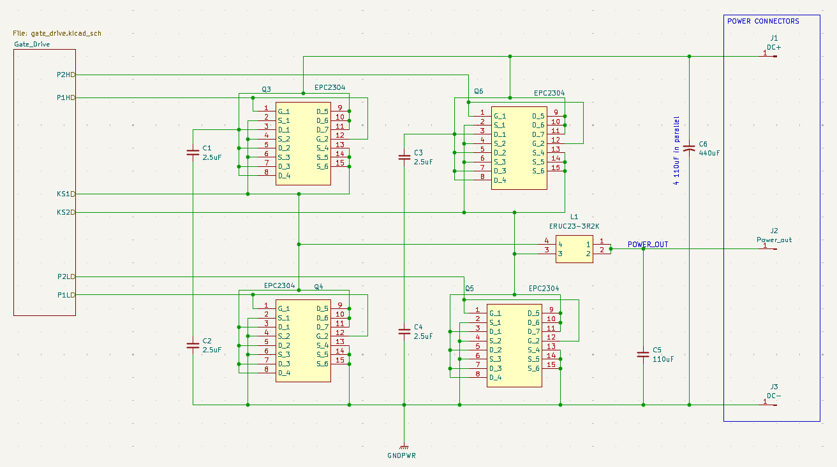
Fig: Power Schematic
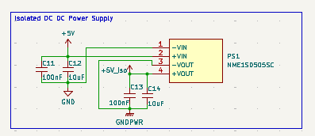
Fig: Isolated 5V DC DC Converter
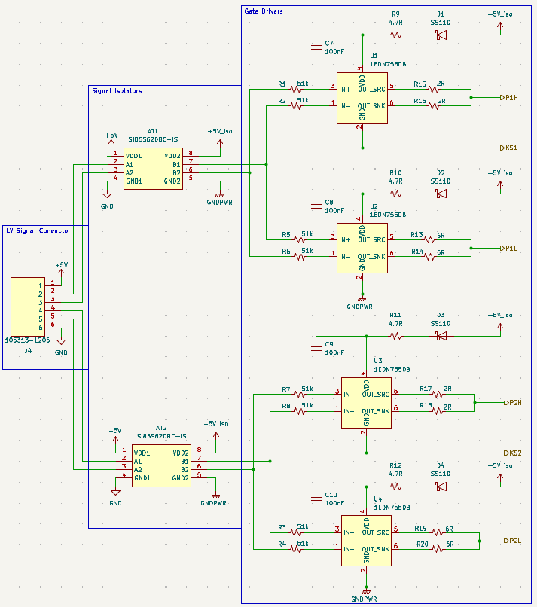
Fig: Gate Control Circuit Schematic

Electrical BOM
Index | MFG Part # | Manufacturer | Qty | Digi-Key # | Price | Designator
1 | SI86S620BC-IS | Skyworks Inc. | 2 | 863-SI86S620BC | 3.28 | AT1, AT2
2 | SS110HL-TP | MCC | 4 | 353-SS110HL-TP | 0.36 | D1-D4
3 | 1053131206 | Molex | 1 | WM14975-ND | 2.54 | J4
4 | ERUC23-3R2K | TDK | 1 | 495-ERUC23-3R2K | 8.96 | L1
5 | NME1S0505SC | Murata Power | 1 | 811-NME1S0505 | 1.86 | PS1
6 | EPC2304 | EPC | 4 | 917-EPC2304CT | 9.05 | Q3-Q6
7 | 1EDN7550UXTSA1 | Infineon | 4 | 448-1EDN7550 | 0.80 | U1-U4
8 | ERJ-2GEJ2R0X | Panasonic | 4 | P2.0JCT-ND | 0.10 | R15-R18
9 | ERJ-2GEJ5R6X | Panasonic | 4 | P5.6JCT-ND | 0.10 | R13, R14, R19, R20
10 | RC0402JR-074R7L | YAGEO | 4 | 311-4.7JRCT-ND | 0.10 | R9-R12
11 | ERA-2AEB513X | Panasonic | 8 | P51KDCCT-ND | 0.11 | R1-R8
12 | GRM21BD72A225K | Murata | 4 | 490-GRM21B | 0.44 | C1-C4
13 | GRM155R62A104K | Murata | 6 | 490-10458-1-ND | 0.10 | C7-C11, C13
14 | GRM155R61A106M | Murata | 2 | 490-GRM155R61 | 0.11 | C12, C14
15 | EGXF161ELL111M | Chemi-Con | 5 | 565-EGXF161 | 2.07 | C5, C6
Total Component Cost (USD) |  |  |  |  | 75.77

Electrical Characterization

Power Loop Inductance
Because of symmetry, it is sufficient to define two nets in the critical power loop as shown below. A 2 MHz solution frequency is used, which is ten times the switching frequency.

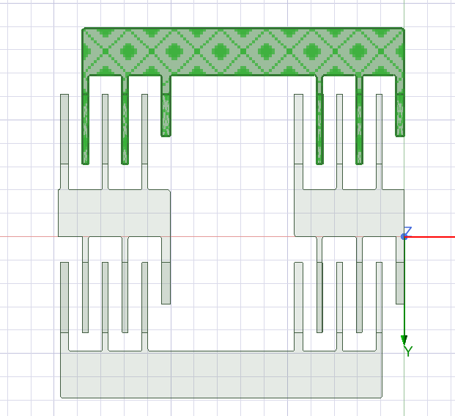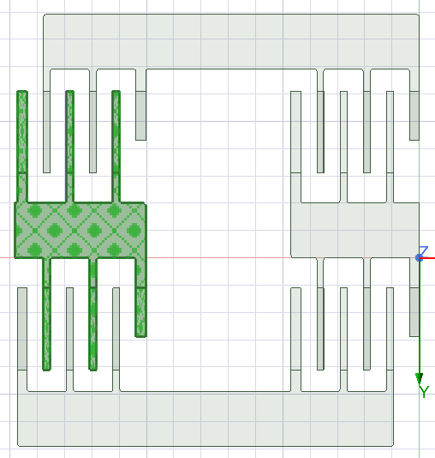
Figure: Power loop nets

The measured DC and AC resistances (mΩ) and inductances (nH) are given below.
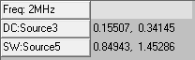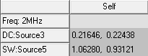

Gate Loop Inductance
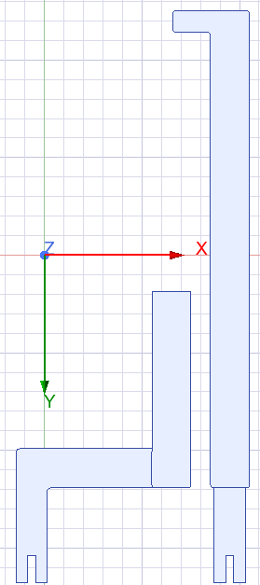
Figure: Gate loop nets
Because of symmetry, only two loops are analyzed for parasitics. A 20 MHz solution frequency is used, which is 10 times the frequency used for the power loop.

The DC and AC values are given below.
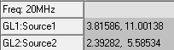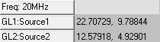

Spice Model with Parasitic Inductances
All parasitics extracted from the power and gate loops are included in the LTspice model. 2.5 µF decoupling capacitors are added to each leg. The model is shown below.
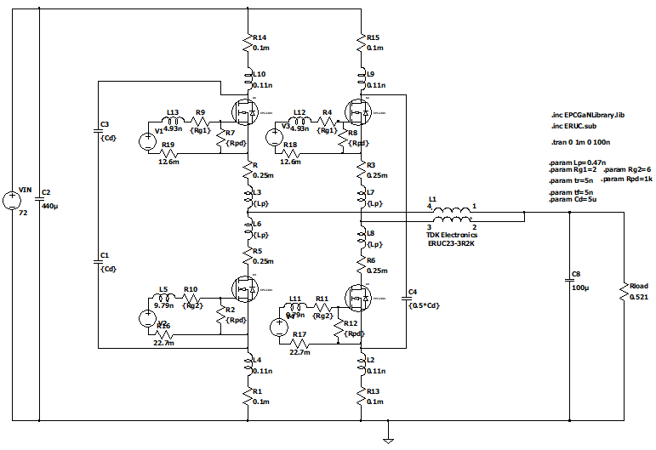
Figure: Spice model with the parasitics

For the upper gate loops, 2 Ω resistors are used; for the bottom ones, 6 Ω resistors are used to prevent overshoot or ringing at the gate. 1 kΩ resistors are used as pull-down resistors in all gate loops to further prevent false triggering. A dead time of 100 ns is used to prevent shoot-throughs. The following figures are shown: V_{DS}, I_{DS}, V_{GS}, and the driver supply voltage for the top and bottom devices of the first half bridge, along with the same waveforms for the second half bridge. Finally, the inductor current and the output voltage are given at the end.
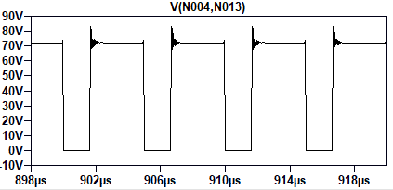
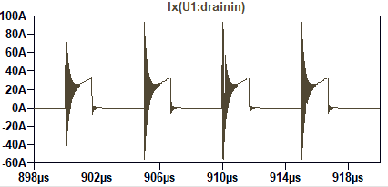
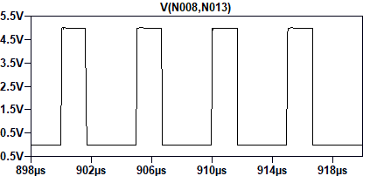
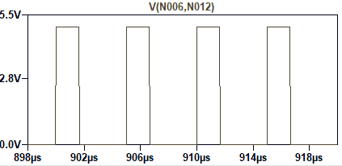
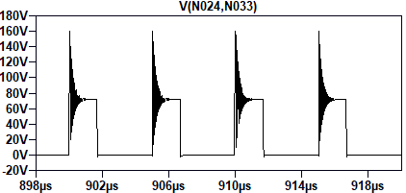
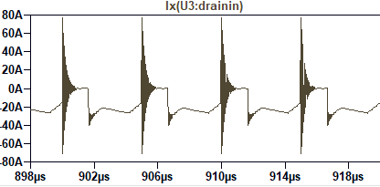
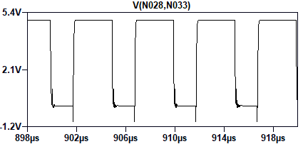
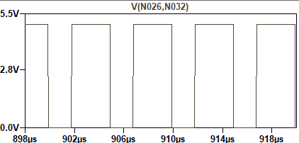

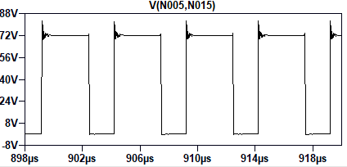
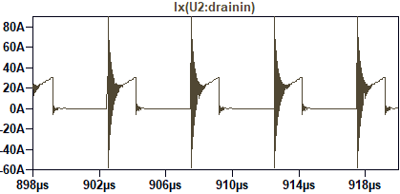
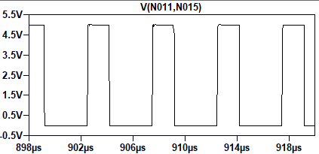
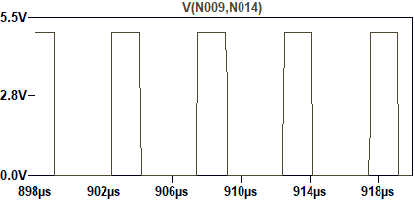
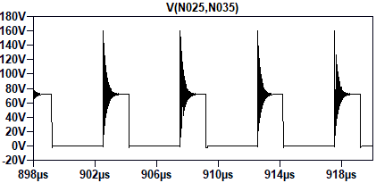
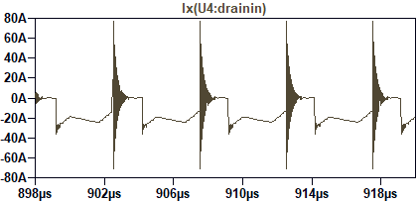
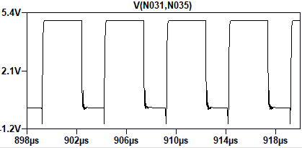
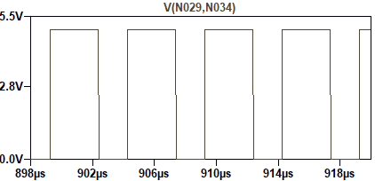
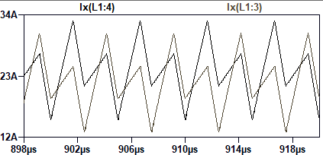
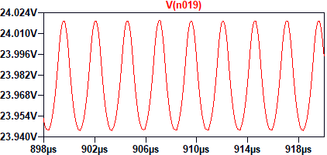

CPU signals with deadtime are shown below.
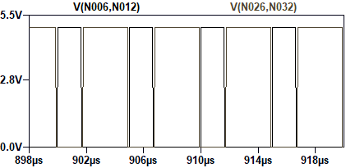
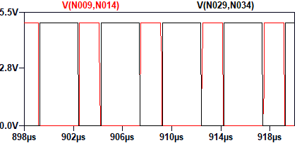
No overshoot is observed in V_{GS} waveforms. The top devices also experience minimal overshoots in their drain-source voltage. The lower devices, however, experience overshoots up to 160 V. This can be minimized by slowing down the transitions, which, in turn, increases switching losses and creates thermal challenges. Since the overshoots remain well within the device rating (200 V), and also the device losses are acceptable, this can be ignored. Loss for the top device of the first half-bridge leg is 2 W, the bottom device is 3.42 W. Similarly, for the second leg, the losses are 1.93 W and 3.07 W, respectively.

Key Contributions — Prob-1B
Electrical characterization confirms that with Q3D-extracted power and gate loop parasitics included, VDS overshoot on the lower devices reaches 160 V, remaining within the EPC2304's 200 V rating. Per-device losses are 2.0 W (HS) and 3.4 W (LS) for leg 1, and 1.93 W and 3.07 W for leg 2. VGS waveforms show no overshoot. Dead time of 100 ns prevents shoot-through. The gate-drive bootstrap supply voltage is maintained above the 1EDN7550's UVLO threshold throughout all four switching cycles.

Common Mode Current

Parasitic Capacitances
For parasitic capacitances, only the power loop traces, the interstitial layer, the alumina, and the thermal interface material (TIM) are considered. The heatsink is not included, and it is assumed that the parasitic capacitance from the interstitial layer to the TIM is sufficient. However, to find the ground path impedance, the heatsink model is included, and it is assumed that the ground is connected to one of the object's sides. The figure below shows the portions considered for this analysis.
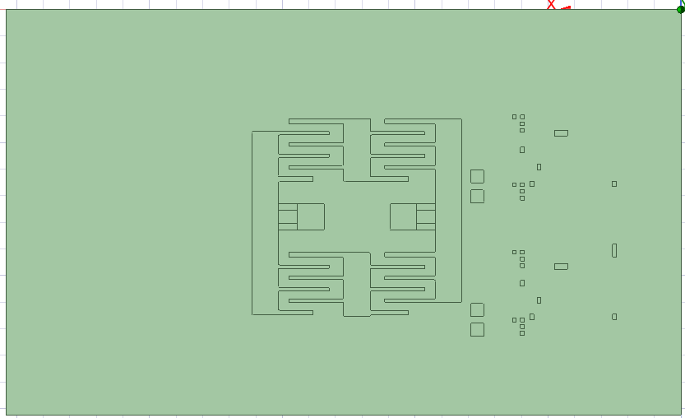
Figure: Q3d model for parasitic capacitances

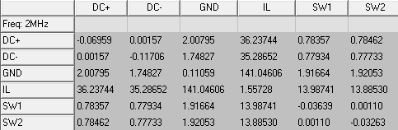
The table above shows the individual nets’ capacitances (pF) to the interstitial layer (IL) and the parasitic capacitance between the IL and ground.

To extract the parasitic resistance and inductance from the decoupling capacitors’ midpoint and the IL, constant-voltage excitations are applied to the copper pads that connect the capacitors and the IL. The following figure shows the IL with the copper pads highlighted.
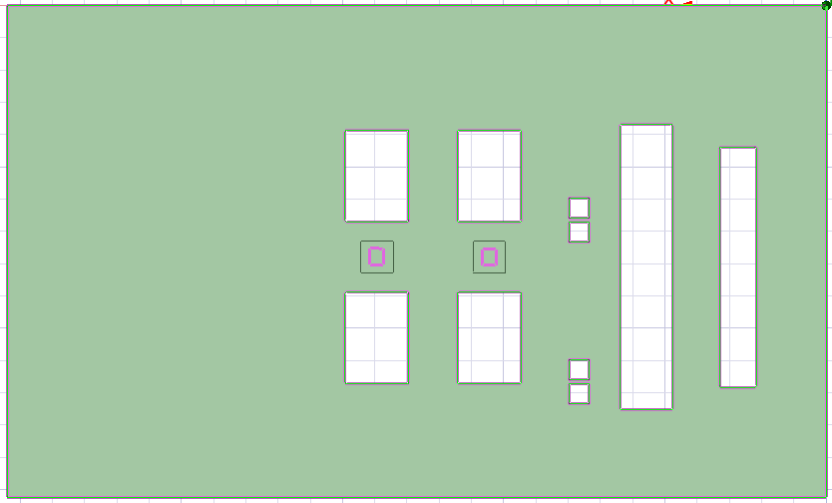
Figure: Q3d model for IL impedance
The parasitics extracted are shown below.
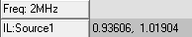
For the ground path, the heatsink is included with the TIM as shown below.
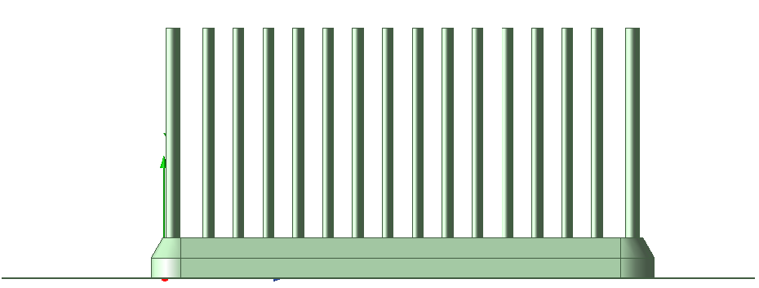
Figure: Q3d model for TIM and heatsink impedance
The results are shown below.
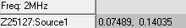
For the ground wire that connects the heatsink’s side to the earth, it is assumed to have 5 nH and 10 mΩ parasitics.

Circuit labeled with Parasitics
Because of symmetry in the circuit and the extracted parasitic values, it is sufficient to analyze one half-bridge.

Key Contributions: Prob-2B
ANSYS Q3D extraction provides all key common-mode circuit parasitics: switching node to interstitial layer capacitances, interstitial layer to ground path resistance and inductance, and TIM/heatsink ground impedance. Because of layout symmetry, analysis of one half-bridge is sufficient. The extracted values are inserted into a labeled circuit schematic following the topology of Lect-25 Slide 2, with the ground wire parasitics (5 nH, 10 mΩ) assumed for the heatsink earth connection.

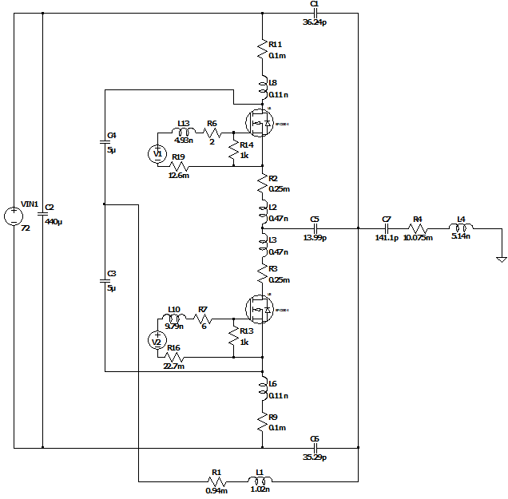
Figure: One of the half-bridges with all the parasitics labeled

Reduced Order Model
The following figure shows the complete model for common-mode current, ignoring the bulk DC capacitors and the inductors. Because of their high values, they are irrelevant in this analysis.
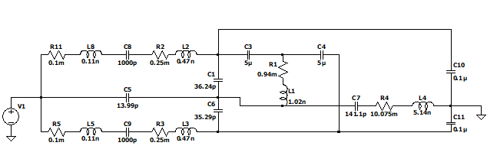
Because C_{LISN} and the decoupling capacitors also have higher values, they can be assumed to be short. This reduces the model to the following.
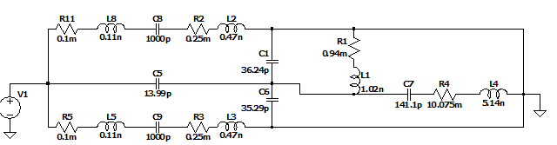
Furthermore, the paths containing C_{oss} can be ignored as they are parallel to the ground current path. Finally, the DC+ and DC- capacitances are added together as they are in parallel. The final reduced model is given below.
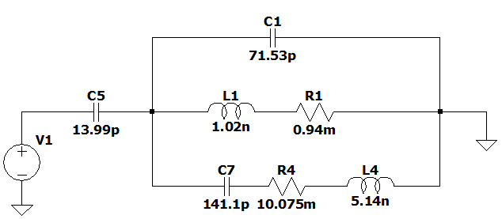
Key Contributions: Prob-2C
Starting from the full common-mode circuit, order reduction proceeds in four steps: (1) bulk DC capacitors and inductors removed due to high impedance at HF; (2) CLISN and decoupling capacitors treated as shorts; (3) Coss paths removed as parallel to the dominant ground path; (4) DC+ and DC− capacitances combined in parallel. The final reduced model retains three branches (Z0, Z1, Z2, Z3) and uses standard LISN values, yielding a circuit tractable for frequency-domain analysis.

Frequency Sweep
In MATLAB, the impedance magnitudes are plotted as a function of frequency. The nomenclature is set according to the lecture. In other words, Z₀ represents C₅, Z₁ represents C₁, Z₂ represents R₁ and L₁, and finally, Z₃ represents C₇, R₄ and L₄.

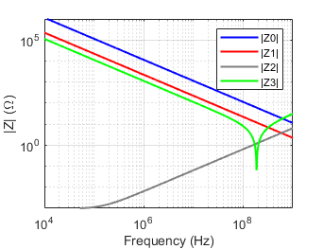
Figure: Branch impedance vs frequency

Afterward, the model is analyzed in LTspice to obtain the branch current responses as a function of frequency. The results obtained are shown in the figure below.
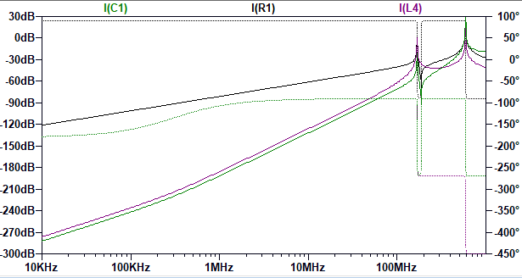
Figure: Branch current response

Here, I(C1) refers to the Z₁ branch current, I(R1) refers to the Z₂ branch current, and I(L4) represents the Z₃ branch current. The resonant frequencies are 169 MHz and 595.6 MHz, respectively.
The resonant frequency of the switching node is found to be 180.5 MHz from LTspice. The close-up figure is shown below.
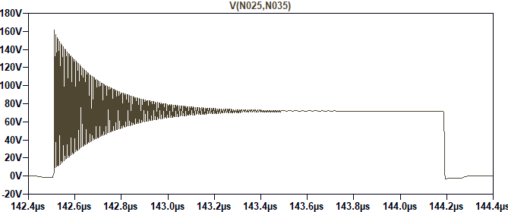
Figure: Ringing at the drain-to-source voltage of the lower device

Even though the resonant frequency of the switching node occurs after the first resonant frequency of the ground path, the dip after the first resonant frequency reduces the current magnitude. The magnitudes of Z₁, Z₂, and Z₃ currents at the switching node resonant frequency are -32.5 dBA, -41 dBA, and -62 dBA, respectively.

CISPR Requirements check
The CISPR 32 Class B conducted emission standard defines quasi-peak voltage limits measured across a 50 Ω Line Impedance Stabilization Network (LISN) over the frequency range of 150 kHz to 30 MHz. The converter's fundamental switching frequency of 200 kHz falls within this band and is therefore the primary frequency of interest for conducted compliance. Reading the branch current magnitudes from the LTspice frequency sweep at 200 kHz, the Z1 (C1), Z2 (R1, L1), and Z3 (C7, R4, L4) branch currents are approximately −120 dBA, −150 dBA, and −210 dBA respectively. Converting to conducted emission voltage levels across the 50 Ω LISN impedance using V(dBµV) = I(dBA) + 120 + 34, the corresponding levels are 34 dBµV, 4 dBµV, and −56 dBµV. The CISPR 32 Class B quasi-peak limit interpolated at 200 kHz is approximately 64.6 dBµV. All three branches are well below this limit by margins of 30.6 dB, 60.6 dB, and 120.6 dB respectively, indicating that the common-mode current routed through the interstitial shield return path does not constitute a conducted emission compliance risk at the fundamental switching frequency or its lower harmonics within the 150 kHz–30 MHz band. For further validation, the dBuV emission for the total ground current is observed in LTspice which is shown below. At 200 kHz, the emission is 35.4 dBµV which is well within the limit. In the figure, the label of Y axis is dBV, however, the expression used for the trace outputs in dBµV. Therefore, the results should be read in dBµV.

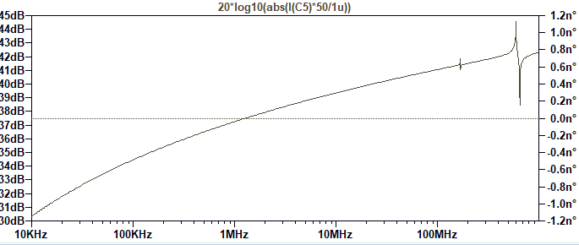
Figure: Emission with respect to the frequency

However, the circuit exhibits two sharp resonances at 169 MHz and 595.6 MHz, both of which fall above the 30 MHz upper boundary of the CISPR conducted emission band. These resonances are therefore not subject to conducted limits but are directly relevant to CISPR 32 Class B radiated emission requirements, which apply from 30 MHz to 1 GHz with a limit of 40 dBµV/m at 10 m. At the switching node resonant frequency of 180.5 MHz, the Z1, Z2, and Z3 branch currents reach −32.5 dBA, −41 dBA, and −62 dBA respectively, corresponding to 121.5 dBµV, 113 dBµV, and 92 dBµV. These levels significantly exceed the radiated limit threshold. However, the drop across LISN would be due to the summation of these branch currents, and this show below 45 dBµV emission. This still violates the limit but with a very small margin. Reducing the parasitic inductance of the interstitial shield return path and increasing the decoupling capacitance at the shield center tap would shift these resonances upward in frequency and reduce peak current magnitudes, improving radiated emission compliance in a future design iteration.

Key Contributions — Prob-2D
The frequency sweep identifies two resonances in the ground current path at 169 MHz and 595.6 MHz, with the switching node ringing at 180.5 MHz. At the switching node resonant frequency, Z1, Z2, and Z3 branch currents are −32.5 dB, −41 dB, and −62 dB respectively, confirming that the interstitial shield successfully attenuates common-mode current propagation into the ground.

Thermal Analysis (ANSYS)
The thermal simulation is carried out in ANSYS Workbench’s static thermal, which uses an APDL FEA solver. For the workbench simulation, the model is updated by replacing the GaN chips with a similar design made out of a conductor (AL6061) to simulate most heat transfer from the chip (designing for the worst-case scenario), with a conductive plate at the top made out of AL-6061, which is part of the top-cooled thermal chip.
The simulation materials are assigned from the ANSYS GRANTA library according to the design in Table 1. The coupled inductor is not included in the thermal simulation, as the effect of thermal expansion is to be investigated on Copper traces. The top-side package devices like the inductor, gate driver and the isolator would actually help the copper traces from expanding, thereby helping the package stay better secured, as the alumina substrate has a lower CTE.
For the simulation, two sets of designs are considered: the package without the heat sink and the package with the heat sink. For both simulations, it is assumed that the package is air-cooled with forced convection using a small fan with a weak speed of 6 m/s, which can be easily achieved with a fan for a package size of 1in x 2in.
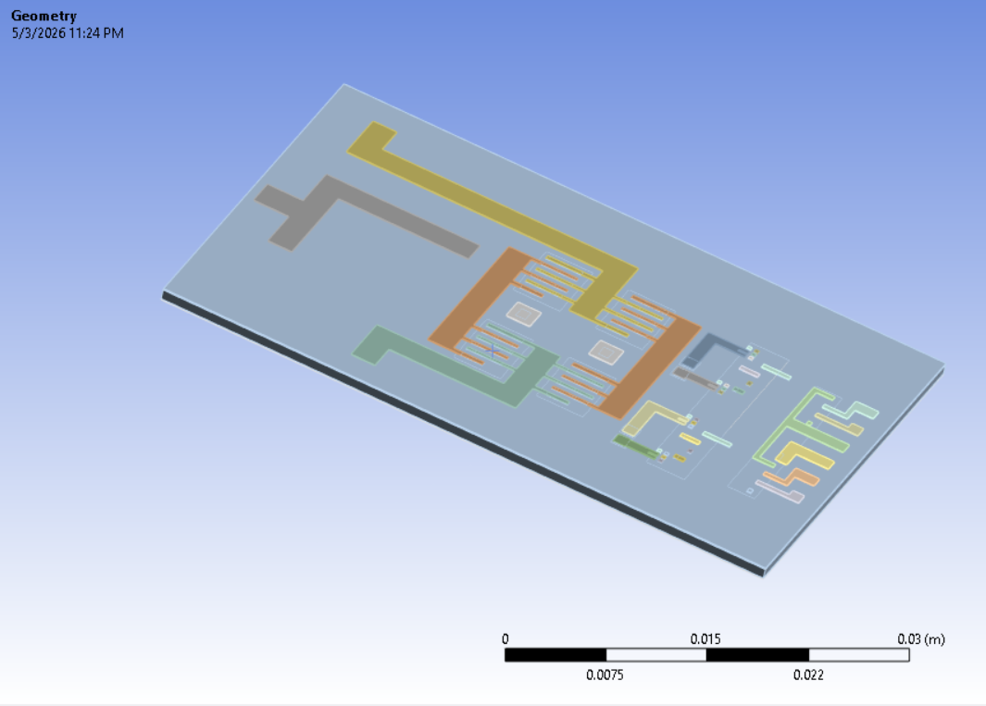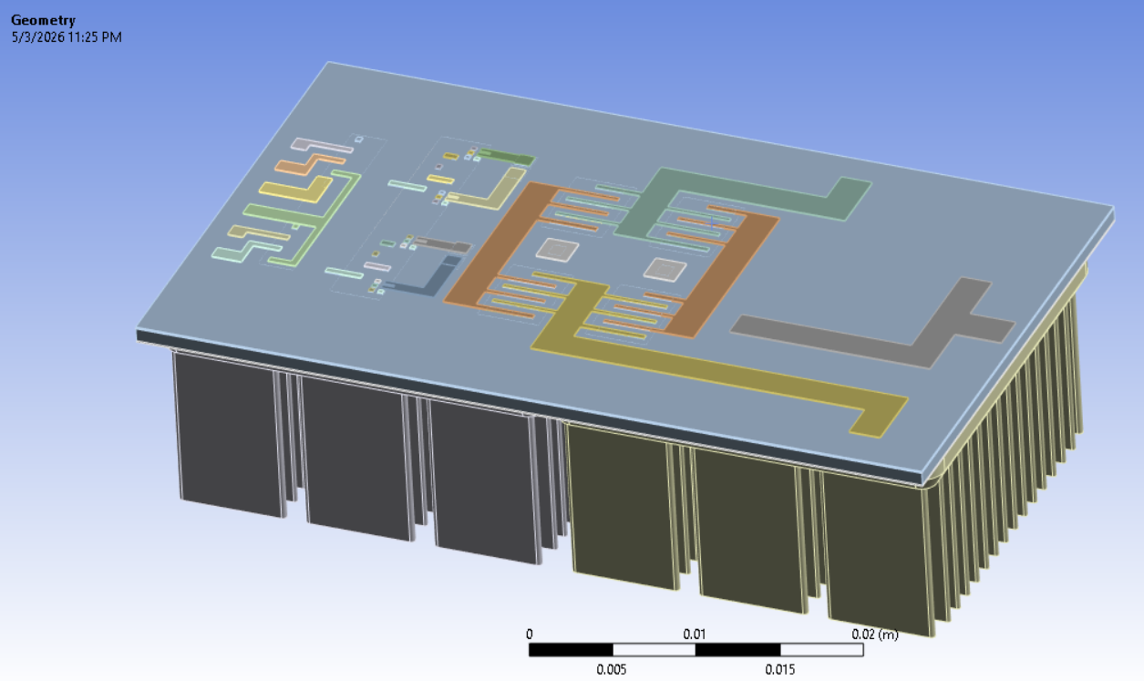
Figure: Geometry used for thermal simulation for the package without a heatsink (left) and with a heatsink (right).

Simulation Setup
The model is meshed with tetrahedral elements for the copper traces and the heat sink, and with hexahedral elements for all other parts. A mesh size of 0.1mm is applied to the copper traces and 1mm to to the interstitial layer for improving the solution quality. The mesh for large geometries is made to be adaptive according to the connections. Hence it is fine wherever there are fine elements and coarser wherever there are not many connections. This helps with solution speed and convergence for the FEA solver.
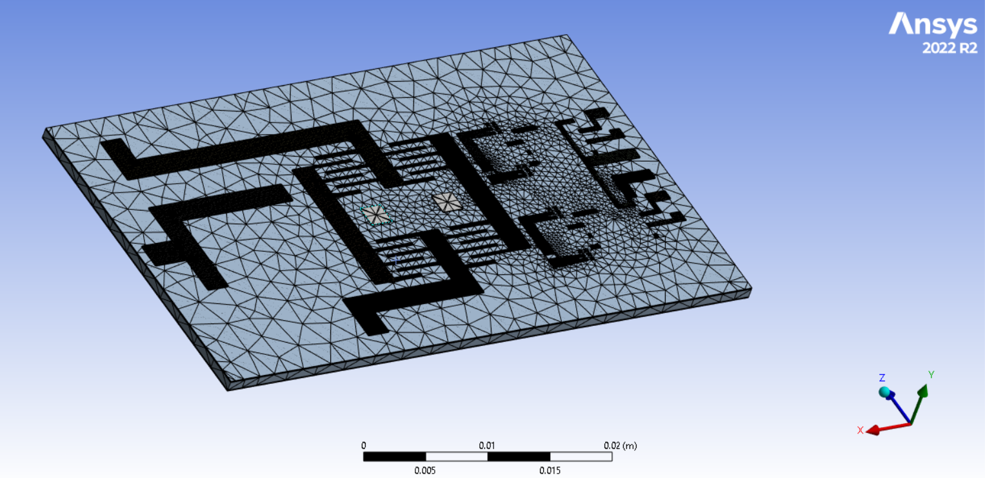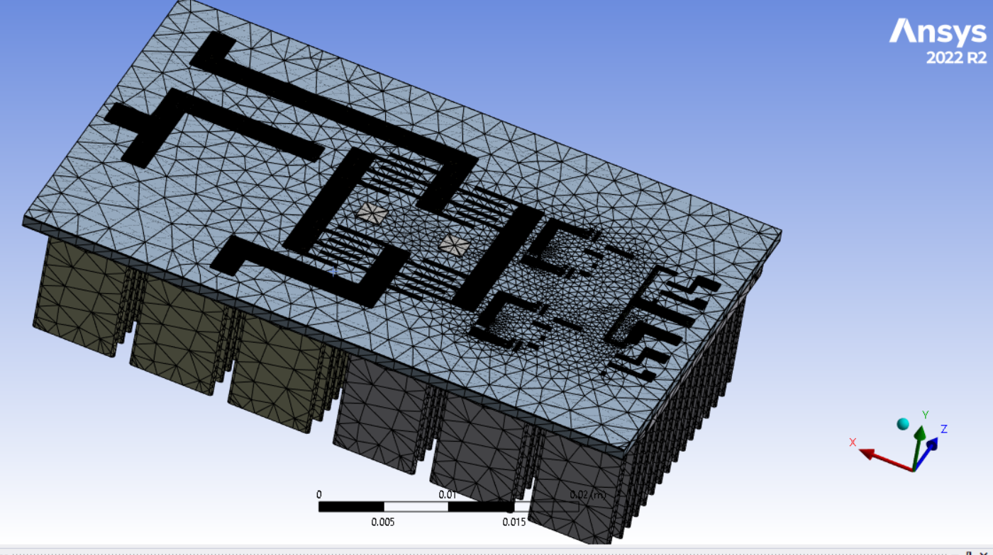
Figure: Mesh used for thermal simulation for the package without heatsink (left) and with heatsink (right).

For the thermal analysis, a boundary heat loss calculated using the parasitics are applied to the top surfaces of all the GaN chips. A convection boundary condition is applied to the bottom copper plate for the non-heat sink design, whereas for the heat sink design, all exposed surfaces are given a convection boundary condition.
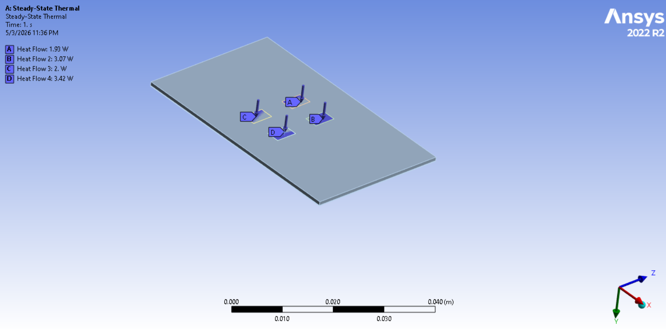
Figure: Heat loss boundary condition applied at the top planes of the GaN chip (top cooled package) for both the simulations.
Now, assuming a fan speed of 6 m/s the convective heat transfer coefficient for a copper plate can be calculated as follows -
Air velocity, V = 6 m/s
Plate length, L = 0.0508 m
Kinematic viscosity of air, ν = 1.5 × 10^-5 m²/s
Thermal conductivity of air, k = 0.026 W/m·K
Prandtl number, Pr = 0.71
Reynolds number:
Re = (V × L) / ν
Re = 2.03 × 10^4
Since Re < 5 × 10^5 → flow is laminar
Nusselt number (laminar flow over flat plate):
Nu = 0.664 × Re^(1/2) × Pr^(1/3)
Nu ≈ 91.2
Convective heat transfer coefficient:
h = (k × Nu) / L
h ≈ 46.7 W/m²·K

Thus, a convection coefficient of 50 W/sq-mK was used for both the simulation. The actual coefficient of convection for the heat sink geometry will actually be in the range of 80-120 W/sq-mK as heat sink’s characteristic length is even higher. However, to keep the simulation conservative the same convection coefficient is assumed for both the assemblies.

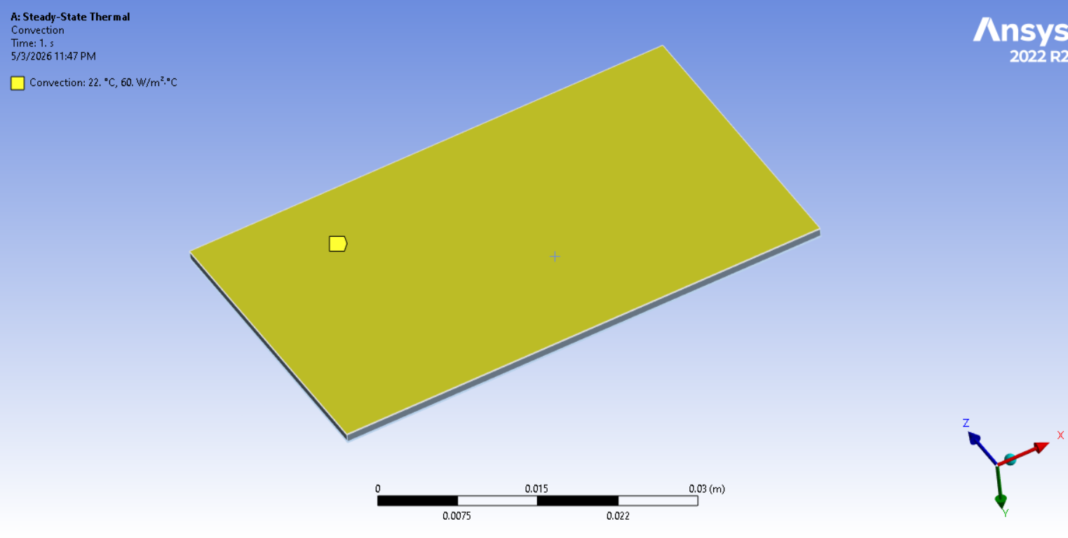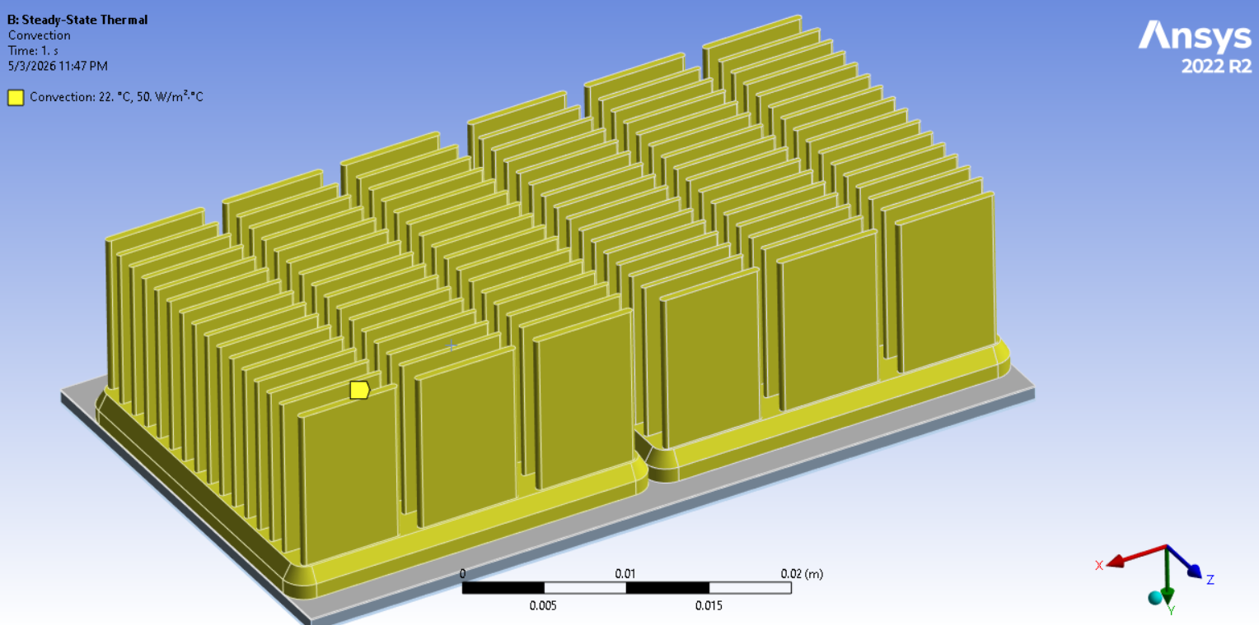
Figure: Convection planes and coefficient of convection used for thermal simulation for the package without heatsink (left) and with heatsink (right).

Thermal Simulation Results
The temperature distribution for the two simulations is shown in the figures below.

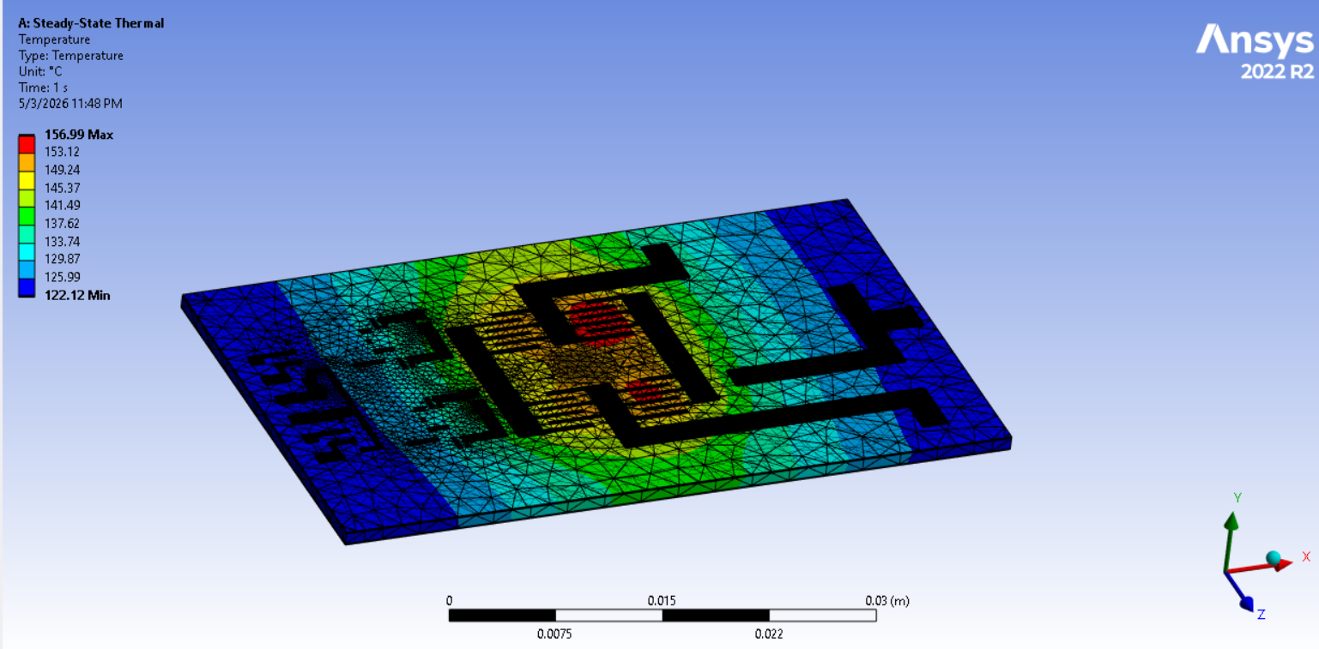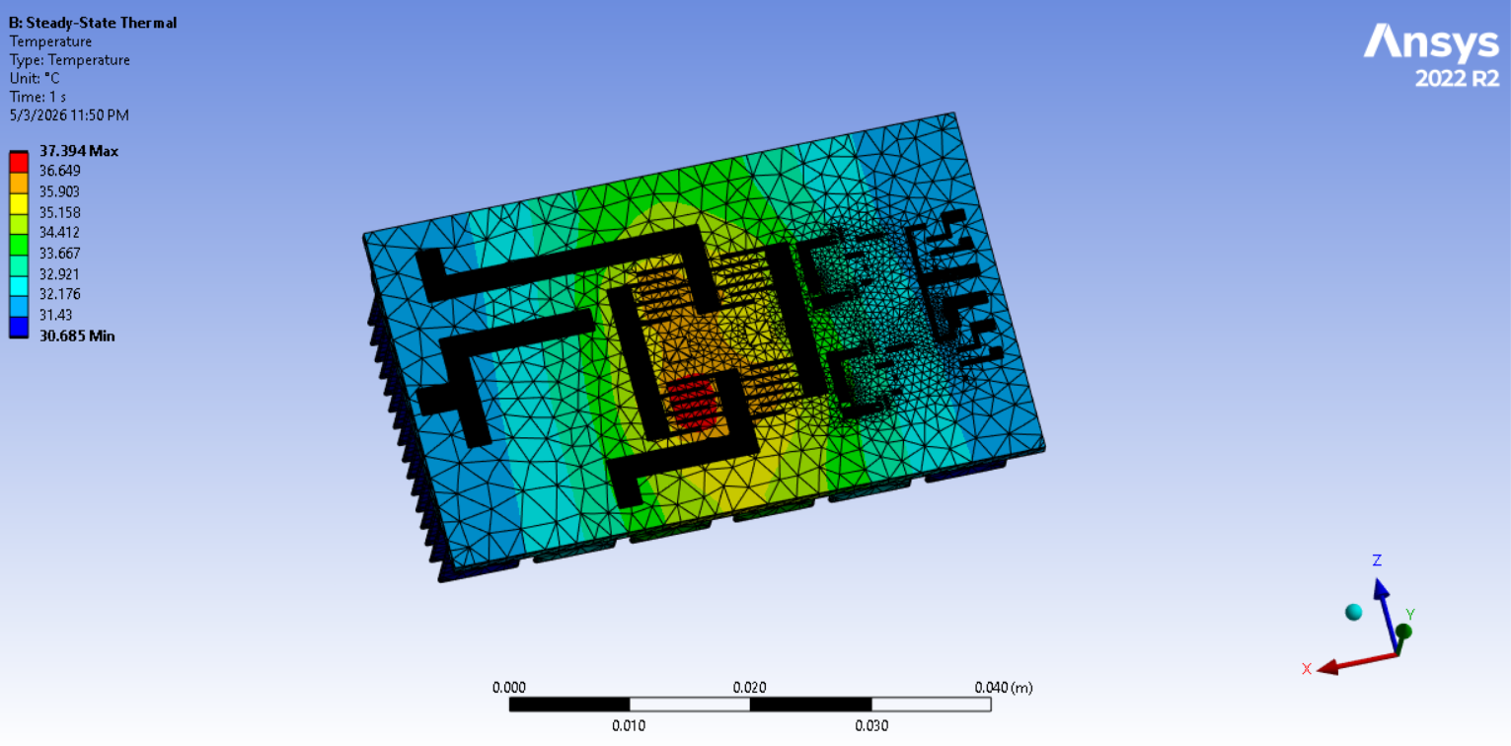
Figure: Temperature distribution observed for the package without heatsink (left) and with heatsink (right)

It is observed that, without the heat sink, the package temperature remains between 156° C and 122° C, with the highest temperatures near the GaN chips and the lowest at the center of the package. This is actually bad for the package as the rated max temperature of the selected GaN chips is 150° C.

For the simulation with the heat sink however, the temperature range is from 38° C to about 31° C. The lowest temperatures, however, are observed on the heat sink, with 38° C recorded in the mid-section of the package. The heatsink thus helps dissipate heat by about 5 times more making the package operate at a safe temperature.

Key Contributions: Prob-1C
ANSYS static thermal FEA shows that with the Al-6063 heatsink and forced convection (h ≈ 50 W/m²K at 6 m/s), device junction temperatures remain at approximately 38°C — well below the EPC2304's 150°C limit. Without the heatsink, temperatures reach 156°C, exceeding the device rating. The heatsink is therefore confirmed as essential to safe operation at the 1.1 kW design point.

Mechanical Analysis (ANSYS)
With the applied thermal loads, mechanical stresses will be induced by thermal expansion and material mismatches. This can potentially lead to material failure and lead to the connectors peeling off the package.
To analyze this, the thermal results for the heat sink and the non-heat sink simulations are transferred to the static structural solver in ANSYS Workbench, which is an implicit solver used for constant loading conditions that do not vary much with time (static or quasi-static).
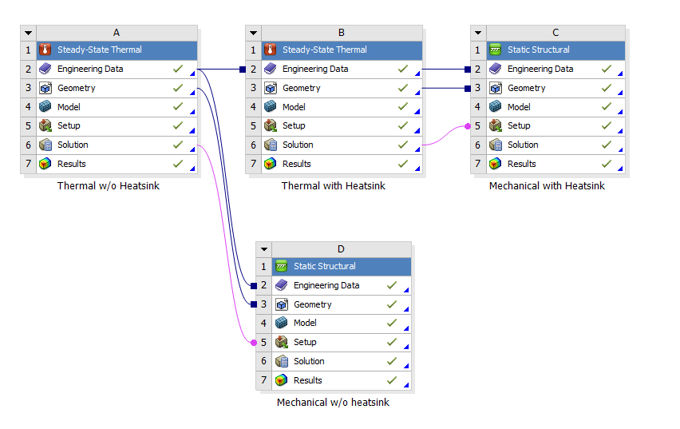
Figure: Thermal load transfer for mechanical simulation.

Simulation Setup
The meshing is done in a similar way to the thermal simulation. All the inter-body connections or contact faces are set to the ‘bonded’ condition, as there is to be no sliding in between the layers of the package.
For the boundary conditions, the thermal load from the thermal simulation is applied. Moreover, to constrain the package in space, three mutually perpendicular frictionless support planes are added, which help prevent the package from expanding. This ensures the package does not incur additional loads due to boundaries.
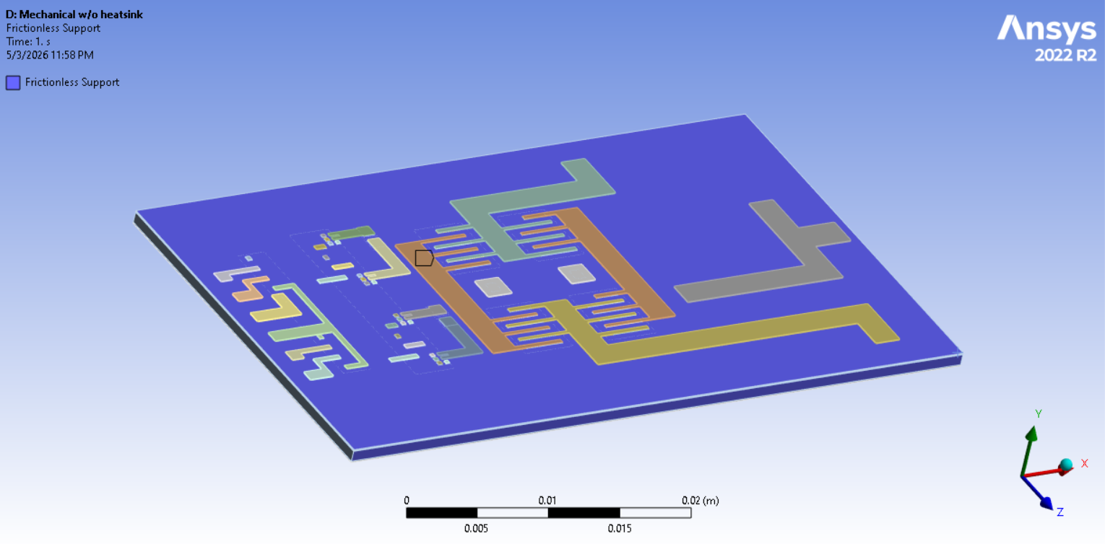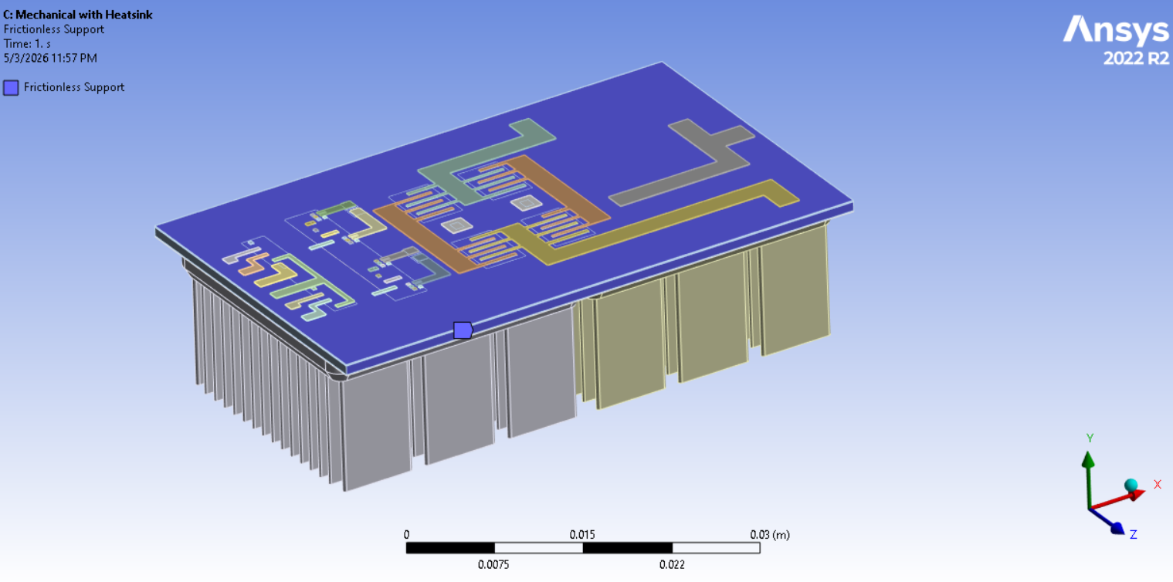
Figure: 3 mutually perpendicular frictionless planes chosen as boundary conditions to constrain the package in space for both the simulations.
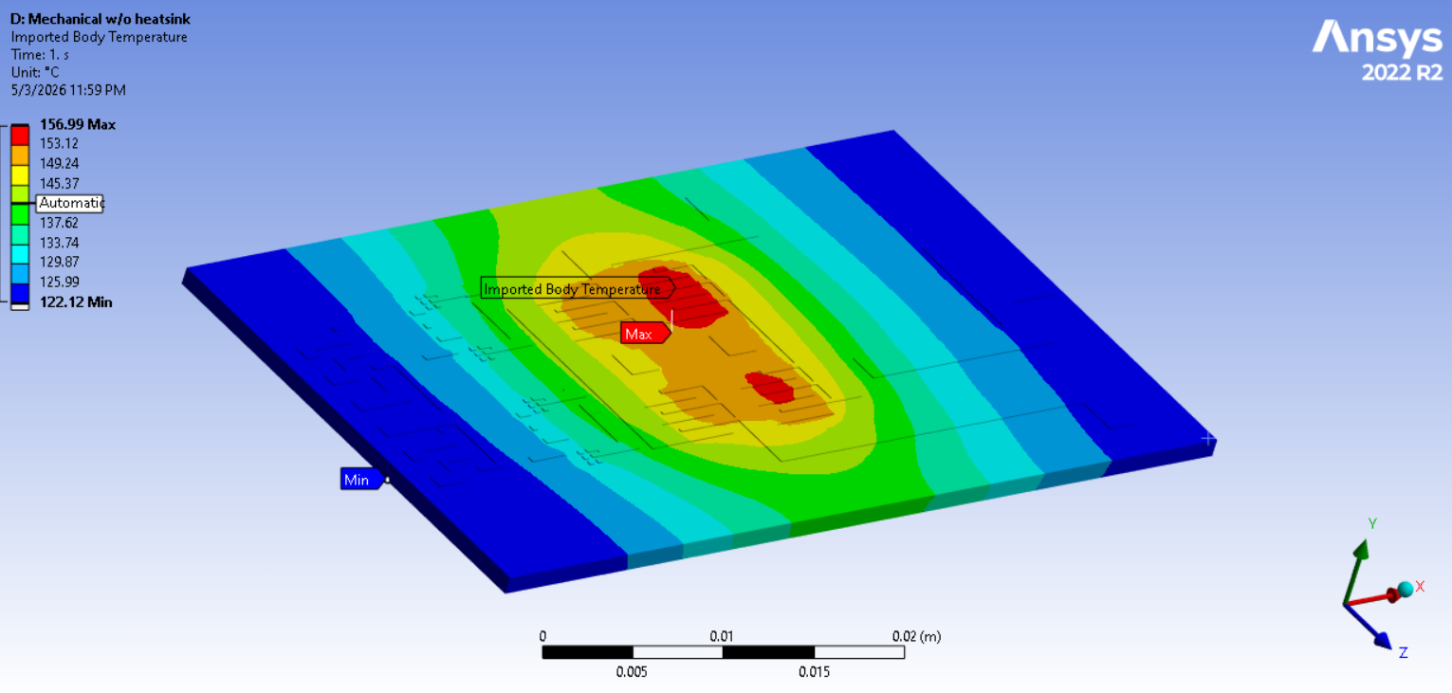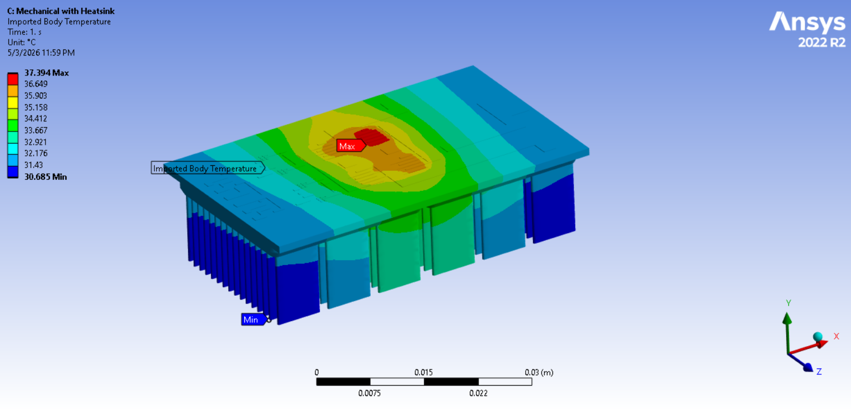
Figure: Imported temperature loads from the thermal simulation for both the models..

Mechanical simulation results
Using the above boundary conditions and constraints, the models were simulated for stresses and total deformation (i.e., expansion).
It is observed that the maximum stress for the package without a heatsink reaches 653.4 MPa.While the stress in the other areas of the package is within the safe region, this stress is observed in a small area at the junction between the GaN chips and the copper traces. However, this stress is too high and exceeds the yield stress of copper, which is 320 MPa which is where this is observed. This could lead to potential disconnection due to peeling of copper traces. Total deformation is also observed to be 0.0065 mm, which is actually really low for a package measuring 1 in x 2 in.
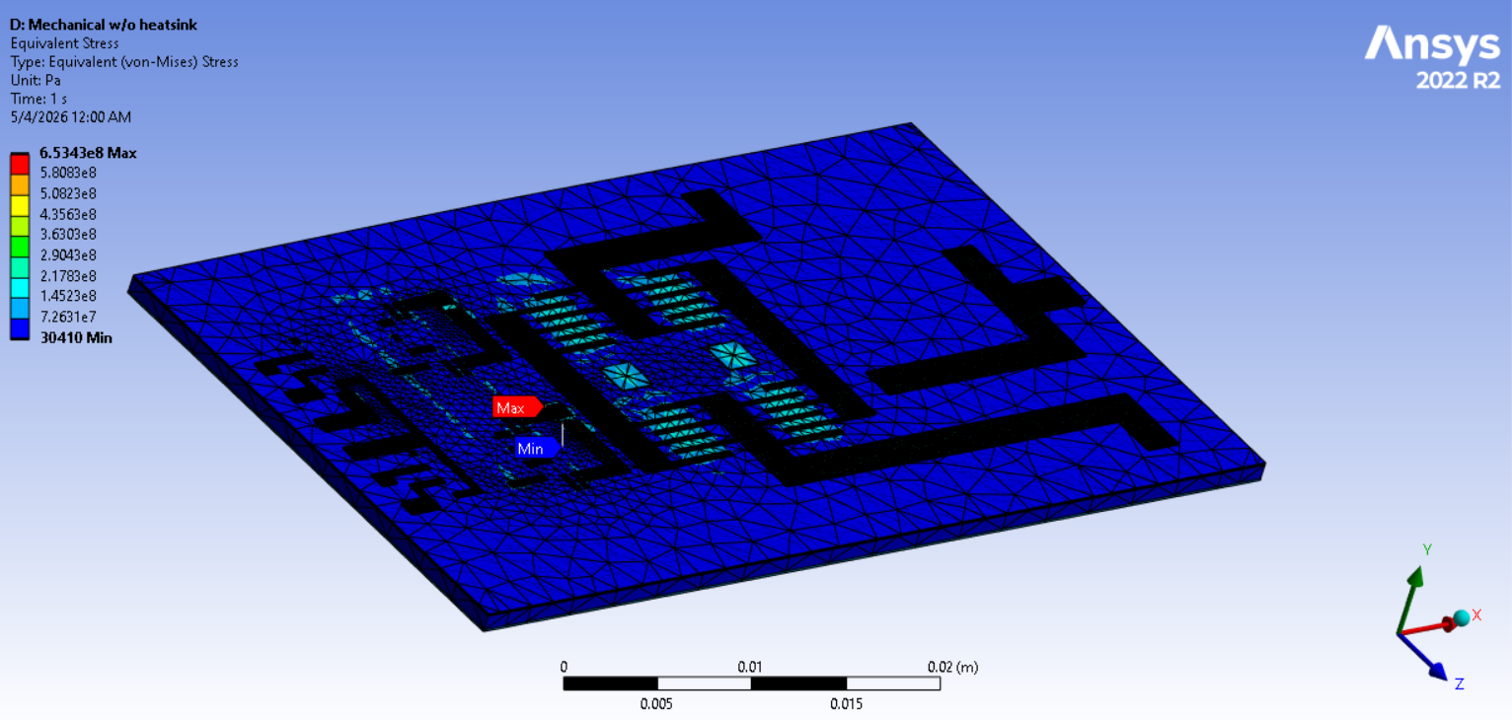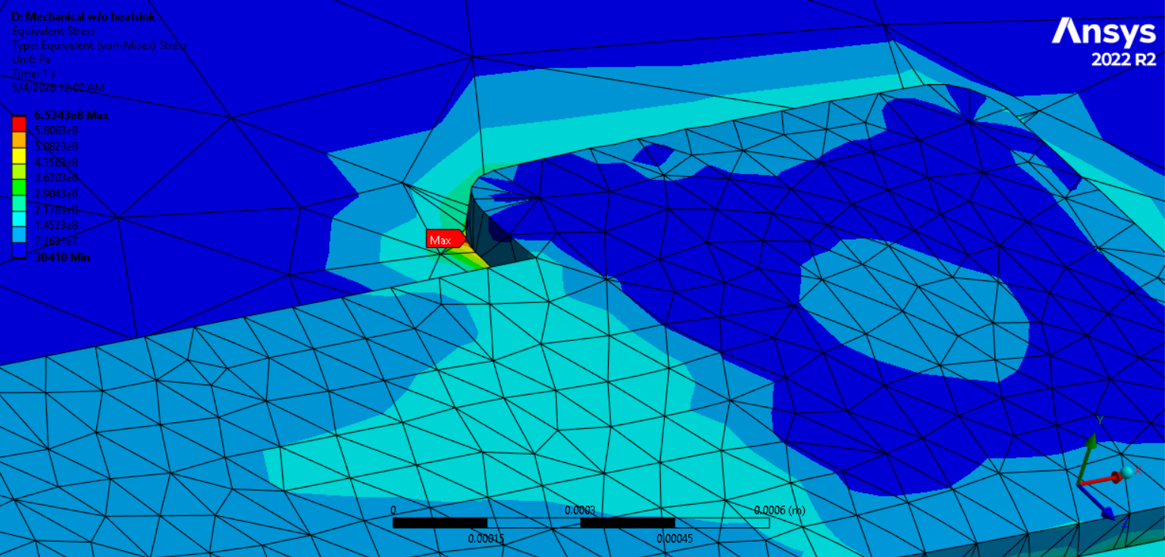
Figure: Equivalent von-Mises stress distribution on the package without heatsink (left) and point of maximum stress of 653.4MPa (right).
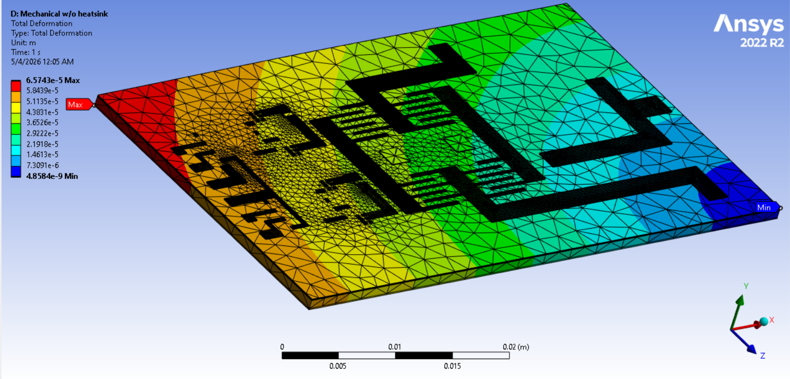
Figure: Total deformation observed in the package without heatsink.

With the heatsink, the maximum stress observed is 83.5 MPa, which is much lower than the copper yield stress. This actually gives a safety factor of about 3.7 for copper and is higher for every other material used as copper is the weakest material in the package.. This is much better than the performance of the package without heatsink and is much safer. One could also eliminate fan cooling for the package without affecting the mechanical and thermal failure.
The deformation of the package is also reduced with the addition of a heat sink, with a maximum deformation of 0.001 mm which is safe.
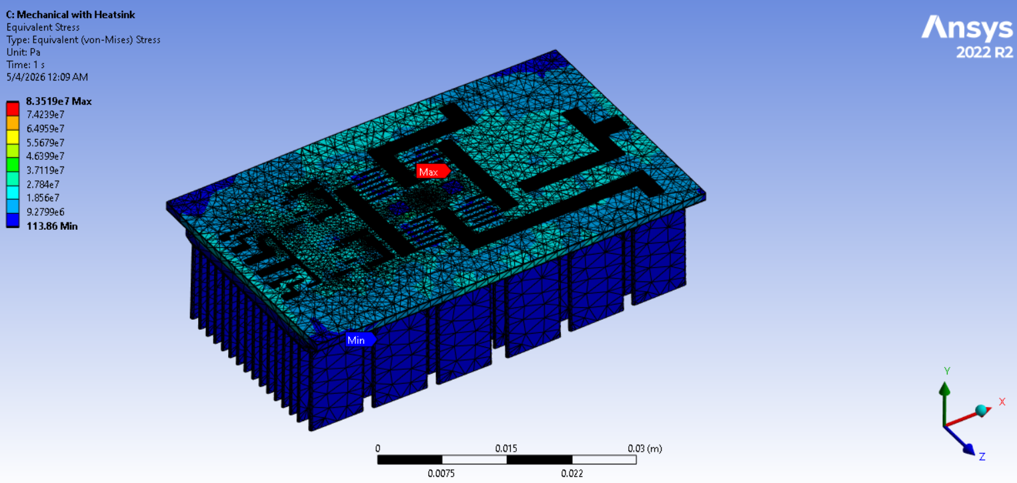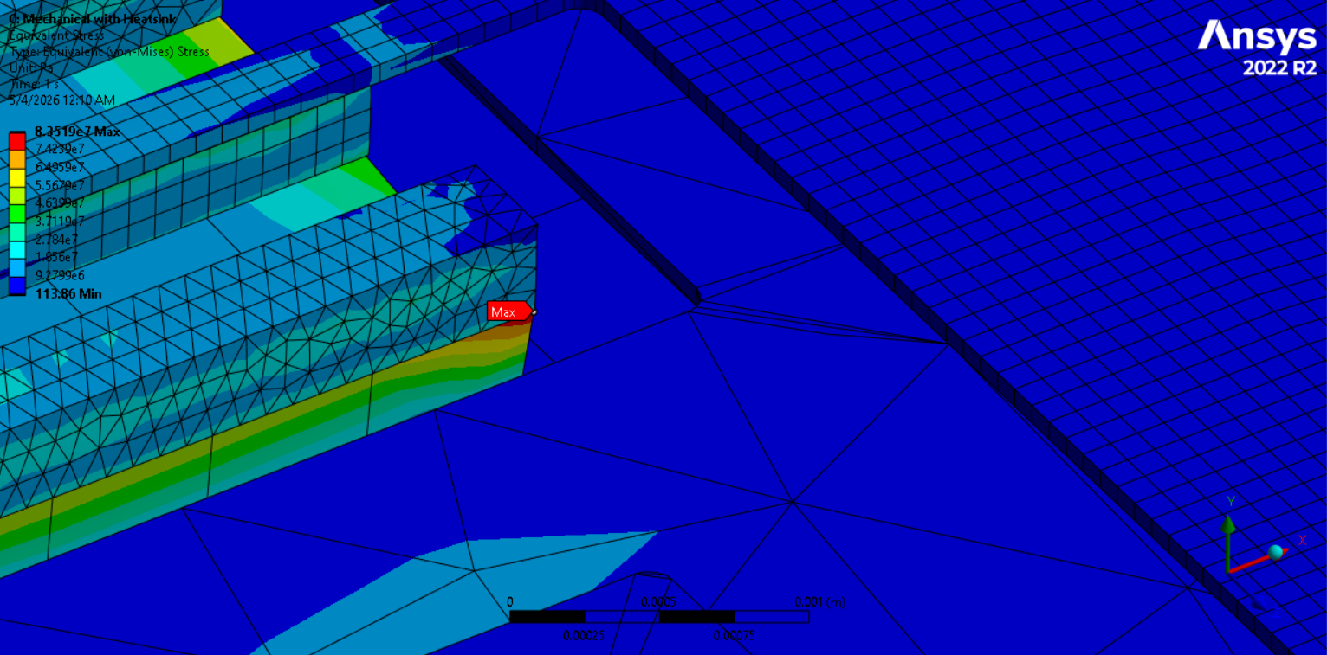
Figure: Equivalent von-Mises stress distribution on the package with heatsink (left) and point of maximum stress of 83.5MPa (right).
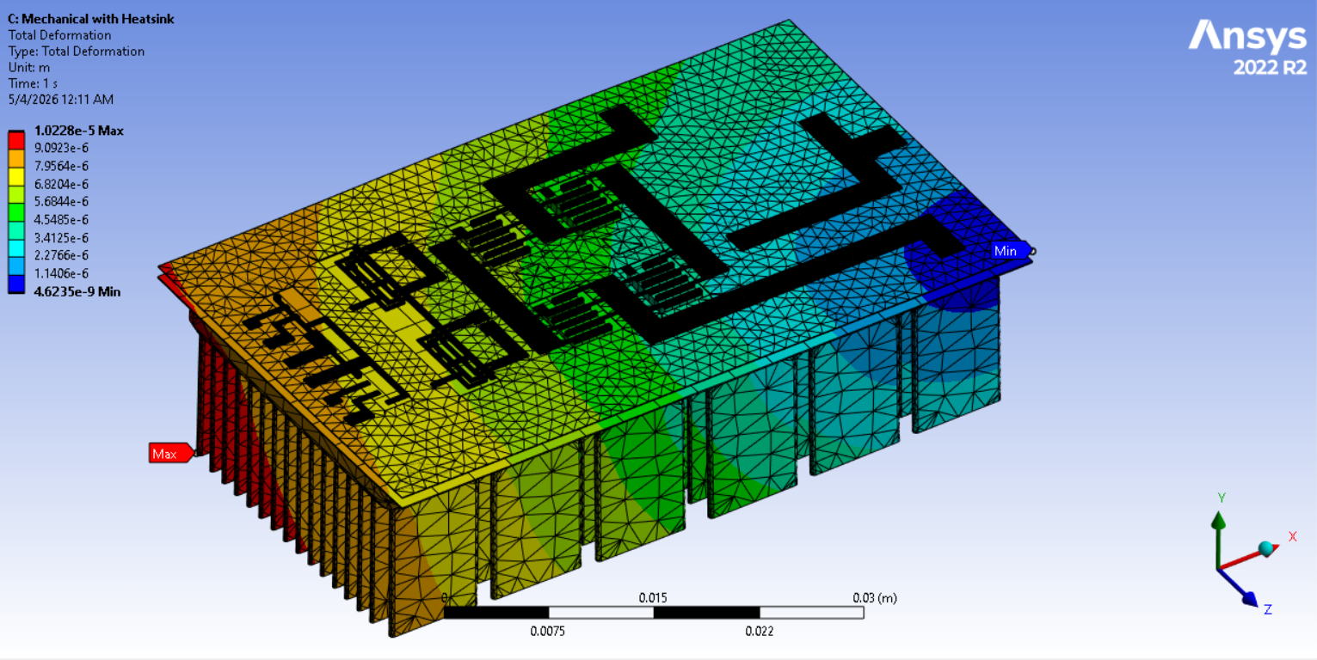
Figure: Total deformation observed in the package with heatsink.

Use of AI
Artificial intelligence tools, specifically Claude, were used throughout this project as a research and design assistance tool. AI was primarily used in three areas: component research and selection, technical writing assistance (google doc embedded Gemini), and guidance on analysis methodology.
For component selection, AI was used to identify candidate parts meeting the electrical requirements of the design, generate structured comparison tables across relevant specifications, and narrow the search before final verification against manufacturer datasheets. All selected components were independently verified by the team prior to inclusion in the design.
For analysis methodology, AI was consulted to help interpret relevant standards, guide unit conversions, and structure analytical procedures such as the common-mode circuit order reduction and conducted emission assessment. All methodologies were verified against course material and lecture notes before being applied.
All simulations, physical design work, and quantitative results were obtained exclusively through dedicated engineering software including LTspice, ANSYS Workbench, ANSYS Q3D, and SolidWorks. AI was not used to generate, substitute for, or interpret simulation outputs. All design decisions, numerical results, and conclusions presented in this report reflect the team's own engineering judgment and simulation work.

Conclusions
Our Power dissipation per mosfet was reduced to a maximum of 4W per FET from the estimated 150W per FET in the midterm which is a significant change while also lowering the Voltage spike from 220V to 120V keeping it within the safe operation threshold. The overall package size has been reduced by 68%.
The MOSFETs also operate at a safe temperature of 37 ° C which is much better than the previous operating temperature of about 150° C which was the maximum limit of the GaN chips. Moreover, the mechanical safety factor increased from about 1.13 to 3.7 which is a three-times increase.
This means that the designed package will operate safely without any electrical, thermal and mechanical issues.

Further Improvements
While the current design meets the core electrical, thermal, and mechanical requirements of the project, several areas remain open for improvement in a future revision.
The most significant electrical concern is the 160 V drain-source overshoot observed on the low-side devices during switching transitions. Although this remains within the EPC2304's 200 V absolute maximum rating, the margin is narrow. The primary path to reducing this overshoot without increasing switching loss is a layout revision targeting the commutation loop inductance, which the Q3D extraction identified at 10.8 nH. Redesigning the MOSFET-side copper plane to shorten and widen the interconnect nets between the upper and lower devices could realistically reduce this to 2–3 nH, which would bring the overshoot well below 100 V and allow the gate resistors to be reduced for faster switching and lower conduction loss.
On the EMI side, the frequency sweep identified resonances at 169 MHz and 595.6 MHz that fall within the CISPR 32 radiated emission band. Reducing the parasitic inductance of the interstitial shield return path and increasing the decoupling capacitance at the shield center tap would shift these resonances upward in frequency and reduce peak ground current magnitudes. Adding a small ferrite bead in series with the shield return connection would provide additional high-frequency attenuation without affecting low-frequency common-mode current routing.
For protection and robustness, a production revision should incorporate a fast overcurrent comparator monitoring phase current and disabling the PWM signals through the SI86S620BC isolator enable pin to protect against shoot-through and load faults. Rail-to-rail TVS diode arrays at the signal connector pins would clamp ESD events before they reach the isolator inputs. A drain-to-source TVS rated at 80–85 V standoff placed as close as possible to each EPC2304 pad would provide a hard clamp on switching-node overshoot independent of gate resistance tuning.
Finally, a two-sided dielectric fluid cooling architecture, as described in the assignment, would allow the gate drivers and isolators on the top copper plane to be thermally managed more effectively, since the current single-sided heatsink design relies on conduction through the full ARC stack for top-side component cooling, which the thermal resistance analysis showed to be limited.

References
[1] Efficient Power Conversion Corporation, "EPC2304 Enhancement Mode Power Transistor Datasheet," EPC, El Segundo, CA, 2023. [Online]. Available: https://epc-co.com/epc/Portals/0/epc/documents/datasheets/epc2304_datasheet.pdf
[2] Texas Instruments, "TIDA-050089: 1.1-kW, High-Density, 48-V to 12-V Converter Reference Design," Texas Instruments Application Report, 2021. [Online]. Available: https://www.ti.com/lit/an/slta055/slta055.pdf
[3] Texas Instruments, "Designing a TI GaN-Based High-Frequency Buck Converter," Texas Instruments Application Report SLVAFT0, 2021. [Online]. Available: https://www.ti.com/lit/an/slvaft0/slvaft0.pdf
[4] Texas Instruments, "Pros and Cons of Using Synchronous Rectification," Texas Instruments Application Report SLYT380, 2010. [Online]. Available: https://www.ti.com/lit/an/slyt380/slyt380.pdf
[5] Würth Elektronik, "WE-TDC Coupled Inductor Datasheet," Würth Elektronik, Waldenburg, Germany. [Online]. Available: https://www.we-online.com/components/products/datasheet/7448709033.pdf
[6] J.-P. Lee, B.-D. Min, T.-J. Kim, D.-W. Yoo, and J.-Y. Yoo, "Analysis and Design of Coupled Inductors for Two-Phase Interleaved DC-DC Converters," Journal of Power Electronics, vol. 9, no. 1, pp. 93–101, Jan. 2009.
[7] Infineon Technologies, "1EDN7550 Single-Channel Gate Driver Datasheet," Infineon Technologies AG, Neubiberg, Germany, 2022. [Online]. Available: https://www.infineon.com/dgdl/Infineon-1EDN7550-DataSheet-v02_00-EN.pdf
[8] Murata Power Solutions, "NME1S0505SC Isolated DC-DC Converter Datasheet," Murata Manufacturing Co., Ltd. [Online]. Available: https://www.murata.com/products/productdetail?partid=NME1S0505SC
[9] Skyworks Solutions, "SI86S620BC Digital Isolator Datasheet," Skyworks Solutions Inc., Irvine, CA. [Online]. Available: https://www.skyworksinc.com/products/isolators
[10] Alpha Novatech, "Z60-12.7B Heatsink Datasheet," Alpha Novatech Inc. [Online]. Available: https://www.alphanovatech.com
[11] TDK Corporation, "ERUC23-3R2K Coupled Inductor Datasheet," TDK Corporation, Tokyo, Japan. [Online]. Available: https://product.tdk.com

