Министерство науки и высшего образования Российской Федерации

федеральное государственное автономное

образовательное учреждение высшего образования

«Самарский национальный исследовательский университет

имени академика С.П. Королева»

Институт информатики и кибернетики

Кафедра технической кибернетики

Отчет по лабораторной работе №2

Дисциплина: «Технологии сетевого программирования»

# Тема «Разработка API»

Выполнили: Жиляев М.И.

Прохоров С.А.

Группа: 6301-010302D

Самара 2025

1. Задание на лабораторную работу

Цель работы: Разработать RESTful API для сервисов.

1. **Реализация API:**
   * Разработать CRUD-методы для работы с моделями;
   * Настроить маршруты и обработку запросов.
2. **Тестирование API:**
   * Использовать Postman/Curl для проверки запросов;
   * Описать примеры запросов и ответов в документации.
3. **Оформление отчета:**
   * Описать структуру API;
   * Создать презентацию с результатами работы.
4. Выполнение работы
   1. Реализация API:

В ходе выполнения лабораторной работы №2 было создано CRUD апи, для которого существует еще и OpenApi. Рассмотрим при помощи рисунков это API. Для подробного рассмотрения в конце отчета предлагаю json, который можно импортировать в swagger editor для просмотра возможностей API.

* 1. Структура API:

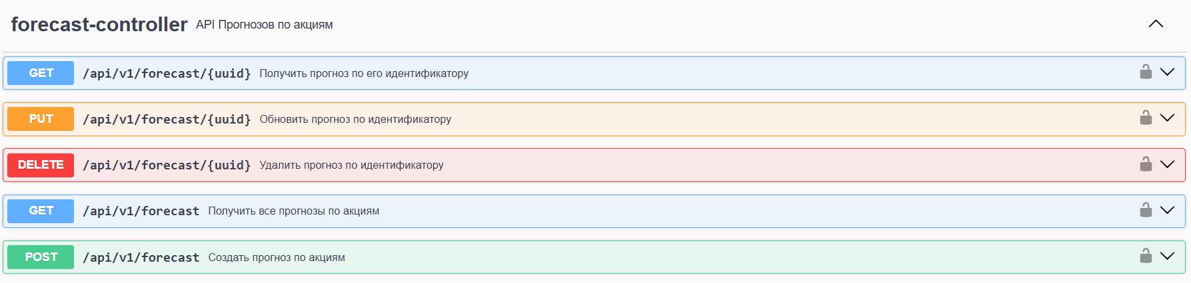

Рисунок 1 – API прогнозов по акциям

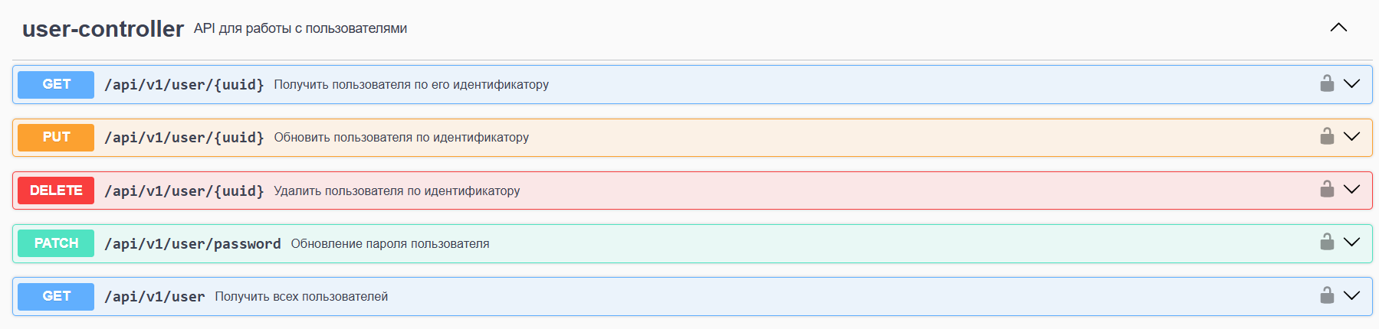

Рисунок 2 – API для работы с пользователями

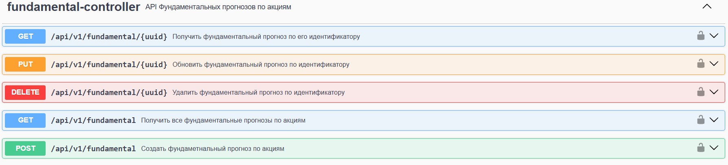

Рисунок 3 – API для работы с фундаментальными прогнозами по акциям

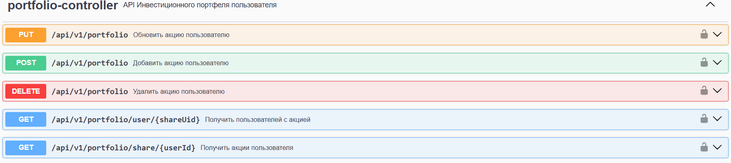

Рисунок 4 – API для работы с инвестиционным портфелем пользователя



Рисунок 5 – API для инициализатора базы данных

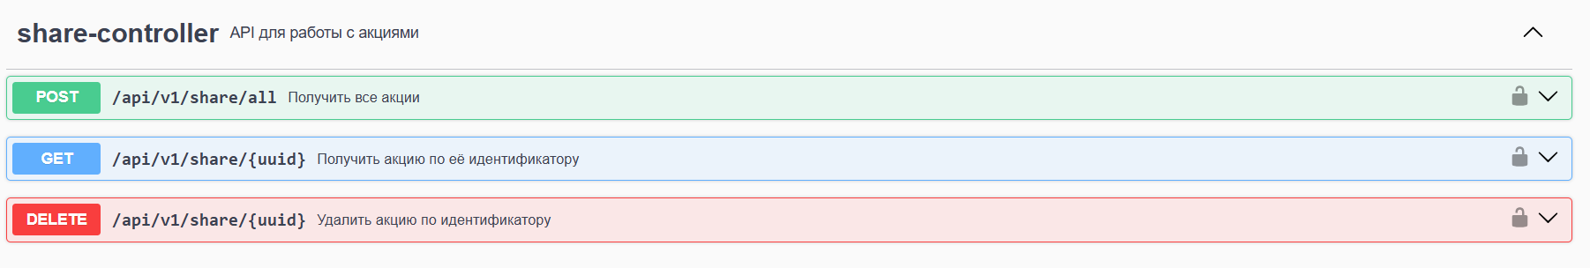

Рисунок 6 – API для управления работы с акциями

* 1. Замечание

Подробные возвращаемые значения и коды ответов можно найти запустив проект и открыв его сваггер по пути http://localhost:8080/swagger-ui/index.html#

Или же можно получить json для OpenApi по пути http://localhost:8080/v3/api-docs

1. Приложение

{"openapi":"3.1.0","info":{"title":"Invest API","version":"1.0.0"},"servers":[{"url":"http://localhost:8080"}],"tags":[{"name":"forecast-controller","description":"API Прогнозов по акциям"},{"name":"user-controller","description":"API для работы с пользователями"},{"name":"fundamental-controller","description":"API Фундаментальных прогнозов по акциям"},{"name":"portfolio-controller","description":"API Инвестиционного портфеля пользователя"},{"name":"initializer-controller","description":"API Инициализатора бд приложения"},{"name":"auth-controller","description":"API для аутентификации и управления сессиями"},{"name":"share-controller","description":"API для работы с акциями"}],"paths":{"/api/v1/user/{uuid}":{"get":{"tags":["user-controller"],"summary":"Получить пользователя по его идентификатору","operationId":"findUserByUid","parameters":[{"name":"uuid","in":"path","required":true,"schema":{"type":"string","format":"uuid"}}],"responses":{"200":{"description":"OK","content":{"*/*":{"schema":{"$ref":"#/components/schemas/UserDto"}}}}},"security":[{"JWT":[]}]},"put":{"tags":["user-controller"],"summary":"Обновить пользователя по идентификатору","operationId":"updateUser","parameters":[{"name":"uuid","in":"path","required":true,"schema":{"type":"string","format":"uuid"}}],"requestBody":{"content":{"application/json":{"schema":{"$ref":"#/components/schemas/UpdateUserRequest"}}},"required":true},"responses":{"200":{"description":"OK","content":{"*/*":{"schema":{"$ref":"#/components/schemas/UserDto"}}}}},"security":[{"JWT":[]}]},"delete":{"tags":["user-controller"],"summary":"Удалить пользователя по идентификатору","operationId":"deleteUser","parameters":[{"name":"uuid","in":"path","required":true,"schema":{"type":"string","format":"uuid"}}],"responses":{"204":{"description":"No Content"}},"security":[{"JWT":[]}]}},"/api/v1/portfolio":{"put":{"tags":["portfolio-controller"],"summary":"Обновить акцию пользователю","operationId":"updateShareToUser","requestBody":{"content":{"application/json":{"schema":{"$ref":"#/components/schemas/OwnedShareDto"}}},"required":true},"responses":{"200":{"description":"OK","content":{"*/*":{"schema":{"$ref":"#/components/schemas/OwnedShareDto"}}}}},"security":[{"JWT":[]}]},"post":{"tags":["portfolio-controller"],"summary":"Добавить акцию пользователю","operationId":"addShareToUser","requestBody":{"content":{"application/json":{"schema":{"$ref":"#/components/schemas/OwnedShareCreateDto"}}},"required":true},"responses":{"200":{"description":"OK","content":{"*/*":{"schema":{"$ref":"#/components/schemas/OwnedShareDto"}}}}},"security":[{"JWT":[]}]},"delete":{"tags":["portfolio-controller"],"summary":"Удалить акцию пользователю","operationId":"deleteShareToUser","requestBody":{"content":{"application/json":{"schema":{"$ref":"#/components/schemas/OwnedShareDto"}}},"required":true},"responses":{"200":{"description":"OK"}},"security":[{"JWT":[]}]}},"/api/v1/fundamental/{uuid}":{"get":{"tags":["fundamental-controller"],"summary":"Получить фундаментальный прогноз по его идентификатору","operationId":"findFundamentalForecastByUid","parameters":[{"name":"uuid","in":"path","required":true,"schema":{"type":"string","format":"uuid"}}],"responses":{"200":{"description":"OK","content":{"*/*":{"schema":{"$ref":"#/components/schemas/FundamentalDto"}}}}},"security":[{"JWT":[]}]},"put":{"tags":["fundamental-controller"],"summary":"Обновить фундаментальный прогноз по идентификатору","operationId":"updateFundamentalForecast","parameters":[{"name":"uuid","in":"path","required":true,"schema":{"type":"string","format":"uuid"}}],"requestBody":{"content":{"application/json":{"schema":{"$ref":"#/components/schemas/UpdateFundamentalRequest"}}},"required":true},"responses":{"200":{"description":"OK","content":{"*/*":{"schema":{"$ref":"#/components/schemas/FundamentalDto"}}}}},"security":[{"JWT":[]}]},"delete":{"tags":["fundamental-controller"],"summary":"Удалить фундаментальный прогноз по идентификатору","operationId":"deleteFundamentalForecast","parameters":[{"name":"uuid","in":"path","required":true,"schema":{"type":"string","format":"uuid"}}],"responses":{"204":{"description":"No Content"}},"security":[{"JWT":[]}]}},"/api/v1/forecast/{uuid}":{"get":{"tags":["forecast-controller"],"summary":"Получить прогноз по его идентификатору","operationId":"findForecastByUid","parameters":[{"name":"uuid","in":"path","required":true,"schema":{"type":"string","format":"uuid"}}],"responses":{"200":{"description":"OK","content":{"*/*":{"schema":{"$ref":"#/components/schemas/ForecastDto"}}}}},"security":[{"JWT":[]}]},"put":{"tags":["forecast-controller"],"summary":"Обновить прогноз по идентификатору","operationId":"updateForecast","parameters":[{"name":"uuid","in":"path","required":true,"schema":{"type":"string","format":"uuid"}}],"requestBody":{"content":{"application/json":{"schema":{"$ref":"#/components/schemas/UpdateForecastRequest"}}},"required":true},"responses":{"200":{"description":"OK","content":{"*/*":{"schema":{"$ref":"#/components/schemas/ForecastDto"}}}}},"security":[{"JWT":[]}]},"delete":{"tags":["forecast-controller"],"summary":"Удалить прогноз по идентификатору","operationId":"deleteForecast","parameters":[{"name":"uuid","in":"path","required":true,"schema":{"type":"string","format":"uuid"}}],"responses":{"204":{"description":"No Content"}},"security":[{"JWT":[]}]}},"/api/v1/share/all":{"post":{"tags":["share-controller"],"summary":"Получить все акции","operationId":"findAllShares","requestBody":{"content":{"application/json":{"schema":{"$ref":"#/components/schemas/Pagination"}}}},"responses":{"200":{"description":"OK","content":{"*/*":{"schema":{"type":"array","items":{"$ref":"#/components/schemas/ShareDto"}}}}}},"security":[{"JWT":[]}]}},"/api/v1/initializer":{"post":{"tags":["initializer-controller"],"summary":"Заполнить записями все таблицы базы данных","operationId":"init","responses":{"201":{"description":"Created"}},"security":[{"JWT":[]}]}},"/api/v1/fundamental":{"get":{"tags":["fundamental-controller"],"summary":"Получить все фундаментальные прогнозы по акциям","operationId":"findAllFundamentalForecasts","responses":{"200":{"description":"OK","content":{"*/*":{"schema":{"type":"array","items":{"$ref":"#/components/schemas/FundamentalDto"}}}}}},"security":[{"JWT":[]}]},"post":{"tags":["fundamental-controller"],"summary":"Создать фундаметнальный прогноз по акциям","operationId":"createFundamentalForecast","requestBody":{"content":{"application/json":{"schema":{"$ref":"#/components/schemas/CreateFundamentalRequest"}}},"required":true},"responses":{"201":{"description":"Created","content":{"*/*":{"schema":{"$ref":"#/components/schemas/FundamentalDto"}}}}},"security":[{"JWT":[]}]}},"/api/v1/forecast":{"get":{"tags":["forecast-controller"],"summary":"Получить все прогнозы по акциям","operationId":"findAllForecasts","responses":{"200":{"description":"OK","content":{"*/*":{"schema":{"type":"array","items":{"$ref":"#/components/schemas/ForecastDto"}}}}}},"security":[{"JWT":[]}]},"post":{"tags":["forecast-controller"],"summary":"Создать прогноз по акциям","operationId":"createForecast","requestBody":{"content":{"application/json":{"schema":{"$ref":"#/components/schemas/CreateForecastRequest"}}},"required":true},"responses":{"201":{"description":"Created","content":{"*/*":{"schema":{"$ref":"#/components/schemas/ForecastDto"}}}}},"security":[{"JWT":[]}]}},"/api/v1/auth/register":{"post":{"tags":["auth-controller"],"summary":"Регистрация пользователя","operationId":"register","requestBody":{"content":{"application/json":{"schema":{"$ref":"#/components/schemas/CreateUserRequest"}}},"required":true},"responses":{"201":{"description":"Created","content":{"*/*":{"schema":{"$ref":"#/components/schemas/UserDto"}}}}}}},"/api/v1/auth/refresh":{"post":{"tags":["auth-controller"],"summary":"Обновление токенов","description":"Генерирует новый access token и устанавливает refresh token в cookie","operationId":"refreshToken","responses":{"200":{"description":"OK","content":{"*/*":{"schema":{"$ref":"#/components/schemas/AuthResponse"}}}}},"security":[{"JWT":[]}]}},"/api/v1/auth/logout":{"post":{"tags":["auth-controller"],"summary":"Завершение сессии","description":"Инвалидирует refresh token и очищает cookie","operationId":"logout","responses":{"204":{"description":"No Content"}},"security":[{"JWT":[]}]}},"/api/v1/auth/login":{"post":{"tags":["auth-controller"],"summary":"Аутентификация пользователя","description":"Возвращает access token и устанавливает refresh token в cookie","operationId":"login","requestBody":{"content":{"application/json":{"schema":{"$ref":"#/components/schemas/AuthRequest"}}},"required":true},"responses":{"200":{"description":"OK","content":{"*/*":{"schema":{"$ref":"#/components/schemas/AuthResponse"}}}}}}},"/api/v1/user/password":{"patch":{"tags":["user-controller"],"summary":"Обновление пароля пользователя","operationId":"updatePassword","requestBody":{"content":{"application/json":{"schema":{"$ref":"#/components/schemas/UpdatePasswordUserRequest"}}},"required":true},"responses":{"200":{"description":"OK","content":{"*/*":{"schema":{"$ref":"#/components/schemas/UserDto"}}}}},"security":[{"JWT":[]}]}},"/api/v1/user":{"get":{"tags":["user-controller"],"summary":"Получить всех пользователей","operationId":"findAllUsers","responses":{"200":{"description":"OK","content":{"*/*":{"schema":{"type":"array","items":{"$ref":"#/components/schemas/UserDto"}}}}}},"security":[{"JWT":[]}]}},"/api/v1/share/{uuid}":{"get":{"tags":["share-controller"],"summary":"Получить акцию по её идентификатору","operationId":"findShareByUid","parameters":[{"name":"uuid","in":"path","required":true,"schema":{"type":"string","format":"uuid"}}],"responses":{"200":{"description":"OK","content":{"*/*":{"schema":{"$ref":"#/components/schemas/ShareDto"}}}}},"security":[{"JWT":[]}]},"delete":{"tags":["share-controller"],"summary":"Удалить акцию по идентификатору","operationId":"deleteShare","parameters":[{"name":"uuid","in":"path","required":true,"schema":{"type":"string","format":"uuid"}}],"responses":{"204":{"description":"No Content"}},"security":[{"JWT":[]}]}},"/api/v1/portfolio/user/{shareUid}":{"get":{"tags":["portfolio-controller"],"summary":"Получить пользователей с акцией","operationId":"findUsersByShare","parameters":[{"name":"shareUid","in":"path","required":true,"schema":{"type":"string","format":"uuid"}}],"responses":{"200":{"description":"OK","content":{"*/*":{"schema":{"type":"array","items":{"$ref":"#/components/schemas/UserDto"}}}}}},"security":[{"JWT":[]}]}},"/api/v1/portfolio/share/{userId}":{"get":{"tags":["portfolio-controller"],"summary":"Получить акции пользователя","operationId":"findSharedByUser","parameters":[{"name":"userId","in":"path","required":true,"schema":{"type":"string","format":"uuid"}}],"responses":{"200":{"description":"OK","content":{"*/*":{"schema":{"type":"array","items":{"$ref":"#/components/schemas/OwnedShareDto"}}}}}},"security":[{"JWT":[]}]}}},"components":{"schemas":{"UpdateUserRequest":{"type":"object","properties":{"login":{"type":"string"},"email":{"type":"string"}},"required":["email","login"]},"UserDto":{"type":"object","properties":{"id":{"type":"string","format":"uuid"},"login":{"type":"string"},"email":{"type":"string"}},"required":["email","login"]},"OwnedShareDto":{"type":"object","properties":{"id":{"type":"integer"},"userId":{"type":"string","format":"uuid"},"shareId":{"type":"string","format":"uuid"},"shareCount":{"type":"number"},"sharePrice":{"type":"number"}}},"UpdateFundamentalRequest":{"type":"object","properties":{"currency":{"type":"string"},"marketCapitalization":{"type":"number"},"highPriceLast52Weeks":{"type":"number"},"lowPriceLast52Weeks":{"type":"number"},"averageDailyVolumeLast10Days":{"type":"number"},"averageDailyVolumeLast4Weeks":{"type":"number"},"revenueTtm":{"type":"number"},"freeCashFlowTtm":{"type":"number"},"threeYearAnnualRevenueGrowthRate":{"type":"number"},"dividendYieldDailyTtm":{"type":"number"},"dividendRateTtm":{"type":"number"},"dividendsPerShare":{"type":"number"}},"required":["currency"]},"FundamentalDto":{"type":"object","properties":{"assetId":{"type":"string","format":"uuid"},"currency":{"type":"string"},"marketCapitalization":{"type":"number"},"highPriceLast52Weeks":{"type":"number"},"lowPriceLast52Weeks":{"type":"number"},"averageDailyVolumeLast10Days":{"type":"number"},"averageDailyVolumeLast4Weeks":{"type":"number"},"revenueTtm":{"type":"number"},"freeCashFlowTtm":{"type":"number"},"threeYearAnnualRevenueGrowthRate":{"type":"number"},"dividendYieldDailyTtm":{"type":"number"},"dividendRateTtm":{"type":"number"},"dividendsPerShare":{"type":"number"}},"required":["currency"]},"UpdateForecastRequest":{"type":"object","properties":{"currency":{"type":"string"},"ticker":{"type":"string"},"recommendation":{"type":"integer","format":"int32"},"currentPrice":{"type":"number"},"consensus":{"type":"number"},"minTarget":{"type":"number"},"maxTarget":{"type":"number"},"priceChange":{"type":"number"},"priceChangeRel":{"type":"number"}},"required":["currency","ticker"]},"ForecastDto":{"type":"object","properties":{"id":{"type":"string","format":"uuid"},"currency":{"type":"string"},"ticker":{"type":"string"},"recommendation":{"type":"string"},"currentPrice":{"type":"number"},"consensus":{"type":"number"},"minTarget":{"type":"number"},"maxTarget":{"type":"number"},"priceChange":{"type":"number"},"priceChangeRel":{"type":"number"}},"required":["currency","ticker"]},"Pagination":{"type":"object","description":"Параметры пагинации","example":{"page":0,"size":100},"properties":{"page":{"type":"integer","format":"int32","minimum":0},"size":{"type":"integer","format":"int32","minimum":1}}},"ShareDto":{"type":"object","properties":{"id":{"type":"string","format":"uuid"},"assetId":{"type":"string","format":"uuid"},"ticker":{"type":"string"},"currency":{"type":"string"},"name":{"type":"string"},"exchange":{"type":"string"},"sector":{"type":"string"},"countryOfRiskName":{"type":"string"},"buyAvailableFlag":{"type":"boolean"},"sellAvailableFlag":{"type":"boolean"},"figi":{"type":"string"},"shareType":{"type":"string"},"dlongClient":{"type":"number"},"dshortClient":{"type":"number"},"nominal":{"type":"integer"},"dailyChange":{"type":"number"},"volumeShare":{"type":"number"},"marketCapitalization":{"type":"number"}},"required":["countryOfRiskName","currency","exchange","figi","name","sector","shareType","ticker"]},"OwnedShareCreateDto":{"type":"object","properties":{"userId":{"type":"string","format":"uuid"},"shareId":{"type":"string","format":"uuid"},"shareCount":{"type":"number"}}},"CreateFundamentalRequest":{"type":"object","properties":{"assetId":{"type":"string","format":"uuid"},"currency":{"type":"string"},"marketCapitalization":{"type":"number"},"highPriceLast52Weeks":{"type":"number"},"lowPriceLast52Weeks":{"type":"number"},"averageDailyVolumeLast10Days":{"type":"number"},"averageDailyVolumeLast4Weeks":{"type":"number"},"revenueTtm":{"type":"number"},"freeCashFlowTtm":{"type":"number"},"threeYearAnnualRevenueGrowthRate":{"type":"number"},"dividendYieldDailyTtm":{"type":"number"},"dividendRateTtm":{"type":"number"},"dividendsPerShare":{"type":"number"}},"required":["currency"]},"CreateForecastRequest":{"type":"object","properties":{"currency":{"type":"string"},"ticker":{"type":"string"},"recommendation":{"type":"integer","format":"int32"},"currentPrice":{"type":"number"},"consensus":{"type":"number"},"minTarget":{"type":"number"},"maxTarget":{"type":"number"},"priceChange":{"type":"number"},"priceChangeRel":{"type":"number"}},"required":["currency","ticker"]},"CreateUserRequest":{"type":"object","properties":{"email":{"type":"string"},"login":{"type":"string"},"password":{"type":"string"}},"required":["email","login","password"]},"AuthResponse":{"type":"object","properties":{"accessToken":{"type":"string"}}},"AuthRequest":{"type":"object","properties":{"login":{"type":"string"},"password":{"type":"string","maxLength":2147483647,"minLength":3}},"required":["login","password"]},"UpdatePasswordUserRequest":{"type":"object","properties":{"username":{"type":"string"},"oldPassword":{"type":"string"},"newPassword":{"type":"string"}}}},"securitySchemes":{"JWT":{"type":"http","scheme":"bearer","bearerFormat":"JWT"}}}}