CprE 381 – Computer Organization and
Assembly Level Programming

Mini-Project A
Fall 2015
Version 1.0
Last update: 10/1/2015

[Summary] This is a three-week project. You will first program a behavioral model for a MIPS single-cycle CPU. Then, you will program a structural model for the same CPU, and use your behavioral model to verify the structural model. Then, you will integrate your codes from Labs 1-4 into the structural modeling.

Notes：
- The template code for Part 1 is provided first. The template code for Part 2 will be provided soon.
- Due to the complexity of the assignment, this document is subject to minor changes between now and the due date.

Prelab [Not graded]
- Download Proj-A-part1.zip, unzip it, and inspect the contents.
- Make a complete list of the instructions that your SCP has to support to run the bubble sort program. Convert any pseudo instructions into native instructions.

Part 1. Behavioral Modeling of MIPS Single-Cycle Processor

Behavioral Modeling of MIPS ISA. The provided code includes a behavioral model (in cpu_entity.vhd and cpu_behavior.vhd) that support four MIPS instructions, namely lw, sw, add, and beq. Extend the program in cpu_behavior.vhd to cover all the MIPS instructions used in the bubble sort program.

Preparations of Testing Code and Data. Convert the MIPS assembly code for bubble sort into MIPS binary code. Use the bubble sort assembly code from the textbook as it is. You may do it manually (which is fun) or search Internet for tools to generate the MIPS binary code. Replace the memory contents of imem.txt with the binary code.

Note that the MIPS assembly code for bubble sort includes the swap() and sort() functions. The MIPS codes are given in Figure 2.25 and Figure 2.27, respectively. You also need to add a main function to set up the parameters for the function.

Then, create an unsorted data array to replace the memory content of dmem.txt. The array must have at least 10 integers, have a zero, and have both negative and positive integers.

Provided VHDL Files. The following VHDL files are provided and to be used in Part 1:
- mips32.vhd: A VHDL package of pre-defined constants and VHDL data types.
- mem.vhd: The memory modeling, to be used for both instruction memory and data memory.
- cpu_entity.vhd: The VHDL entity for the CPU.
- cpu_behavior.vhd (template): The VHDL architecture for the behavioral modeling of the CPU.
- tb_cpu0.vhd: Test bench for the CPU.
- imem.txt: Instruction memory contents.
- dmem.txt: Data memory contents.
- bubblesort-asm.txt: A sample of the bubble sort assembly code with main function.

**Testing and Demonstration**. The provided code includes a test bench program, tb_cpu0.vhd, for testing this part. Start simulation with entity tb_cpu0, and run the simulation until the bubble sort program completes the sorting. Inspect the data memory contents to verify that all elements are sorted.

Project Report. In your project report, include the following for Part 1:
- The test array in textual format.
- Two screenshots of the memory contents (from ModelSim), one in the beginning of the simulation and one at the end of the simulation.

Part 2. Structural Modeling of the MIPS Single-Cycle Processor

Your modeling is based on the datapath and control design as shown in Figure 1. You have to extend it to support all the instructions used in bubble sort.

Note: The template files for this part will be provide in first half of the 2nd week of the project.

Before you start, list all components that you must have. Those include all datapath elements, the main control unit, and the ALU control unit. Note that the textbook provides all the details of all datapath elements, the main control unit, and the ALU control unit for nine MIPS instructions.

VHDL Modeling Requirements. Complete the cpu_scp.vhd which is for CPU composition, i.e. building the CPU with all the datapath elements and control units. The cpu_scp.vhd program must be strongly structural with the following requirements:
- No behavior modeling. In particular, no process statement can be used.
- Limited dataflow modeling. Only the following two forms of dataflow modeling are accepted:
- Signal connecting and splitting, e.g.
PC <= NPC;
opcode <= inst(31 downto 26);
- Signal merging, e.g.
j_target <= PC(31 downto 28) & j_offset & "00";
In particular, dataflow modeling that embeds logic gates is NOT allowed; for example,
taken_branch <= branch AND zero;
- All entities that are used in cpu_scp.vhd must be declared as components. Only component instantiation can be used; no entity instantiation may be used.

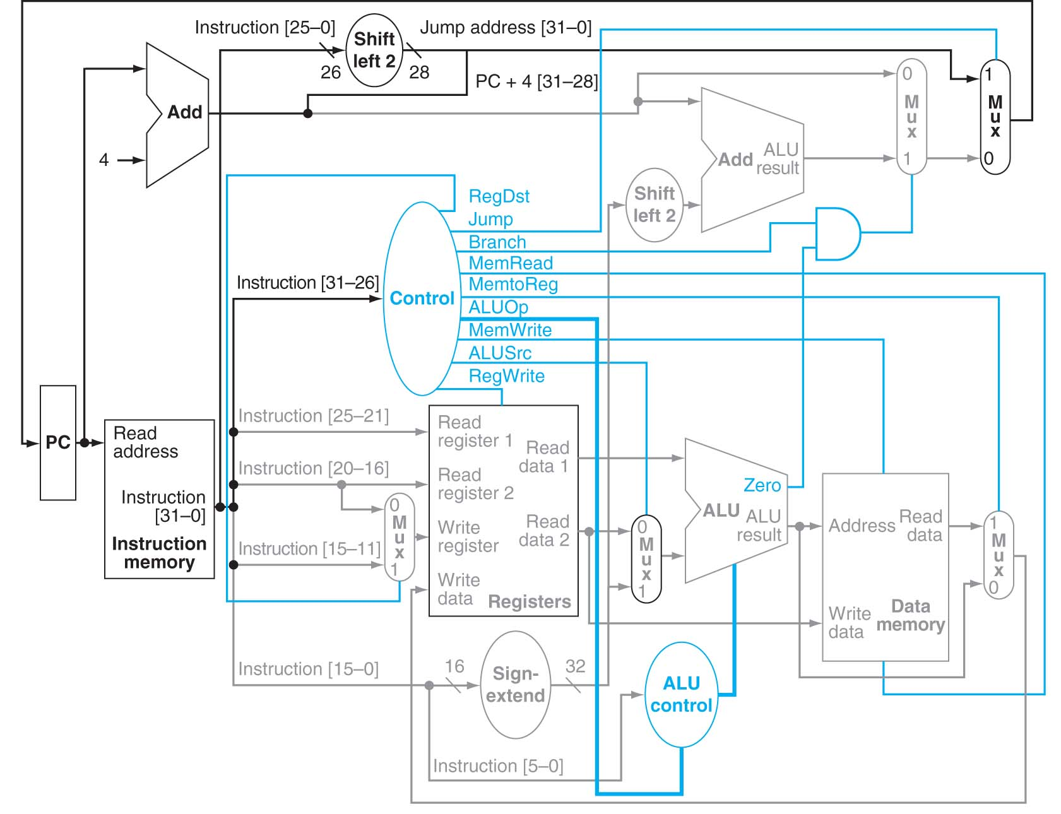

Figure 1. The control and datapath for implementing SCP-V1. It is from the textbook, Figure 4.24.

However, you may use any modeling style and techniques to model any datapath elements and the two control units. The provided regfile.vhd, alu.vhd and adder.vhd all use behavior modeling.

Provided VHDL Files. TBD.

VHDL Programming Style. You are required to use a good VHDL programming style. The code should be well indented and formatted, use meaningful names, and be sufficiently commented. You and your partner must use a consistent programming style, but it doesn’t have to be consistent with the provided VHDL program files.

Use a separate file for an entity or multiple entities of one type, e.g. alu_ctrl.vhd for the ALU control unit, and mux.vhd for 2-to-1 mux, 3-to-1-mux and so on. Use VHDL generic when appropriate.

You’ll have to revise the datapath, the main control unit, and the ALU control. Re-read P&H 4.4 if necessary. In the class we will discuss how to add the support for ADDI, SLL, BNE and SLL, and more importantly the thought process behind extending the CPU to support more MIPS instructions.

**Demonstration**. A test bench names tb_cpu1.vhd is provided. It works if and only if you code in Part 1 works correctly. The test bench compares the outcome of two CPU instances, cpu0 (from Part 1) and cpu1 (from this part), of every clock cycle. The test bench program will stop the simulation when the first mismatch appears. Then, you may inspect the CPU internal signals to identify the error. This will reduce the debugging time.

Demonstrate that the CPU works correctly, and inspect the memory contents at the end of execution. You should test your CPU using multiple input data arrays.

Notes on Debugging. You may have learned a number of debugging skills on ModelSim simulation. The following tips may be useful in this project:
- Inspecting signals: You may pause the simulation at any time and then inspect the signal values inside any component instance.
- Inspecting memory structure: You may pause the simulation at any time and then inspect the contents of any memory structure. Those include the contents of the CPU register file and the data memory.
- Be selective with waveform signals: The CPU has many signals ongoing. For a debugging purpose, select only the relevant signals into the waveform. For example, when you monitor the CPU program execution for a sequence of instructions, you may want to include the registers and memory words to be changed by your program, not all registers and memory words.
- Pause simulation and inspect signals at the right time: You may use 100ns as the default clock cycle. When inspecting signals, you may want to stop right before a rising clock edge. There can be uncertainty if you inspect exactly at the time of the rising clock edge.
- For example, if the rising clock edge occurs at 100ns, 200ns, 300ns and so on, you may want to inspect signals at 90ns, 190ns, 290ns, respectively. Alternatively, you may make the rising clock edge occur at 110ns, 210ns, 310ns and so on, and inspect signals at 100ns, 200ns, 300ns, respectively.

Project Report. In your project report, include the following for Part 2:
- A datapath diagram of your design, with a mark on each control signal. To keep the diagram clear, you don’t have to include the main control and the ALU control and their connections to the control signals. You may use a software tool to draw the diagram. Alternatively, you may hand-draw the diagram, take a photo, and include the photo in the report. In the latter case, make the diagram as readable as possible.
- For each instruction beyond the nine instructions discussed in the textbook, include a short description of the changes to the datapath and control.

Part 3. Integrating Detailed Modeling of Datapath Elements

In the first two parts, the modeling for datapath elements is coarse-level: Behavior modeling is used for ALU, adder, and register file. In this section, you will use detailed modeling for those three components. The requirements are as follows:
- Extend the provided regfile.vhd and adder.vhd by adding another architecture body with your preferred name, e.g. “structural”. Do not remove the current architecture body.
- Integrate your codes from Labs 1-4 (not all the codes) into the new architecture bodies. You may revise your code.
- Your code should be strongly structural. The general guideline is that that code should be detailed enough for a VHDL synthesis tool to generate efficient circuits. If you are not sure if your code would meet the requirement, consult your lab TA or the instructor.

**Demonstration**. Repeat your demonstration for Part 2, but this time test your CPU with the new architecture bodies for the register file and adders. To do so, create a new tb_cpu2.vhd, using tb_cpu1.vhd as the template. Add VHDL configuration statements to bind the new architecture bodies. Here is a link for more examples of using VHDL configuration statements:
http://www.sigasi.com/content/advanced-vhdl-configurations-tying-component-unrelated-entity.

Note that it is common in hardware design that the designers first work out a high-level model and then move to a more detailed model.

Project Report. You might find new bugs in your previous lab code. In the project report, for Part 3, report any bugs and give a short description to each of them. If no bug is found (congratulations!), simply state “None.”

Evaluation Form and Submission:
- Print out a hard copy of the evaluation from (Lab1-Eval.pdf in Lab-01.zip).
- Complete the demos to your TA and ask your TA to sign on the evaluation form.
- Create a zip file Project-A-submit.zip, including the completed code and document from the four lab parts and the lab report.
- Include a project report named Project-A-Report.doc. See the description of project report contents in Parts 1, 2 and 3.
- The names of any new files in your zip file should be self-explained.
- Submit the zip file on BlackBoard Learn under “Project A” assignment.

