CprE 381 – Computer Organization and
Assembly Level Programming

Lab #2

[Note: This is a fairly lengthy lab in which you will learn some good VHDL design practices that will be helpful in your later projects. By ‘structural’ VHDL code, we mean code that has only basic logic gates implemented behaviorally. In contrast, ‘dataflow’ VHDL code uses concurrent assignment statements and allows for a greater amount of abstraction of the underlying logic structure. No ‘behavioral’ code (i.e. processes) is needed to complete this lab, beyond those that would drive signal values in the optional testbenches.]

This lab is due in two weeks.

0) Prelab.
- Read the VHDL Tutorial on Blackbo:spard, pages 9-30.
- [Optional] In Lab 1, you have used ModelSim console commands to compile, add waveforms, and run simulation. Try to repeat the same by creating a ModelSim Project and then using ModelSim menu commands.
1. Start ModelSim, choose menu “File” => “New” => “Project”.
2. In the next dialogue window, give a name to your project (e.g. “Lab-01”) in “Project Name”, and choose your working folder for Lab 1 as “Project Location”. Keep the default value for the other fields.
3. In the following dialogue window, choose “Add Existing File”, and then select all your .vhd files.
Now your project is ready to use. You may use the “Compile”, “Simulate”, “Add”, and other menus on your project.

1) A One’s Complimenter unit is a combinational functional unit that takes a single input and negates each individual bit. Provide your solution to this problem (VHDL code, simulation waveforms) in a folder called ‘P1/’.

- Implement an N-bit one’s complimenter using structural VHDL, with the included inv.vhd NOT gate design as the basic building block. [It is highly recommended that you create an entity using a “generic” port for the N value, similar to what is done in included file generate_example.vhd. You can greatly simplify your code with a “generate / for” block, which essentially acts as a macro expansion.]

- Create a second architecture for this unit that makes use of dataflow VHDL only. [Create this as a second file with a new entity name, to simplify the testing of both modules concurrently.]

- Create a single testbench design that uses structural VHDL to wrap both of these one’s complimenters into a single entity with shared inputs (but different outputs). Use ModelSim to test that both designs give consistent results for the N=32 configuration. Include a waveform screenshot in your report PDF. [An example VHDL testbench is provided as tb_and2.vhd.]

2) A Two-Input Multipliexer (or 2:1 mux) takes two bits as input, and forwards one of them to its output based on the value of a control signal. Provide your solution to this problem in a folder called ‘P2/’.

- Draw the truth table, Boolean equation, and Boolean circuit equivalent (using only two-input gates) that implements a 2:1 mux. Include this in your report PDF.

- Implement a 2:1 mux using structural VHDL, with the included inv.vhd NOT gate design, and2.vhd two-input AND gate design, or2.vhd two-input OR gate design, and xor2.vhd two-input XOR gate design as the basic building blocks. If your solution to part a) uses other two-input Boolean gates, then feel free to design and use those structural components as well.

- Create an N-bit version of this structural 2:1 mux implementation. [Again, implementing this using a “generate / for” block will greatly simplify this task.]

- Create a second architecture for this N-bit unit that makes use of dataflow VHDL only.

- Create a single testbench design that wraps both of these N-bit two-input multiplexers into a single entity with shared inputs (but different outputs). Use ModelSim to test that both designs give consistent results for the N=32 configuration. Include a waveform screenshot in your write-up.

3) A Full Adder takes three bits as input (two operands and one carry-in bit) and calculates both a sum and a carry-out value. Provide your solution to this problem in a folder called ‘P3/’.
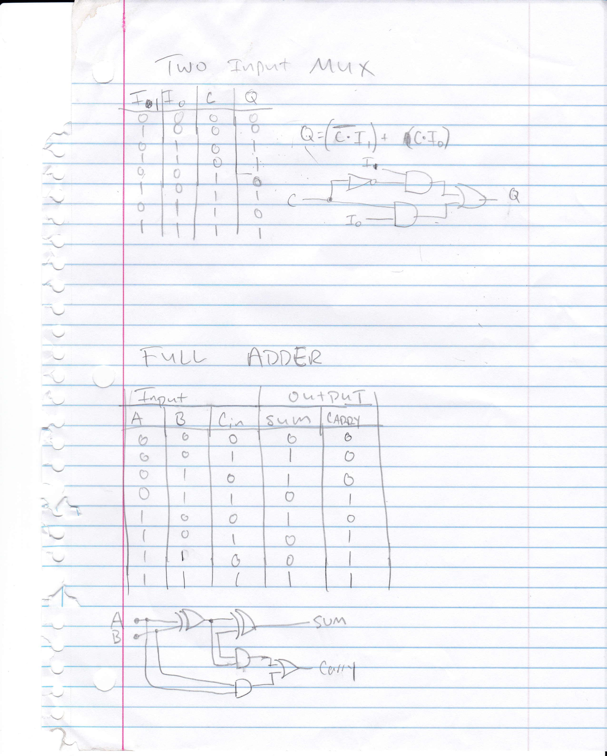
- Draw the truth table, Boolean equation, and Boolean circuit equivalent (using only two-input gates) that implements a full adder. Include this in your report PDF.

- Implement this full adder using structural VHDL, with the included gate designs as the basic building blocks.

- Create an N-bit version of this structural full adder design. [This is slightly less trivial than the previous two designs.]

- Create a second architecture for this N-bit unit that makes use of dataflow VHDL only. [If you are using the VHDL-93 syntax, then the ‘+’ operator is defined for the std_logic_vector data type in the std_logic_unsigned and std_logic_signed libraries. It is recommended to start using the VHDL-02 syntax, with the signed and unsigned data types and the numeric_std library. Ask your TA for details.]

- Create a single testbench design that wraps both of these N-bit adders into a single entity with shared inputs (but different outputs). Use ModelSim to test that both designs give consistent results for the N=32 configuration. Include a waveform screenshot in your write-up.

4) An Adder/Subtractor with Control takes two values (A, B) as input, plus a control bit (nAdd_Sub), and calculates A+B when nAdd_Sub = ‘0’, and A-B when nAdd_Sub = ‘1’. Provide your solution to this problem in a folder called ‘P4/’.

- Draw a schematic showing how an N-bit adder/subtractor with control can be implemented using only the three main components designed in problems 1), 2), and 3) (the N-bit inverter, N-bit 2:1 mux, and N-bit adder). How is the ‘nAdd_Sub’ bit used? Include this in your report PDF.

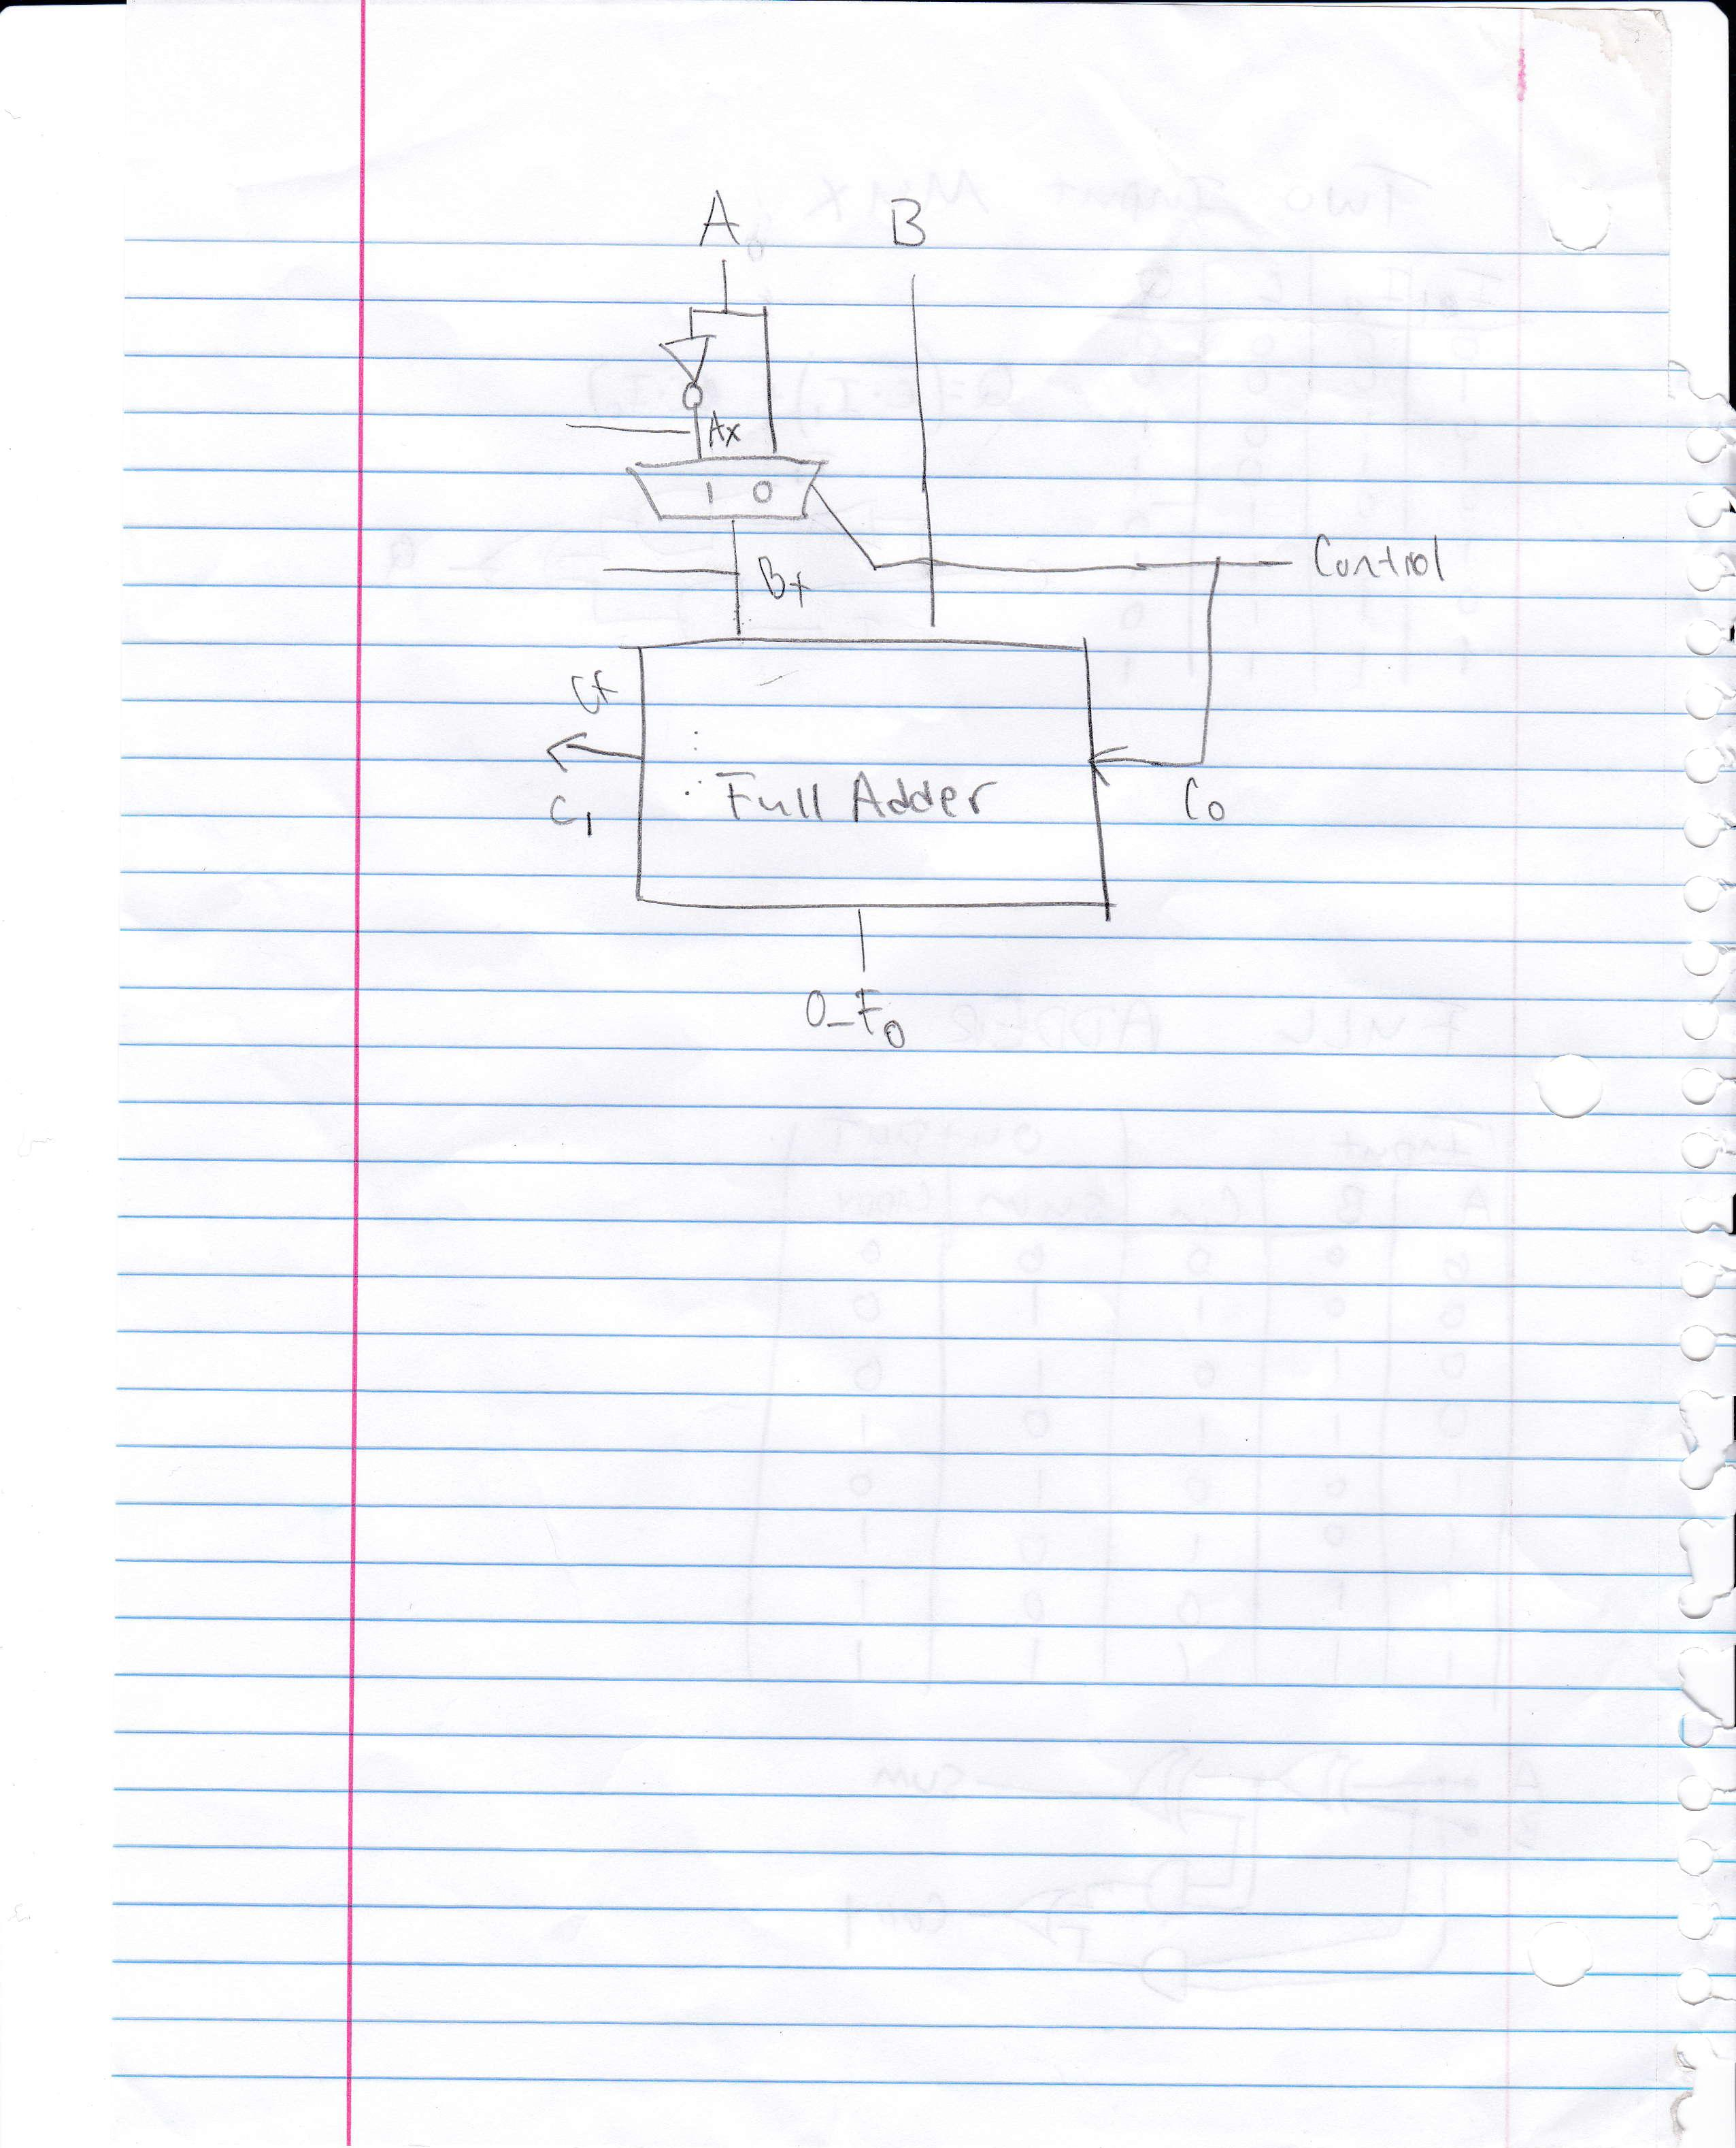

- Implement this adder/subtractor with control using structural VHDL. [Although the dataflow version of your components will simulate faster, you should use the structural N-bit adder, as your dataflow version most likely doesn’t have a carry-in bit.]

- Thoroughly test this design for correctness. Provide multiple waveform screenshots in your write-up to confirm that this component is working correctly. What test-cases did you include and why?

Demo and Submission:
- Print out a hard copy of the evaluation from (Lab2-Eval.pdf in Lab-02.zip).
- Complete the demo to your TA and ask your TA to sign on the evaluation form.
- Create a zip file Lab-02-submit.zip, including the completed code and document from the four lab parts, under directory P1/, P2/, P3/, and P4/.
- The Lab report (using template Lab2-Report.doc in Lab-02.zip)
- The file names in your zip file should be self-explained.
- Submit the zip file on BlackBoard Learn under “Lab 2” assignment.

Credit: This lab was originally created by Dr. Joe Zambreno.

