Pandoc-fignos Demo

# Chapter 1

In-text references to B and results in **Figure 1B and Table 1**.

Multi-reference to Figures (A), the cool part of & and Tables (very cool) & *especially* is rendered as **Figures 1 (A), the cool part of 1 & 2 and Tables 1 (verycool) & *especially* 1**

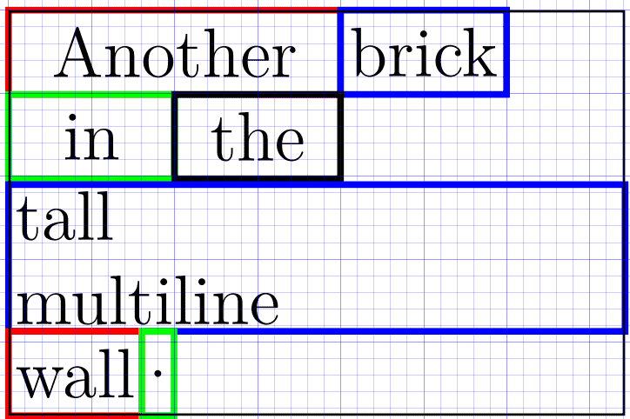

Figure : The number one.



Figure : The unlabeled number two.



Figure : The number three.

Plot is given above, without adding the “Figure” prefix.

As seen in , commas are handled properly.

## Equations

Equations, such as , have to be put into a span with an id:

$$a^{2}+b^{2}=c^{2}$$

## Tables

Table : Caption

| Foo | Bar |
| --- | --- |
| 1 | 2 |

# Another chapter

References to Section and the unnamed Section

Text at end.