Data Transformation and Preparation System

(Interim solution)

Use Cases and Functional Requirements

2016-12-01

Version 1.0

# Document Information and Revision History

|  |  |  |  |
| --- | --- | --- | --- |
| Version | Date | Author(s)/Reviewer(s) | Revision Notes |
| V0.1 | August 26, 2016 | Tatiana Stepourska | Initial draft |
| V0.2 | August 30,2016 | Sandra Thomas, Tatiana Stepourska | Draft. Reviewed some use cases. Added Appendix B with end-to-end scenarios, and referenced additional documents |
| V0.3-V0.8 | 2016-09-07 - 2016-11-18 | Tatiana Stepourska | Draft. Added use cases for Competent Authority to enter encryption passwords, other minor updates, updates according to clients’ answers to EEI questions |
| V1.0 | 2016-12-01 | Richard Smith,  Shib Das,  Subankar Pandit,  Tatiana Stepourska | Captured use cases and functional requirements |
|  |  |  |  |
|  |  |  |  |
|  |  |  |  |
|  |  |  |  |

Table Of Contents

Document Information and Revision History 2

System Development Objective 3

Overview of Business Objectives 3

Participants and Target Users 4

Out of Scope 4

Use Cases 4

Case 1: Outbound Process – Send Domestic Data 5

Use Case 1 Description 6

Case 2: Inbound Process – Receive Foreign Data from CTS 8

Use Case 2 Description 8

Case 3: Access Data 9

Use Case 3 Description 10

Case 4: Receive Status Messages 11

Use Case 4 Description 11

Case 5: Send Status Messages 11

Use Case 5 Description 12

Functional Requirements 12

Non-functional Requirements 15

Business Rules 15

Appendix A. End-to-end Scenarios 15

Appendix B. References 21

# System Development Objective

The Data Transformation and Preparation System described in this document is designed to provide an interim solution, capable of handling the exchange of tax information between the Canada Revenue Agency (CRA) data providers, such as Infodec for Common Reporting Standard (CRS), or CDC for Country by Country Reporting (CbC), and the Common Transmission System (CTS), while following international standards for data transformation, encryption, transmission, confidentiality and security, until permanent solution produced by the designated vendor is put in place

# Overview of Business Objectives

There is a need to perform tax data exchange for CRA with foreign jurisdictions to prevent international base erosion and profit shifting.

Data exchange includes data preparation, data transfer and notification delivery for the Common Reporting Standard (CRS), Country by Country Reporting (CbCR), Foreign Account Tax Compliance Act (FATCA) and Exchange Tax Rulings (ETR) projects.

Under the CRS, foreign tax authorities will provide information to the CRA related to financial accounts in their jurisdictions that are held by Canadian residents. The CRA will reciprocate by providing corresponding information to the foreign tax authorities on financial accounts in Canada that are held by residents of their jurisdictions5.

The CbC report will be filed by multinational enterprises (MNEs). It is anticipated that most (if not all) of the domestic enterprises that will be required to file the CbC report are corporations. There are approximately 100 ultimate parent entities that will be required to file the CbC report in Canada. In addition, depending on the pending legislation, constituent entities resident in Canada may be designated as surrogate parent entities and in such case would also be required to file the CbC report in Canada.

FATCA IT systems capture information from Canadian financial institutions (FIs) on certain financial accounts held by U.S. persons, including U.S. citizens, U.S. residents and non-U.S. entities with substantial U.S. owners, and then send it electronically to the Internal Revenue Service (IRS)7.

Under ETR, the system will support the mandatory spontaneous exchange on certain tax rulings between countries.

# Participants and Target Users

Data exchange occurs between domestic data providers, such as InfoDec (for CRS) or CDC (for CbCR), and the Common Transmission System (CTS) which serves as a hub for transmitting data[1] internationally.

Competent Authority Service Delivery (CASD) is responsible for intercepting outgoing and incoming data for the purpose of validation. They will use the system to view and validate data sent to or received from international partners.

# Out of Scope

Manual data modifications and / or adjustments are outside of the EEI team scope of responsibility.

# Use Cases

Data exchange top level use cases for interim solution include sending domestic data to foreign jurisdictions, receiving data from foreign jurisdictions, generating file level status messages, preparing and forwarding record level status messages, generated by data providers, and receiving status messages. CASD has access to the data and status messages in transition, as well as historical status message content and transmission statistics.

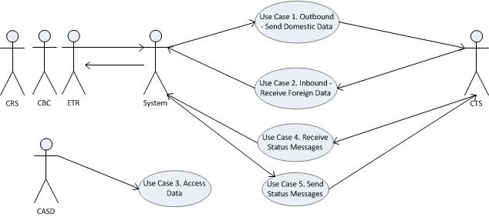

## Case 1: Outbound Process – Send Domestic Data

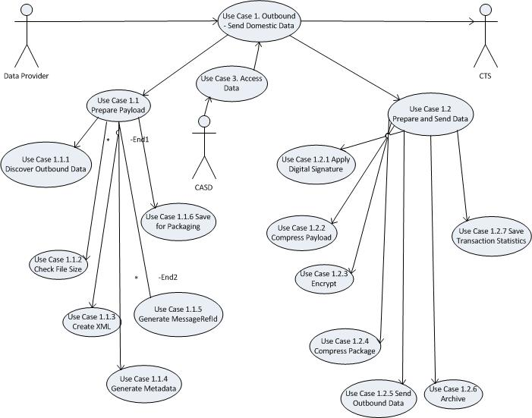

### Use Case 1 Description

The CRA data providers will collect, validate, and store Domestic tax data. Data selected for exchange is compiled in a file and stored in a drop zone for further processing. Depending on the project / workflow it might be a different data channel and file type: for example, a flat file stored on mainframe for CRS and FATCA, or ready to go XML file, generated by CDC for CbCR.

File coming from domestic data provider can be also a status message to be sent to foreign partner as a result of data validation performed by data provider on the incoming data package received some time earlier.

Due to the sensitive nature of the data, manual intervention by CASD is required after XML file is ready and before further data preparation. That is why outbound use case consists of two major subcases, which in turn are divided into smaller subcases.

#### Prepare XML Payload

During this step data is prepared for CASD to trigger digital signing, encryption and packaging

##### 1.1.1 Receive Outbound Data

The process of sending data to foreign tax authority starts with getting the data package from domestic storage.

##### 1.1.2 Check File Size

System checks the calculated package size.

##### 1.1.3 Create XML

Based on a data provider and message type (report or status message), system selects appropriate XML schema, then builds and / or validates XML content.

##### 1.1.4 Generate Metadata

System generates metadata.

1.1.5 Generate MessageRefId

Message reference identifier needs to be generated for each XML data file to be sent, and saved together with PSN numbers (Infodec specific ) for future handling: if this file is accepted by other jurisdiction, MessageRefId with PSNs has to be fed back to Infodec

##### 1.1.6 Save for Packaging

System saves XML payload file for further processing at a future time. System sends email to CASD to inform that an XML file is available and waiting for manual intervention.

#### Package and Send Data

This case is triggered by CASD

##### 3.4 Access Data – Use Case 3

##### 1.2.1 Apply Digital Signature

At this point system digitally signs the validated and well formatted XML file. System accesses keystore to retrieve sender key and receiver certificate.

##### 1.2.2 Compress Payload

System compresses XML file.

##### 1.2.3 Encrypt

System encrypts the signed payload

##### 1.2.4 Compress Package

System compresses the encrypted XML file and metadata file into a single package

##### 1.2.5 Send Outbound Package

System transfers the data package to the designated drop zone to upload to CTS

##### 1.2.6 Archive

System transfers compressed data package to the designated location for retention for specified number of years

##### 1.2.7 Save Transaction Statistics

System saves status of the completed process and the error message(s), if any, and metadata to the database.

## Case 2: Inbound Process – Receive Foreign Data from CTS

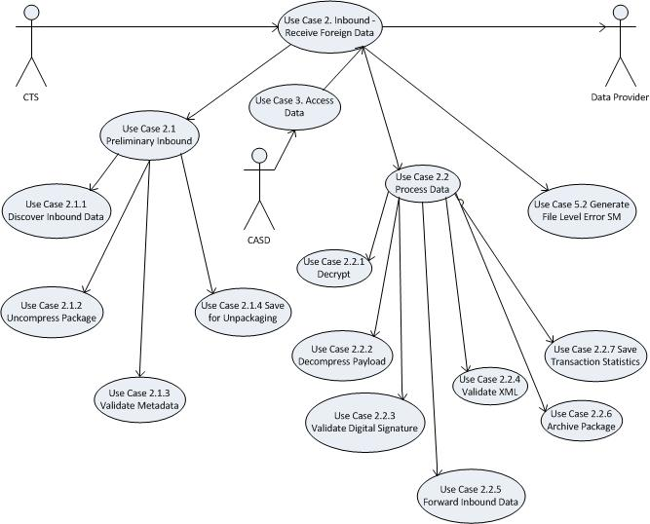

### Use Case 2 Description

Foreign tax data is sent to CRA by international partners via CTS[2]. System gets the data package from CTS and stores it in a designated location.

Due to the sensitive nature of the data, manual intervention by CASD is required after data package is received from CTS and before further data preparation. That is why inbound use case consists of two major subcases, which in turn are divided into smaller subcases.

#### Use Case 2.1 Preliminary

Discover the package and save it for CASD access

##### 2.1.1 Discover Inbound Data

System discovers the incoming package.

##### 2.1.2 Decompress Package

System decompresses the inbound package

##### 2.1.3 Validate Metadata

System validates the schema and content of the metadata

##### 2.1.4 Save for Processing

System saves files for future processing and view, and sends an email to CASD to inform them that file is available and waiting for manual intervention.

#### Use Case 2.2 Process Data

##### 2.2.1 Decrypt

System checks the validity and revocation status of the sender certificate(s) and decrypts the data

##### 2.2.2 Decompress Payload

System decompresses payload

##### 2.2.3 Validate Digital Signature

System validates digital signature. If digital signature is invalid, file is immediately deleted.

##### 2.2.4 Validate XML

System selects appropriate XML schema and validates the XML payload against it

##### 2.2.5 Forward Inbound Data

System forwards the unencrypted payload XML to the data provider’s repository

##### 2.2.6 Archive Package

System stores the inbound package in the designated location for archiving

##### 2.2.7 Save Transaction Statistics

Metadata, status or error with error code and message(s), other info need to be saved by the system for reporting

## Case 3: Access Data

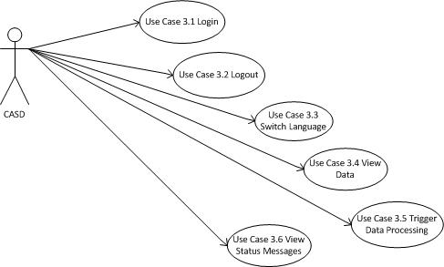

### Use Case 3 Description

When the information from a data file is accessed, the following Treaty stamp must be visible on the screen display, as well as being printed on all hard copies made5:

This information is furnished under the provisions of an income tax treaty with a foreign government. Its use and disclosure must be governed by the provisions of that treaty.

Les renseignements sont donnés en vertu des articles d’une convention fiscale conclue avec un Gouvernement étranger ces renseignements doivent être utilises et divulgues selon les articles de cette convention.

Competent Authority user needs to be able to view and modify content of the available outgoing and incoming files in transition, and to trigger further processing.

The system must interface with the module that is responsible for receiving automatic notifications from partner jurisdictions.

#### Login

User should be able to log into the system with his / her personal username and password

#### Log out

User should be able to log out of the system

#### 3.3 Switch Language

User should be able to select English or French for web system controls

#### Trigger Data Processing

Competent Authority user should be able to trigger the remaining part of the inbound or outbound processes

#### 3.5 View data

CASD user has the ability to view data from all files in transition, both being received from other jurisdictions and being sent to other jurisdictions

#### 3.6 View Status Messages / Track Issues

User should have the capability to view content of status messages received from other jurisdictions and to track issues

## Case 4: Receive Status Messages

Data provider needs to receive status messages sent by foreign partners.

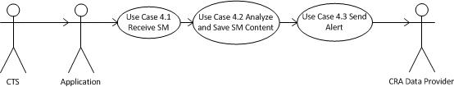

### Use Case 4 Description

#### 4.1 Receive Status Message

System discovers status message package from CTS/SSC and unpackages it (see Use case 2)

#### 4.2 Analyze and Save Status Message Content

The content of a status message is parsed for error codes to handle file level errors and any other specific handling based on status code and file acceptance status. Content of received status message is saved in the database for tracking purposes.

#### 4.3 Send Alert

CASD needs to be notified about incoming status message.

## Case 5: Send Status Messages

Foreign partners need to receive status messages for file and record level errors.

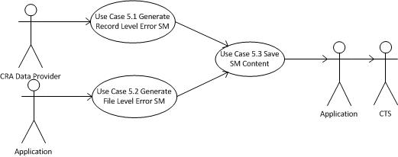

### Use Case 5 Description

#### 5.1 Generate Record Level Error SM

After analyzing and validating data received from a foreign jurisdiction data provider creates record level error status message that contains error codes, descriptions and file acceptance status. Data provider sends it over to the application in a same manner it sends domestic data message. Application follows process described in Use Case 1 to prepare and send SM to CTS.

#### 5.2 Generate File Level Error SM

Application generates file level error status message if it encounters any errors during processing incoming data package. Application follows process described in Use Case 1 to prepare and send SM to CTS.

#### 5.3 Save SM Content

SM content is saved in the application database to be available for viewing by CASD to track issues with data flow.

# Functional Requirements

|  |  |  |
| --- | --- | --- |
| **Req. ID** | **Requirement Definition** | **Questions / Comments** |
| FR1 | System will discover, prepare and package the tax data to the foreign jurisdictions and send it over to CTS for transmission |  |
| FR1.1 | System will discover file and prepare payload to be sent to foreign jurisdictions via CTS |  |
| FR1.1.1 | System will discover the data package, determine what data provider is it from, and what message type is it (data or SM), then will save it to the temporary location and parse flat file |  |
| FR1.1.2 | System will check the flat file size and calculates XML payload size (x3). If allowed threshold of 250 MB exceeded, payload should be split | If Infodec generates messageRefId, they have to check file size |
| FR1.1.3 | System will generate XML file in the format provided by the appropriate OECD schema(s) and/or validate it | Except CbC, for which it will validate only |
| FR1.1.4 | System will generate metadata file, that will contain traceable ID(s), information to determine which party/country/data provider it belongs to, and any other fields provided in the specification, according to the OECD schema and message type |  |
| FR1.1.5 | System will generate MessageRefId in a format provided in OECD/ CTS specification and save it in the application database together with metadata information and Infodec PSN numbers mapping. | Infodec specific: no feeding back of MessageRefId and mapped PSN numbers happens at this stage. |
| FR1.1.6 | System will save payload for CASD to access data and trigger further processing |  |
|  |  |  |
| FR1.2 | Triggered by manual intervention from CA, system will package the XML payload and send it over to the CTS |  |
| FR1.2.1 | System will apply digital signature to the XML to ensure data integrity during transmission |  |
| FR1.2.2 | System will compress the XML file as specified in the OECD documentation |  |
| FR1.2.3 | System will encrypt the XML file as specified in the OECD documentation |  |
| FR1.2.4 | System will compress the encrypted XML and metadata into a single package |  |
| FR1.2.5 | System will forward the packaged data to the CTS or drop zone for further transmission |  |
| FR1.2.6 | System will archive / backup data package to be retained for specified number of years |  |
| FR1.2.7 | System will save metadata, results of the execution of the steps 1.1 and 1.2, and other information for statistics |  |
|  |  |  |
| FR2 | System will receive the data from foreign jurisdiction via CTS, unpack, validate and save it |  |
| FR2.1.1 | System will receive data package from CTS, determine whether it is a data or status message, and what data provider it belongs to |  |
| FR2.1.2 | System will decompress the package |  |
| FR2.1.3 | System will validate metadata |  |
| FR2.1.4 | System will save the package files in the designated directory for CASD and send an email. Timeout 3 days. |  |
|  |  |  |
| FR2.2 | Triggered by CASD manual intervention, system will unpack data and forward it to the appropriate data provider |  |
| FR2.2.1 | Triggered by CASD, system will decrypt the compressed XML payload |  |
| FR2.2.2 | System will unzip the decrypted payload |  |
| FR2.2.3 | System will validate digital signature |  |
| FR2.2.4 | System will validate XML file against the appropriate schema and check for file level errors, according to OECD specification |  |
| FR2.2.5 | System will forward inbound data to the appropriate data provider |  |
| FR2.2.6 | System will archive/ back up the data |  |
| FR2.2.7 | System will save metadata and transaction statistics in the database |  |
| FR2.2.8 | System will perform the virus check |  |
|  |  |  |
| FR3 | System will provide a secure interface for CASD user to trigger further data processing, to provide access to XML data files and status messages in transition for viewing and validating, to historical status messages and statistics |  |
| FR3.1 | System will provide user with ability to log in with personal username and password |  |
| FR3.2 | System will provide user with ability to log out |  |
| FR3.3 | System will provide a bilingual interface (English and French) and will provide capability to switch between languages. |  |
| FR3.4 | System will provide CASD an ability to trigger data and status messages packaging / un-packaging |  |
| FR3.5 | System will provide CASD user with an ability to view inbound and outbound data and status messages. File names must be distinctive, timestamps must indicate when file was loaded |  |
| FR3.6 | System will provide CASD user with an ability to trigger file forwarding to the appropriate data provider after they viewed the data or status message received from a foreign partner |  |
| FR3.7 | System will provide CASD user with an ability to make modifications to, or remove records from outbound data before the data is packaged | CASD needs direct approval for that from FI, so automatic email function might make sense |
| FR3.8 | System will provide CASD with the search capability for viewing XML files |  |
| FR3.9 | System will record any outbound data modification along with the correlated IDs, user name and time stamp |  |
| FR3.10 | System will attach a treaty message to any data opened for viewing or modifications |  |
| FR3.11 | System will provide CASD user with ability to view information from sent and received status messages |  |
| FR3.12 | System will provide CASD user with the ability to associate status message with appropriate messageRefId to track issues |  |
| FR3.13 | Web interface will provide role “casd” – competent authority can view data, enter encryption passwords, view status messages and transmission statistics | CASD need only one role |
|  |  |  |
| FR4.1 | System will have the capability to receive status messages in XML format |  |
| FR4.2 | System will be able to parse XML status message and extract data, such as error code, message, and other relevant information. | For Infodec: at this point it has to receive MessageRefId for accepted data file along with PSN numbers mapping |
| FR4.3 | System will save status message content and metadata in the database |  |
| FR4.4 | System will send alert to designated person(s) about receiving status message |  |
|  |  |  |
| FR 5 | System will send out file level and record level status messages for incoming data packages |  |
| FR5.1 | System will accept status message information from data providers to be sent to CTS. File will be prepared and sent out using the same data transformation and preparation process as outbound data package |  |
| FR 5.2 | In case of any error during data package processing system will generate file level status message. It will contain error code (50000-59999), error description and file acceptance status. File will be prepared and sent out using the same data transformation and preparation process as outbound data package |  |
| FR5.3 | System will save SM content in the application database for further viewing |  |
|  |  |  |
|  |  |  |
|  |  |  |
|  |  |  |

# Non-functional Requirements

|  |  |  |  |
| --- | --- | --- | --- |
| **Req ID** | **Requirement Definition** | **Questions / Comments** |  |
| NFR1 | System environment: Java 1.7 and Weblogic 12 on eBCI |  |  |
| NFR2 | System technologies and frameworks: EJB, Struts 2, WET 4, JSP, RCCI components, cob2java, JAXB |  |  |
| NFR3 | File size threshold allowed by CTS is 250 MB compressed. For some European parties it is 100 MB non-compressed. |  |  |
| NFR4 | RAM allocated to Weblogic / JVM is 2 GB |  |  |
| NFR5 | OS is Linux |  |  |
|  |  |  |  |
|  |  |  |  |
|  |  |  |  |
|  |  |  |  |
|  |  |  |  |
|  |  |  |  |

# Business Rules

|  |  |  |
| --- | --- | --- |
| BR ID | Definition | Questions / Comments |
| BR1 | Amendments, Corrections and Cancellations can only be sent after original data package |  |
| BR2 | Infodec must receive new MessageRefId if, and only if, data file has been accepted by other jurisdiction |  |
| BR3 | If the same data file needs to be sent to more than one country, a unique messageRefId must be generated for each country |  |
|  |  |  |

# Appendix A. End-to-end Scenarios

#### Scenario 1. Send data from CRA to OJ (outbound), receive notification and remedy action

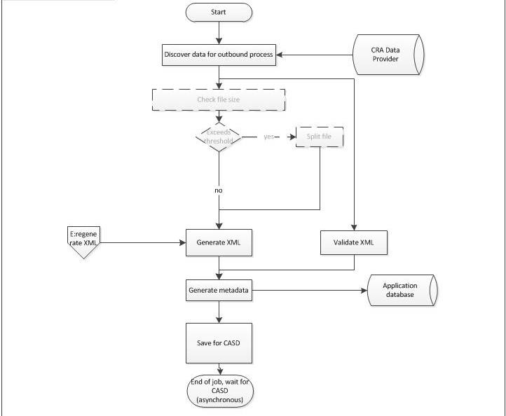

*Scenario 1 (contd.)*

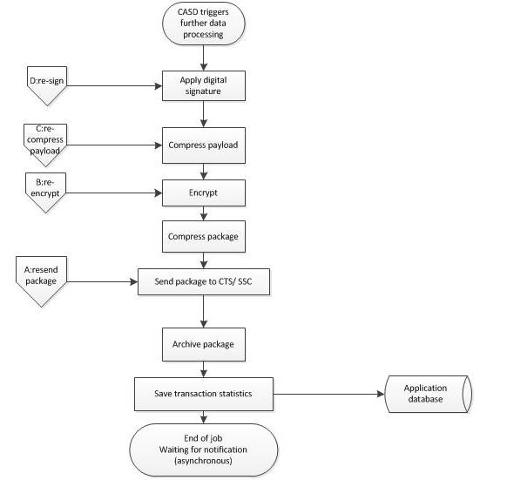

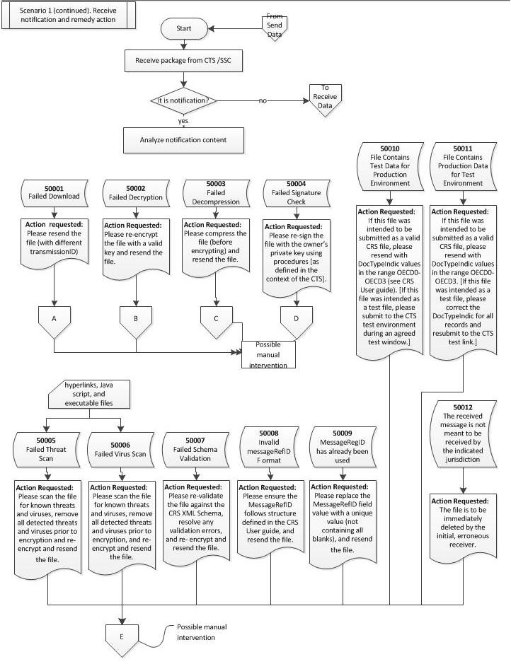

#### Scenario 2. Receive data from OJ to CRA (inbound) and send status message back

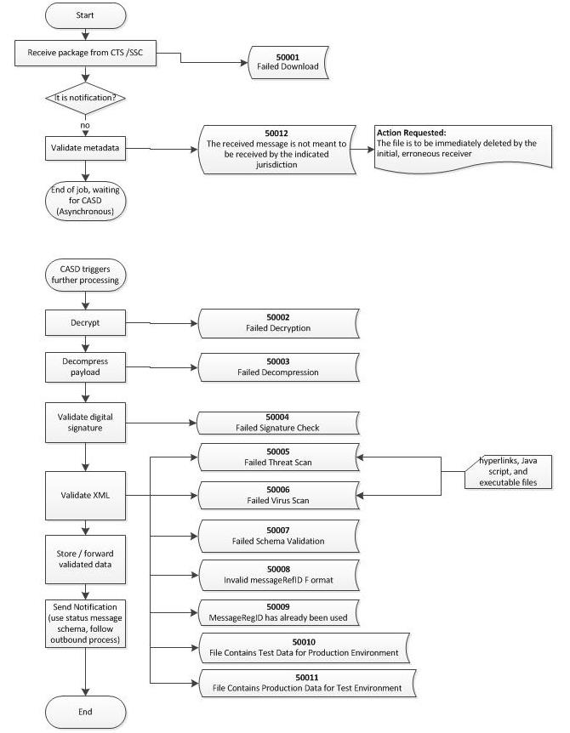

#### Scenario 3. CASD Data Access

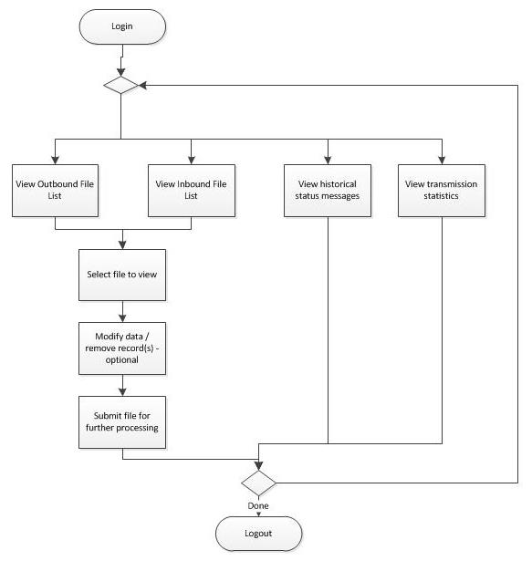

# Appendix B. References

1. G:\EEI\1 Projects\Common Reporting Standard (CRS)\1 Planning\PM-BA Processes-Documents\3 HLBR-DBR\IAS Brainstorm of High Level Requirements for CRS 2016-01-05.docx
2. G:\EEI\1 Projects\Common Reporting Standard (CRS)\1 Planning\Docs from DCO\141003 CRS Implementation Handbook.docx
3. G:\EEI\1 Projects\Country by Country Reporting (CbC)\1 Planning\Docs from DCO\FlowCharts\CbC Business Process Flowv1.2.vsd
4. RFI for electronic exchange of files initiative
5. G:\EEI\1 Projects\Common Reporting Standard (CRS)\1 Planning\PM-BA Processes-Documents\3 HLBR-DBR\CRS - Outgoing CRS data_v4 – IAS.doc
6. G:\EEI\1 Projects\Country by Country Reporting (CbC)\1 Planning\PM-BA Processes-Documents\3 HLBR-DBR\CbCReport_Phase1_Release1_PITA_Preliminary Impacting Turnaround_SG2016-04-18 (2)
7. G:\EEI\1 Projects\Foreign Account Tax Compliance Act (FATCA)\2 Development\Documents-Processes\Analysis of FATCA reporting scenarios 2014-02-25.docx

1. [G:\EEI\1 Projects\Common Reporting Standard (CRS)\1 Planning\Docs from DCO\Proposal\CRS Project Vision Mar 5 v1 8.docx](G:\\EEI\\Team2 old folder\\1 Projects\\Common Reporting Standard (CRS)\\1 Planning\\Docs from DCO\\Proposal\\CRS Project Vision Mar 5 v1 8.docx) p. 7
2. G:\EEI\Common Reporting Standard (CRS)\1 Planning\PM-BA Processes-Documents\RFI\ CRS MFT requirements.xlsx
3. G:\EEI\1 Projects\Foreign Account Tax Compliance Act (FATCA)\1 Planning\1 Processes-Documents\IAS Process Flow Doc\Procedure - FATCA - Transmission and Notification Process_v2.docx
4. G:\EEI\1 Projects\Foreign Account Tax Compliance Act (FATCA)\1 Planning\1 Processes-Documents\2 HLBR-DBR\IRS to CRA - Notifications (PSL25033)\ CA HLBR_FATCA_Notifications_EOI(VKS).docx
5. G:\EEI\1 Projects\Common Reporting Standard (CRS)\1 Planning\PM-BA Processes-Documents\3 HLBR-DBR\CRS - Outgoing CRS data_v4.doc : links to
   1. COMMON APPROACH TO CTS FILE PREPARATION AND ENCRYPTION.pdf and
   2. COMMON APPROACH TO CRS RELATED TECHNICAL ISSUES
6. G:\EEI\1 Projects\Common Reporting Standard (CRS)\2 Development\Research\OECD CRS schemas\CRS-schema-v1.0
7. G:\EEI\1 Projects\Common Reporting Standard (CRS)\2 Development\Research\OECD CRS schemas\CRS-Status-Message-XML-Schema-V1.0
8. RE Definition of MVP for Thursday.msg
9. CASD_questions_0.3_with_client_responses.docx
10. FW CASD question Draft V2 - for your consideration.msg

<End Of Document>

1. Excludes FATCA data, which will be submitted to the US via the IDES
2. Currently FATCA data is received from US via IDES.