Database Description

This document’s purpose is to serve as a descriptive piece for the database itself. It will describe the purpose of each table, what each column is, and if the column is required or not.

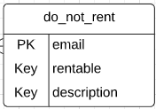do_not_rent