Creator: Vedran Stanic (vedran.stanic@teaminformatics.com)

Company: TEAM Informatics, Inc.

**Speedy Archiver**

**About**

Speedy arhiver helps you transfer contents of a single archive job between environments using only the OOTB CS pages. This helps in situations where Archiver Replication cannot not be setup and you want to avoid logging into all the environments using an RDP, etc.

You must be logged in as „sysadmin“ to see the additional „Speedy Archive“ menu:

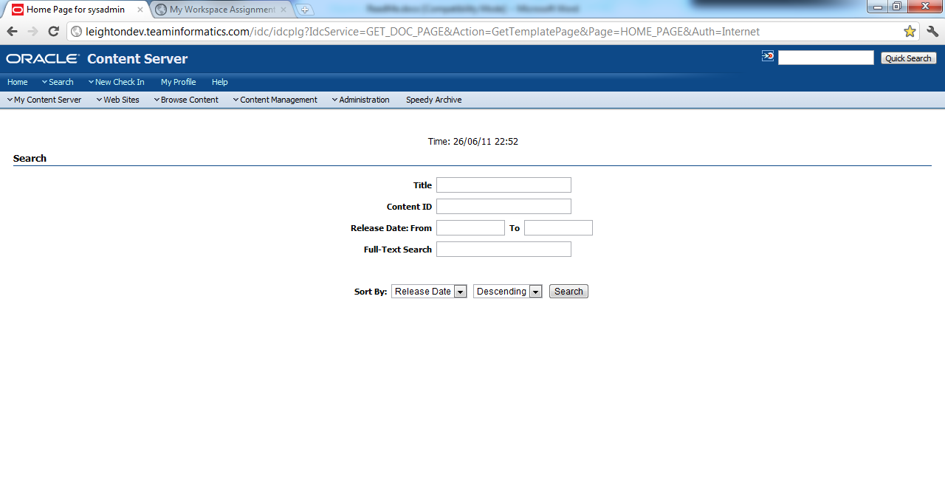

**How to use it**

1. Use the Archiver Applet to create, define, and export an archive job
2. Go to the „Speedy Archive“ landing page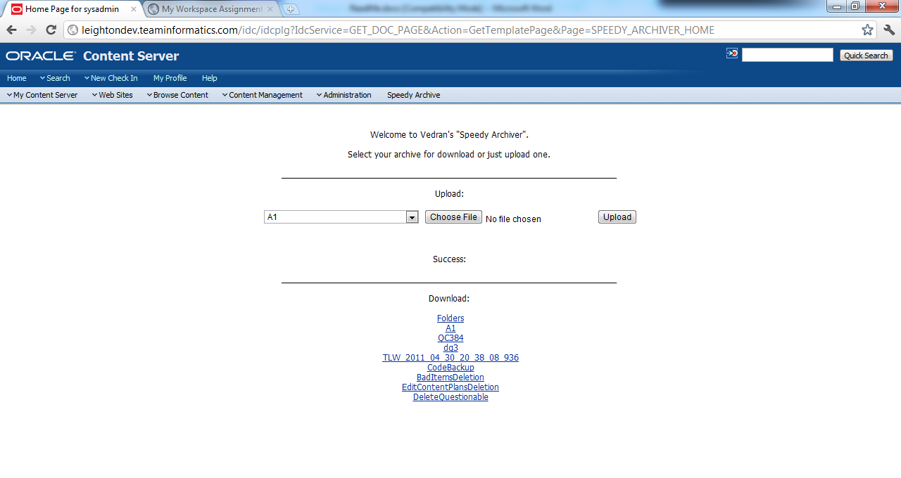
3. If you have exported the job using the Archive Applet you can now download it from the download section (the link will package up a .zip file on the fly using the contents of the „ucm/server/archives/yourjob/“ contents
4. Now you can use this ZIP file and upload it to the destination environment using this same landing page on that destination environment. This will unpackage the contents you downloaded into the „ucm/server/archives/yourjob/“ folder.
5. On the destination environment go to the Archiver Applet and import „yourjob“

**Things to look out for**

1. SpeedyArchiver was created in under a day of work and is lacking any extensive testing, validation, etc.
2. Do not rely on it being smart enough to not mess things up for you.
   1. If you upload a „YourJob.zip“ file while the dropdown selection is „SomeOtherJob“ the contents of the „SomeOtherJob“ will be replaced with the contents of the „YourJob.zip“ file and this will corrupt the archives and you will manually need to fix it.
   2. You need to have an „YourJob“ archive created on all envs using the Archiver Applet first, because there is an .hda file that needs to be updated before the archive job is visible in the Archiver Applet
   3. Once you have created a „YourJob“ on all envs, the uploading of the zip file will extract the contents into that folder appropriatelly and the contents will be visible in the archiver applet for that env.
   4. You might need to restart the Archiver Applet after you have uploaded the zip file for the new info to be visible.
3. It works good with CS 10gR3-4, but it is not tested for 11g
4. I usually create an archive job „A1“ on all environments and always delete the previous batched content in it before i export it on the source environment.