Supplementary material
Appendix S1. Estimation of the extent to which identified prey items in fox dietary samples are consumed as carrion or killed by the fox that ate them. (Available as separate word document)

Table S1. Description and source of all predictor variables used for fox density, fox diet and cat diet analyses.
Predictor variable | Description | Source
Mean annual temperature | Mean annual temperature (°C) averaged over 1961-1990. | Australian Bureau of Meteorology, (2016a) Average Annual and Monthly Maximum, Minimum, and Mean Temperature
Mean annual rainfall | Mean annual precipitation (mm) averaged over 1961-1990. | Australian Bureau of Meteorology, (2016b) Average Annual, Seasonal and Monthly Rainfall.
Mean tree cover | MODIS satellite-derived tree cover (percentage green vegetation cover) within a 5 km radius of the study site. | Hansen, M. C., R. S. DeFries, J. R. G. Townshend, M. Carroll, C. Dimiceli & R. A. Sohlberg (2003) Global percent tree cover at a spatial resolution of 500 m: first results of the MODIS vegetation continuous fields algorithm. Earth Interactions, 7.
Topographic ruggedness | Standard deviation of elevation (m) within a 5 km radius of the study site. | Jarvis, A., H. I. Reuter, A. Nelson & E. Guevara, (2008) Hole-filled SRTM for the globe Version 4 available from the CGIAR-CSI SRTM 90m Database.
Distance from the coast | Distance to the coast (km) calculated as distance to the nearest coastline using GIS.
Mean human population density | Mean human population within a 5 km radius of the study site. | Australian Bureau of Statistics. (2014). Australian population grid, 2011.
Vegetation disturbance | Mean vegetation disturbance within a 5 km radius of the study site taken from the 'vegetation assets and states and transitions classification' (VAST) of Australian vegetation. The VAST classification categorises vegetation by the degree of modification from least to most intact: 0=bare,1= residual, 2=modified, 3=transformed, 4-5=replaced, 6=removed. For the purposes of our study natural 'bare' vegetation was combined with 'residual' vegetation. When averaged across a study site, VAST categories were converted to a continuous measure of vegetation disturbance ranging from 1 (least disturbed) to 5 (most disturbed). | Australia State of the Environment (2017). Land VAST classification of Australian vegetation, 2016.
Table S2. Complete list of fox diet studies used to provide frequency of occurrence estimates of reptiles, birds, and mammals in fox diets (scats and/or stomachs).
(Available as separate excel workbook)

Table S3. Relative variable importance for all predictor variables used for modelling the frequency of occurrence of each major prey group in fox diets, including and excluding the four island sites. Bolded values highlight significant variables (RVI ≥0.73).
Prey group | Vegetation disturbance | Distance to coast | Mean annual temperature | Vegetation cover | Human population density | Ruggedness | Proportion scats
Reptile including islands | 0.92 | 0.33 | 0.98 | 0.95 | 0.27 | 0.31 | 0.26
Reptile excluding islands | 0.94 | 0.29 | 0.94 | 0.98 | 0.27 | 0.30 | 0.25
Bird including islands | 0.83 | 1.00 | 1.00 | 0.45 | 0.32 | 0.27 | 0.97
Bird excluding islands | 0.77 | 0.98 | 1.00 | 0.30 | 0.65 | 0.27 | 0.61
Native mammals including islands | 0.41 | 0.28 | 0.57 | 1.00 | 0.31 | 0.29 | 0.31
Native mammals excluding islands | 0.46 | 0.54 | 0.43 | 1.00 | 0.41 | 0.33 | 0.26
Introduced mammals including islands | 0.98 | 0.30 | 0.43 | 1.00 | 0.99 | 0.38 | 0.91
Introduced mammals excluding islands | 1.00 | 0.31 | 0.55 | 1.00 | 1.00 | 0.36 | 0.97

Table S4. Model ranking table for models to explain spatial variation in fox density. Models were ranked according to increasing AIC_{c}. ΔAIC_{c} represents the difference between a model's AIC_{c} value and the minimum AIC_{c} value in the set of candidate models. w_{i} is the Akaike weight, or the probability of the model being the best in the candidate set. The set of candidate models included all combinations of the six explanatory variables (i.e. 64 models), but only the models with ΔAIC_{c} ≤10 are shown. Relative variable importance (RVI) is also shown for the six explanatory variables; values in bold indicate a clear effect (RVI ≥0.73).

Model rank | Mean annual temperature | Human population density | Tree cover | Distance to coast | Ruggedness | Disturbance | ΔAIC_{c} | w_{i} | R²
1 | + | + | + |  |  |  | 0.0 | 0.16 | 0.66
2 | + | + |  | + | + |  | 0.6 | 0.12 | 0.67
3 | + | + | + |  | + |  | 1.3 | 0.08 | 0.67
4 | + | + |  | + |  | + | 1.4 | 0.08 | 0.00
5 | + | + |  |  |  | + | 1.4 | 0.08 | 0.65
6 | + | + | + |  |  | + | 1.6 | 0.07 | 0.67
7 | + | + | + | + |  |  | 1.8 | 0.07 | 0.67
8 | + | + |  | + | + | + | 2.0 | 0.06 | 0.68
9 | + | + | + | + | + |  | 2.3 | 0.05 | 0.68
10 | + | + |  | + |  |  | 2.3 | 0.05 | 0.64
11 | + | + |  |  | + | + | 2.9 | 0.04 | 0.66
12 | + | + |  |  | + |  | 2.9 | 0.04 | 0.64
13 | + | + | + | + |  | + | 3.2 | 0.03 | 0.68
14 | + | + | + |  | + | + | 3.5 | 0.03 | 0.67
15 | + | + |  |  |  |  | 3.6 | 0.03 | 0.61
16 | + | + | + | + | + | + | 4.5 | 0.02 | 0.69
17 | + |  |  |  |  | + | 8.9 | 0.00 | 0.56
RVI: | 1.00 | 1.00 | 0.51 | 0.47 | 0.43 | 0.41

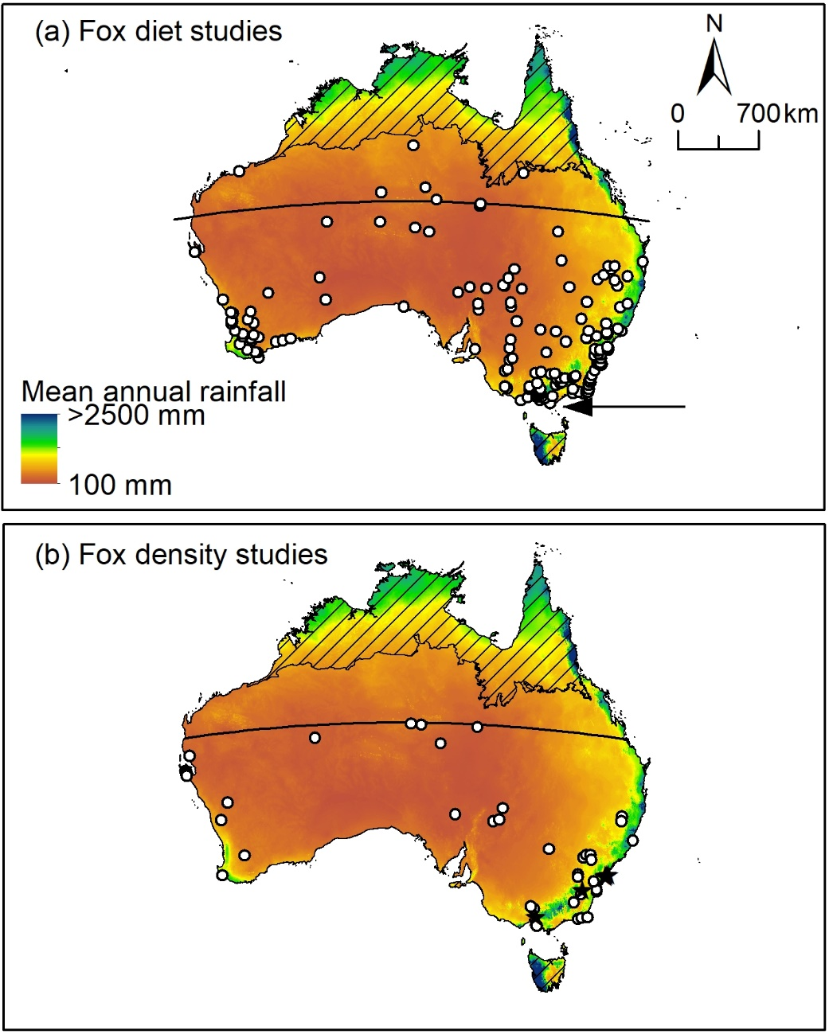
Figure S1. (a) The occurrence of fox dietary studies used in this study (circles); of the 168 sites all but three occurred on the Australian mainland, the other three sites were located on Phillip Island (2 sites) and Bennison Island (1 site) where fox eradication has since occurred (rough location indicated by black arrow). (b) The occurrence of fox density studies used in this study, 38 of which occurred in largely natural landscapes, indicated by white circles, and six of which occurred in highly modified environments, indicated by black stars. Hatching indicates areas outside of the fox’s distributional range. The background map indicates mean annual rainfall (Australian Bureau of Meteorology, 2016). Solid black line indicates the Tropic of Capricorn.

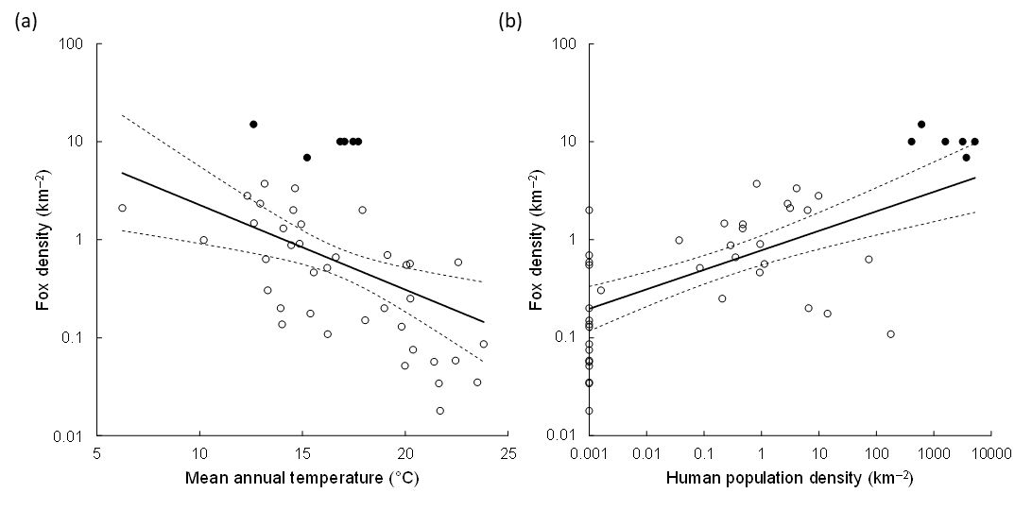
Figure S2. The relationship between fox density and each of: (a) mean annual temperature; and (b) human population density. The circles indicate the raw data; filled circles are observations from urban areas, and unfilled circles are observations elsewhere. The regression lines indicate the predictions of the best model (Table S4). In (a), all predictor variables other than mean annual temperature were held constant (at their mean value). In (b), all predictor variables other than human population density were held constant (at their mean value). The dashed lines indicate the 95% confidence intervals of the regressions. Note that in (b), 16 datapoints had a human population density of zero, such that they could not be plotted on a logarithmic axis; hence, they have been plotted with a value of 0.001.

Figure S3. Observed fox density plotted against fox density predicted by the best model (Table S4). The line indicates the one-to-one relationship.

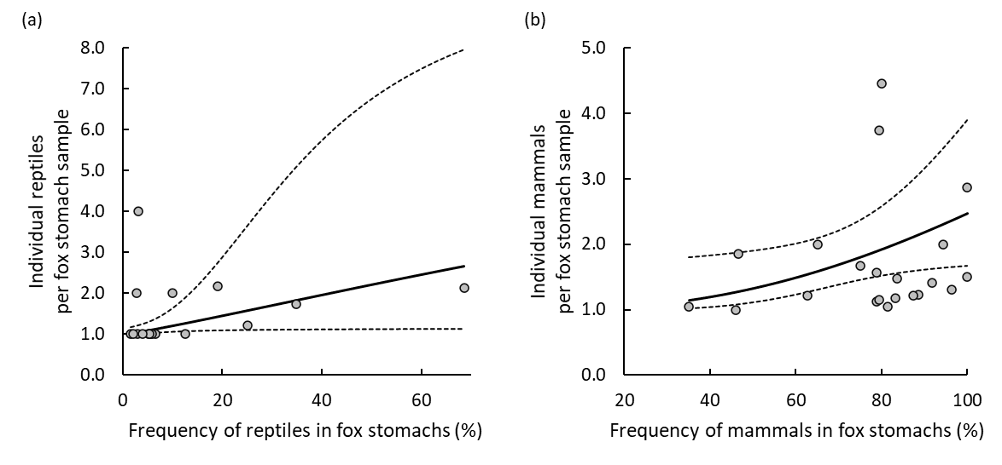
Figure S4. The modelled relationship between the number of individual (a) reptiles and (b) mammals in fox diet samples containing (a) reptiles and (b) mammals, and the frequency of occurrence (a) reptiles and (b) mammals in fox diet samples, according to linear least-squares regression models of the form: log₁₀ (individuals – 0.99) ~ log₁₀ (frequency), with (a) reptiles p= 0.05, R² of 0.23 and (b) mammals p= 0.05, R² of 0.19. Bold lines indicate the predictions of the regression model, dashed lines indicate 95% confidence intervals, and circles show raw data values.

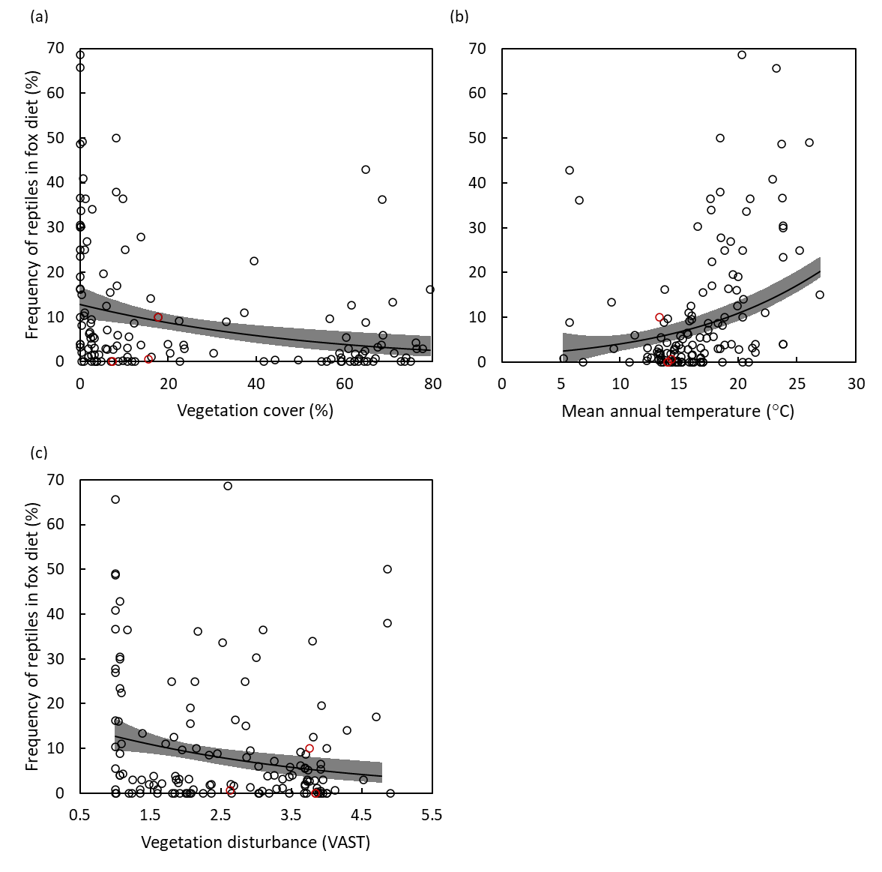
Figure S5. Variation in the frequency of occurrence of reptiles in fox diet samples (stomachs and/or scats) in relation to significant predictor variables: (a) vegetation cover (p= 0.001); (b) mean annual temperature (p= 0.015); and (c) vegetation disturbance (p= 0.011). Solid lines represent the predictions of a generalised linear model, shaded bands represent 95% confidence intervals and circles show raw data values (black circles are from mainland sites, red circles from island sites).

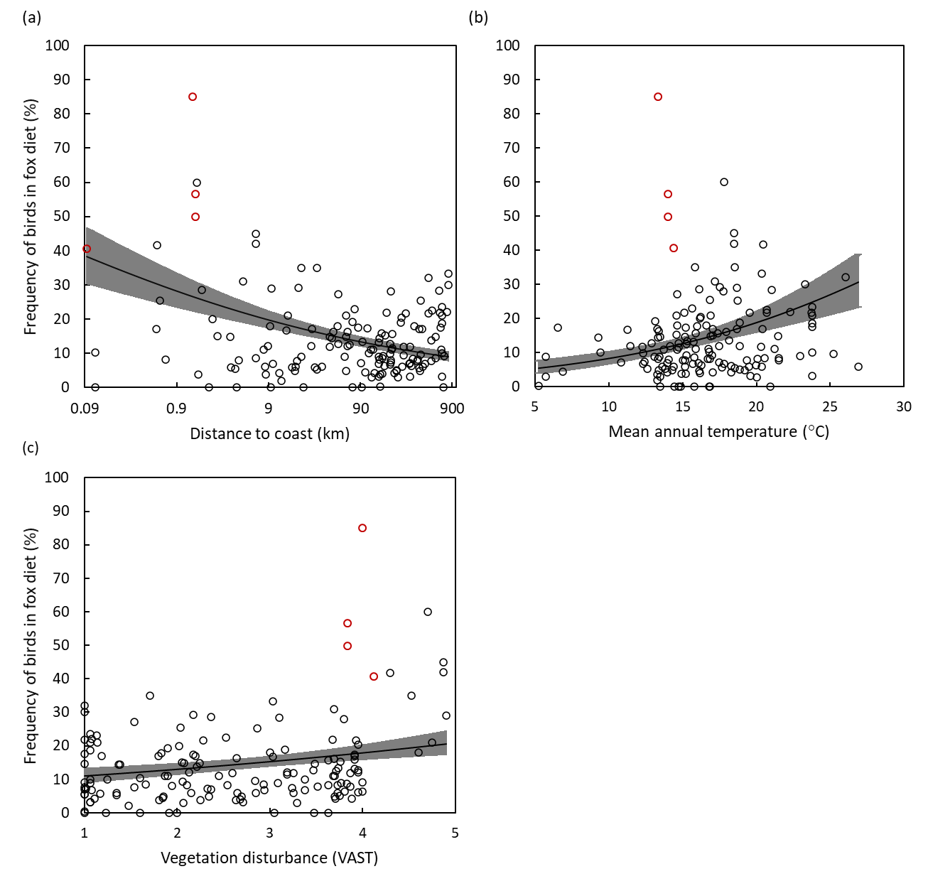
Figure S6. Variation in the frequency of occurrence of birds in fox diet samples (stomachs and/or scats) in relation to significant predictor variables: (a) distance to the coastline (p <0.001); (b) mean annual temperature (p <0.001); and (c) vegetation disturbance (p <0.001). Solid lines represent the predictions of a generalised linear model, shaded bands represent 95% confidence intervals and circles show raw data values (black circles are from mainland sites, red circles from island sites).

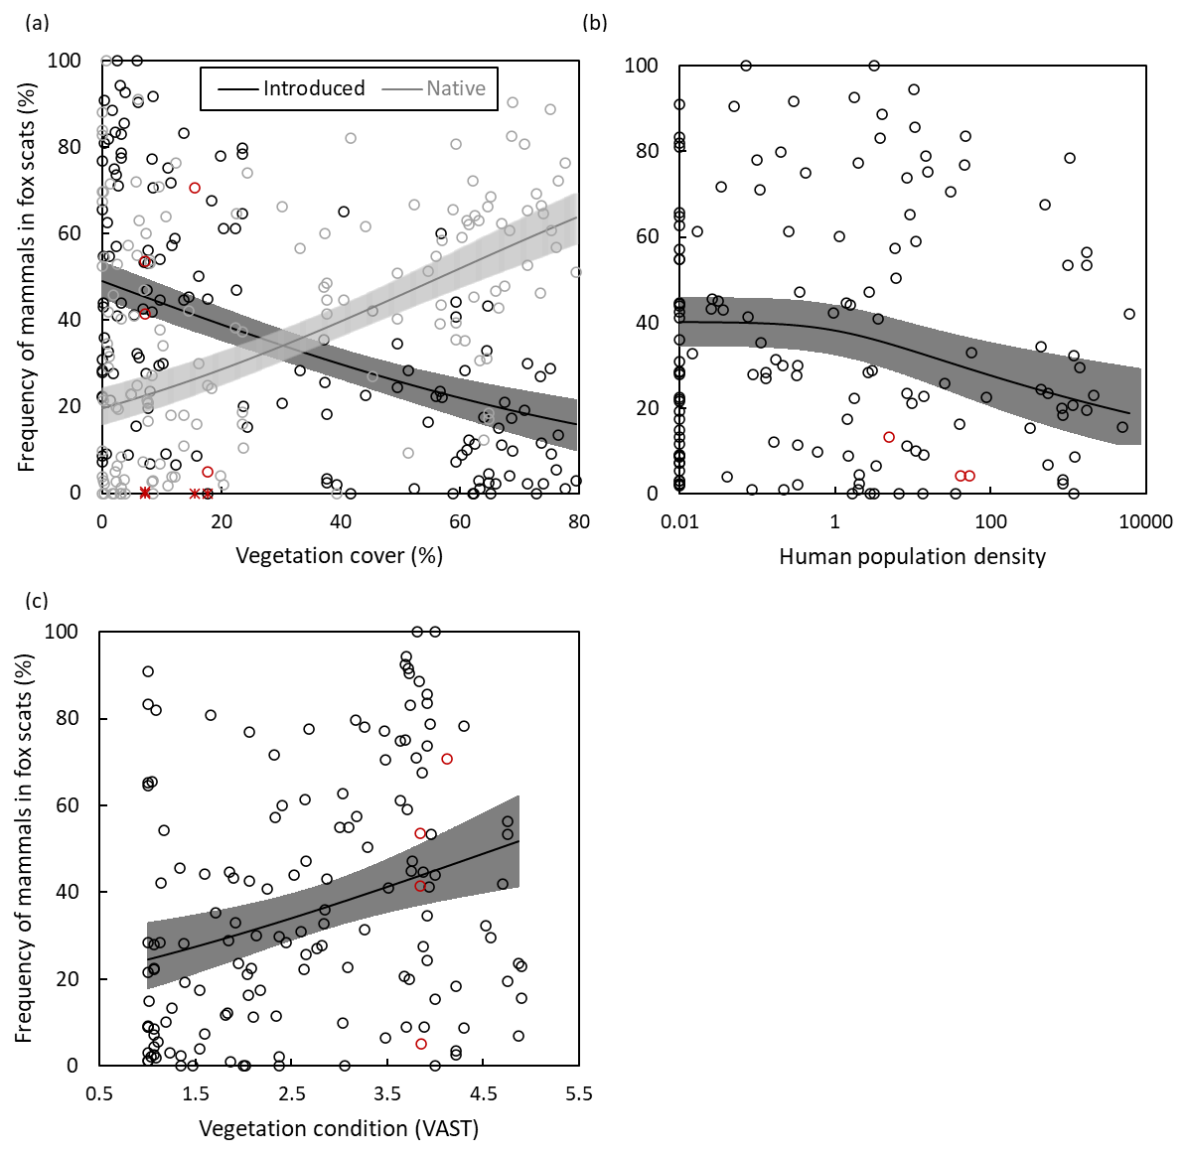
Figure S7. Variation in the frequency of occurrence of introduced (dark shades) and native mammals (light shades) in fox diet samples (stomachs and/or scats) in relation to significant predictor variables: (a) vegetation cover (introduced mammals p <0.001; native mammals p <0.001); (b) human population density (introduced mammals p= 0.001); and (c) vegetation disturbance (introduced mammals p= 0.001). Solid lines represent the predictions of a generalised linear model, shaded bands represent 95% confidence intervals and circles and asterisks show raw data values (black circles are from introduced mammal records on mainland sites, grey circles are from native mammals on mainland sites, red circles are from introduced mammals on island sites, red asterisks are from native mammals on island sites).

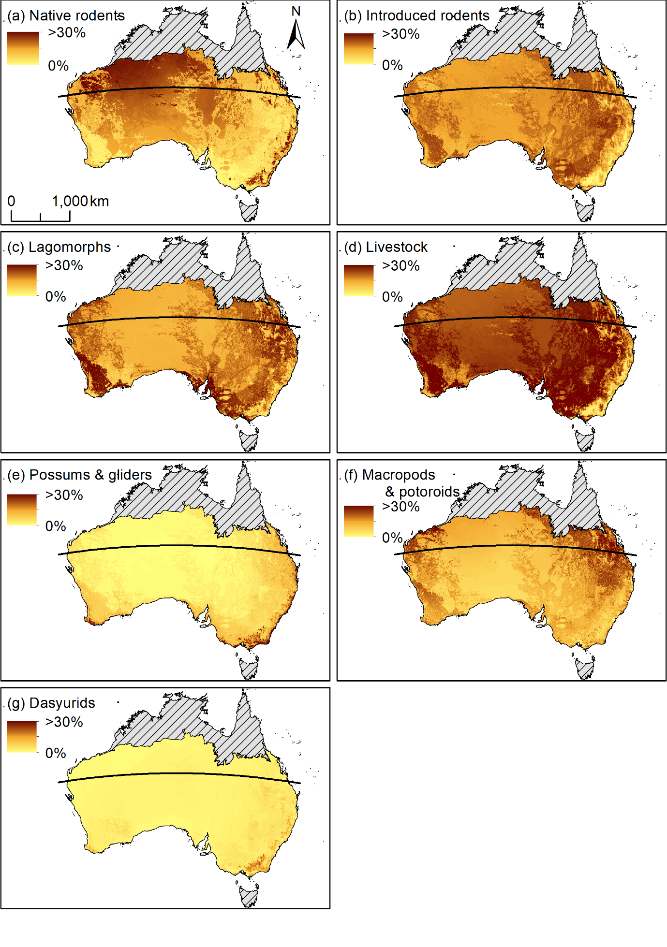
Figure S8. Model projections of the frequency of occurrence of (a) native rodents, (b) introduced rodents, (c) lagomorphs, (d) livestock, (e) possums and gliders, (f) macropods, and (g) dasyurids in fox diets throughout Australia. Solid black line indicates the Tropic of Capricorn and hatching indicates areas outside of the fox’s distributional range.

